Partnerships Victoria
Excellence in public private partnerships

The Secretary
Department of Treasury and Finance
1 Treasury Place
Melbourne, Victoria, 3002
Telephone: +61 3 9651 5111
Fax: +61 3 9651 2062
Website: dtf.vic.gov.au
Authorised by the Victorian Government
1 Treasury Place, Melbourne, 3002
Printed by Doculink, Port Melbourne
© State of Victoria
(Department of Treasury and Finance) 2017
You are free to re-use this work under a Creative Commons Attribution 4.0 licence, provided you credit the State of Victoria (Department of Treasury and Finance) as author, indicate if changes were made and comply with the other licence terms. The licence does not apply to any branding, including Government logos.
Copyright queries may be directed to IPpolicy@dtf.vic.gov.au.
ISBN 978-1-925551-34-1 (print)
ISBN 978-1-925551-35-8 (pdf/online)
Published May 2017

Message from Tim Pallas MP,
Treasurer of Victoria

Victoria’s 2017-18 Budget capitalises on our robust economic credentials and healthy population growth. Victoria has an historic $30 billion infrastructure pipeline, investing an average of $9.6 billion a year over the next four years into infrastructure projects. This will continue to boost our economy, create jobs and benefit Victoria and its people for years to come. Victoria’s infrastructure pipeline is underpinned by a triple-A rating and a strong balance sheet.
Infrastructure is key to meeting the challenge of population growth and is critical to unlocking productivity benefits essential for a modern economy. Better infrastructure deepens markets, brings consumers closer to businesses, and offers workers more job opportunities.
The Victorian Government is regarded as a leader in the delivery of privately financed infrastructure. As one of the early adopters of public private partnerships (PPPs), Victoria continues to evolve the PPP model by fostering innovation and encouraging industry development. The Partnerships Victoria framework makes it easier to do business in Victoria and aims to reduce the cost and time taken to tender.
The PPP model promotes efficiency and social and economic returns from government expenditure and ensures value for money over the longer term. Since the 1990s, roads, prisons, hospitals, schools and many other projects have been procured by the Government working with the private sector to build high-quality infrastructure and services, using the PPP framework.
Victoria is a world-class provider of high-quality education, research and training and is recognised as Australia’s Education State.
Victoria’s professional services sector is sophisticated, large and growing. Victoria has considerable capacity in the legal, accounting, management consulting, architectural, engineering and technical sectors, which can benefit those active in the PPP sector.

Tim Pallas, MP
Treasurer

Victoria: Australia and South-East Asia’s leading destination for PPPs

Victoria: Australia’s infrastructure powerhouse
- Victoria’s economy has grown strongly and consistently for more than 20 years, and accounts for close to 25 per cent of Australia’s economic activity.
- Investing in world-class infrastructure projects is vital for Victoria’s continuing economic development and growth.
- Infrastructure investment by the Victorian public sector is up to$73.6 billion in capital funding in the 2017-18 Budget.
- In many infrastructure projects, the Government will partner with the private sector through PPPs.

Investing in an expanding economy
Victoria’s economy is one of the strongest in Australia, having experienced 3.3 per cent growth in 2015-16, significantly above the national average of 2.7 per cent over the same period
The Victorian Government is investing an average of $9.6 billion a year for four years to fund productivity enhancing infrastructure and address Victoria’s growing population, while maintaining a strong balance sheet. There is a substantial and
ongoing investment in core services such as health, education and public safety, together with significant funding for transformative projects, including the Metro Tunnel and the West Gate Tunnel Project.

Government infrastructure investment
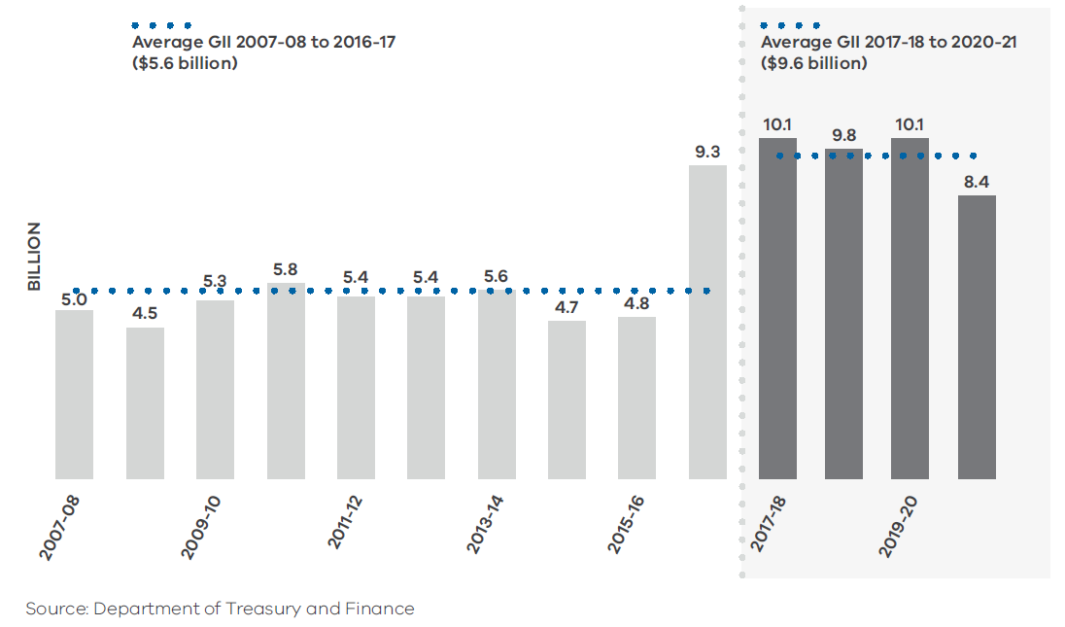

Pipeline of opportunities for investing in Victoria
The Victorian Government understands the importance, for both the public and private sectors, of taking a long-term view of planning and prioritising new infrastructure projects.
The Government has established Infrastructure Victoria as an independent statutory authority to provide expert advice and guide decision-making on Victoria’s infrastructure needs and priorities.
Infrastructure Victoria recommends a 30-year infrastructure strategy, to inform Victorian Government infrastructure investment priorities.
The strategy identifies projects worth nearly $100 billion across a number of sectors including transport, education, housing, health, energy, water and justice.
This is in addition to funding already committed to existing infrastructure projects.
For example, the Metro Tunnel is the biggest public transport project in Victoria’s history. The Metro Tunnel PPP scope includes nine kilometre twin tunnels and five new underground stations.
The North East Link is a new freeway that will complete the missing link in Melbourne’s metropolitan ring road.
The project is in the business case development phase and is Victoria’s next priority road project identified in Infrastructure Victoria’s 30-year strategy.
The project will take trucks off local streets and reduce congestion in Melbourne’s northern and eastern suburbs. It will provide an essential north-south connection, catering for Melbourne’s future growth, while linking the eastern suburbs to the northern and western suburbs and the airport.
Plans are also underway for the Western Suburbs Roads Package, which incorporates capital projects and road maintenance. This PPP demonstrates Victoria’s track record of highly sophisticated, innovative projects that contribute to the greater public good.

The pipeline for new PPP projects in Victoria is strong. We think Victoria is going to be the most vibrant PPP market in Australia over the next few years.
Compared to other jurisdictions, the Australian PPP market is very active.
Malcolm Macintyre,
Director, Head of Origination, Capella Capital

Establishing Infrastructure Victoria shows Victoria is not complacent. There’s a commitment to wanting to develop the market.
Sandra Lee,
Manager Private Markets, UniSuper

Melbourne has the right metrics in place for infrastructure growth. It’s an expanding, exciting city. Relative to many other jurisdictions around the world, the government support environment is also quite sophisticated.
Trevor Hall,
Executive General Manager (Victoria, South Australia, Tasmania, New Zealand) John Holland Pty Ltd

World leader in PPP projects
Victoria’s expertise and success in PPPs has been honed by nearly 20 years’ experience.
During that time, the State has executed 29 PPPs investing more than $15.6 billion in capital funding for major roads, hospitals, schools, prisons and water initiatives.
High-quality infrastructure assets such as CityLink, the Royal Children’s Hospital and the Melbourne Convention and Exhibition Centre demonstrate Victoria’s commitment to continually improve and refine its PPP framework.
PPPs benefit Victorians through private sector design innovation, creating world-class infrastructure, and enabling and incentivising efficient and focused public services. The structures embedded in PPPs incentivise the private sector to design the roads, hospitals and schools with an eye on the long term. As a result, users benefit from assets that are well maintained.
Victoria’s experience brings a maturity to our relationships with both PPP consortia and professional advisory firms.
We strive to ensure our projects:
- are built on time and on budget;
- transition smoothly from the delivery phase into services and ongoing operations; and
- benefit the community through improved service delivery.

What is a public private partnership (PPP)?
The Government contracts the private sector to design, build, finance and maintain infrastructure and provide services.
It is different to privatisation, with the PPP asset handed back to government at the end of the contract period.
Payment is based on the services delivered and conditional upon meeting performance standards.
PPPs always have a private finance element, and there is clear and enforceable risk allocation.

Victoria is a leader in terms of developing the PPP model. There is a long history in Victoria, and that means there’s a strong retained knowledge. This also means Victoria’s PPP model continues to evolve for the better.
Paul Crowe,
Executive Director, Head of Origination, Plenary Group

The PPP environment in Victoria supports an innovation mindset. Project scoping documents are articulated in terms of the outcomes the client is looking to achieve, not in terms of how to achieve outcomes.
The Victorian market has matured over the years. The State gets the balance of risk allocation right for the sustainability of the project and to ensure the right financial incentives. The breadth of projects in terms of their differing inherent characteristics, means there is a recognition that the unique dimensions of individual projects are properly thought through.
Kate Evans,
Partner PwC

Investors and other PPP participants can be confident they are operating in a consistent and well-supported environment.
Victoria’s extensive experience in PPPs is the bedrock of Australia’s sophisticated and comprehensive framework for PPP investment: the National PPP Policy and Guidelines. The State’s Partnerships Victoria Requirements complement the National Guidelines.
This means PPP participants operating in Victoria are confident individual projects are informed by the certainty of Australia-wide guidelines.
The State’s detailed Partnerships Victoria Requirements gives the private sector a consistent approach, underpinned by a commitment to reducing bid costs and negotiation time, and ensuring transparency.
The attractiveness and certainty offered by doing business in Victoria is further supported by Australia’s sound legal and governance frameworks. Australia ranks in the top 10 countries for rule of law (IMD World Competitiveness Yearbook 2016).
Australia’s strong financial services sector is ranked by the World Bank as fourth in the world for supporting business efficiency (Worldwide Governance Indicators 2016).

The decision-making process has traditionally been the most straightforward and accessible to the private sector without losing any aspect of the risk transfer and the public-sector policy outcomes.
John Walter,
Partner (construction), Corrs Chambers Westgarth

Private sector investment over a 25-year timeframe makes it critical that we design and build with a long-term mindset that incorporates redundancy, maintenance, energy efficiency and efficiencies of labour – this all drives a quality outcome.
Our involvement in PPP projects in Victoria has enabled our business to sharpen its skills in applying innovative thinking to design, construction, and taking a bigger picture view of how these impact on the ongoing operation.
David O’Shaughnessy, Project Director for the Bendigo Hospital and Royal Children’s Hospital projects, Lendlease Building

CASE STUDY ONE

Victorian Comprehensive Cancer Centre
$1. 27 billion net present cost
The Victorian Comprehensive Cancer Centre (VCCC) is home to Peter MacCallum Cancer Centre, treating more than 30 000 patients a year. It is one of the most advanced cancer centres in the world, attracting recognised leaders in cancer research, clinical treatment, education and training.
The VCCC, located within Australia’s premier biomedical and research precinct in Parkville, Melbourne, is helping consolidate Victoria’s reputation as a world leader in health care and research.
The VCCC brings together Australia’s leading cancer treatment and research organisations, including:
- the Peter MacCallum Cancer Centre;
- Melbourne Health (through the Royal Melbourne Hospital);
- the University of Melbourne;
- the Walter and Eliza Hall Institute of Medical Research;
- the Royal Women’s Hospital;
- the Royal Children’s Hospital;
- Western Health;
- St Vincent’s Hospital Melbourne (including St Vincent’s Institute);
- Austin Health (including the Olivia Newton-John Cancer Research Institute and Austin LifeSciences); and
- the Murdoch Childrens Research Institute.
The commitment by the consortium to build a world-class facility that meets the needs of patients, clinicians, researchers and staff was underpinned by the stakeholder engagement process early in the design phase.
The resulting innovative design solutions not only maximise collaborative potential between member organisations, but have also delivered an aesthetically striking and uplifting facility.
Laboratory clusters were designed to manage expansion and linkages built between the VCCC, the Royal Melbourne Hospital and the Royal Women’s Hospital to optimise the patient-centric model of care.
The VCCC’s flexible design enables it to host up to 1 200 cancer researchers with more than 25 000 square metres of dedicated research space for Peter MacCallum Cancer Centre, Melbourne Health, and the University of Melbourne.
The facilities will be home to the largest cancer immunotherapy laboratory in the southern hemisphere, involving researchers from the Peter McCallum Cancer Centre, the Peter Doherty Institute and the University of Melbourne.

Partners
The Plenary Health consortium is responsible for the design, construction, finance and ongoing maintenance of the majority of the VCCC facilities over the 25-year contract term.
The lead parties within Plenary Health are Plenary Group as sponsor and investor, the Grocon/PCL joint venture as the builder, and Honeywell as the facilities manager. The architectural design team was led by DesignInc, Silver Thomas Hanley and McBride Charles Ryan. Equity investors in the project are Plenary Group, investment vehicles owned by UniSuper and investment vehicles advised by Partners Group.

Consortium lead
Plenary Group Executive Director, Head of Origination, Paul Crowe: ‘We took some significant risks, as all bidders do, in terms of how you formulate a strategy and respond to the brief.
‘This is a very rewarding project to be involved in. Being involved at the front end gives you an opportunity to deliver something that captures the imagination of the client and the users, while also bringing the project together financially.
The VCCC was delivered on time and to program, and the feedback we have received has been very positive.’

User
According to Professor Sean Grimmond, the Bertalli Chair in Cancer Medicine and Director, the University of Melbourne Centre for Cancer Research, located in the VCCC: ‘The VCCC provides an opportunity to pioneer new techniques and research and build new partnerships between a community of world-leading research and clinical experts.’

Facility operator
Peter MacCallum’s Chief Operating Officer, Felicity Topp believes PPPs with their long-term maintenance obligations, are an excellent option for greenfield site hospitals.
‘The builders were really invested in the longevity and design of the building and fully engaged with staff and clinicians, which has delivered a world-class outcome.
The clinicians working in the building were involved at the very beginning of the project. Their input was incorporated into final designs, and this has had a really positive impact on their working environment and patient care.
‘We know that hospitals degrade relatively quickly, and that it’s difficult to dedicate capital funds to maintenance requirements when prioritising other budget commitments. Ongoing payments through service level agreements with agreed KPIs takes care of this, which is key to the hospital retaining its newness.
‘Honeywell has been with us from the beginning of the project, and, as a result, we are able to build on our strong relationships and knowledge base as we transition into the operational phase of the PPP. It’s like a 25-year marriage.’

Private sector capability – well positioned for the international PPP marketplace
Victoria’s early leadership in PPPs and our commitment to evolving and improving the model through shared experience has been the incubator for a growing and sophisticated private sector, ready to apply their skills in the international PPP marketplace.
In Victoria, bidders are encouraged and supported through the PPP process to be forward thinking and innovative, and to deliver value-for-money outcomes at the same time.
A number of Australian companies involved in complex and significant PPP projects in Victoria are already active in overseas markets, including Transurban, Lendlease, Macquarie Group and a number of superannuation funds such as the Future Fund, IFM, Australian Super, UniSuper and Hastings Fund Management.
Victoria has clearly defined rules of engagement, and clarity of focus of a PPP as a commercial transaction.
We understand the difference between privatisation and PPP projects and don’t confuse the two.
A key to the success of infrastructure in Victoria is the detailed business planning process undertaken before any project, be it a PPP or other delivery model, is approved to move to the bid phase.
With nearly 20 years’ experience, Victoria knows when projects are suitable for the PPP model, and just as importantly, when they are not.
This is a competitive strength as the upfront rigour applied to PPP decision making can have a direct correlation to the project’s eventual success: a principal objective of both government and private sector partners. Victoria uses the appropriate form of contract for the appropriate circumstances and recognises that risk transfer should be optimised, not maximised.
The competitive environment encouraged by the Victorian Government provides Australian- based companies with an appreciation of the benefits of a partnership approach attuned to the long-term success of an infrastructure project.
This translates to a competitive advantage in exporting skills in PPP projects in international markets.
Victoria’s PPP skills base is further supported by capability-building initiatives such as the University of Melbourne’s Public Private Partnerships Leadership Program.
The course is designed for professionals involved in all aspects of bidding for, planning and realising PPP projects, and is closely linked to the Partnerships Victoria framework.

Victoria very early in the piece adopted a mature response to PPPs as a commercial transaction. Their view on delivery of infrastructure is commercial not ideological.
Value for money, clear guidelines and supporting commercial capability underpin Victoria’s approach.
Victoria has been a stand out in supporting a culture of excellence for companies like us. Our people who have advised on PPP projects in Victoria and across Australia are taking their skills into the international market, particularly into Asia.
Darrin Grimsey,
Lead Client Service Partner, Ernst & Young

Australia’s advanced PPP market has resulted in a capability for delivering PPP projects that is highly sought after domestically and internationally. Our PPP specialists have a real perspective on first principles.
This gives them an understanding of the fundamentals in working on a successful PPP project anywhere, they are able to negotiate outcomes that work for the client and are appropriate for the transaction.
Sammy Isreb,
Division Director, Macquarie Capital

Global market participants in Victorian PPPs

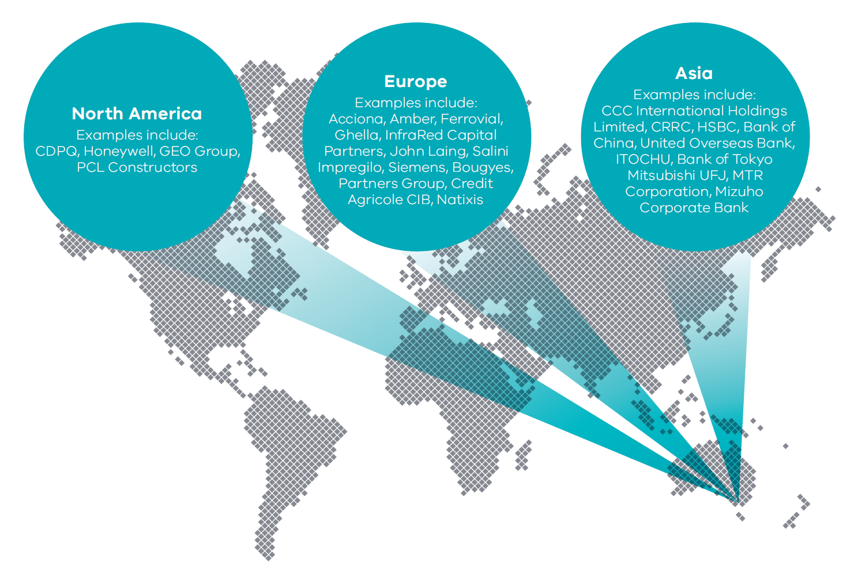

CASE STUDY TWO

Peninsula Link
$849 million net present cost
The $849 million Peninsula Link is a 27-kilometre toll-free road between Carrum Downs and Mount Martha, which significantly reduces congestion on key traffic routes in Frankston and the Mornington Peninsula, particularly during peak periods. The link enables commuters to avoid eight signalised intersections and five roundabouts on the Frankston Freeway and Moorooduc Highway. The result is that users benefit from material travel time savings, by up to 40 minutes.
Other benefits of the Peninsula Link project include:
- Ensuring an integrated transport network, by
  - improving freight and commercial vehicle access within the corridor;
  - delivering related traffic information systems;
  - integrating the project with the existing surrounding transport network;
  - providing flexibility to improve public transport services both within the project and on the surrounding transport network; and
  - retaining flexibility for future enhancement of the Peninsula Link.
- Environmental sustainability
The project preserves and, where possible, enhances the local environment while adhering to applicable government laws, guidelines and standards concerning environmental protection (including noise, water and air quality);
- Social amenity
The project enhances the amenity of the corridor through high quality urban design, noise attenuation solutions and socially sensitive construction and operations management; and
- Value for money
The project delivers value for money for the State and road users through innovative design, optimum risk allocation between the project parties and a whole of life approach to the design and operation of the road.

Partners
The Southern Way consortium is responsible for the design, construction , finance and ongoing maintenance of the roadway over the 25-year contract term.
The lead parties within the Southern Way are Abigroup Contractors Pty Ltd (construction); Lendlease Services (operations and maintenance); Plenary Group (asset manager); AMP Capital Investors Clients and Whitehelm Capital Clients (equity partners).

Asset manager
‘The PPP provides great value for taxpayers and road users, due to our stringent maintenance and safety regime. We have a 24/7 responsibility for making sure traffic moves as safely and effectively as possible, we are responsible for all landscaping and conservation, and we partner with a local sculpture gallery to provide a rotating series of public artworks alongside the freeway,’
Kylie O’Halloran,
Senior Asset Manager, Plenary Group.

Openness to innovative financing and readiness to adapt to the market
Preparedness to support innovative financing solutions has played an important role in the evolution and success of Victoria’s PPP program.
Victoria has responded to significant shifts in the way global financial markets generate private sector financing for PPP projects.
The global financial crisis, for example, had a significant impact on changing the landscape for PPP financiers; long-term bond financing was replaced with relatively short-term bank debt (five to seven years).
This type of financing model provides opportunities to secondary market investors interested in taking a longer term position in PPP projects once the lower risk operational phase has commenced. This often coincides with the first refinancing for the project.
Notwithstanding, there are signs that the financial market’s appetite for longer term financing is gradually returning to the Victorian PPP market. The Victorian Government has supported private sector alternative financing solutions that offer value to the State.
In Victoria, we are not prescriptive: we look to the private sector to put together the finance solutions.
The Victorian Government’s commitment to a successful outcome has also played a pivotal role in providing market confidence to invest in difficult times. The State’s commitment demonstrates its understanding of how markets operate and the importance of flexibility and quick action to adapt when required.

In our view Victoria has always been a leading party in the PPP sector. We have been impressed by the commercial approach to PPPs in Victoria, which has always been first class.
Victoria’s engagement with construction parties, financiers and operators in the private sector, through the market sounding process has always been very positive.
Martyn Jackson,
Amber Infrastructure

At the height of the global financial crisis, Victoria’s $5.7 billion Victorian desalination plant was the largest and most complex PPP project globally. You could ask how it was able to be successfully delivered when projects were falling over left and right all around the world.
The answer was two-fold: Victoria had a track record in delivering PPPs.
And just as importantly, the PPP was structured so that every encouragement was given to provide the private sector with the confidence to come up with the financing including acting as a last resort source of financial support. I think the flexibility shown by Victoria in dealing with the difficult PPP circumstances is a real market strength.
John Walter,
Partner (construction), Corrs Chambers Westgarth

CASE STUDY THREE

Melbourne Convention and Exhibition Centre
$515 million net present cost
The Melbourne Convention and Exhibition Centre (MCEC) is an example of the flexibility of ongoing arrangements that are a part and parcel of the PPP environment in Victoria. The project is a prime example of value creation. The new convention space was complemented with neighbouring commercial development opportunities (retail, office, hotel, residential), the value of which offset the upfront cost to the State of the MCEC.
The new convention centre opened in 2009 and the 25-year contract includes the facility management of both the convention centre and existing exhibition centre. Events are managed by the Melbourne Convention and Exhibition Trust.
The State contributed $370 million toward constructing the convention centre, and the remaining commercial development was financed privately. The City of Melbourne contributed an additional $43 million for municipal works around the precinct. And as part of the PPP arrangements, the State received $93.2 million from the Plenary Group for development rights of the precinct. A subsidiary of the group, Austexx Plenary Melbourne, received a 99-year leasehold for the commercial areas, and a 25-year leasehold for land relating to the MCEC.
At the 2016 World Travel Awards, MCEC was voted Australasia’s Leading Meetings and Conference Destination. The number of events held at MCEC continues to grow with 980 events being hosted during 2015-16, delivering an economic benefit of $959.4 million to the Victorian economy.

Expansion flexibility
In 2015-16, the Victorian Government committed an additional $205 million for a 20 000 square metre expansion of MCEC, which will add nearly 9 000 square metres of flexible, multi-purpose event spaces.
The project shows the benefits of introducing flexibility into the masterplan and the importance of complementary facilities, such as a hotel and other commercial activities. It is also a good example of how a successful PPP project can offer significant expansion opportunities.

Partners
The Plenary Conventions consortium is responsible for the design, construction, finance and ongoing maintenance of MCEC over the 25-year contract term.
The lead parties within Plenary Conventions were Plenary Group as sponsor and investor, Multiplex Group as builder and facilities manager, Austexx (commercial precinct developer) and NH Architects/Woods Bagot/Larry Oltmanns (architects and designers). The MCEC expansion is being built by Probuild Constructions and maintained by Brookfield Global Integrated Solutions.

Consortium lead, equity investor and project manager
According to Plenary Group’s Executive Director, Origination, Paul Crowe: ‘The MCEC project is an example of the benefits gained from introducing flexibility into a master plan that recognises the importance of inter-related assets, such as a hotel and other commercial activities.’

User
Speaking about the project’s PPP partners, MCEC’s Chief Executive Officer, Peter King said: ‘We are like-minded in the way we see the event world. The PPP arrangements allows MCEC to focus on our core business and what we do best.
Having long-terms partners has also meant that our Stage Two build, which was originally contemplated as a simple extension of exhibition space, is being designed architecturally in a way that complements the existing convention centre.’
With regard to MCEC’s ongoing facilities management:
‘The venue looks wonderful, especially considering that we hold about 1 000 events and move around 2.5 million people through the centre every year, and it’s already nine years old.’

Client
Contract Manager, Karen Pepperell, Department of Economic Development, Jobs, Transport and Resources: ‘In my mind there is no doubt that on the asset management side, things are being done well. The processes are a lot more rigorous within a PPP arrangement and as a result, the centre is well-maintained with asset replacement planned for the duration of the contract.’

Partnership approach achieves long-term community benefits
The Victorian Government supports PPPs because they are proven to innovate and benefit communities.
Government selects a PPP model based on a comprehensive analysis in a business case. The PPP tender process is conducted to encourage potential bidders to innovate to create additional benefits for the community.
PPP projects are ideally positioned to deliver community benefits, with numerous partners (including architects, builders, financiers, and facility managers) collaborating in a competitive environment that encourages a holistic view, beyond merely building a piece of infrastructure.
Additional outcomes benefiting the community include:
- associated child care, conference centre and hotel at Bendigo Hospital, and at the Royal Children’s Hospital associated child care, retail, and community programs;
- early learning centres, community hubs at multiple schools sites as well as learn-to-swim pools at two schools; and
- bike paths and improved public transport interchanges as part of the Peninsula Link and EastLink road projects.
Under ongoing PPP arrangements, system upgrades and repairs enable the introduction of new technology, which helps ensure infrastructure retains its currency. This is particularly important for PPP projects such as roads, schools and hospitals.
In major commercial projects, such as the new Melbourne Convention and Exhibition Centre, the PPP involves the provision of hotel accommodation and commercial business operations, which provide additional economic benefits to the State through job creation and tourism.

The guiding principles that provided direction for the building of our school was that it should be perceived as a hub for the community. This thinking delivered a facility with an adjacent early childhood centre. The facility was also constructed with its very own wetlands to support a strong focus on sustainability and environmental education programs.
Frank Vetere,
Principal, Point Cook Prep to Year 9

Because the clinicians and staff were so involved in the design process, the Royal Children’s Hospital was built to reflect the everyday needs of the staff and patients. The children that come here need an open and friendly environment and that was uppermost in our minds when designing and building the hospital.
Martyn Jackson,
Amber Australia

Our patient surveys clearly show they are appreciating the hospital environment and the way it is being maintained.
Felicity Topp,
Chief Operations Officer, Peter MacCallum Cancer Centre

CASE STUDY FOUR

New Schools PPP projects
$750 million net present cost
The Victorian Government has built more than 25 new primary and secondary schools using the PPP procurement approach (invested $255 million in 2008 and $495 million in 2015). Located across Victoria’s metropolitan and regional growth areas, the new schools address high population growth and enrolment demand.
To ensure the design and approach to building a school is linked to supporting better educational outcomes, school principals and communities are consulted to input into the development of a set of guiding principles for each school. These guiding principles underpin the schools’ design and build.
One of the many schools to benefit from the PPP approach is Point Cook’s Prep to Year 9 College, which is located in one of Australia’s fastest growing municipalities.
For Point Cook’s Prep to Year 9 College, a guiding principle was that the school should be viewed as a community hub and provide access to community partnerships during and after school hours. The PPP solution delivered a child care centre through a partnership with the YMCA, which is linked into the school’s transition to Prep program. From an educational and student perspective, the YMCA partnership was also extended to run the school’s environmental programs.

Partners
The Axiom consortium is responsible for the design, construction, finance, and ongoing maintenance of eleven new schools procured in 2008. The consortium comprises AMP Capital as equity owner and SPV manager, Abigroup as builder, Cushman & Wakefield as facilities manager, Hayball and Gray Puksand as architect and YMCA as community partner.
The Learning Communities Victoria consortium is responsible for the design, construction, finance and ongoing maintenance of 15 new schools procured in 2015.
The consortium comprises Amber as sponsor and SPV manager, INPP as equity investor, ClarkeHopkinsClarke as architect, Watpac as builder, Spotless as facilities manager and YMCA and CERES as community partners.

Client
Andrew Major, Department of Education and Training:
‘We have a structured and methodical process for assessing the quality of PPP proposals. This helps give us transparency around outlay and risk, and all parties involved understand their obligations.
‘The PPP process allows a critical mass to be brought to bear, so that one-off design gains are able to be spread across a number of sites.
‘There are also no lumpy unexpected surprises for school principals. There are clear standards that have been set in place, and the Education Department has a robust team approach to holding the private provider to account.’

User
Frank Vetere, Point Cook Prep to Year 9 College:
‘The PPP approach has enabled me to focus on my core business, which is teaching and learning, and not have to focus energy around building infrastructure and maintenance. Our students have daily access to wetlands, which has been built into our environmental studies curriculum, and has amazing features.
‘Our partnership with the YMCA, for example, is allowing us to provide child care facilities onsite as well as run our Middle Years outdoor education program.’

Consortium lead
Martyn Jackson, Amber Infrastructure:
‘We have responsibility for the delivery of the project through the design development, construction and operating phases for the term of the agreement. To meet this obligation we look to actively engage with the State and make sure our delivery and operational teams have the skills and resources necessary for each of these phases.
‘It’s important to maintain the partnership in PPPs and in our experience Victoria has a good approach to the partnership concept, this is partly because of the quality of the people they commit to the projects.’

Partnerships Victoria: Victoria’s first point of contact for PPPs
The Victorian Government is committed to PPPs that promote efficiency and provide value for money, as well as social and economic returns from government expenditure.
This commitment by the Victorian Government is underpinned by support from Partnerships Victoria and helps explain why Victoria has such a long and successful history in PPP projects.
The experienced Partnerships Victoria team in Victoria’s Department of Treasury and Finance has a central coordination, advisory and facilitation role in managing the tender process. The team also advises Victoria’s Treasurer, who presides over the State’s PPP policy and approves key PPP project milestones.
The Partnerships Victoria team also serves as a conduit for communication between the private sector and government.
Because of its extensive PPP delivery experience, the Partnerships Victoria team is well placed to provide expert guidance to government agencies to ensure their requirements are developed recognising private sector perspectives.
Partnerships Victoria also works closely with the private sector to communicate public sector requirements. The interactive tender process clarifies tender document requirements throughout the bid phase.
For bidding consortia, this helps provide confidence and certainty that they understand the requirements. It also helps facilitate quality responses from bidding consortia.
The Partnerships Victoria framework provides the private sector with clear policy and guidelines underpinned by a number of whole of government infrastructure policies.
Templates to facilitate the bidding process are available to make it easier for the private sector to participate. Standard expression of interest, request for tender and base contract documents are helping reduce bid costs, while increasing certainty and transparency for PPP participants and investors.
From the Victorian Government’s view point: a well-run tender process means greater contestability, which has a direct impact on value for money and infrastructure quality.
Recognising that long-term partnerships are critical to PPP success, Partnerships Victoria is also responsible for ensuring PPP contract managers undertake PPP training. The training covers the technical skills required to manage a PPP project (e.g. performance monitoring), as well as important behavioural skills such as dispute resolution and negotiation.

Partnerships Victoria’s experience is generated from a 20-year consistent pipeline of PPP projects. We work closely with government project teams and seek the views of private sector proponents up-front to structure projects efficiently.
And we don’t forget about monitoring long-term performance. Partnerships Victoria welcomes the opportunity to learn from others to ensure Victoria’s PPP model is leading practice.
Jason Loos,
Director, Partnerships Victoria

The government team is open to engagement, and this helps bidders seek verifications and understand the project risks better. The approach yields better results for government and for bidders. Victoria is a clear market leader in this area.
Paul Crowe,
Executive Director, Head of Origination, Plenary Group

The State and the bureaucracy know what to do, and have got a track record. That’s very comforting. Like all of us, we know the State has had good experiences and bad experiences. This is important because you want to know you are partnering with a government or entity that can deal with challenges and stay the course.
Kent Robbins,
Head of Property and Private Markets, UniSuper

Further information
Further information, including in relation to current and upcoming projects and opportunities can be found at:
- www.dtf.vic.gov.au/Infrastructure-Delivery/Public-private-partnerships
- www.budget.vic.gov.au/
- www.dtf.vic.gov.au/Publications/Infrastructure-Delivery-publications/Partnerships-Victoria/Partnerships-Victoria-Requirements
- www.infrastructure.gov.au/infrastructure/ngpd/index.aspx
- www.business.vic.gov.au/export/meet-the-international-vgbo-trade-team
- www.nics.gov.au/
- www.infrastructurepipeline.org/
Contact us: information@dtf.vic.gov.au

Partnerships Victoria Project  (year of contract execution) | Project cost  (net present cost as at contract execution, $ million) | Project status as at May 2017
CityLink-Tulla widening (2015) | 872 | Under construction
High Capacity Metro Trains (2016) | 2 343 | Under construction
New Schools PPP (2015) | 495 | Under construction
Ravenhall Prison (2014) | 2 529 | Under construction
Ballarat North Water Reclamation Project (2006) | 52 | In operation
Barwon Water Biosolids Management Project (2007) | 78 | In operation
Bendigo Hospital (2013) | 1 110 | In operation
Biosciences Research Centre project / AgriBio (2009) | 288 | In operation
Campaspe Water Reclamation Scheme (2002) | 51 | In operation
Casey Community Hospital (2002) | 120 | In operation
County Court (2000) | 195 | In operation
Desalination Plant (2009) | 5 720 | In operation
Eastlink (2004) | 2 500 | In operation
Fulham Correctional Centre Extension (1997, 2015) | 593 | In operation
Hopkins Correctional Centre (2010) | 394 | In operation
Melbourne Convention and Exhibition Centre (2004) | 515 | In operation
Metropolitan Mobile Radio (2004) | 120 | In operation
Mobile Data Network (2003) | 140 | In operation
Partnerships Victoria in Schools (2008) | 255 | In operation
Peninsula Link Project (2010) | 849 | In operation
Port Phillip Prison Extension (1997, 2015) | 1 831 | In operation
Royal Children's Hospital (2007) | 946 | In operation
Royal Melbourne Showgrounds (2005) | 101 | In operation
Royal Women's Hospital (2005) | 365 | In operation
Southern Cross Station (2002) | 309 | In operation
Victorian Comprehensive Cancer Centre (2011) | 1 278 | In operation
Victorian Correctional Facilities (2004) | 275 | In operation
Emergency Alerting System (2004) | 100 | Completed
Wodonga Wastewater Treatment Plant (2001) | 32 | Completed

