2013-14 Victorian Budget
Regional and Rural Victoria
Budget Information Paper No. 1

Building for Growth

Table of contents

Introduction 3
Regional Growth Fund 4
Infrastructure for growth 6
Continuing to link up Victoria – East West Link 13
Delivering better education and skills 22
Water 26
Boosting our regions 29
Key projects timeline – a snapshot 30
Boosting local communities 31
Open for business 42
Initiatives by region 50

The Secretary
Department of Treasury and Finance
1 Treasury Place
Melbourne, Victoria, 3002
Australia
08
Fall

Telephone: +61 3 9651 5111
Facsimile: +61 3 9651 5298
Website: www.budget.vic.gov.au

Authorised by the Victorian Government
1 Treasury Place, Melbourne, 3002

Print managed by Finsbury Green,
Level 9, 124 Exhibition Street, Melbourne, 3000

This publication makes reference to the
2013-14 Budget Paper set which includes:
Budget Paper No. 1 – Treasurer’s Speech
Budget Paper No. 2 – Strategy and Outlook
Budget Paper No. 3 – Service Delivery
Budget Paper No. 4 – State Capital Program
Budget Paper No. 5 – Statement of Finances
(incorporating Quarterly Financial Report No. 3)

© Copyright State of Victoria 2013

This book is copyright. No part may be reproduced by any process except in accordance with the provisions of the Copyright Act 1968.

ISSN 1440-6969

Published May 2013

Introduction
Regional and rural Victoria’s contribution is critical to securing the State’s economic growth and prosperity.
Victoria’s economic fundamentals remain strong. The economic outlook is proving resilient in the face of a strong Australian dollar and global uncertainties. The strength of regional and rural industries and communities is a key factor underpinning Victoria’s economic strength and future growth prospects.
The Coalition Government’s fiscal strategy allows it to advance major transformational infrastructure projects, as well as the ongoing road, rail and other infrastructure required to meet future population growth and plan for new prosperity, more opportunities and a better quality of life.
The Coalition Government is supporting the long-term prosperity of Victoria through investments to boost the growth of regional Victoria and enable better integration with Melbourne, national and international markets.
Long-term growth in Asia is expected to accelerate demand for beef, lamb, wheat, and dairy products along with processed foods, which Victoria is well placed to capitalise upon. Increasing growth and urbanisation in the Asian region will also present opportunities for the State’s significant brown coal and mineral sands deposits. Linking these rural industries to national and international markets will also be critical to the State’s long term prosperity.

Regional Growth Fund

Continued implementation of the Government’s $1 billion Regional Growth Fund (RGF) is making investments in infrastructure, services, facilities and locally driven programs that improve regional ar eas. These projects deliver benefits for regional and rural Victoria over and above existing State Government department core programs and infrastructure.
During the term 2011-2014, within the RGF, $300 million has been allocated to strategic Initiatives (including Economic Infrastructure an Energy for the Regions) and $200 million to Local Initiatives (Local Government Infrastructure and Putting Locals First Program).
To March 2013, the RGF has supported 943 projects to the value of $282.6 million, leveraging total investments of $944.2 million supporting regional jobs.
In April 2013, the Government launched Thinking Regional and Rural: Guidelines for Assessing Regional and Rural Impacts of Government Policy and Legislation for introduction across the Victorian Government.
Developed by the Regional Policy Advisory Committee (RPAC) with assistance from Regional Development Victoria, Thinking Regional and Rural provides a framework to highlight key questions and issues policy makers across government should consider where a major decision is being contemplated. The framework is designed to minimise negative impacts or unintended consequences of policy or legislation, while highlighting opportunities where regional and rural communities may benefit.
The Government is working closely with businesses and communities, and including local voices in the strategic planning of their future. This includes the ongoing work by the RPAC’s Regional Business Leaders Forums (held across Victoria in 2012‑13) and the support for development of Regional Growth Plans.
Regional Growth Plans provide a broad direction for regional land use and development and high level planning frameworks for key regional centres. The plans will be completed by mid‑2013, and guide implementation of strategic land use and infrastructure directions set out in Regional Strategic Plans prepared in 2010.

Ballarat Technology Park
In October 2012, $2.9 million in funding from the Regional Growth Fund was announced towards the University of Ballarat’s $6.4 million Ballarat Technology Park (BTP) expansion.
The expansion is anticipated to generate 520 jobs during construction and 1 820 jobs during the operational phase, and leverage capital investment of more than $155 million during the construction works.
In November 2012 IBM announced it will expand its presence at the BTP with a new IBM Asia Pacific Centre of Excellence for Software Testing. The centre is expected to create 150 new jobs in software application development and high‑level specialist technical support.

A plan for growing the Geelong region
In April 2013, the G21 Regional Growth Plan was released. It is the first of eight Regional Growth Plans and provides a critical framework to underpin economic and jobs growth while protecting and preserving the Geelong region’s precious cultural and environmental assets. It acknowledges the important role of Geelong as Victoria’s second major city and central service provider to the surrounding areas.
The Plan provides direction for accommodating the strong growth occurring in the region by identifying necessary land supply and strategic supporting infrastructure. The G21 Regional Growth Plan identifies residential land supply for the next 30‑40 years to accommodate a projected population of 500 000 and identifies employment land to accommodate up to 800 000 new jobs by 2050. The Plan has been endorsed by the five shires that form the G21 region – City of Greater Geelong, Surf Coast Shire Council, Golden Plains Shire Council, Colac Otway Shire Council and the Borough of Queenscliffe.

Infrastructure for growth

Transport
An efficient freight transport system is critical to support the State’s economic growth. High‑capacity transport connections that link regional Victoria with industrial precincts in Melbourne’s outer metropolitan area and with export gateways are critical.
The Government is ensuring that regional centres and towns have access to effective and efficient rail, road and freight connections.

Maintaining our road network
Metropolitan Melbourne and regional Victoria are economically integrated, so it is vital that these connections are considered when planning for strategic employment precincts, residential growth opportunities and infrastructure connections.
It is equally important that country roads are maintained to support local industry and businesses, enhance liveability and save lives.

New funding
The 2013‑14 Budget provides over $280 million in additional funding for the restoration, maintenance and upgrade of key sections of Victoria’s road network.
The Government is providing $90 million for targeted road restoration, focusing first on high priority roads on strategic economic routes. Restoring the regional sections of these roads will improve their safety and reduce ‘whole of life’ costs involved in maintaining the State’s road network into the future.
Adding to VicRoads’ base 2013‑14 road maintenance budget, an additional $80 million is being provided for arterial road maintenance across Victoria. This funding will help address the backlog in country road maintenance across regional and rural Victoria.
Funding of $32 million is provided to repair fatigue defects on the West Gate Bridge. This maintenance will ensure the longevity of this important road asset.
The Government is providing $7 million to complete the sealing of the Omeo Highway improving road safety and travel times and $10 million for planning and preparatory work for the Kilmore‑Wallan Bypass.
The Government is also providing $28 million for infrastructure upgrades, principally focusing on roads that present bottlenecks to the growth of productivity in regional Victoria. These projects will increase capacity on the network by better utilising existing infrastructure.
To help keep young people safe on our roads, the Government is providing $49 million for the continuation of the Graduated Licensing System, which aims to ease young people across Victoria into driving using a safer, evidence‑based system.
To prepare the East Werribee Employment Precinct for future investment, $33 million is being provided to upgrade transport infrastructure to access regional and state transport networks and conduct necessary environmental site assessments and implementation planning.

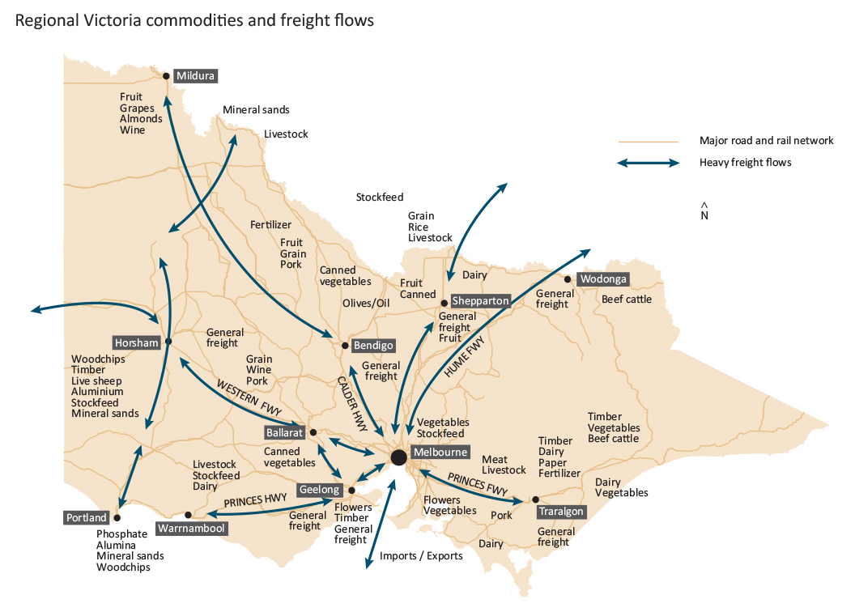

Stage 1 of East West Link
The Government is committed to delivering the East West Link project, with the first stage being the Eastern section from the Eastern Freeway at Hoddle Street to CityLink in Parkville.
The Government will provide the funding capacity to deliver this first stage, commencing in 2013-14. The East West Link - Stage 1 has an estimated capital cost of between $6-8 billion.
The East West Link will provide improved connections to Melbourne Airport and the Port of Melbourne for business, travellers and freight generators.
Current Government action
As part of the $160 million Country Roads and Bridges program, the Government is providing 40 rural councils the opportunity to apply for up to $1 million per year in funding for country roads and bridges projects.
The $60 million Better Regional Roads program is providing funding for road connections between Melbourne and regional Victoria to further support regional growth.
Other previously funded road projects for regional areas include:
- $50 million to duplicate the Western Highway between Burrumbeet and Beaufort;
- $42 million to duplicate the Western Highway between Beaufort and Buangor;
- $15 million for Princes Highway overtaking lanes west of Colac;
- $8 million for the first stage of sealing of the Omeo Highway;
- $7.1 million to construct overtaking lanes on the Strzelecki and Hyland Highways, and two new lanes on the Melbourne‑Lancefield Road to reduce congestion and improve road safety;
- $4.5 million for Ballarat–Buninyong Road upgrade;
- $5 million to start work on the Princes Highway West from Colac to Winchelsea;
- $3.4 million to start work on the Kilmore‑Wallan Bypass;
- $3 million for noise walls on the Geelong Ring Road;
- $36 million to deliver the Government’s election commitment to construct the 4.2 kilometre long Ballarat Western Link Road between the Western Freeway and Ballarat‑Burrumbeet Road;
- $6 million to upgrade existing rest areas along the Hume Freeway to provide additional truck parking spaces and improved amenities; and
- $1 million for road upgrades to widen and seal road shoulders used frequently by the timber industry.
The Government is investing $3.9 million in local projects and delivering election commitments that improve the safety and amenity of the road system, including the construction of a pedestrian overpass over the Henty Highway in Portland.
Additional funding of $25 million has been provided to conduct road restoration works to sections of the Geelong-Ballan Road, Murray Valley Highway, Great Ocean Road, Surf Coast Highway, Hamilton Highway and other regional arterial roads connecting towns and cities across regional Victoria.
Assistance is being provided to cover costs of recovery and repair of strategic roads, including $12 million for arterial roads, and $400 000 for the removal of flood debris, the inspection of bridges damaged during flood events and drainage works.

Expanding rail capacity
New funding
The Government has provided $22 million to build and operate a new station at Grovedale, incorporating a single platform with passenger amenities, on‑road bus bays, bicycle storage and car parking for 200 cars. The project will upgrade track and signalling to maximise the number of trains that can operate to and from the new station.
The Government is investigating the viability of rail services between South Geelong to Drysdale and Grovedale to Torquay.
The Government is providing $9 million to build and operate a new train station at Epsom. The development includes a 160 metre platform with shelters, ticketing, public announcements and hearing loops, and parking for 60 cars.
Bendigo route services will be changed to make Epsom and Eaglehawk the terminuses for some services, improving public transport access in the northern areas of Bendigo.
Funding of $7.1 million is being provided to upgrade the broad gauge rail track from Echuca to Toolamba and install new signalling at Toolamba junction so this line can be reopened for freight. When reopened, the branch line will provide a more efficient link to the Port of Melbourne for exporters moving freight from the Goulburn Valley and southern New South Wales.
As a part of national regulatory reforms, the Government is investing $62 million over five years to replace the existing V/Line Non‑Urban Train Radio system with a digital radio communications system. This will improve the reliability of train services to regional Victoria and improve interoperability with metropolitan and national freight trains.
Current Government action
Regional Rail Link is well underway and will provide improved rail services from Geelong, Ballarat and Bendigo into Melbourne, making these regional cities more attractive places to live and invest.
In addition, the Government has ordered 40 new V/Line carriages to deliver increased service levels when the Regional Rail Link opens in 2016.
The Government is investing $5.1 million as a part of its election commitment to deliver a new rail link to Avalon Airport. This will fund the necessary planning and business case development for the new rail link. In addition, $2 million has been provided for research into the return of regional rail services between the major regional cities of Geelong, Ballarat and Bendigo.
Funding of $10 million is being directed to the improvement of the Warrnambool to Geelong rail link through the construction of a new rail passing loop. The passing loop will provide both V/Line and rail freight operators with greater flexibility, improving their ability to schedule and operate more frequent passenger and freight trains.
The Government has provided $172 million for major periodic maintenance of the regional rail network for both passenger and freight services. This will enhance punctuality, reliability and passenger comfort to significantly improve passenger services. Better network reliability will increase the competitiveness of Victoria’s freight services.
Additional funding initiatives to support regional public transport and rail include:
- delivering more train services to Wendouree Station and improved access to rail services for people in Ballarat. This includes $1.6 million to provide an additional 68 services each week to and from Wendouree;
- returning passenger rail services to the north‑central Victorian town of Talbot, with the allocation of $2.5 million to upgrade Talbot Station; and
- implementing a $47 million program to improve country level crossings across Victoria, including the upgrade of Warragul Station. As part of this package, $2 million has been allocated to improve the crossing at Lardners Track, Victoria’s number one country level crossing black spot.

Increasing our capacity for trade – investing in Victoria’s ports
Regional industries rely on strong freight connections to Victoria’s ports. Approximately 43 per cent of containerised exports through the Port of Melbourne are agricultural products.
New funding
The 2013‑14 Budget provides $110 million to develop the Port of Hastings. The Port of Hastings development is critical for the future of our growing freight trade, well beyond the next decade, providing a significant expansion to Victoria’s container freight capacity.
The $110 million initiative in the 2013‑14 Budget provides for a capital injection in the Port of Hastings Development Authority to progress planning and approvals to develop this critical infrastructure.
Planning for the construction of a second Victorian container port with land-side transport connections will meet expected demand for containerised shipping well into the future, providing enhanced certainty for Victorian imports and exports.
This initiative complements the Port of Melbourne redevelopment, which is undergoing a $1.6 billion expansion of container and automotive capacity at Webb Dock.
The Government will also invest $5 million in 2013‑14 to improve access to Victoria’s coastal and inland waterways. This will include essential works to local infrastructure to help maintain safe access to the marine environment.
Current Government action
The Government is investing $23 million for the redevelopment and repair of local port assets to support tourism, aquaculture and recreation.
In November 2012, the Government provided $3.8 million towards the $5.6 million Port of Geelong Grain Loop upgrade, which will enable up to 30 per cent more grain per train to be delivered to the port by rail and reduce the number of trucks on the road.

Better bus services
New funding
This budget provides $25 million to enhance bus services. The initiative will increase the number of bus services in key growth areas, improving transport coordination for commuters. Precincts include St. Albans, Caroline Springs, Wyndham, Bacchus Marsh and Warrnambool.
Current Government action
An additional 800 weekly bus services are being provided in the Latrobe Valley. The new bus services run more frequently, for longer hours, and have expanded network coverage in Traralgon, Moe, Morwell, Churchill and surrounding smaller townships.
Investing in regional jobs
The 2013‑14 Budget provides $179 million for eight new X’Trapolis trains and associated infrastructure, and planning for future train acquisition. This adds to the seven trains funded by the Coalition Government in the 2011‑12 Budget.
This funding delivers stage two of the Coalition Government’s commitment to acquire 40 additional commuter trains for Melbourne during its first and second terms. The trains will be fitted out by Ballarat train manufacturer Alstom, securing jobs in the region. The trains are expected to commence running on the network by 2015.
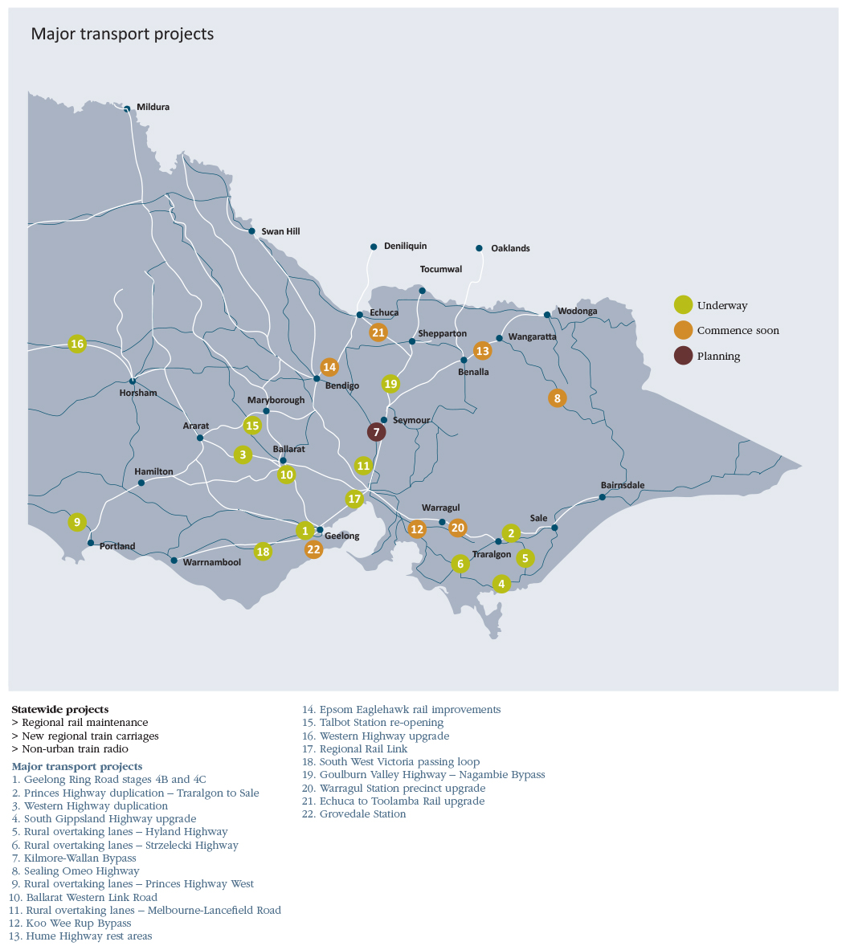

Continuing to link up Victoria – East West Link

Why East West Link?
- Melbourne’s cross-city connectivity is constrained.
- The only major east-west route across the city, the M1 corridor, is operating at or close to capacity.
- Daily queues and congestion where the Eastern Freeway terminates at Hoddle Street.
- East-west traffic is forced onto residential streets in the inner north and inner west.
- The city’s busiest tram routes through the inner north to the CBD are becoming less reliable due to congestion caused by east-west traffic.
- Constrained connections to and from the city’s major economic gateways and freight destinations (such as Melbourne Airport and the Port of Melbourne) restrict business and freight movements.
- Population growth in Melbourne, in particular in the west and north, will continue to place pressure on cross‑city routes.

Investment
- Total capital cost of the program of works for the first stage is estimated at between $6-8 billion.
- The 2013-14 Budget makes provision for delivery of the first stage, allowing for some private financing and $1.5 billion of Commonwealth funding.
- Funding of $294 million has been released over the next 2 years to complete detailed planning, and commence procurement and early works construction.
- The project road will be tolled, however tolling revenue will not recover the full cost. Therefore, significant investment is required by the State and Commonwealth Governments, and private sector.
- The Coalition Government will engage with communities regarding the preferred corridor and the needs and concerns of local communities.

Delivering on the first stage of East West Link
- The Coalition Government is committed to delivering the full East West Link, which is an 18 kilometre freeway‑standard road from the Eastern Freeway to the Western Ring Road.
- The scale and complexity of the project means it will be delivered in stages.
- The first stage of the project is the Eastern Section, a 6 kilometre link from the Eastern Freeway in Clifton Hill to CityLink in Parkville.
- The section will be predominantly in tunnel to minimise social, visual, noise and other environmental impacts.
- The first stage will also provide for transport and urban amenity improvements along the corridor, including public transport initiatives and initiatives to address congestion on adjoining roads.
- Main construction on the first stage is expected to commence in late 2014 with the construction period of approximately 5 years.
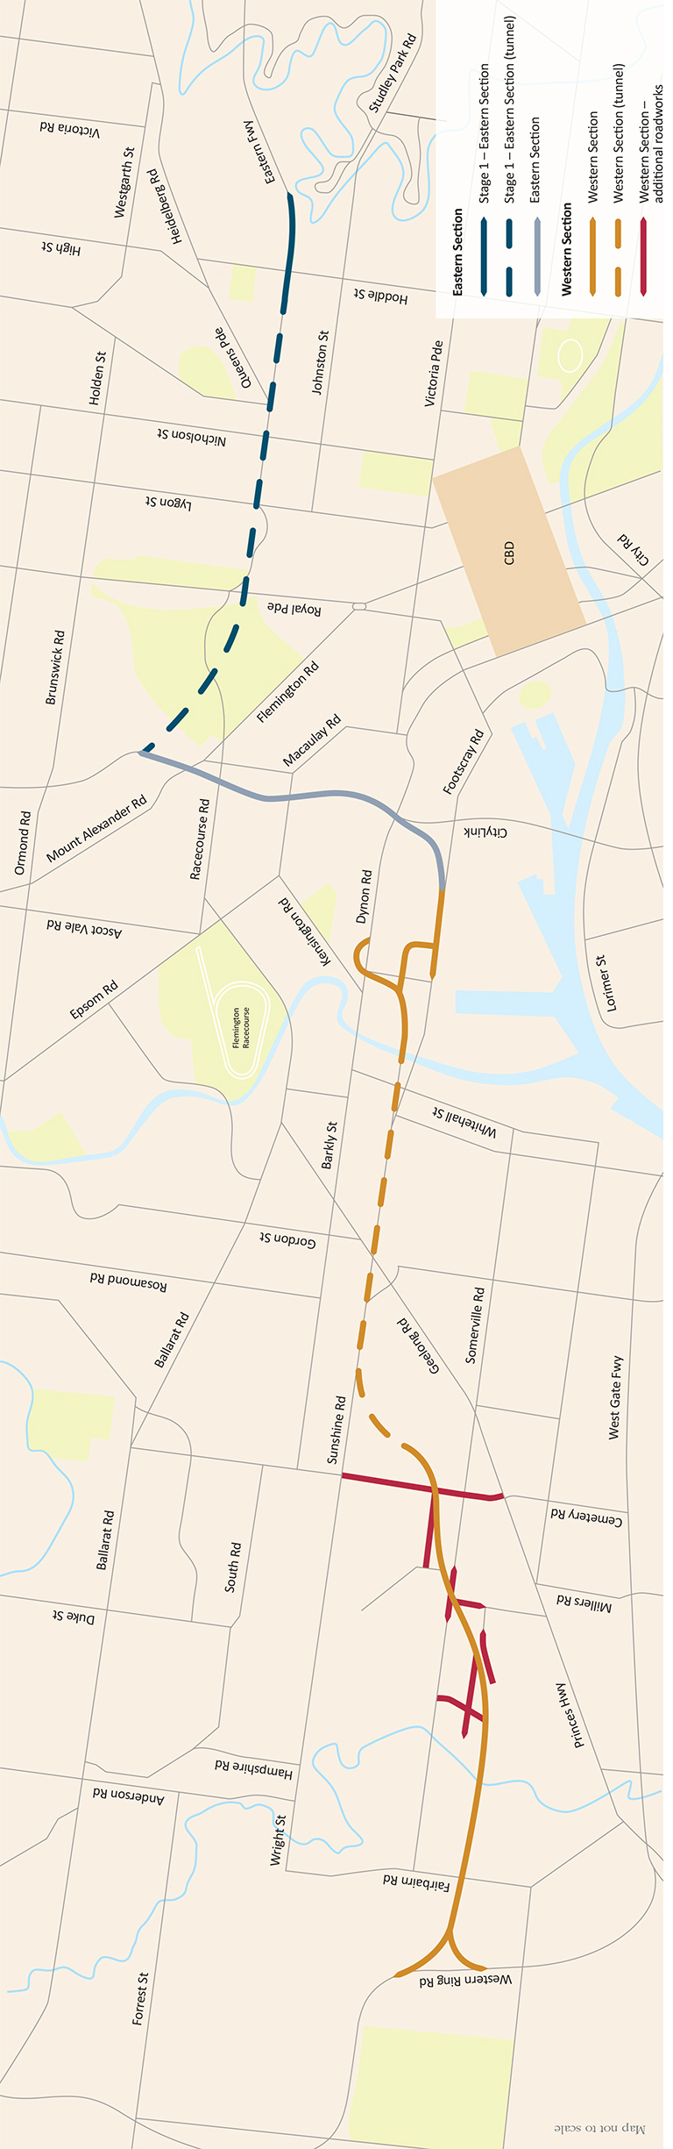
Strengthening health care and community services
The 2013-14 Budget provides an additional $426 million in 2013-14 and $1.8 billion over the forward estimates to Victoria’s hospitals and health system, bringing expenditure on acute health to $11.2 billion in 2013-14.
Building up health infrastructure
The 2013‑14 Budget is providing substantial investment in vital capital works.
The Government will deliver its election commitment to build a new 32‑bed community hospital in the southern suburbs of Geelong by investing in the Waurn Ponds Community Hospital. This hospital will meet service pressures for the growing populations of Geelong and the Surf Coast Shire. The new facility will provide same‑day surgery, chemotherapy chairs, renal chairs and capacity for specialist clinics.
Investment of $18 million will re‑establish a range of acute health services at Numurkah Hospital, which was damaged extensively in the March 2012 floods. The new purpose‑built facility includes ten acute beds, a two‑bed high dependency unit, four beds for palliative or restorative care and a six‑bed day procedure unit.
Funding of $35 million for the new Werribee Mercy Hospital mental health facilities, will deliver the construction of a new 54-bed acute mental health facility, including 25 additional beds. This investment will increase local access to mental health services and improve the efficiency of service delivery.
Funding for the Northern Hospital of $29 million will build on the expansion of the emergency department and special care nursery that was funded over the past two years – to deliver a new three storey building at the existing site including 32 beds and support areas. The funding will expand inpatient capacity and enable the hospital to better manage immediate demand pressures and broaden the range of acute services offered, resulting in improved access.
Critical care capacity will be expanded with an investment of $2.2 million for four adult intensive care beds and five neonatal intensive care respiratory support beds, together with upgraded medical retrieval equipment for health services across Victoria.
The 2012‑13 Budget Update made provision for the redevelopment of two key specialist facilities
The Monash Children’s Hospital and the Royal Victorian Eye and Ear Hospital redevelopment, funded in the 2012‑13 Budget Update, are significant infrastructure projects that deliver on the Government’s election commitments.
Rural and Regional Victorians will benefit from investment in world class specialist medical facilities that provide services to the State as a whole.
The new Monash Children’s Hospital will deliver 230 beds, which will provide capacity for increases in demand and improve access for the growing populations in south-east Melbourne, the Mornington Peninsula and south-east Victoria.
The redevelopment at the Royal Victorian Eye and Ear Hospital will enable the hospital to meet current and future demand for specialist adult and paediatric ophthalmology and ear, nose and throat services on its existing site in East Melbourne. It will include major reconfiguration, upgrade and expansion of facilities for clinical services and significant improvements to the onsite teaching, training and research facilities.
The Government has already funded numerous capital projects across the State’s hospitals to improve the standard and accessibility of health care services for rural and regional communities, delivering on its election commitments, through:
- $630 million for the new Bendigo Hospital project. This will create a new integrated cancer centre, a new mental health unit, as well as 372 beds and 10 operating theatres for this thriving regional centre. Twenty-first century facilities will enable the hospital to deliver improved patient care according to best practice, develop a skilled health workforce for the future, improve operational efficiency and provide for the health needs of a growing population;
- $93 million for a major upgrade of Geelong Hospital. This will include 64 additional beds in order to increase capacity to provide cancer care, palliative care and care for older patients with complex needs;
- $46 million to the redesign and upgrade of the Ballarat Hospital. A helipad will be added to the hospital’s roof, additional car parking will be provided, and an additional 60 beds will improve the hospital capacity;
- $40 million for the Echuca Hospital redevelopment and expansion;
- $23 million with a contribution from the Commonwealth Government to reconstruct the Charlton Hospital, which was extensively damaged in the January 2011 floods. The new hospital will ensure enhanced residential aged care services, better ambulatory care services, and improved patient access to services;
- $20 million to redevelop and expand the Kilmore and District Hospital. This will provide an additional 30 acute beds, dedicated outpatient services, and enhanced ambulatory care services;
- $18 million to redevelop the residential aged care facilities at Swan Hill District Health, providing 45 residential aged care beds as well as additional upgrades to essential infrastructure and site services;
- $18 million for the Kerang District Health residential aged care redevelopment;
- $10 million to relocate and refurbish the urgent care department, construct a second theatre, redesign a surgery ward and upgrade infrastructure at Castlemaine Hospital;
- $2 million for the Ballan Hospital redevelopment;
- $2 million for the Warragul Hospital emergency department upgrade; and
- $1.8 million for the refurbishment and expansion of Ballarat District Nursing and Healthcare facilities.

Upgrading health facilities and technology
New funding
The Government will invest $10 million to develop radiotherapy services for south‑west Victoria in Warrnambool. This builds on the $5 million invested in the 2012‑13 Budget and will enable residents to receive treatment locally instead of needing to travel long distances. This delivers on the Government’s election commitment.
Health facilities across the State, including acute hospitals, dental health services, mental health services and aged care services, will benefit from $35 million in additional funding to update and replace medical equipment. Health services assets, such as lifts, generators and fire safety equipment will also be improved, with $25 million funding for health system infrastructure replacement.
Current Government action
To support the Rural and Regional Health Plan released in December 2011, the Government announced in the 2011‑12 Budget the $56 million Rural Capital Support Fund. Grants have already been allocated through two funding rounds with the next round set to commence mid-2013. Infrastructure investment supported by the Rural Capital Support Fund includes:
- > $1.2 million to the redevelopment of the public dental clinic at Bass Coast Regional Health;
- > $1.9 million towards inpatient rehabilitation service facilities at Albury-Wodonga Health; and
- > $2 million towards the relocation of the day procedure unit at Swan Hill District Health.
To support patients to receive treatment locally, the Government has provided $2 million to develop chemotherapy services at Seymour District Memorial Hospital.

Training the health workforce
It is critical that the right skills and expertise are available to meet the health care needs of Victorians in regional and rural areas. The Government is continuing to invest in training our medical professionals.

New funding
Funding of $3 million will provide an additional six training posts for rural general proceduralists, building on current programs to train rural doctors in procedural skills in areas such as obstetrics, anaesthetics, emergency and surgery.
The Government is investing $194 million over four years to increase delivery of clinical training for undergraduate students. The initiative will support an increase of more than 20 per cent in clinical placement days over the next four years.
This is alongside statewide funding of $42 million over four years for additional intern and new graduate places in medicine, nursing, midwifery and medical radiation, increasing the overall supply of qualified health professionals.
Current Government action
In the 2011‑12 Budget, the Government provided funding of $73 million for additional health services in Ballarat, including supporting the recruitment of 10 general practitioners to fill vacancies in the Ballarat area, and an additional 20 doctors and 80 nurses at Ballarat Base Hospital.
Commencing in 2011‑12, the Government also invested $1.1 million over 4 years to support dental practitioners to relocate from metropolitan locations to rural and regional communities.
To improve ambulance services for rural and regional Victorians, the Government is building new rural ambulance branches, upgrading existing rural branches and recruiting new rural ambulance staff. This will enable the upgrade of the Maryborough and Castlemaine branches to 24‑hour rostered coverage with professional paramedics, new 24‑hour professionally staffed ambulance stations at Beaufort, Grantville and Wallan and establishment of mobile intensive care single‑responder units in Warrnambool, Horsham, Mildura, Shepparton, Wangaratta, Wodonga, Sale, Bairnsdale, Wonthaggi and Swan Hill.

Boosting mental health and drug services
New funding
The budget also meets a Government election commitment by allocating $25 million over four years to increase capacity through:
- > 16 new mental health beds across Western Health (Footscray), Eastern Health, Austin Health, and the Latrobe Regional Hospital (Traralgon);
- > three five-bed mother-baby units in regional Victoria for women with a mental illness and their infants; and
- > enhanced mental health and wellbeing services in Bairnsdale, which will coordinate access to mental health, welfare and social services in East Gippsland.

Home and community care
New funding
The Home and Community Care program supports older and younger people with a disability to remain in their home. Victoria allocates around $665 million annually to this important service, and the 2013‑14 Budget builds on this investment and provides an additional $34 million a year to maintain current service levels and meet growing demand.
The Government will provide $7.9 million towards new supported accommodation homes in the Bendigo area for the current residents of Sandhurst Residential Services. The new accommodation options will aim to create better lives for the residents of Sandhurst Residential Services by providing smaller, more personalised home environments that allow for greater involvement in the local community. Current residents, their families and carers will play a key role in the development of the new homes to ensure they meet their support needs and living preferences.
Funding of $107 million over four years is being provided for individualised support for people with a disability, their families and carers. Up to 720 additional individual support packages will be available to provide essential care and support services for people with a disability, their families and carers. Individual support packages provide Victorians with a disability choice about the types of support they access and greater control over their own lives. A number of these packages will be available to meet demand for students with a disability currently exiting the school system, and those exiting the Futures for Young Adults program. This will ensure that young people with high ongoing needs are provided with the assistance they require.
The Government is also providing $4 million in additional subsidies for aids and equipment for people living with a disability to enhance their quality of life and build independent living skills.

Delivering health services
New funding
A funding pool of $421 million over four years is being provided to drive efficiencies in elective surgery. This follows a successful pilot in the 2012‑13 Budget and will encourage the most efficient use of facilities to see more patients treated sooner.
The Government will further develop Services Connect, Victoria’s integrated human services system, by extending activity at the existing Services Connect trials sites in Dandenong and Barwon. Services Connect will deliver support to those most in need in the community, ensuring service delivery is client centred and more efficient.
Extra funding of $772 million over four years will enhance the capacity of health services across Victoria to meet and manage growth in demand for essential hospital services. Support will target services such as emergency inpatient bed capacity, outpatient services, renal dialysis, chemotherapy and radiotherapy services, as well as cost-effective substitutes for acute care. This funding also includes additional critical care capacity in intensive care units, as well as additional maternity and neonatal service care funding.
Access to lifesaving treatment for heart disease and stroke will be improved by a $22 million program with a targeted focus on rural and regional Victoria. This will reduce readmission and disease progression rates by better managing and supporting people with chronic heart failure and introducing new models of care to enhance rehabilitation.
Culturally appropriate service options for Aboriginal Victorians will be expanded to ensure that they receive access to appropriate health care. Investment of $62 million will build pathways to support increased use of mainstream services by Aboriginal Victorians, and help to better respond to their needs.
Current Government action
The Government is providing $300 million to launch the National Disability Insurance Scheme, to help improve the lives of Victorians with a disability.

National Disability Insurance Scheme – launch site
The Victorian and Commonwealth Governments agreed to a launch site of the National Disability Insurance Scheme in the Barwon area commencing on 1 July 2013.
Over the course of the launch, approximately 5 000 eligible people with significant disabilities will have their needs assessed and will start to receive care and support under a National Disability Insurance Scheme model. Under the Scheme, eligible people with disabilities in the Barwon area will:
- be assessed to receive ‘reasonable and necessary’ support;
- continue to have decision making power about their care and support, including choice of service provider;
- be assisted by local coordinators to help manage and deliver their support; and
- be able to access a system they can easily navigate, and that will link them to mainstream and community services.

Delivering better education and skills
The Government has set an objective to lift Victoria’s education and development outcomes into the global top tier over the next 10 years. Funding provided in the 2013‑14 Budget supports this goal.
This year, regional and rural Victoria will benefit from the Government’s continued investment to upgrade the quality of school infrastructure around the State. Funding has been allocated to support the construction of new schools in growth areas, and secure land for building schools in the future.

Upgrading our schools
New funding
The 2013‑14 Budget provides for total school capital works of $203 million.
The funding will provide for five new schools and land acquisitions in growth locations, so that these areas benefit from quality education in the future.
This funding builds on the Government’s recent announcement of $52 million funding to repair, rebuild or remove buildings at more than 200 schools across the State.
Current Government action
Funding of $27 million was provided for a new secondary college at Torquay, which enables students along the Surf Coast to complete their schooling in their local community.
The Government has already completed upgrades and redevelopments at the following schools:
- Seymour College - $7 million;
- Colac Secondary College - $11 million; and
- Horsham Special School - $7 million.
Upgrades have commenced at the following schools:
- Leongatha Secondary College - $10 million;
- Eaglehawk Primary School - $2 million;
- Toorloo Arm Primary School - $3 million;
- Bairnsdale Secondary College - $10 million;
- Phoenix Community College - $10 million;
- Castlemaine Secondary College - $7 million;
- Belvoir Wodonga Special Development School - $6 million;
- Golden Square Primary School - $5 million;
- Wodonga Senior Secondary College - $10 million;
- Mirboo North Secondary College - $7.5 million;
- Northern Bay College - $8.3 million;
- Ouyen College - $5 million; and
- Woolsthorpe Primary School - $2.5 million.

Upgrading our kindergartens
New funding
The Government is ensuring that families in regional and rural areas have access to quality early childhood services and care, with funding of $4.6 million over four years for workforce improvements supported across the sector to provide incentives to attract qualified early childhood educators and provide scholarships for educators to attain or upgrade their qualifications.
Grant funding of $7 million will be available to build and upgrade kindergartens and children’s services. This forms part of the Government’s annual expenditure for early childhood development of $543 million.
The Children’s Facilities Capital Program is investing in a range of infrastructure initiatives for children’s services infrastructure, including new facilities, upgrades, renovation and refurbishment.
Current Government action
The Government has provided $6 million over five years to Victoria’s smallest rural kindergartens to continue to provide vital preschool education for families. There have been some 135 grants of up to $20 000 to assist with administrative and operational costs for small rural kindergartens.
Funding of $2.3 million is being provided for five early childhood development workers in Loddon Mallee, Gippsland, and the Grampians. Early childhood development workers provide education and training to Child FIRST family services staff and early years workers to improve the linkages between the Child FIRST family services and early childhood systems.
Children’s Facilities Capital Program – Shepparton and Kialla
In November 2012 the Government announced that the Children’s Facilities Capital Program would invest in four early childhood centres in the Shepparton and Kialla region.
The Gowrie Street Extended Early Learning Hub has been provided a grant of $300 000 to provide new early childhood facilities as well as renovating the existing school library to provide space for extended access to playgroups, childcare and community partners on one site. This will provide an integrated services approach for the Shepparton community.
The Kialla Children’s Centre grant of $276 004 will provide an additional building at the centre on Council land adjoining the existing centre. The current building entrance will be adjusted to provide a walkway and add a landscaped play yard suitable for all abilities. The service will be able to increase enrolments and broaden the community aspect.
The Knight Street Preschool and Child Care Centre in Shepparton received a $205 000 grant to convert a large single room currently used for 3 to 5-year-olds into two individual rooms, each with toilets and storage. This will accommodate an individual three‑year-old group and an individual kindergarten group.
The St Mel’s School and Kindergarten in Shepparton has been provided a grant of $150 200 to refurbish an existing unused space to retain two three-year-old kindergarten programs. In 2013 the service will provide a 15 hour program for four-year-old children.

Skilling Victoria
New funding
A $200 million TAFE Structural Adjustment Fund will be established to provide support for TAFE institutes for initiatives that promote innovation, collaboration, structural reform and business transformation.
The Government will provide $2 million to support the engagement and participation of young people in Victoria’s economy and community. This will be enhanced through new enterprise and mentoring programs. These programs will focus on supporting young people aged 18‑25 years to be engaged, involved and creative in a range of mentoring, training and business start‑up and support initiatives. Additionally, funding will be provided for three Victorian local government areas to manage safer annual school leaver celebrations.
Current Government action
Through the $20 million Regional Partnerships Facilitation Fund, part of the Regional Growth Fund, the Government is supporting projects that contribute to increasing the rate of higher education participation and attainment in regional Victoria. These projects help bridge the current gap between participation and attainment rates in metropolitan Melbourne compared with regional Victoria.
The Government is providing $5 million over four years through the Regional Growth Fund to improve Year 12 retention rates in regional and rural Victoria. The Local Solutions Year 12 Retention Program is supporting government, Catholic and independent secondary and P‑12 schools to introduce innovative programs and improve retention rates.
Funding of $2 million has been provided for the design, tendering and site preparation for planned major upgrades at the Geelong campus of the Gordon Institute of TAFE and $1.5 million for the East Gippsland Institute of TAFE.
Technology Enabled Learning Centres – Gippsland
TAFE institutes in Gippsland will be the first to pilot the roll-out of the new Technology Enabled Learning Centres in 2013. Seed funding of $5 million has been provided to develop and install electronic learning technology at existing campuses of Chisholm, Gippsland and Advance TAFEs as well as a selection of other training providers. This will allow students to access and directly interact with teachers in a wide range of education services close to home, including courses previously delivered only at metropolitan campuses.

Assisting children with a disability to learn and achieve
New funding
An additional 1 000 early childhood intervention services places are being provided across Victoria to support children with a disability or developmental delay from birth until school age.
The Government will provide an additional $38 million to provide support for additional students with moderate to severe disabilities in mainstream and specialist government schools. Students with a disability will also benefit from an additional $13 million being provided to the Students with Disabilities Transport Program.
Funding of $21 million will be provided for support services, including psychology, speech pathology and social work services, for government school students across Victoria facing barriers to learning.

Water
New funding
The Government will provide $16 million to the Macalister Irrigation District. This project will achieve water savings of 12.3 gigalitres, and aims to increase on‑farm productivity, regional economic production and waterway and estuarine health through the modernisation of the district’s waterways.
Further funding includes:
- $4 million to deliver a program of works that will manage the strategic repair, maintenance and replacement of over 100 groundwater monitoring bores. This will ensure effective and efficient management of groundwater resources;
- $4.2 million to meet Victoria’s contribution towards the annual operating costs of the Murray‑Darling Basin Authority;
- $9 million to fund high‑priority works that will protect the open coast as well as Port Phillip Bay and Western Port. This program will focus on addressing emerging issues across the whole coast and improve support to Coastcare volunteers; and
- $7 million over four years to engage with communities, local government and business to help protect and improve health of the Yarra River and Port Phillip Bay and practical partnerships for on‑ground action.
Current Government action
Funding of $59 million has been provided to improve the environmental condition of Victoria’s high priority rivers, wetlands and estuaries. The program focuses on physical works across regional Victoria and provides for statewide policy coordination and planning.
The Government is investing $41 million to manage, monitor and report on the Environmental Water Reserve. This will help ensure the sustainable development of water resources.
To address concerns about the health of the Yarrowee River in Ballarat, the Government is investing $1 million to work with community groups to reduce the amount of pollutants, litter and weeds, and to restore wildlife habitats.
To give water users more clarity and flexibility, the Government is investing $3.4 million to refine water entitlements and to enhance the Victorian water market.
The Government is investing $5.5 million to improve water-use efficiency and natural resource management on farms to reduce the impact irrigation has on the environment.
The Government has provided $4.7 million to maintain the level of Victoria’s groundwater resources by addressing depletion of groundwater resources caused by reduced recharge and overuse.
Improving water reliability and conserving environmental values are also a key focus of the Lindenow Valley Water Security Project. Under this program $1 million is being provided to study how best to improve water reliability in the Lindenow Valley whilst conserving the Mitchell River and Gippsland Lakes.
To complement efforts to improve efficiency in the use of water, the Government is implementing programs to better track and monitor the use of water. These programs include:
- $7 million to monitor the impact of investment on waterway management activities. This will allow the Government to tailor attention, policy and investment to the most important areas;
- $4.8 million to upgrade the data, accounting and auto‑processing functions of the Victorian Water Register;
- $7.8 million to maintain the quality of groundwater data and information collection from the 2 500 groundwater bores across the State Observation Bore Network;
- $10 million to provide data for water‑resource decision making and management. This will lead to more sustainable management of water resources and increased support in planning for critical incidents such as floods, droughts and fires;
- $6 million to support the development and adoption of a single national hydrologic modelling platform for the Murray‑Darling Basin;
- $1.8 million to better integrate existing water analysis and reporting functions. This is designed to improve the planning and use of the State’s water resources;
- $1.2 million to simplify and adapt the existing Bulk Water Entitlement Works to better meet Victoria’s future water needs; and
- $1.2 million to maintain the protocol for quantification of water savings from irrigation modernisation projects, and enhance studies on the calculation and allocation of water savings from irrigation modernisation projects. This will provide the community and stakeholders with greater confidence in savings gained from water projects.

Gippsland Lakes Enviromental Strategy
The Victorian Government’s Gippsland Lakes Environmental Strategy will help secure the health of the iconic Gippsland Lakes. The strategy was developed by the Gippsland Lakes Ministerial Advisory Committee with input from local individuals, government agencies, community and special interest groups, and industry bodies to balance the needs of the environment, local communities and industries such as tourism and fishing.
It provides a framework for investment through the $10 million Gippsland Lakes Environment Fund, which is drawn from the Government’s Regional Growth Fund. In addition to $800 000 worth of projects announced last year, the fund is providing $1.67 million for investment this year in projects that build partnerships and support on‑the-ground environmental works, planning, community engagement and sustainable fishing and boating.

Boosting our regions

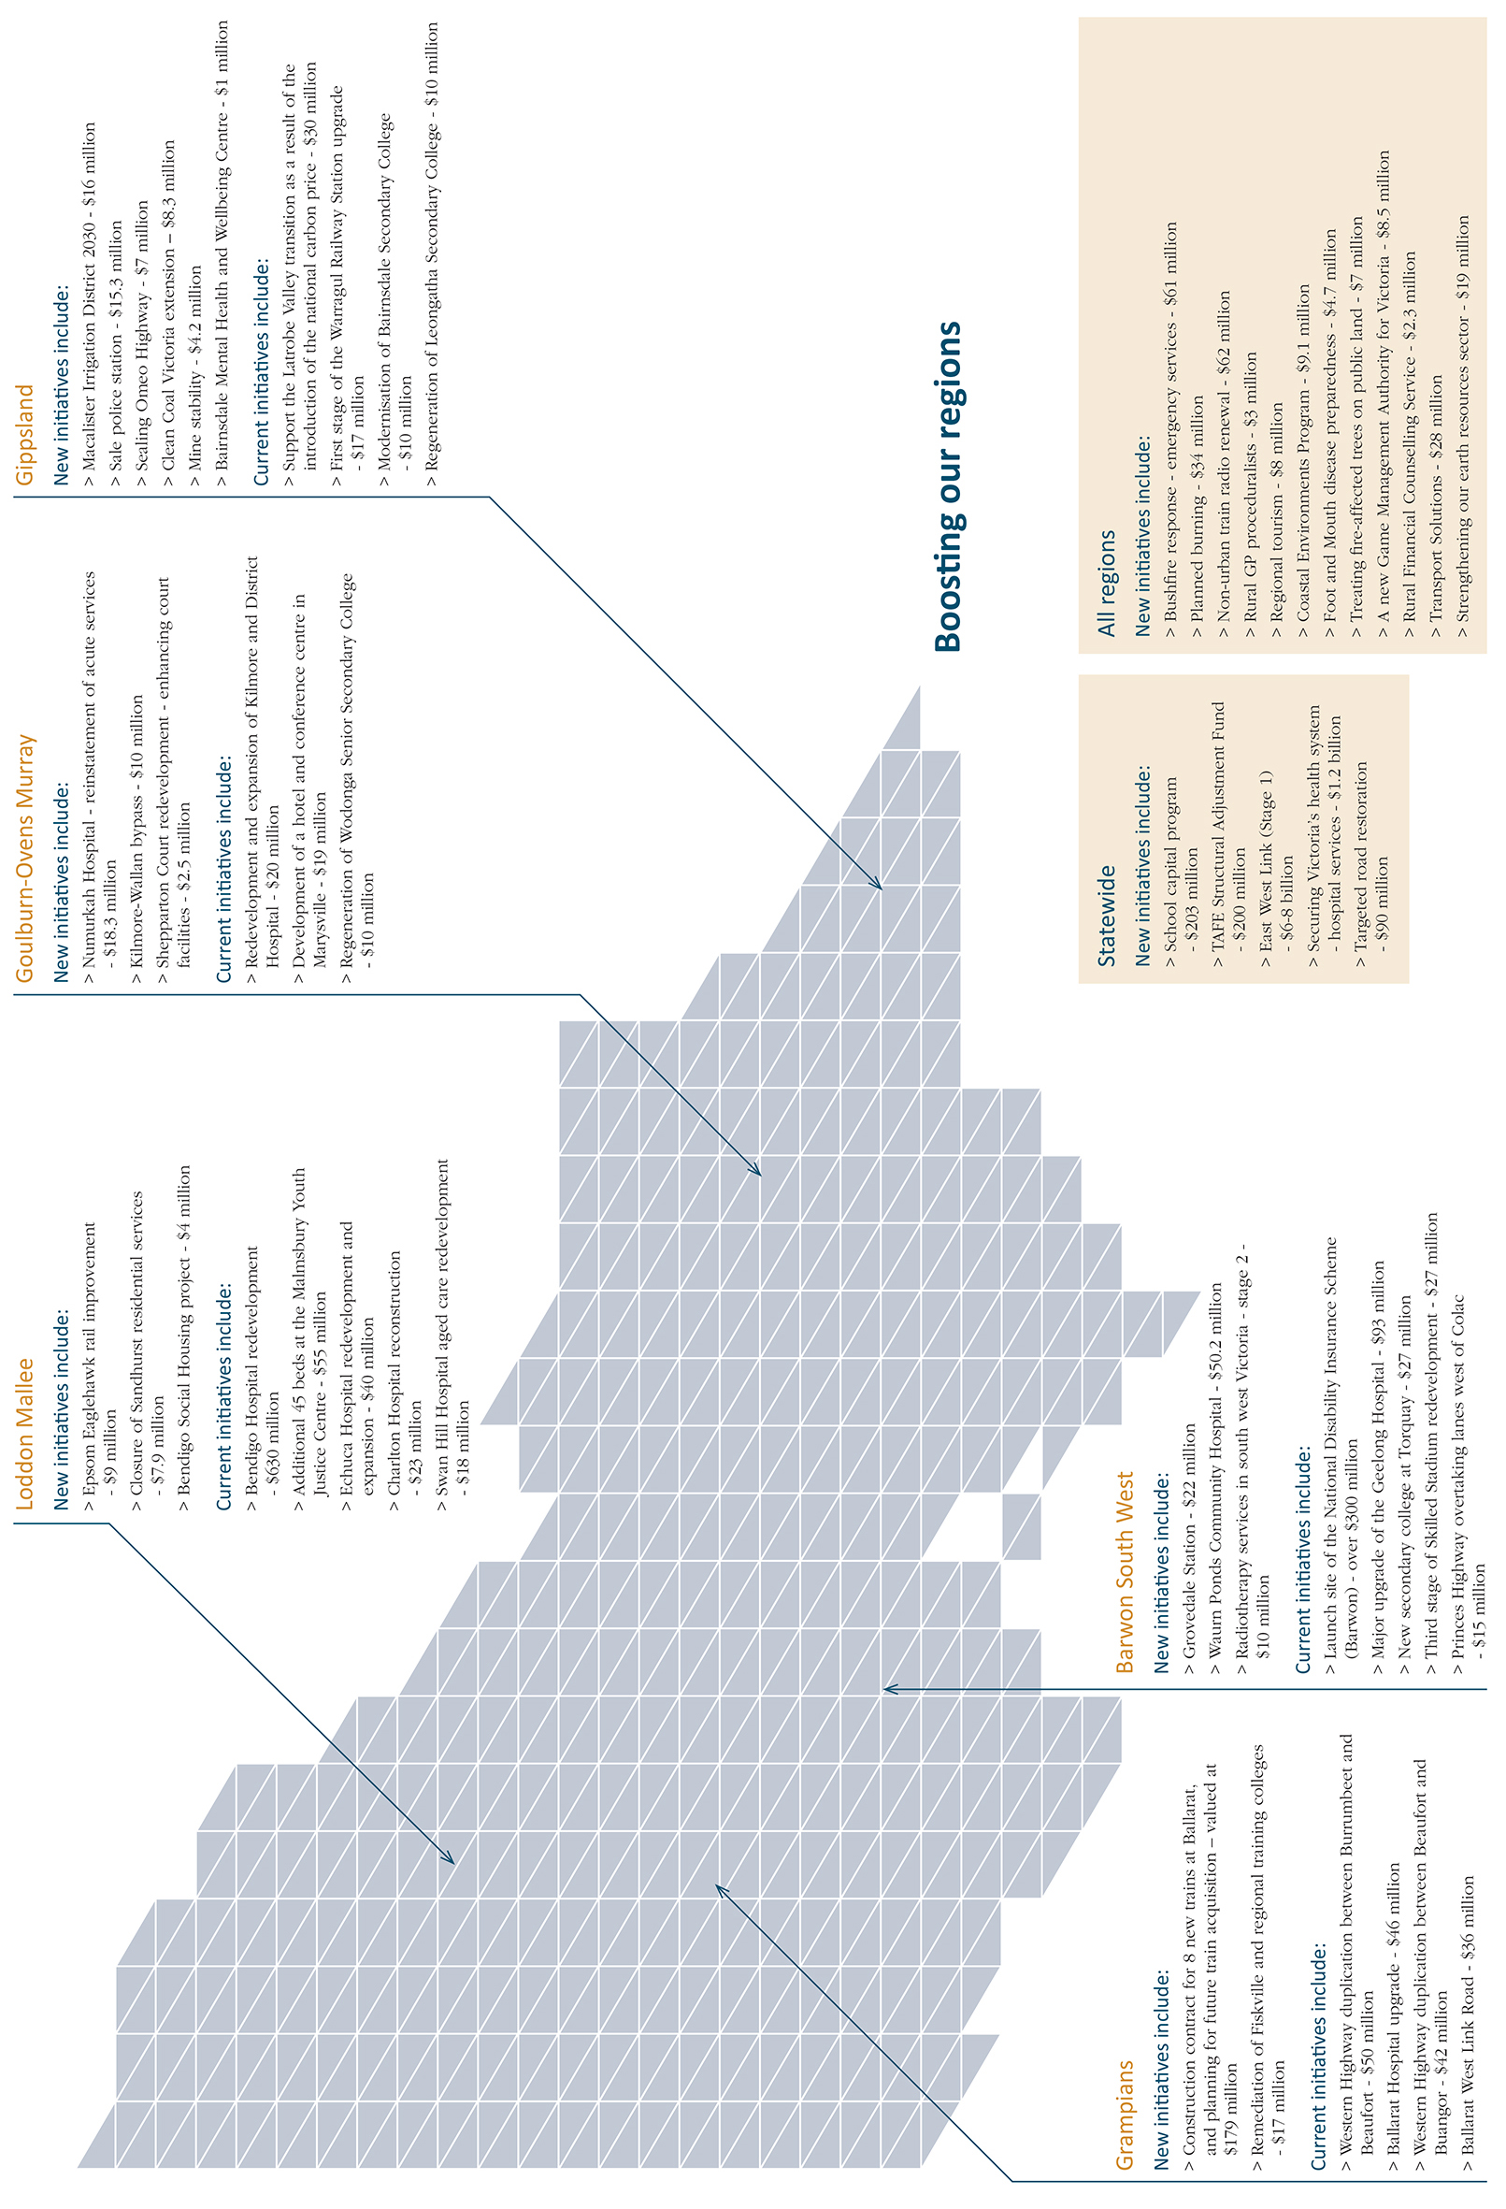

Key projects timeline – a snapshot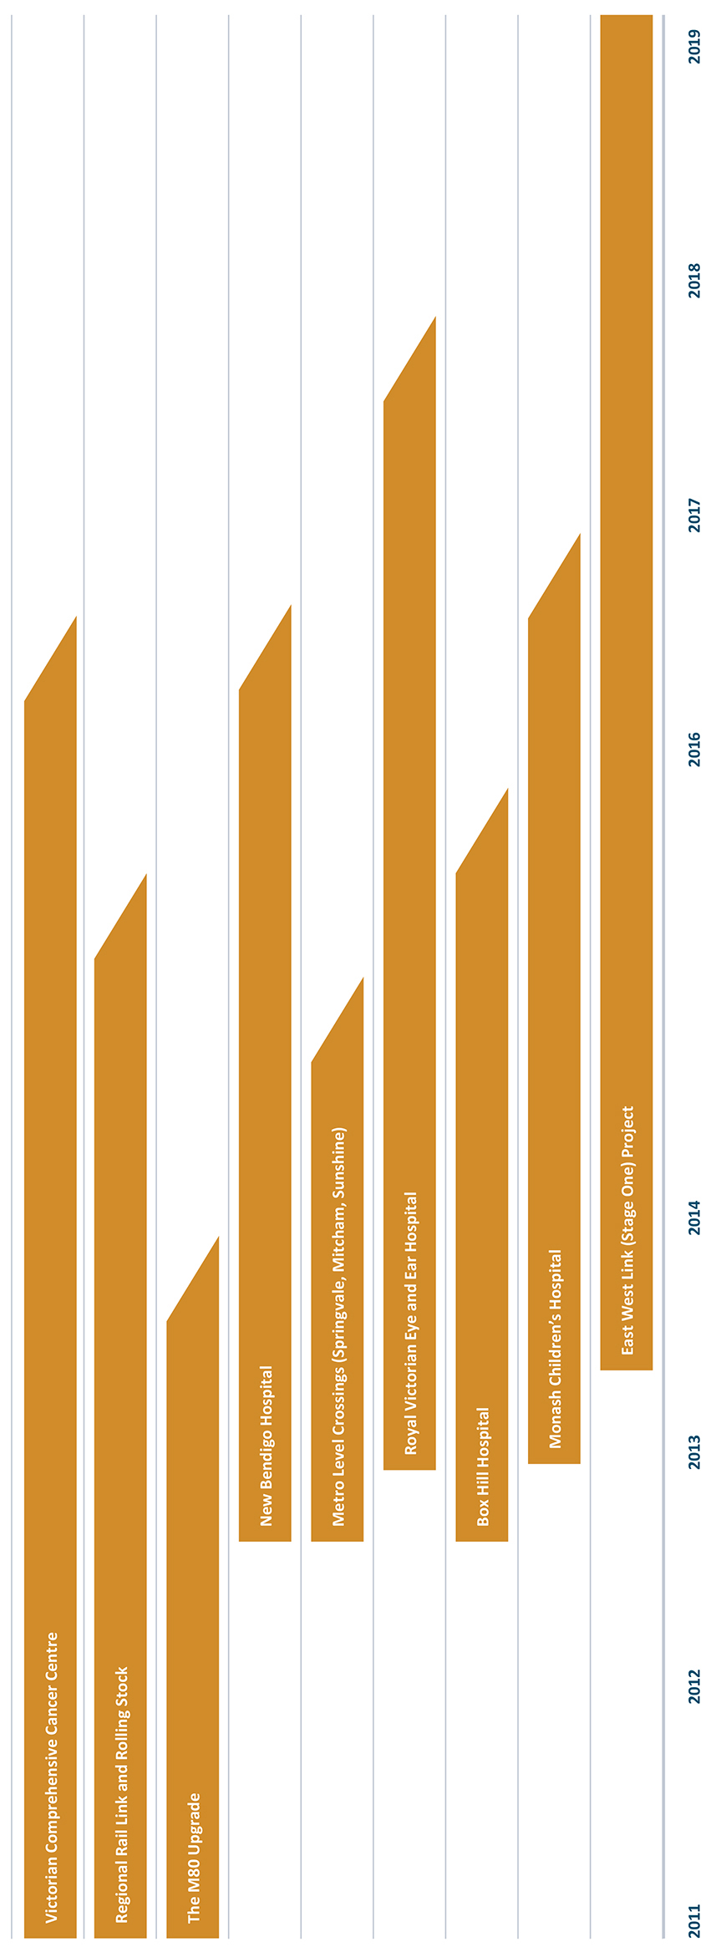

Boosting local communities

Celebrating our diverse community

Victoria’s rich multiculturalism
Rural and regional Victoria benefits from the rich and varied backgrounds of the people within its communities.
New funding
The Government will provide an extra $360 000 over two years to support the Victorian Multicultural Commission to deliver increased assistance for community strengthening initiatives that build the capacity of multicultural communities, with particular focus on culturally and linguistically diverse organisations in rural and regional Victoria.
Grants funding for peak multicultural organisations across Victoria will be increased by $1.5 million over two years to improve services for culturally and linguistically diverse Victorians, with a particular focus on rural ethnic and multicultural communities’ councils.
Current Government action
To support the work of the Centres for Multicultural Youth in regional areas, the Government has provided funding to support disadvantaged young people living in regional areas who are from culturally and linguistically diverse backgrounds to actively participate in their communities. The funding, provided for four years, includes the establishment of two regional Centres for Multicultural Youth and employment of two bicultural workers.
To support multicultural communities in regional Victoria, the Government has appointed five Regional Advisory Councils that include local residents, representatives from community organisations and multicultural service providers. The newly established Regional Advisory Councils better enable the Victorian Multicultural Commission to fulfil its role in regional Victoria. The Councils advise the Victorian Multicultural Commission on local issues, advocate on behalf of local communities and advise, consult and engage with culturally and linguistically diverse communities.

Supporting Aboriginal communities
Rural and regional Victoria is a particular focus for supporting Aboriginal communities.
New funding
Registered Aboriginal Parties (RAPs) and the Right People for Country project will receive continued support while a long-term framework is developed to enable RAPs to operate sustainably as part of the Government’s response to the Parliamentary Inquiry in the establishment and effectiveness of RAPs. RAPs play a critical role in managing Aboriginal cultural heritage on behalf of all Victorians, and where appointed, RAPs provided clarity to Government and landholders, thereby facilitating the development approval process.
The Government will provide $5 million to support first and second generation members of the Stolen Generations in identifying their heritage and addressing the ongoing effects of past policies.

A vibrant arts scene
The Victorian arts and cultural sector fosters vibrant communities and helps build a stronger economy with expanded opportunity. The Government recognises the importance of the arts sector as a major contributor to Victoria’s cultural exports, supporting artists and arts enterprises.
The 2013‑14 Budget provides an additional $29 million to support the arts sector.
The Government will invest $5.3 million to create a new grants program to support independent arts organisations across Victoria, including regional Victoria. The program will help organisations build leadership and be innovative in the ways they engage audiences.
Current Government action
The Government strongly supports the arts and cultural pursuits in rural and regional Victoria and the enormous value they bring to sustaining the social and economic viability of the regions.
The Government is providing $3.7 million to upgrade the Bendigo Art Gallery.

Protecting our community

A safer Victoria
The Government is supporting people living in regional and rural communities to feel safe in their homes, on the road, on public transport and in public spaces. The 2013‑14 Budget builds on steps already taken to ensure a safe and just community for all Victorians.
New funding
As part of the next stage of the Government’s election commitment to deliver new and upgraded police stations, $30 million will be allocated to enable the completion of new police stations in Sale and Somerville.
This budget allocates $28 million to replace mobile road safety cameras with new technology. This investment supports the implementation of Victoria’s Road Safety Strategy and will improve the detection of non‑compliant drivers, improving safety for all road users.

Upgrading and enhancing the courts
New funding
Community safety has been a top priority for the Government since taking office, and the 2013‑14 Budget builds on the steps already taken to ensure a safe and just community for all Victorians.
The Government is investing $9.4 million to upgrade Court IT infrastructure to improve performance and reliability, and undertake capital improvement works at the Shepparton Magistrates’ Court.
The Supporting Courts initiative will provide $48 million over the next four years to ensure that courts are appropriately resourced to address growing demand for their services. This builds on the $437 million of base funding provided for administration of the State’s judicial system.

Improving access to justice
New funding
The Government expects that all Victorians have appropriate access to justice and related support services. The 2013‑14 Budget addresses growing demand pressures in the victim support system by expanding services across the State. The Victims Helpline operating hours will be extended to include weekends, and additional case managers will be allocated to the Victims Support System.
The Government will provide further support for Victoria Legal Aid with additional funding of approximately $3.4 million per year to ensure Victorians most in need of legal advice can access these services. The budget initiative funds additional case work and duty lawyer services.

Addressing prison capacity
New funding
The 2013‑14 Budget provides funding of $131 million to strengthen Victoria’s corrections system by increasing capacity and to address growing demand pressure on prisons. This includes:
- an additional 357 prison beds to be provided across the male prison system; and
- a new 40-bed unit at Barwon Prison to manage increased numbers of high‑security prisoners. Other infrastructure upgrades at the Barwon Prison will provide for better management of high‑risk inmates.
Current Government action
The Government is investing $49 million for a program of capital works across the State to accommodate the additional 1 700 frontline police and 940 Protective Services Officers provided for in the 2011‑12 Budget.
Regional and rural Victoria is benefiting from the Government’s record investment of $602 million to fund 1 700 additional frontline police.
The four major regional centres of Ballarat, Geelong, Bendigo and Traralgon will also benefit from the Government’s $212 million investment to recruit and train 940 Victoria Police Protective Services Officers to patrol train stations after 6pm until the last train.
The Government has also invested $78 million towards police station upgrades including Ballarat, Mooroopna, Axedale, Paynesville, Waurn Ponds and Heywood, as well as land acquisition in Waurn Ponds and Sale.
The Government is investing $55 million for the creation of an additional 45 beds at the Malmsbury Youth Justice Centre to meet the medium to long‑term demands on Victoria’s youth justice system. The initiative will also support improvements to infrastructure at Malmsbury Youth Justice Centre.
To strengthen security systems at Barwon Prison, the Government has provided $1.3 million.

Sustaining support for vulnerable children
New funding
Protecting Victoria’s vulnerable children is a priority for the Government. The 2013‑14 Budget builds on the Government’s significant investments in the 2012‑13 Budget.
Funding of $91 million is provided for additional residential and home-based care placements along with financial assistance for education, medical and other client expenses. The therapeutic foster-care program will be expanded and the system’s capacity to respond to the needs of children with complex needs will be improved through additional flexible funds to tailor the assistance.
Current Government action
In response to the Protecting Victoria’s Vulnerable Children Inquiry, a package of initiatives totalling $336 million was funded in the 2012‑13 Budget including:
- $48 million for services in the early years. Funding will support and strengthen early home learning and parenting through preventive interventions including supported playgroups and parenting groups, and the Smalltalk literacy and learning program;
- $70 million to meet demand for residential care placement, and expand therapeutic residential care to provide an improved speciality response and greater placement stability;
- $52 million provided to expand the Child FIRST and Integrated Family Services programs to assist an additional 1 400 families across Victoria each year to better meet a range of parenting challenges; and
- $33 million to expand alternative dispute resolution programs to increase families’ involvement in decision making in child protection matters.

Helping those who are homeless or at risk of homelessness
New funding
The Government is providing $4 million contribution to build a 26‑unit medium‑density social housing project in Bendigo. Tenants will be assisted to build their skills to sustain a long‑term tenancy independently. This initiative will be undertaken in conjunction with a community housing association.
In addition the Government is continuing to provide assistance and support to vulnerable Victorians who are homeless or at risk of homelessness. Initiatives include:
- $19 million over five years to continue helping families who are homeless or at risk of homelessness to access affordable and appropriate accommodation;
- $7.5 million to fund a third youth foyer to provide medium‑term accommodation in a safe and supportive environment for up to two years to young people who are homeless or at risk of homelessness.
- Young people residing in the youth foyer will be provided with both onsite and community support to participate in education, employment and training, delivering on the Government’s election commitment to a youth foyer program; and
- $27 million in 2013‑14 to maintain support services for homeless Victorians as part of the National Partnership Agreement with the Commonwealth Government.
Natural disasters, such as devastating fire and floods, take a significant toll on rural and regional communities. The Government is continuing to invest to improve the State’s capacity to prepare for and respond to natural disasters across Victoria, and minimise the impacts on affected communities.
New funding
The level of planned burning will be increased to reduce the risk to bushfires communities. The $34 million allocated in this budget will enable the continued expansion of the planned burning program.
Completing the Government’s election commitment to build and upgrade 250 Country Fire Authority rural fire stations, the Government is investing $61 million in this budget to deliver the remaining 142 fire station replacements and upgrades over the next two years. This will enhance the capacity of emergency services infrastructure and assist the Country Fire Authority to respond to emergency events.
The Government is providing $17 million for further remediation work to be undertaken at the Country Fire Authority’s Fiskville State Training Facility to address occupational health and safety concerns and undertake environmental investigations.
The Government is providing $4.3 million over three years for the State’s contribution towards flood mitigation works. Additional works include development of the State Flood Management Strategy and commencing better flood information mapping for priority rural areas.
Current Government action
The Government’s $750 million Powerline Bushfire Safety program aims to reduce the risk of bushfires caused by electrical assets without causing significant impact on electricity supply reliability.
The program includes:
- changes to network operations to prevent bushfire starts at the times and locations of greatest risk, while minimising disruptions to customer supply;
- a Government contribution of up to $200 million over 10 years towards the replacement of the most dangerous power lines in the State that would otherwise not have been replaced;
- $40 million from Government to mitigate power reliability impacts on customers critically reliant on power through the Local Infrastructure Assistance Fund; and
- a Government contribution of $10 million to continue research and development to identify cost‑effective risk reduction technologies and procedures.
The Government has already invested heavily in measures to support community safety including:
- $38 million commitment in the Victorian State Emergency Service for volunteer support programs including 23 staff for volunteer support across Victoria, 10 additional staff to fill gaps in key incident management teams that provide warnings and information to communities, critical communication equipment and the purchase of command and control vehicles including a heavy rescue truck for Colac and six medium rescue trucks to Ballarat, Cobram, Marong, Foster, Bannockburn and Dartmoor;
- $9.5 million to Life Saving Victoria for clubhouse upgrades and lifesaver volunteer programs. Lifesaving clubhouses form a vital community hub for many Victorian towns and this funding has ensured Life Saving Victoria and its volunteers can continue the important role of protecting the lives of Victorian communities, especially in regional and rural areas; and
- $12 million has been allocated to 196 local volunteer emergency services groups through the Volunteer Emergency Services Equipment Program (VESEP), with the overall value of equipment purchased in excess of $16 million. VESEP provides local emergency services volunteer groups access to grants for operational equipment, vehicles, trucks, tankers, watercraft, trailers and minor facility improvements.
The Regional Growth Fund’s Putting Locals First Program has funded a $1.75 million recovery package for communities affected by the 2013 Alpine fires. Initiatives include:
- $1 million contribution towards a rail trail between Bright and Harrietville;
- $350 000 for the development of the all-season Dinner Plain Adventure Park;
- $300 000 for renovation works to the Centenary Park river front in Bright; and
- $30 000 to assist local grape growers to conduct critical smoke-taint testing.
Low-interest concessional loans have been made available to eligible small businesses, primary producers and not-for-profit organisations affected by the March 2013 events in regional Victoria. Loans of up to $200 000 will be made available in Golden Plains and South Gippsland for the March 2013 bushfires, and Alpine, Benalla, Greater Shepparton, Indigo, Moira, Strathbogie, Wangaratta and Wodonga for the tornadoes in March 2013.
The Government also made concessional loans available following the January 2013 Chemstowe‑Charngham and Aberfeldy‑Donnelly bushfires, and the June 2012 floods.
The Government has provided significant support to victims of the floods that occurred in 2010, 2011 and 2012. Beyond the initial disaster relief, the Government continues to deliver much‑needed recovery initiatives through:
- $2 million Flood Recovery Community Infrastructure Fund.
This initiative was established in response to the February, March and June 2012 flood events and is providing support to re‑establish and restore damaged community infrastructure such as recreation reserves, walking tracks and a range of local sporting facilities. Applications submitted to the Fund are currently under assessment;
- $5 million 2012 Flood Support Program.
Following the February and March 2012 extensive flooding across the North Central, North East, East Gippsland and Goulburn Broken regions. In June 2012 larger areas across Gippsland and Corangamite experienced significant rainfall.
Funding is allocated to Catchment Management Authorities in the affected areas to help deliver multiple outcomes that address environmental, economic and social issues currently facing flood-affected communities;
- $10 million Victorian Business Flood Recovery Fund.
Encouraging private sector investment and job creation to enhance economic development and recovery in flood-affected communities, the Victorian Business Flood Recovery Fund was extended to cover municipalities affected by the 2011 flood events; and
- $30 million Flood Recovery Community Infrastructure Fund.
In addition, the Government provided assistance following the floods of February and March 2012 through:
- grants of up to $25 000 for primary producers, small businesses and not for profit organisations in the areas of Greater Shepparton and Moira, who suffered direct damage, to fund clean-up activities, replacement of damaged equipment, stock and other general repairs. Assessment of other affected areas is ongoing; and
- low interest concessional loans of up to $200 000 for eligible primary producers, small businesses and not for profit organisations affected by the floods in Alpine, Ballarat, East Gippsland, Greater Bendigo, Greater Shepparton, Indigo, Macedon Ranges, Mildura, Moira, Mount Alexander, Strathbogie, Towong, Wangaratta and Wodonga local government areas.
In recognition of the continued need to provide specific ongoing assistance to individuals and communities affected by the 2009 Victorian bushfires, the Government established the Fire Recovery Unit in Regional Development Victoria.
The Fire Recovery Unit was established on 1 July 2011 to assist fire‑affected communities across Victoria by facilitating strong relationships and clear responses to identified community needs. New or extended programs provided by the Government in the last 12 months include:
- $5.2 million Marysville and Triangle Economic Recovery Package to support new investment in Marysville and surrounding communities;
- announcement that Melbourne Civic City Property, in partnership with Toga Pty Ltd and Metier3 Architects, will develop and operate a new $28 million hotel and conference centre in Marysville;
- Skills, Training, Engagement and Practical Support grants up to $30 000 for individual projects to promote community leadership, provide training and skill development, strengthen community networks and communications, or provide mentoring and practical human resources support;
- the Rebuilding Advisory Service to support households through the challenging task of rebuilding their homes; and
- completion of the Bushfire Buy‑back Scheme to support the voluntary acquisition of property destroyed by the 2009 bushfires determined to be of unacceptably high bushfire risk.

Emergency response and bushfire recovery

A fairer way to fund Victoria’s fire services
On 1 July 2013, the Coalition Government will introduce a fairer and more equitable property-based levy to replace the insurance‑based funding of fire services. The Metropolitan Fire and Emergency Services Board (MFB) and the Country Fire Authority (CFA) are currently funded by contributions made by the insurance industry, metropolitan councils and the State Government. Insurance companies pass the cost of their contributions on to policy holders through a fire services levy on insurance policies.
This significant reform is part of the Government’s commitment to implement the recommendations made by the 2009 Victorian Bushfires Royal Commission. The Commission found that the current system is flawed, unfair and needs reform, and recommended that the State replace the insurance-based levy with a property-based levy.
The new Fire Services Property Levy will ensure that all Victorian property owners pay a fair contribution to fire services and are not penalised for adequately insuring their property. The Fire Services Property Levy will also provide a concession for pensioners and Department of Veterans’ Affairs TPI Gold Card holders.
The Fire Services Property Levy will be charged to property owners through their council rates notices. The levy comprises a fixed charge of $100 for residential properties and $200 for non-residential properties, plus a variable component calculated on the capital improved value of the property. The levy rate for the variable component will differ depending on the property type and the location of the property. Property owners located in the Metropolitan Fire District will contribute to the funding of the MFB, and property owners located in an area serviced by the CFA will contribute to the funding of the CFA.
The 2012-13 financial year is the last year that the insurance industry will be required to contribute to the funding of Victoria’s fire services. The removal of the insurance-based fire services levy and associated goods and services tax and stamp duty will reduce the cost of insurance for all Victorians.
To ensure a smooth transition to the new property-based levy the Government has appointed Professor Allan Fels as the State’s Fire Services Levy Monitor.
The Office of the Fire Services Levy Monitor provides information to consumers and investigates complaints regarding the insurance-based levy not adequately resolved by insurance companies. It closely monitors the industry to make sure insurers genuinely pass on the abolition of the existing levy to policyholders.

Local Infrastructure Assistance Fund – Kilmore and District Hospital
The Local Infrastructure Assistance Fund is a $40 million program to deliver back-up power generators to residential care facilities where residents are critically reliant on continuous power for health and wellbeing.
The generator at Caladenia Nursing Home at the Kilmore and District hospital was the first to be installed under this program.
The generator has already played an important role, automatically providing backup power to residents in January this year when a fault at a substation caused a 24‑hour outage.

Victorian bushfires
Individuals and communities affected by the 2009 Victorian bushfires have shown remarkable resilience in their ability to recover. Homes have been rebuilt, public infrastructure has been reopened, and communities have been rejuvenated. A survey conducted in mid‑2012 showed that 87 per cent of the almost 1 600 households who lost their primary place of residence have rebuilt, purchased a new property or begun the process of rebuilding.
In 2012, the Victorian Government continued to deliver projects and support services funded by the Victorian Bushfire Appeal Fund to aid the medium and long‑term recovery of individuals and communities affected by the bushfires. The Government has committed to implementing all 67 recommendations of the 2009 Victorian Bushfires Royal Commission.
In October 2012, the Deputy Premier announced that Melbourne Civic City Property, in partnership with Toga Pty Ltd and Metier3 Architects, had been selected to develop and operate the new Vibe Hotel and Conference Centre in Marysville.
Representing a significant milestone in the continuing renewal of the Marysville area, the hotel and conference centre will include 100 guest rooms, conferencing facilities for 300 people, a cafe/restaurant, public bar, day spa and recreational facilities for hotel guests. Construction is scheduled to commence in the first half of 2013 and will create 85 new full‑time jobs over the construction phase. The facility will support up to 60 full‑time jobs in the community within five years of completion.

Open for business
The Government will provide $16 million to increase investment in Victoria, both locally and from outside the State. This will establish the Office of State Development, and enable the new organisation to identify and capture investment opportunities domestically and internationally.

Investing in food and fibre
Victorian food and fibre exports were worth almost $9 billion in 2011‑12, up 11 per cent on the previous year. Assisted by varied climatic conditions across its regions, the State has earned a strong international reputation for clean, green, high‑nutrition food and beverages, including dairy, meat, fruit, wine, cereal and confectionery. Up to 28 000 people are employed in food processing in regional Victoria, which is around 30 per cent of all regional manufacturing jobs.
The Government is investing in productivity-boosting initiatives that support the continued growth and prosperity of regional Victoria’s major industries, including agriculture, fisheries, natural resources and tourism.

Increasing productivity through our agriculture industry
New funding
Government funding of $16 million provided in the 2013‑14 Budget as part of the Macalister Irrigation District 2030 project will be matched by contributions from irrigators, to modernise on‑farm infrastructure, increase productivity, expand regional economic production and improve the health of the area’s waterways and estuaries.
Measures will be implemented to better prepare Victoria for outbreaks of foot‑and‑mouth disease. Funding of $4.7 million will be provided and will respond to a number of urgent issues raised in the Matthews Report, A review of Australia’s preparedness for the threat of foot-and-mouth- disease, including improving disease surveillance and detection, and goat and sheep traceability.
Current Government action
The $2 billion Northern Victoria Irrigation Renewal Project has been integrated into Goulburn‑Murray Water. The project is helping meet Victoria’s contribution to a future Murray‑Darling Basin Plan and deliver a world‑class irrigation system for northern Victoria’s food producers.
The Government’s $61 million Food and Fibre Strategy is the key project designed to strengthen the performance of the agricultural sector in Victoria by improving productivity and competitiveness. This Strategy is targeted to assist key industries to harness strong growth from Asia and demand for high quality agricultural goods.
To encourage innovation in the dairy industry the Government has allocated $14 million to provide targeted research and development to increase the rate of genetic improvement in dairy cattle, improve feed-conversion efficiency, and improve water‑use efficiency in dairy production systems.
Funding has also been provided to improve genetics, livestock fertility, weaner survival and the efficiency of feeding systems in the red meat industry. Funding of $9 million is being provided to the beef and lamb sectors to boost output and productivity growth in order to harness improved seasonal conditions and strong export demand.
The Government has provided $11 million to help ensure the long‑term success of the Victorian grain industry. The initiative will improve plant genetics, technologies and farm practices to increase the productivity, product resilience and flexibility of the industry as well as establish a National Genetics Resources Centre in Horsham.
Funding of $5 million has been provided to establish cooperatives to market high quality Victorian agricultural food and fibre products. This will help Victorian farmers access premium markets around the world. In addition, the provision of $2 million for the Farmers Market Support Program is supporting new and existing farmers markets and stallholders across Victoria.
The Government is investing $8.1 million in food and industry revitalisation in response to growing demand from Asia. This involves research and development spending on new orchard production systems for pears, stonefruit and almonds, and the development of new varieties. This program will also seek to achieve better market access in North and Southeast Asia.
Funding of $20 million has been allocated to address biosecurity threats and maintain market access. This will strengthen the protection of food and fibre producers from the threat of weeds, pest animals and diseases. This will involve wild dog management, weeds eradication, livestock disease surveillance, and forestry biosecurity.
The Government allocated $3.5 million to the Farm Debt Mediation scheme, where banks and other creditors must now offer to mediate with Victorian farmers before foreclosing on their debts.
To support young people in agricultural careers, farmers under age 35 are benefiting from a land transfer duty exemption scheme. The Government is also providing assistance to young farmers to purchase their first property by expanding a concessional loans scheme from $15 million to $23 million over five years.
Macalister Irrigation District
The Macalister Irrigation District is the largest irrigation district in the south of Victoria, generating significant economic benefits for the State, principally through dairy farming.
The Macalister Irrigation District 2030 project will increase on‑farm productivity, regional economic production, and waterway and estuarine health through the modernisation of the district. Key modernisation works include channel automation in the Southern ‑ Cowwarr region.
A more efficient irrigation district will enable improved productivity from existing land and support more land being brought into intensive agricultural production, thereby increasing the agricultural output for the district. The modernisation program will improve farm profitability and provide significantly improved customer service for irrigators in the district. The health of waterways in the region will be improved by reducing nutrients flowing into Gippsland rivers and the Gippsland Lakes.
The project will provide regional employment opportunities during construction and into the longer term to help offset forecast employment losses as Gippsland moves towards a carbon constrained future.

Fisheries and responsible game management
New funding
The Government recognises the enormous support game hunting provides to local economies in regional Victoria. The activity generates more than $70 million each year and supports jobs in hospitality, the supply of vehicles, boats, firearms and ammunition, plus camping and hunting equipment.
Funding of $8.5 million will be provided to establish an independent Game Management Authority to improve the effectiveness of game species management and administration, as well as the enforcement of game hunting and associated laws, and the promotion of responsible hunting.
Current Government action
The Government has provided $1 million for the construction of an offshore reef between Anglesea and Torquay. Fisheries Victoria will construct another eight recreational fishing reefs in Victorian waterways over the next two years, with locations such as Gippsland Lakes, Western Port and Port Phillip Bay being assessed. This is in addition to three already provided in Port Phillip Bay.
The Government’s $4 million bounty program has seen 133 000 fox scalps and 430 wild dog pelts handed in so far from rural areas.

Industry Support for Transition
The Government continues to encourage new industry investment in regional Victoria and has been directly assisting industries and employees transitioning as a result of a changing economy.
The $15 million Latrobe Valley Industry and Infrastructure Fund is assisting the Latrobe Valley to manage the challenge of structural adjustment and reposition its economy for sustainable long-term growth.
The Victorian Government is providing $15 million to support economic adjustment in the greater Geelong region. The area is currently facing structural pressures on key industries, including a high Australian dollar. The Government’s approach to support recognises the competitive advantages of the region and the potential for growth in existing businesses including high value-add and niche manufacturing.
The investment includes the $11 million Geelong Advancement Fund, which has been established to drive jobs growth, increase skills and innovation and deliver economic and community infrastructure in Geelong. Funding is available to support collaborative ventures with public and private sector, education and community organisations that will improve economic and liveability outcomes in Geelong.
The $4 million was provided to promote new investment and jobs for the Geelong region, and provides existing industry with support to develop new products and identify and capture new markets.

Promoting investment in our natural resources

Earth resources
Regional Victoria also supports significant mining activity, primarily centred on coal, oil and gas, gold and mineral sands. The image above illustrates where this mining is occurring in Victoria and the numerous regional towns that support this activity.
Mining contributes around 2 per cent ($6 billion) to Victoria’s economy and employs some 6 000 people across the state.
New funding
The 2013‑14 Budget provides $19 million over four years to attract new exploration, reduce barriers to investment and promote Victoria as an investment destination in the earth resources sector, generating employment and economic growth.
Brown coal is the State’s largest mineral endowment, with Victoria holding the second largest deposit in the world. Clean Coal Victoria will receive funding of $8.3 million allocated in the 2013‑14 Budget. This will allow Clean Coal Victoria to continue its work facilitating coal technology projects and coal allocation plans, which includes the provision of coal resource information to industry to assist investment attraction and deliver extensive stakeholder and community consultation to support investigation and development of Victoria’s coal resources.
Focusing on mine stability, particularly in response to the Hazelwood and Yallourn incidents, the Government is providing $4.2 million to address the highest priority and highest risk issues identified by the Technical Review Board, and increases the Government’s technical, support, data-gathering and response capabilities. This initiative aims to address at risk structures and improve capability, systems and processes to mitigate future risks.
Current Government action
The Government has provided an additional $41 million towards the Energy Technology Innovation Strategy to drive advances in low‑emission technologies.
The Victorian and Commonwealth Governments are partnering in the $90 million Advanced Lignite Development program. The program funds the development and deployment of emerging technologies to improve the economic recovery of brown coal and reduce emissions from coal-fired electricity generation.
Energy for the regions
The Energy for the Regions program is investing $100 million through the Regional Growth Fund to drive new investment in regional communities and new industry and business opportunities. The program fast-tracks delivery of natural gas to an initial 14 towns including Avoca, Lakes Entrance, Invermay, Winchelsea, Heathcote, Orbost, Warburton, Marong, Bannockburn, Terang, Maldon, Koo Wee Rup, Wandong-Heathcote Junction and Huntly, and incorporates a major upgrade of Mildura’s natural gas supply capacity.
The investment of $8.4 million in Avoca will mean more than 700 properties and businesses in Avoca will have access to cheaper, cleaner energy, with the potential to lower their energy costs.

Managing our parks and Crown land
New funding
The Government will provide $2.3 million in 2013‑14 to maintain services at River Red Gum Parks so that their landscape value is maintained and they continue to function as safe visitor sites.
The Government will provide $7 million over two years to remove trees destroyed by previous bushfires and help improve the safety for people who access public land. This program will focus on the Alpine and Mountain Ash forest areas in eastern Victoria.

Reducing red tape
New initiatives
The Government is reorganising the public service to ensure it better supports investment and jobs, delivers responsible financial management, and provides enhanced frontline services to all Victorians.
The changes will take effect from 1 July 2013 and contribute to a sharp focus of the public service on regional and rural Victorian business growth and issues.
This will be achieved by:
- incorporating land and water management with primary industries in the Department of Environment and Primary Industries (DEPI) to help boost the productivity of Victoria’s world-class food and fibre sector, while recognising the vital role played by land managers and Landcare groups in the protection of our environment and the management of our natural resources;
- bringing energy and resources functions into the new Department of State Development, Business and Innovation (DSDBI) to focus on major development opportunities, including Victoria’s coal resources;
- DSDBI will be bolstered through the inclusion of Red Tape Commissioner to help implement the Government’s regulation reform agenda; and
- integrating urban and transport planning with local infrastructure and services into the Department of Transport, Planning and Local Infrastructure (DTPLI) to support improved liveability and greater economic opportunities for regional and rural communities.
In response to the Victorian Competition and Efficiency Commission’s independent report, which recommended sensible and sensitive development in national parks, the Government has released guidelines for tourism investment opportunities in national parks. The guidelines for environmentally friendly and sustainable tourism in national parks will support and help grow the tourism sector and attract more international visitors to Victoria.
In April 2013, the Government released the finalised Point Nepean National Park Master Plan, and Sustainable Use and Tourism Framework confirming its support for appropriate investment in the park’s quarantine station precinct for its long-term future. This is a key step in securing private sector investment to help preserve this important part of our history, ensuring it is cared for and accessible to the Victorian public.
The Government will provide $16 million over two years to pilot a new approach to natural resource management, linking market-based approaches to new international standards for environmental accounting. The initiative aims to address critical threatened species, environmental assets and the decline in native vegetation and will use competitive market processes to ensure value for money environmental objectives are achieved.
Current Government action
The review is underway of Victoria’s native vegetation permitted-clearing regulations and the Government has identified opportunities where the current permitted-clearing policy settings can be improved to strengthen this system and deliver better outcomes for the environment and community. This regulatory reform will mean less red tape, more transparent decision making and increased certainty for landholders. Most importantly, it will mean stronger environmental outcomes.

Boosting regional tourism, sport and racing
New funding
The 2013‑14 Budget allocates $8 million over four years to support the regional tourism industry. Additionally funding of $8 million will implement the China Tourism Strategy, which aims to increase the number of international visitors to Victoria from China. This investment will help increase the number of visitors to regional Victoria, and raise awareness of Victoria’s attractive regional destinations and experiences.
Current Government action
The Racing Industry Development Fund supports the implementation of a number of initiatives including the improvement of racing and training infrastructure at racetracks, providing support for breeding industries, and for the promotion of thoroughbred, harness and greyhound racing and measures to increase on-course attendance.
$13 million has been provided to raise awareness of regional Victorian destinations, experiences and products in key interstate markets and to support growth of travel to regional Victoria through a regional events program.
Through partnerships with regional councils and sporting organisations, the Government helped secure the Davis Cup tie in Geelong and Australia’s first-ever world‑ranking snooker event in Bendigo.
The Government is strengthening Victoria’s iconic regional events, providing $600 000 to secure the future of the historic Stawell Gift, one of the world’s most prestigious footraces, and $200 000 towards the Melbourne to Warrnambool Cycling Classic.
The Government is supporting sporting and recreational opportunities in regional and rural communities. The Community Facility Funding Program makes grants available to local councils and community organisations to help fund planning and building of community infrastructure. In 2011, the Government increased the maximum grants limit for all grant categories and communities such as Colac have benefitted, with a grant of $650 000 for a fitness centre and stadium redevelopment. Other beneficiaries include the Tallangatta multi‑sporting precinct with $400 000, Katamatite sports centre and community hub with $500 000 and $100 000 for the Shepparton sports precinct development.
In addition, $27 million is being provided to support the third stage of the redevelopment of the Geelong Football Club’s stadium at Kardinia Park.
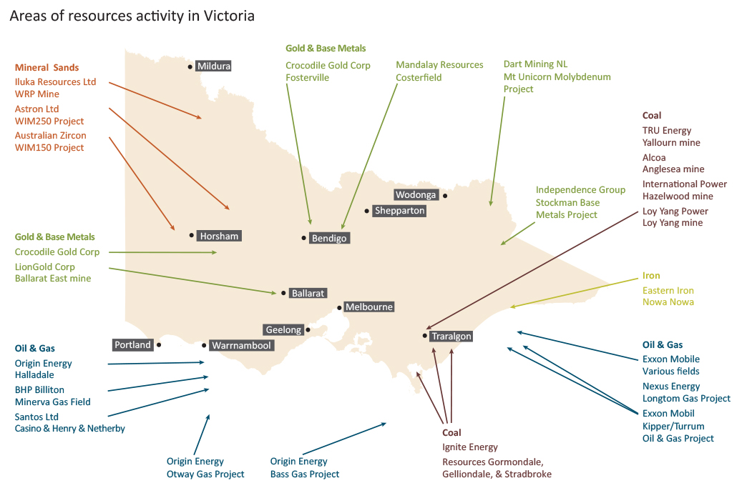

Initiatives by region

Barwon South West
Barwon South West region includes:
- Colac Otway Shire
- Corangamite Shire
- Glenelg Shire
- City of Greater Geelong
- Moyne Shire
- Borough of Queenscliffe
- Southern Grampians Shire
- Surf Coast Shire
- Warrnambool City
The Government has been delivering a number of key projects in the Barwon South West region including:
- funding of over $300 million for the launch site of the National Disability Insurance Scheme in the Barwon area;
- funding of $93 million to a major upgrade of the Geelong Hospital;
- funding of $5 million to develop a radiotherapy service for South West Victoria in Warrnambool;
- funding of $8.3 million for regeneration of Northern Bay College;
- funding of $2.5 million for modernisation of Woolsthorpe Primary School;
- funding of $5.1 million for planning the Lara to Avalon Airport Rail Link;
- funding of $2 million for renewal of the Geelong Performing Arts Centre
- a new police station at Waurn Ponds;
- funding of $27 million for a new secondary college at Torquay;
- funding of $27 million for the third stage of the redevelopment of Simonds Stadium;
- funding of $8.3 million to support the upgrade of the Geelong Hospital;
- funding of $11 million to support the regeneration of Colac Secondary College;
- funding of $10 million for the improvement of the Warrnambool to Geelong rail link;
- funding of $5 million to begin work on Princes Highway West between Colac and Winchelsea;
- funding of $3 million for the Geelong Ring Road Noise Walls initiative;
- funding of $2 million for planned upgrades at the Geelong Campus of the Gordon Institute of TAFE; and
- the opening of the new Geelong SES headquarters.
Through the 2013‑14 Budget, the Government is implementing the following initiatives for the Barwon South West region:
- funding of $22 million to build and operate the new train station at Grovedale;
- further funding of $50 million for the Waurn Ponds Community Hospital;
- funding of $10 million for radiotherapy services in South West Victoria; and
- investigating the viability of rail services between South Geelong to Drysdale and Grovedale to Torquay.

Gippsland
Gippsland region includes:
- Bass Coast Shire
- Baw Baw Shire
- East Gippsland Shire
- Latrobe City
- South Gippsland Shire
- Wellington Shire
The Government has been delivering a number of key projects in the Gippsland region including:
- funding of $10 million for modernisation of Bairnsdale Secondary College;
- funding of $7.5 million for modernisation of Mirboo North Secondary College;
- funding for overtaking lanes on the Strzelecki and Hyland Highways;
- a new Multi‑Disciplinary Centre for the Latrobe Valley to improve responses to sexual assault;
- the provision of extra early childhood development workers;
- funding of $30 million to support the Latrobe Valley transition to a more diversified economy to meet the challenges brought about by the introduction of the Commonwealth Government’s national carbon price;
- funding of $8 million for the first stage of sealing the Omeo Highway;
- funding of $6 million for repair of the road to Tidal River;
- the establishment of 800 new weekly bus services in the Latrobe Valley;
- the establishment of the Gippsland Lakes Ministerial Advisory Committee with funding of $10 million over four years for environmental projects;
- funding of $2 million towards the Great Southern Rail Trail extension;
- funding of $10 million for regeneration of Leongatha Secondary College;
- funding of $3 million for modernisation of Toorloo Arm Primary School;
- investigating the potential for carbon capture storage in the Latrobe Valley;
- funding of $2 million towards the Warragul Hospital emergency department upgrade;
- funding of $1.5 million to upgrade the East Gippsland Institute of TAFE;
- funding of $1.1 million towards the enhancement of Wonthaggi town entrance;
- funding of $1 million to complete stage 1 of the Lindenow Valley Water Security project;
- funding of $1 million to connect Alberton to a pressured sewerage system;
- a new 24‑hour staffed ambulance station for Grantville; and
- additional funding for economic infrastructure and community initiatives through the Regional Growth Fund.
Through the 2013‑14 Budget, the Government is implementing the following initiatives for the Gippsland region:
- funding of $16 million for Macalister Irrigation District upgrades;
- funding of $110 million for the Port of Hastings development;
- funding of $15 million for the Sale police station;
- funding of $7 million to complete sealing of the Omeo Highway;
- funding of $8.3 million for Clean Coal Victoria;
- funding of $4.2 million for mine stability;
- funding new mental health beds in Latrobe Regional Hospital (Traralgon); and
- funding for a enhanced Mental Health and Wellbeing Services in Bairnsdale, which will coordinate access to mental health, welfare and social services in East Gippsland.

Grampians
Grampians region includes:
- Ararat Rural City
- City of Ballarat
- Golden Plains Shire
- Hepburn Shire
- Hindmarsh Shire
- Horsham Rural City
- Moorabool Shire
- Northern Grampians
- Pyrenees Shire
- West Wimmera Shire
- Yarriambiack Shire
The Government has been delivering a number of key projects in the Grampians region including:
- funding of $42 million to duplicate approximately 18 kilometre of the Western Highway between Beaufort and Buangor;
- funding of $36 million for the Ballarat West Link Road;
- funding of $46 million for an upgrade of the Ballarat Hospital;
- funding of $10 million for modernisation of Pheonix Community College;
- provision of extra early childhood development workers;
- funding of $1 million to return the health of the Yarrowee River;
- funding of $73 million for additional health services in Ballarat, including support for the recruitment of 10 general practitioners to fill vacancies in the Ballarat area and an additional 20 doctors and 80 nurses at Ballarat Base Hospital;
- funding of $50 million to duplicate the Western Highway between Burrumbeet and Beaufort;
- funding of $4.5 million for the Ballarat‑Buninyong Road upgrade;
- funding of $2.5 million for planning of the Ballarat Western Link Rd;
- funding of $1.6 million to provide an additional 68 services each week to and from Wendouree train station;
- funding of $1.2 million towards the replacement of the Magpie Bridge in Ballarat;
- funding of $3.4 million to establish a national grains genebank in Horsham;
- funding of $7 million for regeneration of Horsham Special School;
- funding of $2 million towards redevelopment of the Ballan Hospital;
- funding of $1.8 million over two years for the refurbishment and expansion of Ballarat District Nursing and Healthcare facilities;
- a new 24‑hour staffed ambulance station for Beaufort; and
- additional funding for economic infrastructure and community initiatives through the Regional Growth Fund.
Through the 2013‑14 Budget, the Government is implementing the following initiatives for the Grampians region:
- funding of $179 million for eight new trains to be fitted out in Ballarat and planning for future train acquisitions; and
- funding of $17 million for the remediation of Fiskville and regional training colleges.

Goulburn-Ovens Murray
Goulburn-Ovens Murray region includes:
- Alpine Shire
- Benalla Rural City
- City of Wodonga
- Greater Shepparton City
- Indigo Shire
- Mansfield Shire
- Mitchell Shire
- Moira Shire
- Murrindindi Shire
- Strathbogie Shire
- Towong Shire
- Wangaratta Rural City
The Government has been delivering a number of key projects in the Goulburn-Ovens Murray region including:
- delivering the $2 billion Goulburn‑Murray Water Connections Project;
- funding of $20 million to redevelop and expand the Kilmore and District Hospital;
- funding of $10 million for regeneration of Wodonga Senior Secondary College;
- funding of $6 million for modernisation of Belvoir Wodonga Special Development School;
- funding of $2 million to develop chemotherapy services at Seymour District Memorial Hospital;
- funding of $6 million for rest area upgrades from the Hume Highway;
- funding of $7 million for regeneration of Seymour College;
- funding of $5.2 million to support economic recovery in Marysville and surrounding communities;
- funding of up to $19 million towards the development of a hotel and conference centre in Marysville;
- funding of $2.1 million towards redevelopment of the Indigo Shire Civic Centres;
- funding of $2.2 million toward a new wastewater management system at Bruck Textiles plant in Wangaratta;
- funding of $3.4 million to start work on the Kilmore‑Wallan Bypass;
- funding of $1 million to connect Moyhu to a sewerage system;
- a new 24‑hour staffed ambulance station for Wallan; and
- additional funding for economic infrastructure and community initiatives through the Regional Growth Fund.
Through the 2013‑14 Budget, the Government is implementing the following initiatives for the Goulburn‑Ovens Murray region:
- funding of $18 million for the Numurkah Hospital;
- funding of $10 million for the Kilmore-Wallan Bypass; and
- funding of $2.5 million for the Shepparton Court redevelopment.

Loddon Mallee
Loddon Mallee region includes:
- Buloke Shire
- Campaspe Shire
- Central Goldfields Shire
- City of Greater Bendigo
- Gannawarra Shire
- Loddon Shire
- Macedon Ranges Shire
- Mildura Rural City
- Mount Alexander Shire
- Swan Hill Rural City
The Government has been delivering a number of key projects in the Loddon Mallee region including:
- funding of $55 million to create an additional 45 beds at the Malmsbury Youth Justice Centre;
- funding of $23 million to reconstruct the Charlton Hospital;
- funding of $10 million to upgrade the Castlemaine Hospital;
- funding of $18 million to redevelop the Swan Hill Hospital aged care facilities;
- funding of $7 million for modernisation of Castlemaine Secondary College;
- funding of $5 million for regeneration of Golden Square Primary School;
- funding of $5 million for regeneration of Ouyen College;
- a new multi‑disciplinary centre for Bendigo to improve responses to sexual assault;
- the provision of extra early childhood development workers;
- funding of $40 million towards the Echuca Hospital redevelopment and expansion;
- funding of $18 million towards the Kerang District Hospital residential aged care redevelopment;
- funding of $5 million is being provided for the Mildura Base Hospital expansion;
- funding of $5.2 million for two rural overtaking lanes for the Melbourne‑Lancefield Road;
- delivering the $2 billion Goulburn‑Murray Water Connections Project;
- provided broad support for flood affected communities including $18 million for a Lower Loddon Irrigators Recovery package, and $5.1 million for Lower Loddon floodplain and groundwater bore works;
- funding of $2.8 million for the upgrade of the Talbot train station;
- funding of $2 million towards redevelopment of the Bendigo Library and Community Hub;
- funding of $7 million towards the Mildura Riverfront Development project;
- funding of $5.2 million towards the upgrade of the Mildura Airport Terminal;
- funding of $4 million over four years to establish a Centre of Expertise in Smoke Taint in Mildura;
- funding of $2 million for infrastructure works at Hazeldene’s Lockwood site;
- funding of $2 million for the refurbishment of Eaglehawk Primary School;
- funding of $1 million for a new water treatment plant at Wycheproof;
- upgrade of the Maryborough and Castlemaine ambulance stations to 24‑hour rostered coverage; and
- additional funding for economic infrastructure and community initiatives through the Regional Growth Fund.
Through the 2013‑14 Budget, the Government is implementing the following initiatives for the Loddon Mallee region:
- $630 million new Bendigo Hospital, the largest regional health project in Australia.
- funding of $9 million for the new train station at Epsom;
- funding of $7.9 million for the Redevelopment of Sandhurst residential services; and
- funding of $4 million for the 26‑unit medium-density social housing project in Bendigo.

