AMAF Guidance note – Intangible assets

Contents
1. Introduction 2
2. What are intangible assets? 2
2.1 Identifying and classifying intangible assets 2
2.2 Definition of an intangible asset 3
2.3 Recognition criteria 3
2.4 Categories and examples of intangible assets 4
3. Items not recognised as intangible assets 5
4. How the AMAF applies to intangible assets 5
4.1 AMAF and intangible assets – key guidance notes 5
4.2 Applying the AMAF to intangible assets 6
4.3 How to develop an Asset Management Plan for intangible assets 7
4.4 Management of other intangibles that do not qualify as assets 8
4.5 Implementing the Asset Management Plan for Intangible Assets 9
Appendix – AASB 138 Intangible assets 10
AASB 138 10

    - Introduction
This guidance outlines an approach to including intangible assets in your organisation’s Asset Management Framework to meet the requirements of the Asset Management Accountability Framework (AMAF).
The AMAF sets out the Victorian Government’s asset management requirements. It details mandatory requirements including developing asset management strategies, governance frameworks, performance standards and processes to regularly monitor and improve asset management.
The AMAF applies to non-current physical and intangible assets, including ICT assets, controlled by public sector bodies. This means, the AMAF should be applied to intangible assets much like it would be applied to tangible assets.
This guidance is based on the premise that the organisation’s intangible assets have already been identified, included on an asset register and reported on the balance sheet. However, it is important for the asset manager to understand how and why such assets come into being. The asset manager is not expected to duplicate the work already undertaken by their financial department.
Asset Managers are also encouraged to encouraged to identify and apply the AMAF to ‘items’ that are important to the entity but do not meet all of the accounting requirements that classify them as intangible assets.
This guidance contains:
- Section 2: how intangible assets can be identified.
- Section 3: other items which do not qualify as intangible assets but which could be incorporated into an organisation’s asset management framework.
- Section 4: an approach to including intangible assets and other items into asset management systems and process developed to meet AMAF requirements.
This guidance is not compulsory. It is expected to be of greatest assistance to those who are uncertain of where to begin.
    - What are intangible assets?
Intangible assets are identifiable non-monetary assets without physical substance. They are generally long-term resources of an organisation and derive their value from an organisation.
      - Identifying and classifying intangible assets
Intangible assets need to be identified to be included in an organisation’s asset management framework. Asset managers should consult with their finance teams in this process.
All intangible assets which are included on the entity’s balance sheet must also be included in the asset management systems and processes or framework. Australian Accounting Standards describe such assets as meeting:
- the definition of an intangible asset; and
- the recognition criteria of an intangible asset.
It should be noted that an organisation may determine that they do not have any items which qualify as intangible assets that require management in accordance with the requirements of the AMAF. However, this guidance suggests that where an item meets one but not both of the accounting requirements for recognition on the balance sheet, it may still be beneficial to the entity to incorporate it into the organisation’s asset management framework.
The definition and recognition criteria are discussed in more detail below.
      - Definition of an intangible asset
Under Australian Accounting Standard AASB 138 Intangible Assets, five principles are applied as the first step in evaluating whether or not an item qualifies as an intangible asset.

Appendix 1 includes more information on AASB 138 including further detail on the five principles used to determine if an item satisfies the necessary requirements to be classified as an intangible asset.
      - Recognition criteria
In addition to meeting the definition of an intangible asset (above), an item also needs to meet the recognition criteria (below) before it can be identified as an intangible asset. If it passes both tests it is reported in the financial statements and is therefore required to be managed under the AMAF.
Under the recognition criteria, an intangible asset is recognised if:
- it is probable that the expected future economic benefits that are attributable to the asset will flow to the entity; and
- the cost of the asset can be measured reliably.
An organisation would need to measure the probability of expected future economic benefits using reasonable and supportable assumptions that represent management’s best estimate of the set of economic conditions that will exist over the useful life of the asset.
When assessing whether or not the cost of the asset can be reliably measured, this requirement applies to costs incurred initially to acquire or internally generate an intangible asset and those incurred subsequently to add to, replace part of, or service it.
Appendix 1 includes more information on the process of determining if an item should be recognised as an intangible asset or not. Guidance is also provided on how an asset manager might identify and manage non-tangible items which may have a benefit to the agency but which did not fully meet the accounting requirements for recognition as intangible assets.
This guidance is provided so that Asset managers can better understand the process of asset identification and recognition. To better understand the application of the accounting standards in defining and recognising such assets on the balance sheet, it is strongly recommended that asset managers seek advice from their finance department on the assessment process which was used in determining their intangible assets.
For further information, asset managers could also refer to CPA Australia’s “IAS 38 Intangible Assets Fact Sheet”. Note that AASB 138, mentioned previously, is the Australian application of the International Standard IASB 38 in the link below:
https://www.cpaaustralia.com.au/~/media/corporate/allfiles/document/professional-resources/reporting/reporting-ifrsfactsheet-intangible-assets.pdf?la=en
Please note that Accounting Standards are subject to change.
      - Categories and examples of intangible assets
Below are five categories that help to identify items within the organisation as intangible assets.
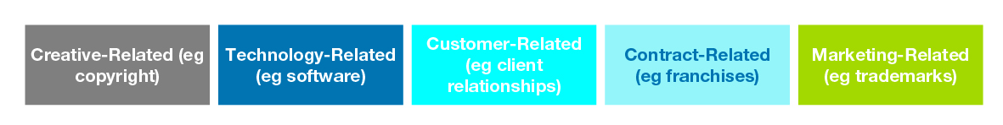
Creative-related intangible assets include items such as copyrights, which protect ownership rights of creative material for the organisation or government. Examples include: performance events, literary works, musical works, pictures, motion pictures and television programs.
Technology-related intangible assets include items such as patents and software. Examples include: patented technology, computer software and trade secrets (such as secret formulas and recipes).
Customer-related intangible assets include customer-related information and data. Examples include: customer lists, order backlog and customer relationships.
Contract-related intangible assets include items in the form of franchise agreements, licenses, and permits. Licenses and permits come into play when a government organisation grants a private company operating rights, such as the use of city streets or designated areas for taxicab stands. Examples include: licensing agreements, service contracts, lease agreements, franchise agreements, broadcast rights, employment contracts and use rights (such as drilling rights or water rights).
Marketing-related intangible assets help promote the company’s goods or services. These assets are unique signs, symbols, or names the organisation uses to create a brand or unique image. Examples include: trademarks, newspaper mastheads, internet domain names and noncompetition agreements.
Information and data could potentially be classified as intangible assets within any of the five categories above.
N.B. An item must meet both the definition of an intangible asset and the recognition criteria before it would constitute a recognised intangible asset that must be managed within the organisation’s asset management framework. It is possible for an organisation to identify an item using the guidance above which meets the definition of an intangible asset, but which does not meet the required recognition criteria.
    - Items not recognised as intangible assets
The AMAF applies equally to intangible assets and tangible assets (i.e. land, buildings, infrastructure, plant and equipment). However, intangibles are often not highly visible assets from a balance sheet perspective but never-the-less can be integral to an organisation’s service delivery.
There may be other items, such as information, that do not meet the accounting definition or recognition criteria of an asset but could still be included into an organisation’s asset management framework on the basis that they are often critical items that if lost would disrupt the service delivery of the organisation.
N.B the “IAS 38 Intangible Assets Fact Sheet“ issued by the CPA Australia, equally applicable in the Australian context, specifically prohibits the following internally generated intangibles from being recognised as assets:
- Goodwill;
- Brands;
- Mastheads;
- publishing titles;
- customer lists;
- item similar in substance that cannot be distinguished from the cost of developing the business as a whole; and,
- intangible assets arising from research (or from the research phase of an internal project).
For example:
A higher education facility develops a reputation for service standard excellence and this standard resonates with the general public when represented by the organisations brand. While this brand satisfies the definition requirements of an internally generated intangible asset, it does not satisfy the recognition criteria. Therefore the requirements of the AMAF would not apply.
    - How the AMAF applies to intangible assets
      - AMAF and intangible assets – key guidance notes
To be included as an intangible asset within the organisation’s Asset Management Framework, it must meet the definition criteria of an intangible assets as well as the recognition criteria of an intangible asset.
An item can meet the definition criteria of an intangible asset but not meet the recognition criteria. In this case, the requirements of AMAF do not strictly apply.
However, for items which meet the definition but do not meet the recognition criteria (point 2 above), the asset manager should still assess the underlying benefit of the item to the organisation and determine whether or not it could still be incorporated within the AMAF anyway.
      - Applying the AMAF to intangible assets
Assets exist within organisations to provide value, generally in the form of financial or service outcomes. To protect these assets, and the value they provide, organisations typically develop management plans to guide the lifecycle management of that asset. This is usually called an Asset Management Plan and is developed to ensure the actions to manage the asset over its lifecycle, align with and support the stated service delivery objectives of the organisation.
Organisations can manage their intangible assets in accordance with the AMAF by developing and implementing Asset Management Plans that include intangible assets using the information described in the “AMAF Implementation Guidance March 2017”. An Asset Management Plan for an intangible asset is developed and implemented in the same way that you would do so for the organisation’s tangible assets.
Asset Management Plans interpret the service delivery objectives of the organisation and translate them into actions that guide the management practices of the asset to achieve these business goals over the asset’s lifecycle.
It is important to note that there is a logical order in the development of key asset management documentation. It is vital that this development and linkage of parent / child documents occurs in the correct manner in order to ensure that the “line of sight” between organisational business goals and the management activities on the ground is established. The intent is to develop processes that allow the organisation to implement actions that align with, and deliver, the aims of the organisation. Therefore, the AMPs must refer to and align with the organisations Asset Management Strategy Part A (AM policy) and Part B (SAMP) to ensure they are developing management plans that achieve the stated objectives of the organisation.
For example:
One of Vic Police’s publicised values under the heading of integrity states their management practices will “maintain confidentiality and respect those we deal with.” While this would take many forms, one of these would be the requirement to develop appropriate data systems with the necessary security protection to ensure sensitive information cannot be accessed without proper authorisation. If the organisation developed a specific software solution for this requirement, the new software could be an intangible asset.
Within the Asset Management Strategy Part A, Vic Police would translate that stated value into a commitment to supporting this value by acquiring or developing appropriate technology solutions.
Within the Asset Management Strategy Part B, Vic Police could detail the strategies that should be implemented in order to meet the commitment stated within Part A.
These strategies would then inform the development of detailed business requirements within an Asset Information Strategy whereby the standards for higher level data integrity and security would inform the development of any information software solution. This “line of sight” from organisational values to the development of software solutions ensures that ALL organisational requirements are incorporated into the development of fit for purpose software.
The flow chart below demonstrates the structured link between the organisation’s service delivery objectives and the activities that the organisation performs in order to manage its assets to meet those organisational goals.
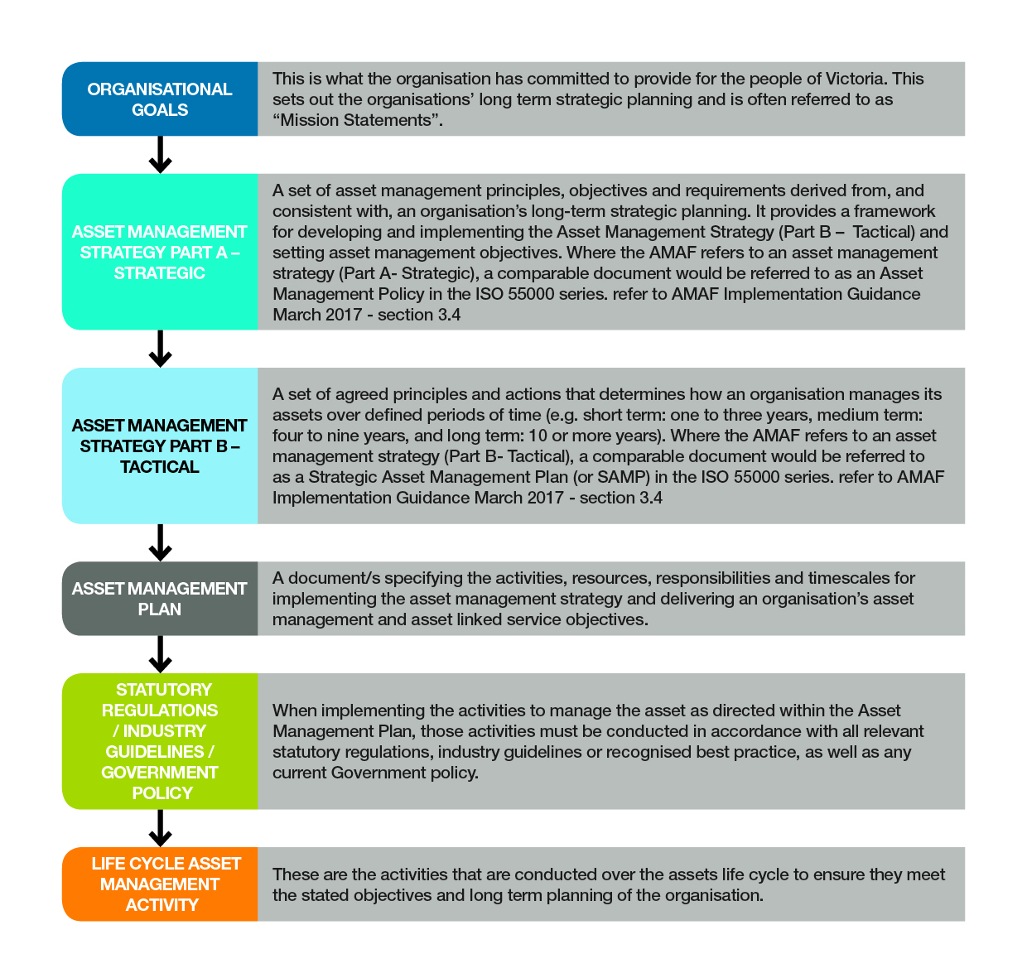
For further guidance refer to the Victorian Governments AMAF Implementation Guidance document located at
https://www.dtf.vic.gov.au/infrastructure-investment/asset-management-accountability-framework
      - How to develop an Asset Management Plan for intangible assets
The AMP should follow the format shown in “Appendix B – Typical Content of an Asset Management Plan” within the AMAF Implementation Guidance March 2017:
Intent: The Asset Management Plan defines the activities undertaken for the operation and maintenance of the assets. It is the operational plan for the activities and actions to deliver the Asset Management Strategy (Strategic and Tactical).
Typical contents of the asset management plan include:
- scope;
- organisational/business drivers;
- description of assets;
- management activities;
- asset condition/performance;
- operating requirements;
- capital requirements;
- resources to be used;
- asset reporting requirements;
- performance measures;
- assurance requirements; and
- approvals.
Asset Management Plans for every organisation are different in scale and content due to the varying nature and size of organisations within Government. Therefore, the Implementation Guidance has not included a standard template as one size does not fit all. Further advice on how to develop the detailed content, under each heading, suitable for an organisations AMP can be sought from local peak industry asset management bodies such as:
- the Asset Management Council (AMC) AMBoK Publication 001: Companion Guide to ISO55001 http://www.amcouncil.com.au/knowledge/publications/ambok-publications.html
- the Institute of Public Works Engineering Australasia (IPWEA) International Infrastructure Management Manual (IIMM) https://www.ipwea.org/publications/ipweabookshop/iimm
      - Management of other intangibles that do not qualify as assets
AMAF requires that organisations manage recognised intangible assets in a manner consistent with their Asset Management System Framework.
However, organisations should consider the value and benefits to the entity of a range of other intangible items (see examples in Section 3 above) that do not meet the criteria of an asset, and include the management of these items within their AMS Framework anyway.
For example:
Organisations could manage information-based intangible items through the development of an Asset Information Strategy (AIS). An AIS is, in essence, an asset management plan specifically for information-based and data-related assets and other items which can be more broadly defined as being of benefit to the entity. An AIS would typically detail the value/benefit of the data and information to the organisation, the value to the stakeholders, the function of the data and information and how it will be managed to ensure it is accessible as required, but also how the data integrity will be protected over its intended lifetime.
An AIS can be a valuable management strategy for organisations that have multiple legacy data and information systems that have been developed over many years, but not necessarily recognised on the entity’s balance sheet. An AIS does not focus on the technology that houses the data, rather it manages the value of the data itself and the functionality that it is intended to provide. An AIS will assist organisations to manage the complexities of multiple legacy data systems in the short term, while establishing the business requirements that will define the functional solutions required, for example, to migrate to a single source solution for the data and information management.
      - Implementing the Asset Management Plan for Intangible Assets
Many asset management plans and strategies that are developed for organisations never achieve their intended purpose because the organisation fails to operationalise the actions contained within the plan. AMAF specifically requires that all organisations not only plan to manage their assets effectively, but they also monitor if this is occurring and report back to top management on the standards being achieved. See AMAF Clause:
3.1.4 Leadership and Accountability – Asset Management System Performance Part 1 - Accountable Officers must establish systems and processes for monitoring the performance of both:
- their assets; and
- the overall asset management systems themselves;
to ensure that the systems have been implemented and maintained and are effective in meeting asset management requirements and responsibilities.
The key to ensuring that the Asset Management Plan achieves its intended purpose is to clearly articulate the responsibility for each element within the Asset Management Plan to a specific role within the organisation. This responsibility should also include the method of monitoring and reporting if the intended outcomes have been achieved and the period of review. This ensures that there is a level of accountability to implement the Asset Management Plans and ensure the business benefits from the plan are realised.

Appendix – AASB 138 Intangible assets

AASB 138
The Australian Accounting Standards Board (AASB) is a Commonwealth Government body that issues accounting standards for the benefit of companies, not-for-profit entities and the public sector. The AASB develops standards and interpretations in the Australian context that set out the required accounting treatment for particular transactions and events that affect the financial statements of a business. For most public sector reporting entities, compliance with these Standards is mandatory under the Financial Management Act, 1994.
AASB 138 follows IAS 38 Intangible Assets as issued by the International Accounting Standards Board (IASB). It sets out the definition and recognition requirements for intangible assets.
AASB 138 provides the following 2-step process for identifying and classifying an asset as a recognised intangible asset.
Step 1. Determine if the asset meets the definition an intangible asset under AASB 138
Definition | Description | Satisfied yes /no
Identifiability | An asset is identifiable if it either:  (a) is separable, i.e. is capable of being separated or divided from the entity and sold, transferred, licensed, rented or exchanged, either individually or together with a related contract, identifiable asset or liability, regardless of whether the entity intends to do so; or  (b) arises from contractual or other legal rights, regardless of whether those rights are transferable or separable from the entity or from other rights and obligations.
Non-Monetary | An intangible asset must be non-monetary, in the sense that you cannot value it in fixed or determinable amounts of money.
Lack of Physical Substance | There must be a lack of physical substance for an asset to be classified as intangible. Therefore, it is something that you cannot physically touch or hold. For example, a trade mark is not physical.
Control | You must be able to exert a level of control over the asset and what happens to it. Whether you have control over the asset also depends on whether you have the power to obtain future economic benefits. Further, you should be able to prevent others from obtaining any economic benefits.
Future Economic Benefit | Another vital factor to consider is the future economic benefits of the asset. It is essential to be able to determine that the asset will result in the flow of future economic benefits of the asset. Further, you should be able to measure such future economic benefits reliably.  Future economic benefits may include revenue from selling products or services and saving costs.
If the asset satisfies all the definitions in the table above, then it would be considered an intangible asset.
Step 2. Determine if the intangible asset meets the recognition criteria
Criteria | Description | Satisfied yes /no
a) | it is probable that the expected future economic benefits that are attributable to the asset will flow to the entity; and
b) | the cost of the asset can be measured reliably.

If the asset meets the definition of an intangible asset and it also meets the recognition criteria, then, under the AMAF, an organisation is required to manage that intangible asset within its asset management framework.
If the item satisfies the definition of an intangible asset but does not meet the recognition criteria, then it would not be required to manage that item within its asset management framework in order to satisfy its obligations under the AMAF. However, all organisations should consider the value/benefit of the item to the organisation and determine if it should be managed within the asset management framework anyway.

Asset managers are generally not in a position to assess whether or not an item is an intangible asset. The finance department will already have identified and approved the valuation of the entity’s intangible assets.

