Commercial and Industrial Property Tax Reform
Information sheet

About the reform
As announced in the 2023-24 Budget, the Victorian Government is progressively abolishing stamp duty on commercial and industrial property and replacing it with a more efficient annual tax based on unimproved land value – to be called the ‘Commercial and Industrial Property Tax’.
A fact sheet was released in June 2023 providing further detail on the intended policy objectives of the reform, with a commitment to undertake targeted consultation to inform development of the final design and transition arrangements.
The Government has completed its targeted consultation on the details of this reform with business and industry leaders.
This information paper provides further detail on the design of the reform and transition arrangements, which have been informed by this consultation.

Guide to this Information Sheet
This information sheet provides detail on the final design features of the Commercial and Industrial Property Tax Reform, including information on the government-facilitated transition loan. Case studies are also included to illustrate key reform features via hypothetical worked examples.
Please refer to the following sections of this document for further information:
- Expected benefits of the reform and summary of the reform design– refer to Page 2
- A practical description of the reform in 5 steps – refer to Page 3
- How a commercial or industrial property enters into the reform – refer to Page 4
- How the Commercial and Industrial Property Tax will be applied – refer to Page 5
- Key features of the government-facilitated transition loan – refer to Page 6
- Treatment of mixed-use properties and complex transactions – refer to Page 7
- The reform’s treatment of properties that change use – refer to Page 8
- Other further details underpinning the reform – refer to Page 1010

Expected benefits
Currently, when you buy or acquire a commercial or industrial property in Victoria you pay land transfer duty, also called stamp duty.
Stamp duty adds to the cost of purchasing property. When applied to commercial and industrial properties, it discourages businesses from investing, expanding, or relocating their operations – impeding growth and productivity.
Reforming stamp duty has been recommended by numerous inquiries over recent decades – including the Henry Tax Review, the Productivity Commission and the Grattan Institute.
Replacing stamp duty with the Commercial and Industrial Property Tax will:
- encourage businesses to expand or set up in the best location, for example closer to their customers or where there is a growing workforce
- support businesses to invest in buildings and infrastructure
- promote more efficient use of commercial and industrial land.
Put simply, the change means a retailer will be more likely to buy the new premises they need for their business to take the next step, or a transport company will have more reason to move into that larger warehouse.
By removing a key barrier to more effective investments, the benefits will multiply across the economy.
Removing upfront costs on commercial and industrial property purchases will accelerate business growth and boost jobs – with the cumulative increase in the size of the Victorian economy as a result of this reform up to $50 billion in Net Present Value terms.

Reform design features
The new tax system will apply to commercial and industrial property transactions with both a contract and settlement date on or after 1 July 2024. For these properties stamp duty will be paid one final time on the property if and when it is transacted, and the new annual Commercial and Industrial Property Tax will be payable 10 years after the final stamp duty payment, regardless of whether that property has transacted again.
If a property is sold again, stamp duty will not apply if the property continues to be used for commercial and industrial purposes.
To smooth the transition to the new tax system, the Government will give purchasers of commercial or industrial property (who meet the eligibility criteria as outlined in this information sheet) the option of accessing a government-facilitated transition loan as an alternative to self-financing the upfront stamp duty amount.
In this way, eligible purchasers who choose the transition loan option transition to an annual repayment from the time of purchase – freeing up capital businesses can use to invest in expanding and employing more workers.
The Commercial and Industrial Property Tax will be set at a flat one per cent of the property’s unimproved land value – with no complicated rate schedules or thresholds.
The reform will not apply to:
- commercial or industrial property purchased before 1 July 2024
- properties primarily used for residential, primary production, community services, sport, or heritage and culture purposes, as coded by the Valuer-General.

The reform in 5 steps
Step 1: The reform will commence on 1 July 2024. People who own residential or primary production property will not be directly affected. People who own commercial and industrial property prior to that date and do not transact will not be directly affected. (If 50 per cent or more of the property is sold, it is considered that the property has transacted).  Step 2: If a commercial/industrial property is contracted on or after that date, at settlement a 10-year transition period will commence for that property.  Additionally, at settlement the purchaser will have a choice to either:  - pay the property’s final stamp duty liability as an upfront lump sum; or  - finance stamp duty through a government-facilitated transition loan, allowing them to make annual loan repayments over 10 years – equivalent to the property’s final upfront stamp duty liability plus interest.  Step 3: Stamp duty will not be payable on future transactions of that property, even if it is sold multiple times within the 10-year transition period, if it continues to have a commercial or industrial use. | If the property is sold within the 10-year transition period and the initial purchaser opted for a transition loan, they will be obliged to make the remaining repayments prior to settlement of the sale.  Step 4: The Commercial and Industrial Property Tax will start 10 years after the initial transaction, regardless of whether the property has been transacted since.  The Commercial and Industrial Property Tax will be set at a flat one per cent of that property’s unimproved land value. It will be separate from and in addition to the existing land tax system.  Step 5: After the 10-year transition period, the property will become liable for the Commercial and Industrial Property Tax.  As long as the property is used for a commercial or industrial purpose no stamp duty will be payable on any transaction, and whoever owns that property will be liable for the Commercial and Industrial Property Tax.

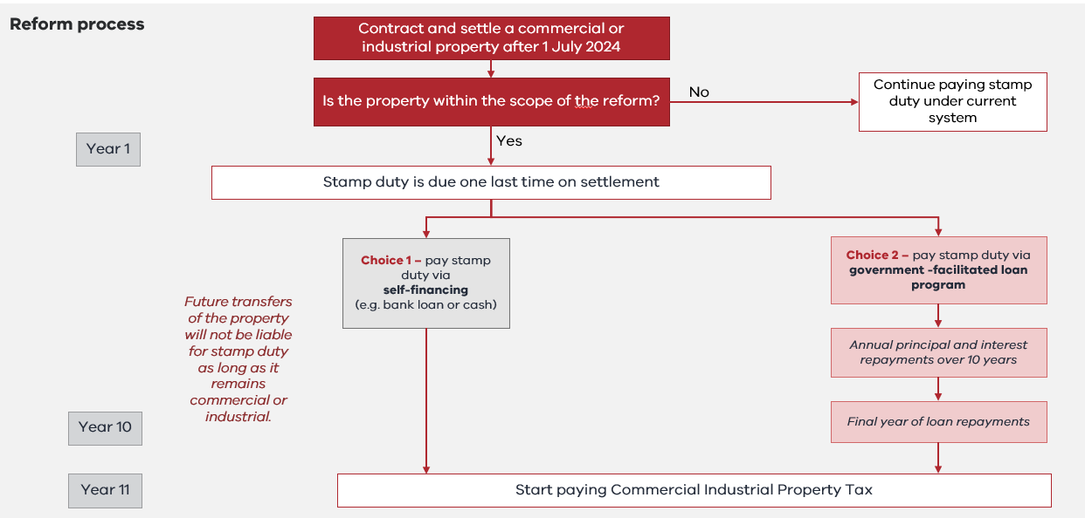

Entry into the new tax system

A property will enter the reform if:
- a contract of sale is entered on or after 1 July 2024
- 50 per cent or more of the property transacts
- there is a positive duty liability; and
- it has a qualifying commercial or industrial use at the date of settlement.
A property is considered to have a qualifying commercial or industrial use if it meets one of the following conditions at the settlement date of a property transaction:
- Property is allocated an Australian Valuation Property Classification Code (AVPCC) that represents commercial, industrial, extractive industries, or infrastructure and utilities land (included in the 200s, 300s, 400s, and 600s AVPCC categories) (see Appendix for further details), or
- Property is qualifying student accommodation (defined below).
This means the reform will not apply to properties coded by the Valuer-General as having residential, primary production, community services or sport, heritage and culture purposes.
Stamp duty concessions will continue to apply, and these properties will enter the reform provided other required conditions are also met. For example, transfers of qualifying properties which are eligible for the regional commercial and industrial duty concession will enter the reform and will continue to receive a 50 per cent reduction on their final stamp duty payment.
Commercial and industrial property transactions that are currently exempt from stamp duty will not enter the reform. This includes transfers such as:
- Deceased estates
- Transfer between spouse or partner
- Purchases by charities and Friendly Societies.
Subsequent transactions of these properties that are liable for stamp duty enter the reform and incur that property’s final stamp duty payment.
For a full list of concessions and exemptions currently available for stamp duty, please visit the State Revenue Office website:
https://www.sro.vic.gov.au/land-transfer-duty
The reform will not apply to the following:
- Property primarily used for residential purposes
- Property primarily used for primary production, community services or sport, heritage and culture purposes
- Transfers of commercial or industrial property that are exempt from stamp duty, for example a purchase by a charity, a transfer from a deceased estate, or a transfer between spouses or partners, and
- Commercial and industrial property purchased prior to 1 July 2024 (unless 50 per cent or more of the property is transacted after this date).

Case Study Example 1 – Entry into the tax reform system (first transaction)
Emma buys a commercial property on 25 September 2024 to set up her business. This transaction will trigger entry of that property into the reform (as it was contracted and settled on or after 1 July 2024).
At this point Emma can choose to pay stamp duty upfront or opt for a transition loan to pay the stamp duty, reducing her upfront costs.
If Emma’s property is in a regional area, she will receive a 50 per cent discount on her stamp duty through the regional commercial and industrial stamp duty concession.
The Commercial and Industrial Property Tax will commence 10 years after her purchase in 2035.

Case Study Example 2 – Buying a property which has entered the reform (subsequent transactions)
Minh is the owner of a small online business, and purchases a retail premise in October 2030 to expand their business. This property was previously sold in 2025, at which point it entered into the reform.
Minh would pay no stamp duty on the transaction, freeing up capital to invest in their business.
They would begin to pay Commercial and Industrial Property Tax annually from 2036.

Application of the Commercial and Industrial Property Tax

The Commercial and Industrial Property Tax is a replacement for stamp duty, and is separate to land tax, which will continue to apply. This reform does not make any changes to existing land tax arrangements.
For commercial and industrial property that has transacted since 1 July 2024 and entered the new tax system, landowners will start paying the Commercial and Industrial Property Tax 10 years after the initial transaction.
It will be set at one per cent of that property’s unimproved land value per annum with no
tax-free threshold.
Existing land tax exemptions will apply to the Commercial and Industrial Property Tax.
For a full list of exemptions currently available for land tax, please visit the State Revenue Office website: https://www.sro.vic.gov.au/land-tax/land-tax-exemptions
Consistent with land tax, the Commercial and Industrial Property Tax will not be allowed to be passed through by landowners to specific retail tenants identified in the Retail Leases Act 2003.
The Commercial and Industrial Property Tax will be based on land ownership as at 31 December following the 10th anniversary of the first transaction of the property since 1 July 2024.
Administrative arrangements for the Commercial and Industrial Property Tax will largely align with those already in place for land tax. Similar to land tax, you will be able to pay the Commercial and Industrial Property Tax in a single annual payment or by instalments.

A stylised example of entry into the new tax system and the assessment timing of the Commercial and Industrial Property Tax is included in the diagram below.
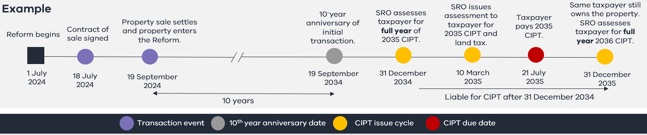

Transition loan

The Victorian Government will give first purchasers of a qualifying use property from 1 July 2024 the option of accessing a government-facilitated transition loan to finance the upfront stamp duty liability on their purchase. This offers purchasers an opportunity to spread out the upfront cost of stamp duty over time.
The loan will be available to eligible applicants, who are:
- Australian citizens/permanent residents or an Australian business
- the first purchaser of a commercial or industrial property where settlement occurs for contracts entered into on or after 1 July 2024
- purchasing property up to a maximum purchase price of $30 million; and
- approved for finance from an Authorised Deposit-taking Institution or other approved lender for the subject property.
The loan will be issued by the Treasury Corporation of Victoria with a fixed interest rate. The interest rate will be a commercial market-based interest rate and calculated at the start of the loan. It will be equal to the Treasury Corporation of Victoria’s bond rate plus a credit risk margin (to be finalised and published in 2024). The same interest rate will apply to all eligible borrowers at a given time.
Annual loan repayments will in aggregate be equal to the stamp duty plus interest over a 10-year period. These amounts will be set upfront to provide borrowers with certainty and the first repayment will be due 12 months after settlement. Early repayment will be allowed but a break fee will apply.
If the property is subsequently sold or the property changes to a non-qualifying use the borrower will be obliged to repay the outstanding balance on the loan. The loan cannot be novated or transferred to a subsequent purchaser.
Treasury Corporation of Victoria will have a first ranking statutory charge over the interest in the land in relation to the loan. This will be registered on title to inform prospective purchasers.
Further details on the reform, how to apply for the loan and the specific terms and conditions of the loan will be available in 2024.

Case Study Example 3 – Opting for a transition loan
Christos purchases a former car yard in October 2024 to start a car wash business. He opts to take out a business mortgage via a private bank to finance the purchase of the property.
Christos is eligible for the government-facilitated transition loan to finance his stamp duty. Christos repays the transition loan in fixed instalments over 10 years. Christos pays the last loan repayment in October 2034.
From 2035 Christos will pay the Commercial and Industrial Property Tax.

Mixed-use properties

Some properties will have a mixture of qualifying and non-qualifying uses across different occupancies – for example, a street level shop with a residence above. In some instances, these properties may have more than one AVPCC, and they may have a mixture of qualifying and non-qualifying AVPCCs.
For these properties the sole or primary use test will be used to determine if the property will enter into the reform in the event it is transacted and if the Commercial and Industrial Property Tax will apply.

If the sole or primary use test indicates that a property with several occupancies is qualifying, the Commercial and Industrial Property Tax will apply to the entire mixed-use property. However, concessions or exemptions from the Commercial and Industrial Property Tax may apply to relevant portions of the property.
The sole or primary use test can be in reference to factors such as the land or floor area of each use; the relative intensity, economic and financial significance of each use, and the length of time of each use, with ‘primary’ ascertained by the Commissioner of State Revenue.
If the primary use of the property is determined to be non-qualifying (e.g. residential), then the Commercial and Industrial Property Tax will not apply to the property.
Future transactions of a mixed-use property that is already in the reform will not pay stamp duty provided its sole or primary use remains as commercial or industrial.

Case Study Example 4 – Mixed-use properties
Eva purchases a suburban restaurant with a small loft upstairs on one land title where she lives. She leases the restaurant to Nicholas.
The sole or primary use test classifies this property as commercial. The property enters the reform after being transacted for the first time after 1 July 2024, with stamp duty paid one last time. The property becomes liable for Commercial and Industrial Property Tax after 10 years.
However, given Eva lives in the loft upstairs, a Principal Place of Residence exemption is applied to the residential portion of the property, reducing her Commercial and Industrial Property Tax to the restaurant portion of the property only.
After 15 years, Eva sells the property with the same mixed-use. The next purchaser pays no stamp duty and uses the property in the same way.

Changes in use

A property which enters the reform with a commercial or industrial use may change to a different use over time. For example, an industrial warehouse that has entered the reform could later be re-developed into residential apartments.
From 1 July 2024, a property owner who purchases a qualifying commercial or industrial property pays stamp duty and the property enters the reform.
If they convert the property to a non-qualifying use (e.g. residential) and the property continues to be used for that use as at the liability date for Commercial and Industrial Property Tax for a given tax year, they will not be liable for the Commercial and Industrial Property Tax for that tax year. Commercial and Industrial Property Tax is not payable on any property with a non-qualifying use.
If they sell the property whilst it has a non-qualifying use (e.g. residential) – consistent with sales of other non-qualifying properties – stamp duty will be payable.
If a property that has entered the reform is sold a second or subsequent time with a qualifying commercial or industrial use, stamp duty would not be payable on the transaction. However, if this property is subsequently converted to a non-qualifying use (e.g. residential) then change-of-use duty would apply.
Change-of-use duty is intended to apply where no stamp duty was paid on a recent property transaction, but the property is also no longer liable for the Commercial and Industrial Property Tax. It ensures equitable tax treatment across different kinds of properties, including those that change use.
The change-of-use duty will be calculated based on the stamp duty that would have been payable when the property was transacted, including any relevant concessions, but reduced by 10 per cent for every 31 December that has passed since that transaction, to a maximum of 100 per cent. For example, if change-of-use duty was payable seven years after the property was transacted, then the change-of-use duty payable would be equal to 30 per cent of the duty that would have been payable at the time the property was transacted.
Commercial and Industrial Property Tax is not payable on any property with a non-qualifying use (e.g. residential). However, if a property in the reform returns to a qualifying commercial or industrial use (after converting to a non-qualifying use such as residential), Commercial and Industrial Property Tax becomes payable immediately after the original 10-year transition period has concluded. No refund on change-of-use duty will be given if a property returns to a qualifying use.
Property owners will need to notify the SRO within 30 days of any change of use of the property.

Case Study Example 5 – Change of use
A company purchases a small factory in 2025. They use it as a factory for seven years, then in 2032 develop it and convert it to a residential use as an apartment complex. The apartments are all sold between the years 2035 and 2040.
The company opted for a transition loan to finance the stamp duty on the initial purchase of the factory in 2025. They met all of the eligibility requirements to access the transition loan, including using the property for a commercial purpose only. They make seven annual repayments on the transition loan before the use of the property changed to residential. They must pay off the remaining balance of the transition loan when they change the use of the property from industrial to residential in 2032.
They never pay any Commercial and Industrial Property Tax as the properties have been converted to residential property. However, stamp duty will be levied on the sale of the apartments, subject to any stamp duty concessions or exemptions applying.

A stylised example of the calculation for change-of-use duty is included in the diagram below.
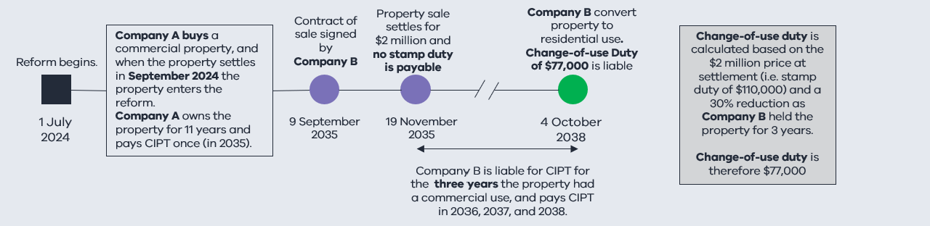

Complex transactions

The majority of property transactions are direct transfers of 100 per cent of a property. However, shares of a property can also be transacted, and there are also indirect forms of transactions.
Where less than 100 per cent of the interest in a property is transacted, the transaction is referred to as a ‘fractional interest transaction’.
Fractional interest transactions of 50 per cent ownership or more will cause the entire property to enter the reform. The entire property would be subject to Commercial and Industrial Property Tax after 10 years and the property would be exempt from stamp duty on subsequent transactions.
Indirect transactions of property will be captured by the reform, including landholder acquisitions (i.e. acquisitions in companies and trusts that own land).
Certain complex transactions will not trigger entry into the reform, specifically: transactions eligible for the corporate reconstruction or consolidation concession, dutiable leases and economic entitlements. Properties associated with these transactions or dutiable sub-sales will only enter the reform when they are directly transferred via a standard dutiable transaction (or fractional interest transaction of 50 per cent or more of the property).
Anti-avoidance provisions will be put in place to support the integrity of the reform. Further details on these provisions will be provided in 2024.

Further details

Subdivided properties: If a property that is in the reform is subdivided, the child lots will be exempt from stamp duty if they transact and will be subject to the Commercial and Industrial Property Tax 10 years after the initial transaction of the parent property.
Consolidated properties: Properties that are consolidated will be subject to the Commercial and Industrial Property Tax if 50 per cent or more of the total land area of the parent properties had entered the reform.
Foreign owners: Foreign owners will be liable for the Commercial and Industrial Property Tax. Unlike land tax, there is no absentee owner surcharge on the Commercial and Industrial Property Tax. Foreign owners will not be eligible to apply for the transition loan.

Information for purchasers: Information on whether a property has entered the tax reform, including the amount of any outstanding Commercial and Industrial Property Tax will be included on the Property Clearance Certificate issued by the State Revenue Office.
Student accommodation: Student accommodation will be included as a qualifying use for the purpose of the reform. Land which is solely or primarily used as commercial residential premises and that is used solely or primarily for providing accommodation to tertiary students will be considered commercial property. This is consistent with the definition of a commercial residential premises in the A New Tax System (Goods and Services Tax) Act 1999. This definition will exclude accommodation provided in connection with a university, such as university colleges.

Further information
Legislation to facilitate this reform is expected to be introduced into Parliament in 2024.
Additional details on the reform will be released ahead of the 1 July 2024 start date.
For further enquiries on the Commercial and Industrial Property Tax Reform, please contact information@dtf.vic.gov.au

Appendix: Australian Valuation Property Classification Code ranges included in the reform*
Code | Classification
200-299 Commercial
20 | Commercial Use Development Land
21 | Retail
22 | Office
23 | Short Term Business and Tourist Accommodation
24 | Hospitality
25 | Entertainment – Cinema, Live Theatre and Amusements (non-sporting)
26 | Tourism Facilities/Infrastructure
27 | Personal Services
28 | Vehicle Car Parking, Washing and Sales
29 | Advertising or Public Information Screens
300-399 Industrial
30 | Industrial Use Development Land
31 | Manufacturing
32 | Warehouse/Distribution/Storage
33 | Noxious/Offensive/Dangerous Industry
400-499 Extractive Industries
40 | Extractive industry site with permit or reserve not in use
41 | Quarry (in use)
42 | Mine (open cut)
43 | Mine (deep shaft)
44 | Tailings Dumps
45 | Well/Bore
46 | Salt Pan (evaporative)
47 | Dredging Operations
48 | Other Unspecified
600-699 Infrastructure and utilities (industrial)
60 | Vacant
61 | Gas or Petroleum
62 | Electricity
63 | Waste Disposal, Treatment and Recycling
64 | Water Supply
65 | Transport – Road Systems
65 | Transport – Road Systems
66 | Transport – Rail and Tramway Systems
67 | Transport – Air
68 | Transport – Marine
69 | Communications, including Print, Post, Telecommunications and Airwave Facilities
* As per the Valuation Best Practice Specifications Guidelines (VBPSG) 2023, Valuer-General Victoria

Land in Victoria will have a Qualifying Use where land is allocated one AVPCC under the Valuation of Land Act 1960 in the AVPCC ranges of 200-499 or 600-699, or where the land is used solely or primarily for Eligible Student Accommodation. Mixed use properties will be subject to a sole or primary use test to determine qualifying use.

