Gateway Review Process
Gate 2 – Business case workbook

The Secretary
Department of Treasury and Finance
1 Treasury Place
Melbourne Victoria 3002
Australia
Telephone: +61 3 9651 5111
dtf.vic.gov.au

Authorised by the Victorian Government
1 Treasury Place, Melbourne, 3002

© State of Victoria 2019
Copyright queries may be directed to IPpolicy@dtf.vic.gov.au

ISBN 978-1-925551-41-9
Published October 2019

If you would like to receive this publication in an accessible format please email information@dtf.vic.gov.au

This document is also available in Word and PDF format at dtf.vic.gov.au

Contents
The Gateway Review Process 1
About this workbook 1
The Business Case 1
Project Development and Due Diligence 2
Gateway Review 2: Business Case 5
Project documents 6
1. Policy context and strategic fit 7
2. Business case and stakeholders 8
3. Project Development and Due Diligence 11
4. Risk management 14
5. Readiness for next phase: readiness for market 15
Appendix 1: Best practice sources 17

The Gateway Review Process
The Gateway Review Process examines programs and projects at key decision points. It aims to provide timely advice to the Senior Responsible Owner (SRO) as the person or people responsible for overseeing the delivery of the project and transitioning it into operation. A review provides the SRO with an independent view on the current progress of the program or project and assurance that it can proceed successfully to the next stage.
Given the aim is to help the SRO at key decision points, each review is short and focused on the work that is complete at the time. For the best result, a review is carried out shortly before a decision is made to allow sufficient time for any recommendations to be implemented.

About this workbook
This workbook supports a Gateway Review 2: Business Case. This review investigates the business case and the proposed way forward to confirm the project is achievable and likely to deliver what is required. The review checks that:
- stakeholders approve the intended benefits from the project;
- the link with program and organisational objectives is clear; and
- the optimum balance of cost, benefits and risk has been identified.
This workbook describes the key products, appraisal questions and sources of further information, including best practices. It provides review teams with key questions to explore and suggested evidence to support those questions. Because each program or project is unique and circumstances change, the workbook should be used as a guide to the range of appropriate questions and evidence, not as a complete checklist of mandatory items.

The Business Case
The project initiation process produces a case for the project, based on business needs and an assessment of the project’s likely costs and potential for success. This Gateway review generally comes after the business case has been prepared and before any development proposal goes before a project board, executive authority or Minister for authority to proceed.
For all capital projects with a Total Estimated Investment (TEI) over $10 million that have not yet received budget funding for contruction, the project team will need to complete a project profile model. This tool creates a risk profile for the project to inform DTF’s decision on whether the project is likely to be High Value High Risk (HVHR) following a funding decision. If the project is likely to be HVHR post funding, then it is expected to complete a Gateway Review 2 – Business Case Gateway Review prior to the budget process.
The review focuses on the project’s business case. It provides assurance that the proposed approach to meeting the business requirement has been adequately researched and can be delivered. It also confirms the project benefits are identified at a high level and their achievement will be tracked using a defined measurement approach e.g. benefits management plan.

Project Development and Due Diligence
One important element to consider when assessing a business case is whether an appropriate level of Project Development and Due Dilligence (PDDD) has occured.
The successful execution and performance of a project depends on the quality of its PDDD, which refers to the specific technical and planning analysis that may be conducted for a project at each stage of the GRP. It helps identify key risks and issues including technical, contextual and environmental matters and enables the risks to be better estimated. The level of PDDD analysis may be scaled according to the risk profile and value of the proposal in accordance with the PDDD Guidelines.
The review team should assess the extent and adequacy of due diligence conducted by evaluating documents and evidence that describe to what extent PDDD activities have been completed and to what extent their findings have been translated into identifiable or quantifiable project risks. For this element of the assessment, the review team should not be concerned with the PDDD findings as much as whether it has been conducted and quantified into risks. Where relevant, measures to address gaps in the extent of due diligence conducted could be detailed in the Recommendation Action Plan.
More information on PDDD is available in the Project Development and Due Dilligence Guidelines, which are available on the DTF website.

Figure 1: Overview of the Gateway Review Process
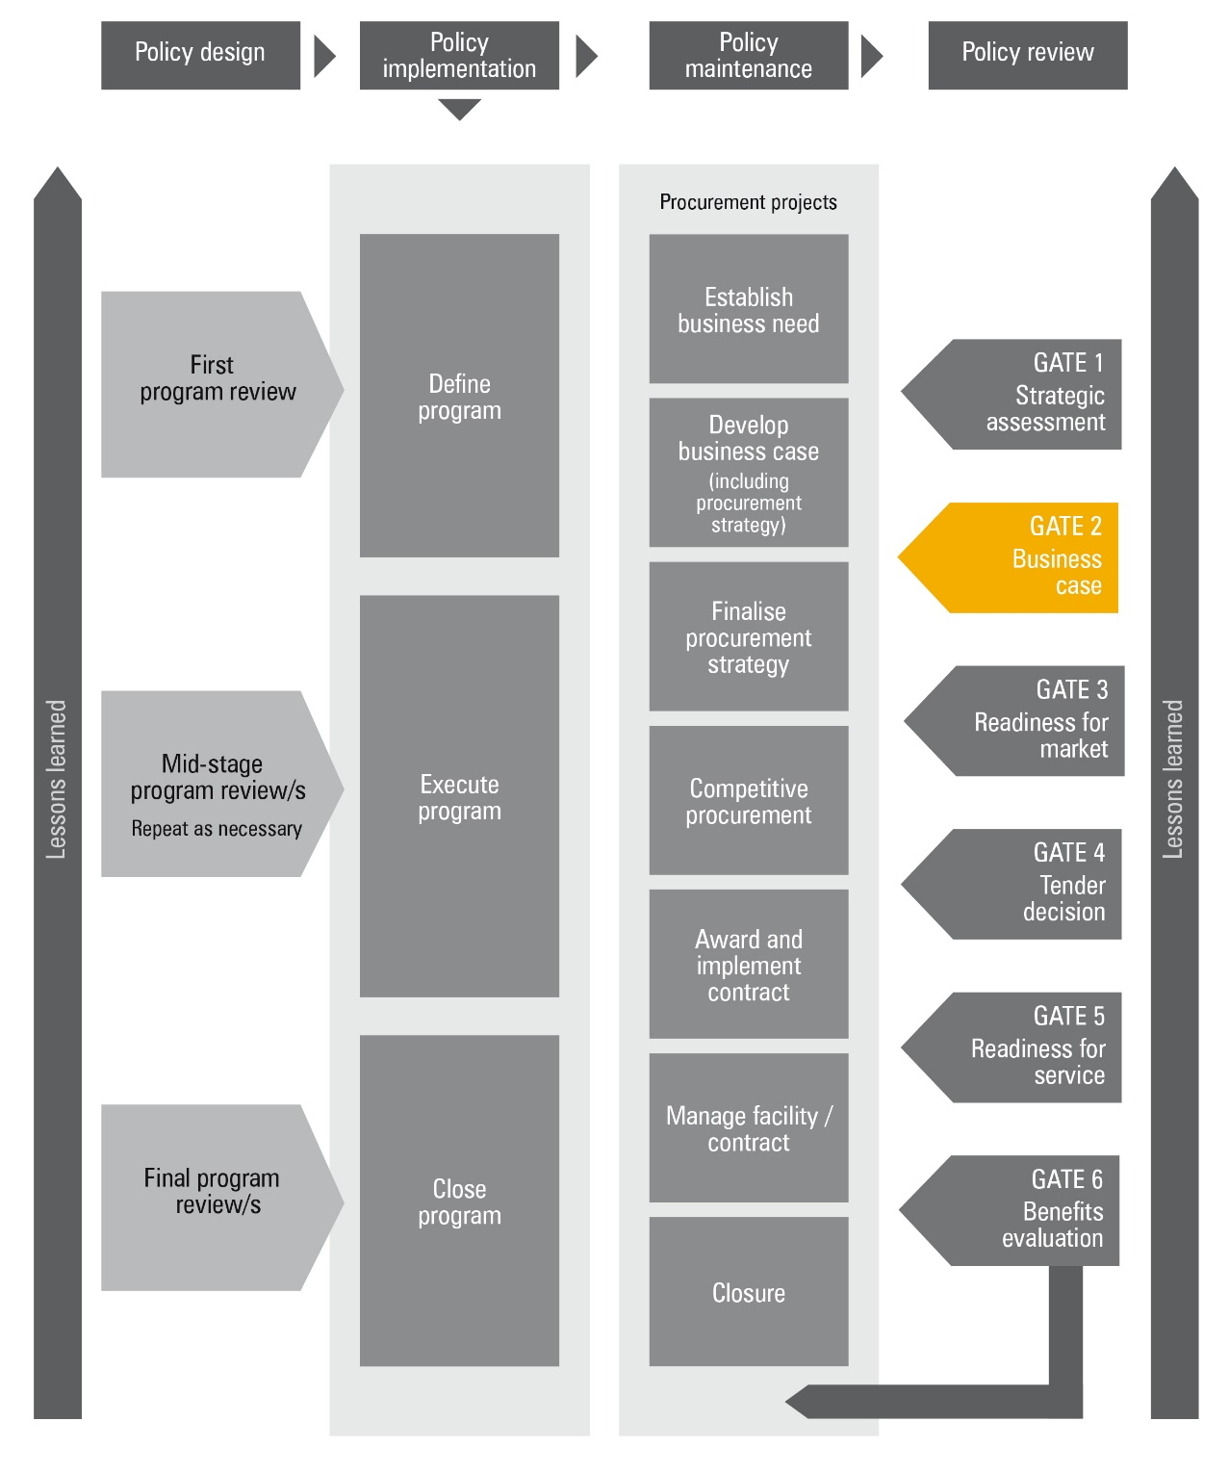
** This Figure assumes a two-stage budget process. If Government elects for a one-stage budget process, then Gate 1 and 2 reviews are usually combined into one review.
Figure 2: Applying the Gateway Review Process to different project delivery methods
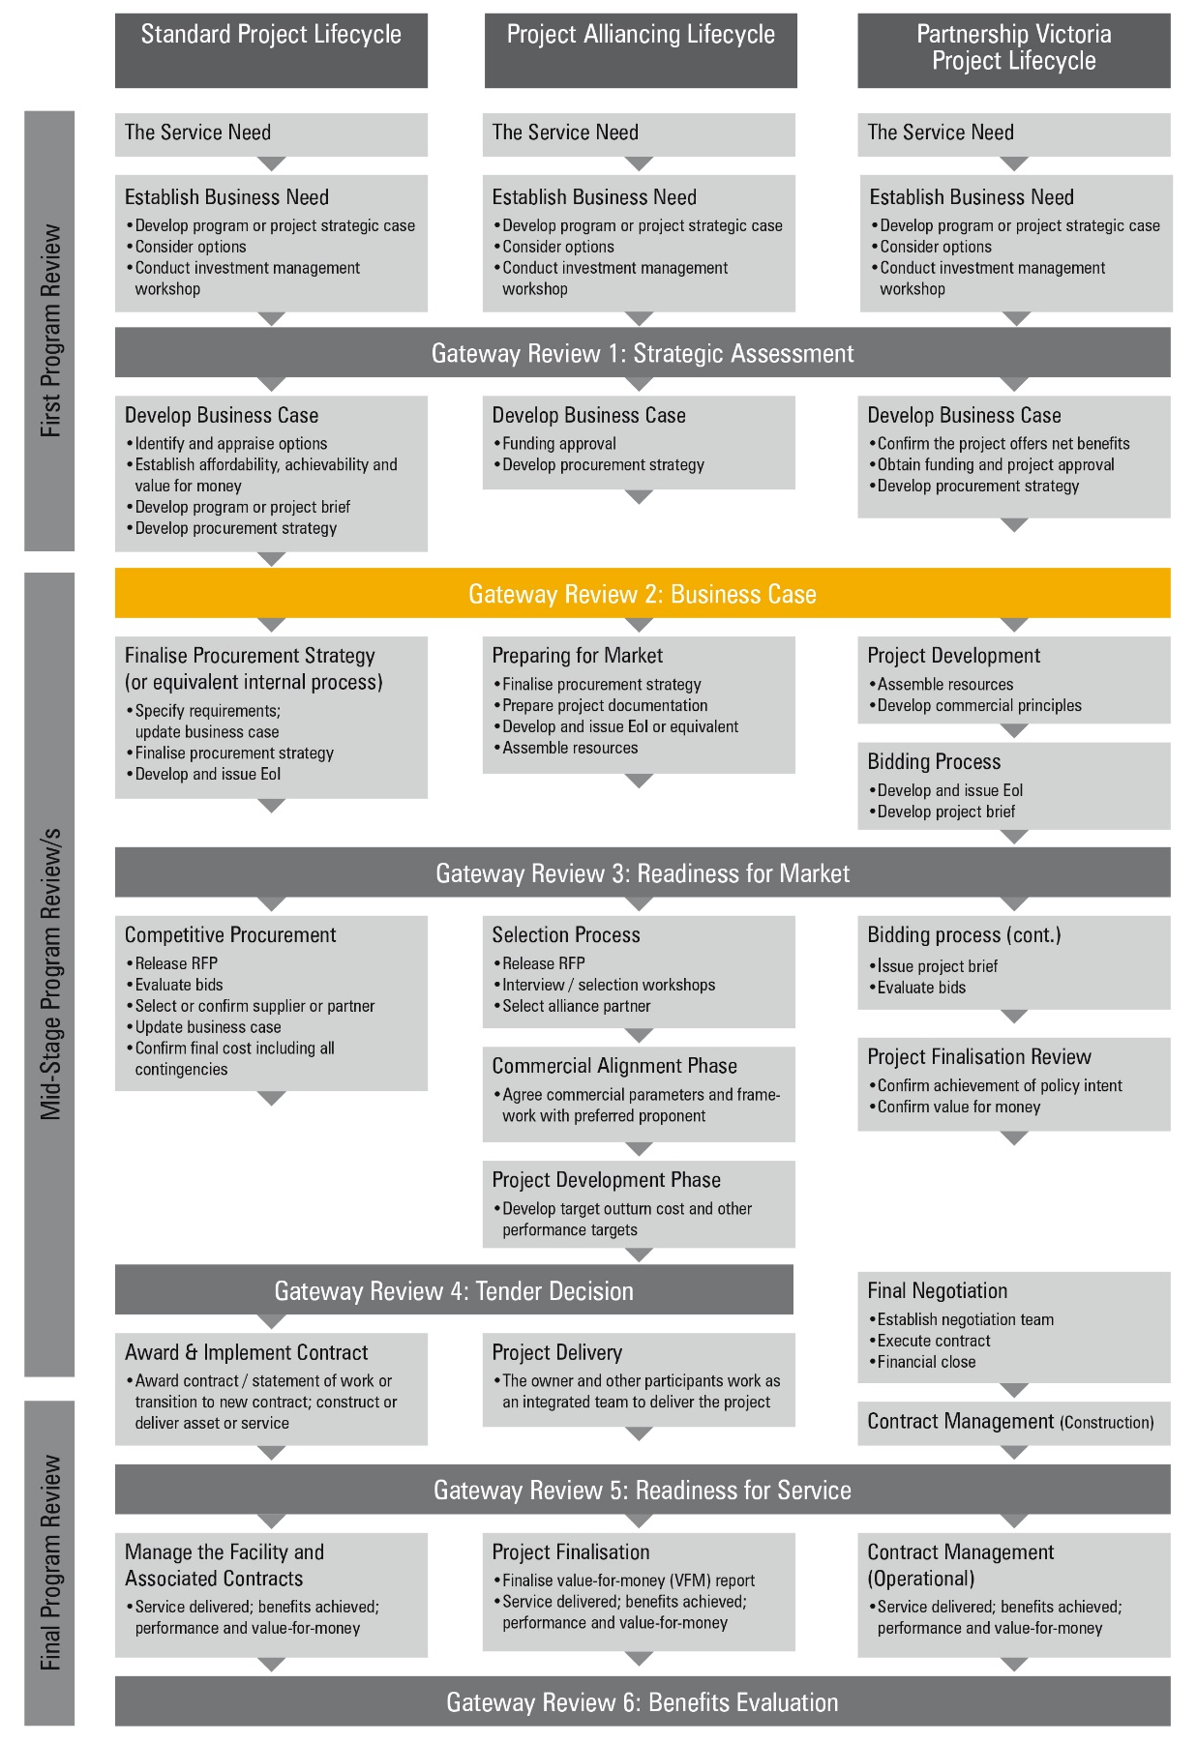
Gateway Review 2: Business Case
The purpose of the Gateway Review 2 Review is to:
- confirm the business case is robust, that is, it meets the business need, is affordable, achievable, has appropriate options explored and is likely to achieve value-for-money;
- confirm potential options have been identified and analysed, and expert advice has been obtained;
- confirm the underlying investment logic has been reflected and proven by evidence in the business case and the project remains aligned with the objectives and deliverables of the program and organisation;
- establish the feasibility study has been completed satisfactorily and a preferred way forward has been developed and decided in dialogue with the market;
- confirm the market’s likely interest has been investigated and appropriate high-level procurement strategies have been considered;
- ensure there is internal and external authority and support for the project;
- establish the level of PDDD analysis that has been undertaken and evaluate its appropriateness;
- ensure the major investment and project level risks have been identified and risk management plans have been developed;
- establish the project is likely to deliver its business goals and that it supports wider business change;
- confirm the scope and requirements specifications are realistic and clear;
- ensure the full-scale, intended outcomes, timescales and impact of relevant external issues have been considered;
- ensure there are plans for the next stage, confirm planning assumptions and that the project team can deliver the next stage;
- confirm overarching and internal business and technical strategies have been considered; and
- confirm quality and benefit management plans are in place, including Key Performance Indicators (KPIs) for the project and its outcomes.

Project documents
The areas of investigation and examples of evidence should be available before the Gateway review starts. The information is likely to be found in documents suggested below, but may be located in other project documents or elsewhere in the organisation’s documentation system:
- the business case, addressing:
  - the business need;
  - affordability;
  - achievability;
  - value-for-money and the range of options;
  - estimates of the project’s cost and benefits;
  - a feasibility study;
  - a sensitivity analysis;
  - market sounding; and
  - the preliminary procurement strategy.
- a project brief detailing the project scope and the need for change;
- a project initiation document or equivalent;
- an investment logic map, benefit management plan and investment concept brief;
- a quality management strategy;
- the project approach, including how the intended outcome is delivered;
- a strategy outlining the approach to business change including staff training, new facilities, etc.;
- an initial assessment of the current and proposed physical and technical environment, e.g. Information Technology (IT) infrastructure and workspace facilities;
- project development and due diligence analysis;
- an approvals strategy;
- a cost report on the project to date, against budget;
- a draft high-level definition of the business requirements and total scope of change;
- a communications strategy to keep stakeholders informed of the project progress;
- a list of the major risks, with draft plans for managing them;
- a high-level activity, time and resource plan for the whole project;
- a detailed project schedule as part of the business case outlining critical paths and milestones;
- funds to cover all work to Gate 3 Review: Readiness for Market;
- how performance is to be reported and monitored;
- project organisation – key roles and governance and/or reporting arrangements;
- for construction projects, design quality indicators; and
- identified business impacts for IT-enabled projects.
    - Policy context and strategic fit
Areas to probe | Evidence expected
1.1 Are all relevant government initiatives being addressed? | - the Senior Responsible Owner (SRO) or equivalent is undertaking their responsibilities in relevant policy initiatives.
1.2 Does the preferred option meet wider government and organisational policies, strategic objectives, standards and business change programs? | - an assessment against a list of wider government objectives, standards and business change programs;  - an assessment against a list of current organisational strategy and business objectives and policy initiatives, confirmation of the role of the project in a wider policy or program initiative;  - an assessment of business justification as stated in the business case;  - account taken of relevant impact assessment and appraisal issues such as regulatory impact, sustainable development and environmental effects;  - for IT-enabled projects, compliance with e-government frameworks; consideration of information assurance requirements in relation to business objectives; compliance with IT security requirements; compliance with freedom of information and data privacy requirements; and  - for construction projects, the contribution to the property and/or workspace strategy; health and safety, sustainability and design quality is considered.
1.3 Have the internal and external factors affecting the project been identified and assessed? | - the initiative responds to the organisational objectives;  - an assessment of the objectives, timescales and scale of the project;  - legislation, policy and regulatory issues are considered;  - an assessment of the stability of the current business environment and strategic direction;  - an assessment of dependencies, e.g. other programs or projects that could affect current priorities;  - an assessment of the impacts on the existing physical and technical environment, e.g. brownfield site, current infrastructure and legacy systems; and.  - an assessment of the skills and knowledge required by the project for successful implementation, the availability of skills in the project team and access to external expertise; appropriate allocation of key project roles between internal staff and consultants or contractors.
1.4 Are the external stakeholder issues being addressed, such as:  - communications;  - public relations;  - social inclusion, e.g. equality and diversity issues;  - environmental issues;  - personnel; and  - statutory processes. | - plans for each stakeholder, showing responsibilities and roles in the project; and  - a demonstrated consultation and impact on the plans.
1.5 Is there an opportunity to integrate the program or project with other government initiatives? | - a demonstrated consultation with potential areas of related programs or service-delivery providers, related services or geographically aligned service provision; and  - specific integration features.
    - Business case and stakeholders
Areas to probe | Evidence expected
2.1 Is the business case complete and consistent with the requirements of the Department of Treasury and Finance Investment Lifecycle guidelines and business case template? | - the documented preferred option demonstrates it is selected from a rigorously assessed wide range that satisfies the project objectives, including the contribution to the business strategy, is likely to offer value-for-money and is affordable and achievable;  - stakeholder views are adequately represented including the general public, if appropriate;  - objectives are clearly defined and expectations are realistic;  - appropriate expert advice has been sought; and  - the delivery strategy aligns with the overall organisational goal.
2.2 Is there a clear and agreed understanding of business objectives and how the project will deliver these? | - a complete investment logic map, benefits management plan and investment concept brief;  - business objectives for the project are clearly stated and specific, measurable, agreed, realistic and timely, and meet the business needs of the organisation;  - a strategy for achieving business benefits is defined and agreed with the stakeholders;  - the scope, including timescales, is documented and agreed with stakeholders including end-users or their representatives and technical authorities;  - the scope and requirements specifications are realistic and clear;  - the delivery approach and mechanisms are defined and agreed with stakeholders;  - options are reviewed and a case made for their selection; and  - for IT-enabled projects: IT developments defined as component(s) of a wider program of business change and/or policy initiative.
2.3 What are the critical success factors, the essential areas of activity that must be performed well if the mission, objectives or goals of the project are to be achieved? | - details of the critical success factors for each of the main objectives;  - details about any impact assessments and regulatory approvals required to be completed; and  - a benefit management plan.
2.4 Can the critical success factors be quantified or measured? | - an explanation of how the factors will be measured and an identification of baseline measures;  - a definition of effective systems for measuring and tracking the realisation of benefits; and  - for construction projects, design quality indicators.
2.5 Have all the stakeholders been identified and their needs clearly understood? | - internal and external stakeholders identified and documented;  - stakeholders’ roles and responsibilities and their potential influence on the project defined and agreed;  - end-users for the project identified and documented;  - the decision-making process is inclusive of all the relevant stakeholders and is efficient and effective;  - results of consultations documented as part of project stakeholder engagement and/or communications strategy; and  - if the project crosses organisational boundaries, there are clear governance arrangements to ensure sustainable alignment with the business objectives of all organisations involved.
2.6 Do stakeholders support the preferred option, including the potential or recommended delivery approach and mechanisms? | - demonstrated stakeholder consultation, involvement, support and endorsement.
2.7 Has the business case examined a wide enough range of options for solution and delivery that will meet the business requirement? | - options explored for collaboration with other public sector organisations and programs or projects;  - an investment concept brief for each option;  - an evaluation of the environmental impact assessment and approvals options available to the project including traditional options;  - a rigorous assessment of the procurement options including a sound understanding of market capability;  - the advantages and disadvantages for each option are identified to determine its potential for meeting the critical success factors; and  - market sounding indicates that suitable solutions can be found.
2.8 Is there a clear best option, or would several options meet the business need? | - options appraised in accordance with principles outlined in the investment evaluation guidelines, Partnerships Victoria guidance material and/or the Department of Treasury and Finance project alliancing practitioner’s guide;  - options are ranked showing an examination of all options that are acceptable in principle;  - an examination of prioritised options as they relate to service requirements;  - climate change impacts on the project have been appropriately considered, including the associated risk and/or uncertainty of these impacts;  - a clear analysis of whole-life costs for each option; and  - use of software metrics to test robustness of costs for information and ICT projects.
2.9 If there are several options, how was their robustness tested and was the selection process valid? | - a sensitivity analysis of all options;  - detail provided on the consequence of doing nothing; and  - the major sensitivities included in the list of identified risks.
2.10 Were whole-of-life costs and benefits analysed for all options? | - an assessment of operational and capital costs and a comparison using net present value analysis;  - a benefits management plan.
2.11 Will the project be attractive to the market? | - market sounding taken, including an examination of recent similar procurements by others and an indication of suitable suppliers available to deliver requirements;  - there is adequate capacity, capability and competitive interest in the market to meet the requirement;  - appropriate allocation of risk associated with the implementation of the conditions of any approvals or change required to approvals;  - early supplier involvement to help determine and validate the outputs and outcomes sought for the project, including proof of concept exercises; and  - senior management is sufficiently engaged with the industry to be able to assess the supply risks.
2.12 Have contract management issues been considered? | - requirements for intelligent customer capability considered;  - arrangements for managing single and/or multiple suppliers considered;  - where multiple suppliers are likely to be appointed, there are high-level plans for managing the interfaces; and  - the appropriate relationship is determined and the optimum scale of contract(s) appropriately considered.
2.13 Have assumptions been identified and their validity checked? | - details of the assumptions that have been made and the basis for their use.
2.14 Has the project organisation been considered and is there an overall project management process? | - details of the project governance model or the proposed model to be used.
    - Project Development and Due Diligence
Areas to probe | Potential evidence
3.1 Has the client updated the preliminary requirements based on latest information? | - documentation of the extent of PDDD analysis that has been undertaken and resulting new information;  - updated preliminary requirements document that defines any new information and impacts to existing requirements; and  - new requirements based on new information, and how that affects any core assumptions including but not limited to risks, cost, schedule, etc.
3.2 Is there a sound understanding of the scope of the project and its interdependencies? | - defined scope statement that documents the core scope as well as ancillary or enabling works; and  - clear definition of works that are out of scope but might be related to or have interdependencies with this project.
3.3 Has an Approvals Strategy been developed, and engagement been undertaken with the relevant regulators? | - details regulator engagement for environmental impact assessments and regulatory approvals (Local, State and Commonwealth);  - A list of the Local, State and Commonwealth legislation considered and the implications for the project;  - list of an a demonstrated understanding of the process associated with the undertaking of environmental referrals, impact assessments and approvals required (Local, State and Commonwealth);  - consideration of expected time, cost and effort to pass through the referral and / or impact assessment phase and to obtain the relevant regulatory approvals;  - risk register includes risks from the referral and / or impact assessment phase and to obtain the relevant regulatory approvals; and  - understanding of the implications of conditions approval including an analysis of lessons learnt from other projects.
3.4 Are the operator requirements clearly understood? | - details of engagement efforts with operator to understand requirements;  - documentation of operator requirements and how they have been mapped into scope statement;  - operator agrees that scope statement adequately addresses requirements, or documentation of points of disagreement; and  - risk analysis for any operator requirements that are not being considered, including consequences for both operator and the project.
3.5 Has a strategic land use assessment been undertaken? | - details of the personnel engaged to undertake the strategic land use assessment;  - analysis of strategic land use assessment required;  - consideration of expected time, cost and effort and likelihood for achieving changes required; and  - risk register includes risks from strategic land use assessment.
3.6 Is the scope of work feasible within the constraints of the existing site conditions, time and budget envelope? | - development of budget and schedule that demonstrates achievability of scope within envelope and identifies budget and schedule capacity to manage potential issues arising from key site condition risks; and  - risk register includes site conditions.
3.7 Has the operator been consulted and disruptions identified? | - details of engagement efforts with operator to understand potential disruptions;  - documentation of potential or planned disruptions and how they have been mapped into scope statement, budget and schedule;  - risks and impacts to operator for potential or planned disruptions; and  - operator agreement for planned disruptions and agreement frame for resolving unplanned disruptions.
3.8 Is the preliminary cost estimate updated? P50/P90 estimate available for transport projects? | - preliminary cost estimate;
3.9 Is the preliminary program/schedule updated? Is the critical path identified? | - updated preliminary schedule with critical path identified.  - Work Breakdown Structure (WBS) dictionary defined.
3.10 Have all considered options been recorded? Is the recommended single option (or Real Options strategy) approved by relevant governance? | - documentation of options assessments and findings from 2.6, 2.7, 2.8, 2.9, 2.10;  - stakeholder engagement matrix identifying relevant governance bodies and approval pathways for each option; and  - approval from relevant governance bodies.
3.11 Is the scope of work consistent with baseline requirements identified? | - mapping of baseline requirements to scope and WBS to demonstrate all requirements are met by a scope element, and that no scope elements are present without a supporting requirement.
3.12 Have urban requirements and approvals been included? | - analysis of urban requirements including planning and approvals required;  - consideration of expected time, cost and effort to pass through urban planning and approvals; and  - risk register includes risks from urban requirements analysis.
3.13 Is there an air quality plan available? | - air quality assessment and plan
3.14 Are EPA regulations clearly noted and recorded? | - analysis of EPA regulations against proposed scope, including planning and approvals required;  - consideration of potential new requirements under the Environment Protection Act 2017;  - EPA approval pathway noted on schedule and associated costs defined in budget;  - stakeholder engagement matrix identifying relevant governance bodies including EPA and other regulatory authorities; and  - risk register includes risks from EPA analysis.
3.15 Has an ecological assessment been undertaken? | - analysis of ecological assessment including scope, time and cost impacts for mitigation of adverse findings from a State and Commonwealth perspective; and  - risk register includes risks from ecological assessment.
3.16 Is a cultural heritage (Aboriginal and historic) assessment required? | - analysis of potential cultural heritage risks or issues; and  - cultural heritage risks defined in risk register.
3.17 Has a landscape and visual impact assessment been prepared? | - landscape and visual impact assessment including scope, time and cost impacts for mitigation of adverse findings; and  - risk register includes risks from landscape and visual impact assessment.
3.18 Is there a noise and vibration assessment and management plan? | - noise and vibration assessment and plan.
    - Risk management
Areas to probe | Evidence expected
4.1 Are there processes to identify, assess, allocate, manage and monitor current, anticipated and emerging risks and issues? | - a list of risks and key issues, categorised as strategic, political and/or reputational; legislative, implementation and operational service risks including business, technical, financial and commercial and/or contractual risks and:  - for IT-enabled projects, information security risks; for e-government, risks relating to poor take-up;  - for construction projects, risks relating to health and safety and the condition of the asset, including latent conditions; and  - for policy projects, regulatory impact assessment carried out;  - a risk management strategy developed in accordance with best practice;  - an individual identified as responsible for managing risk across the project, mitigation options and contingency plans; and  - defined roles, responsibilities and processes for managing issues and risk with clearly defined routes for bringing issues and risks to the attention of senior management.
4.2 Have any issues raised in a previous review been resolved satisfactorily? | - details of actions taken and their outcomes.
4.3 Have the risks for each option been evaluated and has an opportunity for appropriate risk transfer been considered? | - current, emerging and anticipated risks classified by probability, impact, ownership, effect on the project and counter-measure, contingency and/or business continuity; and  - scope for a risk transfer opportunity analysis for different options, particularly delivery options.
4.4 Have the risks for the preferred option been fully assessed? | - involvement of senior stakeholders in assessing strategic risks;  - an assessment of risk, costs and benefits to show appropriate balance of risk and reward in the preferred option, demonstrating planned risk-taking and support for innovation, including PDDD findings and analysis; and  - plans for managing and allocating the risks associated with the preferred option through the contract(s).
4.5 Have the worst-case implications associated with these risks been assessed? | - risks financially assessed and risk allocation estimated.
4.6 Are the costs and time implications of managing the risks included in the cost and time estimate or treated as a contingency? | - costs and time for managing risks are separately identified;  - costs and time estimated for risk countermeasures and contingency and business continuity plans;  - where risks cannot be reduced, the costs of managing these risks are separately identified and included as a risk allocation provision;  - an analysis undertaken of the effects of slippage in time, cost, scope or quality; and  - for construction projects, decisions on how residual risks are managed.
4.7 Does the project break new ground in any area, i.e., is it iconic, novel or innovative? | - an examination of leading-edge projects to assess the project impact on the business, stakeholders and end-users;  - an examination of non-traditional ways to seek project regulatory approval;  - evidence of similar projects or activities from which lessons may be drawn, including from the construction, operation and maintenance phases;  - professional advisors have assessed innovative solutions;  - the market is consulted to help refine the approach, identify risks and risk mitigation methods;  - a defined approach to the management of change in the affected organisations; and  - sufficient account taken of the current organisational culture and leadership and organisational capability.
4.8 Should the project be broken down into a series of small steps? | - documentation of the chosen approach and a justification for making the decision; and  - the business case details any phased delivery or expected improvements over time.

    - Readiness for next phase: readiness for market
Areas to probe | Evidence expected
5.1 Is there an overall project structure for the procurement stage? | - a definition of the project approach to be adopted; and  - an assessment of its suitability.
5.2 Is there a current and operational risk register? | - details of a framework to manage risk and a current register with identified risks that also addresses PDDD analysis and findings for the next phase.
5.3 Is there a realistic plan to reach Gate 3 Review: Readiness for Market? | - objectives, planning assumptions, constraints, activities, quality plans, deliverables and milestones are defined and agreed for the next and remaining phases;  - an assessment of the validity of current assumptions;  - the project addresses short and long-term business requirements;  - suitable solutions are available from the market and it has sufficient capacity;  - for projects with a design phase such as construction projects, evidence the project timescale allows enough time for the development of the required design quality; and  - for IT-enabled projects, evidence of consideration of a proof of concept stage.
5.4 Have requirements for external specialist advice been determined? | - requirements for specialist expertise considered and resourced; and  - external advice used appropriately.
5.5 Are the necessary internal and external skills available at the right time and in the right numbers? | - a resource plan for internal staff, identification of the skills required for the next phase of the project and a skills appraisal and plans for addressing shortfalls;  - appropriate allocation of key project roles between internal staff and consultants or contractors; and  - the project team has requisite skills or access to specialist expertise.
5.6 Is there a training need, what is it and how is it being addressed? | - details of training assessment, plans and training sources.
5.7 Is the time plan for the next stage realistic and does it account for statutory lead times? | - a time plan identifying statutory lead times and a realistic assessment of the time needed for pre-procurement activities.  - senior management commitment to the time plan; and  - the time plan for delivery is justified and not longer than necessary.
5.8 Is there a clearly defined project organisation with agreed roles and responsibilities? | - details of project organisation and methodology;  - governance and/or reporting arrangements;  - named individuals in key positions, with appropriate skills, experience and status:  - Senior Responsible Owner (SRO);  - project manager;  - project sponsor and/or project director;  - stakeholder representation;  - project board or project steering group;  - for construction projects, a design champion responsibility; a project sponsor and independent client adviser/s to support the SRO (note: a project manager may not always be required);  - for IT-enabled projects, Chief Information Officer (CIO) or equivalent role, an IT and/or Information Security manager and/or accreditor to support the SRO;  - for collaborative projects, a single SRO and senior representatives from each collaborating organisation; and  - if the project crosses organisational boundaries, clear governance arrangements to ensure a sustainable alignment of the business objectives of all organisations involved with clear lines of accountability and ownership.
5.9 Has an appropriate level of PDDD analysis been undertaken for the next phase? | - PDDD analysis and findings.

Appendix 1: Best practice sources
Source | Information
Investment management guidelines  See Investment management  www.dtf.vic.gov.au/infrastructure-investment/investment-management-standard | - investment management standards  - investment logic maps  - investment concept briefs  - benefit management plans
Investment lifecycle guidance  See lifecycle guidance  www.dtf.vic.gov.au/infrastructure-investment/investment-lifecycle-and-high-value-high-risk-guidelines  See PDDD guidance  https://www.dtf.vic.gov.au/investment-lifecycle-and-high-value-high-risk-guidelines/stage-1-business-case | - business case development guidelines, including strategic assessment guidance  - procurement strategy guidelines  - project tendering guidelines  - risk management guidelines  - Project Development and Due Diligence guidelines
Procurement advice, policy and guidelines  Victorian Government Purchasing Board  www.procurement.vic.gov.au/Home  National PPP policy and guidelines  www.infrastructure.gov.au/infrastructure/ngpd  Social Procurement Framework  www.dtf.vic.gov.au/infrastructure-investment/public-private-partnerships | - longer term contract management  - contract variations  - National guidelines for Infrastructure Projects  - Public Private Partnership resources  - Social Procurement Framework
PPP projects  National PPP policy and guidelines  www.infrastructure.gov.au  Partnerships Victoria requirements  www.dtf.vic.gov.au/infrastructure-investment/public-private-partnerships | - contract management policy and guidance material
Project alliancing  See Project alliancing at www.dtf.vic.gov.au | - Project Alliancing Practitioners Guide
Information and Communications Technology (ICT) projects  www.enterprisesolutions.vic.gov.au  www.dtf.vic.gov.au/infrastructure-investment/high-value-high-risk-framework | - Guidance on High Value High Risk projects including ICT projects  - ICT-related strategy, standards, policies, project dashboard, and  - technical resources for Whole of Victorian Government (WoVG).
Asset Management Accountability Framework  Department of Treasury and Finance  www.dtf.vic.gov.au/infrastructure-investment/asset-management-accountability-framework | - further information about government asset management expectations including acquiring new assets
Gateway Review Process  www.dtf.vic.gov.au/infrastructure-investment/gateway-review-process | - Gateway Guidance material  - Becoming a Gateway reviewer

