Gateway Review Process
Gate 4 – Tender decision workbook

The Secretary
Department of Treasury and Finance
1 Treasury Place
Melbourne Victoria 3002
Australia
Telephone: +61 3 9651 5111
dtf.vic.gov.au

Authorised by the Victorian Government
1 Treasury Place, Melbourne, 3002

© State of Victoria 2019
Copyright queries may be directed to IPpolicy@dtf.vic.gov.au

ISBN 978-1-925551-37-2
Published October 2019

If you would like to receive this publication in an accessible format please email information@dtf.vic.gov.au

This document is also available in Word and PDF format at dtf.vic.gov.au

Contents
The Gateway Review Process 1
About this workbook 1
Tender decision 1
Project Development and Due Diligence 2
Gateway Review 4: Tender decision 5
Project documents 5
1. Assessment of proposed solution 7
2. Business case and stakeholders 9
3. Project Development and Due Diligence 10
4. Risk management 13
5. Review of current phase 13
6. Readiness for next phase: Readiness for service 14
Appendix A: Best practice sources 17

The Gateway Review Process
The Gateway Review Process examines programs and projects at key decision points. It aims to provide timely advice to the Senior Responsible Owner (SRO) as the person or people responsible for overseeing the delivery of the project and transitioning it into operation. A review provides the SRO with an independent view on the current progress of the program or project and assurance that it can proceed successfully to the next stage.
Given the aim is to help the SRO at key decision points, each review is short and focused on the work that is complete at the time. For the best result, a review is carried out shortly before a decision is made to allow sufficient time for any recommendations to be implemented but not too early that key documentaiton is not sufficiently progressed.

About this workbook
This workbook supports Gateway Review 4: Tender Decision. This review investigates the business case and the governance arrangements for the tender decision to confirm the project is still required, affordable and achievable. The review also checks implementation plans are robust.
This workbook describes the main products and provides appraisal questions and sources of further information, including best practices for review teams. It offers key questions to explore and evidence to look for. Because each policy, program or project is unique and circumstances change, the workbook should be used as a guide to the range of appropriate questions and evidence, and not a full checklist of mandatory items.

Tender decision
Gateway Review 3 reviewed the project’s market readiness, in particular the procurement strategy for achieving the project’s objectives, prior to proposals or tenders. For organisations with existing commercial arrangements, it reviewed similar information and decisions. During this project phase, potential suppliers, partners and/or other delivery organisations - such as internal units of the client organisation - submitted proposals or tenders. An evaluation panel analysed them on a ‘like-for-like’ basis and recommended the proposal which met client and end-user needs and which offered the best value-for-money. This Gateway Review 4 should happen before a work order is placed with a supplier or other delivery partner, or at preferred bidder stage, and before the award of a contract.
Gateway Review 4 confirms the recommended tender decision is appropriate before the contract is awarded to a supplier or partner, or a work order is placed with an existing supplier or other delivery partner. It assures the project board the processes used to select a supplier are sound. It also assesses whether the process has been well managed; whether the business needs are being met; whether the client and supplier can implement and manage the proposed solution; and whether a successful outcome can be achieved. The project team and review team must be satisfied that due consideration has been given to all the factors, including choices about proposed commercial arrangements with any existing supplier that offer value-for-money.
A project will normally go through one Gate 4 review. However, on occasions it may be necessary for a project to repeat Gate 4 review including:
- for construction projects, if there is a second tender decision such as for two-stage design and construct or there may be a need for an initial review for the contract award and a subsequent review to confirm the tender decision based on the construction price;
- for IT-enabled and service enhancement projects which may need an initial review before a pilot implementation or initial design contract is undertaken, and a subsequent review to confirm the tender decision before full implementation; and
- for alliance projects once the commercial parameters and framework are agreed with the preferred proponent and again once the out-turn costs and performance targets have been developed at the project development phase.
It should be noted Partnership Victoria projects are exempt from performing Gateway 4 Reviews.

Project Development and Due Diligence
One important element to consider when assessing procurement documentation is whether an appropriate level of Project Development and Due Dilligence (PDDD) has occured.
The successful execution and performance of a project depends on the quality of its Project Development and Due Diligence (PDDD). PDDD refers to the specific technical and planning analysis that may be conducted for a project at each stage of the GRP. It helps identify key risks and issues including technical, contextual and environmental matters and enables the risks to be better estimated. The level of PDDD analysis may be scaled according to the risk profile and value of the proposal in accordance with the PDDD Guidelines.
The review team should assess the extent and adequacy of due diligence conducted by evaluating documents and evidence that describe to what extent PDDD activities have been completed and to what extent their findings have been translated into identifiable or quantifiable project risks. For this element of the assessment, the review team should not be concerned with the PDDD findings as much as whether it has been conducted and quantified into risks. Where relevant, measures to address gaps in the extent of due diligence conducted could be detailed in the Recommendation Action Plan.
This workbook includes some areas for reviewers to probe to establish the level of PDDD analysis that has been undertaken and evaluate its appropriateness.
NB: The terms ‘supplier’, ‘bid’, ‘tender’, ‘contract’ etc. in the following sections should be interpreted in the context of the nature of the procurement solution and the likely commercial relationship between the client organisation and the procurement partner organisation.

Figure 1: Overview of the Gateway Review Process
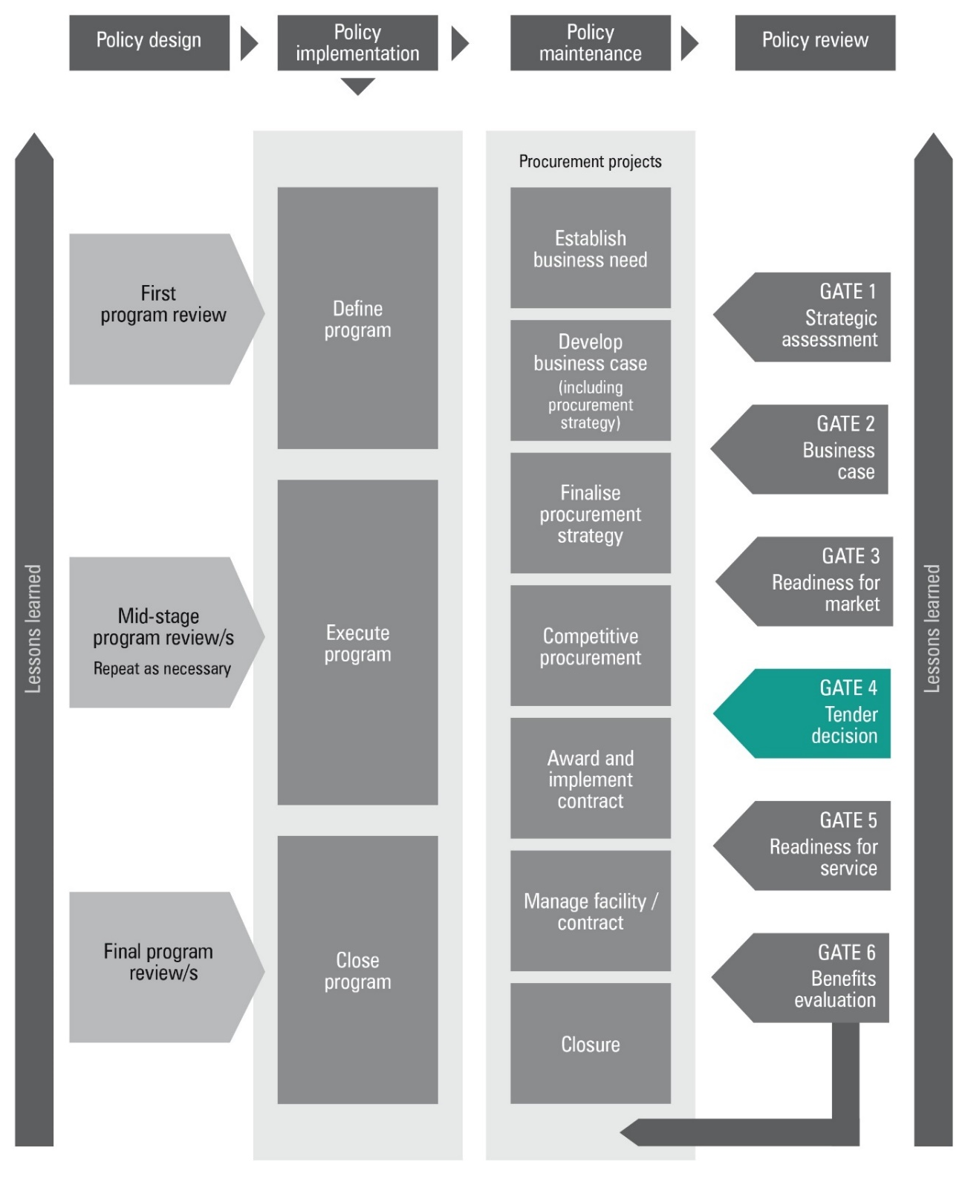

Figure 2: Applying the Gateway Review Process to different project delivery methods
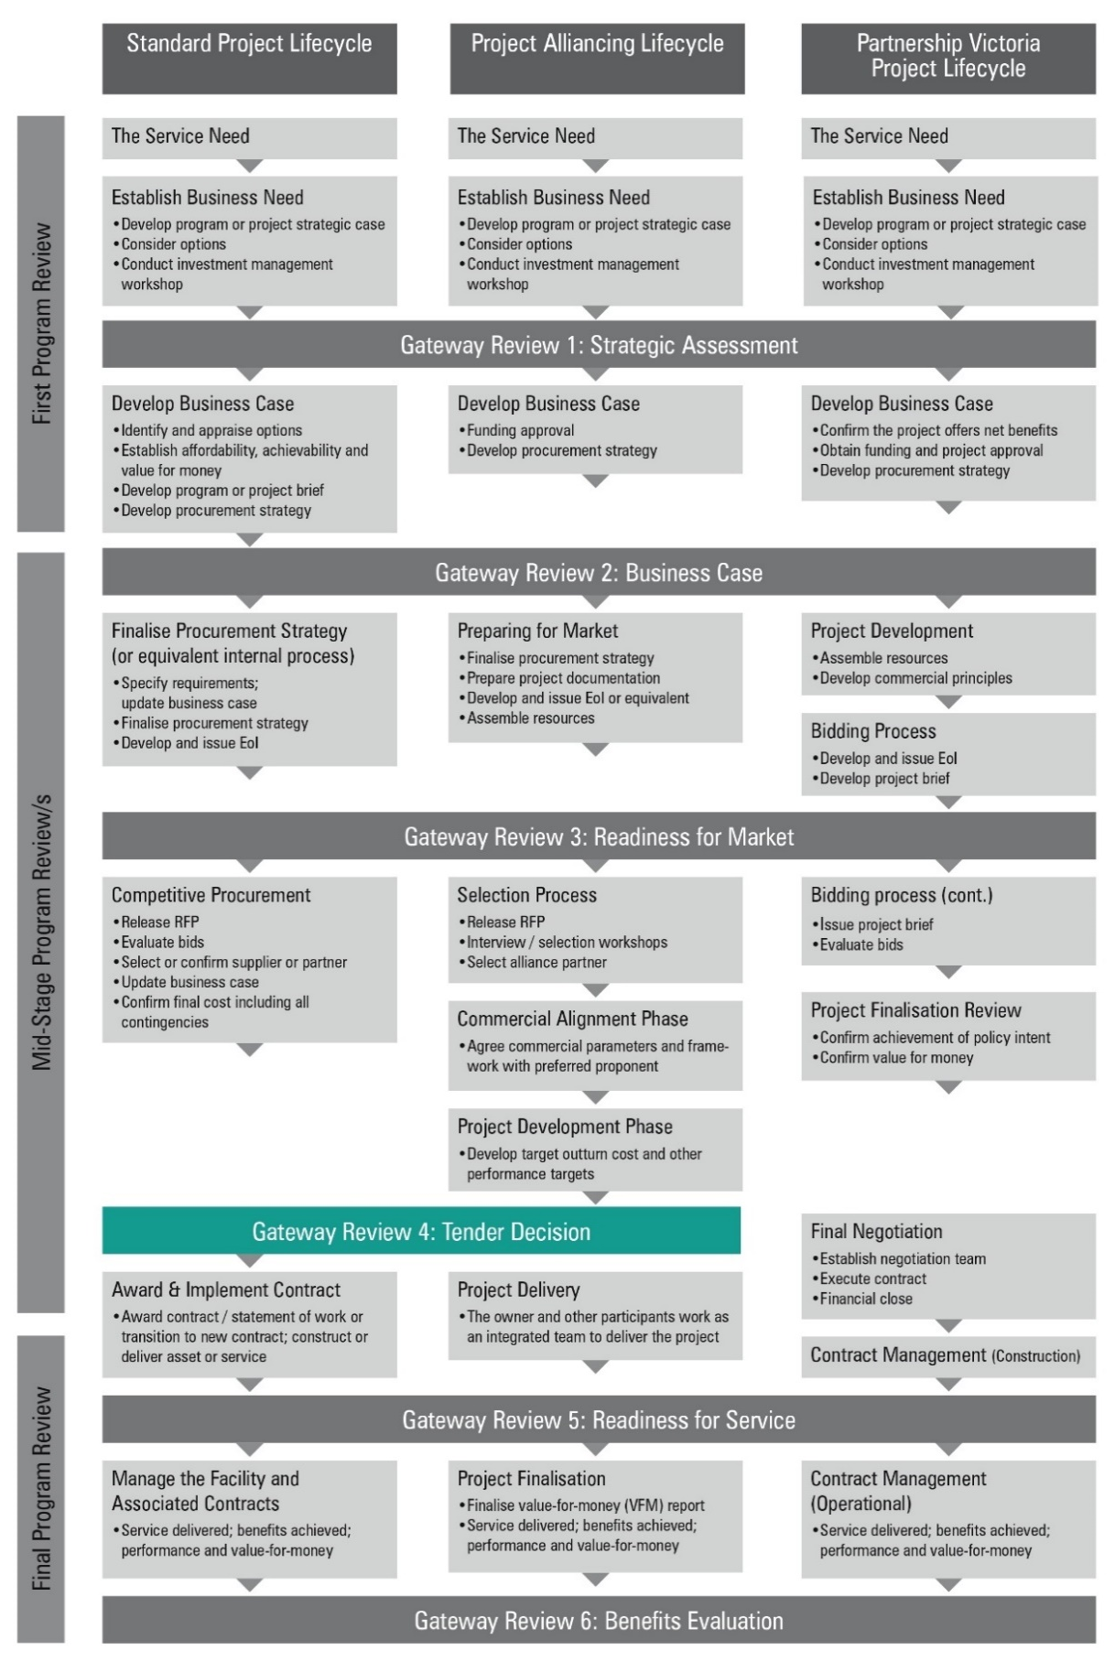

Gateway Review 4: Tender decision
The purpose of the review is to:
- confirm the business case and/or change control register and benefits management plan, now the bid information is approved;
- confirm the objectives and desired outputs of the project remain aligned with the wider organisation’s business strategy and/or the program to which it contributes;
- check all the necessary statutory and procedural requirements were followed through the procurement and/or evaluation process;
- confirm the recommended contract decision is properly executed within a standard lawful agreement and is likely to deliver the specified outputs and/or outcomes on time, within budget and provide value-for-money;
- ensure management controls are in place to manage the project through to completion, including contract management aspects;
- ensure there is continuing support for the project;
- confirm the approved procurement strategy has been followed;
- establish the level of PDDD analysis that has been undertaken and evaluate its appropriateness;
- confirm the development and implementation plans of both the client and the supplier and/or partner are sound and achievable;
- check the business has prepared for developing new processes, for implementing and operating new services or facilities and the transition process;
- confirm there are plans for risk management, issue management and change management both technical and business, and these plans are shared with suppliers and/or delivery partners;
- confirm the technical implications, such as ‘buildability’ for construction projects, information assurance and security for IT-enabled projects, and the impacts of e-government frameworks have been addressed; and
- confirm the proposed procurement meets financial approvals and has an adequate budget.

Project documents
The investigation areas and examples of evidence should be available before the review starts. The required information is likely to be found in the documents suggested below, but may be located in other program or project documents, or elsewhere in the organisation’s documentation system:
- project management documents, including:
  - strategies for managing risks and issues, plus plans and a risk register showing identified and managed risks;
  - financial impact report, which includes a snapshot of the financial performance of the project, including spend to date, cost to complete, and contingency and risk draw-down.
  - plans for implementing business change and handling future change;
  - service management documents defining how services will be managed, how performance will be measured, and outlining responsibilities for client and supplier;
  - the benefit management strategy, benefit management plans and responsibilities for delivery;
  - the delivery strategy, including a procurement strategy, if appropriate; and
  - the operational requirement and draft contract.
- business case, change control register and benefits plan for each of the acceptable bids:
  - to confirm the delivery strategy;
  - to confirm negotiated and agreed solutions remain within the original criteria;
  - realistic supplier plans for development and implementation;
  - an evaluation report recommending the selected supplier or partner; justification of the selected supplier; details of close contenders; and plans for the debriefing of unsuccessful suppliers;
  - an outline of tender decision plans and plans for the next phase;
  - an updated time plan developed with the selected suppliers;
  - an updated communications plan; and
  - confirmation of funds and authority to proceed.

    - Assessment of proposed solution
Areas to probe | Evidence expected
1.1 Does the proposed solution still meet business needs, and government and departmental objectives? | - the proposed solution complies with all requirements; and  - consultation with stakeholders and their acceptance of the proposed solution.
1.2 Have the suppliers proposed any alternatives or innovative options beyond a fully compliant bid? If so, how was this assessed? | - an assessment showing whether options benefit the project and remain within the scope of the tender documents.
1.3 Will the proposed bid deliver the business need described in the business case? | - analysis showing:  - the proposal is defined in business outcome terms;  - proposed solution is fit for purpose, meeting business objectives and anticipated benefits and delivers value for money;  - the business can achieve the necessary process changes; and  - the proposed services and service levels, as defined in the contract or agreement, meet agreed business requirements.
1.4 Has the proposed solution affected the strategy for business change and expectations of business benefits? | - an updated plan for managing change on the basis of the proposed solution, which is agreed by the project board, users and stakeholders;  - an analysis of changes to the original plan;  - an updated plan for realising benefits and descriptions of benefits and their owners; and  - changes documented and agreed with users and stakeholders.
1.5 Is the client and supplier prepared for the development including new systems and processes, implementation, transition and operation of new services? | - the proposed supplier’s development and implementation plans are included in the delivery solution and recommended to the project board; and  - the client’s implementation plan is agreed with users, or their representatives if the end-user is the citizen, and stakeholders.
1.6 Are there plans and processes to address future business and technical issues? | - all parties agree with the strategy for managing change.
1.7 Is there clear demarcation and understanding of responsibilities between all parties, beyond any contractual liabilities? | - defined client and supplier organisation, personnel and responsibilities;  - the client has identified internal relationships and interfaces describing ‘who does what’ with the supplier;  - the supplier has reciprocal arrangements, including senior management roles;  - partnering arrangements are defined;  - details of how a single supplier will manage their supply chain;  - details of how the client will manage the interface with multiple suppliers;  - the client and supplier will work together in an integrated project team; and  - if the project crosses organisational boundaries on the client side, governance arrangements will align the business objectives of all organisations.
1.8 Are there resources available for the business to fulfil its obligations within the contract and/or agreement? | - there is a plan for implementing the new contract which identifies the quantity, type and quality of resources required;  - formal management acceptance of agreed resource requirements, with key roles and personnel identified and in place; and  - adequate plans and procedures for contract management, including availability of requisite skills and experience.
1.9 Have the technical implications been assessed including ‘buildability’, health and safety and sustainability issues for construction projects, and information assurance and security, the impact of e-business and legacy systems for IT-enabled projects? | - the delivery solution is technically acceptable and has addressed PDDD findings;  - for construction projects, design quality indicators are used; there are project-specific plans for health and safety; and sustainable construction practices; and  - for IT-enabled projects, information assurance and the impact of e-business etc. has been considered.
1.10 Does the project have resources with the appropriate skills and experience to achieve the intended outcomes of the investment? | - plans for providing the required ‘intelligent customer’ capability, with names allocated to the major roles;  - an internal and external commitment to provide the resources required;  - job descriptions for key project staff;  - a skills appraisal has been undertaken and any shortfall addressed; and  - external sources of expertise can be accessed.
1.11 Does the proposed procurement meet financial approvals and is there an adequate budget for it? | - confirm financial approvals have been obtained and budgeted costs are adequate.
1.12 Do the transaction documents accurately reflect the business requirements and the risk allocation approved for the project? | - confirm the business requirements and risk allocation have been approved and details are contained in the transaction documents.
1.13 If the proposed solution identified areas of delivery risk that are higher than acceptable, then what PDDD activities have been incorporated to improve the chances of success | - detail additional PDDD activities to mitigate identified delivery risks.
    - Business case and stakeholders
Areas to probe | Evidence expected
2.1 Is the project still required? | - confirmation the project still fits with strategic objectives, including government and/or organisational objectives; and  - confirmation external factors have not affected priorities.
2.2 Are the requirements of the business case complete or does the tender decision require the change control register to be amended and/or re-assessed? | - a reassessment of the business case along with the change control register, including strategic, economic, financial, commercial and project management factors.
2.3 Does the recommended way forward meet the business need? | - the main objectives are reviewed against the final bid and proposed solution.
2.4 Has the most appropriate option been selected and has it been appropriately supported by PDDD activities? | - a cost/benefit/risk analysis against the final bid information is complete and results of the evaluation, including sensitivity analysis, are available;  - for construction project, whole-life design quality, cost and time are maximised; and  - details of supporting PDDD activities.
2.5 Does the commercial arrangement represent value-for-money, with an appropriate level of quality over the project’s life? | - market conditions, other organisational benchmarks and previous experience assessed;  - evaluation results; and  - assessment of a supplier’s funding arrangements.
2.6 Is the client realistic about their ability to manage the change? | - documented understanding of cultural implications and account taken of the current organisational culture; and  - comparison with others.
2.7 Is the business case still viable when incorporating the bid proposal? | - the business case, and change control register, incorporate bid information including:  - changes in budgeted figures;  - returns and value recalculated with new benefits plan; and  - costs compared with budget and pretender estimates.
2.8 Is there an agreed benefits-realisation plan? | - benefits management strategy and plans, including:  - critical success factors;  - those responsible for achieving benefits are identified;  - an agreed process for measuring and assessing benefits;  - measurement baselines data is available for assessment; and  - the post implementation review plan identifies review points and benefits to be assessed and payment mechanisms are linked to benefits realisation.
2.9 Have suitable stakeholders, business and user representatives been involved and have they approved the tender recommendation and draft contract? | - involvement of stakeholders and business or user representatives in reviews;  - stakeholder views have been considered;  - representation on the evaluation team; and  - project board or steering group approval.
    - Project Development and Due Diligence
Areas to probe | Potential evidence
3.1 Has a transaction management plan or equivalent been followed? | - transaction management plan or equivalent and status update.
3.2 Have additional project specific conditions and modifications been identified from evaluation? | - documentation of additional conditions and modifications and how they have been mapped into scope statement.
3.3 Have any further governance approvals been identified and have been obtained following the evaluation? | - stakeholder engagement matrix identifying relevant governance bodies and approval pathways.  - approval from relevant governance bodies.
3.4 Have any system, operator, functional or other requirements been challenged by the recommended tenderer?  Is there confidence that they understand all requirements? | - documentation of requirement challenges and the project response, along with risk assessment and impact analysis for project objectives, scope, budget and schedule.  - tender documents received accurately reflect all requirements.
3.5 Is all the necessary information available to commence the reference design? | - consideration of all completed design work, business case, risk assessment, specifications and PDDD findings and analysis.  - all requests for information by tenderer have been resolved.
3.6 Has the recommended tenderer demonstrated that the baseline is achievable?  Have all waivers been addressed? | - tenderer’s schedule reflects appropriate baseline.  - details of waiver resolution.
3.7 Has the recommended tender acknowledged the interfaces and interdependencies with the location and other projects and developed an appropriate management strategy? | - tenderer’s documentation addresses interdependency management strategy.
3.8 Have the client and operator been consulted while reference design progresses? | - details of client and operator engagement during reference design.  - document management system logs for comments and revisions.
3.9 Can the recommended tenderer deliver on Building Information Modelling (BIM) requirements? | - tenderer’s documentation addresses BIM strategy and how it will deliver to requirements.  - BIM target maturity level defined for the project.  - BIM requirements defined in information management plan.  - BIM system / platform evaluation and determination of key roles undertaken.  - required BIM data sets defined for the project and mapped into contract requirements.
3.10 Have all necessary approvals been obtained prior to contract award? | - stakeholder engagement matrix identifying relevant governance bodies and approval pathways.  - approval from relevant governance bodies.
3.11 Have all processes related to land acquisition been completed? | - land acquisition requirements assessment.  - completed register of required land acquisition.
3.12 Are all approvals in place to award the contract? Is funding available? | - stakeholder engagement matrix identifying relevant governance bodies and approval pathways.  - approval from relevant governance bodies.  - confirmation of funding sources and availability.
3.13 Have all management plans been updated to reflect the latest changes and ready to enter delivery phase? | - review of all management plans.  - project change register that reflects any changes since business case approval.
3.14 Has the project management plan been updated with the reporting process clearly noted? | - project management plan.
3.15 Is there an analysis of the real or potential impact of any operational interfaces and interdependencies? | - interface management plan.
3.16 Has a work breakdown structure (WBS) been established and agreed with the finance division? Does it align with the finance’s cost breakdown structure (CBS) to allow earned value reporting? | - Defined WBS dictionary.  - cost and schedule management plans.  - alignment of cost breakdown structure (CBS) and work breakdown structure (WBS).
3.17 Has the communication and media protocol been identified and provided in a matrix? | - communication management plan.  - media management training plan.
3.18 Is there time or budget contingency to allow for possible impacts? | - risk and opportunity management plan.  - time phased risk register with costed (time and money) risks.  - budget incorporates costed risks as well as unknown risks.
3.19 Has the tender schedule been updated to the contractor's approved schedule? | - final project schedule with critical path and baseline compared with actual delivery schedule.
3.20 Are there project assurance milestones? | - updated project management plan.
3.21 Is the management plan consistent with the RFT document? | - updated project management plan.
3.22 Has a change request management process been identified? | - updated project management plan.
3.23 Has the stakeholder engagement plan been updated for delivery phase? | - updated stakeholder management plan.
3.24 Has the planning approval process document been updated? | - updated stakeholder engagement matrix identifying relevant governance bodies and approval pathways.
3.25 Does it adequately attempt to create minimum disruption to the surrounding area? | - traffic or logistics management plan.  - community engagement plan.
3.26 Have plans been developed to mitigate any potential impacts to adjacent property, business or other projects? | - interface management plan.  - community engagement plan.
3.27 Is there an assessment of noise and vibration levels from the project? | - updated noise and vibration assessment and plan.
3.28 Is there a comprehensive OHS plan? Have all safety incidents been documented? | - health and safety management plan.  - incident management system and process.
3.29 Has the CMP been updated to reflect contactor's approved strategy and defects management? | - updated construction management plan.  - defect register and management process.
3.30 Have you received confirmation that all drawings are submitted to the appropriate drawing management system? | - drawing management system and acquittals log
3.31 Have project objectives and benefits been identified and benefits management plan been updated? | - updated benefits management plan

    - Risk management
Areas to probe | Evidence expected
4.1 Are risk and issue management plans up-to-date? Are they being monitored? | - the risk register and issue log is regularly reviewed, updated and acted upon.
4.2 Have all major risks that arose during this stage been resolved? | - risk and issue management plans and the risk register have been updated to include risks associated with project resourcing and funding; team competencies; legislation; technical dependencies; users and stakeholders and any risks associated with earlier PDDD findings and analysis. Owners of risks and/or issues have been assigned under the client’s risk transfer plans.
4.3 Are arrangements in place to minimise risks to the business in the event of major problems during implementation and roll-out? | - a business continuity and contingency approach has been agreed with stakeholders and suppliers;  - business or client continuity and contingency plans are under development;  - an assessment of supplier continuity and contingency plans; and  - for IT-enabled projects, information assurance including risk assessment and management is in place.
4.4 Does the contract reflect the standard terms and conditions, and the required level of risk transfer? | - contracts comply with standard terms and conditions;  - any changes to standard terms and conditions are assessed; and  - an analysis of the risk allocation proposed by supplier or partner versus expectations of the client.
4.5 For longer term partnering contracts, have the retendering issues been considered? | - plans for an exit strategy at the end of the contract, with appropriate review points built in over the contract’s life to update these arrangements.

    - Review of current phase
Areas to probe | Evidence expected
5.1 Is the project under control? | - project is running to schedule and costs are within budget; and  - recommendations from the last Gateway review have been acted upon.
5.2 What caused any deviation such as over and under-runs? | - reconciliations set against budget and time plan.
5.3 What actions are necessary to prevent deviations recurring in other phases? | - analyses and plans are included in project documentation which is continually updated and reviewed.
5.4 Have all PDDD findings and analysis from Gateway Reviews 1, 2 and 3 been validated and mitigated? | Validation or mitigation of all due diligence findings and analysis. Any that cannot be validated or mitigated are examined, appear in the risk register and/or issue management log, and are assessed and discussed with potential suppliers and partners.
5.5 Have all the required organisational procurement and technical checks been undertaken? | - review of bid management and approval processes;  - compliance with relevant procurement policies and guidelines;  - the evaluation strategy, underpinning models and criteria have been followed; and  - compliance with statutory requirements such as planning and building regulations.
5.6 Did the project team follow the steps in the delivery strategy? | - documented information confirms activities and processes in the delivery strategy and plan were followed.
5.7 Has the procurement process adequately managed probity? | - probity advisor or equivalent sign off.

    - Readiness for next phase: Readiness for service
Areas to probe | Evidence expected
6.1 Is the working relationship likely to succeed? | - realistic assessment of management style and/or behaviours on both sides;  - appropriate level reporting arrangements are identified on both sides;  - suitable procedures and responsibilities for contract management are defined and agreed;  - plans for partnering workshops are in place;  - continuity of personnel from the contract award phase into the implementation phase; and  - for construction projects, there are plans for integrating the project team.
6.2 Are all resources and internal funds in place? | - budget provision;  - agreed human resource;  - subsequent years’ expenditure included in program or project budgets;  - an authorisation and/or approval process for payments to suppliers;  - a process for expenditure reporting and reconciliation; and  - insurances established by supplier.
6.3 Are the supplier’s project, risk and management plans adequate and realistic? | - confirmation the project plan meets timescale;  - realistic implementation and risk management plans; and  - are the appropriate long lead time items and PDDD plans in place.
6.4 Do the client’s plan reflect the supplier’s plan, and vice versa? | - updated project management plan reflects tender proposals;  - defined client organisation, personnel and responsibilities;  - supplier personnel cleared to meet project requirements;  - process for resolving issues agreed with supplier and/or partner; and  - all plans have been reviewed, agreed and included in the contract.
6.5 Has an appropriate level of PDDD analysis been undertaken for the next phase? | - PDDD analysis and findings.
6.6 Are the long-term contract administration plan and benefit measurement process complete? | - long-term plan includes contract management strategy and a detailed service delivery plan;  - identified sources of resources;  - benefit measures agreed with supplier and/or partner;  - project plan shows resource requirements have been identified, planned, budgeted for and are available; and  - defined roles and responsibilities.
6.7 Are all the mechanisms and processes in place for the next phase? | - project plan confirms arrangements for management, monitoring, transition and implementation; and  - external consultants are accountable and committed.
6.8 Are the service management plan, administration and service level arrangements complete? | - documented service management strategy and plan;  - defined and agreed service level management, service levels, quality and measurement;  - defined responsibilities for each party;  - defined and agreed standards for services; and  - defined and agreed monitoring, reporting and review mechanisms.
6.9 Is the management process for service change complete? | - technical and business change control procedures are defined, agreed and included in the contract; and  - defined and agreed management process and responsibilities.
6.10 Is there an acceptance strategy or commissioning strategy? | - an acceptance and/or commissioning strategy and plan, with fully documented and timetabled decision paths;  - decision makers clearly identified and informed about their role and the information they will be given;  - agreed acceptance criteria; and  - a validated acceptance testing plan, including technical and business components.
6.10 Is there an implementation strategy? | - implementation strategy and plan;  - users, stakeholders and client business management are involved in developing strategy;  - organisational transition plans;  - clearly defined roles for client and supplier to monitor and control handover; and  - clearly defined training roles for client and supplier.

Appendix A: Best practice sources
Source | Information
Investment management guidelines  See Investment management  www.dtf.vic.gov.au/infrastructure-investment/investment-management-standard | - investment management standards  - investment logic maps  - investment concept briefs  - benefit management plans
Investment lifecycle guidance  See lifecycle guidance:  www.dtf.vic.gov.au/infrastructure-investment/investment-lifecycle-and-high-value-high-risk-guidelines  See PDDD guidance  https://www.dtf.vic.gov.au/investment-lifecycle-and-high-value-high-risk-guidelines/stage-1-business-case | - business case development guidelines, including strategic assessment guidance  - procurement strategy guidelines  - project tendering guidelines  - risk management guidelines  - Project Development and Due Diligence guidelines
Procurement advice, policy and guidelines  Victorian Government Purchasing Board  - www.procurement.vic.gov.au | - longer term contract management  - contract variations
- www.infrastructure.gov.au/infrastructure/ngpd | - National guidelines for Infrastructure Projects
- www.dtf.vic.gov.au/infrastructure-investment/public-private-partnerships | - Social Procurement Framework
- www.dtf.vic.gov.au/public-construction-policy-and-resources/ministerial-directions-and-instructions-public-construction-procurement | - Ministerial Directions and instructions for Public Construction Procurement
- www.dtf.vic.gov.au/infrastructure-investment/market-led-proposals | - Market-led proposals guideline
PPP projects  For the National PPP policy and guidelines, see  www.infrastructureaustralia.gov.au  Specific Partnerships Victoria requirements apply, see  www.partnerships.vic.gov.au | - contract management policy and guidance material
Project alliancing  See Project alliancing at www.dtf.vic.gov.au | - Project Alliancing Practitioners Guide
Information and Communications Technology (ICT) projects  www.enterprisesolutions.vic.gov.au  www.dtf.vic.gov.au/infrastructure-investment/high-value-high-risk-framework | - Guidance on High Value High Risk projects including ICT projects  - ICT-related strategy, standards, policies, project dashboard, and  - technical resources for Whole of Victorian Government (WoVG).
Asset Management Accountability Framework  Department of Treasury and Finance  www.dtf.vic.gov.au/infrastructure-investment/asset-management-accountability-framework | - further information about government asset management expectations including acquiring new assets  - other general information
Gateway Review Process  www.dtf.vic.gov.au/infrastructure-investment/gateway-review-process | - Gateway Guidance material  - Becoming a Gateway reviewer

