Investment Management Standard 2017
Technical Guide for Facilitators –
Response Definition workshop

The Secretary
Department of Treasury and Finance
1 Treasury Place
Melbourne Victoria 3002
Australia
Telephone: +61 3 9651 5111
Facsimile: +61 3 9651 2062
dtf.vic.gov.au

Authorised by the Victorian Government
1 Treasury Place, Melbourne, 3002

© State of Victoria 2017
You are free to re-use this work under a Creative Commons Attribution 4.0 licence, provided you credit the State of Victoria (Department of Treasury and Finance) as author, indicate if changes were made and comply with the other licence terms. The licence does not apply to any branding, including Government logos.

Copyright queries may be directed to IPpolicy@dtf.vic.gov.au

ISBN 978-1-925551-42-6
Published May 2017

If you would like to receive this publication in an accessible format please email information@dtf.vic.gov.au

This document is also available in Word and PDF format at dtf.vic.gov.au

Contents
Purpose of this document 1
What are the differences between IMS edition 5.0 and IMS 2017? 1
1. Context for the Response Definition workshop 3
1.1 Is a dedicated Response Definition workshop always required? 4
1.2 Timing of the Response Definition workshop 4
2. Response Definition workshop 6
2.1 Purpose of a Response Definition workshop 6
2.2 Responsibility of the facilitator 7
2.3 Who should be there? 7
2.4 What preparation is required? 8
2.5 Before the workshop 8
2.6 At the workshop 9
2.7 After the workshop 19
2.8 Templates, examples and other resources 20
Appendix 1: 16 Questions – Investment decision-maker’s checklist 21
Appendix 2: Shaping new investments using the IMS 23
Appendix 3: Fictional – Response Options Analysis Report and worksheets 25
Appendix 4: Design guidelines – Response Options Analysis Report 32
Appendix 5: Sample email – before the Response Definition workshop 34
Appendix 6: Checklist – Response Definition workshop 35
Appendix 7: Sample agenda – Response Definition Workshop 36
Appendix 8: Difference between risk and uncertainty 37
Appendix 9: Sample email – after the Response Definition workshop 38
Appendix 10: Quality assessment form – Response Options Analysis Report 39

Purpose of this document
This is the third of four guidance documents within the ‘shape a new investment’ series of IMS Technical guides for facilitators. It primarily targets facilitators and provides practical guidance on how to lead a successful initiative-level Response Definition workshop, and prepare supporting documentation which is consistent with the Investment Management Standard (IMS) Version 6.0.
This guidance assumes users have read and understood the IMS – its principles, practices and the theory on which it is built. (The IMS is available at the investment management website, www.dtf.vic.gov.au/infrastructure-investment/investment-management-standard.) It also assumes that users are familiar with the guidance material for the Problem Definition and Benefits Definition workshops.
Section 1 outlines the context and objectives for the Response Definition workshop.
Section 2 describes how facilitators should approach, conduct, and conclude the workshop.
Appendices contains additional materials which may be useful for facilitators.

What are the differences between IMS edition 5.0 and IMS 2017?
IMS 2017 is the first update to the IMS since 2013. Over this period there has been an increased focus on improving the planning and delivery of infrastructure investments, and on using real options analysis to manage related uncertainty. In response, the Department of Treasury and Finance has updated its ‘Investment Lifecycle and High Value/High Risk’ (HVHR) framework to provide advice on incorporating real options analysis when developing business cases and procurement strategies. The related guidelines are available at www.dtf.vic.gov.au/investment-lifecycle-and-high-value-high-risk-guidelines/stage-1-business-case.
The 2017 update reflects these changes and includes several enhancements to refine the workshop process and the development of an Investment Logic Map (ILM), and the other documents in the IMS suite. These incorporate the feedback and experiences of both those involved in the workshops and the end-users of ILMs. The major changes are:
- more detailed advice on preparing for a workshop;
- clearer definition of the preferred participant types for each workshop;
- greater and more explicit consideration of uncertainty during the workshops including identifying investments which may need real options analysis;
- increased focus on determining the quality and availability of evidence throughout the workshop process;
- a reshaped and more robust Benefit Definition workshop which tests alignment with Government policy, or other relevant strategic drivers, and focuses on the integrity of KPIs and measures;
- restructure of the Response Definition and Solution Definition workshops to clarify the objectives of each and to ensure both are more intuitive, robust and make a valuable contribution to decision-making;
- consequential changes to the supporting documentation for all the workshops; and
- amendments to the 16 questions – decision-maker’s’ checklist (Appendix 1) to include more consideration of uncertainty and reflect the changes described above.

    - Context for the Response Definition workshop
The ability to select the investments that provide the most benefit to society is a key component of good government. This is often a complex exercise requiring the contributions of many people, each of whom bring their specialist skills and perspectives.
The Investment Management Standard (IMS) is a process for applying simple, common-sense ideas and practices that help organisations direct their resources to deliver the best outcomes from their investments. The IMS addresses many of the issues that arise during investment decision-making and aligns with the HVHR business case guidelines, and templates. In the context of the IMS and these guidance documents, DTF defines investment as ‘the commitment of the resources of an organisation with the expectation of receiving a benefit’.
The IMS helps decision-makers determine whether:
    - there is a real, evidence-based problem that needs to be addressed now;
    - the benefits which will be delivered through successfully addressing the problem are of high value to the organisation and the community;
    - the benefits’ KPIs are meaningful, measurable and attributable to the investment and are worth tracking and reporting;
    - the way the problem will be addressed is strategic, feasible, and innovative;
    - the solution is likely to be delivered within time and budget constraints; and
    - the solution can be applied flexibly to manage and respond to uncertainty and adapt to changing conditions and demand.
The IMS includes a set of 16 questions (the Investment Decision-maker’s Checklist) which address the four IMS elements - problem, benefits, response and solution. Each element asks key questions that enable decision-makers to make sensible and informed investment decisions. The depth of enquiry for each question will depend on the scale and complexity of the investment. These questions correlate with key elements of the Victorian government full business case template and aid business case writers and assessors.
The relevant questions that the Response Definition workshop should explore and help to answer are:
Table 1: Investment decision-maker’s checklist – response
Response – Investment decision-maker’s checklist
9. Has a reasonable spread of interventions been identified and packaged into sensible response options? | Yes | Maybe | No | Not sure
10. Is there evidence to demonstrate that the response options are feasible and can respond to future uncertainty? | Yes | Maybe | No | Not sure
11. Were the options evaluated fairly to reflect their ability to respond to the problem and deliver the benefits? | Yes | Maybe | No | Not sure
12. Is the preferred response option the most effective way to address the problem and deliver the benefits? | Yes | Maybe | No | Not sure

The IMS practices are focused on the early stages of shaping investments and on the evidence required to understand and validate the investment need or problem, articulate the benefits that will be delivered, and shape a robust indicative solution (Appendix 2-Shaping a new investment using the IMS). The practices also enable the tracking of benefits and support evaluation of the effectiveness of the investment.
      - Is a dedicated Response Definition workshop always required?
Shaping a new investment provides an opportunity to challenge the way government has solved problems in the past. Whilst tried and tested approaches may indeed be the best way to proceed, it is vital that decision-makers explore other responses which may be more effective, adaptable, or enduring.
The Response Definition workshop provides a structured forum to examine a range of responses, not just the most obvious one, which could address the identified problem and deliver the desired benefits. The workshop’s focus is very much on the ‘how’ of the investment rather than the ‘what’, and will generally be required when:
    - no ‘obvious’ response to the problem has been validated and new thinking is genuinely required;
    - the investor wants to get an overview of the possible responses and indicative benefit delivery, risks, dis-benefits, costs, and timeframes before deciding whether further development of the investment is warranted;
    - the nature, scale, complexity, level of impact, and potential cost of the investment requires more detailed analysis and exploration of options (e.g. HVHR); and
    - the external environment is subject to material uncertainty or there are significant interdependencies with other organisations or policy initiatives.
This workshop generally requires some sophistication, imagination and innovation from the participants and the facilitator. Practitioners will generally need to do more preparation for this workshop than for the Problem Definition and Benefit Definition workshops.
      - Timing of the Response Definition workshop
The time between the Problem and Benefit Definition workshops and the Response Definition workshop is usually between two and eight weeks depending on organisational readiness, the scale and complexity of the investment, the availability of dedicated resources to prepare for the workshop, and the stage of the budget process. For example, if the:
    - organisation is preparing a strategic assessment and is at an early stage in the budget process, it can probably move quite quickly (i.e. within two to four weeks) into the Response Definition workshop with the expectation that the workshop’s output may undergo more detailed analysis during the preparation of a subsequent full business case; or
    - investment is complex and costly and/or qualifies as HVHR, more preparation will be required prior to the Response Definition workshop and dedicated resources may need to be allocated. In this case, the full eight weeks may be required.
Above all, for the workshop to be successful, the investor and the participants must have started thinking about potential responses and interventions before the workshop.
It is also critical that the KPIs developed in the Benefits Definition workshop have been fully accepted by the investor, and the organisation, as these are used in the Response Definition workshop to rate interventions. Specific measures, their baselines and targets may be refined in the business case, as its evidential base is developed, but they do need to be reasonably well-defined in advance of the Response Definition workshop.
The facilitator may need to manage the expectations of the investor in respect of timing as the workshop’s value will almost certainly be undermined if the participants, and the organisation, are not ready.

    - Response Definition workshop
      - Purpose of a Response Definition workshop
The two previous workshops focused primarily on determining the problem driving consideration of a new investment, and defining the benefits that will demonstrate the investment’s success.
The Response Definition workshop assumes that the previous workshops have been completed, and focuses on identifying and assessing different approaches to resolving the problems and delivering the benefits - the ‘how’ of the investment.
Specifically, the workshop will:
    - agree a suite of realistic response options which can deliver the KPIs and resolve the problem;
    - identify a range of high-level interventions associated with each of these response options;
    - assess and rank the response options on their KPI delivery, relative risks and uncertainties, interdependencies, and dis-benefits; and
    - select an initial preferred response.
Figure 1 depicts the place of this discussion within the ‘line of enquiry’ that underpins the IMS. It also describes the three individual steps within the discussion.
Figure 1: Line of enquiry –Response Definition workshop
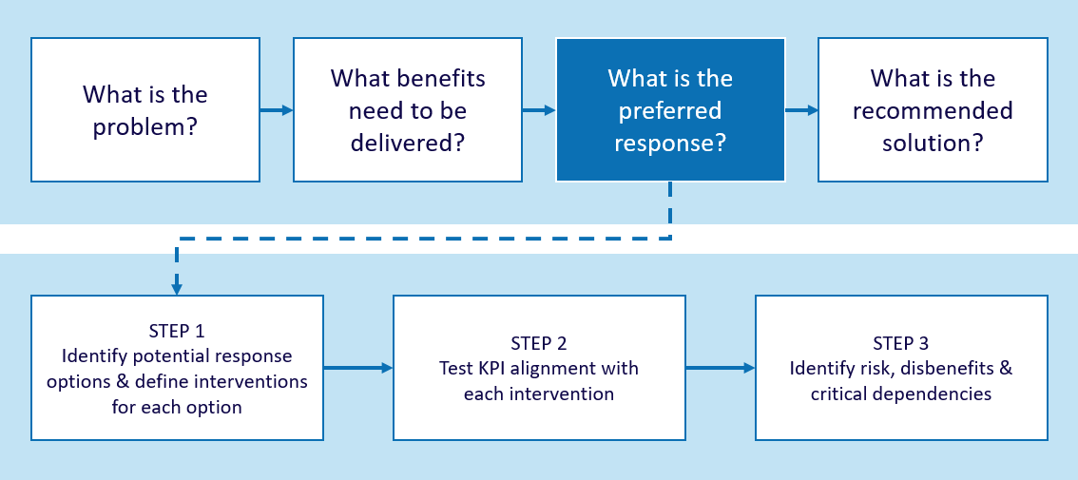

For projects requiring resources over the medium-long term (especially large infrastructure investments and assets), an assessment of how effectively each response option deals with uncertainty is an important element of this workshop. You should consider what circumstances would lead to the preferred response being ineffective or inappropriate, and where a different response would be preferable. Any uncertainty identified should be recorded.
The key output of the workshop is an agreed range of response options to deliver the benefits and address the problem. This information is captured in the form of a Response Options Analysis Report and supporting worksheets (Appendix 3).
You should note that not much time is spent in this workshop determining cost estimates or timelines. This reflects the workshop’s primary objective to find the best response to the problem, without undue focus on budgetary considerations. It also acknowledges that reliable costs are, in any case, rarely derived in a 2-hour workshop where not all the resources may be available to participants.
The investor should appoint an internal nominee to complete more detailed work on cost estimates and timelines after the workshop. They should update participants on this work before the Solution Definition workshop, the fourth and last workshop in the IMS series. This will ensure that a value-for-money perspective is considered. This may change the initial ranking of response options.
      - Responsibility of the facilitator
It is your responsibility to help the participants develop the most compelling, evidence-based case for the investment that they can.
To be successful, you must:
    - try to ensure the right people attend and that two hours have been allocated for the discussion;
    - circulate (via the Investor) a list of potential interventions to initiate the workshop discussion. These will be derived from the discussion in the Problem Definition workshop (see the Cause section of the problem trajectory diagrams);
    - conduct the discussion following the guidance provided in this document; and
    - finalise the discussion and documentation within 48 hours.
You should refer to ‘Design guidelines – Response Options Analysis Report for some tips on preparing a high-quality report.
      - Who should be there?
The key person is the investor who owns the problem and who will be responsible for delivering the benefits if the investment is funded. Participants from the previous workshops who have most knowledge of the problem environment should also attend.
Some people may drop out and others may join as different skills and experience will be required to stimulate the discussion. However, it is important for continuity that about 60% of participants have also attended the Problem and Benefit Definition workshops. Others participants who may be useful at as this stage include:
    - the Chief Financial Officer/Chief Information Officer/Chief Strategy Officer/Human Resource Director or similar senior staff who have an overarching view of the organisation and understand any internal independencies;
    - innovative and objective thinkers who can question the old ways of operating and suggest different ways of responding to a problem;
    - those who are experienced in implementing and designing solutions;

    - strategists who understand how the investment will assist in delivering broader organisational and government-level goals and policies; and
    - the business case developer (if already identified), who can learn more about the potential investment and act as a common-sense check of the discussion.
It will generally be helpful if some participants are external to the organisation as this should provide different perspectives.
The most effective group size is usually six to eight participants, depending upon the nature of the investment.
      - What preparation is required?
The workshop will not succeed unless there is a clear and common understanding and agreement about the problems, benefits and KPIs. To reinforce this, it is important that, prior to the workshop, the investor:
    - confirms that the KPIs specified in the Benefit Map are as well-developed as possible with baselines determined and indicative targets set;
    - briefs any new participants, particularly those with solution or implementation skills, so that they come to the workshop with a clear understanding of the preceding discussions;
    - ensures that participants have reviewed the current ILM and Benefit Map together with the list of potential interventions provided by the facilitator (see 2.2); and
    - encourages participants to think about other interventions not included in the facilitator’s list, and overall responses ranging from the least complex (do minimum) to the most complex and far-reaching.
      - Before the workshop
Confirm the investor has undertaken the required preparation, as outlined in Section 2.4.
Confirm the investor is attending the workshop, and has identified the other appropriate participants.
You should ask the investor to send an email outlining the purpose of the discussion to the participants attaching:
    - an overview of the IMS framework and how the Response Definition workshop fits in;
    - the current ILM and Benefits Map;
    - your list of potential interventions indicating that these will be tested and additional interventions identified during the workshop; and
    - examples of the documents that this session is aiming to produce (these can be found at www.dtf.vic.gov.au/investmentmanagement).
You may find it helpful to tailor the Sample email – before the Response Definition workshop (Appendix 5) and provide this to the Investor.
Make sure that the venue has been reserved 30 minutes prior to the start of the workshop, can accommodate the number of participants comfortably, and has two suitably sized whiteboards.
      - At the workshop

Setting up the whiteboard
Arrive 30 minutes beforehand and set up the whiteboards. You will need at least two screens to cover three to four options It is preferable to have two whiteboards or one plus a flip chart. Figure 2 illustrates how a single response option can be laid out on one whiteboard. This will be repeated for each option.
Figure 2: Suggested whiteboard layout for one response option
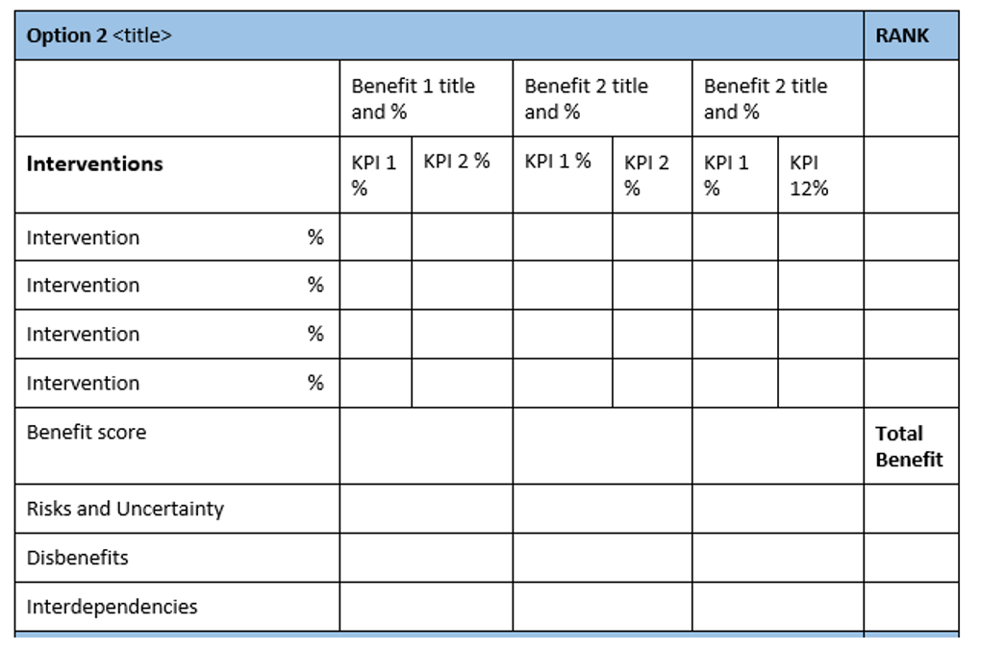

Structuring the workshop
The structure and time allocation within the Response Definition workshop will depend on the size and complexity of the proposed investment.
DTF recommends you roughly map out how you aim to structure the workshop in terms of the time allocated to each section. This structure may change depending on how the discussion progresses or if it is discovered that the investment is more, or less, complex than previously thought. The Checklist - Response Definition workshop (Appendix 6) provides an overview of the steps that should be completed in this workshop.

Timing
This workshop is time-constrained and you will need to manage it very carefully. You should maintain awareness of this time pressure throughout the discussion.
Allow for an initial discussion around the range of options and the filters of demand, productivity and supply to elevate the thinking from a solution view to a higher-level perspective. This is likely to take 15–20 minutes.
Focus on identifying three to four robust response options in addition to the Business as Usual/Do Nothing option. Only occasionally will this extend to five options and, if it does, this will put pressure on the workshop timing.
Defining the interventions associated with each of these response options is likely to take up a significant proportion of the workshop (approximately 50 minutes). It is time well spent though, as a clear understanding of the broad intent and scope of each intervention will make assessment and indicative costing more realistic and meaningful.
Assessing the relationship between each intervention and the KPIs outlined in the Benefit Map will take about 20 minutes. This will ensure tight alignment between the response and the delivery of benefits and KPIs. The resulting weighted benefit score will provide a clear demonstration of the value of the investment.
Assessing each option against the key criteria of risk, uncertainty, dis-benefit, and interdependency, will take the remaining time in the workshop.
Appendix 7 includes a sample agenda for a Response Definition workshop.

Set expectations
It is a good idea to set some general expectations at the start of the workshop:
    - you expect people to be at the workshop for the full two hours;
    - phones should be turned off, including messaging and email; and
    - polite behaviour within the group is expected but this should not compromise the robust and probing nature of the discussion. This is a workshop where you expect high levels of participation and contribution from those at the table.

Step 1: Set the scene
Set the context and objective of the workshop, the roles of each participant, the approach, the time criteria and your role. Unless everyone is clear about their roles, time will be lost as the workshop proceeds. This is particularly important where the number of people is larger than recommended.
Hand out copies of the ILM as it stands and take the participants through it so they understand the problem that needs to be solved, and the benefits (and KPIs) that must be delivered.
Why are we here?
[Hand out the current ILM and Benefit Map, to those who haven’t arrived with their copy, and a sample Response Options Analysis Report.]
In the Problem and Benefit Definition workshops we have carefully defined the problems to which this investment is responding, and the benefits and KPIs it will be delivering. At this workshop, we will be exploring how we could respond to these problems and deliver these benefits and KPIs. Too often investments in government are directed at increasing the supply of some service – roads, hospitals, schools, etc. We now want to get everyone to think more strategically and more broadly about what approaches could be adopted to respond to a problem instead of merely trying to justify a predetermined supply solution.
Refer to the copy of the ‘Example – Response Options Analysis Report’.
This is to demonstrate the outcome we are looking for in this discussion (for other examples go to www.dtf.vic.gov.au/investment-management-standard/ims-workshops-and-examples).
The Response Options Analysis Report specifies the responses that were considered in this example, and their assessment against a range of criteria to help the preferred response that was incorporated into the ILM. The report provides an easy to read summary of the response options and analysis.
What is my role?
You will remember that my role as the facilitator is to be content free, although clearly after two workshops I am more familiar with the context, need for, and potential value of this investment. My aim is to help you tell the best investment story that is possible, achievable and can be supported by verifiable evidence. In this workshop, we are focusing on ensuring that we have genuinely considered a range of options prior to recommending our preferred option.
The investor’s role
As the investor you are the most important person in the room. This is your forum and you are responsible for the delivery of the benefits claimed for this investment. The key decisions in respect of this investment will be your responsibility.
Other participants
You are here to assist the Investor to think strategically and creatively about the range of options that could be considered. Many of you were participants in the previous workshops. You have been selected to participate because you know most about this investment, and its impact, and it is your insights that will help to shape and bring rigour to this investment story.

Step 2: Define the range of response options
The purpose of this step is to create a range of response options that participants can compare against one another.
Each response option is a strategic approach to resolving the problem and delivering the benefits and is typically made up of between one and four key interventions. Option 1 is always a Business as usual/ Do nothing/Stop investing option.
In the past, we started with defining interventions and then packaging these into responses. Experience over the last four years has, however, indicated that groups are often more comfortable defining the range and focus of the response options first and then describing the interventions that support the option.
There are a couple of ways to approach this. You could start with the least complex, do minimum option and then consider the remaining options in increasing complexity. This is outlined in the blue box below. Alternatively, we have found that some groups find it easier to shape responses by thinking about the least complex and then the most complex option and then describe those that fall between. Whatever the approach taken, you ideally want to arrive at a suite of potential responses, recorded on the summary whiteboard, which reflects a continuum from least complex to most complex. At this stage, it is only necessary to record each response option title in the summary table on the whiteboard.
Identifying a range of response options
Let’s review our ILM and Benefit Map to reconfirm context. We also circulated a list of potential interventions that were based on the cause elements of the problem statements, and the discussion during the Problem Definition workshop.
Firstly, let’s clarify what a response option is. It is a combination of interventions that when packaged together form a response. Each response that we shape should seek to resolve the problems and deliver the benefits, KPIs and target measures. They will just do it in different ways. Option 1 is the Business as usual/ Do nothing/Stop investing option and is already listed on the whiteboard. However we will not be spending much time on this option other than to determine the disbenefits.
Now, ‘What’s the simplest (least expensive?) response that we could consider?
Let’s call this option 2.’
Then ask either, “Well what could we do next?” (call these Options 3 and 4) or “What is the most complex, innovative and potentially costly approach we could take?” (call this Option 5)
Review the response options to ensure that they represent a broad coverage and include a focus on changing demand, improving productivity and changing supply.
To help participants think more broadly than any preconceived ideas they may have of what a solution may look like, a structured series of questions can help draw out a fuller range of potential interventions. In an environment of constrained resources, it is critical that the range of interventions considered includes those that can manage demand for services, as well as those that can improve the productivity of the existing services being delivered.
You should invites workshop participants to first consider:
    - What options does the Government have to manage demand for a service? This could include user charging, rationing or queueing.
    - What options does the Government have to increase the productivity of the existing service? This could include options such as removing seats in trains, or traffic treatments that improve the flow of vehicles.
Once the viability of options to manage demand and improve the productivity of existing investments have been considered, if there is a residual requirement for further services or investment, then supply side options can be considered:
    - What options does the Government have to increase the level of service provision through new investment in assets or programs.
Responses will generally use a mix of demand, supply and productivity interventions but are likely to have a dominant lever. For example: an option that is focused on changing demand may have its most important intervention focused on reducing demand for a particular service (60%) and its remaining interventions aimed at improving the efficiency and productivity of some internal processes 40%.
Other ways to expand thinking for those in the government sector is to consider the tools that government has at its disposal. For example, government can:
    - use its legislative and regulatory functions;
    - change behaviour of key stakeholders and audiences through incentives, education, market tools, instruments, etc.;
    - improve its internal organisation, functionality and services; and
    - invest directly in structural and supply options to achieve a desired change or improvement.
Continue to ask for responses until you have a representative suite of reasonably robust and realistic options, generally around four, in addition to Option 1 (‘business as usual’).
More options may also present themselves when further analysis takes place after the workshop, and this may need to be revisited in the Solution Definition workshop.

Step 3: Identify potential interventions
There is often confusion in the minds of participants between the response option and the interventions within it. Interventions differ from responses in that they are specific actions that respond to one or more problems and deliver one or more KPIs. The combination of 1-4 interventions that are packaged together becomes a response option. The response title will often reflect the intent of the highest weighted intervention.
Interventions should be at a sufficiently high level that there is more than one way it can be implemented. This prevents the group from jumping to specific solutions too quickly. Interventions also typically start with a verb/action such as improve, create, enhance, rationalise, reconfigure, refocus, understand, align, streamline.
Start with Option 1, the Business as usual/ Do nothing/Stop investing option. This option can usually be dealt with quite quickly as the intervention is typically “Continue to…” and is usually weighted at 100%.
Then focus on Option 2 and review the initial intervention list that you circulated with the pre-workshop preparation. Ask whether any of these interventions are important to this particular response. Next consider other interventions that might be included. These could be new interventions and may be developed for the first time in this workshop.
It is useful to note some attributes about each intervention. This makes it clearer to all participants what is included in each response. The attributes will necessarily be brief, dot points but will be helpful in both describing the intervention as well as defining the solution later, if this option becomes the preferred response.
Continue to cross check that the workshop is considering interventions across the spectrum of demand, productivity and supply.
Allocate a % out of 100 to each intervention that indicates the relative level of importance and potential resourcing and effort needed for this intervention, within this response. The interventions in each response should total 100%.
Repeat this process for the other response options that have been identified.
Conclude this step by asking participants to reflect on the developed response options:
    - do the interventions range across demand, productivity and supply approaches?
    - do the responses provide us with a range of options that are robust and feasible?
    - are the titles representative of the intent and is the intent clear?
    - does each response option clearly stand alone?

Step 4: Evaluate response options
The purpose of this step is to evaluate each response option identified in the previous step against an initial set of four criteria (benefit delivery, risk and uncertainty, dis-benefits, interdependencies). The overriding obligation of any investment is to deliver benefit such as service improvement, improved efficiency, reduced cost, improved safety etc. The benefits and KPIs of this investment have been identified and weighted in earlier workshops. During this workshop, options will be assessed against their contribution to benefits and their KPIs as well as risk and uncertainty, dis-benefit, and interdependencies.
Determine KPI alignment and benefit delivery
Determining the KPI alignment of each intervention varies from previous practice. Feedback and recommendations from IMS practitioners, business case assessors, gateway reports and DTF indicated the need for this greater alignment to ensure a more accurate assessment of benefit delivery (some facilitators were already doing this informally).
Participants now formally assess each intervention i against the KPIs outlined in the Benefit Map using a simple 3 point/colour scale:
    - White or Blank = 0 or Marginal contribution. This intervention contributes only marginally to the KPI, or not at all
    - Orange = 1 or Partial contribution. This intervention makes a meaningful contribution to the KPI
    - Blue = 2 or Full contribution. This intervention makes a substantial contribution to the KPI and is the overarching mechanism that will deliver the KPI.
It is best to start with the response option that participants are most familiar with so you can establish a benchmark for the other options quickly.
The estimate of the weighted benefit score will then be calculated in a similar way to previous practice.
    - For the first intervention in the selected response ask, ‘on a scale where white is zero contribution; Orange is partial or 1 out of 2 contribution; and Blue is full or substantial contribution to KPI delivery and represents 2 out of 2 how well would this intervention deliver benefit 1 KPI 1 and then KPI2.?’
    - Repeat this for each benefit and its associated KPI.
    - Each KPI can only receive a maximum score of two. This will be derived from either one intervention that is scored at two (blue) and is the overarching mechanism for delivery of the KPI or from two interventions each scoring one (orange) that together deliver the KPI. The intention here is to align the KPI to the major interventions that deliver it.
    - Calculation of benefit percentage is very simple and you can complete it as you go.
Taking this approach should reduce the ‘technical’ nature of the assessment while still providing a comparative benefit weighting for the response options. It also ensures much closer alignment between the interventions in the response option and the delivery of KPIs.
After the workshop download the ROAR excel workbook, open the KPI and Intervention assessment worksheet and enter the title, option description, interventions and their weightings and KPI descriptor into the options. Then enter the KPI/Intervention scores for each option. A total weighted benefit percentage will be generated. Then select the ROA Report from the top ribbon of the spreadsheet and press the Copy Interventions icon. This will send all of this data into the ROA worksheet where the remaining options analysis fields are ready for completion.
Figure 3: ROA Report – KPI and Intervention assessment worksheet
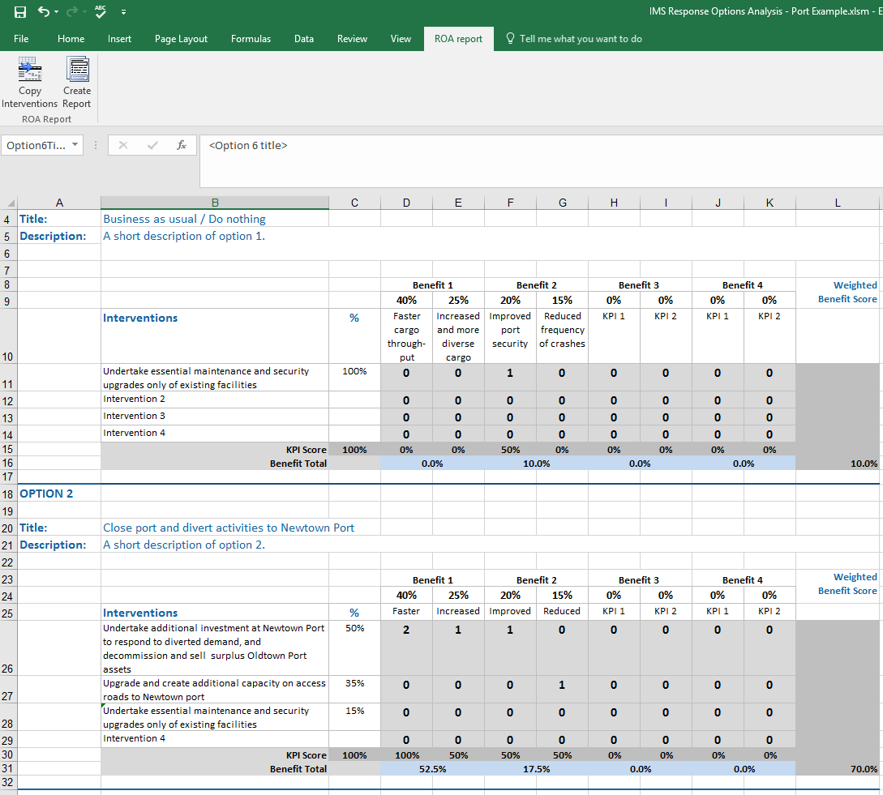

Total benefit percentage (per response option)
For each option, the ‘percentage of full benefit to be delivered’ is calculated by:
- expressing delivery of each KPI against the intervention/s as a % where 2=100% of the possible KPI % and 1=50%
- adding the weighted scores across all benefits to arrive at the weighted benefit score expressed as a percentage of the maximum score available (100%).
Note: The Excel spreadsheet (which can be found at www.dtf.vic.gov.au/investment-management-standard/facilitator-guidance-and-templates) is set up to do these calculations automatically (Figure 4). This can be done either during the workshop or later.
Figure 4: Calculation of the weighted benefit score
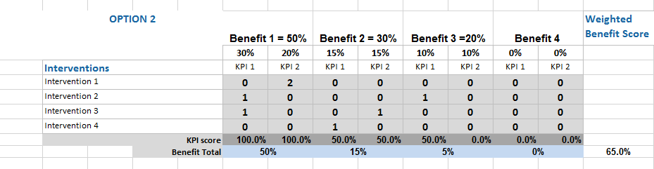
Apply ranking criteria – risk
Appendix 8 Difference between risk and uncertainty clarifies the scope and differences between risk and uncertainty and how they are managed within the IMS workshops.
Risk is the first of the key criteria which is considered in this workshop:
    - ask, ‘if this response option is funded, what are the primary risks that the benefits will be not be delivered?’
    - get participants to identify two or three of the most significant benefit delivery risks for each response option and then assess these based on their ‘consequence’ and ‘likelihood’ – each rated high, medium and low (H, M, L) - to give an overall ‘risk’ rating.
Apply ranking criteria –uncertainty
Investors are required to consider the potential impacts of uncertainty on any proposal, regardless of the investment type. Considering the impacts of uncertainty is a good investment management practice and can benefit any proposal. By arming Government to anticipate change and respond advantageously to prevailing conditions we can minimise Government’s obligations under negative conditions and take advantage of opportunities. As the outputs of the IMS workshops set the direction of the business case, agencies are required to capture any areas of uncertainty impacting their proposal so that they can be further explored if the investment proceeds to business case stage.
    - ask if there are any other potential shifts in the organisation’s current or future operating environment, such as those arising from demographic, economic, environmental, social, political, industry or technological factors, which, if they occurred would fundamentally change the investment’s benefit delivery;
    - Ask whether there are any circumstances or scenarios in which any of the proposed responses would be less successful in delivering the planned benefits or would lead to investment regret; and
    - Ask whether any of the proposed responses enable Government to respond flexibly to changing circumstances, minimising Government’s obligations under unfavourable conditions or enabling opportunities for benefit enhancement to be leveraged.
If the answer to one or more of these questions is ‘yes’, this may indicate the need to undertake real options analysis to inform the business case if the investment proceeds to this stage. This should be recorded on the whiteboard and noted on the Response Options Analysis Report.
You should make it clear that responses impacted by uncertainty are not necessarily bad options. They may in fact be superior options that enable Government to minimise obligations under unfavourable circumstances or to leverage opportunities. However, these options may need to be treated differently in the cost-benefit analysis and other aspects of the business case if the investment proceeds.
The role of the IMS is to identify uncertainty and its impacts on an investment and, where those impacts are potentially significant, recommend further investigation through real options analysis.
Apply ranking criteria - dis-benefits
Dis-benefits are the disadvantages that will result, or the problems that will arise, as a direct result of the successful delivery of the investment. For example, consolidating existing high schools into a single regional secondary college will increase travel time for a significant percentage of students, a dis-benefit.
Dis-benefits are important and are often overlooked (or hidden) when making a case for investment. Consequently you may also overlook opportunities which could actively mitigate a dis-benefit, through changing an approach or adding a further element to a response option or, subsequently, a solution.
Participants may find the concept of dis-benefit difficult to grasp or fail to see how a dis-benefit differs from a risk. It is a good idea to have some examples to hand which are tailored to the organisation’s own operating environment. Encourage participants to identify one or two of the most significant dis-benefits for each response option and then rank them based on ‘impact’ – high, medium and low (H, M, L).
Completing the first response options will establish baseline assumptions that will allow the dis-benefits of the rest to be assessed much more quickly.
Apply ranking criteria - interdependencies
Ask whether any of the interventions have any interdependencies. These should be ranked with a high-medium or low (H,M,L) ‘criticality’. You must also consider whether any interdependency is so fundamental that a real options workshop may be required, if the investment proceeds to business case development. If so, you should note this on the whiteboard and the Response Options Analysis Report.
Identify the preferred response
When participants have assessed all response options and are comfortable with the relativities, invite an overall assessment and ranking. This is a subjective ranking by the workshop group based on their understanding of the problem and the relative benefit delivery, identified risks and uncertainties, dis-benefits and interdependencies associated with each option. When this is done ask: “which of the response options should proceed to be analysed further as part of a business case?” It is usual to have 2 or 3 options, excluding the Business as Usual/Do Nothing option, that are commended for further investigation.
You should make it clear the next stage in the progress of this potential investment, if it moves to a full business case, is to conduct a thorough assessment of the preferred response to validate that the assumptions made in this workshop are reasonable. If this is not the case, it might be necessary to re-convene participants to reconsider the responses. It is also likely that more than one response option will be analysed fully in the business case.
What about time and cost?
As described in 2.1, the investor’s nominee will undertake further analysis of cost and timeframe after the workshop and prior to the Solution Definition workshop, where participants will either validate the preferred response or replace it with another. This will be used to generate a recommended solution.
The assessment of relative costs and timeframe, which go to the heart of value for money, will be the starting conversation in the Solution Definition workshop. This change to previous practice recognises that the assessments of costs and timeframe undertaken in the old Strategic Options workshop were often so unrealistic that they compromised decision-making and distracted participants from focusing on benefit delivery.
Greater accuracy around costs and timeframes is better achieved outside the workshop when more time can be spent on understanding the specific implications of the interventions, particularly if they had not been considered prior to the Response Definition workshop. A nominee of the investor will gather and complete the information for these criteria outside the workshop. The nominee may be a project manager, budget or finance person, analyst or other person with implementation and costing experience.
The cost and timeframe analysis must, however, be completed prior to the Solution Definition workshop and early enough for updated documentation to be circulated to the workshop participants before the workshop.

Step 5: Finalise the workshop
Advise the participants that within 24 hours you will provide them with version 1.0 of the ROAR. This will contain observations of the quality of the plan and any suggestions for improvement. Ask them to provide any suggested changes within 24 hours. Within a further 24 hours you will distribute version 1.0.
      - After the workshop
As with all workshops of the IMS, it is important to wrap-up the Response Definition workshop without delay.

Within 24 hours
    - you should complete the Excel workbook (which can be found at www.dtf.vic.gov.au/investment-management-standard/ims-workshops-and-examples) with the information gathered to date. This workbook contains two spreadsheets: the the KPI and Interventions Assessment (worksheet 1) and the Response Options Analysis (worksheet 2). Worksheet 1 captures the KPI/Intervention scoring that will automatically complete the Benefits section of Worksheet 2. Worksheet 2 outlines the analysis of all options. At this stage, cost and timeframe fields will be blank and will be completed over the next week or so, depending on the scale and complexity of the investment;
    - worksheet 2 has a report function and so pressing the submit button will generate the Response Options Analysis Report in Word format. This should, at this stage, be a simple summary of the scope and intent of each response option and is likely to be expanded during the business case preparation;

    - as soon as possible following the workshop send all participants your draft of the Response Options Analysis Report with your comments as to its current quality and how it might be improved. The participants should be directed to focus their review on the Response Options Analysis Report. The Response Options Analysis (spreadsheet) is available to demonstrate how the report has been generated;
    - in the email, ask that participants provide feedback (and copy to all other participants) with any suggested amendments within 24 hours and confirm that you will make changes and provide them with version 1.0 of the documents within 24 hours of that time – see ‘Sample email – after the Response Definition workshop’ (Appendix 9); and
You can assess the effectiveness of the Response Options Analysis Report using the ‘Quality assessment form – Response Options Analysis Report (Appendix 10). You do not need to complete this form each time a Response Definition workshop is held, but it is required for facilitator accreditation and re-accreditation.

Within 48 hours
Within 48 hours of the end of the workshop send version 1.0 of the ROAR and updated ILM and BMP documents. This will incorporate feedback but will still require cost and timeframe data. If you do not receive feedback, finalise the document as you think best. Highlight that the project team will need to validate any assumptions made during the development of the responses as part of the business case.

Prior to the Solution Definition workshop
The agency is required to complete the cost and timeframe data well in advance of the Solution Definition workshop, and update the Response Options Analysis Report and worksheet 1. The ranking of responses and confirmation of the preferred response will be tested and confirmed at the Solution Definition workshop.

During business case development and beyond
The Response Definition workshop is largely designed to support the development of a preliminary business case. A full business case, particularly one prepared for a HVHR investment is likely to require a more detailed project response analysis in line with the Stage2: Prove guideline and the Sustainability Investment Guidelines.
The project team or business case writer should update all IMS documents to reflect new analysis and understanding which emerges during business case development. This may change the recommended solution. If major changes occur, then the project team will need to review the Response Options Analysis Report more comprehensively. The failure to update IMS documents has been regularly reported in Gateway Reviews and has often undermined confidence in the case for investment.
The ILM should be the primary reference document at each meeting of the project’s governance body and a current copy should be available to all stakeholders and anyone working to implement the investment.
      - Templates, examples and other resources
The templates and examples are available for download at www.dtf.vic.gov.au/investment-management-standard/facilitator-guidance-and-templates

Appendix 1: 16 Questions – Investment decision-maker’s checklist
The 16 questions (the Investment Decision-Maker’s Checklist) are a set of prime questions that any decision-maker should have answered before funding an investment. The depth of enquiry for each question will depend on the scale and complexity of the investment. These questions can be asked, in part or in their entirety, at various stages in the investment management process to test the robustness of the IMS workshop document suite and the business case, if developed.
The 16 questions correlate with key elements of the Victorian government full business case template and aid business case writers and assessors. The focus for the Response Definition workshop is questions 9-12.
Figure 5: 16 Questions – Investment decision maker's checklist

Appendix 2: Shaping new investments using the IMS
The Victorian Government’s Investment Management Standard (IMS) establishes a set of simple practices that enable organisations to select the investments that matter most and shape and implement them so they deliver the maximum benefit and best value for money. The practices can also be used to help prioritise investments, develop policy, evaluate programs and improve the effectiveness of an organisation.
The IMS supports a way of thinking characterised by evidence-based discussion, robust logic and simple storytelling. It brings together the best thinkers on a subject to discuss and shape new investments in two-hour facilitated discussions (workshops) to address the four questions that are fundamental to investment decision making:
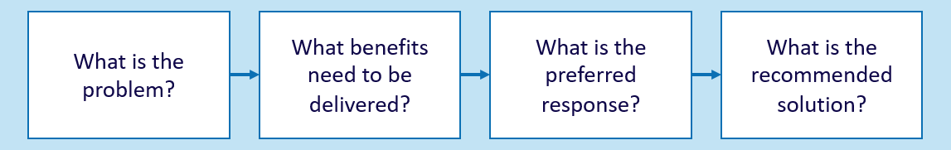
The number of workshops required is determined by the nature of an investment. Large and complex investments might require four separate workshops that would produce four documents critical to establishing a sound business case. Small and simple investments might require just one or two workshops and would produce an Investment Logic Map (ILM) and a Benefit Management Plan. The four workshops are described below.
PROBLEM
Successful investments are made as a considered reaction to an identified or emerging problem. This workshop focuses on:
- defining the problem that need to be addressed;
- validating that the problem is real; and
- specifying the benefits that will result from addressing the problem.
The output of this workshop is the first version of an Investment Logic Map (ILM) with the problems and benefits defined.
BENEFIT
Investments are often shaped with little understanding of the benefits expected to be produced. This workshop will:
- identify the KPIs, measures, targets and timelines that the investment will need to deliver; and
- specify how the delivery of the benefits will be measured and reported.
The output of this workshop is a Benefit Management Plan (BMP) including a Benefit Map and Benefit Profile.
RESPONSE
Business cases for new investments often fail to consider the full range of things that could be done to address the identified problem. This workshop will:
- explore the interventions that could deliver the expected benefits;
- formulate and evaluate a mix of response options; and
- assess response options and potentially select the preferred response.
The output of this workshop is a Response Options Analysis Report (ROAR).
SOLUTION
This workshop ensures that a solution is developed which is consistent with the foundations established in previous workshops. This workshop will:
- confirm the preferred response and the interventions it contains;
- identify and evaluate the changes and assets that are required to implement the preferred response and deliver the benefits;
- define a recommended solution; and
- identify cost range, timeframe for project and benefit delivery, key risks, uncertainties, dis-benefits and critical assumptions associated with the recommended solution.
The output of this workshop is an Investment Concept Brief (ICB).

Appendix 3: Fictional – Response Options Analysis Report and worksheets
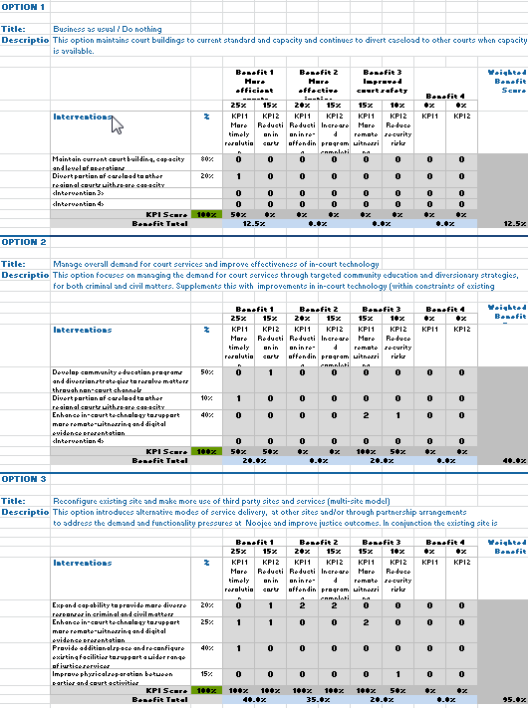

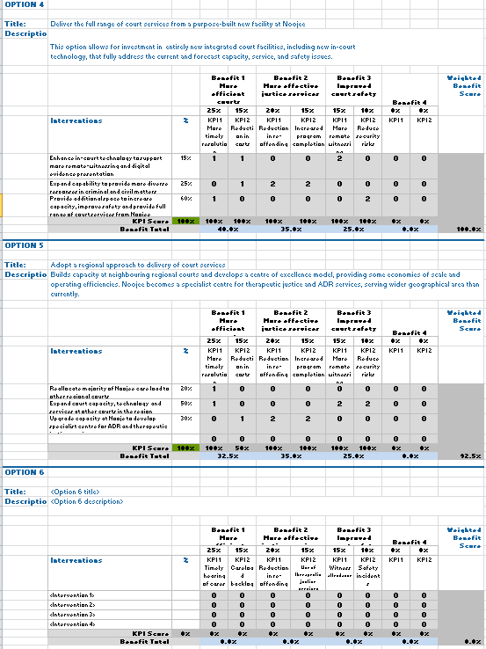
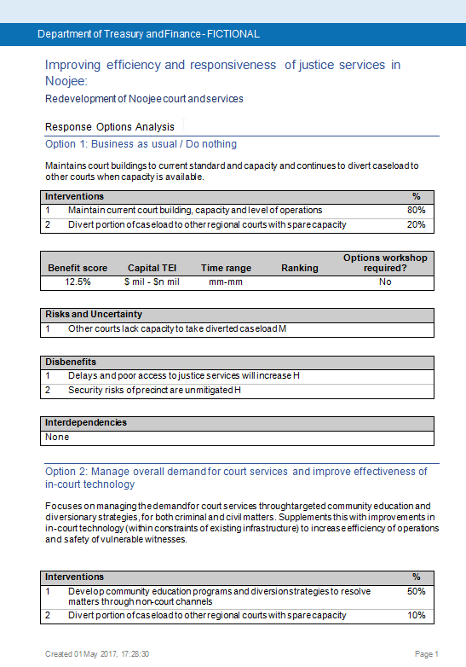
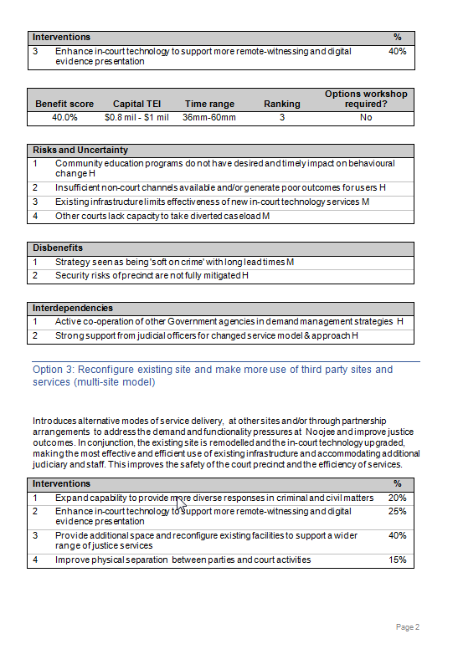

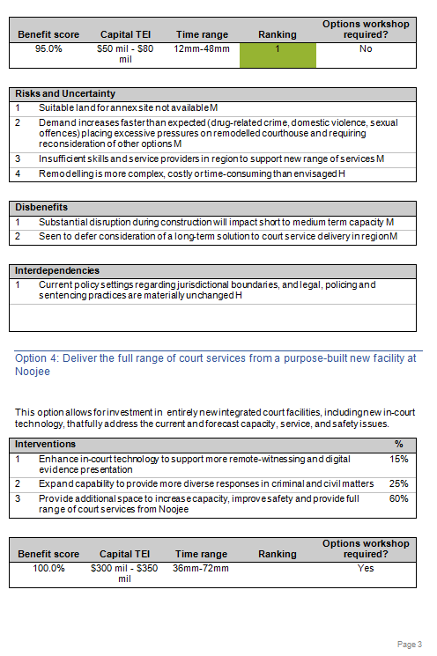

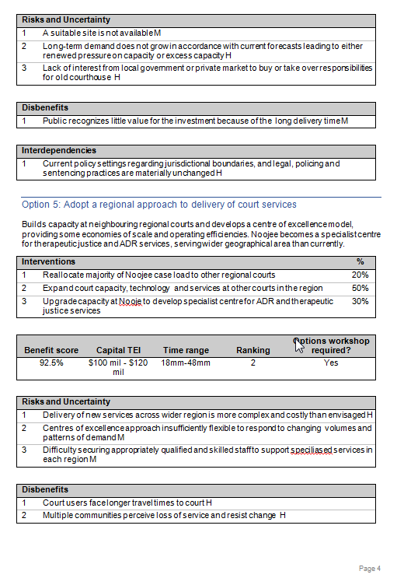
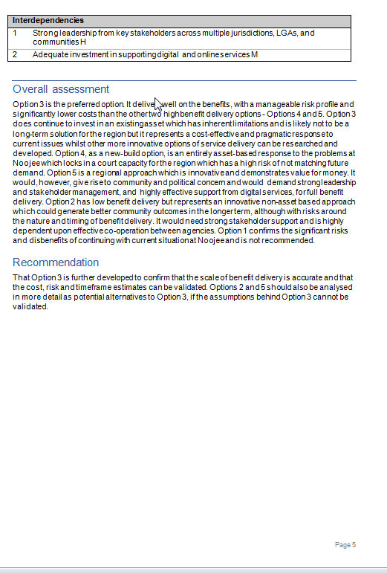

Appendix 4: Design guidelines – Response Options Analysis Report
These design guidelines have been developed to assist facilitators to develop high-quality Response Option Analysis Reports. Their use will…
Any of these rules can be broken but, in doing so, be aware of the impact it will have on the storytelling.
Item | Practice | Reason
Template | Always use the current response options analysis report template and worksheet. Do not alter the template. Current templates can be found at www.dtf.vic.gov.au/investmentmanagement. | Formats continue to improve to make them more useful as communication tools and contain better information.
Use of words | Be brief, clear and specific in your statements. | It forces precision in meaning and communication. It also maintains clarity and consistency when reading.
Options | Do Nothing/BAU, least complex to most complex | Demonstrates genuine consideration of a range of options not just as a means of justifying a pre-determined solution
Interventions | One to four interventions and their weightings for each option | Appropriately considers demand, productivity and supply levers within a range of options
KPI Scoring | Assess each intervention in an option against its contribution to the delivery of KPIs. This will generate a weighted benefit score for each option.  0=Marginal  1=Partial  2 =Significant | Demonstrates alignment between interventions and KPI delivery and provides a weighted benefit score that allows for comparison between options.
Risk and uncertainty | Identify one to four of the most significant things that might result in the delivery of the benefits being significantly different from expectations. These should include exogenous factors that may influence the investment's benefit delivery. | Provides insight into key factors and their significance that will need to be managed if the investment proceeds.
Dis-benefits | Identify negative impacts that will occur as a direct consequence of successfully implementing this option | Provide insight into negative outcomes that could influence the decision to invest.
Inter-dependencies | Identify external factors that need to be in place if an option and its interventions are to be successful | Ensure full understanding of the policy and implementation requirements that inform decision-making and planning
Real options | Assess whether a real options analysis workshop is recommended if this investment proceeds to full business case | Highlight the need for further analysis that may introduce more flexibility to the management of infrastructure projects that are significantly affected by uncertainty. able to meet the community’s evolving needs
Cost | Capital TEI- range should be sufficiently reliable to provide an order of magnitude for the response  Output costs should be identified as these may substantially differ between responses. These should be the incremental costs, directly incurred as a result of the investment, net of any expected savings as a result of the investment | Provide insight into both capital and on-going costs that will result from the investment.
Timeframe | Estimate time from commencement of funding to date of full benefit delivery (not completion of the investment delivery) | Provide a view of the timeframe for project completion and importantly benefit delivery
Ranking | Considering all factors, determine which response option is the preferred approach to resolving the problem and rank order the options from 1-5 | To prioritise investment options
Overall assessment | Assess each option and outline why the preferred response was chosen? Make any other assessment observations. | Provide a rationale for the ranking and comparative assessment of options.
Recommendation | Determine whether this investment should proceed and which options should be investigated further if proceeding to business case. | To make a recommendation regarding the options that are of interest and that require further investigation in the business case.
Use and distribution of percentages (%) | A total of 100% to be distributed within each response options column. This is distributed to indicate the relative importance of the various elements within each column. | Acts as a tool to extract judgments on the relative importance of the identified interventions.
Use of ranges | Express timeframes and costs in ranges from lowest to highest. | Forces realistic estimates to be made.
Completing the control fields | Ensure the document control fields have been completed including the names of the:  - investment;  - department/agency/organisation; and  - Investor; and  - facilitator. | Provides legitimacy and accountability to the investment.

Appendix 5: Sample email – before the Response Definition workshop

[Greeting]
You may or may not be aware of the business need we have in relation to [investment name] and the thinking we have been doing to shape an investment that will respond to that need. Consistent with the Victorian Government’s Investment Management Standard we have already held workshops to identify the problem and specify and validate the expected benefits, their KPIs, measures and targets.
We will now be holding a two-hour Response Definition workshop or informed discussion that will develop our preferred. The guideline for this discussion is attached. The result of this exercise will be a Response Options Analysis Report [example attached].
The preparation required from you for this workshop is:
- review the current ILM, Benefit Map and summary of potential interventions (attached) and ensure you are familiar with our developing investment story;
- focus on the KPIs (and measures) for the benefits and consider whether they are meaningful, attributable and measurable;
- consider the list of potential interventions and think about any that could be added. This list will be tested, and additional interventions identified, during the workshop; and
- think about what our most straightforward, and our most complex response, to the problems identified in the ILM could be. How could we change demand, improve productivity or change supply in our efforts to deliver the KPIs and solve the problems.
The discussion will be held as follows:
- Date:
- Time:
- Venue:
Your role in this would be as [role, if relevant]. Please let me know if you are able to attend.
If you would like to read more about the benefits and practices of this approach you should refer to www.dtf.vic.gov.au/investment-management-standard/ims-workshops-and-examples
[Investor sign off]

Appendix 6: Checklist – Response Definition workshop
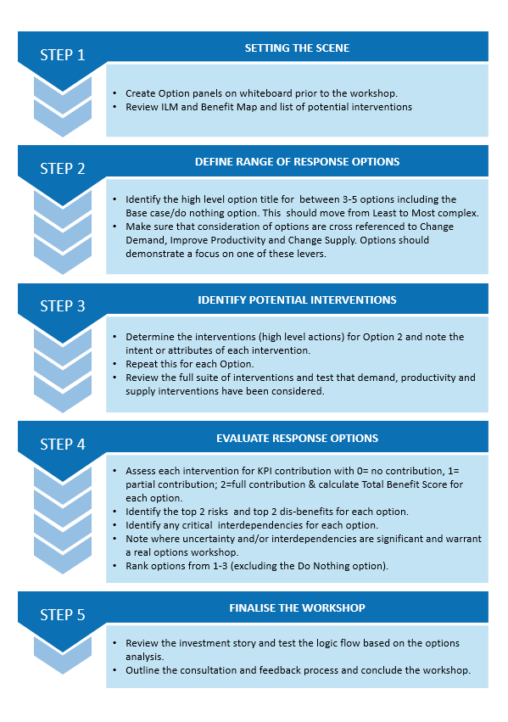

Appendix 7: Sample agenda – Response Definition Workshop
Before the workshop
15–20 minutes | Set up the whiteboards
At the workshop
5 minutes | Introduction and outline of purpose and role
5–10 minutes | Review ILM and Benefit Map and list of potential interventions
50–60 minutes | Formulate response options
35–40 minutes | Evaluate response options
5 minutes | Conclusion and next steps

Appendix 8: Difference between risk and uncertainty
Risk is expressed as the ‘expected outcome given the probability and impact of the event based on data and expert judgment’. Risks usually apply to the delivery of a project. A risk describes situations where:
- decision makers can estimate the possible outcomes and consequences for a given situation with a certain degree of confidence
- can assign probabilities to these various outcomes
- are inside the control of the project team to minimise and mitigate.
The key risks related to the delivery of an investment’s benefits are identified in the Response Definition and Solution Definition workshops and will be further analysed and documented during the preparation of the business case.
Uncertainty exists when the outcomes of a situation cannot be reasonably identified or the probability of an event occurring is unknown. Uncertainties are usually found in regard to the investment need or problem. Uncertainty describes situations where:
- decision-makers either know all the potential outcomes for a given situation, but the probabilities attached to these outcomes are entirely unknown; or
- potential outcomes cannot be initially envisaged
- the likelihood and/or consequence of these events are very difficult to quantify with any confidence
- are outside the control of the project team.
These events include technological developments, major shifts in markets and economic conditions, the behaviour of other organisations, political orders, demographic, societal structures, or the natural environment. If such events occur their impact on benefit delivery can be both positive and negative.
The key uncertainties related to the delivery of an investment’s benefits are firstly noted in the Benefit Management Plan and then explored further in the Response Definition and Solution Definition workshops. High levels of uncertainty will be further analysed and documented during the preparation of the business case.

Appendix 9: Sample email – after the Response Definition workshop

[Greeting]
Thanks for your participation at yesterday’s Response Definition workshop for [investment name]. I have attached version 0.1 of the Response Options Analysis Report and worksheets that we produced and ask that you provide me with any suggested amendments by close of business today. I will then make any necessary changes and have version 1.0 to you by close of business tomorrow.
…my observations
[any observations on the investment itself or the process and any suggestions that might improve the case for the investment or the strength of the Response Options Analysis Report]
…about the Response Options Analysis Report
A Response Options Analysis Report is a powerful document. It provides credibility to an investment proposal by demonstrating that a range of legitimate options has been considered and assessed against a common set of criteria. This provides a strong basis for the development of robust business case.
[Facilitator sign off]

Appendix 10: Quality assessment form – Response Options Analysis Report
The purpose of this form is to assist an Investor, facilitator or anybody with an interest to assess the quality of a Response Options Analysis Report that has been developed under the IMS.
Test 1: On reading the response options analysis, would a layperson be able to understand the options that were considered and the reasons for ranking and selecting a preferred option? | Assessment:  YES / NO / MAYBE
Please explain why you have assessed it this way.
Test 2: Is the intent of each intervention clear, strategic, discrete and are sufficiently high level so as not to lock the investment into a specific project option? | Assessment:  YES / NO / MAYBE
Please explain why you have assessed it this way.
Test 3: Do the potential response options provide a broad coverage of responses? | Assessment:  YES / NO / MAYBE
Please explain why you have assessed it this way.
Test 4: Would the potential response options genuinely respond to the problem(s), deliver the nominated KPIs, measures and targets? | Assessment:  YES / NO / MAYBE
Please explain why you have assessed it this way.
Test 5: Has the extent to which response strategies need to contemplate uncertainty been appropriately assessed? | Assessment:  YES / NO / MAYBE
Please explain why you have assessed it this way.
Test 6: Do the rankings and recommendations reflect genuine consideration of all the options and selection of the most compelling option? | Assessment:  YES / NO / MAYBE
Please explain why you have assessed it this way.
How do you rate this response options analysis? | Assessment:  SATISFACTORY/ UNSATISFACTORY
Please explain why you have assessed it this way.

Further detail on the facilitator training course, in which this guidance is used, can be found at www.dtf.vic.gov.au/investment-management-standard/investment-management-facilitator-training-and-accreditation.
Within the New Zealand government investment framework, significant investment proposals from relevant state sector agencies must use the options analysis methodology outlined in the Better Business Case guidance rather than the Response Definition workshop approach described here.)
Real options analysis is an investment evaluation and decision-making framework which introduces more flexibility to the management of infrastructure projects that are significantly affected by uncertainty. It assists Government make investments that are more adaptable over time and better able to meet the community’s evolving needs.
Previously the Strategic Options workshop
See Department of Treasury and Finance (Victoria) Investment lifecycle and High Value High Risk guidelines – Overview https://www.dtf.vic.gov.au/infrastructure-investment/investment-lifecycle-and-high-value-and-high-risk-guidelines.
Previously known as Strategic Options
Workshop discussions can help identify policy requirements and synergies. IMS workshops may identify potential value creation and value capture opportunities within a proposal, or projects that can contribute to other government priorities such as Victoria’s Climate Change Adaptation Plan. Consideration of these opportunities will be important in defining benefits as well as option analysis and solution design. Where this occurs, these additional proposal details should be captured within the IMS documents, in particular the ICB, and further explored during business case development.
The benefit score for option 1 (‘business as usual’) will generally be very low as this option is unlikely to deliver much improvement on the baselines that were articulated in the Benefit Map.

