Incentivised Target Cost Contract Suite
Guidance Notes

The Secretary
Department of Treasury and Finance
1 Treasury Place
Melbourne Victoria 3002
Australia
Telephone: +61 3 9651 5111
dtf.vic.gov.au

Authorised by the Victorian Government
1 Treasury Place, Melbourne, 3002

© State of Victoria2023
You are free to re-use this work under a Creative Commons Attribution 4.0 licence, provided you credit the State of Victoria (Department of Treasury and Finance) as author, indicate if changes were made and comply with the other licence terms. The licence does not apply to any branding, including Government logos.

Copyright queries may be directed to IPpolicy@dtf.vic.gov.au.

ISBN 978-1-925551-93-8
Published September 2023

If you would like to receive this publication in an accessible format, please email information@dtf.vic.gov.au.

This document is also available in PDF format at dtf.vic.gov.au.

Disclaimer
The material contained in the Department of Treasury and Finance (DTF) Incentivised Target Cost (ITC) Contract Suite – Guidance Notes (Guidance Notes) is made available on the understanding that:
- the State is not providing professional advice;
- users exercise their own skill and care with respect to its use; and
- users will seek independent advice as necessary.
The State gives no warranty and does not make any representation, express or implied, as to the contents or accuracy of the information contained in this publication. The State expressly disclaims any and all liability relating to or resulting from:
- the use of these Guidance Notes by any person; and
- anything done, or omitted to be done, in reliance upon information contained in these Guidance Notes.
These Guidance Notes must not be used for the interpretation of the ITC Contract Suite. Nothing in these Guidance Notes limits or affects the application, interpretation or enforcement of the terms and conditions in:
- any Expression of Interest (EOI) or Request for Proposal (RFP); or
- the ITC Development Deed, ITC Delivery Deed or any Project Document entered into by the State.

Contents
1. Introduction 1
1.1 Purpose 1
1.2 Context 2
1.3 ITC Contract Suite 3
1.4 Procurement process of the ITC Contract Suite 6
1.5 Form and structure of the ITC Contract Suite 9
1.6 Legislative context 10
2. Governance, approvals and assurance 12
2.1 Governance arrangements 12
2.2 Role of the informed and engaged client 13
2.3 Approvals and project assurance 14
2.4 Principal Representative 15
3. Commercial framework 16
3.1 Value-for-Money 16
3.2 Assessing the Delivery Phase Offer 16
3.3 Principal’s Benchmark 17
3.4 Role of competition 18
3.5 Expectations for TOC development 19
3.6 Expectations for Design Development 21
3.7 Administering the payment regime 22
3.8 Monitoring and reporting 25
4. ITC Development Deed guidance 27
4.2 Early Delivery Activities (clause 9 of the ITC Development Deed) 29
4.3 Payment (clause 16 of the ITC Development Deed) 31
4.4 TOC Estimate (clause 12 of the ITC Development Deed) 32
4.5 Process for entry into ITC Delivery Deed (clause 14 of the ITC Development Deed) 35
4.6 Time (clause 15 of the ITC Development Deed) 40
4.7 Indemnities (clause 19.1 of the ITC Development Deed) 40
4.8 Limitation and exclusion of Liability (clauses 19.3, 19.4 and 19.5 of the ITC Development Deed) 41
4.9 Insurance (clause 18 of the ITC Development Deed) 42
4.10 Intellectual Property and the Delivery Phase Offer (clauses 14 and 20 of the ITC Development Deed) 43
4.11 Termination (clause 25 of the ITC Development Deed) 45
5. ITC Delivery Deed guidance 46
5.1 Key price concepts 46
5.2 Risk or Reward Regime (Schedule 5 to the ITC Delivery Deed) 49
5.3 Principal’s KRAs (clause 4.6 of the ITC Delivery Deed) 55
5.4 Cost planning and control (clause 21 of the ITC Delivery Deed) 55
5.5 Adjustment Events (clause 27 of, and Schedule 15 to, the ITC Delivery Deed) 56
5.6 Defects (clauses 1 and 28 of the ITC Delivery Deed) 60
5.7 Subcontracting and third party arrangements (clause 8 of the ITC Delivery Deed) 63
5.8 Site Information and Site Conditions (clauses 5, 10, 12, 13 and 41 of the ITC Delivery Deed) 65
5.9 Change in Law and Change in Policy (clause 36 of the ITC Delivery Deed) 69
5.10 Force Majeure (clauses 1, 27 and 41 of the ITC Delivery Deed) 70
5.11 Pandemics (clauses 1 and 6A of the ITC Delivery Deed) 72
5.12 Time (clauses 1, 27, 30, 37 and 41 of the ITC Delivery Deed) 74
5.13 Variations (clauses 1, 6, 34, 35 and 36 of, and Schedules 9 and 15 to, the ITC Delivery Deed) 81
5.14 Indemnities (clause 41 of the ITC Delivery Deed) 85
5.15 Limitation and exclusion of Liability (clause 41 of the ITC Delivery Deed) 87
5.16 Insurance (clause 42 of the ITC Delivery Deed) 89
5.17 Security (clause 33 of the ITC Delivery Deed) 90
5.18 Default (clauses 1 and 43 of the ITC Delivery Deed) 91
5.19 Termination (clauses 1, 3 and 44 of the ITC Delivery Deed) 94
5.20 Notices and bars to claims (clause 59 of the ITC Delivery Deed) 96
Annexure 1 – Terminology and interpretation 97
Annexure 2 – Defects 98

    - Introduction
      - Purpose
This document is one of a suite of publications that comprise the Department of Treasury and Finance’s (DTF’s) whole-of-government Infrastructure Procurement Framework (Framework).
It sets out guidance notes for the development and application of the DTF Incentivised Target Cost Contract Suite (ITC Contract Suite) for the delivery of High Value High Risk (HVHR) projects.
The document is for Victorian Government procuring agencies and departments. It is also relevant to other industry practitioners, government stakeholders, tenderers and advisers who wish to understand this contract suite.
The document details:
    - the context for developing the ITC Contract Suite;
    - an overview of the ITC Contract Suite, including issues to consider;
    - governance, approvals and assurance processes for ITC contracts;
    - the stages of the procurement process for ITC contracts;
    - the legislative and commercial framework for the delivery of ITC contracts; and
    - a clause-by-clause breakdown of the contracts, including key principles and considerations in implementing these clauses.
These Guidance Notes should be read in conjunction with the ITC Contract Suite, the ITC Contract Suite – Commercial Principles and the Cost Reimbursable Procurement Requirements available at Cost Reimbursable Procurement Category webpage.
      - Context
The ITC Contract Suite sits within the whole-of-government infrastructure procurement framework. The Framework includes three categories of procurement, including whole of life, lump sum and cost reimbursable. Each category contains a set of approved procurement models for use on Victorian Government infrastructure projects.
It consists of the following policy, guidance and standard form contracts:
    - the Ministerial Directions and Instructions for Public Construction Procurement (Ministerial Directions), established under Part 4 of the Project Development and Construction Management Act 1994 (Vic)
    - the Procurement - Investment Lifecycle Guideline, which outlines the three procurement categories and a set of approved procurement models
    - a procurement requirements document for each of the three procurement categories; and
    - standard form contracts and guidance for a subset of the approved procurement models.
Figure 1 provides an overview of the Framework and indicates where the ITC Contract Suite sits within it.
Figure 1 – Framework
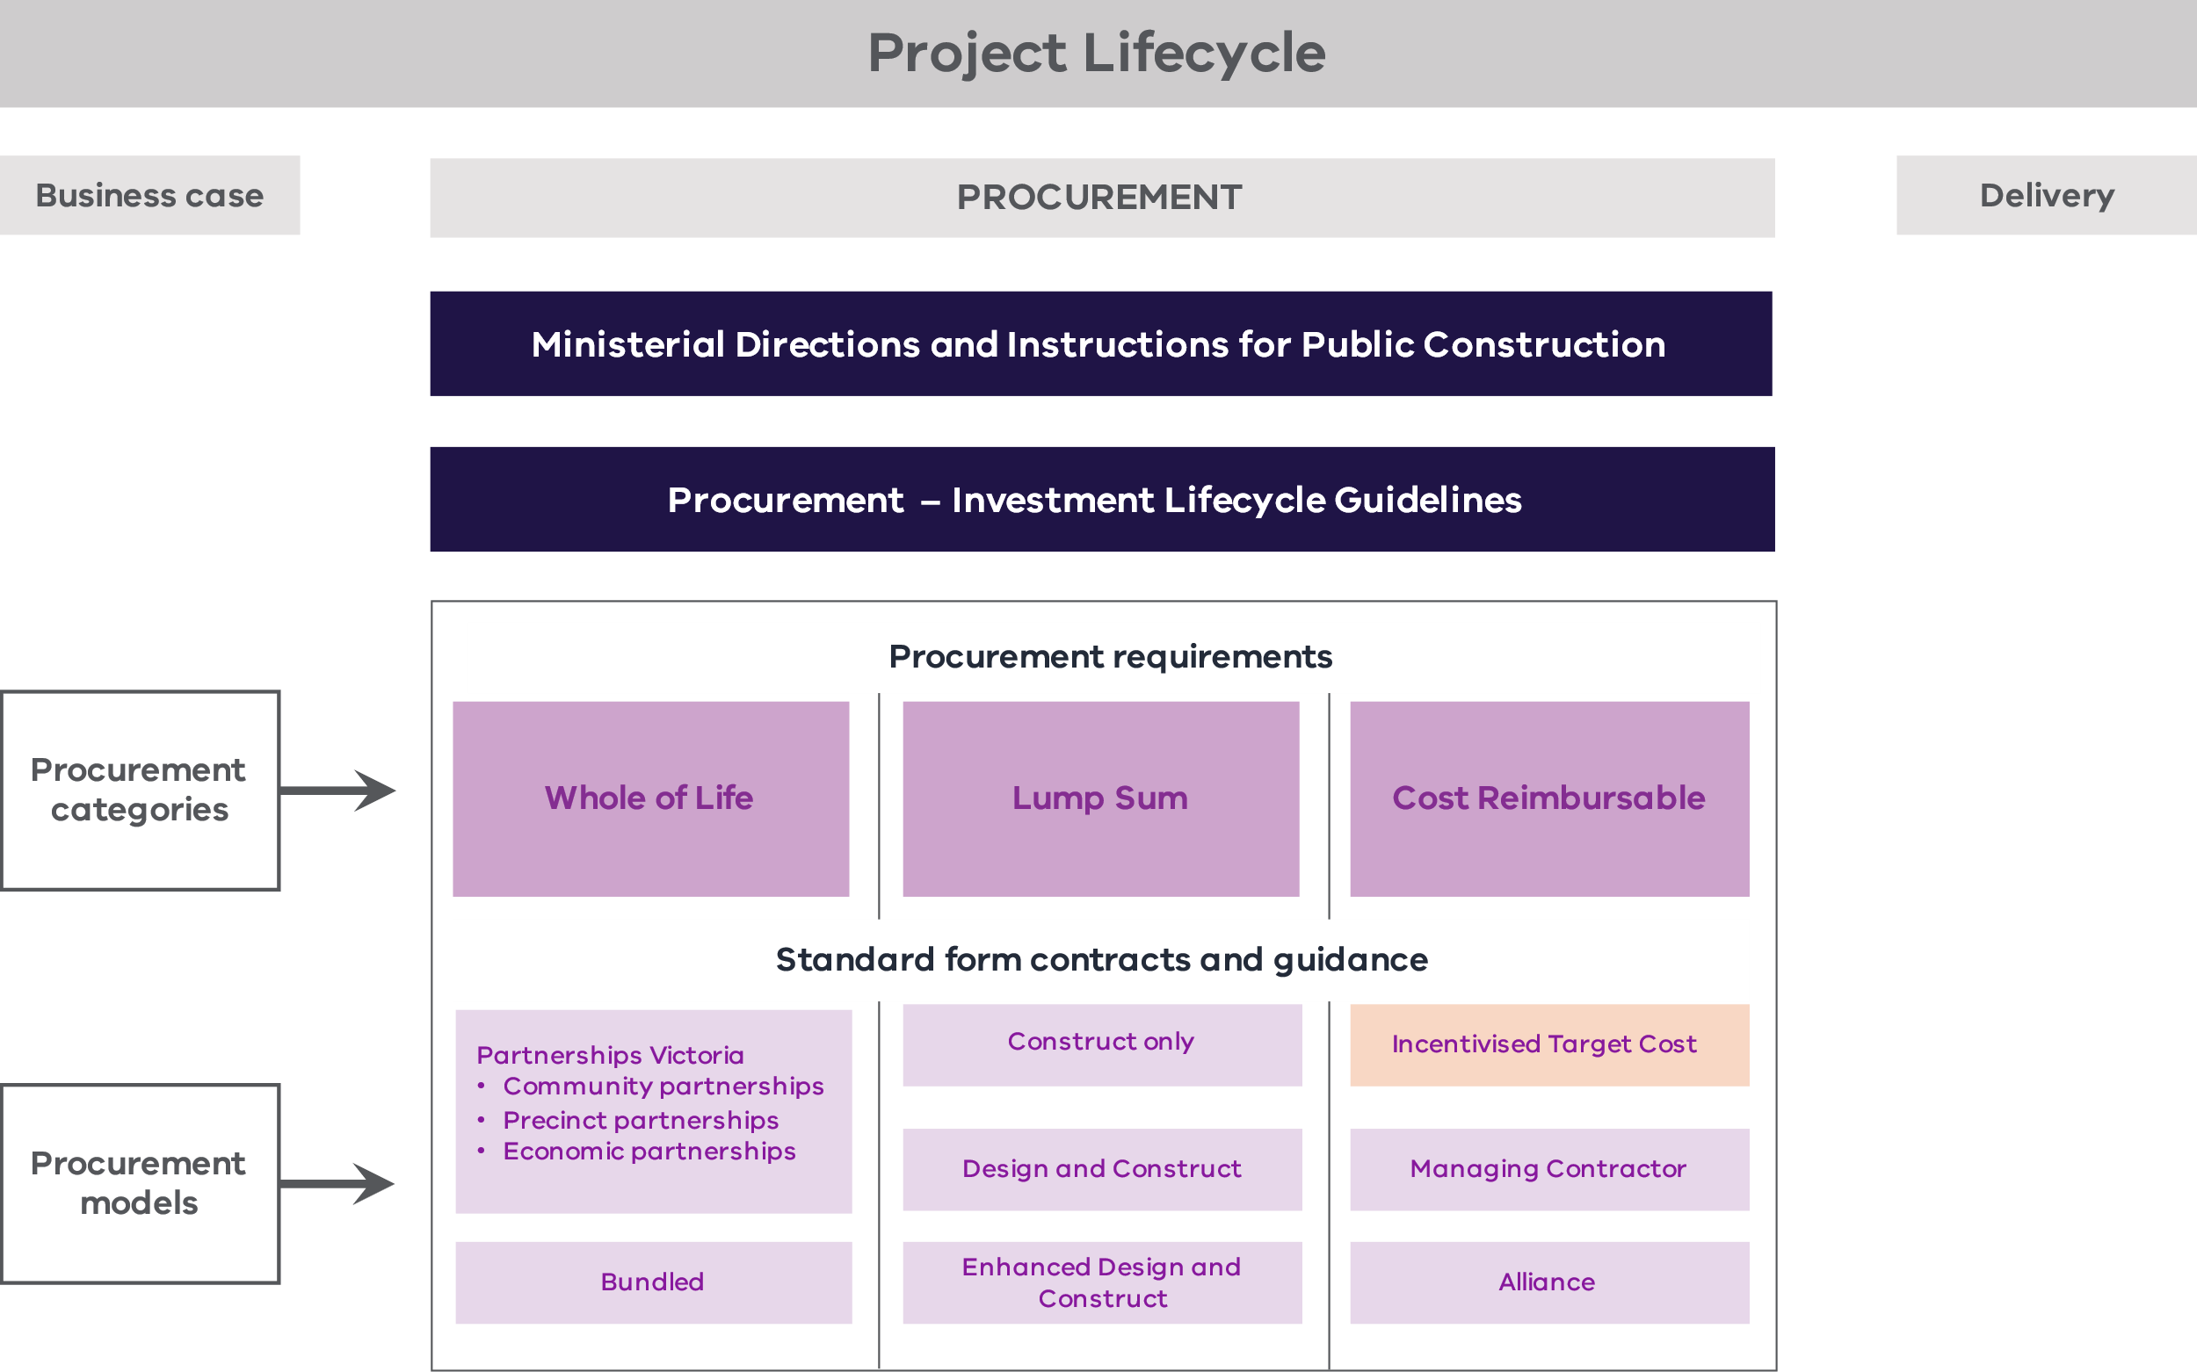
Other Victorian Government legislation, policies and frameworks that are applicable across the project lifecycle include:
- the Standing Directions 2018 under the Financial Management Act 1994 (Vic)
- the Investment Lifecycle Guideline series
- the Asset Management Accountability Framework, Investment Management Standard and Bid Cost Reimbursement Policy for Major Construction Projects
- the High Value High Risk (HVHR) project assurance framework and associated Gateway Review Process.
National policies, such as the National Alliance Contracting Guidelines may also be applicable.
      - ITC Contract Suite
The new standard form ITC Contract Suite comprises two separate contracts:
    - an ITC Development Deed; and
    - an ITC Delivery Deed.
The ITC Development Deed supports a Development Phase. During the Development Phase, Shortlisted Respondents are engaged to complete design work, develop a Project proposal (including a Target Outturn Cost (TOC)) and deliver Early Works.
The ITC Delivery Deed supports a Delivery Phase. During the Delivery Phase, works proceed on an open book basis and the Contractor is reimbursed for all agreed costs and a percentage for Corporate Overhead and Profit (COP) (sometimes referred to as ‘margin’ by industry participants). A Gainshare/Painshare Adjustment mechanism also incentivises performance and delivery of the Works against the TOC.
Figure 2 – Stages of the ITC Contract Suite
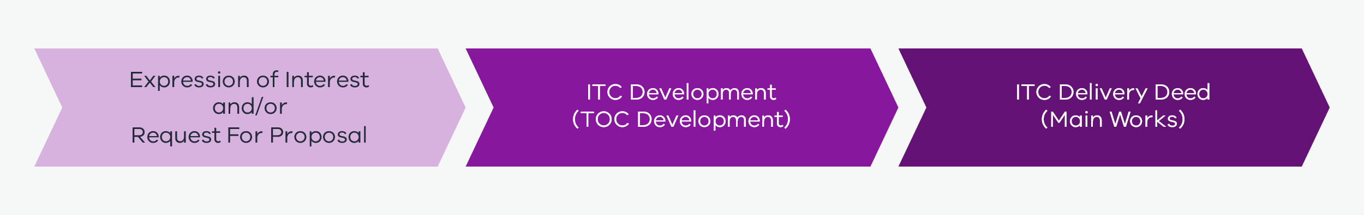
The ITC Contract Suite recognises the increasing use of this procurement model and promotes its consistent application by Victorian Government procuring agencies. It addresses the challenges and opportunities encountered in a real project delivery environment, providing a consistent and efficient risk allocation with flexibility to accommodate project-specific requirements.
The ITC Contract Suite seeks to:
    - promote efficient processes in delivering ITC projects, specifically providing time and cost savings for the State and private sectors in drafting and negotiating project documentation;
    - enhance contract administration;
    - allow project teams and bid teams to focus on project-specific issues;
    - improve contract interpretation and enforceability; and
    - provide tenderers with greater certainty regarding project contractual terms.
        - Basis for developing the ITC Contract Suite
The ITC Contract Suite has been developed based on:
    - established contract forms accepted by the market and State;
    - guidance issued by government agencies (e.g. National Alliance Contracting Guidelines) and industry groups (e.g. Roads Australia Procurement Reform Report);
    - feedback from the private sector and government stakeholders; and
    - learnings from other projects and jurisdictions where ITC contracts are a recognised and regularly used form of contract.
The ITC Contact Suite has been adapted from the underlying deeds used by Major Roads Projects Victoria as part of the Program Delivery Approach.
The ITC Delivery Deed also adopts applicable Partnerships Victoria standard terms (where consistent with generally accepted market terms in similar contracts) to promote greater consistency in contracts used in Victorian HVHR infrastructure projects.
        - Underlying principles driving the ITC Contract Suite
The ITC Contract Suite has been developed as a way of rebalancing roles where traditional risk allocations are not considered appropriate to the nature of the project risk profile. The infrastructure delivery environment is increasingly complex, and the ITC delivery model complements existing contract models, providing more optionality for procuring agencies in procurement.
These are some key aspects of the ITC Contract Suite:
    - The Principal is an ‘informed and engaged’ client, actively participating in the interrogation of the TOC. However, the Principal’s employees are not embedded in the Contractor’s delivery team, nor is there joint Project decision-making.
    - The Contractor provides the traditional contractual warranties as to fitness for purpose and design and is responsible for the delivery of the Project.
    - The majority of the Project risks are shared between the Contractor and the State, with the Contractor incentivised to complete the Project on time and under the estimated TOC through an alliance style risk or reward performance regime.
    - A Principal Representative appointed by the Principal administers the contract with a non-binding leadership team.
Further details on the aspects of the ITC contract model, including risk allocation, are outlined in the ITC Contract Suite – Commercial Principles available on the Cost Reimbursable Procurement Category webpage.
Throughout the ITC Contract Suite, there are instances where the Principal’s position is determined on a project-specific basis.
DTF will continue to monitor the market and seek feedback from stakeholders to ensure that the risk allocation in the standard ITC Delivery Deed remains consistent with the Victorian Government’s preferred risk allocation principles and captures any changes or updates within the industry.
As an alternative to the ITC Contract Suite, DTF has also developed an Enhanced Design and Construction (D&C) Deed. Refer to the Enhanced D&C Deed – Guidance Notes available on the Lump Sum Procurement Category webpage.
      - Procurement process of the ITC Contract Suite
The ITC Contract Suite allows for an Expression of Interest (EOI) or Request for Proposal (RFP) (or both) to occur prior to the Development Phase to determine which Respondent(s) best meet the Principal’s requirements for the Project. The Shortlisted Respondent(s) then proceeds to the Development Phase to develop a Delivery Phase Offer, including the TOC. One Respondent then proceeds to the Delivery Phase if their Delivery Phase Offer is accepted by the Principal. The key steps in the procurement process are shown below in Figure 3.
Figure 3 – Key steps in the ITC Contract Suite procurement process
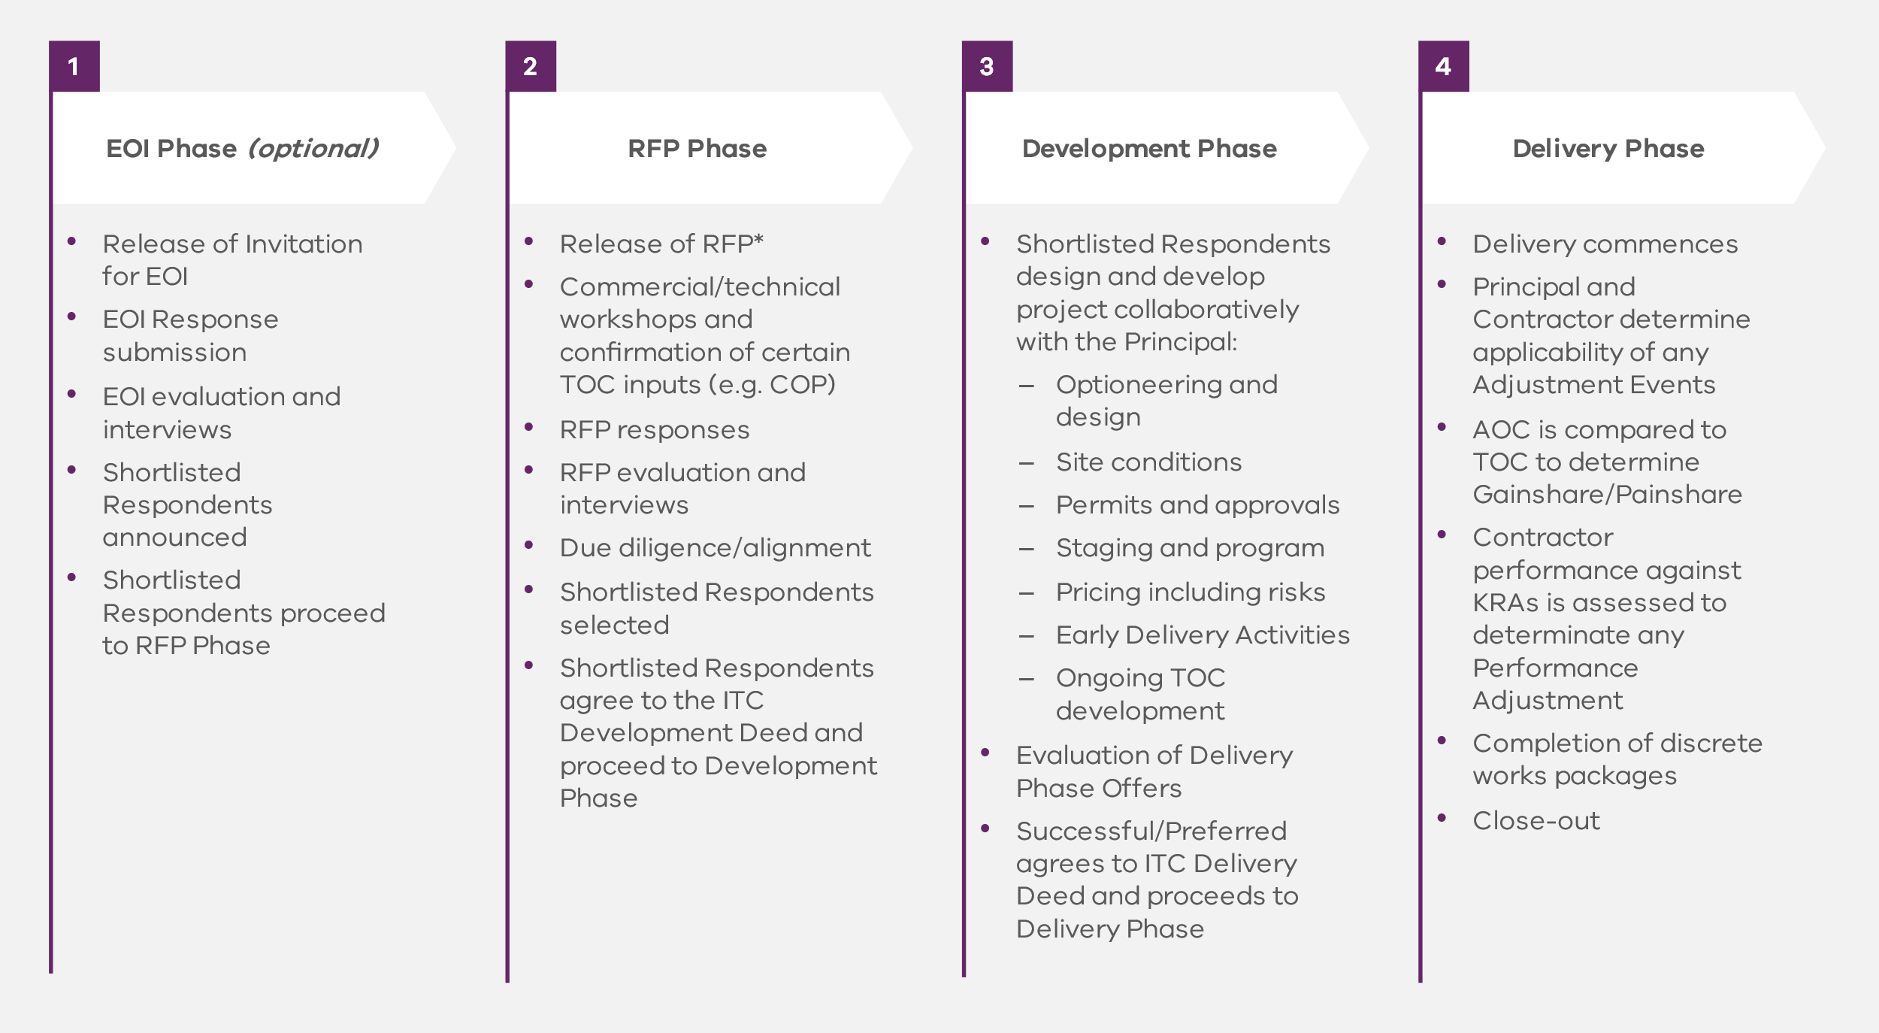
* The procurement approach may involve an EOI and an RFP process, or an RFP process only, in accordance with existing DTF infrastructure procurement guidance. There may also be approaches where the Development Phase occurs within a traditional RFP process.
        - Procurement process
The procurement process for a Project should be determined in consultation with the DTF in accordance with the HVHR Project Assurance Framework. It consists of an RFP and – if the procuring agency and DTF determine it is necessary – an Invitation for EOI. See section 1.4.2 below for guidance regarding the need to incorporate an Invitation for EOI process into the procurement process.
        - Requirement for an Invitation for EOI
Whether the procurement process for a Project requires both an Invitation for EOI and RFP is determined by the procuring agency on a project-specific basis, having regard to the nature of the Works and the value of the Project.
For some projects, only an RFP is required. More complex or higher value projects may warrant an Invitation for EOI to gauge market interest and allow the procuring agency to gain feedback on its proposed approach from the private sector before proceeding to an RFP phase.
        - RFP phase and the submission of Project proposals
The RFP requests Respondents to develop and submit Project proposals for carrying out the specified Development Phase Services, and potentially Early Delivery Activities, under an ITC Development Deed. The RFP informs Respondents about the scope of Development Phase Services and any Early Delivery Activities, outlines indicative timelines and sets out what information is required from Respondents as part of their Project proposals.
If more than one Shortlisted Respondent are engaged under separate ITC Development Deeds to undertake Development Phase Services and are competing to secure the Delivery Phase Activities, care should be taken to consider whether it is appropriate for Early Delivery Activities to be awarded to a Shortlisted Respondent through the relevant ITC Development Deed or through a separate arrangement. As an alternative, a separate arrangement with a party not involved in the ITC Development Phase could be used for the delivery of the relevant Early Delivery Activities.
Evaluation criteria for Project proposals include:
    - capability and past performance through a demonstrated track record of successful delivery of a project of a similar project scope;
    - capacity to undertake the Project, given any commitment to other projects;
    - fee estimate for the Development Phase Services;
    - adherence to key commercial principles for the Delivery Phase Services, which include expected Development Phase Services, COP and Reimbursable Cost Multipliers for Non-Wages Personnel; and
    - the experience of the proposed team members, which include the proposed Key Personnel and the proposed representatives for the Project Management Team and the Project Leadership Team.
At this stage, Respondents provide a Project proposal for the Development Phase Services only. However, it is expected that key commercial considerations influencing Delivery Phase Services are also bid back at this stage. These include the estimated Delivery Phase COP and Reimbursable Cost Multipliers for Non-Wages Personnel. Procuring agencies should consider these elements in the evaluation of contracts and can request benchmarking support from DTF if required.
Prior to the final submission of the Project proposal for the Development Phase Services, the Respondents should have the opportunity to provide proposed departures to the ITC Development Deed and the ITC Delivery Deed. This may take the form of an interim submission and should allow sufficient time for procuring agencies to consult with key stakeholders (such as DTF) and provide guidance to Respondents in line with probity requirements. Procuring agencies should use these Guidance Notes to understand which departures require further consultation with DTF prior to acceptance.
If the procuring agency accepts a Project proposal, the Principal and the Successful Respondent(s) (the Shortlisted Respondent(s)) enters into an ITC Development Deed. If there are multiple Shortlisted Respondents, a separate ITC Development Deed is created for each. The procuring agency reserves the right to enter into an ITC Development Deed with more than one Shortlisted Respondent on a Project.
Following receipt of Project proposals, the procuring agency may wish to cap the fee associated with the Development Phase Activities to support price and budget certainty.
The Shortlisted Respondent(s) may propose additional departures to the ITC Delivery Deed as part of the Delivery Phase Offer, which should be considered as part of the value for money (VfM) assessment and acceptance of the Delivery Phase Offer, including impact on risk allocation.
In all scenarios, procuring agencies should consider the impact of contract departures on risk allocation as outlined in these Guidance Notes. It is expected that the risk allocation will not change from the ITC Delivery Deed unless in exceptional circumstances as agreed with DTF.
          - Contractor Corporate Overhead and Profit
As part of the RFP process, Contractors are asked to provide a proposed COP that is paid through the Development and Delivery Phases. The procuring agency should use the proposed COP to assess VfM when determining the Shortlisted Respondents. DTF and the Office of Projects Victoria or a specialist cost estimator (or both) may assist the procuring agency in developing an indicative benchmark COP based on any combination of a project’s size, value and complexity.
Comparison of proposed margins from Shortlisted Respondents and comparison with an appropriate benchmark should support the procuring agency to identify where contingency has been included in the COP.
      - Form and structure of the ITC Contract Suite
The ITC Development Deed and ITC Delivery Deed consist of:
    - two deeds (a deed each for the ITC Development Deed and the ITC Delivery Deed);
    - 33 schedules (11 schedules for the ITC Development Deed and 22 schedules for the ITC Delivery Deed);
    - three annexures (two annexures for the ITC Development Deed and one annexure for the ITC Delivery Deed); and
    - four attachments (no attachments for the ITC Development Deed and four attachments for the ITC Delivery Deed).
Some schedules are documents created by the Principal that are generally included in the Project’s RFP, such as the Adjustment Event Guidelines. Other schedules are prepared by the Principal but completed by the Shortlisted Respondent to reflect their proposal, such as for the COP, and TOC Schedules.
Annexures include large documents, such as the Project Scope and Delivery Requirements (PSDR). Annexures may also consist of documents that are exclusively prepared by the Successful Respondent and generally included in the Successful Respondent’s Proposal.
Attachments to the ITC Delivery Deed are included for convenience. They do not form part of the ITC Delivery Deed (as stated in clause 2.2 of the ITC Delivery Deed) but are often referred to in it. They are included as attachments to avoid any confusion over the version being referred to in ITC Delivery Deed.
Some schedules are project-specific and need to be developed by the Principal as they do not form part of this standard form contract suite.
        - ITC Development Deed
The early Contractor involvement process that forms part of the ITC Development Deed provides a longer lead time for the Shortlisted Respondents to mobilise and understand the Project. Early collaboration may provide opportunities to resolve design and other risks, thereby encouraging more thorough risk identification, investigation and mitigation, and the opportunity for de-risking, including through Front End Engineering Design. The collaborative integration of the supply chain also supports development of more accurate estimates. These mitigate the risk of inaccurate construction programs and cost estimates.
The Shortlisted Respondents engaged under an ITC Development Deed are required to perform the Development Phase Services as set out in the Development Phase Services and Deliverables Schedule (DPSDS) (Schedule 4). The Development Phase Services typically involve developing design and associated plans and progressively developing a TOC Estimate. The Shortlisted Respondent’s services may also include assisting with the relevant approvals (in a non-competitive TOC development approach).
        - ITC Delivery Deed
After the Principal selects a Shortlisted Respondent as the Successful Respondent, that party is engaged as the Contractor under the ITC Delivery Deed to deliver the Project. The Contractor is required to:
    - design and construct the Project in line with the risk profile of the ITC Delivery Deed;
    - be paid the Reimbursable Costs (Schedule 3), COP (Schedule 4) and any payments due under the Risk or Reward Regime (Schedule 5);
    - competitively and transparently tender proposed Subcontracts; and
    - achieve Completion by the relevant date, hand the Project over to the Principal and rectify any Defects identified during the Defects Liability Period (DLP).
      - Legislative context
        - Major Transport Projects Facilitation Act 2009 (Vic)
The ITC Contract Suite has been drafted on the basis that the Major Transport Projects Facilitation Act 2009 (Vic) (MTPF Act) applies.
The MTPF Act seeks to facilitate the development of major transport projects. It also applies when the ITC Contract Suite is used for transport projects that are declared projects under section 10 of the MTPF Act. The Premier of Victoria is responsible for declaring projects under the MTPF Act.
For the purposes of the MTPF Act, a ‘transport project’ is broadly defined as a project for the development of transport infrastructure, or transport infrastructure together with non-transport infrastructure. Some non-transport infrastructure may also qualify as part of a transport project under the MTPF Act.
The declaration of a transport project may either be in relation to the entire MTPF Act (including planning assessment and approval) or the MTPF Act excluding Parts 3 and 8 (project delivery only).
If the entire MTPF Act applies, the transport project attracts the planning assessment and approval processes and the project delivery powers under the MTPF Act.
If the MTPF Act excluding Parts 3 and 8 applies, the transport project can benefit from the project delivery provisions of the MTPF Act, once planning approval has been obtained under standard processes.
The MTPF Act’s planning assessment and approval provisions seek to streamline the assessment and approvals processes. They provide a range of planning and environmental approvals for a project in a single approval decision (see Parts 3 and 8 of the MTPF Act).
The MTPF Act’s project delivery provisions provide a range of project delivery powers. These govern land acquisition, assembly and management, road management, utilities and a range of other facilitating provisions.
        - ITC Delivery Deed implications
The ITC Delivery Deed has been drafted on the assumption that the MTPF Act applies. Accordingly, amendments may need to be made to the following clauses in the ITC Delivery Deed where there are project-specific issues that do not accord with the assumptions or regimes included in the MTPF Act:
    - traffic management (clause 12.4 of the ITC Delivery Deed) – potential traffic management implications;
    - Utilities (clause 13 of the ITC Delivery Deed) – regime under Part 7 of the MTPF Act in relation to interface with Utilities and discovery of unknown Utility Infrastructure; and
    - Date for Practical Completion (clause 27 of the ITC Delivery Deed and associated definitions).
Further amendments will also need to be made to the above clauses if the MTPF Act does not apply or reflect the Principal’s preferred risk allocation.
        - Alternative supporting legislative frameworks
The ITC Contract Suite can be amended to incorporate alternative supporting legislation to the MTPF Act, such as the Project Development and Construction Management Act 1994 (Vic). Amendments to the ITC Contract Suite should be drafted with input from the procuring agency’s legal adviser to ensure the appropriate legislative requirements apply.
    - Governance, approvals and assurance
Project governance sets a firm framework that guides project delivery to create transparency and confidence in decision-making, clarity of roles and responsibilities, and consideration of stakeholder interests.
Strong project governance is integral to maximising the benefits of the ITC Contract Suite and supporting successful project delivery.
The Investment Lifecycle Guidelines Governance Technical Supplement, available on the Procurement – Investment Lifecycle High Value High Risk Guidelines webpage, and the Cost Reimbursable Procurement Requirements document, available on the Cost Reimbursable Procurement Category webpage, provide guidance on governance for major infrastructure projects, including the requirement for a Project Steering Committee with DTF representation.
      - Governance arrangements
The ITC Contract Suite requires the establishment of the following contractual governance and personnel arrangements.
        - Senior Representatives Group
This group makes strategic decisions and provides the leadership required to successfully implement the contract. Its key functions include:
    - providing strategic leadership;
    - promoting appropriate culture and behaviours;
    - reviewing Contractor performance; and
    - monitoring and helping resolve issues referred to the group.
        - Project Control Group
This group makes tactical decisions and is across the detail of the Project. Its key functions include:
    - monitoring Contractor compliance with Project documentation and providing guidance on achievement of key requirements;
    - assisting in resolving matters referred to the group;
    - reviewing reports, plans and the quality of Contractor work; and
    - considering value engineering, cost-saving opportunities and other issues, including interface management, environmental issues and occupational health and safety.
        - Working groups
These can be established by the Principal as required.
      - Role of the informed and engaged client
The ITC Development Deed and the ITC Delivery Deed support the achievement of VfM principles (as outlined in the Procurement – Investment Lifecycle High Value High Risk Guidelines webpage) and broader project objectives through the State’s role as an ‘informed and engaged client’.
DTF considers an informed and engaged client to be one where the State:
    - has the capacity, capability and seniority of resources to manage the achievement of the State’s outcomes throughout project planning, procurement and delivery;
    - participates in the development of the Delivery Phase Offer by interrogating the TOC and taking part in risk identification, mitigation and quantification workshops to confirm the Delivery Phase Offer meets expectations;
    - demonstrates professional judgement and discernment in administering the delivery contract;
    - shares knowledge and experience gained throughout the Project lifecycle; and
    - works closely with the Contractor to support the achievement of Project outcomes.
Cost reimbursable contracting models require the procuring agency to establish an organisational structure that aligns with the Contractor’s skills, capability and seniority to ensure both parties benefit from the collaborative approach.
Procuring agencies should work closely with the Contractor throughout the investment lifecycle to understand and identify the specific risks of the Project. They should provide input to the quantification and risk mitigation strategies, particularly for risks that are shared. In some scenarios, the procuring agency may have more expertise in the specific risk mitigation strategies. These should be used to assist and supplement the Contractor’s own processes.
Similar to other cost reimbursable contracting models, the resourcing and capability required to procure and deliver the ITC Development Deeds and ITC Delivery Deeds is expected to be higher than those of a traditional contract, such as a fixed-price D&C contract.
An informed and engaged client model requires expertise and experience in:
    - project delivery;
    - planning and approvals;
    - environmental and cultural heritage impacts;
    - communication and stakeholder engagement;
    - health and safety management systems;
    - Utilities management;
    - cost and risk assessment; and
    - commercial and contract management.
        - Relationship between the parties
The parties involved in the ITC Delivery Deed are the same as those under a traditional D&C contract. Figure 4 below shows the interrelationship between the different entities.
Figure 4 – Interrelationship between entities
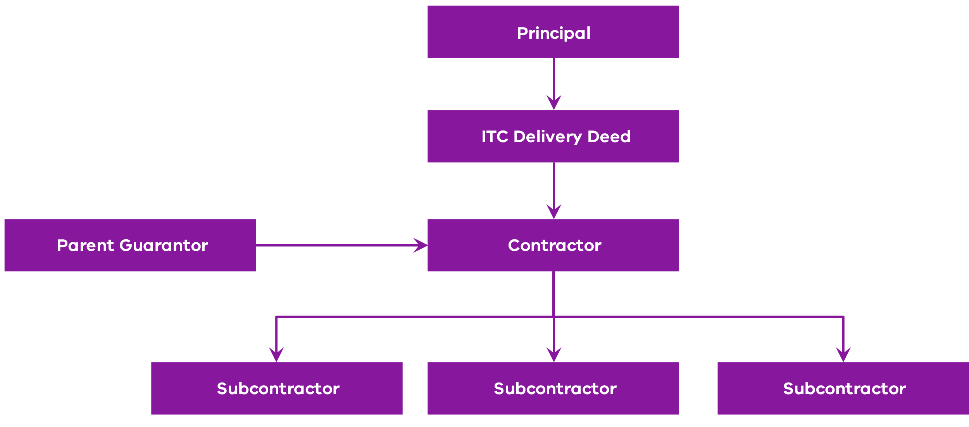
      - Approvals and project assurance
All HVHR Projects are required to undertake a series of centralised checks and processes tailored to the risk profile and characteristics of the Project. These are documented in the Project Assurance Plan that is developed for each project.
HVHR Projects require the Treasurer’s approval at key phases of the procurement process. In some cases, central agencies may be involved in the tender selection process.
Variations to standard deeds, commercial principles or risk allocations require input from DTF, and are typically confirmed through Project governance groups but may also require DTF or Treasurer approval (or both), as specified in a Project’s individual Project Assurance Plan.
Projects procured through cost reimbursable contracts, including the ITC model, are also required to meet the Cost Reimbursable Procurement Requirements.
For the ITC Contract Suite, DTF’s Commercial Division expects to be consulted on proposed changes to key commercial principles or risk allocations, including:
    - whether a Single TOC Process is used instead of a Competitive TOC Process;
    - any changes to the default payment and performance regimes; and
    - whether traditional or delayed liquidated damages regimes are used.
      - Principal Representative
The role of the Principal Representative under the ITC Contract Suite is to administer the ITC Development Deed and the ITC Delivery Deed and ensure the contractual obligations are performed.
The Principal Representative has two separate and distinct roles:
    - to act as agent for the Principal; and
    - to act as an independent certifier.
As the agent for the Principal, the Principal Representative may exercise all rights, powers, authority and functions of the Principal under the ITC Development Deed and the relevant Project Documents (including the ITC Delivery Deed). This role may include:
    - issuing directions to the Shortlisted Respondent (during the Development Phase) and the Contractor (during the Delivery Phase) on behalf of the Principal;
    - reviewing updates to the Design Development Program and the Development Phase Program (during the Development Phase) and updates to the Program (during the Delivery Phase);
    - approving the Contractor’s proposals to enter into Subcontracts during the Delivery Phase;
    - resolving ambiguities in the ITC Development Deed (during the Development Phase) and ambiguities within and between the Project Documents (during the Delivery Phase);
    - postponement and suspension of the Development Phase Services (during the Development Phase) and the Contractor’s Activities (during the Delivery Phase); and
    - issuing Variation Orders and Scope Variation Orders during the Delivery Phase.
In its role as certifier under the ITC Contract Suite, the Principal Representative performs certain certification functions around time, cost and Practical Completion. In undertaking its certification functions, the Principal Representative must:
    - act honestly and impartially;
    - arrive at a reasonable measure for value of work, quantities or time;
    - determine reasonably whether Practical Completion has been achieved; and
    - act within the time prescribed under the ITC Delivery Deed or, where no time is prescribed, within a reasonable time.
On a project-specific basis, agencies may elect to also appoint an independent reviewer or certifier who may certify payment, determine extensions of time and certify Practical Completion. An independent reviewer may be well suited to large projects where the benefit of additional assurance provided by a third party and the materiality of the relevant decision-making could outweigh the additional costs that come with an independent reviewer.
    - Commercial framework
      - Value-for-Money
VfM is an assessment of outcomes that weighs up the cost of procuring infrastructure against the value it provides. In doing so, it balances the Whole of Life Costs against a range of outcomes, including:
    - suitability and quality of infrastructure;
    - financial benefits;
    - risk exposure;
    - timeliness of outcomes; and
    - social, environmental and industry outcomes.
Whole of Life Costs include technology, obsolescence and maintenance costs. Further, costs to operate, support costs, costs to upgrade and disposal costs should be considered.
This VfM framework applies to the ITC Contract Suite even though the operating phase is not typically bundled under this contracting model. More information on VfM can be found in chapter 3 of the Cost Reimbursable Procurement Requirements available on the Cost Reimbursable Procurement Category webpage.
      - Assessing the Delivery Phase Offer
The ITC Contract Suite contemplates one or more Contractors being engaged through an ITC Development Deed to develop a Delivery Phase Offer. The Delivery Phase Offer includes several components that should be viewed holistically by the State to assess VfM. These components include:
    - Design Management Plan;
    - Design;
    - Delivery Phase Program;
    - Project Plans;
    - Subcontractor Packaging and Procurement Plan;
    - Project Local Industry Development Plan and Workforce Development Plan;
    - Social Procurement Commitment proposal;
    - Recycled First Plan;
    - TOC Estimate, including the State’s assessment of risk; and
    - Value Management.
This section provides an overview of the key activities to be undertaken by the procuring agencies and best practice associated with the Design Development Process and the TOC Estimate, as these are likely to have the greatest impact on VfM. However, the Delivery Phase Offer should be considered in light of all components outlined above. More detail on the specific requirements relating to the broader Delivery Phase Offer can be found in section 5.
      - Principal’s Benchmark
Prior to entering into an ITC Development Deed with one or more Shortlisted Respondents, the procuring agency should develop a Principal’s Benchmark. The Principal’s Benchmark is the State’s independent price comparator estimate of the TOC. This is developed independently of the Shortlisted Respondent’s pricing, other than in respect of ensuring the scope, risk and other bases of estimate assumptions are aligned to enable an appropriate price comparison. Best practice is for the Principal’s Benchmark to be developed prior to the procurement process for the ITC Development Deed, noting that the Principal’s Benchmark may be subject to revision as design and construction methodology is refined through the Development Phase. This should be a pre-estimate of the TOC that reflects whether risks are allocated to the Principal or the Contractor under the ITC Delivery Deed.
        - Development and use of the Principal’s Benchmark
The procuring agency is accountable for the Principal’s Benchmark and confirming the accuracy of the estimate. The procuring agency needs to consider engaging an external estimator to support the development of a robust Principal’s Benchmark. The Principal’s Benchmark should incorporate the reference design developed as part of the business case and any further development work undertaken by the procuring agency prior to procurement.
The Principal’s Benchmark is used in the VfM assessment of the TOC and the Shortlisted Respondent’s overall Delivery Phase Offer. Elements of the Principal’s Benchmark pricing may also be used as a basis for challenging the Shortlisted Respondent’s price, time and volume assumptions regarding the TOC. A Principal’s Benchmark is expected to be used in competitive and non-competitive TOC development processes to confirm the appropriateness of the Delivery Phase Offers.
In a non-competitive TOC process, the Shortlisted Respondent has the opportunity to access a larger share of the performance pool in the Delivery Phase if the TOC submitted as part of the Delivery Phase Offer is below the Principal’s Benchmark. This incentive is offered to promote VfM in the absence of competition. Equally, the procuring agency should challenge the TOC if the estimate is significantly below the Principal’s Benchmark to ensure that all key work activities have been covered and the design solution meets stakeholder expectations.
        - Refinement of the Principal’s Benchmark
As the Respondent(s) undertakes further development work during the ITC Development Phase, the Principal’s Benchmark needs to be continuously refined to reflect understanding of the scope. The Principal’s Benchmark needs to be a direct reflection of the solution developed by the Respondent(s) to be an effective tool in assessing value.
If a Respondent identifies innovation in design that leads to cost savings, in either a Single or Competitive TOC Process, the Principal’s Benchmark should be adjusted to capture these savings and allow for a like-for-like comparison. In a competitive TOC where Respondents compete on design innovation, the Principal may need to develop two Principal’s Benchmarks to reflect the diverging designs. The format, Work Breakdown Structure and Cost Breakdown Structure of each Principal’s Benchmark should be consistent to compare productivity, labour and material costs of each design.
A Shortlisted Respondent’s TOC Estimate may need to be risk adjusted during the evaluation of the Shortlisted Respondent’s Delivery Phase Offer. This is to reflect any departures from the ITC Delivery Deed so it can be evaluated against the Principal’s Benchmark.
        - Review and approval of the Principal’s Benchmark
The Principal’s Benchmark should be developed using the same Work Breakdown Structure and Cost Breakdown Structure that the Shortlisted Respondent(s) is required to use in developing their TOC Estimate(s). This facilitates comparison and assessment against their TOC Estimate(s) and allows the development of benchmarks for key rates.
      - Role of competition
The ITC Contract Suite contemplates a competitive process where the procuring agency simultaneously engages more than one Shortlisted Respondent to prepare Delivery Phase Offers under separate ITC Development Deeds. The Shortlisted Respondents are required to develop a TOC Estimate on an open book basis in their Delivery Phase Offer. Considering Delivery Phase Offers from multiple Shortlisted Respondents ensures that competitive tension is maintained, incentivising Respondents to develop optimal Delivery Phase Offers with respect to pricing, design and program.
A competitive TOC development process must be conducted with Respondents over the same timeframe, with all participants having access to the same information.
The VfM benefits achieved by undertaking a competitive TOC development process are expected to outweigh the additional costs and resourcing requirements. This competitive process allows the procuring agency to assess each Respondent’s performance against discrete development activities, rather than undertake a more limited assessment of a proposed methodology or interviews. A competitive TOC development also best supports procuring agencies in meeting state procurement principles.
The default competitive TOC development process may not be appropriate if there is:
    - a limited number of market participants or significant market capacity constraints;
    - significant project scope uncertainty; or
    - bidder innovation and Intellectual Property (IP) being invested into defining the project scope (in parallel or prior to TOC development) such that TOC submissions from different bidders would not provide a suitable comparison.
DTF should be engaged prior to the procuring agency selecting a Respondent to undertake a non-competitive Delivery Phase Offer development.
      - Expectations for TOC development
In developing the Delivery Phase Offer, Respondents are required to develop a TOC that they consider to be a realistic estimate of the overall cost and resources to deliver the project. It should reflect the project solution and the commercial arrangements.
The final TOC Estimate forms part of the Respondent’s Delivery Phase Offer, with the procuring agency understanding and actively challenging key pricing and resourcing assumptions, including pricing of risk.
The TOC should include the following elements.
    - Reimbursable Costs. This is the Respondent’s estimate for all Reimbursable Costs, direct and indirect, expected to be incurred during project delivery and allowable for reimbursement under the deed. The Reimbursable Cost estimate should clearly outline underlying assumptions, such as assumed price escalation rates.
    - COP. This is the Respondent’s proposed COP (also referred to as margin) to be earned during project delivery. Corporate overhead should support the reasonable recovery of non-project-specific overheads (e.g. general head office management costs). This COP should be expressed as a percentage of the estimated Reimbursable Cost.
    - Risk, contingency and opportunity. This is the Respondent’s estimate for risks associated with the project. The Respondent should share the methodology, assumptions and calculations used to determine the allowance for risk, contingency and opportunity (savings).
The TOC should be developed on a ‘first principles’ basis. This involves disaggregating the physical works into discrete activities. It requires assessing the individual labour and plant productivity and material required for each activity. The TOC should include project design costs, which should also be costed on a first principles basis.
The procuring agency should develop a Work Breakdown Structure and Cost Breakdown Structure for Respondents to complete. These should:
    - drive consistency in TOC Estimates to support VfM comparison;
    - promote transparency in estimation;
    - communicate key assumptions used in developing the TOC;
    - demonstrate the level of detail required in the TOC Estimate (i.e. level of detail for each activity); and
    - support the iterative nature of the TOC development through ongoing review and challenge of key assumptions.
The Respondent should define scope and quantities for a design and delivery solution that is informed by the project’s business case, project documentation and other relevant project information. The Respondent develops and optimises construction methodologies, delivery plans and appropriate procurement or Subcontracting agreements to suit market constraints and the project schedule. The Respondent’s team structure is developed on a best-for-project basis and is costed into the Reimbursable Cost allowance.
The allowance for risk and contingency is determined based on the Respondent’s understanding of key shared risks within the TOC and outcomes of any further investigations undertaken during the Development Phase. Procuring agencies should review these allowances in detail to confirm these costs are not duplicated elsewhere in the TOC. DTF should be invited to all risk workshops to participate in the identification and quantification of risk. This allows DTF to better understand the risk and contingency allowances. The Respondent(s) should seek to minimise risk and contingency through optimising design features that reduce the likelihood or consequence of the identified risks occurring. They should also undertake activities to reduce uncertainty during planning and delivery of the Project.
Activities that could be undertaken as part of the Development Phase to reduce uncertainty in the TOC and Program timelines include:
    - site investigations in relation to geotechnical conditions and the extent of Contamination in the Project area;
    - service proving to understand the exact location of Utilities in the Project and identify treatments to minimise impacts to these assets; and
    - early Works that are progressed prior to Contract Award, which may include detailed design of critical elements, project planning, procurement of long lead items, site establishment, accommodation and site clearance.
The procuring agency should use this information to confirm that the Respondent’s TOC can deliver the proposed scope and provides VfM by reviewing, challenging and comparing the rates, quantities and other underlying assumptions.
In addition to the procuring agency’s review of the TOC, it is recommended that a line by line review of the TOC should be undertaken by an independent estimator to scrutinise each line item. For example, the independent estimator should review exclusions in the TOC and confirm that the proposed use of Subcontractors is appropriate. The independent estimator should provide an independent assessment separately from the team that developed the Principal’s Benchmark. In addition, subject matter experts (from within the procuring agency) should scrutinise non-financial aspects, such as design and Program assumptions.
In a Competitive TOC Process, the Respondent’s TOC should be compared with both the competing Respondent(s) and the Principal’s Benchmark. Significant variations between the competing Respondent(s) and the Principal’s Benchmark should be investigated by the procuring agency.
In a non-competitive TOC, the procuring agency should use the Principal’s Benchmark to review and challenge the TOC. Significant variations should be investigated by the procuring agency to challenge the Respondent to deliver the best possible solution and price.
Best practice is for procuring agencies to review the TOC estimates on a regular basis throughout the Development Phase. The procuring agency reviews and challenges the TOC as the Respondent continues refining the estimate. In a 10–12 week Development Phase, the TOC should be reviewed at least three times, with each review providing more certainty of the TOC (i.e. at ‘bronze’, ‘silver’ and ‘gold’ review meetings). These reviews provide a detailed interrogation of the TOC. The procuring agency should allow sufficient time and resourcing, commensurate with the value and complexity of the project. For large projects, DTF should be invited to these review meetings, as well as the risk workshops.
      - Expectations for Design Development
The procuring agency should provide the Respondent(s) with a reference design at the outset of the Development Phase. The Respondent(s) should refine the design throughout the Development Phase and is encouraged to identify innovation in design solutions and efficiencies in construction methodology. This process aims to reduce the TOC Estimate while maintaining quality standards and meeting the overall project objectives.
Encouraging innovation in design during the development is likely to better support VfM objectives through identifying construction methods or design engineering opportunities (or both) that provide cost savings in up-front capital works or ongoing operating and maintenance costs. If procuring agencies do not provide an opportunity for Shortlisted Respondents to compete on design, these VfM opportunities may not be realised. However, the procuring agency should ensure that proposed designs still meet the overall project objectives and core scope components while addressing identified problems and delivering identified benefits as stated in the business case.
The procuring agency should advocate for the design to minimise uncertainty in the delivery of the Project rather than pricing in the TOC as contingency. An example might be design innovations that minimise disruption to Utilities.
      - Administering the payment regime
        - Assessing payments per contractual obligations
The payment mechanism under the ITC Contract Suite comprises the following.
Phase | Payment mechanism
Development Phase | - payment of Reimbursable Costs, including Early Delivery Activities (if applicable), directly, reasonably and actually incurred; and  - payment of COP
Delivery Phase | - payment of Reimbursable Costs, reasonably and actually incurred as per the Reimbursable Cost Schedule;  - payment of COP;  - a Gainshare/Painshare Adjustment to reflect any project Gainshare Amount or Painshare Amount; and  - a Performance Adjustment to reflect any Performance Reward Amount
          - Development Phase payments
The Shortlisted Respondent(s) is paid a Development Phase Services Fee on a cost reimbursement basis during the Development Phase. The Development Phase Services Fee includes:
    - Development Phase Services Reimbursable Costs, including:
      - design costs (based on a Schedule of Rates and assumed rate of effort); and
      - preliminaries and management costs (based on a Schedule of Rates and Reimbursable Cost); and
    - Development Phase Services COP (being the margin percentage bid back in the Shortlisted Respondent’s RFP response, multiplied by the Development Phase Services Reimbursable Costs).
The Development Phase Services Fee is paid monthly in arrears based on the value of the Development Phase Services performed on an open book basis. An option may be for project teams to require the Development Phase Services Fee to act as a cap. Consideration may also be given to paying a fixed percentage of the incurred Reimbursable Costs.
          - Delivery Phase payments
The Contractor is paid:
    - Reimbursable Costs, including:
      - design costs: all costs related to detailed design and investigations;
      - preliminaries costs: mobilisation and demobilisation and Contractor’s management and supervision costs;
      - construction costs: all direct construction-related activities costs; and
      - management costs: management and offsite overhead costs and insurances;
    - COP, which is the margin percentage bid back in the Contractor’s RFP response multiplied by Reimbursable Costs;
    - Gainshare Amounts payable under the Risk or Reward Regime (Cost Adjustments) based on the relationship between the Actual Outturn Cost (AOC) and the TOC;
    - Performance Reward Amounts under the Risk or Reward Regime based on the achievement of agreed KRAs (and supporting Key Performance Indicators (KPIs)); and
    - Adjustment Events resulting in a revision of the TOC, as specified in the Adjustment Event Guidelines.
The procuring agency should validate Contractor claims prior to payments. This confirms that the work relates to the project and all costs claimed are reimbursable in line with the contract. In addition, the procuring agency should consider using an independent auditor to verify that the project is progressing as reported and Payment Claims reflect this. The scope of the independent auditor’s work should include confirmation that direct costs, COP and Cost Adjustment payments are in accordance with the ITC Delivery Deed. The auditor should also review internal systems and procedures.
        - Assessing entitlement to Risk or Reward Regime
The Risk or Reward Regime provides cost and performance incentives to drive Contractor behaviour. The Risk or Reward Regime is comprised of the following two key elements.
    - Cost Adjustment. This is a mechanism for the Contractor and the State to share cost overruns and underruns in delivering the project as compared to the TOC through a Gainshare/Painshare Adjustment.
    - Performance Adjustment. This is a mechanism to incentivise the Contractor to deliver exceptional performance in non-financial objectives that are important to the State, such as quality and safety, timely completion, community satisfaction and other non-financial objectives.
The Risk or Reward Regime has been developed in practitioner workshops and is based on the approaches used in other ITC contracts in Victoria and New South Wales.
At the end of the project, the procuring agency should use monitoring and reporting provided up to that point (including verification of key metrics by an independent auditor if required) to confirm the payment entitlement under the Risk or Reward Regime. See section 3.8 for further information on monitoring and reporting requirements.
        - Assessing entitlements to Adjustment Events
While most costs are shared through the cost reimbursable model, the ITC Contract Suite allows for both parties to revise the TOC, KRAs and the dates for completion. These revisions, mutually agreed upon, consider unforeseen external events and circumstances. The ITC Delivery Deed lists the unknown events that result in an Adjustment Event. These note that most costs should be addressed by the Gainshare/Painshare Adjustment, consistent with the risk-sharing nature of the ITC model. The model allows for extensive due diligence prior to confirming the TOC. The Adjustment Events are listed in Schedule 15 to the ITC Delivery Deed.
The ITC Delivery Deed provides for a mechanism to adjust the TOC, KRAs and the dates for completion. The Contractor is entitled to Adjustment Events, which include extensions of time and adjustments to the TOC or the KRAs, depending on the event. The procuring agency should consider on a case-by-case basis whether COP should be included in the Adjustment Event, noting that there may be scenarios where excluding COP may significantly disincentivise performance and negatively impact on achievement of project objectives.
There are some acts, events and circumstances that only constitute an Adjustment Event (Cost). This is where the Contractor has been granted an extension of time to a Date for Completion, and the adjustment to the TOC only applies to time-related costs. This is to ensure that these Adjustment Events are sufficiently material to warrant paying relief to the Contractor.
Project-specific Adjustment Events, which impact the TOC (and by extension the Risk or Reward Regime), can be determined on a case-by-case basis in accordance with the Adjustment Event Guidelines. Procuring agencies should consult with DTF regarding project-specific Adjustment Events as part of the HVHR approvals processes.
Care should be taken to ensure the agreed Adjustment Events are as targeted and specific as possible to avoid broad adjustments rights.
      - Monitoring and reporting
On a regular basis, the procuring agency should obtain reporting that outlines how the project is meeting cost, time, VfM and other objectives.
In addition, the Contractor should provide a regular forecast of cost to complete in the agreed Work Breakdown Structure and Cost Breakdown Structure format. Where forecast cost is likely to exceed the TOC, they should provide a list of proposed actions to limit excess. The procuring agency should support decision-making- where the TOC is likely to be significantly exceeded.
This allows for comparison of forecast cost and project delivery against the TOC Estimate.
Reporting should outline agreed variations to the TOC arising from any Adjustment Events. This should include the outcome of the following elements:
    - Contractor-requested TOC adjustments where the Contractor is entitled to claim an adjustment to the TOC for an Adjustment Event (Time) or Adjustment Event (Cost); and
    - Contractor- or Principal-requested TOC adjustments for Variations.
As stated in section 3.7.1, the procuring agency should consider using an independent auditor to verify that the project is progressing as reported and Payment Claims reflect this.
The ITC Delivery Deed contains drafting to require the Contractor’s preparation and pursuit of an overrun cure plan where the TOC is likely to be exceeded or has already been exceeded.
        - Reporting and reconciling VfM over the life of the project
Upon contract completion, procuring agencies are required to prepare a project completion report for government that includes VfM outcomes. The completion report must be developed and verified independently of the Contractor to ensure an impartial and objective assessment of project performance.
The completion report must include:
    - a full reconciliation of total procuring agency budget with the actual total project cost to the government, including a breakdown of provisions outside the TOC, such as owner’s costs and contingencies;
    - a reconciliation of the TOC against the expected AOC;
    - an assessment of the risks that eventuated in comparison to expectations at project tendering;
    - a summary of contractual changes during delivery (since execution);
    - a summary of the Contractor’s performance, including against KRAs and payments made to the Contractor;
    - quality, innovation and other improvements identified and implemented during the project by the Contractor, including the benefits delivered from those innovations (with verification);
    - a summary of scope changes and their effect on capital expenditure and operational expenditure, including a reconciliation between project scope contracted for and what was delivered;
    - an assessment of whether the agreed legal and commercial terms and conditions in the contract executed has provided for a best-in-market actual outcome; and
    - a summary of lessons learned, including aspects that could have been improved on, with recommendations for how performance can be improved in the future.
Procuring agencies are also required to provide progressive reconciliations of changes to project budget, cost, scope and timeframes from what was approved by government in the business case. This is best done at key project decision points where appropriate. These changes should be combined into one report and updated for changes at each approval point. Where there are changes from what was previously approved by government, the reasons for these changes should be included.
    - ITC Development Deed guidance
The ITC Development Deed governs the delivery of the Development Phase Activities by the Shortlisted Respondent (or Shortlisted Respondents, as applicable). Where there are multiple Shortlisted Respondents, there are multiple ITC Development Deeds, each governing the Development Phase Activities.
        - Procurement strategy and Development Phase Objectives (clause 2 of the ITC Development Deed)
          - Procurement strategy (clauses 2.1 and 2.3 of the ITC Development Deed)
Clause 2 of the ITC Development Deed sets out the procurement strategy and Development Phase Objectives of the ITC Development Deed.
This is a two-phase procurement model, with one or more Shortlisted Respondents entering into an ITC Development Deed and one Successful Respondent subsequently entering into an ITC Delivery Deed. The Shortlisted Respondent accepts that neither the negotiation of any Agreed ITC Delivery Deed nor a direction to carry out the Early Delivery Activities constitutes a representation by the Principal that it will accept the Shortlisted Respondent’s Delivery Phase Offer or proceed with the Project. The Shortlisted Respondent acknowledges that while the Principal will cooperate with and assist them to perform the Development Phase Services, the Principal will simultaneously cooperate with and assist Other Shortlisted Respondents (if applicable) provide their services under their respective ITC Development Deeds.
          - Project-specific amendments
Where the scope of the Project forms part of a larger portfolio of works to be delivered (e.g. upgrades to a road or rail network), project-specific amendments may be required to alter the scope of the Works under clause 2.1(c) of the ITC Development Deed. These are at the Principal’s discretion.
In some cases, it may be appropriate for the Principal to use its discretion to reduce the scope of the Project.
        - Relationship Principles (clause 2.3 of the ITC Development Deed)
The ITC Development Deed adopts a collaborative approach, whereby the Shortlisted Respondent agrees to abide by certain principles of behaviour as part of the agreement. This promotes a greater commercial alignment, facilitating collective problem-solving and decision-making to reduce adversarial issues. In particular, the Shortlisted Respondent commits to:
    - establishing and maintaining a culture that emphasises and reinforces integrity and trust;
    - notifying the Principal of perceived or real differences of opinion or conflicts of interest as soon as they arise; and
    - ensuring its officers and agents are also committed to the Relationship Principles.
          - Open book basis (clauses 8.1, 12.2 and 14.3 of the ITC Development Deed)
The Shortlisted Respondent is required to complete certain obligations on an open book basis, including:
    - the procurement of all Subcontractors;
    - the preparation of, and any adjustment to, the TOC Estimate; and
    - making the Deliverables and the Shortlisted Respondent’s Records fully available to the Principal, the Principal Representative and any other person authorised by the Principal or the Principal Representative for examination, audit, inspection, transcription and copying.
Completing an obligation on an open book basis requires the Shortlisted Respondent to be transparent in all dealings and share all relevant information in a timely manner. The Principal should collaboratively and proactively work with the Shortlisted Respondent to ensure that information is provided to the Principal in a format that can be used effectively.
Information that should be provided on an open book basis includes (but is not limited to) the provision of pricing, risks and contingency. This and other information should be provided on an open book basis to the Principal to enable a fully auditable, transparent and VfM assessment of actual costs and profit margins in respect of, among other things:
    - the preparation of, and any adjustment to, the TOC Estimate;
    - the Delivery Phase Offer; and
    - the procurement of any Subcontractors.
      - Early Delivery Activities (clause 9 of the ITC Development Deed)
        - Direction (clauses 9.1 and 9.2 of the ITC Development Deed)
At any time, the Principal Representative may issue an Early Delivery Activities Direction to the Shortlisted Respondent. This Direction is a written notice in the form of Schedule 7 that contains particulars of the scope, commencement and completion dates for the Early Delivery Activities. The Shortlisted Respondent must not carry out any Early Delivery Activities unless so directed by the Principal Representative.
Additionally, the Principal Representative may issue the Shortlisted Respondent with a notice of proposed Early Delivery Activities. Where the Principal Representative issues such a notice, the Shortlisted Respondent must provide an Early Delivery Activities Proposal (in the form of Schedule 8) within 10 Business Days, or as otherwise reasonably agreed.
As noted in section 1.4.3, where there are multiple Shortlisted Respondents, it can be challenging to monitor probity requirements under the ITC Development Deed. This is especially true while undertaking Early Delivery Activities under an ITC Development Deed. The procuring agency should consider whether a separate tender process could be used for Early Delivery Activities if they occur early in the Project (e.g. they are on the critical path), but the work is not so integrated into the Project or design solution that it needs to be completed by a Shortlisted Respondent.
        - Conduct of Early Delivery Activities (clause 9.5 of the ITC Development Deed)
Early Delivery Activities are anything the Shortlisted Respondent is or may be required to do to comply with its obligations under the ITC Development Deed. This incorporates design, construction, commissioning and completion of the Early Works, which are any physical works to be executed in accordance with the ITC Development Deed.
Unless otherwise specified in the Early Delivery Activities Direction, the Early Delivery Activities are subject to the terms of the Agreed ITC Delivery Deed.
Payment for the Early Delivery Activities is made in accordance with the Agreed ITC Delivery Deed unless agreed otherwise (clause 9.5(d) of the ITC Development Deed). The Risk or Reward Regime under the ITC Delivery Deed, which provides for the Gainshare/Painshare Adjustment and Performance Reward payments, does not apply during the Development Phase.
In performing any Early Delivery Activities, the Shortlisted Respondent must not establish any accommodation, facilities or presence on the Site unless expressly directed by the Principal.
        - Early Works DLP (clause 9.7 of the ITC Development Deed)
If the Shortlisted Respondent’s Delivery Phase Offer is rejected by the Principal, the Shortlisted Respondent must continue to carry out the Early Delivery Activities to complete the Early Works in accordance with ITC Development Deed.
The Early Works DLP is 12 Months from the date the Shortlisted Respondent achieves completion of the Early Works (unless extended by the Principal Representative in accordance with clause 9.7(c) of the ITC Development Deed). However, if the Principal Representative directs that the Early Delivery Activities are not to continue, the DLP is 12 Months from the date the Principal notifies the Shortlisted Respondent that it rejects the Delivery Phase Offer under clause 14.4(a)(iii) of the ITC Development Deed.
The Shortlisted Respondent must rectify all Defects that exist at the commencement of the Early Works DLP or that the Principal alerts them to during the Early Works DLP. Where the Shortlisted Respondent is required to rectify a Defect, the Principal Representative may extend the Early Works DLP for the relevant part of the Early Works for up to 6 Months, as the Principal Representative determines.
Figure 5 below shows the relevant timeframes for the Early Delivery Activities Direction and Early Works DLP for the Development Phase and Delivery Phase (by way of example only).
Figure 5 – Early Delivery Activities Direction and Early Works DLP
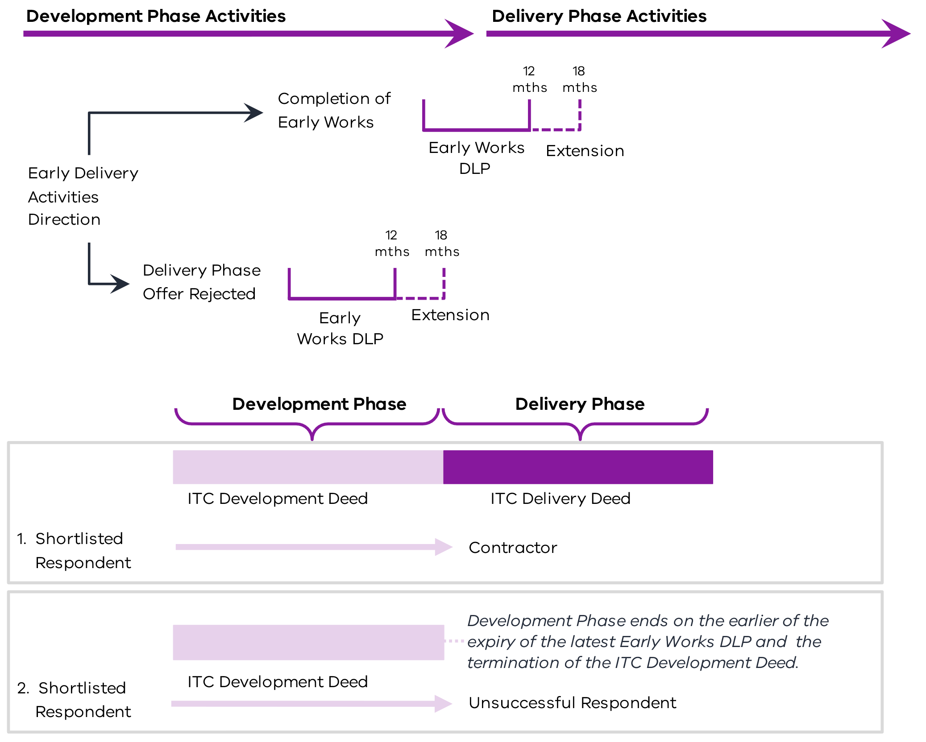
      - Payment (clause 16 of the ITC Development Deed)
The Shortlisted Respondent is paid:
    - a Development Phase Services Fee for the Development Phase Services; and
    - any other amounts payable by the Principal to the Shortlisted Respondent under the ITC Development Deed (such as the Early Delivery Activities Price for any Early Delivery Activities) during the Development Phase in accordance with the ITC Development Deed.
        - Development Phase Services Fee (Schedule 5 to the ITC Development Deed)
The Development Phase Services Fee is calculated as the aggregate of the Development Phase Services Fee Components. Those components are:
    - the Development Phase Services Reimbursable Costs; and
    - the Development Phase Services COP.
The Development Phase Services Fee and Early Delivery Activities Price are paid monthly in arrears following receipt of a Payment Claim. This claim is supported by evidence of actual costs incurred and calculated in accordance with the rates and other assumptions detailed in the ITC Development Deed. The Principal retains discretion to cease the Development Phase (and any activities within the Development Phase) at any time for any reason in accordance with the ITC Development Deed.
          - Development Phase Services Reimbursable Costs
Subject to specific exclusions contained in the ITC Development Deed (including those exclusions identified in section 3 of attachment 1 to Schedule 5 to the ITC Development Deed), the Development Phase Services Reimbursable Costs are costs and expenses that are both:
    - directly, reasonably and actually incurred by the Shortlisted Respondent in performing the Development Phase Services (excluding any corporate overhead component not specific to the Development Phase Services and any profit or mark up of any kind) in accordance with the ITC Development Deed; and
    - identified as Development Phase Services Reimbursable Costs in section 3 of attachment 1 to Schedule 5 to the ITC Development Deed, or that the ITC Development Deed otherwise expressly provides will be Development Phase Services Reimbursable Costs.
The costs identified in section 3 of attachment 1 to Schedule 5 to the ITC Development Deed as Development Phase Services Reimbursable Costs include Non-Wages Personnel costs (calculated using agreed rates and Reimbursable Cost Multipliers).
          - Development Phase Services Corporate Overhead and Profit
The Development Phase Services COP payable by the Principal to the Shortlisted Respondent is calculated as an amount equal to the Development Phase Reimbursable Costs multiplied by the percentage for COP specified in Schedule2.
        - Project-specific amendments
As mentioned in sections 3.7.1 and 4.3, the procuring agency may choose to cap the Development Phase Service Fee.
Where the scope of the Development Phase is well defined and understood, the procuring agency’s team should adjust its procurement process and amend the ITC Development Deed to allow for the Development Phase Activities to be competitively tendered on a fixed-price basis.
DTF should be consulted about setting the Development Phase Services Fee on a project-specific basis.
      - TOC Estimate (clause 12 of the ITC Development Deed)
        - Development of the TOC Estimate (clause 12.2 of the ITC Development Deed)
The Shortlisted Respondent prepares and updates the TOC Estimate on an open book basis. Prior to the submission of the Delivery Phase Offer, the last updated version of the TOC Estimate is the final TOC Estimate. The Delivery Phase Offer must, among other requirements, be prepared without adjustment to the final TOC Estimate (unless otherwise agreed with the Principal).
        - The TOC Estimate (section 1 of Schedule 6 of the ITC Development Deed)
The TOC Estimate is the sum of the TOC Components, which are:
    - Development Phase Services Fee (see section 4.3.1);
    - Early Delivery Activities Price;
    - Estimated Delivery Phase Reimbursable Costs;
    - Estimated Delivery Phase Risk and Contingency Provisions; and
    - Estimated Delivery Phase COP, being an amount equal to the Estimated Delivery Phase Reimbursable Costs multiplied by the Delivery Phase COP percentage set out in the Agreed ITC Delivery Phase Contract.
          - The Estimated Delivery Phase Reimbursable Costs
These are the Shortlisted Respondent’s estimates of the Reimbursable Costs likely to be directly, reasonably and actually incurred in performing the Delivery Phase Activities.
          - The Estimated Delivery Phase Risk and Contingency Provisions
These are the Shortlisted Respondent’s estimates of the Risk and Contingency Provisions that may arise in performing the Delivery Phase Activities.
        - Incentive for the Shortlisted Respondent to prepare a final TOC Estimate that is less than the Principal’s Benchmark (section 4.1 of Schedule 5 to the ITC Delivery Deed)
The Principal prepares the Principal’s Benchmark (the benchmark TOC for the Project) during the Development Phase. See section4.4.7 for further details.
Under a Single TOC Process, if the Shortlisted Respondent prepares a final TOC Estimate that is less than the Principal’s Benchmark, they are entitled to an additional performance percentage amount. This is part of the Performance Reward Potential Pool in accordance with Schedule 5 of the Agreed ITC Delivery Deed.
        - Requirements for preparing the TOC Estimate (clause 12.2 of the ITC Development Deed)
The Shortlisted Respondent must prepare and update the TOC Estimate:
    - in accordance with the Development Phase Services and Deliverables Schedule (DPSDS) and the Delivery Phase Pricing Schedule (to be updated on a project-specific basis but including, for example, the production of Design Reports and the continued updating of Programs);
    - on the basis of the PSDR and most recent Design Deliverables;
    - to reflect the terms of the Agreed ITC Delivery Deed;
    - to be calculated in accordance with:
      - the applicable rates or prices included in the Schedule of Rates;
      - input prices that have been procured following the outcome of a competitive tendering process; and
      - appropriate benchmarking data approved by the Principal Representative;
    - on an open book basis; and
    - so as to ensure that the Estimated Delivery Phase Risk and Contingency Provisions are progressively reduced from the amount in prior versions of the TOC Estimate prepared during the Development Phase to the greatest extent practicable.
As the Shortlisted Respondent is required to progressively develop and resubmit its TOC Estimate, it is expected that any contingency or risk allowance included in the TOC Estimate is progressively and materially reduced. Similarly, the Shortlisted Respondent is required to provide detailed reasons for the changes in subsequent versions of the TOC Estimate. Refer to section 3.5 for further guidance on the TOC development process.
        - TOC Estimate warranties (clause 12.3 of the ITC Development Deed)
The Shortlisted Respondent must ensure that the TOC Components do not include:
    - any amount that is or ought to have been included in another TOC Component
    - any corporate overhead or profit (other than in accordance with the Delivery Phase Pricing Schedule).
        - Preparing and updating the TOC Estimate through the Development Phase and Delivery Phase
Figure 6 below shows the development of the TOC Estimate through the Development Phase and into the Delivery Phase.
Figure 6 – Development of the TOC Estimate
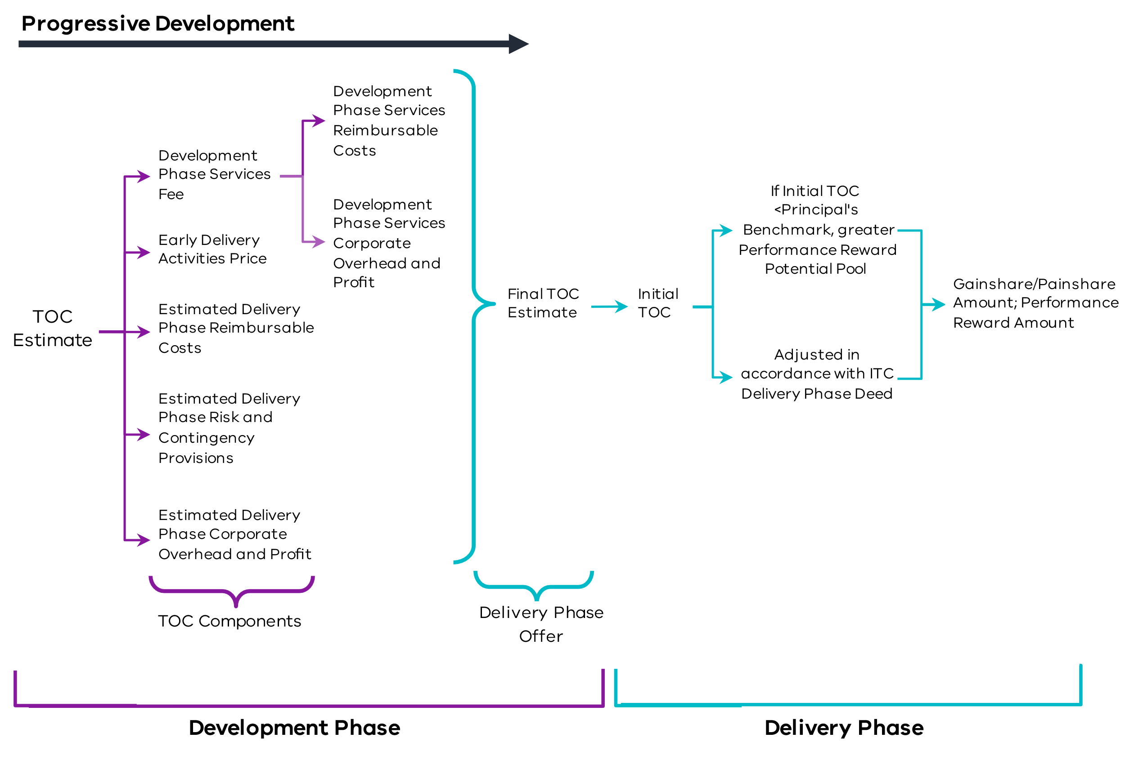
        - Principal’s Benchmark (clause 12.1 of the ITC Development Deed)
During the Development Phase, the Principal prepares the Principal’s Benchmark, being the Principal’s Benchmark TOC for the Project against which Delivery Phase Offers submitted by Shortlisted Respondents are assessed (among other criteria). The Principal’s Benchmark should be developed based on the costing estimates that informed the development of the business case and adapted to inform the RFP.
The Principal should be careful to avoid optimism bias when developing the Principal’s Benchmark. Optimism bias refers to a systematic tendency to be overly optimistic about the outcome of planned actions a can result in underestimating the Project costs. One way to mitigate against optimism bias is to emphasise realistic budgeting, particularly when assessing risks. Refer to section 3.3 for further guidance on developing the Principal’s Benchmark.
The Shortlisted Respondent is not entitled to make, nor will the Principal be liable for, any Claim arising out of or in connection with the Principal’s Benchmark or the preparation of it.
          - Project-specific amendments
The ITC Development Deed contemplates that the Principal may, but is not required to, disclose all or part of the Principal’s Benchmark to the Shortlisted Respondent to support negotiations. On a project-specific basis, procuring agencies are to consider whether the Principal’s Benchmark should remain confidential.
      - Process for entry into ITC Delivery Deed (clause 14 of the ITC Development Deed)
        - Form of ITC Delivery Deed (clause 14.1 of the ITC Development Deed)
Depending on the agreement between the parties, the ITC Development Deed allows for the parties to either:
    - enter the form of Agreed ITC Delivery Deed, inserted at Annexure 1 of the ITC Development Deed; or
    - enter a negotiated form of Agreed ITC Delivery Deed.
          - Annexed form of Agreed ITC Delivery Deed
Under this alternative, the parties acknowledge they have agreed the terms of the Agreed ITC Delivery Deed at the time of entering into the ITC Development Deed. In these circumstances, the ITC Delivery Deed is only amended as set out in clause 14.5(a) of the ITC Development Deed.
          - Negotiated form of Agreed ITC Delivery Deed
Under this alternative, the parties commit to diligently progress negotiations to finalise agreement of the terms of the ITC Delivery Deed. They will seek to agree on the terms of the deed within 30 days of the commencement of negotiations. If the parties reach agreement, those terms will become the Agreed ITC Delivery Deed. Except as expressly provided in the Development Phase Pricing Schedule, the parties are required to bear their own costs arising from the negotiation process.
        - Development and submission of Delivery Phase Offer (clauses 14.2 and 14.3 of ITC Development Deed)
          - Development
A fundamental part of the process under the ITC Development Deed is the requirement for each Shortlisted Respondent to progressively develop the Delivery Phase Offer. They must also provide the Principal Representative with successive drafts of the Development Phase Deliverables, which form part of the Delivery Phase Offer in accordance with:
    - the DPSDS;
    - the Development Phase Program; and
    - the Design Development Program.
This allows the Principal to have visibility of the progressive development of the offer and minimises the need for lengthy negotiations. As information is exchanged between the parties, contingencies built into the Shortlisted Respondent’s TOC should be reduced. This should result in the Delivery Phase Offer becoming more favourable towards the Principal.
The Principal is given the opportunity to review and comment on the successive drafts of the Development Phase Deliverables. This enables the Shortlisted Respondent to address these comments prior to submission of the Delivery Phase Offer. To assist with this process, the Shortlisted Respondent is required to identify amendments and reasons for the amendments in the subsequent versions of drafts provided to the Principal.
          - Submission
The Shortlisted Respondent is required to use its best endeavours to submit the Delivery Phase Offer to the Principal by the Date for Delivery Phase Offer (specified in the Contract Particulars). The Delivery Phase Offer must:
    - be a completed Delivery Phase Offer Form provided by the Principal;
    - remain open to and capable of acceptance by the Principal for the Offer Period (as set out in the Contract Particulars);
    - be prepared:
      - on an open book basis;
      - to reflect the PSDR; and
      - without adjustment to the Design Deliverables, Delivery Phase Program, final TOC Estimate or any other Development Phase Deliverables relevant to the Delivery Phase Activities (unless otherwise agreed with the Principal);
    - reflect the terms of the Agreed ITC Delivery Deed and not contain any amendments, assumptions, conditions or requirements that are inconsistent with the Agreed ITC Delivery Deed, other than those amendments set out in clause 14.5(a) of the ITC Development Deed; and
    - meet any other requirements specified by the Principal.
Where requested by the Principal, the Shortlisted Respondent must promptly provide copies of relevant supporting documentation for the development of the Delivery Phase Offer. This may include quotes and quantities, as well as details of the conduct and outcome of any procurement processes where relevant input prices have been determined.
        - Principal’s consideration
Following submission, the Principal reviews and evaluates the Delivery Phase Offer submitted by the Shortlisted Respondent and any other Shortlisted Respondent against the Evaluation Criteria. The Principal considers comments from its independent advisers including reports provided in accordance with clause 13 of the ITC Development Deed. Experiences and feedback from the Principal Associates’ dealings with the Shortlisted Respondent and other key stakeholders will be considered by the Principal.
The Shortlisted Respondent is required to honestly and openly answer any questions that the Principal or its independent advisers may have in connection with the Delivery Phase Offer (including the TOC Estimate). This is consistent with their commitments under clause 3 of the ITC Development Deed.
        - Principal’s decision (clause 14.4 of the ITC Development Deed)
Prior to the expiry of the Offer Period, the Principal Representative notifies the Shortlisted Respondent that the Principal:
    - accepts the Delivery Phase Offer;
    - wishes to negotiate the Delivery Phase Offer; or
    - rejects the Delivery Phase Offer.
Figure 7 below outlines the process and options available to the Principal, in the scenario where there is more than one Shortlisted Respondent.
Figure 7 – Process and options where more than one Shortlisted Respondent
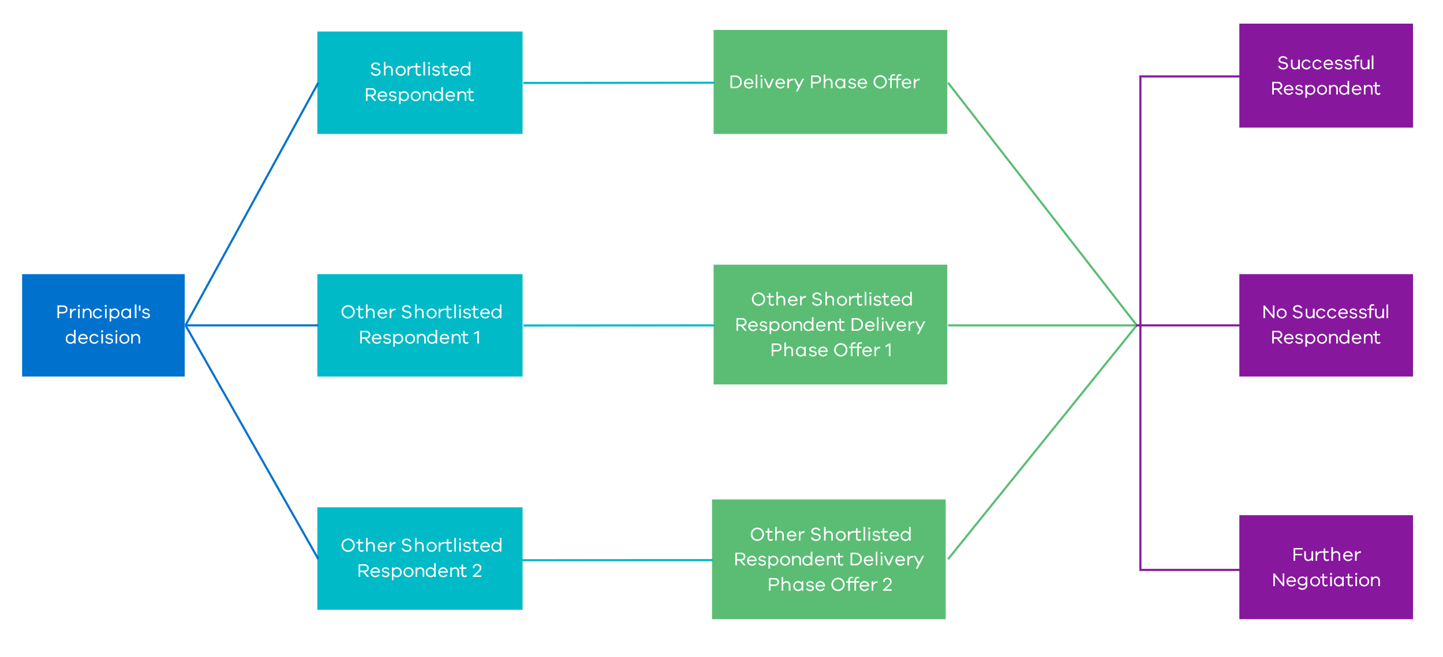
          - Principal accepts the Delivery Phase Offer
If the Principal accepts the Delivery Phase Offer, they prepare the ITC Delivery Deed for execution by the Successful Respondent using the Agreed ITC Delivery Deed, which is only amended:
    - on the basis of any conditions of the Delivery Phase Offer that have been accepted by the Principal;
    - to address matters identified in the ITC Development Deed as being subject to finalisation;
    - to correct a drafting error; or
    - as otherwise agreed.
The Successful Respondent must then execute the ITC Delivery Deed within 10 Business Days of receipt. On the date that the ITC Delivery Deed is executed by the Principal and the Successful Respondent, the ITC Development Deed terminates in accordance with clause 25.1(a).
          - Principal wishes to negotiate the Delivery Phase Offer
If the Shortlisted Respondent is notified by the Principal Representative that the Principal wishes to negotiate the Delivery Phase Offer, the Shortlisted Respondent must undertake genuine and good faith negotiations with the Principal. These negotiations should aim to agree on the adjustment (if any) required to the proposed TOC or incorporate other changes to the Delivery Phase Offer proposed by the Principal.
The Shortlisted Respondent must resubmit the Delivery Phase Offer, adjusted to reflect the outcome of these negotiations, as soon as reasonably practicable. The Offer Period is extended as agreed by the parties and the Principal again makes a determination as to whether the Delivery Phase Offer is accepted pursuant to clause 14.4(a) of the ITC Development Deed.
          - Principal rejects the Delivery Phase Offer
If the Shortlisted Respondent is notified by the Principal Representative that the Principal rejects the Delivery Phase Offer, the Shortlisted Respondent is then required to, (among other things):
    - cease performing the Development Phase Services;
    - promptly vacate and make good (as reasonably required by the Principal) or otherwise make safe the Site;
    - immediately deliver to the Principal all Deliverables, Subcontracts entered into with any Subcontractors and warranties given by any Subcontractor; and
    - novate any Subcontracts required by the Principal.
Where the Principal has not issued an Early Delivery Activities Direction, the ITC Development Deed terminates under clause 25.1(b) on the date of the rejection notice.
Where the Principal has issued an Early Delivery Activities Direction, the Principal may terminate the ITC Development Deed under clause 25.2 with 10 Business Days’ notice.
Figure 8 below outlines the process by which the Shortlisted Respondent can enter the ITC Delivery Deed following the submission of its Delivery Phase Offer.
Figure 8 – Entry into the ITC Delivery Deed
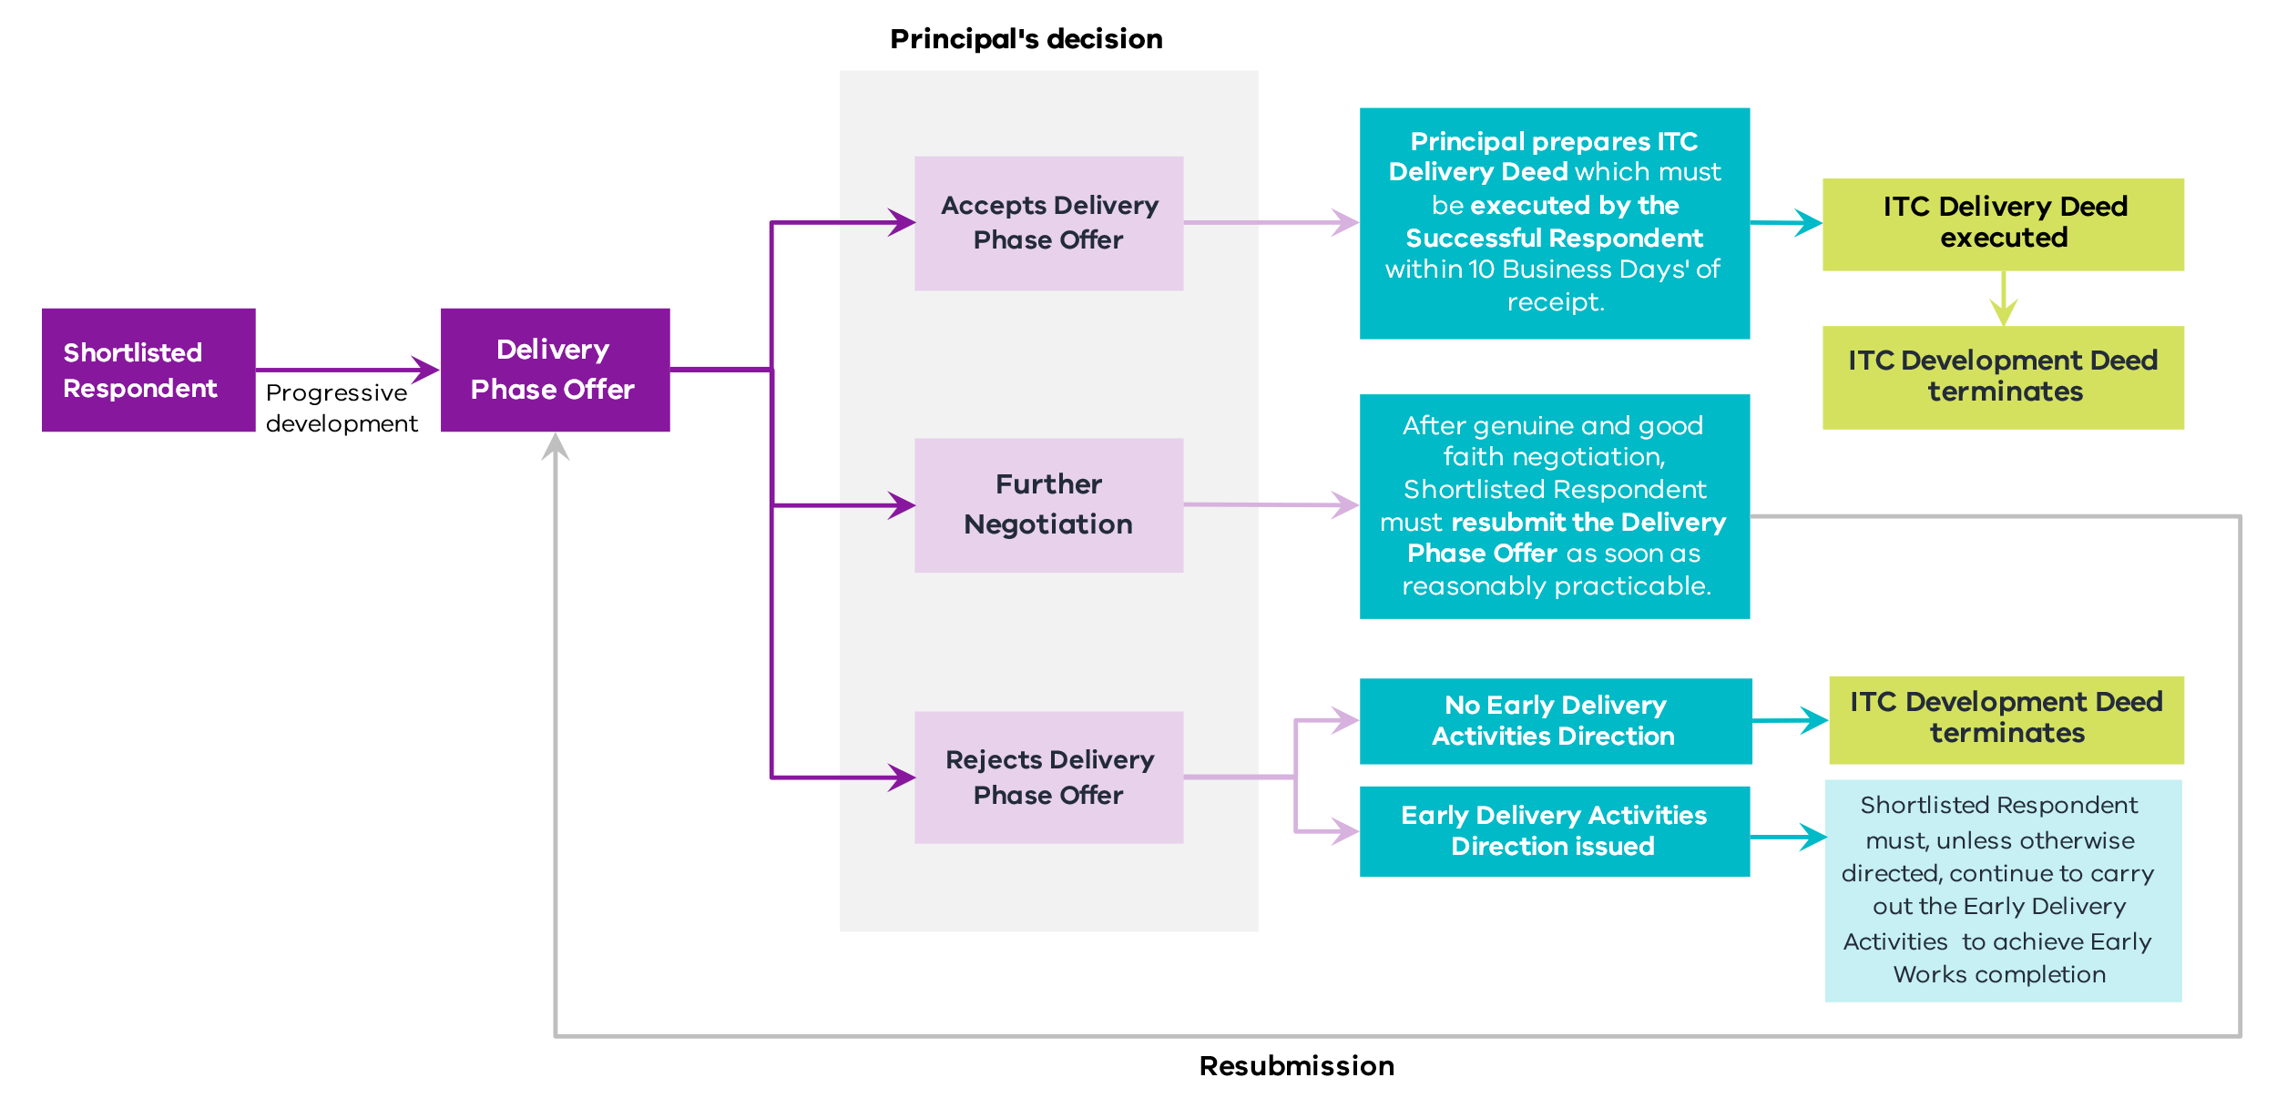
      - Time (clause 15 of the ITC Development Deed)
The Shortlisted Respondent is required to use its best endeavours to submit the Delivery Phase Offer by the Date for Delivery Phase Offer. They must not depart from the Development Phase Program and the Design Development Program without the Principal’s written approval.
The Principal Representative may instruct the Shortlisted Respondent to suspend or, after a suspension has been instructed, recommence carrying out all or any part of the Development Phase Services. Where such a suspension is instructed, other than as a result of a Shortlisted Respondent Act or Omission, the Shortlisted Respondent must take reasonable steps to mitigate the costs incurred as a result of the suspension. Provided it does so, it will be entitled to payment of the Development Phase Services Fee for the period of suspension.
      - Indemnities (clause 19.1 of the ITC Development Deed)
        - General principle
The ITC Development Deed requires the Shortlisted Respondent to provide indemnities to the Principal and the Principal Associates for property damage and personal injury or death arising out of or as a consequence of the performance of the Development Phase Services by the Shortlisted Respondent.
The Shortlisted Respondent’s liability to indemnify will be reduced proportionally to the extent that the Liability is caused or contributed to by any act or omission of the Principal or any of the Principal Associates.
        - Project-specific amendments
Procuring agencies may consider who, in addition to the Principal, should be indemnified. This consideration should account for the number of Principal Associates involved in the Project and the arrangements that the Principal may have in respect of the Principal Associates. On a project-specific basis, the Liability of the Shortlisted Respondent could be limited in respect of economic loss that may be suffered by those Principal Associates through carve outs to the Indirect or Consequential Loss exclusion for the Shortlisted Respondent.
      - Limitation and exclusion of Liability (clauses 19.3, 19.4 and 19.5 of the ITC Development Deed)
        - Shortlisted Respondent’s limitation of Liability (clauses 19.3 and 19.4 of the ITC Development Deed)
The Shortlisted Respondent’s liability under the ITC Development Deed is capped at the amount specified in the Contract Particulars.
However, the limitation on the Shortlisted Respondent’s liability does not apply to (among other things):
    - personal injury, death or loss of or damage to any property;
    - any criminal act, fraud or Wilful Misconduct on the part of the Shortlisted Respondent or any Shortlisted Respondent Associate;
    - any Liability that cannot be excluded at Law; or
    - abandoning the Development Phase Services.
        - Exclusion of Liability for Indirect or Consequential Loss (clause 19.5 of the ITC Development Deed)
          - General principle
The ITC Development Deed provides that neither the Principal nor the Shortlisted Respondent is liable for Indirect or Consequential Loss incurred or suffered by the Shortlisted Respondent or the Principal respectively, except in limited circumstances.
These carve outs to the exclusion of Indirect or Consequential Loss are typically passed through to Subcontractors and are accordingly subject to the liability caps in their Subcontracts.
          - Principal Liability
The Principal and any Principal Associate is liable to the Shortlisted Respondent for Indirect or Consequential Loss in relation to:
    - Liability that cannot be limited at Law;
    - Liability arising from any criminal act, fraud or Wilful Misconduct on the part of the Principal or Principal Associate – on the basis that this type of conduct is so serious that the Liability that flows from it should not be limited;
    - Liability arising from any loss of or damage to third party property or injury, illness or death of any person – on the basis that the party responsible for the loss should be expected to cover this loss, and it is typically insured; and
    - any amounts payable and calculated in accordance with the ITC Development Deed.
          - Shortlisted Respondent Liability
The Shortlisted Respondent and any Shortlisted Respondent Associate is liable to the Principal for Indirect or Consequential Loss in relation to:
    - Liability that cannot be limited at Law;
    - Liability for which the Shortlisted Respondent can recover under any Insurance or in accordance with an indemnity;
    - Liability in connection with any criminal act, fraud or Wilful Misconduct on the part of the Shortlisted Respondent or any Shortlisted Respondent Associate;
    - Liability in connection with any loss of or damage to third party property or any injury to, illness of or death of any person;
    - Liability expressly imposed on the Shortlisted Respondent under the ITC Development Deed to pay the Principal any amounts payable under and calculated in accordance with the ITC Development Deed;
    - any amount payable under and calculated in accordance with the ITC Development Deed; and
    - Liability in connection with the abandonment of the Development Phase Services by the Shortlisted Respondent or any Shortlisted Respondent Associate.
          - Project-specific amendments
The list of exceptions to the exclusion for Indirect or Consequential Loss may include additional project-specific items to reflect relevant project-specific payments or liabilities, such as where there are known liabilities that the Principal has to third parties for loss of revenue that either need to be covered by the Shortlisted Respondent or are subject to a different regime. However, the circumstances for project-specific amendment should be limited, given the insolvency risk it creates for the Shortlisted Respondent.
      - Insurance (clause 18 of the ITC Development Deed)
The Shortlisted Respondent is required to effect public liability insurance, professional indemnity insurance and workers compensation insurance on or before the Contract Date. Before commencing any onsite activities, the Shortlisted Respondent must obtain motor vehicle insurance.
        - General principle
These insurance requirements represent the minimum degree of cover that the Principal expects the Shortlisted Respondent to maintain as part of its risk management strategy. The terms of the Insurance must be for amounts no less than those specified in the ITC Development Deed, if applicable. They must also be effected with an authorised insurer with a prescribed minimum credit rating.
        - Project-specific amendments
The Insurance requirements and structure must be considered on a project-specific basis. Subject to the nature and complexity of the Project and any customised solutions presented by Shortlisted Respondents, project-specific considerations may include:
    - the use of group policies of the Significant Subcontractors;
    - other project-specific insurances that may be required by the Principal (such as Pollution Insurance); and
    - whether the Principal is better placed to procure certain insurances, and this represents VfM to the State.
      - Intellectual Property and the Delivery Phase Offer (clauses 14 and 20 of the ITC Development Deed)
        - General principle (clause 20 of the ITC Development Deed)
The Principal must be able to use and enjoy any IP Rights and Moral Rights in connection with the Deliverables and the Early Works, whether during the Development Phase or after termination of the ITC Development Deed.
The Shortlisted Respondent is responsible for the costs of IP Rights and Moral Rights required for the Development Phase Activities (including costs resulting from infringements, other than in respect of any IP Rights contributed by the Principal to the Project).
The Shortlisted Respondent must indemnify each Indemnified IP Person from and against any Claim or Liability arising in connection with any breach of representation, warranty or obligation relating to IP Rights. These indemnities are set out in clause 20.2(b) of the ITC Development Deed.
          - Licensed IP
The ITC Development Deed allows the Shortlisted Respondent to grant the Principal a broad licence over IP Rights in the Deliverables, rather than ownership by the Principal. This includes, in respect of Background IP Rights and Third Party IP Rights, granting or procuring the grant of a licence from the relevant third party to the Principal.
          - Moral Rights
In addition to obtaining all relevant IP Rights, the Shortlisted Respondent is required to obtain, for the benefit of the Principal, the consent of the authors of all copyrighted works used in the Project.
          - Principal IP
The Principal provides a licence to the Contractor in respect of those IP Rights contributed by the Principal or a Principal Associate to the Project that the Contractor is either required or entitled to use for the Project.
        - Ownership and use of Delivery Phase Offer and IP (clauses 14.6 and 14.7 of the ITC Development Deed)
          - Ownership
Subject to clause 20 of the ITC Development Deed (see section 4.10.1), ownership of the Delivery Phase Offer and all documentation and information comprising the Delivery Phase Offer or prepared for the purposes of the Delivery Phase Offer (defined as ‘Information’) immediately vests in the Principal upon its creation. The Shortlisted Respondent has no right to:
    - use any part of the Delivery Phase Offer or Information without the Principal’s written approval;
    - disclose any part of the Delivery Phase Offer or Information without the Principal’s prior written approval (except as permitted under the Shortlisted Respondent’s Confidential Information disclosure obligations); or
    - request the return of any part of the Delivery Phase Offer or Information.
          - Use
The Principal is entitled to use any information or documentation from the Shortlisted Respondent’s Delivery Phase Offer, regardless of whether the Shortlisted Respondent is selected as the Successful Respondent or the Principal executes the ITC Delivery Deed.
If the Shortlisted Respondent is not selected, the Principal releases the Shortlisted Respondent from any Loss or Claims in connection with this use except those arising out of or in connection with:
    - any breach by the Shortlisted Respondent, or any of its Associates, of any IP Rights of any third party;
    - any fraud, unlawful conduct or wilful default by the Shortlisted Respondent or any of its Associates; and
    - any breach of the ITC Development Deed, the terms of the Invitation for EOI or the RFP by any Member of the Shortlisted Respondent or any of its Associates.
      - Termination (clause 25 of the ITC Development Deed)
The ITC Development Deed can be terminated in the following scenarios:
Event | Trigger | Termination occurs:
Termination upon selection of Successful Respondent (clause 25.1(a) of the ITC Development Deed) | The Shortlisted Respondent is selected as the Successful Respondent. | on the date the ITC Delivery Deed is executed.
Termination upon rejection of Delivery Phase Offer (clause 25.1(b) of the ITC Development Deed) | The Shortlisted Respondent’s Delivery Phase Offer is rejected and the Principal’s Representative has not issued an Early Delivery Activities Direction. | on the date of the rejection notice.
Termination for convenience (clause 25.2 of the ITC Development Deed) | The Principal may, at any time, unilaterally elect to terminate the ITC Development Deed for convenience. | upon 10 Business Days’ notice.

        - Termination upon selection of Successful Respondent (clause 25.1 of the ITC Development Deed)
Regardless of any other provision, the ITC Development Deed terminates following the selection of a Successful Respondent. The ITC Development Deed terminates:
    - if the Shortlisted Respondent is selected as the Successful Respondent on the date the ITC Delivery Deed is executed by the Principal and the Shortlisted Respondent; or
    - if the Shortlisted Respondent’s Delivery Phase Offer has been rejected and the Principal’s Representative has not issued an Early Delivery Activities Direction under clause 14.4(a)(iii)B on the date of the rejection notice.
        - Consequences of termination (clauses 25.3, 25.4 and 25.5 of the ITC Development Deed)
If the Principal terminates the ITC Development Deed, the Shortlisted Respondent must, (among other things):
    - cease performing the Development Phase Services;
    - promptly vacate and make good or otherwise make safe the Site to the reasonable satisfaction of the Principal; and
    - immediately deliver to the Principal all Deliverables prepared or procured by the Shortlisted Respondent or its Associates (whether complete or not) in the format reasonably required by the Principal. They must also deliver all Subcontracts entered into with any Subcontractors and all warranties given by any Subcontractor in relation to the services performed by them for, or materials provided by them which are used on, the Project.
The Principal pays the Shortlisted Respondent all amounts due and payable at the date of termination as if the Shortlisted Respondent had been entitled to submit a Payment Claim on that date. Subject to its obligations in connection with the Early Works DLP, the Shortlisted Respondent is not entitled to complete any part of the Works or to payment of any portion of the TOC Estimate.
If the Principal terminates the ITC Development Deed for convenience, the Principal reserves the right to (among other things):
    - decide to discontinue or otherwise suspend the Project;
    - change the procurement method for the Project;
    - undertake the Delivery Phase Activities itself or through a third party; or
    - negotiate different terms for the delivery of the Project.
    - ITC Delivery Deed guidance
      - Key price concepts
        - TOC (clause 1 of the ITC Delivery Deed)
The TOC is the Initial TOC, as may be adjusted in accordance with the ITC Delivery Deed, which is the estimate of all Reimbursable Costs, COP and Risk and Contingency Provisions required to perform the Contractor’s Activities and bring the Works to a stage where the Certificate of Close-out can be issued in accordance with the ITC Delivery Deed.
The Initial TOC is the sum identified as the TOC in Schedule 6 at the Contract Date.
Schedule 6 does not form part of this standard form contract suite and needs to be developed by the Principal based on project-specific characteristics.
        - AOC (clause 1 of the ITC Delivery Deed)
The AOC is the total verified sum of:
    - all Reimbursable Costs reasonably and actually incurred by the Contractor in performing the Contractor’s Activities; and
    - all COP payable by the Principal to the Contractor under the ITC Delivery Deed until the issue of the Final Certificate, but not including amounts specifically excluded under the ITC Delivery Deed.
        - Reimbursable Costs (Schedule 3 to the ITC Delivery Deed)
Subject to specific exclusions contained in the ITC Delivery Deed and including the exclusions identified in section 3 of Schedule 3, Reimbursable Costs are costs and expenses that are:
    - directly, reasonably and actually incurred by the Contractor in performing the Contractor’s Activities in accordance with the ITC Delivery Deed, excluding any corporate overhead component not specific to the Contractor’s Activities and any profit or mark up of any kind;
    - identified as Reimbursable Costs in section 3 of Schedule 3, or that the ITC Delivery Deed otherwise expressly provides will be Reimbursable Costs; and
    - incurred prior to the date one Month after the Date of Practical Completion.
The Reimbursable Costs should be considered on a project-specific basis.
Examples of costs that are generally considered non-reimbursable include but are not limited to:
    - certain labour-related costs, such as:
      - any costs incurred as a result of negotiation of industrial agreements or attendance at industrial agreement meetings;
      - any costs arising out of or in connection with redundancy of Non-Wages Personnel, or any redundancy payments to Wages Personnel above the rates prescribed by the applicable industrial agreement;
      - any severance payments to Non-Wages Personnel or Wages Personnel in lieu of the notice period required under the relevant agreement;
      - living away from home allowances or any other living allowances, other than expressly approved by the Principal Representative; and
      - any and all costs or expenses (including legal costs and expenses) arising out of or in connection with mobilising, demobilising, recruitment and relocation of resources for the Contractor, unless approved by the Principal Representative;
    - certain construction-related costs;
    - certain corporate, administrative and IT costs, such as:
      - any costs or expenses arising out of or in connection with providing and maintaining the Parent Company Guarantee;
      - any costs incurred by the Contractor in providing any difference in cover of insurance to supplement the insurances referred to in the ITC Delivery Deed;
      - any fine, penalty or sanction imposed by a court or other authority or under any Laws upon the Contractor;
      - any costs or expenses arising out of or in connection with any steps to resolve an Issue in accordance with clause 45 of the ITC Delivery Deed;
      - any and all costs, losses, damages and expenses suffered or incurred by the Contractor arising out of or in connection with a Default or termination under clauses 43 and 44 of the ITC Delivery Deed;
      - goods and services tax;
      - any corporate or personal income tax or capital gains tax imposed on the Contractor;
      - any costs or expenses arising out of or in connection with finance, administration and cash flow fees, charges and costs, including offsite administration costs;
      - any costs or expenses arising out of or in connection with business development and professional development that is not specific to the Project;
      - any costs or expenses arising out of or in connection with senior executives performing corporate support, corporate governance, corporate risk review or internal audit functions or activities;
      - any costs or expenses arising out of or in connection with all corporate training, including cost of training and cost of time of attending the training;
      - any costs or expenses arising out of or in connection with corporate or Project entertainment; and
      - donation or sponsorship costs; and
    - certain miscellaneous costs, such as:
      - any costs or expenses arising out of or in connection with kilometre reimbursement, unless in accordance with an award or policy approved by the Principal Representative;
      - any costs incurred by the Contractor in performing any works or services:
    - that are not bona fide specific costs or expenses directly, reasonably and actually incurred by the Contractor in performing the Contractor’s Activities;
    - that are not directly referrable to Contractor’s Activities;
    - that do not otherwise form part of the Contractor’s Activities; or
    - that have not been incurred in accordance with the requirements on the ITC Delivery Deed; and
      - any cost or expense incurred by the Contractor prior to the Contract Date, including formulation and execution of the ITC Delivery Deed.
          - Project-specific amendments
On a project-specific basis, procuring agencies may consider introducing a concept of Principal Reimbursable Costs into the ITC Delivery Deed for the purpose of recognising certain Principal costs in the Risk or Reward Regime. These Principal Reimbursable Costs, which would be included in the AOC, would be specific costs incurred by the Principal due to the Contractor’s Acts or Omissions.
      - Risk or Reward Regime (Schedule 5 to the ITC Delivery Deed)
        - General principle (section 2 of Schedule 5 to the ITC Delivery Deed)
The ITC Delivery Deed incorporates a performance regime that is referred to as the Risk or Reward Regime. The key commercial principles on which the Risk or Reward Regime is based are that the Contractor will:
    - share in savings;
    - share in cost overruns; and
    - have access to a performance pool.
The Risk or Reward Regime has been designed to promote collaborative relationships between the Principal and the Contractor and to incentivise the Contractor through payments and performance mechanisms.
The Risk or Reward Regime is separated into the following two components.
    - Cost Adjustment. This is the Gainshare/Painshare Adjustment in respect of AOC underrun or overrun, which may result in a:
      - Gainshare Amount;
      - Painshare Amount (Primary); or
      - Painshare Amount (Secondary).
    - Performance Adjustment. This is the potential for a Performance Reward Amount, in respect of performance against the KPIs.
The Risk or Reward Regime is summarised in Figure 9 below.
Figure 9 – Elements of the performance regime – ITC Delivery Deed
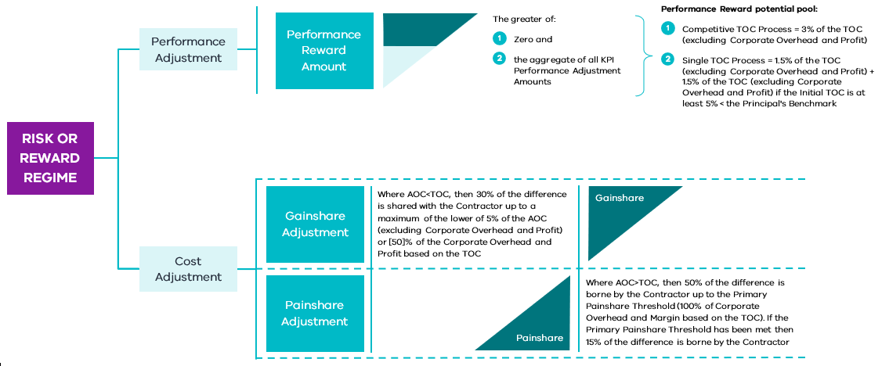

        - Cost Adjustment (section 3 of Schedule 5 to the ITC Delivery Deed)
          - General principles
The Cost Adjustment seeks to incentivise the Contractor to deliver the Project so that the AOC is less than the TOC.
          - Gainshare Amount
If:
    - at the Calculation Date, the AOC is less than the TOC; and
    - the Date of Practical Completion occurs before the date that is 180 days after the Date for Practical Completion, a Gainshare Amount is payable by the Principal to the Contractor as follows.
Gainshare Amount = (TOC – AOC) x 30%, up to a maximum of the Gainshare Cap (the lower of 5% of the AOC (excluding COP) or 50% of the COP based on the TOC)
If:
    - the AOC is equal to or greater than the TOC; and
    - the Date of Practical Completion occurs on or after the date that is 180 days after the Date for Practical Completion, there is no Gainshare Amount.
The grace period of 180 days could be amended on a project-by-project basis depending on the criticality of the end completion date.
          - Painshare Amount
If, at the Calculation Date, the AOC is greater than the TOC, a Painshare Amount is payable by the Contractor to the Principal. The Painshare Amount comprises the Painshare Amount (Primary) and the Painshare Amount (Secondary).
If the AOC is equal to or less than the TOC, there is no Painshare Amount.

Painshare Amount (Primary)
The Painshare Amount (Primary) is calculated as follows.
Painshare Amount (Primary) = (AOC – TOC) x 50%, up to a maximum of the Primary Painshare Threshold (100% of the COP based on the TOC)

Painshare Amount (Secondary)
If the Primary Painshare Threshold has been met, the Painshare Amount (Secondary) is calculated as follows.
Painshare Amount (Secondary) = (AOC – TOC) x 15%
Otherwise, there is no Painshare Amount (Secondary).

General principles
In a Painshare Amount scenario, the Painshare Amount represents a 50/50 share of the cost overrun until the COP is exhausted. Once the COP is exhausted, the Principal proceeds to reimburse 85 per cent of costs (excluding COP) going forward, with the Contractor accordingly bearing 15 per cent of actual costs until completion. The rationale for this ongoing cost-sharing mechanism is to continue to incentivise all parties to manage cost outcomes in a significant cost overrun scenario. It is similar to approaches adopted on recent ITC projects. The project team may consider opportunities for the Contractor to recoup costs associated with the 15 per cent retention on a project-by-project basis.
        - Performance adjustment (section 4 of Schedule 5 to the ITC Delivery Deed)
          - General principles
The Performance Adjustment seeks to incentivise the Contractor to deliver exceptional performance in non-financial objectives of project delivery that are important to the State. These may include objectives such as timely completion of the project, minimising impact on a live operating facility or community satisfaction when delivering the project. These non-financial objectives are grouped into Key Result Areas (KRAs), with each KRA having one or more Key Performance Indicators (KPIs).
Under the Performance Adjustment mechanism, a Performance Reward Potential Pool (see section 5.2.3.3) is available to the Contractor, with a capped Performance Adjustment based on the following principles:
    - positive performance is incentivised with payments from the Performance Reward Potential Pool; and
    - poor performance incurs no additional costs to the Contractor but removes its ability to receive a Performance Adjustment for the applicable KRA.
          - The KRAs and KPIs
Attachment 1 to Schedule 5 sets out:
    - the KRAs;
    - the KPIs for each KRA; and
    - in respect of each KPI:
      - the KPI Maximum Performance Adjustment Amount; and
      - how the Key Performance Score (KPS) is calculated.
To ensure the KRA regime is effective, the procuring agency should consider the following attributes when developing the KRAs and supporting KPIs:
    - supporting and aligning with the objectives of the project;
    - promoting an effective and objective measurement of performance;
    - rewarding exceptional performance;
    - providing a meaningful incentive;
    - incentivising outcomes that are directly within the Contractor’s control; and
    - optimising Contractor and the procuring agency’s contract management effort.
          - Performance Reward Amount
The Performance Reward Amount is the greater of:
    - zero; and
    - the aggregate of all KPI Performance Adjustment Amounts.

KPI Performance Adjustment Amounts
The KPI Performance Adjustment Amount for each KPI is calculated as follows.
KPI Performance Adjustment Amount = (KPS ÷ 100) × KPI Maximum Performance Adjustment Amount
Where:
    - the Key Performance Score (KPS) for the relevant KRA (calculated in accordance with section 1 of attachment 1 to Schedule 5); and
    - KPI Maximum Performance Adjustment Amount is the maximum KPI Performance Adjustment Amount in relation to a KPI (calculated in accordance with attachment 1 to Schedule 5).

KPI Maximum Performance Adjustment Amounts
The KPI Maximum Performance Adjustment Amounts are set so that the Performance Reward Amount is capped at the Performance Reward Potential Pool.
Projects are required to allocate at least 50 per cent of the Performance Reward Potential Pool to achieving a time-based KRA if the delayed liquidated damages regime is selected.

Key Performance Score
The procuring agency is required to update attachment 1 to Schedule 5 to include the methodology for calculating the KPS for each KPI.

Performance Reward Potential Pool
The Performance Reward Potential Pool is calculated as follows:
    - if the Contractor is engaged in a Competitive TOC Process (see below), then 3 per cent of the TOC (excluding COP); and
    - if the Contractor is engaged in a Single TOC Process (see below), then:
      - 1.5 per cent of the TOC (excluding COP); and
      - an additional 1.5 per cent of the TOC (excluding COP) if the Initial TOC is at least 5 per cent less than the Principal’s Benchmark.
The Performance Reward Potential Pool is reduced by 50 per cent if there is an event that results in a fatality or total and permanent disability to any person.

Competitive TOC Process
The Contractor has engaged in a Competitive TOC Process if the Principal simultaneously engaged:
    - the Contractor to prepare and submit to the Principal the Delivery Phase Offer under the ITC Development Deed; and
    - one or more Other Shortlisted Respondents to prepare and submit to the Principal Delivery Phase Offers (as defined in the relevant ITC Development Deed) under separate ITC Development Deeds for the Project.

Single TOC Process
The Contractor has engaged in a Single TOC Process if the Principal:
    - engaged only the Contractor to prepare and submit to the Principal the Delivery Phase Offer under the ITC Development Deed; and
    - did not engage any other Shortlisted Respondent to prepare and submit to the Principal any Delivery Phase Offer under any other ITC Development Deed for the Project.
        - Payment procedure for Risk Amount or Reward Amount (clauses 1 and 30.5 of the ITC Delivery Deed)
          - Calculation
The Risk Amount or Reward Amount (Risk or Reward Amount) is calculated as follows.
Risk or Reward Amount = Gainshare Amount (if any) + Performance Reward Amount (if any) – Painshare Amounts (if any)
Where the Risk or Reward Amount is a positive number, a Reward Amount is calculated as follows.
Reward Amount = Risk or Reward Amount
Where the Risk or Reward Amount is zero, there is no Risk Amount or Reward Amount.
Where the Risk or Reward Amount is a negative number, a Risk Amount is calculated as follows.
Risk Amount = Risk or Reward Amount x –1, subject to the Primary Painshare Threshold (100% of COP based on the TOC)
          - Notice and determination
Within 20 Business Days of the Calculation Date, the Contractor must deliver a notice to the Principal Representative detailing the Reward Amount or Risk Amount (if any) that it considers payable for the period from the Contract Date until the Calculation Date, in accordance with the Risk or Reward Regime. Within 10 Business Days of receipt of the Contractor’s notice, the Principal Representative determines the Reward Amount or Risk Amount (if any) that is payable in accordance with the Risk or Reward Regime. If there is:
    - a Reward Amount, that amount may be claimed by the Contractor in the next payment claim; or
    - a Risk Amount, that amount must be paid by the Contractor within 20 Business Days of receipt of the Principal Representative’s determination.
Payment of any Reward Amount or Risk Amount pursuant to the process above is on account only.
      - Principal’s KRAs (clause 4.6 of the ITC Delivery Deed)
The parties agree on the Principal’s KRAs in respect of the Principal’s engagement on certain matters. Achievement (or otherwise) of the Principal’s KRAs is monitored by the Senior Representatives Group and Executive Review Group, but a failure to achieve the Principal’s KRAs does not entitle the Contractor to any relief. More information on the application of the Principal’s KRA is available in the ITC Commercial Principles available on Cost Reimbursable Procurement Category webpage.
      - Cost planning and control (clause 21 of the ITC Delivery Deed)
The ITC Delivery Deed requires the Contractor to institute a system of cost control. This system provides an oversight process for the Principal, as it includes monthly submissions of relevant cost information to the Principal Representative for review.
At least once per Month, the Contractor must review and, where approved by the Principal Representative, amend the Cost Plan to take account of any item affecting or likely to affect a component of the Cost Plan. The Contractor must advise the Principal Representative of available alternative steps where:
    - a tender for any part of the Contractor’s Activities to be performed by a Subcontractor exceeds the amount included for that work in the Cost Plan;
    - reimbursable Costs incurred in respect of any Contractor’s Activities exceed the amount allowed for in the cash flow that forms part of the Cost Plan, or the forecast final Reimbursable Costs of the Contractor’s Activities appears likely to exceed the total amount allowed for (including contingency) in the Cost Plan; or
    - no tenders are received for any part of the Contractor’s Activities to be Subcontracted.
      - Adjustment Events (clause 27 of, and Schedule 15 to, the ITC Delivery Deed)
        - General principle (clause 27.5 of, and Schedule 15 to, the ITC Delivery Deed)
The ITC Delivery Deed provides a mechanism for the:
    - TOC to be adjusted following an Adjustment Event (Cost);
    - KRAs to be adjusted following an Adjustment Event (KRA); and
    - Dates for Completion to be adjusted following an Adjustment Event (Time).
As set out below in Table 1, certain events are only one type of Adjustment Event (e.g. a Force Majeure Event is only an Adjustment Event (Time)), while other events are two or three types of Adjustment Event (e.g. a breach by the Principal of a Principal Project Document is an Adjustment Event (Cost), an Adjustment Event (KRA) and an Adjustment Event (Time)).
Adjustment Events are expected to be agreed between the procuring agency and the Shortlisted Respondent(s) during the Development Phase. Adjustment Events should consider the specific risks associated with the Project and be as specific as possible to avoid ambiguity in delivery. Given the Reimbursable Cost and risk-sharing nature of the contract, Adjustment Events should be limited to a small number of risks that cannot be reasonably managed or priced by the Contractor, where it would not be VfM for these risks, if they materialise, to be factored into a Gainshare/Painshare Adjustment.
Approval for Adjustment Events ultimately resides with the Principal. DTF should be consulted on the appropriateness of additional Adjustment Events that are not specified in this guidance.
Table 1 below summarises the standard Adjustment Events specified in Schedule 15 to the ITC Delivery Deed.
Table 1 – Adjustment Events for the ITC Delivery Deed
Item | Event | Adjustment Event (Cost) | Adjustment Event (Time) | Adjustment Event (KRA)
 | A breach by the Principal of any Principal Project Document | ü* | ü | ü
 | An act or omission of the Principal when acting in connection with the Project, or any Principal Associate, in each case other than any act or omission that is:  - a Permitted Act; or  - an Act where an Authority is acting in accordance with its statutory powers | ü* | ü
 | Cessation or suspension of any part of the Contractor’s Activities in connection with a Heritage Claim or Native Title Claim | ü* | ü
 | A material change to the way in which the Contractor’s Activities are carried out in connection with a Heritage Claim or Native Title Claim, unless such change is the subject of a Variation Order (on a project-by-project basis, this may be extended to include Artefacts) | ü* | ü
 | Industrial Action that only occurs at or in the direct vicinity of the Site and is a direct result of an act or omission of the Principal, which is not a Permitted Act, undertaken as part of any Interface Works or by an Authority acting in accordance with its statutory powers | ü | ü
 | A direction by the Principal Representative to accelerate where the Contractor incurs more or less cost than would otherwise have been incurred, except to the extent the need for acceleration arises in connection with any Contractor breach of or non-compliance with the Project Documents | ü |  | ü
 | The Reimbursable Costs of a Provisional Sum Item or Provisional Quantity Item exceed the relevant Provisional Sum included in the TOC | ü
 | Suspension of the Contractor’s Activities not caused by a Contractor Act or Omission or Force Majeure Event | ü | ü
 | Due to a material change in the terms of any Insurances (Principal), the Contractor is required to take action to maintain an equivalent level of insurance coverage^ | ü | ü
 | A Change in Mandatory Requirements that results in a Scope Variation | ü | ü** | ü
 | A Scope Variation directed under clause 35.1 of the ITC Delivery Deed | ü | ü | ü
 | On a project-specific basis, a breach of a Direct Interface Deed by a Direct Interface Party^^ | ^^ | ^^ | ^^
 | A Force Majeure Event |  | ü
 | Any act, event or circumstance or any other event expressly stated to be an Adjustment Event (Cost) in the ITC Delivery Deed or the Adjustment Event Guidelines | ü
 | Any act, event or circumstance or any other event expressly stated to be an Adjustment Event (Time) in the ITC Delivery Deed or the Adjustment Event Guidelines |  | ü
 | Any act, event or circumstance or any other event expressly stated to be an Adjustment Event (KRA) in the ITC Delivery Deed or the Adjustment Event Guidelines |  |  | ü
Notes:
* These acts, events or circumstances only constitute an Adjustment Event (Cost) where the Contractor has been granted an extension of time to a Date for Completion in accordance with clause 27.8 of the ITC Delivery Deed, and the adjustment to the TOC only applies to time-related costs.
** These acts, events or circumstances only constitute an Adjustment Event (Cost) where they also constitute a Scope Variation under the ITC Delivery Deed.
^ Item 9 in relation to Insurances (Principal) is to be considered on a project-specific basis.
^^ Item 12 in relation to breach of a Direct Interface Deed by a Direct Interface Party is to be considered on a project-specific basis, including whether the entitlement is time or cost (or both).

        - Adjustment Events and notice of claim (clauses 27.6, 27.7, 27.8 and 27.9 of the ITC Delivery Deed)
          - Notice of claim
If an Adjustment Event occurs, and the Contractor wishes to claim an extension of time to the relevant Date for Completion or an adjustment to the TOC or the KRAs, the Contractor must submit a notice of claim to the Principal and the Principal Representative within the time required under the ITC Delivery Deed and must continue to update the Principal and the Principal Representative in respect of the relevant Adjustment Event.
          - Conditions Precedent to extension
In the case of an extension of time, it is a Condition Precedent to the Contractor’s entitlement that the Contractor:
    - can demonstrate that it has been or will be delayed from carrying out the Contractor’s Activities by the relevant Adjustment Event (Time) in a manner that has delayed or will delay the achievement of Completion;
    - can demonstrate that the relevant Adjustment Event (Time) has caused or will cause activities on the critical path contained in the then current Program to be delayed; and
    - submits an updated Program to the Principal and the Principal Representative that complies with the requirements of the ITC Delivery Deed, takes into account the impact of the relevant Adjustment Event (Time) and contains a level of detail sufficient to enable the Principal Representative to determine the Contractor’s entitlement to an extension of time.
          - Claim determined by Principal Representative

Extension of time
If:
    - the Condition Precedent set out in section 5.5.2.2 is satisfied;
    - the Principal Representative has not given an interim determination of the Contractor’s entitlement to an extension of time pursuant to clause 27.8 of the ITC Delivery Deed (see below); and
    - the Principal Representative has not issued a direction under clause 27.12 of the ITC Delivery Deed to accelerate the Contractor’s Activities beforehand (or the parties agree the adjustment to the TOC or KRAs);
the Principal Representative must:
    - extend the relevant Date for Completion (if at all) in accordance with the determination of the Principal Representative; and
    - adjust the TOC or KRAs (if at all) in accordance with the determination of the Principal Representative;
within 10 Business Days after the later of:
    - receipt of a notice of claim from the Contractor; or
    - where the Principal Representative determines that the updated Program submitted with the notice of claim is non-compliant, receipt of a compliant updated Program.

Interim determinations
Where the Contractor is entitled to an extension of time, and the effects of the relevant Adjustment Event (Time) are continuing, the Principal Representative, if it is reasonably able to do so, gives interim determinations (on an interim basis) of the Contractor’s entitlement to an extension of time until the Contractor is able to submit a final notice of claim.
Where the Principal Representative gives interim determinations of the Contractor’s entitlement to an extension of time in respect of an Adjustment Event (Time) that is also an Adjustment Event (TOC) or Adjustment Event (KRA), the Principal Representative does not give interim determinations of the adjustment to the TOC or the KRAs. The adjustment to the TOC or the KRAs (if any) is only determined once the Contractor submits its final notice of claim.
          - Unilateral extensions
The Principal may unilaterally extend a Date for Completion or adjust the TOC or a KRA regardless of whether the Contractor has made, or is entitled to make, a claim in respect of an Adjustment Event. If the Principal exercises such power in respect of an Adjustment Event (Time), Adjustment Event (Cost) or Adjustment Event (KRA) for which, but for the exercise of the Principal’s powers, the Contractor would be entitled to an extension of time to a Date for Completion or adjustment to the TOC or KRAs, and the Contractor disputes the determination made by the Principal, the Contractor may refer the dispute to expert determination within 10 Business Days after the Principal exercises its power.
      - Defects (clauses 1 and 28 of the ITC Delivery Deed)
        - General principles (clause 1 of the ITC Delivery Deed)
          - Defect
The definition of ‘Defect’ expressly excludes damage to the Works or the Returned Assets. There is a separate regime in the ITC Delivery Deed for damage that reflects that damage is typically an Insured Risk, while Defects are not.
          - Defects Liability Period
The ITC Delivery Deed provides for a DLP of 12 or 24 Months commencing on the Date of Practical Completion. Any Works rectified during the DLP are subject to a further 12-month DLP from the date of rectification, with a cap on the overall DLP of 24 or 36 Months after the Date of Practical Completion.
          - Overview of the Defects regime (clause 28 of the ITC Delivery Deed)

Defects in the Works
The Contractor must promptly rectify all Defects in the Works as soon as they are identified, unless the Defect is a Defect that the Principal accepts or rectifies.
Before the Principal agrees or determines to accept or rectify any Defects in the Works, the Principal may require the Principal Representative to determine the cost necessary to rectify the relevant Defect and the relevant diminution in the value of the Works as a consequence of the Defect. The Principal may also require to the Contractor to provide details of the Defect, including the impact of the Defect on the Operations, the Works or other assets in the vicinity of the Works, whether the Defect can be rectified, and the work required to rectify the Defect if it is capable of rectification.
If the Principal accepts or rectifies (or engages others to rectify) a Defect in the Works, the greater of:
    - the costs necessary to rectify that Defect; or
    - the relevant diminution in value of the Works as a consequence of that Defect
as determined by the Principal Representative, will be a debt due and payable by the Contractor to the Principal.

Defects in Returned Assets
The Contractor must rectify Defects in the Returned Assets identified during the Returned Asset DLP in accordance with the Program reviewed by the Principal in accordance with the Review Procedures. If the Principal Representative determines that the Contractor has failed to do so, the Principal may elect to accept or rectify (or engage others to rectify) the relevant Defect.
Before the Principal agrees to accept or rectify any Defect in a Returned Asset, the Principal may require the Principal Representative to determine the cost necessary to rectify the relevant Defect and the relevant diminution in the value of the Returned Asset and any Works as a consequence of the Defect. The Principal may also require the Contractor to provide details of the Defect, including the impact of the Defect on the Returned Asset or other assets in the vicinity of the Returned Asset, whether the Defect can be rectified, and the work required to rectify the Defect if it is capable of rectification.
If the Principal accepts or rectifies (or engages others to rectify) a Defect in the Returned Works, the greater of:
    - the costs necessary to rectify that Defect; or
    - the relevant diminution in value of the Works or relevant Returned Assets as a consequence of that Defect
as determined by the Principal Representative, will be a debt due and payable by the Contractor to the Principal.

Reimbursable Costs
The Contractor’s cost of rectifying Defects prior to the Date of Practical Completion, where the Principal has not given the Contractor notice of the Defect, will be a Reimbursable Cost. However, the Contractor’s cost of rectifying Defects:
    - prior to the Date of Practical Completion, where the Principal has given the Contractor notice of the Defect; or
    - following the Date of Practical Completion
will not be Reimbursable Costs.

Performance security
The Contractor is required to provide the DLP Bond (one or more Performance Bonds with an aggregate face value of 2.5 per cent of the TOC) to the Principal on or before the Condition Precedent Deadline. The Principal must release the DLP Bond within 10 Business Days after the date that is 24 Months after the Date of Practical Completion unless, at that date, the Contractor has not corrected Defects previously notified by the Principal. In that case, the Principal’s entitlement to the DLP Bond is reduced to the Outstanding Defect Cost Amount (the higher of a monetary threshold or a specified percentage of the reasonable cost of completing the rectification of the relevant Defects). The Principal’s entitlement to the Security for the Outstanding Defect Cost Amount ceases 20 Business Days after the Date of Close-out, after which the Principal must release the Security to the Contractor.
        - Project-specific amendments
The ITC Delivery Deed provides that the Returned Asset DLP is 24 Months from the Date of Practical Completion. This may not be appropriate for Returned Assets handed back well before Practical Completion or for Returned Assets handed back after Practical Completion.
The ITC Delivery Deed may also include a more detailed regime for managing and accepting non-conformances. These are typically design non-conformances that, if progressed, will result in Defects that are not practicable for the Contractor to rectify. Any such regime should work consistently with the terms of the ITC Delivery Deed in respect of Defects.
      - Subcontracting and third party arrangements (clause 8 of the ITC Delivery Deed)
        - General principle
The Principal’s intention is to ensure that it has full visibility of contractual arrangements and access to documentation in connection with the Project, and appropriate rights in respect of those arrangements. There are two key principles that underlie the Subcontracting provisions in the ITC Delivery Deed:
    - the Contractor is ultimately responsible for the delivery of the Project, regardless of the acts or omissions of its Subcontractors; and
    - notwithstanding the above, there are certain minimal levels of control that the Principal requires over subcontracting arrangements, given the criticality of some Subcontracts to the successful delivery of the Project (these are to ensure that the Principal’s rights are acknowledged by Subcontractors, the Principal has rights to secure continuity of the Project in circumstances of the Contractor becoming insolvent, and statutory protections for the Subcontractor market are upheld).
        - General Subcontracting requirements (clause 8 of the ITC Delivery Deed)
Subcontracting requirements are specifically contained in clause 8 and generally throughout the ITC Delivery Deed. In summary, the provisions primarily focus on the following matters:
    - the Contractor’s responsibility for Subcontractors;
    - approval of Subcontractors;
    - award of Subcontracts;
    - prescribed terms the Contractor must ensure each Subcontract contains;
    - access to and approval of Subcontracting contractual documentation and access to project documentation, sites and assets;
    - consistency between Subcontracting arrangements and ITC Delivery Deed requirements and Standards;
    - specific requirements for Significant Subcontracts;
    - changes to or significant impacts on Subcontracting arrangements;
    - direct contracting requirements between the Principal and Subcontractors;
    - Subcontractor termination entitlements;
    - payments of amounts owed to Subcontractors, including addressing matters dealt with under the Building and Construction Industry Security of Payment Act 2002 (Vic);
    - Subcontractor claims and issues;
    - probity requirements; and
    - the application of government policy and Law to Subcontracts and Subcontractors, including work, health and safety matters.
        - Tendering and award of Subcontracts (clauses 8.2 and 8.3 of the ITC Delivery Deed)
The ITC Delivery Deed contains a detailed process for the tendering and award of Subcontracts. Except in the case of Minor Subcontracts all Subcontracting must be in accordance with the Subcontract Packaging and Procurement Plan. This is to ensure that all Subcontracting is consistent with the approved procurement strategy and Cost Plan. The Contractor is required to provide the Principal Representative with copies of all Subcontract tender and contract documentation, including documentation received from tenderers, within a prescribed time before the date on which the Contractor proposes to enter into the relevant Subcontract, and, otherwise, on request of the Principal Representative (clause 8.2(d) of the ITC Delivery Deed). If required by the Principal Representative, the Contractor must also carry out any post-tender negotiations with the tenderer(s) in the presence of the Principal Representative.
Prior to awarding Subcontracts, the Contractor is required to demonstrate to the Principal Representative why a particular Subcontractor should be awarded a Subcontract, and this is deemed to be a warranty by the Contractor as to the suitability of that Subcontractor. This should be in accordance with any Subcontractor Packaging and Procurement Plan agreed by the parties. Notwithstanding this, the Principal Representative has ultimate discretion to reject a recommendation by the Contractor on certain grounds, including where the Subcontract price exceeds the allowance for the relevant work in the Cost Plan, the proposed Subcontractor is not an appropriate Subcontractor for the relevant work, or the Subcontract does not follow the template form approved by the Principal or Principal Representative. In these circumstances, the Principal Representative has the right to direct the Contractor to accept another tender or to seek alternative proposals.
      - Site Information and Site Conditions (clauses 5, 10, 12, 13 and 41 of the ITC Delivery Deed)
        - General principle (clauses 5.7, 5.8, 10.1 and 10.3 of the ITC Delivery Deed)
          - Risk of adverse Site Conditions
The Contractor is liable for all Site Conditions, other than where it is expressly stated otherwise in the ITC Delivery Deed.
          - Contractor warranty
The Contractor warrants that it has been given the opportunity to undertake tests, enquiries and investigations of the Site and its surroundings, including all Site Conditions and the existence, adequacy, location, conditions, completeness or availability of Utility Infrastructure.
          - Site investigations
The Principal typically engages consultants to undertake site investigations prior to and during the RFP phase and the Development Phase, and releases the information prepared by those consultants to the Shortlisted Respondents. Where there are significant Site Condition risks, the Principal may invite the Shortlisted Respondents to suggest any additional survey work for the Principal to undertake during the RFP phase. Alternatively, the Respondents could be given the opportunity to undertake additional site investigations during the Development Phase.
On a project-specific basis (particularly where the risk of adverse Site Conditions is considered low), the procuring agency may include drafting pursuant to which the Principal may elect to either:
    - assign its rights in respect of a Site Information Report to the Contractor; or
    - obtain a third party warranty from the Site Information Report Provider in favour of the Contractor.
The procuring agency should discuss the inclusion of this drafting with DTF prior to commencing the RFP phase.
        - Interference, obstruction and nuisance (clause 12.3 of the ITC Delivery Deed)
Under the ITC Delivery Deed, the Contractor is obliged to:
    - minimise road disruptions;
    - prevent nuisance;
    - ensure the safety of people and property;
    - prioritise the safety of people and property; and
    - remove structures or equipment on completion.
Where the Principal reasonably believes that the Contractor is failing to meet the above, the Contractor must comply with any reasonable directions to stop or change the manner of undertaking the Contractor’s Activities and amend the applicable Plan to Cure the issue.
        - Notifiable Contamination and Remediation (clauses 12.1, 12.6 and 41.4 of the ITC Delivery Deed)
In respect of any ‘notifiable incident’ or ‘notifiable contamination’ as defined in sections 30 and 37 (respectively) of the Environment Protection Act 2017 (Vic), the Contractor is obliged to notify the Environment Protection Authority (EPA) and the Principal accordingly. The Contractor has management or control of the Site for the purposes of the Environment Protection Act 2017 (Vic) and must comply with all obligations imposed under the Environmental Requirements.
The Contractor’s Contamination Remediation obligations are determined on a location basis. When considering the risk allocation for the ITC Delivery Deed, the Principal decided that there was VfM in limiting the Contractor’s Remediation obligations, so it is not automatically required to Remediate all Contamination in or in the direct vicinity of the Development Area or Remediate the Contamination back to source.
However, the Principal requires the Contractor to indemnify the Principal for Liability the Principal suffers in connection with Contamination that the Contractor or any Contractor Associate caused to occur or to spread (regardless of whether the Contractor is obliged to Remediate the Contamination), so that the Contractor will put in place reasonable measures to contain such Contamination.
Figure 10 below summarises the Contractor’s Contamination Remediation obligations for any Contamination and the Remediation work for which the Contractor is entitled to compensation and relief under the ITC Delivery Deed.
Figure 10 – Contamination rights and obligations
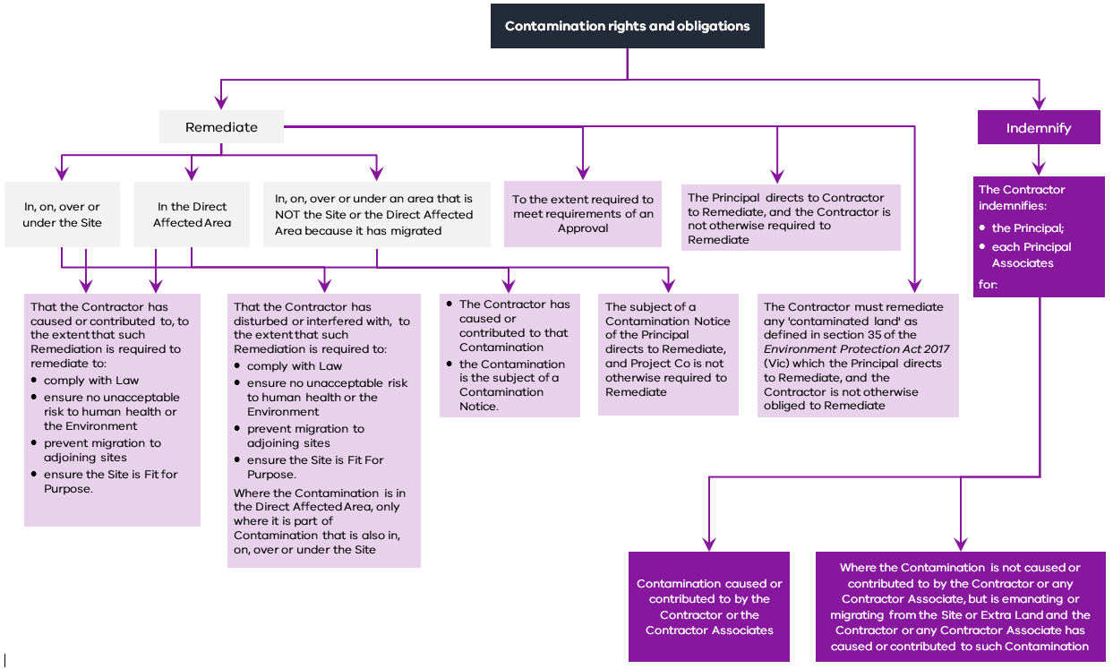
        - Project-specific amendments
The general principles outlined above in relation to Site Conditions may be varied on a project-specific basis, depending on the condition of the Site and other associated considerations. For example, the Principal may consider an alternative risk allocation:
    - where the Project involves the extension or modification of existing infrastructure where it is difficult to access the Site to carry out investigations, such as dilapidation surveys, and gain a good understanding of the condition of the asset;
    - depending on the amount of site investigation work undertaken by the Principal;
    - where the extent, impact or nature of pre-existing Contamination cannot reasonably be adequately assessed before or during the procurement process;
    - where there is extensive pre-existing Contamination of the Site; or
    - where the Principal considers extending or reducing the Contractor’s Remediation obligations will enhance VfM.
The prevention of nuisance is reviewed on a project-specific basis. For example, there may be circumstances where the maximum noise level set out in the Environmental Management Plan is too high, in which case the ITC Delivery Deed should include an obligation to reduce noise levels to the Principal’s reasonable requirements.
The ITC Delivery Deed provides that, except as expressly provided in the Deed, neither the Principal nor any Principal Associate gives any warranties or guarantees or owes any duty of care in respect of, among other things, the existence, adequacy, location, condition (including the fitness for purpose), type, number, availability or suitability of any works or assets, including those made available to the Contractor by or on behalf of the Principal. This exclusion needs to be considered on a project-specific basis, as it will not be required if there are no project assets made available by or on behalf of the Principal during the performance of the Contractor’s Activities.
        - Utilities and underground structures (clause 13)
          - General principle
The Contractor is required to make enquiries as to the location of existing Utility Infrastructure and must liaise with the owner of that Utility Infrastructure and the relevant Utility provider as to the need for any Utility Activities. The Contractor is required to obtain the Principal’s consent to carry out any Utility Activities.
The Contractor assumes the risk in relation to existing Utility Infrastructure, the continuous supply and sufficiency of Utilities in connection with the Contractor’s Activities, the need to carry out Utility Activities, and any access to the Site or interference with the Contractor’s Activities by or on behalf of a Utility provider.
          - Project-specific amendments
If the MTPF Act applies to the Project, there is a regime under Part 7 of the MTPF Act for the interface with Utilities that includes:
    - a process for negotiating Utility agreements with Utilities where the Project requires the relocation of or otherwise impacts those Utilities;
    - a dispute resolution process, if no agreement is reached within the timeframes specified in the MTPF Act; and
    - a process for the removal, relocation or protection of unknown Utility Infrastructure encountered during the course of a Project either by the Utility or the project authority.
Certain Utilities risk may be agreed to constitute Adjustment Events under the Adjustment Event Guidelines.
      - Change in Law and Change in Policy (clause 36 of the ITC Delivery Deed)
        - Obligations regarding Change in Law and Change in Policy (clause 36.1 of the ITC Delivery Deed)
After becoming aware of any actual or likely Change in Law or Change in Policy that may have an impact on the Project, the Contractor’s Activities or the Project Documents, the Contractor must submit a notice to the Principal.
The Contractor must comply with any Change in Law.
The Contractor must comply with a Change in Policy, unless the Principal directs the Contractor not to comply with the relevant Change in Policy.
        - Change in Mandatory Requirements (clauses 1 and 36.2 of the ITC Delivery Deed)
The Principal retains the risk of Changes in Law and Changes in Policy that are Changes in Mandatory Requirements. Not every Change in Law or Change in Policy is a Change in Mandatory Requirements. A Change in Mandatory Requirements occurs where:
    - a Change in Law occurs that (subject to exceptions):
      - requires a change to the Works or the Working Parameters; and
      - has a material cost or time impact (with specific cost and time thresholds included on a project-specific basis); or
    - a Change in Policy (subject to exceptions) that is not a Change in EPA Standard occurs that:
      - requires a Contractor to comply as a matter of Law; or
      - is the subject of a direction from the Principal to a Contractor to comply under clause 33.1(b); or
    - a Change in Policy that is a Change in EPA Standard occurs that:
      - requires a Contractor to comply under an EPA Statutory Instrument; or
      - is the subject of a direction from the Principal to a Contractor to comply under clause 33.1(b); and
      - has a material adverse effect on how the Contractor undertakes its Activities.
If a Change in Mandatory Requirements occurs, the relevant Change in Law or Change in Policy is deemed to be a Variation, and relief and compensation are provided in accordance with the Variation regime under the ITC Delivery Deed. The Contractor may also be entitled to an Adjustment Event (Cost), an Adjustment Event (Time) and an Adjustment Event (KRA) to the extent the Variation constitutes a Scope Variation (see item 10 in Table 1 in section 5.5.1).
Certain Changes in Law and Changes in Policy will not be deemed to be a Variation, as they are specifically excluded in the definition of Change in Mandatory Requirements. These excluded Changes in Law and Changes in Policy are considered to be business-as-usual risks that should be accepted by the Contractor, and, where appropriate, a risk allowance may be included in the TOC.
      - Force Majeure (clauses 1, 27 and 41 of the ITC Delivery Deed)
        - General principle
The purpose of the Force Majeure provisions is to give the Contractor (and the Principal) certain relief from Default and Liability in respect of a limited category of events that are catastrophic, generally outside of the control of either party and prevent the Contractor (or the Principal) from performing all or a material part of its obligations under the ITC Delivery Deed.
As neither party is likely to be in a better position than the other to manage either the occurrence or the effects of the Force Majeure Event, and the events may continue for a long period of time, such events are treated differently to other Relief Events. The entitlement to relief and compensation in the ITC Delivery Deed generally reflects the common law principle in respect of Force Majeure Events that the loss lies where it falls.
        - Force Majeure Event (clause 1 of the ITC Delivery Deed)
There are two limbs to the definition of Force Majeure Event in the ITC Delivery Deed.
Under the first limb, a Force Majeure Event occurs if an event listed in the definition occurs (these include natural disasters, winds producing sustained surface winds in excess of a specified threshold, fires, explosions or floods caused by natural disasters and Uninsurable Risks) and that event:
    - occurs at or in the direct vicinity of the Site;
    - was not caused by the Contractor, the Principal or any of their associated parties; and
    - prevents the Contractor from carrying out all or a material part of the Contractor’s Activities or the Principal from carrying out its obligations.
Under the second limb, a Force Majeure Event occurs to the extent that the circumstances leading to a direction from the Principal to suspend the Contractor’s Activities were a Force Majeure Event (see clause 37.1(b)(ii) of the ITC Delivery Deed).
        - Potential relief (clauses 27.5 and 27.7 of ITC Delivery Deed), and Schedule 15 to, the ITC Delivery Deed)
A Force Majeure Event is an Adjustment Event (Time) (see item 13 in Table 1 in section 5.5.1). Consequently, provided the Condition Precedent to the Contractor’s entitlement to an extension of time is satisfied (see section 5.12.3.1), the occurrence of a Force Majeure Event entitles the Contractor to claim an extension of time to the relevant Date for Completion for the period of delay caused by the Force Majeure Event.
As a Force Majeure Event is not an Adjustment Event (Cost) or Adjustment Event (KRA), the occurrence of a Force Majeure Event does not entitle the Contractor to claim an adjustment to the TOC or the KRAs.
        - Limitation on Principal Liability to the Contractor for Force Majeure Events (clause 41.14 of the ITC Delivery Deed)
As a Force Majeure Event is a Relief Event, the Principal’s Liability to the Contractor in connection with a Force Majeure Event is reduced to the extent that:
    - the Force Majeure Event or the consequences of the Force Majeure Event are caused or contributed to by a Contractor Act or Omission; or
    - the Contractor or any Contractor Associate fails to take all reasonable steps that a prudent, competent and experienced contractor in the circumstances of the Contractor or the relevant Contractor Associate exercising Best D&C Practices would take to mitigate, minimise or avoid the effects, consequences or duration of the Force Majeure Event.
        - Project-specific amendments
The definition of a Force Majeure Event require consideration on a project-specific basis. The following principles should be applied.
    - All Force Majeure Events should align with the general principle set out above in section 5.10.1.
    - Tropical cyclone has been considered by the Principal and excluded from the definition on the basis that, by definition, these events do not occur in Victoria. However, the reference to high winds in paragraph (a)(ii) of the definition has been included in case the procuring agency considers it appropriate to give relief for ‘cyclonic’ winds.
    - The definition is limited to events that occur at or in the direct vicinity of the Site. Taking into account project-specific considerations, in very limited circumstances, the Principal may agree to extend the Force Majeure Regime to other locations (including outside Victoria or Australia). For example, this may be appropriate where a large and critical item required for the Works with a long lead time is manufactured in a different location.
      - Pandemics (clauses 1 and 6A of the ITC Delivery Deed)
        - Introduction
‘Pandemic’ is defined in the ITC Delivery Deed as COVID-19 and any other pandemic declared by the World Health Organization.
          - The Initial Pandemic Management Plan

Initial Pandemic Management Plan
During the Development Phase, the Shortlisted Respondent is required to submit a Pandemic Management Plan as part of its Delivery Phase Offer. For the Successful Respondent, this version of the Pandemic Management Plan becomes the Initial Pandemic Management Plan and is set out with the other Bid Plans in Attachment 4 to the ITC Delivery Deed.
The Initial Pandemic Management Plan includes all mitigation measures the Contractor is implementing with respect to COVID-19 and those in response to any and all:
    - Legislation in response to COVID-19; and
    - Pandemic Directions in response to COVID-19
that are in place at the Contract Date.

Updates to the Pandemic Management Plan
Any updated Pandemic Management Plan includes all mitigation measures the Contractor is implementing with respect to any Pandemic and those in response to any and all:
    - Pandemic Change in Law; and
    - Pandemic Adjustment Events
that are in place or have occurred at the date of the relevant update.
          - Allowance in the Program for COVID-19
The Contractor warrants that the Program contains sufficient allowances for the assumption by the Contractor of all risk in relation to the impact of COVID-19 on the performance of the Contractor’s Activities at the Contract Date and the assumption of that risk in respect of the period between the Contract Date and the Pandemic Impact Date (a specified number of weeks following the Contract Date).
          - Relief
The Contractor accepts the risk of Pandemic Adjustment Events and Pandemic Changes in Law that occur on or before the Pandemic Impact Date (provided that the Contractor may be entitled to relief where those events occur prior to the Pandemic Impact Date but continue after that date).
For Pandemic Adjustment Events and Pandemic Changes in Law that occur after the Pandemic Impact Date, the ITC Delivery Deed provides a regime for relief (through Adjustment Events (Time) and Adjustment Events (Cost)), subject to the Contractor demonstrating that certain requirements have been satisfied.
          - Pandemic Change in Law (clause 1 of, and Schedule 15 to, the ITC Delivery Deed)
A Pandemic Change in Law is defined as:
    - a change in (including any extension, repeal, revocation or expiry of) existing Legislation in response to a Pandemic;
    - new Legislation in response to a Pandemic; or
    - a new Pandemic Direction or a change to (including any extension, repeal, revocation or expiry of) an existing Pandemic Direction.
A Pandemic Change in Law is an Adjustment Event (Time) and Adjustment Event (Cost) to the extent the change requires any changes to the measures contemplated by the current Pandemic Management Plan.
        - Pandemic Adjustment Event (clause 1 of, and Schedule 15 to, the ITC Delivery Deed)
Subject to certain exceptions, a Pandemic Adjustment Event occurs if any of the following occurs:
    - a Pandemic Subcontractor’s Plant Closure (a full-day closure of a Subcontractor’s plant or factory in certain Pandemic-related circumstances);
    - a full day’s delay in the supply of any Key Plant and Equipment from a Key Plant and Equipment Manufacturing Country as a result of:
      - Australian quarantine restrictions; or
      - closure of the Australian international border or any other international border, where such quarantine restrictions or border closures are introduced after the Contract Date as a result of a Pandemic and have a material adverse impact on the Contractor’s Activities; or
    - a Pandemic Area Closure (a full-day closure of the Site in certain Pandemic-related circumstances).
A Pandemic Adjustment Event is an Adjustment Event (Time) and an Adjustment Event (Cost).
      - Time (clauses 1, 27, 30, 37 and 41 of the ITC Delivery Deed)
        - General principle (clauses 1, 27.5, 27.7 and 41.14 of the ITC Delivery Deed)
Subject to the relevant Condition Precedent being satisfied, the Contractor is entitled to:
    - time relief (via an extension to the relevant Date for Completion) following the occurrence of an Adjustment Event (Time); and
    - cost relief (via an adjustment to the TOC) following the occurrence of Adjustment Event (Cost)
with certain events being both an Adjustment Event (Time) and an Adjustment Event (Cost).
As Adjustments Event (Time) and Adjustment Events (Cost) are Relief Events, the Principal’s Liability to the Contractor in connection with those Adjustment Events are reduced to the extent that:
    - the relevant Adjustment Event or the consequences of the relevant Adjustment Event are caused or contributed to by a Contractor Act or Omission; or
    - the Contractor or any Contractor Associate fails to take all reasonable steps that a prudent, competent and experienced contractor in the circumstances of the Contractor or the relevant Contractor Associate exercising Best D&C Practices would take to mitigate, minimise or avoid the effects, consequences or duration of the relevant Adjustment Event.
        - Primary obligation (clauses 27.1, 30.8 and 37.1 of the ITC Delivery Deed)
The Contractor has an obligation to commence and regularly, expeditiously and diligently progress the Contractor’s Activities and achieve Completion by the relevant Date for Completion. The Contractor must not suspend the progress of the whole or any part of the Contractor’s Activities except where pursuant to the Building and Construction Industry Security of Payment Act 2002 (Vic) or as directed or approved by the Principal.
        - Extension of time (clauses 27.5, 27.7 and 27.8 of, and Schedules 5 and 15 to, the ITC Delivery Deed)
Relief Events that are both Adjustment Events (Cost) and Adjustment Events (Time) are:
    - a limited category of events that are generally within the control of the Principal; or
    - risks that are considered to be better managed or mitigated by the Principal.
Accordingly, they are events in respect of which the Principal retains time and cost risk.
Adjustment Events (Time) that are not Adjustment Events (Cost) are neutral events, such as Force Majeure Events, in respect of which the risk allocation is shared with the Principal, whereby the Date for Practical Completion is extended, but the Contractor has no, or more limited, entitlement to compensation.
          - Conditions Precedent
The following is the Condition Precedent to the Contractor’s entitlement to an extension of time for an Adjustment Event (Time):
    - the Contractor submits a notice of claim to the Principal and the Principal Representative within the timeframe specified in clause 27.6 of the ITC Delivery Deed;
    - the Contractor can demonstrate that:
      - it has been or will be delayed in carrying out the Contractor’s Activities by the relevant Adjustment Event (Time) in a manner that has delayed or will delay the achievement of Completion; and
      - the relevant Adjustment Event (Time) has caused or will cause activities on the critical path contained in the current Program to be delayed; and
    - the Contractor, at the time it submits the relevant notice of claim, submits an updated Program that:
      - complies with the relevant requirements of the ITC Delivery Deed;
      - takes into account the impact of the relevant Adjustment Event (Time); and
      - contains a level of detail that is sufficient to enable the Principal Representative to determine the Contractor’s entitlement to an extension of time.
If the Principal Representative determines that the updated Program does not comply with the requirements set out above, the Contractor must, within 10 Business Days after receipt of the Principal Representative’s notice, submit an updated Program.
If the Contractor does not submit an updated Program, the Contractor is not entitled to claim an extension of time for the relevant Adjustment Event (Time).
If the Contractor submits an updated Program and the Principal Representative determines that the updated Program addresses the non-compliances prviously notified by the Principal Representative, the Contractor is deemed to have met the requirements of the Condition Precedent in respect of the submission of the updated Program.
If the Contractor submits an updated Program and the Principal Representative determines that the updated Program does not address the non-compliances previously notified by the Principal Representative, the Contractor is not entitled to claim an extension of time for the relevant Adjustment Event (Time).The ITC Delivery Deed provides an opportunity for the Contractor to resubmit an updated Program in circumstances where the Principal Representative determines that the Program does not comply with the extension of time Condition Precedent. This is so that the Contractor is not significantly prejudiced by a minor non-conformance in a complex Program that is potentially unrelated to an extension of time claim.
If the Condition Precedent (as set out above) has been satisfied, unless the parties otherwise agree on an extension to the relevant Date for Completion, the Principal Representative must extend the relevant Date for Completion.
The Principal Representative may give interim determinations of the Contractor’s entitlement to an extension of time, notwithstanding that the effects of the relevant Adjustment Event (Time) are continuing.
        - Unilateral extensions (clause 27.9 of the ITC Delivery Deed)
Irrespective of the Contractor’s entitlement to an extension of time, the Principal may unilaterally extend a Date for Completion.
        - Time KRA and Performance Reward Potential Pool (Schedule 5 to the ITC Delivery Deed)
The ITC Delivery Deed contemplates a time KRA to incentivise on-time delivery under the Risk or Reward Regime depending on the Contractor’s performance against pre-agreed milestones (see section 5.2.3).
As referred to in section 5.2.3.3, the procuring agency is required to develop the methodology for calculating the KPS for the time KPI. This methodology should be tailored to the characteristics of the Project, including the extent to which there are interdependencies with other projects or other critical milestones.
An example methodology that involves positive incentives for timely completion is set out below.
    - Project is completed ahead of schedule or within 5 per cent of schedule: the KPS for the time KPI is 100.
    - Project is delayed by more than 5 per cent but less than 10 per cent of schedule: the KPS reduces proportionally with the delay (e.g. if the delay is 6 per cent, the KPS is 80, but if it is 9 per cent, the KPS is 20).
    - Project is delayed by 10 per cent or more of schedule: the KPS for the time KPI is 0.
        - Liquidated damages (clause 27.18 of the ITC Delivery Deed)
The ITC Delivery Deed provides that the Principal is entitled to be paid an agreed, liquidated sum (up to an agreed cap) by the Contractor for failure to achieve Practical Completion by the Date for Practical Completion or failure to achieve Close-out by the Date for Close-out. This is necessary to incentivise timely completion. The rate for liquidated damages and the liquidated damages cap are found in the Contract Particulars in Schedule 1 of the ITC Delivery Deed.
Schedule 1 does not form part of this standard form contract suite and needs to be developed by the Principal based on project-specific characteristics.
The ITC Delivery Deed provides the following two regimes addressing the Contractor’s failure to reach Completion by the Date for Completion.
    - Alternative A: liquidated damages regime only. If the Contractor does not achieve Completion by the relevant Date for Completion, the Contractor must pay the Principal liquidated damages at the daily amount specified in the Contract Particulars.
    - Alternative B: delayed liquidated damages regime. Liquidated damages are applied where the Performance Reward Potential Pool allocated to the time KRA is reduced to zero (see section 5.12.5). After this point, the Contractor must pay the Principal liquidated damages at the daily amount specified in the Contract Particulars. It is expected that this delayed liquidated damages regime applies to the ITC Delivery Deed. However, there may be instances where a traditional liquidated damages regime is more appropriate. This may include projects where achievement of milestones is critical, or there are multiple complex interfaces to manage.
The Contractor’s total aggregate liability to the Principal for liquidated damages is limited to an amount equal to 10 per cent of the Initial TOC.
Once the liquidated damages cap is exhausted, other contractual measures, such as Default Termination, are available to the Principal.
        - Concurrent Delays (clause 27.10 of the ITC Delivery Deed)
The Concurrent Delay principle limits the Contractor’s entitlement to time and cost relief for an Adjustment Event (Time) where, at the same time as the delay caused by the Adjustment Event (Time), the Contractor is also delayed by an event that is not an Adjustment Event (Time). This limitation applies whether or not the Adjustment Event (Time) occurs first. In those circumstances, the Contractor is not entitled to claim compensation.
The exception to this principle is where there is a Principal Concurrent Event that occurs before the other concurrent event that is not an Adjustment Event (Time). Principal Concurrent Events consist of:
    - an Adjustment Event (Cost) that is a Principal breach of a Principal Project Document or an act or omission of the Principal or an Associate of the Principal when acting in connection with the Project that is not a Permitted Act; and
    - Scope Variations.
    - This approach to risk sharing for Concurrent Delay reflects a fair and common-sense approach to causation.
Figure 11 illustrates where the Contractor’s entitlement to claim an extension of time is limited by the Concurrent Delay principle set out in clause 27.10 of the ITC Delivery Deed.
Figure 11 – Concurrent Delays
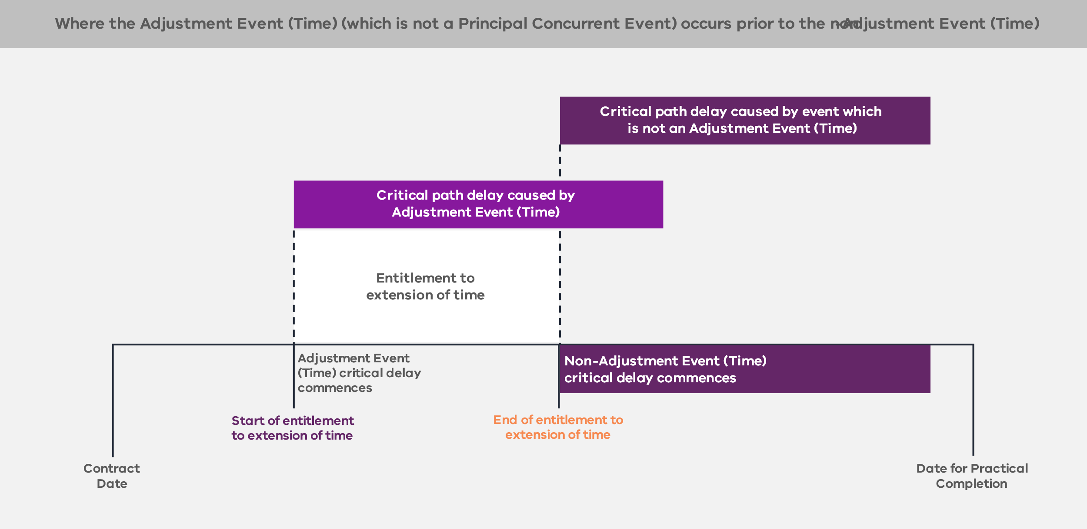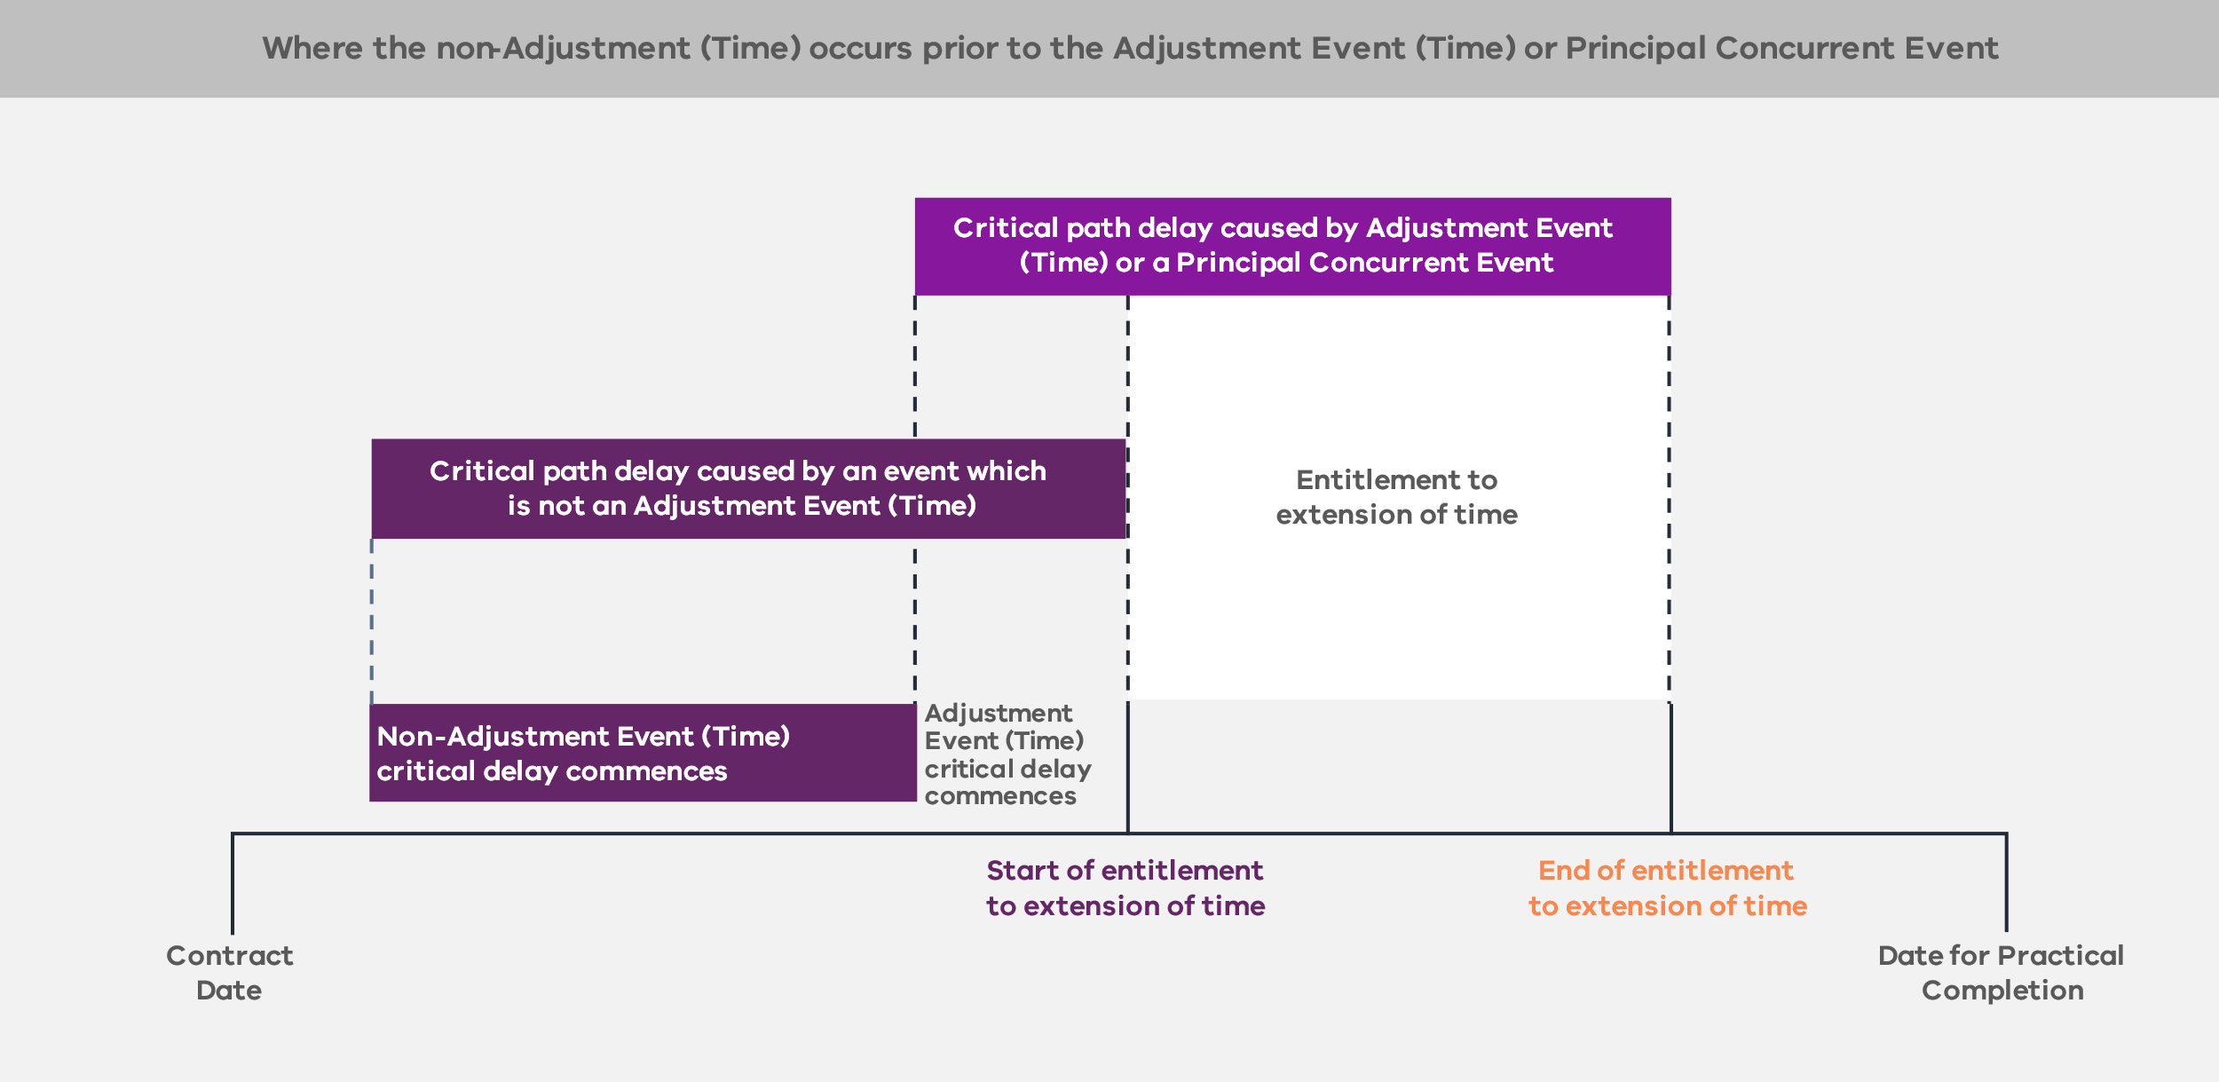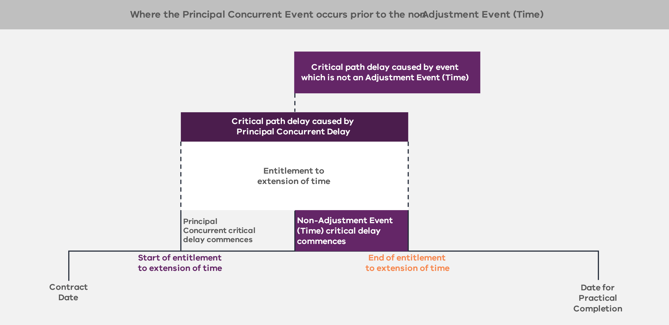
        - Acceleration (clauses 27.11, 27.12, 27.13 and 27.15 of the ITC Delivery Deed)
The Contractor may choose to compress the Contractor’s Activities or otherwise accelerate progress at its own cost and risk.
The Principal may direct the Contractor to complete the Contractor’s Activities in advance of the Date for Completion of those activities shown on the Program, including to:
    - achieve Completion prior to the relevant Date for Completion; or
    - overcome or minimise the extent and effects of some or all of a delay caused by an Adjustment Event (Time) for which the Contractor is or would have been entitled to an extension of time to a Date for Completion for that Adjustment Event (Time).
The Contractor must submit a written claim to the Principal and the Principal Representative within the time required under the ITC Delivery Deed setting out the estimated time and cost consequences of accelerating any part or the whole of the Contractor’s Activities that are the subject of the Principal’s notice and must identify whether and to what extent that acceleration is reasonably achievable in the circumstances. If the Principal Representative accepts an acceleration proposal, the Contractor’s entitlements (including to extensions of time and adjustments to the TOC and KRAs) in connection with the acceleration are governed by the proposal that was accepted by the Principal Representative.
The Contractor is entitled to claim as Reimbursable Costs the direct, reasonable and properly evidenced extra costs necessarily incurred by the Contractor by reason of the direction, as determined by the Principal Representative, except that the Contractor has no entitlement to claim Reimbursable Costs for a direction to accelerate to the extent that:
    - the need for acceleration arises out of or in connection with any breach of the Project Documents by the Contractor (e.g. a failure to reach Completion by the Date for Completion); or
    - the direction for acceleration is, in effect, a direction to the Contractor to take corrective action to rectify any non-compliance with the requirements of the Project Documents.
If compliance with the Principal Representative’s direction causes the Contractor to incur more or less cost than would have been incurred had the Contractor not been given the notice, the notice constitutes an Adjustment Event (Cost), except to the extent that:
    - the need for acceleration arises out of or in connection with any breach of the Project Documents by the Contractor (e.g. a failure to reach Completion by the Date for Completion); or
    - the direction for acceleration is, in effect, a direction to the Contractor to take corrective action to rectify any non-compliance with the requirements of the Project Documents.
      - Variations (clauses 1, 6, 34, 35 and 36 of, and Schedules 9 and 15 to, the ITC Delivery Deed)
        - Introduction (clauses 1 and 34.1 of, and Schedule 15 to, the ITC Delivery Deed)
A Variation is:
    - an increase, decrease or omission of any part of the Contractor’s Activities;
    - a change to the character or quality of any material or work or of anything described in the ITC Delivery Deed or the Design Documentation;
    - a change to the levels, lines, positions or dimensions of anything described in the ITC Delivery Deed, the Design Documentation or any part of the Contractor’s Activities;
    - the performance of additional work; or
    - the demolition or removal of material or work no longer required by the Principal.
The occurrence of certain events is deemed to be a Variation.
    - Variations do not include:
    - Changes in Law or Changes in Policy (unless they are a Change in Mandatory Requirements that are the subject of a Variation Proposal); or
    - directions by the Principal or the Principal Representative to perform the Contractor’s Activities in accordance with the ITC Delivery Deed or in respect of Provisional Sum Work.
The Contractor acknowledges and agrees that an amount for Variations, other than Variations determined to be Scope Variations, is included in the Risk and Contingency Provisions component of the TOC. The Contractor bears the risk of less material Variations and is only entitled to make a Claim for an adjustment to the TOC, KRAs or a Date for Completion for Scope Variations. Scope Variations are Variations that amount to either:
    - a significant change, significant amendment or significant alteration to the scope of the Contractor’s Activities; or
    - a significant change to the fundamental requirements of the Contractor’s Activities.
        - Variations requested by the Principal (clause 34.1 of the ITC Delivery Deed)
At any time prior to the issue of the Final Certificate, the Principal may issue a Variation Request to the Contractor that must include details of:
    - the proposed Variation or Scope Variation (as applicable) that the Principal is considering; and
    - any specific information that the Principal requires the Contractor to include in its Variation Proposal or that may be relevant to the preparation of the Variation Proposal, including whether the Contractor considers that the proposed Variation is a Scope Variation.
The Principal is not obliged to proceed with any Variation or Scope Variation (as applicable) proposed in a Variation Request.
        - Directions giving rise to a Variation or Scope Variation (clause 34.4 of the ITC Delivery Deed)
At any time, if the Contractor considers that an approval, consent, direction, requirement, determination, request, claim, notice, agreement, demand or the like (a direction) by the Principal constitutes or involves a Variation or Scope Variation, and the Principal has not given that direction by way of a Variation Order or Scope Variation Order (as applicable), the Contractor must:
    - give written notice to the Principal within the time period required under the ITC Delivery Deed that it considers the direction constitutes or involves a Variation or Scope Variation (as applicable); and
    - give the Principal a Variation Proposal within the time period required under the ITC Delivery Deed, as if that direction by the Principal was a Variation Request.
If, within 10 Business Days, the Principal does not:
issue a notice that is a Variation Order or Scope Variation Order (as applicable) in respect of the relevant direction;
    - withdraw the direction; or
    - inform the Contractor that, in the Principal’s view, the direction does not constitute or involve a Variation or Scope Variation (as applicable)
the direction will be deemed to be withdrawn, and the Contractor must not comply with the direction.
If, within 10 Business Days, the Principal:
    - issues a notice that is a Variation Order in respect of the relevant direction, the Contractor must comply with the Variation Order;
    - withdraws the direction, the Contractor must not comply with the direction; or
    - informs the Contractor that, in the Principal’s view, the direction does not constitute or involve a Variation, the Contractor must comply with the direction but may refer the matter to expert determination.
The Contractor is not entitled to make any Claim for an extension of time to any Date for Completion or an adjustment to the TOC or KRAs in respect of a direction that may constitute or involve a Scope Variation, unless it has given a Variation Proposal within the time period required under the ITC Delivery Deed.
        - Variation Proposal (clause 34.2 of the ITC Delivery Deed)
The Contractor must submit a Variation Proposal to the Principal within 10 Business Days after receiving a Variation Request from the Principal. The Variation Proposal must satisfy the requirements of clause 34.2 of the ITC Delivery Deed and include:
    - the effect that the Contractor anticipates the Variation or Scope Variation (as applicable) will have on the Program and each Date for Completion;
    - whether the Contractor considers that the proposed Variation (which is not stated to be a Scope Variation) is a Scope Variation and include the basis for its consideration;
    - submissions or recommendations that the Contractor believes are appropriate to reduce or optimise the impact of the Variation or Scope Variation (as applicable) on the AOC, the Contractor’s performance against the KRAs and the achievement of Completion by the Date for Completion;
    - submissions or recommendations on any alteration to the TOC, the KRAs and any Date for Completion (as the case may be) that are required as a result of the Scope Variation; and
    - the likely changes to, or additional, permits and approvals required to implement the Variation or Scope Variation (as applicable).
The Contractor must provide the Principal with any additional information reasonably requested by the Principal. The Principal must then inform the Contractor whether it accepts the Variation Proposal, and, if it does accept, issue a Variation Order or Scope Variation Order (as applicable) to the Contractor.
        - Deemed Variations (clauses 6.1, 24.2, 36.2 and 39.2 of the ITC Delivery Deed)
The following events are deemed to be Variation in respect of which the Contractor may submit a Variation Proposal:
    - a Principal Approval Event;
    - a Change in Mandatory Requirements;
if loss or damage to the Works or the Temporary Works occurs due to an Uninsurable Risk (in combination with other risks or not), and the Principal Representative directs the Contractor to rectify such loss or damage, the rectification is deemed to be a Scope Variation.
if the parties reach early agreement on certain specifications in respect of an item of Equipment, and the Principal later changes those specifications, that change constitutes a Scope Variation and the Principal is deemed to have issued a Variation Direction with a request to prepare a Variation Proposal.
        - Variations proposed by the Contractor (clause 34.7 of the ITC Delivery Deed)
The Contractor may, at any time, request the Principal to direct a Variation by submitting a Contractor Variation Proposal to the Principal. If such a Variation is approved by the Principal, the Contractor must implement the Variation at its own cost and risk and is not entitled to make any Claim against the Principal in connection with the Variation, including in respect of an extension of time or relief from performance.
        - Pre-Agreed Scope Variations (clause 35 of, and Schedule 9 to, the ITC Delivery Deed)
The rights and obligations of the parties in respect of Pre-Agreed Scope Variations are set out in Schedule 9 of the ITC Delivery Deed.
Schedule 9 does not form part of this standard form contract suite and needs to be developed by the Principal based on project-specific characteristics.
      - Indemnities (clause 41 of the ITC Delivery Deed)
        - General principle (clauses 41.1, 41.2, 41.3, 41.4, 41.5, 41.6, 41.11, 41.12 and 41.13 of the ITC Delivery Deed)
The ITC Delivery Deed sets out a number of broad indemnities that the Contractor must provide, including indemnities in relation to:
    - destruction, loss or damage to the Works or the Temporary Works during the period the Contractor is responsible for their care;
    - property damage and personal injury or death in connection with any act or omission of the Contractor or any Contractor Associate in connection with the Project;
    - the Contractor or Contractor Associate breach of any Project Document;
    - the provision and use of Project Information by the Contractor, a Contractor Associate or any other person to whom the Project Information is disclosed;
    - the disruption, damage, removal and relocation of Utility Infrastructure to the extent caused or contributed to by a Contractor Act or Omission;
    - Contamination caused or contributed to by the Contractor or any Contractor Associate;
    - Contamination that is not caused or contributed to by the Contractor or any Contractor Associate but emanates or migrates from the Site or Extra Land, and the Contractor or a Contractor Associate has caused or contributed to such Contamination emanating or migrating from the Site or Extra Land;
    - any Claim or Liability suffered or incurred by an Indemnified IP Person in connection with any alleged or actual infringement or violation of IP Rights or Moral Rights (other than in relation to any Principal IP);
    - any Claim or Liability suffered or incurred by an Indemnified IP Person in connection with a breach of the warranties in relation to IP Rights;
    - any Claim or Liability suffered or incurred by an Indemnified IP Person in connection with the IP Rights necessary for the continuation of the Contractor’s Activities being unavailable as a result of or in connection with the Contractor breaching its obligation to obtain the required licences; and
    - any Claims that arise in connection with an infringement of Moral Rights resulting from the use, operation or modification of the Contractor’s Activities or the Works.
The Contractor’s liability to indemnify is reduced to the extent that any such liability is caused or contributed to by:
    - any breach by the Principal of any Project Document;
    - any fraudulent, negligent, reckless, unlawful or malicious act or omission of the Principal, any Principal Associate or other indemnified parties;
    - any Adjustment Event (Time);
    - subject to a notification requirement by the Contractor, the Contractor complying strictly with a direction from the Principal or the Principal Representative (except to the extent the direction is to comply with a Project Document, is permitted under a Project Document or was given as a result of a Contractor Act or Omission); or
    - a failure by the Principal, any Principal Associate, any Interface Party (other than any Direct Interface Party) or any other Indemnified IP Person (as relevant) to use reasonable endeavours to mitigate the extent or consequences of the Liability
other than to the extent that the Contractor or any Contractor Associate is entitled to recover an indemnified amount under the Insurances (or would have been entitled to do so but for an Insurance Failure Event).
Further, the Contractor’s liability to indemnify is limited by:
    - subject to certain exclusions, the Contractor’s aggregate liability cap (refer to section 5.15.1); and
    - subject to certain exceptions, the exclusion of Liability for Indirect or Consequential Loss exclusion.
          - Project-specific amendments
Procuring agencies may consider who, in addition to the Principal, should be indemnified for breach, having regard to the number of Principal Associates involved in the Project and the arrangements that the Principal may have in respect of the Principal Associates. Consideration should also be given on a project-specific basis to limiting the liability of the Contractor in respect of economic loss that may be suffered by those Principal Associates by way of carve outs to the Indirect or Consequential Loss exclusion for the Contractor.
      - Limitation and exclusion of Liability (clause 41 of the ITC Delivery Deed)
        - General principle (clauses 41.11, 41.12 and 41.13 of the ITC Delivery Deed)
          - Limitation of Liability
The Contractor’s total aggregate liability is limited to 50 per cent of the Initial TOC. This liability cap is subject to the exclusions detailed in clause 41.13 of the ITC Delivery Deed, which include:
    - Liability to the extent it cannot be limited or excluded at Law;
    - the extent to which the Contractor or a Contractor Associate is entitled and able to recover under any Insurances in respect of such a Liability;
    - Liability to the extent the Contractor recovers in accordance with an indemnity under any Project Documents;
    - Liability in connection with any criminal act, fraud or Wilful Misconduct on the part of the Contractor or any Contractor Associate; and
    - Liability in connection with abandonment of the whole or a substantial part of the Contractor’s Activities by the Contractor or any Contractor Associate.
          - Exclusion of Liability for Indirect or Consequential Loss
The ITC Delivery Deed provides that the Principal and the Contractor have no Liability in respect of Indirect or Consequential Loss incurred or suffered by the Contractor or the Principal respectively, except in limited circumstances.
Exceptions to the Contractor’s exclusion of Liability for Indirect or Consequential Loss include:
    - Liability to the extent it cannot be limited or excluded at Law;
    - the extent to which the Contractor or a Contractor Associate is entitled and able to recover under any Insurances in respect of such a Liability;
    - Liability to the extent the Contractor recovers in accordance with an indemnity under any Project Documents;
    - Liability in connection with any criminal act, fraud or Wilful Misconduct on the part of the Contractor or any Contractor Associate; and
    - Liability in connection with abandonment of the whole or a substantial part of the Contractor’s Activities by the Contractor or any Contractor Associate.
          - Subcontractors
The carve outs to the Contractor’s exclusion of Indirect or Consequential Loss are typically passed through to Significant Subcontractors and are accordingly subject to the liability caps in their Significant Subcontracts.
        - Project-specific amendments
The ITC Delivery Deed contemplates that the carve outs to the exclusion of the Contractor’s liability for Indirect or Consequential Loss may include liability the Principal has to third parties (including for economic loss) (see clause 41.13(j) of the ITC Delivery Deed). The clause should be carefully considered on a project-specific basis, having regard to the likelihood of the risk of any such liability, the potential extent of that liability, the level of control the Contractor has in respect of the risk that might give rise to such a liability and the insolvency risk that it creates for the Contractor. The carve out, if it is used, should be limited to specified parties. It may also be appropriate to consider a specific cap on that liability. The Principal may also need to disclose the terms of its agreements with the relevant third party to the Shortlisted Respondents during the RFP phase, so the Shortlisted Respondents can make an informed assessment of their potential exposure.
The list of exceptions to the exclusion for Indirect or Consequential Loss may include additional project-specific items to reflect relevant project-specific payments or liabilities, for example, where there are known liabilities that the Principal has to third parties for loss of revenue that either need to be covered by the Contractor or are subject to a different regime. However, the circumstances for project-specific amendments should be limited, given the insolvency risk it creates for the Contractor.
        - Limitation on Principal Liability to the Contractor for Relief Events (clause 41.14 of the ITC Delivery Deed)
As mentioned in section 5.12.1, the Principal’s Liability to the Contractor in connection with any Relief Event is reduced to the extent that:
    - the Relief Event or the consequences of the Relief Event are caused or contributed to by a Contractor Act or Omission;
    - the Contractor or any Contractor Associate fails to take all reasonable steps that a prudent, competent and experienced contractor in the circumstances of the Contractor or the relevant Contractor Associate exercising Best D&C Practices would take to mitigate, minimise or avoid the effects, consequences or duration of the Relief Event.
Further, to the extent that compensation in relation to a Relief Event is in respect of an Insured Risk, the Contractor is not entitled to claim such compensation from the Principal, unless the Contractor can demonstrate that the compensation is not covered by the proceeds of Insurance due to a Principal Insurance Breach.
      - Insurance (clause 42 of the ITC Delivery Deed)
        - General principle (clauses 42.1, 42.2 and 42.3 of, and Schedule 13 to, the ITC Delivery Deed)
The ITC Delivery Deed provides for a hybrid approach to insurances, pursuant to which the Principal effects insurances for the construction works and public liability (referred to as the Insurances (Principal)), and the Contractor effects insurances for transportation of plant, equipment and material, insurance of employees, professional indemnity, motor vehicle insurance and constructional plant (referred to as the Insurances), as set out in the Insurance Schedule. The Principal’s insurance requirements in the Insurance Schedule represent the minimum degree of cover that the Principal expects the Contractor to maintain as part of its risk management strategy.
In addition to the requirements of the Insurance Schedule, the Contractor is required to ensure that the Insurances comply with the requirements under clauses 42.2 and 42.3 of the ITC Delivery Deed.
Schedule 13 does not form part of this standard form contract suite and needs to be developed by the Principal based on project-specific characteristics.
        - Procurement of Insurances (Principal) (clause 42.4 of the ITC Delivery Deed)
The Principal procures certain insurances (the Insurances (Principal)) where it is better placed to do so, such as insurance for construction works and public liability. Any other Insurances (Principal) typically depend on the extent to which the Principal insures other assets that interface with the project assets. For example, on rail projects, if the Principal already insures other interfacing assets (such as rolling stock and the rail network), it may be preferable for the Principal to insure project assets to avoid double insurance and subrogation issues. Procuring agencies should consult the DTF if Principal-procured insurance, aside from construction works and public liability, is proposed for a project.
        - Pass through of insurance payouts (clause 42.12 of the ITC Delivery Deed)
Other than in respect of Contract Works Insurance and Transit Insurance, to the extent the Contractor or the Principal receive an Insurance or Insurances (Principal) payment in relation to an amount already reimbursed under the ITC Delivery Deed or that was treated as Reimbursable Costs for calculating the AOC, the AOC will be reduced by that amount. If a Gainshare Amount or Painshare Amount has been paid to or by the Contractor, clause 29.4 of the ITC Delivery Deed (which addresses overpayments or underpayments) applies in respect of any determined underpayment or overpayment.
        - Project-specific amendments
The Insurance requirements and structure must be considered on a project-specific basis. Subject to the nature and complexity of the Project and any customised solutions presented by Respondents, project-specific considerations may include the use of group policies of the Significant Subcontractors or other project-specific insurances that may be required by the Principal (such as Pollution Insurance).
      - Security (clause 33 of the ITC Delivery Deed)
        - Parent Company Guarantees (clause 33.6 of the ITC Delivery Deed)
The Principal requires the Contractor to provide a Parent Company Guarantee (PCG). If the proposed Parent Guarantor is not the ultimate holding company, the Principal needs to be satisfied that the assets of that Parent Guarantor are retained for the duration of the PCG. This is a matter of evaluation and the DTF should be consulted on the form of the PCG, including in regard to any enforceability risks.
If a PCG is provided for a Significant Subcontractor, the parent of a Significant Subcontractor should be a party to the relevant Significant Subcontractor Direct Deed for the purposes of acknowledging the Principal’s security rights in respect of the Project.
There may be circumstances where the proposed PCG is provided by a foreign entity. In these instances, it is recommended that the procuring agency consults with their legal adviser to ensure the PCG is sufficiently enforceable in accordance with the laws of that jurisdiction and to advise on any enforceability risks. There may be circumstances where additional security is required to mitigate identified enforceability risks.
        - Performance Bond (clauses 33.1 and 33.2 of the ITC Delivery Deed)
The Principal requires the Contractor to provide the following Performance Bonds in favour of the Principal prior to commencement of the Contractor’s Activities:
    - the Bond, being one or more Performance Bonds with a face value of 5 per cent of the TOC; and
    - the DLP Bond, being one or more Performance Bonds with a face value of 2.5 per cent of the TOC.
The Performance Bonds must be in a form approved by the Principal and issued by a financial institution or insurance company (as applicable) with a minimum credit rating of A– (Standard and Poor’s) or A3 (Moody’s). These specified credit ratings provide the Principal with an appropriate degree of protection against the risk that any financial institution or insurance company (as applicable) will be unable to meet its relevant obligations in respect of the Project.
Procuring agencies should consider on a case-by-case basis whether Performance Bonds should include insurance bonds, having regard to VfM.
Provision of the Performance Bonds should be identified as a Condition Precedent in the Condition Precedent Schedule.
Schedule 2 does not form part of this standard form contract suite and needs to be developed by the Principal based on project-specific characteristics.
      - Default (clauses 1 and 43 of the ITC Delivery Deed)
        - Defaults (clauses 1 and 43.2 of the ITC Delivery Deed)
If the Principal considers that a Default (any failure by the Contractor or a Parent Guarantor to comply with any obligation of the Contractor or a Parent Guarantor under any Project Document, other than a Major Default or Default Termination Event) has occurred, the Principal has the right to serve a Default Notice on the Contractor to Cure the Default (or, where it cannot be Cured, meet the Principal’s reasonable requirements) within 20 Business Days or such longer period as the Principal notifies.
If the Default is not Cured, or, where the Default cannot be Cured, the reasonable requirements of the Principal are not met within the notified period, the Default becomes a Major Default. This interim process gives the parties the ability to manage minor breaches that are not otherwise regulated by the Project Documents before they are elevated to Major Defaults.
        - Major Default Notice (clauses 1, 43.1 and 43.3 of the ITC Delivery Deed)
Major Defaults are events that trigger the operation of the Major Default mechanism.
The following Major Defaults are deemed to be capable of Cure:
    - where the Contractor fails to achieve Practical Completion by the Date for Practical Completion;
    - where the Contractor breaches the Local Jobs First Requirements;
    - where the Contractor breaches the Social Procurement Commitment or the Social Procurement Commitment Schedule, or fails to meet the Social Procurement Target; and
    - where the Contractor breaches the Fair Jobs Code requirements.
The deeming provision puts it beyond doubt that, notwithstanding that these events may not be capable of remedy or cure as a matter of fact, the Contractor has the benefit of the maximum Cure period permitted by the Principal under the Project Documents in respect of those Major Defaults.
Figure 12 below sets out the Major Default Notice regime. The regime ensures that there are sufficient protections for the Contractor to provide input in the Major Default procedure.
Figure 12 – Major Default mechanism
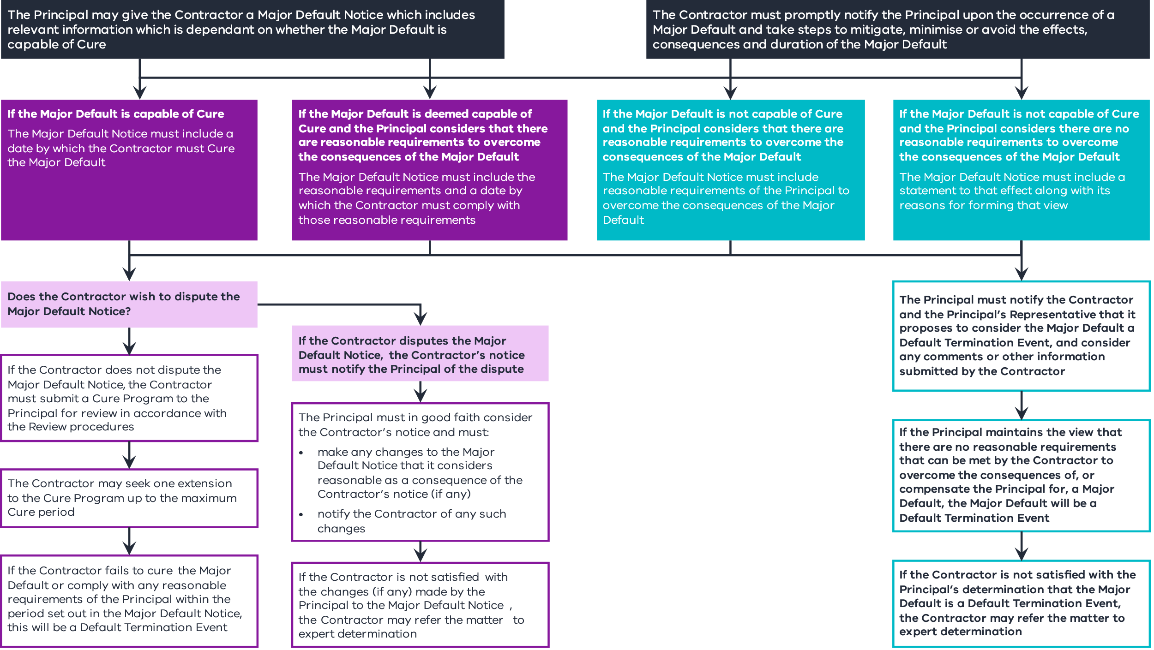
        - Cure Program and Cure periods (clauses 1, 43.4 and 43.5 of the ITC Delivery Deed)
          - Cure Program
The Contractor must provide a Cure Program within 10 Business Days after receiving a Major Default Notice.
Where the Major Default is a failure by the Contractor to achieve Practical Completion by the Date for Practical Completion, and the Contractor has provided a Remediation Plan in accordance with the requirements of the expert’s review of progress (in accordance with clause 27.3(e)(ii) of the ITC Delivery Deed) or an Amended Remediation Plan (in accordance with clause 27.3(j) of the ITC Delivery Deed), the Contractor may submit that Remediation Plan or Amended Remediation Plan (as applicable) as the Cure Program for the Major Default.
          - Extension to Cure Program and the time set out in a Major Default Notice
If the Contractor diligently pursues:
    - if the Major Default is capable of Cure, the Cure of that Major Default; or
    - if the Major Default is not capable of Cure, compliance with any reasonable requirements of the Principal
the Contractor may request that the Principal, and the Principal must, extend the Cure Program, and the time stated in the Major Default Notice will be extended. The Contractor is only entitled to one extension in connection with the same Major Default. Limiting the number of extensions gives certainty to the parties and avoids the risk of open-ended Cure rights.
Clause 43.4(h) of the ITC Delivery Deed sets out the maximum Cure period permitted by the Principal in respect of a Major Default. For most projects, the maximum Cure period is 24 months. When determining the maximum Cure period, procuring agencies should consider a number of factors, including the length of the Delivery Phase, the complexity of the Project and the maturity of the market in providing the required Works. The maximum Cure periods should be agreed with the DTF.
It is for the Contractor and the Significant Subcontractors to determine the exclusive Cure period (if any) that each party has for Curing a Major Default.
The maximum Cure periods that the Contractor has under the ITC Delivery Deed may be extended if the Contractor is prevented from carrying out its obligations in accordance with a Cure Program as a direct result of an Adjustment Event (Time), provided that:
    - the Contractor is entitled to be granted an extension of time under clauses 27.8 or 27.9 of the ITC Delivery Deed (as applicable) for the relevant Adjustment Event (Time); and
    - the Contractor demonstrates to the Principal’s satisfaction (acting reasonably) that the Contractor has diligently pursued and, to the extent reasonably possible, continues to diligently pursue the Cure Program.
The maximum Cure period and the Major Default Notice may only be extended by the amount of time for which the Contractor is entitled to an extension of time or relief for performance of the obligations in respect of the Adjustment Event (Time).
If the Contractor fails to Cure the Major Default within the time set out in the Major Default Notice (as may be amended, determined or extended), a Default Termination Event occurs.
      - Termination (clauses 1, 3 and 44 of the ITC Delivery Deed)
        - Sole basis (clause 44.1 of the ITC Delivery Deed)
The Principal is only entitled to terminate, rescind or accept a repudiation of the ITC Delivery Deed in accordance with the termination rights under the ITC Delivery Deed.
The Contractor has no right to terminate any Project Document. The rationale for this is that:
    - there are a very limited number of fundamental obligations the Principal has under any Project Document; and
    - failure of the Principal to meet its obligations under a Project Document is an Adjustment Event, and the Contractor’s rights to sue the Principal for damages for breach of the Project Documents are excluded only in limited and specified circumstances.
        - Termination events (clauses 1, 3.4, 44.2 and 44.3 of the ITC Delivery Deed)
          - Termination triggers
The ITC Delivery Deed can be terminated as a result of the events listed in the following table.
Table 2 – Termination triggers
Event | Trigger
Termination for failure to satisfy a Condition Precedent by the Condition Precedent Deadline | If any Condition Precedent is not satisfied (or waived in accordance with clause 3.3(b) of the ITC Delivery Deed) by the relevant Condition Precedent Deadline, the Principal may, at its option, terminate the ITC Delivery Deed.
Termination for Convenience | The Principal may, at any time, unilaterally elect to terminate the ITC Delivery Deed for convenience.
Termination for a Default Termination Event | The Principal may terminate the ITC Delivery Deed if a Default Termination Event occurs.
          - Default Termination Events
The Default Termination Events are events that are sufficiently fundamental as to trigger automatic rights for the Principal to terminate the ITC Delivery Deed. The definition of ‘Default Termination Events’ is set out in clause 1 of the ITC Delivery Deed and, subject to project-specific considerations, includes the following:
    - whole or substantial abandonment of all or any material (in scope and effect) part of the Contractor’s Activities;
    - the Contractor being engaged in fraud, collusion or dishonest conduct in performing its obligations under the Project Documents;
    - an Insolvency Event occurring in relation to the Contractor or the Parent Guarantor;
    - breach of the assignment, transfer or disposal requirements of the ITC Delivery Deed;
    - a Change in Control occurring in respect of the Contractor or a Parent Guarantor (other than a permitted Change in Control under the ITC Delivery Deed);
    - unremedied Major Default (whether capable of Cure or not);
    - the aggregate liability of the Contractor to the Principal under or in connection with the Project Documents is equal to or exceeds a set percentage of the Initial TOC;
    - where any PCG provided in accordance with the ITC Delivery Deed becomes void, voidable or unenforceable for any reason;
    - Practical Completion has not occurred by a specified Sunset Date; and
    - any other event that is deemed to be a Default Termination Event under the ITC Delivery Deed.
        - Termination Payments (clause 44.4 of the ITC Delivery Deed)
The applicable Termination Payment is calculated by applying the relevant Termination Payment formula (which depends on the termination trigger).
    - If the ITC Delivery Deed is terminated due to a failure to satisfy a Condition Precedent by the Condition Precedent Deadline, there is no Termination Payment.
    - If the ITC Delivery Deed is terminated for convenience, the Termination for Convenience Payment is calculated by applying the formula set out in clause 44.2(d) of the ITC Delivery Deed.
    - If the ITC Delivery Deed is terminated for a Default Termination Event, the rights and liability of the parties are the same as they are at common law if the defaulting party repudiates the ITC Delivery Deed, and the other party elects to treat the ITC Delivery Deed as at an end and recover damages. The Contractor is not entitled to quantum meruit (i.e. the reasonable or fair value of services or works performed).
Default Termination Payments are payable by the Principal (if the Termination Payment is a positive amount) or by the Contractor (if the Termination Payment is a negative amount). The Principal’s obligation to make a Termination Payment to the Contractor is subject to the Contractor having delivered the vacated Site and the Works to the Principal.
        - Termination for Convenience Payment
The key components of the Termination for Convenience Payment are the following amounts (as honestly and fairly determined by the Principal Representative):
    - Reimbursable Costs and COP
    - Gainshare Amount or Painshare Amount (if any and as the case may be)
    - Performance Reward Amount (if any)
    - payable for the Contractor's Activities performed prior to the date of termination (to the extent not included in an amount previously paid by the Principal to the Contractor) costs of plant or materials reasonably ordered by the Contractor for the Works for which the Contractor is legally bound to pay;
    - costs reasonably incurred by the Contractor in the expectation of completing the whole of the Contractor’s Activities and not included in any payment by the Principal; and
    - the reasonable cost of removing all labour, Constructional Plant and other things used in connection with the Contractor’s Activities from the Site.
In considering any amounts that may be payable in regard to Reimbursable Costs, COP, Gainshare or Painshare Amounts and Performance Reward Amounts, the Principal Representative must estimate the amount that would have been payable if the ITC Delivery Deed had not been terminated (on a pro rata basis).
        - Project-specific amendments
The nature and number of the Major Defaults and Default Termination Events may be subject to project-specific considerations, such as the length and complexity of the Contractor’s Activities.
      - Notices and bars to claims (clause 59 of the ITC Delivery Deed)
The Principal requires certainty in relation to the time period within which the Contractor can prosecute Claims against the Principal.
A number of time bars for different types of Claims are set out in the ITC Delivery Deed.
Where there is no express and specific time bar for the making of a claim identified in clause 59.2(b) of the ITC Delivery Deed, there is a catch-all in clause 59.2(c) of the ITC Delivery Deed.
- – Terminology and interpretation
Capitalised terms used in these Guidance Notes have the meanings given to them in the ITC Contract Suite or the glossary of terms to the RFP included in Appendix A, Volume 1, Part A of the Standard Form Request for Proposal, unless otherwise defined in these Guidance Notes. Any reference to a clause is a reference to a clause in the ITC Development Deed or ITC Delivery Deed (as applicable).
For the purposes of these Guidance Notes:
Acronym/Term | Meaning
AOC | Actual Outturn Cost
COP | Corporate Overhead and Profit
DLP | Defects Liability Period
DPSDS | Development Phase Services and Deliverables Schedule
DTF | Department of Treasury and Finance
HVHR | High Value High Risk
ITC | Incentivised Target Cost
ITC Development Deed | As defined in section 4
ITC Delivery Deed | As defined in section 5
KPI | Key Performance Indicator
KRA | Key Result Area
MTPF Act | As defined in section 1.6
PDDD | Project Due Diligence Documentation
PSDR | As defined in section 1.5
TOC | Target Outturn Cost
VfM | Value for Money
- – Defects
Defects
In the Works until the end of the DLP or in the Returned Asset until the end of the relevant Returned Asset DLP
The Principal may give notice to the Contractor and the Principal Representative if it believes that there is a Defect or likely Defect
The Contractor must notify the Principal and the Principal Representative if it identifies a Defect or likely Defect in the Works or a Returned Asset
The Contractor must develop, submit, update and comply with the Defect Corrective Action Plan in accordance with clause 28.4
The Contractor must promptly rectify all Defects in the Works as soon as they are identified, unless the Defect is a Defect that the Principal accepts or rectifies in accordance with clause 28.6
If the Principal accepts or rectifies (or engages others to rectify) a Defect in the Works or the Returned Assets, the Contractor must pay the Principal (as a debt due and payable) the greater of:
- the costs necessary to rectify that Defect
- the relevant diminution in value of the Works or the relevant Returned Assets (as applicable) as a consequence of that Defect
Prior to the Date of Practical Completion where the Principal has NOT given the Contractor notice of the Defect will be a Reimbursable Cost
The Contractor’s cost of rectifying Defects:
Prior to the Date of Practical Completion where the Principal HAS given the Contractor notice of the Defect will NOT be a Reimbursable Cost
After the Date of Practical Completion will NOT be a Reimbursable Cost

