Procurement
Investment Lifecycle and High Value High Risk Guidelines

The Secretary
Department of Treasury and Finance
1 Treasury Place
Melbourne Victoria 3002
Australia
Telephone: +61 3 9651 5111
dtf.vic.gov.au

Authorised by the Victorian Government
1 Treasury Place, Melbourne, 3002

© State of Victoria 2024
You are free to re-use this work under a Creative Commons Attribution 4.0 licence, provided you credit the State of Victoria (Department of Treasury and Finance) as author, indicate if changes were made and comply with the other licence terms. The licence does not apply to any branding, including government logos.

Copyright queries may be directed to IPpolicy@dtf.vic.gov.au

ISBN 978-1-925551-88-4
Published September 2023

If you would like to receive this publication in an accessible format please email information@dtf.vic.gov.au

This document is also available in Word and PDF format at dtf.vic.gov.au

Contents
Introduction 1
Part 1: Understanding the infrastructure procurement environment 4
1. Overview of infrastructure procurement 4
1.1 Government infrastructure procurement 4
1.2 Principles for government procurement 5
1.3 Procurement legislation and policy 8
1.4 Project assurance 11
Part 2: Developing the procurement strategy 15
2. Procurement strategy 15
2.1 What is a procurement strategy? 15
2.2 Why is a robust procurement strategy necessary? 16
3. Process for developing a procurement strategy 17
3.1 Step 1: Scope key project success factors and establish procurement objectives 18
3.2 Step 2: Project structuring, bundling and packaging 24
3.3 Step 3: Test procurement model fit and shortlist 33
3.4 Step 4: Analyse shortlist and justify procurement model selection 36
3.5 Step 5: Detail the preferred procurement model and feed impacts through the business case 43
4. Overview of procurement models 45
4.1 Early contractor involvement 46
4.2 Lump sum procurement models 46
4.3 Cost reimbursable models 56
4.4 Whole-of-life models 67
Part 3: Implementing the procurement strategy 76
5. Preparing for procurement 76
5.1 Establishing governance and resourcing for the procurement phase 77
5.2 The procurement plan 80
5.3 Risk management 82
5.4 Probity management 84
5.5 Market consultation 85
5.6 Tender engagement strategy 86
5.7 Preparing for procurement phase checklist 88
6. Pre-tender and tender documentation 89
6.1 Due diligence 89
6.2 Pre-tender cost estimate 90
6.3 Tender documentation 90
6.4 Tender evaluation criteria and documentation 92
6.5 Contract documentation 93
6.6 Pre-tender and tender documentation checklist 94
7. Tendering 94
7.1 Running an expression of interest process 95
7.2 Commencing the tender process 96
7.3 The tender period 96
7.4 Communications during the tender period 98
7.5 Closing and receiving tenders 101
7.6 Tendering phase checklist 104
8. Tender evaluation 104
8.1 Review the tender evaluation plan 104
8.2 Tender evaluation resources 105
8.3 Probity in tender evaluation 106
8.4 Evaluation process 107
8.5 Tender evaluation phase checklist 114
9. Contract negotiation 114
9.1 Negotiating mutually successful outcomes 115
9.2 Developing a negotiation strategy 115
9.3 Establishing the negotiating team 116
9.4 Preparing for negotiations 117
9.5 Agreeing the negotiating framework and protocols 117
9.6 Recommended negotiation practices 118
9.7 Re-calling tenders 119
9.8 Negotiation phase checklist 119
10. Approvals and contract award 119
10.1 Awarding and executing the contract 121
10.2 Informing unsuccessful tenderers of the outcome 122
10.3 Approvals and contract award phase checklist 123
Appendices 124
Appendix A – Legislation and policy 124
Appendix B – Issues influencing project delivery performance and success 146
Appendix C – Preferred DTF two-stage managing contractor approach 150
Appendix D – Common elements and considerations of the procurement plan 152
Appendix E – Form of invitation to tender 154

List of tables
Table 1 – Public construction procurement principles 6
Table 2 – Subordinate legislation and policy that governs infrastructure procurement 10
Table 3 – Project assurance requirements by project value 12
Table 4 – The HVHR framework 13
Table 5 – Types of issues influencing project delivery performance and success 21
Table 6 – Common procurement objectives and how they can apply in developing the procurement strategy 24
Table 7 – Packaging strategies 32
Table 8 – Indicative procurement model alignment to project characteristics 35
Table 9 – Standard procurement model selection criteria (SC) 37
Table 10 – Key team governance requirements 78
Table 11 – Preparing for procurement phase checklist 89
Table 12 – Typical components of tender documents 92
Table 13 – Pre-tender and tender documentation phase checklist 95
Table 14 – Tender phase checklist 105
Table 15 – Tender evaluation phase checklist 115
Table 16 – Negotiation phase checklist 120
Table 17 – Approvals and contract award phase checklist 124
Table 18 – Common elements of the procurement plan 153
Table 19 – Types of invitations to tender 155

List of figures
Figure 1 – Document overview 1
Figure 2 – The investment lifecycle 2
Figure 3 – Infrastructure procurement framework 3
Figure 4 – Chapter 1 overview 4
Figure 5 – Primary legislation for infrastructure procurement 10
Figure 6 – Project lifecycle and HVHR project assurance process 14
Figure 7 – Chapter 2 overview 15
Figure 8 – Chapter 3 overview 17
Figure 9 – Process for developing a robust procurement strategy 18
Figure 10 – Key factors in project delivery performance 20
Figure 11 – Chapter 4 overview 45
Figure 12 – Construct only structure 48
Figure 13 – Design and construct structure 51
Figure 14 – Enhanced design and construct structure 54
Figure 15 – Managing contractor structure 58
Figure 16 – Incentivised target cost structure 62
Figure 17 – Alliance structure 65
Figure 18 – Partnerships Victoria structure 69
Figure 19 – Bundled structure 73
Figure 20 – Chapter 5 overview 76
Figure 21 – Key elements of the procurement plan 81
Figure 22 – Chapter 6 overview 90
Figure 23 – Chapter 7 overview 95
Figure 24 – Chapter 8 overview 105
Figure 25 – Chapter 9 overview 115
Figure 26 – Chapter 10 overview 120

Introduction

Purpose
These guidelines set out requirements, processes and issues to consider throughout the stages of the investment lifecycle when procuring infrastructure and assets. This includes:
- detailing the principles, legislative and policy context and assurance requirements that underpin government infrastructure procurement (Part 1, Chapter 12)
- developing a procurement strategy that supports the optimal packaging, bundling and procurement approach for implementing a project, and outlining the three procurement categories and the set of approved procurement models for use on Victorian Government infrastructure projects (Part 2, Chapters 2 to 4)
- implementing the procurement strategy, which includes preparing for tender, developing documentation, conducting tenders, evaluating market responses and negotiating and awarding a contract (Part 3, Chapters 5 to 10).
Figure 1 – Document overview
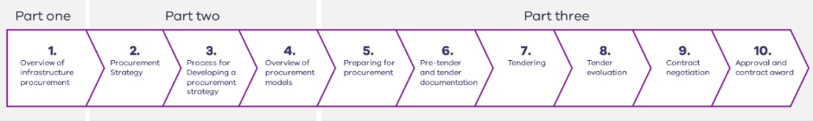
These guidelines apply to all Victorian Government investments with a capital asset or information and communications technology component with a total estimated investment of $10 million or more. They also apply to investments that require a full business case in line with the Business Case Investment Lifecycle and High Value High Risk Guidelines (refer to the next section, ‘Context,’ which explains the guideline suite).
These guidelines apply to Victorian Government delivery agencies and portfolio departments. They can also be used by other industry practitioners, government stakeholders, tenderers and advisers who wish to understand government asset procurement.
These guidelines are intended to be applied flexibly, depending on the size, risk, complexity and other characteristics of an investment.
The Ministerial Directions and Instructions for Public Construction Procurement, established under Part 4 of the Project Development and Construction Management Act 1994 (Vic), establish mandatory requirements that agencies must comply with when they procure public construction works and services.
Mandatory requirements are highlighted throughout this document. Further guidance is available at: https://www.dtf.vic.gov.au/infrastructure-investment/public-construction-policy-and-resources.

Context

The investment lifecycle
This document is part of a suite of guidance documents that makes up the Investment Lifecycle and High Value High Risk (HVHR) Guidelines (ILG). The investment lifecycle is the Victorian Government’s process for planning, procuring and delivering asset investments, as set out in Figure 2.
Figure 2 – The investment lifecycle
Business case | Procurement | Delivery
Establishes need, defines benefits, explores interventions, estimates costs, identifies delivery process | Explores delivery options, finalises delivery plan, engages the market, awards the contract | Implements solution, transitions investment into normal business
What is the problem, issue or service need?  What are the benefits from addressing the problem?  Is there a compelling case for investing?  Can the project be delivered as planned? | What is the preferred method for packaging and procuring the investment?  Has a fair and transparent procurement process been undertaken and market responses evaluated rigorously?  Is there a clear, preferred tender response that addresses the investment need and optimises value-for-money outcomes? | Is the investment proceeding as planned?  Are the investment benefits being delivered?  Are changes to the investment needed?  Gateway benefits realisation

All documents in the ILG suite provide better-practice guidance for delivery agencies to navigate each stage of the investment lifecycle and successfully deliver an investment. This document – the Procurement ILG – considers processes and issues that apply to all infrastructure procurements, regardless of procurement model. Delivery agencies should read this Procurement ILG in conjunction with the following guidelines, templates and tools:
- the Business Case ILG (when developing a procurement strategy)
- ILG supplementary guidances including:
  - Developing information and communication technology investments;
  - Project governance
  - Real options analysis technical supplement
  - Project development and due diligence
  - Risk, time, cost and contingency guidelines
  - Sustainable investment guidelines
  - ICT projects technical guidance
  - Investment Managment Standard tools
- the procurement strategy
- template (a component of the long-form business case template).

The infrastructure procurement framework
This Procurement ILG sits within the whole of government infrastructure procurement framework (framework). The framework builds on the Procurement ILG by supporting procurement and delivery of specific procurement models, as detailed in Figure 3.
Figure 3 – Infrastructure procurement framework
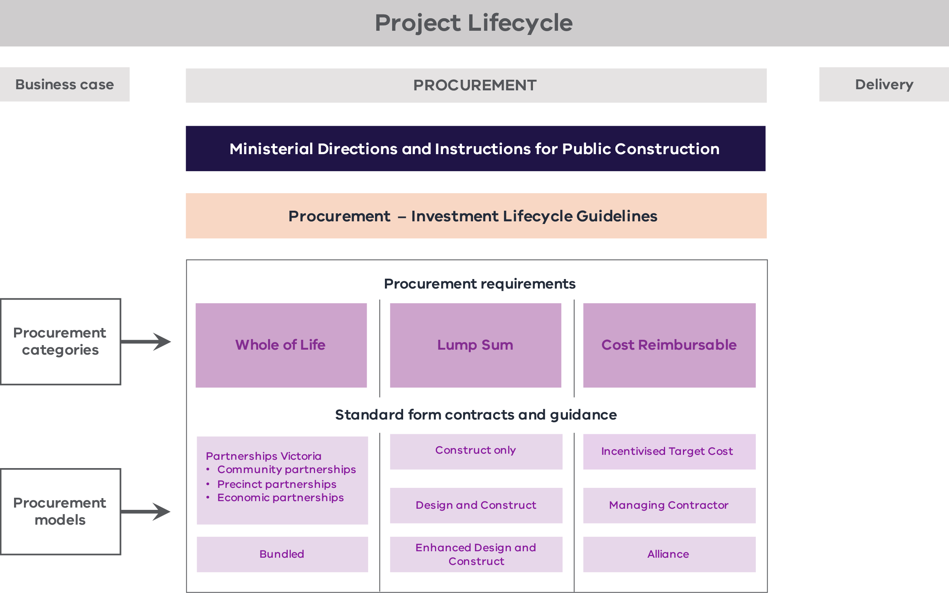
For each of the three categories of procurement – whole-of-life, lump sum and cost reimbursable – there is a procurement requirements document that clarifies government policy obligations and provides better-practice guidance to support implementation.
Under each procurement category there are a series of procurement models with standard form contracts (each with associated guidance) for HVHR projects supported by the Department of Treasury and Finance (DTF). Authorised contracts available for use under each procurement model are set out in Chapter 4.
Departments and delivery agencies seeking to use a procurement model outside of those outlined in these guidelines should consult with DTF.

Part 1: Understanding the infrastructure procurement environment
    - Overview of infrastructure procurement
Figure 4 – Chapter 1 overview
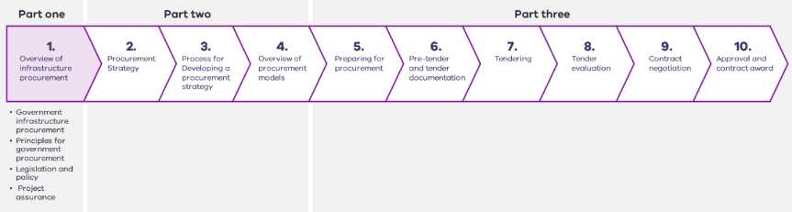
Part 1 of this Guideline (Chapter 1) explains the core features of government infrastructure procurement. It outlines the principles that must be applied during procurement processes, summarises the policy and legislative context that regulate procurement activities and provides an overview of project assurance requirements.
Understanding the procurement environment is essential for selecting the optimal procurement strategy for an investment (Part 2, Chapters 2 to 4) and effectively implementing that strategy (Part 3, Chapters 5 to 10).
      - Government infrastructure procurement
Procurement is defined in the ILG as the process of seeking market offers and engaging one or more respondents to deliver infrastructure and asset investments. These investments may include buildings, civil infrastructure, and information and communications infrastructure.
Procurement is first considered as part of the development of the business case. Here, the department or agency (agency) establishes the procurement outcomes for a given investment and determines the optimal strategy for realising these outcomes while achieving value-for-money.
Implementation of the procurement strategy commences when the Government decides to invest in an initiative. The key stages are detailed in Part 3. It typically includes:
    - preparing for procurement, including undertaking project development and due diligence activities to further scope and define a project’s requirements, as well as any risks and constraints to their delivery
    - developing pre-tender, tender and contract documentation
    - engaging the market and seeking and receiving market offers to deliver the required scope of works
    - rigorously evaluating offers to confirm the procurement can deliver the required outcomes and achieve value-for-money
    - negotiating to confirm scope, risk allocation and cost with a preferred bidder
    - awarding a contract to the successful respondent (contractor) to undertake the required scope of works to deliver the asset.
Cost reimbursable procurement models differ from other procurement models in confirming the decision for a contractor to proceed to construct infrastructure. They typically have two stages that are governed by different contractual arrangements.
    - A development phase: a respondent or respondents develop a project proposal for consideration by the Government. This includes collaboration with the Government, and successful respondents (contractor)may perform early works.
    - A delivery phase: the Government decides to proceed with the proposal, and the successful respondent contractor delivers it.
Procurement is an iterative process. Agencies may need to revisit and reassess previous decisions and outcomes as they progress through the procurement to account for new information as it arises.
      - Principles for government procurement
The Ministerial Directions and Instructions for Public Construction Procurement, established under Part 4 of the Project Development and Construction Management Act 1994 (Vic), set out the principles that Victorian government departments and public bodies must follow when they procure public construction works and services.
These are available at: https://www.dtf.vic.gov.au/infrastructure-investment/public-construction-policy-and-resources.
The principles seek to ensure that expenditure of public money is conducted lawfully, fairly and with integrity. They also balance the Government’s accountabilities for responsible financial management of public resources with the need to be efficient in the way the Government interacts with industry. A summary of the principles for government procurement is provided in Table 1.
Table 1 –Procurement principles
Procurement principle | Intent
Value-for-money (VfM) | VfM is an assessment of procurement outcomes that weighs the cost of procuring infrastructure and assets against the value they provide.  Tender evaluation and selection considers:  - the total benefits and costs over the life of the services or works procured (not the lowest upfront price)  - a range of attributes to define value, including service delivery outcomes and timeliness of benefit realisation, quality and suitability of the works and services , financial benefits, risk exposure, policy alignment, convenience, resource use and social and environmental impacts.
Accountability commensurate with appropriate levels of authority and responsibility | Procurements proceed with appropriate approval and authority in accordance with delegation and decision-making thresholds, to:  - align procurement needs with the agency’s long-term strategic planning and service delivery requirements as well as legislation, government policies and priorities  - confirm approval to proceed with the procurement is provided by an officer with appropriate financial delegation and authority  - undertake appropriate procurement planning to confirm objectives are deliverable  - give the public confidence in government’s expenditure of public resources, avoid waste, ensure resources are used in a proper manner and in the community’s best interests and ensure benefits are maximised.
Transparency and competition | Procurement processes are transparent, appropriately competitive and contestable and provide equal opportunity to all parties, to:  - ensure that competent contractors are not deterred by poor processes, lack of access or information, inadequate response times or cost of tendering  - encourage fair competition throughout the procurement process.
Probity | Proper and ethical standards and high levels of integrity are demonstrated in the conduct of all commercial transactions, including procurement processes and evaluations, ensuring defensibility of processes. Adherence to this principle involves:  - ensuring all tender participants are treated fairly and equally, by avoiding any practice that gives one party an improper advantage over another  - maintaining confidentiality throughout the procurement process  - managing all actual and perceived conflicts of interest  - respecting the intellectual property rights of all parties by not using intellectual property submitted with a tender to obtain prices from, or negotiate with, other tenderers for like or similar scope  - exhausting negotiations with the initial best-value respondent before negotiating with subsequent respondents  - not negotiating with more than one respondent at a time, unless the tender process has been designed to allow this, or trading off one respondent’s price against another, in an attempt to obtain a lower price.  For further information on applying probity to government procurements, including requirements for appointing a probity adviser or auditor, see https://www.buyingfor.vic.gov.au/plan-probity.
Scalability and efficiency | Tender processes are efficient, timely and reduce unnecessary burdens on all parties. In practice this involves using appropriate procurement models and processes, considering the complexity and value of the project and its market capability.
Building skills and capability | Procurement is leveraged to foster capability development and intergenerational skills transfer in infrastructure across both the public and private sectors. Key aspects of this principle include:  - identifying lessons learnt from past projects to inform new project development and delivery approaches, better risk management practices and improved contractor management  - leveraging government procurement to identify and address skills gaps and support capability development by Victorian public sector and industry practitioners  - sizing and packaging works in a way that best considers market capacity across all tiers of industry.
Continuous improvement | Adoption of innovative and modern methods of infrastructure to drive continuous, incremental improvements to productivity in infrastructure sectors. This will encourage appropriate innovation and responsiveness from the market.
      - Procurement legislation and policy
State, Commonwealth and local government legislation, policies and frameworks establish accountabilities, mandatory requirements and expectations for both government and industry practitioners in the procurement of government infrastructure.
Ministerial Direction 7.2.1 requires agencies to ensure public construction contracts comply with relevant legislative and policy requirements and mandates compliance with a selection of policies.
This section outlines key0F legislation and policies that agencies may need to consider in the planning, implementation and outcomes of procurements. Appendix A – Legislation and policy provides further detail on these, including the purpose of the legislation or policy and its impact on infrastructure procurement and delivery.
This section is not exhaustive. Legislation and government requirements evolve over time. Agencies should undertake their own due diligence at procurement commencement to identify any legislative or policy requirements they will need to address for a project.
        - Primary enabling legislation and policies for infrastructure procurement
For public money to be spent for any purpose, there must be lawful authority for an agency to spend it for that purpose. The following Acts are examples of primary legislation that govern how agencies can use money for infrastructure investment and delivery. These include requirements for ministers to account to Parliament to ensure financial resources are appropriately managed.

Legislation that enables and regulates government spending on infrastructure
    - The Financial Management Act 1994 sets out requirements for the use of public money, including:
      - the Treasurer’s and Assistant Treasurer’s accountabilities for the Government’s overall financial performance, including for the delivery of the Government’s capital program
      - principles and ministerial and agency accountabilities for infrastructure procurement.
    - The Annual Appropriations Bill sets out the Government’s infrastructure priorities and outlines the amount of public money appropriated to each department, and its relevant agencies, to deliver the asset proposals approved in the annual State Budget.
    - The Public Administration Act 2004 and the Audit Act 1994 establish accountabilities for decision-making and resource management and ensure the Government is held to account for the responsible and appropriate spending of public money.

Legislation that facilitates infrastructure project procurement and delivery
    - The Project Development and Construction Management Act 1994 (PDCM Act) and associated MDs is the primary legislation used by agencies to procure construction works and services. It sets out the framework, rules and requirements for procuring infrastructure, including:
      - competition and contestability requirements, including thresholds for limited, selective and open tendering
      - transparency requirements, including for communicating tender open times and evaluation criteria
      - probity requirements to ensure procurement processes are robust
      - requirements for compliance with subordinate legislation and policies, including international agreements and state and Commonwealth policy requirements
      - contracting requirements.
The MDs apply to the procurement of construction works or services undertaken by, or on behalf of, a government agency.
All agencies are required to comply with the MDs, except for Excluded Entities such as school councils, cemeteries, some committees of management and certain emergency services bodies such as volunteer fire brigades.
    - The Major Transport Projects Facilitation Act 2009 (MTPF Act) and Development Victoria Act 2003 provide alternative legislation to facilitate the delivery of major transport projects, property development and social and economic capital works projects, respectively. This legislation enables planning and environmental assessments and approvals to be sought efficiently.
Figure 5 – Primary legislation for infrastructure procurement
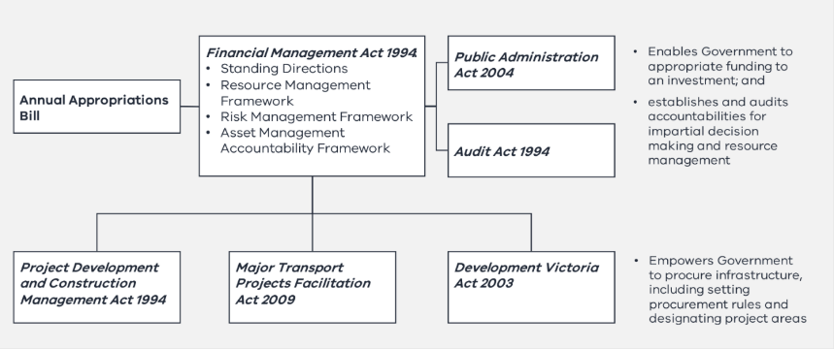
        - Secondary legislation and policy frameworks for infrastructure procurement
Secondary legislation and policy frameworks also need to be considered throughout infrastructure procurement. Table 2 provides a high-level overview of legislation and policy that agencies commonly need to consider at each stage of the investment lifecycle procurement process.
Table 2 – Subordinate legislation and policy that governs infrastructure procurement
Function | Legislation or policy
Facilitates project development and due diligence to scope and cost project risks | - Building Act 1993  - Climate Change Act 2017
Supports assessment and approvals of project risks and seeks to address stakeholder issues | - Planning and Environment Act 1987  - Environment Protection and Biodiversity Conservation Act 1999 (Cth)  - Environment Effects Act 1978  - Aboriginal Heritage Act 2006  - Heritage Act 2017  - Victorian Civil and Administrative Tribunal Act 1998
Facilitates site acquisition and readiness and early works | - Crown Land (Reserves) Act 1978  - Land Act 1958  - Sale of Land Act 1962  - Subdivision Act 1988  - Traditional Owners Settlement Act 2010  - Transfer of Land Act 1958
Sets rules and requirements for the conduct of government procurement | - Ministerial Directions and Instructions for Public Construction Procurement  - International agreements  - National alliance contracting policy and guidelines  - National public private partnerships (PPP) policy and guidelines  - Victorian Government Purchasing Board
Regulates construction practices to ensure work is undertaken safely by appropriately qualified practitioners | - Australian Government Building and Construction Work Health and Safety (WHS) Accreditation Scheme  - Building Act 1993 and Building Regulations 2018  - National Construction Code  - Occupational Health and Safety Act 2004  - Professional Engineers Registration Act 2019  - Prohibition of High-Risk Cladding Products Declaration
Addresses industrial relations issues to ensure fair work practices and payment is upheld | - Building and Construction Industry Security of Payment Act 2002  - Fair Jobs Code  - Victorian Government Fair Payments Policy  - Tip Truck Owner Drivers Policy  - Trade Practices Act 1974
Sets rules and requirements to optimise social, environmental and economic values in the outcomes of government procurement | - Building Equality Policy  - DataVic Access Policy  - Digital Asset Policy  - Gender Equality Act 2020  - Local Jobs First Act 2003  - Victorian Protective Data Security Standards  - Recycled First Policy  - Social Procurement Framework  - Supplier Code of Conduct  - Victoria’s Value Creation and Capture Framework

      - Project assurance
Project assurance is the independent monitoring of project delivery performance against service delivery outcomes and cost and time parameters, to provide the Government with confidence that a project is ready to proceed to the next stage of the project lifecycle.
Agencies are required to apply a level of assurance to their projects commensurate with project cost and risk, as outlined in Table 3.
Table 3 – Project assurance requirements by project value
All projects <$10 million | Non-HVHR  Low risk projects >$10 million and <$250 million | HVHR  Projects >$250 million or risk-based from $100 million
- Portfolio departments and agencies apply internal assurance processes | - Central agency oversight through quarterly asset investment reporting (QAIR) | - Central agency oversight through:  - DTF, via the HVHR framework  - Whole-of-Life Requirements (for projects delivered using the Partnerships Victoria procurement model)  - Cost Reimbursable Requirements (for projects delivered using cost reimbursable procurement models)
        - Why does DTF undertake project assurance?
Under the Financial Management Act 1994, both the Treasurer and the Assistant Treasurer are accountable to Parliament for the overall financial management performance of the Government including the Government’s capital program. Central agency project assurance supports these ministers to discharge their legislative accountabilities. It is applied under authority of section 4.2 of the Standing Directions 2018 issued under the Financial Management Act 1994.
        - High Value High Risk framework
The HVHR frameworkcomprises a series of project assurance checks and processes that facilitate greater central agency scrutiny and ongoing Treasurer oversight and approval of major infrastructure and information and communication technology projects considered to have the highest risks. Assurance checks are independent and undertaken to inform government decision-making.
The HVHR framework seeks to:
    - verify that robust project planning and procurement processes have been undertaken and related documentation has been prepared to meet a high standard of quality
    - provide impartial and informed advice to the Government on deliverability risks
    - increase the likelihood that projects will be delivered successfully on time, to budget and with their stated outcomes and benefits.
The HVHR framework includes a range of project assurance checks as outlined in Table 4 and Figure 6.
Table 4 – The HVHR framework
HVHR assurance checks | What each check involves
Treasurer’s oversight and approval throughout the project lifecycle | - Treasurer approval at key milestones, including procurement documentation release, shortlisting, selection of preferred tenderer, contract award and major contract variations  - Greater Treasurer oversight of time, scope and budget reporting
DTF direct engagement in a project throughout the project lifecycle | - DTF participation in the project steering committee, project control groups, tender evaluation committees and other governance bodies and processes  - DTF review of draft business case and procurement documentation  - DTF assessment of projects at key milestones
Major project performance reporting undertaken quarterly throughout the project lifecycle | - Agency-led quarterly reporting to the Government on the performance of major projects. Reporting tracks cost, time, scope, and risk areas that include:  - the entire capital portfolio view of risk  - commentary on individual project performance and actions being taken to address risks and issues
Independent gateway reviews undertaken at key ‘gates’ (project milestones) throughout the project lifecycle | - Independent reviews that examine projects at six key decision points in their lifecycle and provide timely and confidential advice to the project team about progress and likelihood of delivery success  For more information see: https://www.dtf.vic.gov.au/infrastructure-investment/gateway-review-process
Independent project assurance reviews undertaken as required throughout the project lifecycle | - Independent reviews that complement the Gateway Review Process and provide advice on a project’s current progress, its objectives, governance and readiness  For more information see: https://www.dtf.vic.gov.au/infrastructure-investment/gateway-review-process

Figure 6 – Project lifecycle and HVHR project assurance process
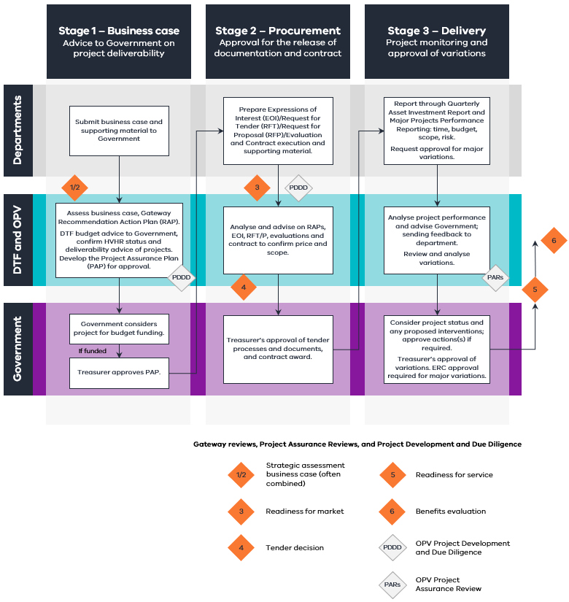
DTF prepares and agrees on a project assurance plan (PAP) for HVHR projects at project approval stage, prior to commencing procurement activities. The PAP determines which HVHR assurance processes will be applied to a given project. Projects may also be subject to technical assurance reviews. Further information on the HVHR framework can be found at: https://www.dtf.vic.gov.au/infrastructure-investment/high-value-high-risk-framework.
        - Projects not considered HVHR
Projects valued at $10 million or greater are required to undertake QAIR to report to government on project progress and delivery confidence every quarter.
Projects valued less than $10 million are not subject to central agency assurance. Practitioners should apply departmental assurance processes as appropriate.

Part 2: Developing the procurement strategy
Part 2 of this Guideline (Chapters 2 to 4)outlines the approach to developing and documenting a procurement strategy. It includes undertaking analysis for project structuring, bundling and packaging strategies and procurement model selection. It identifies the decision points and recommendations to be made in each step, highlighting the key issues that underpin those decisions.
Part two of this Guideline also provides an overview of the different procurement models, their key features and when they are best used. It lists Victorian Government standard form contracts available for use. The resulting strategy provides the road map for implementing the procurement (Part 3, Chapters 5 to 10).
    - Procurement strategy
Figure 7 – Chapter 2 overview
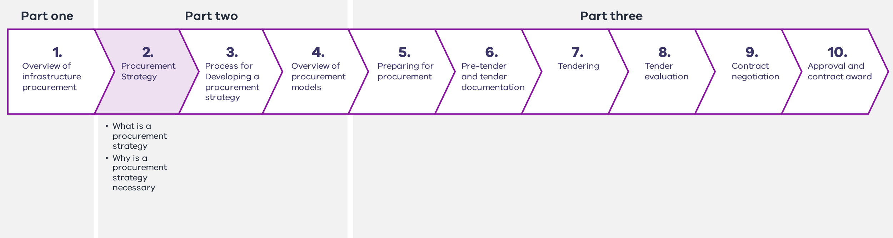
      - What is a procurement strategy?
A procurement strategy establishes the procurement outcomes for a given project and sets out a high-level plan for optimising and achieving them. It documents (to the scale and complexity suitable for the project) the intended project structure, bundling and packaging approach and consideration of the appropriate procurement model(s). It identifies the project characteristics and risks that are likely to have the greatest influence on successful procurement and delivery.
The procurement strategy presents an assessment of the ability to achieve the procurement outcomes under different procurement models, having regard to the desired project structure and packaging approach as well as key risks and considerations. It makes a recommendation on the overall procurement approach that will maximise the service outcomes of an investment while delivering value-for-money.
The procurement strategy is a key component of the development of a business case, as the decision to fund a project includes a decision on the procurement methodology supported by robust analysis of all suitable procurement options. The business case must demonstrate that the investment would be procured using the most appropriate method and provide an overview of the recommended procurement strategy.
      - Why is a robust procurement strategy necessary?
A robust procurement strategy ensures that project approval and funding decisions are underpinned by a justifiable, evidence-based rationale for the recommended procurement approach. It provides decision-makers with confidence that the risks and issues likely to impact project procurement and delivery have been identified and analysed and will be appropriately managed. This improves the likelihood that a project can be delivered on time, within budget and to scope.
Depending on the selected procurement approach, project parties will have different accountabilities and responsibilities. There will be different implications for how project risks are allocated and treated, how cashflows are managed and for governance arrangements and stakeholder interactions. Selecting a suboptimal approach can have serious consequences for the success of project delivery and the realisation of the project’s benefits, undermining the case for the investment.
The procurement strategy supports the justification that an investment can be procured in accordance with government legislation and policies.
The Government’s decision to invest includes approval of the overall procurement strategy at the business case stage. The recommended procurement strategy will be retested and reconfirmed in the detailed development and procurement stages, as more detailed information on scope, risks and market feedback are obtained.
    - Process for developing a procurement strategy
Figure 8 – Chapter 3 overview
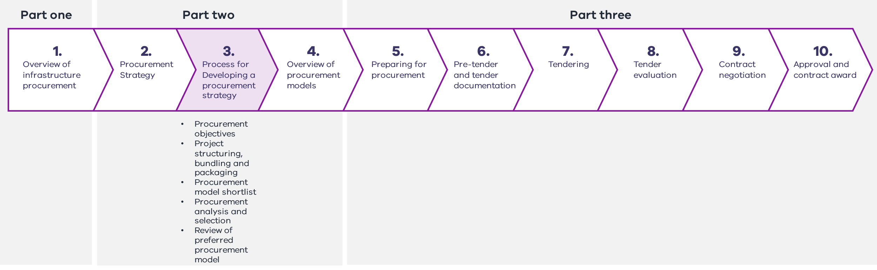
Developing and documenting a procurement strategy comprises five steps:
    - Step 1: Identify the key project characteristics, risks and other issues likely to influence the success of the project and establish procurement objectives.
    - Step 2: Confirm project structuring (including the applicability of programmatic approaches), bundling, packaging strategies.
    - Step 3: Test the procurement model fit and shortlist.
    - Step 4: Undertake detailed procurement model analysis to identify which procurement option is likely to optimise project or program strategic objectives, address risks and deliver public value.
    - Step 5: Detail the preferred procurement model(s), addressing how any remaining risks and issues will be managed in the delivery phase and confirming what controls (if any) are needed to realise the given procurement model.
These steps are set out in Figure 9 and are detailed in this chapter.
Project structuring, bundling and packaging decisions should be made upfront with procurement model shortlisting, analysis and selection (Steps 3–5) undertaken for each identified bundle or package. However, the process is iterative, and project structuring, bundling and packaging decisions may need to be revisited if they are found to be suboptimal after subsequent stages.
Figure 9 – Process for developing a robust procurement strategy
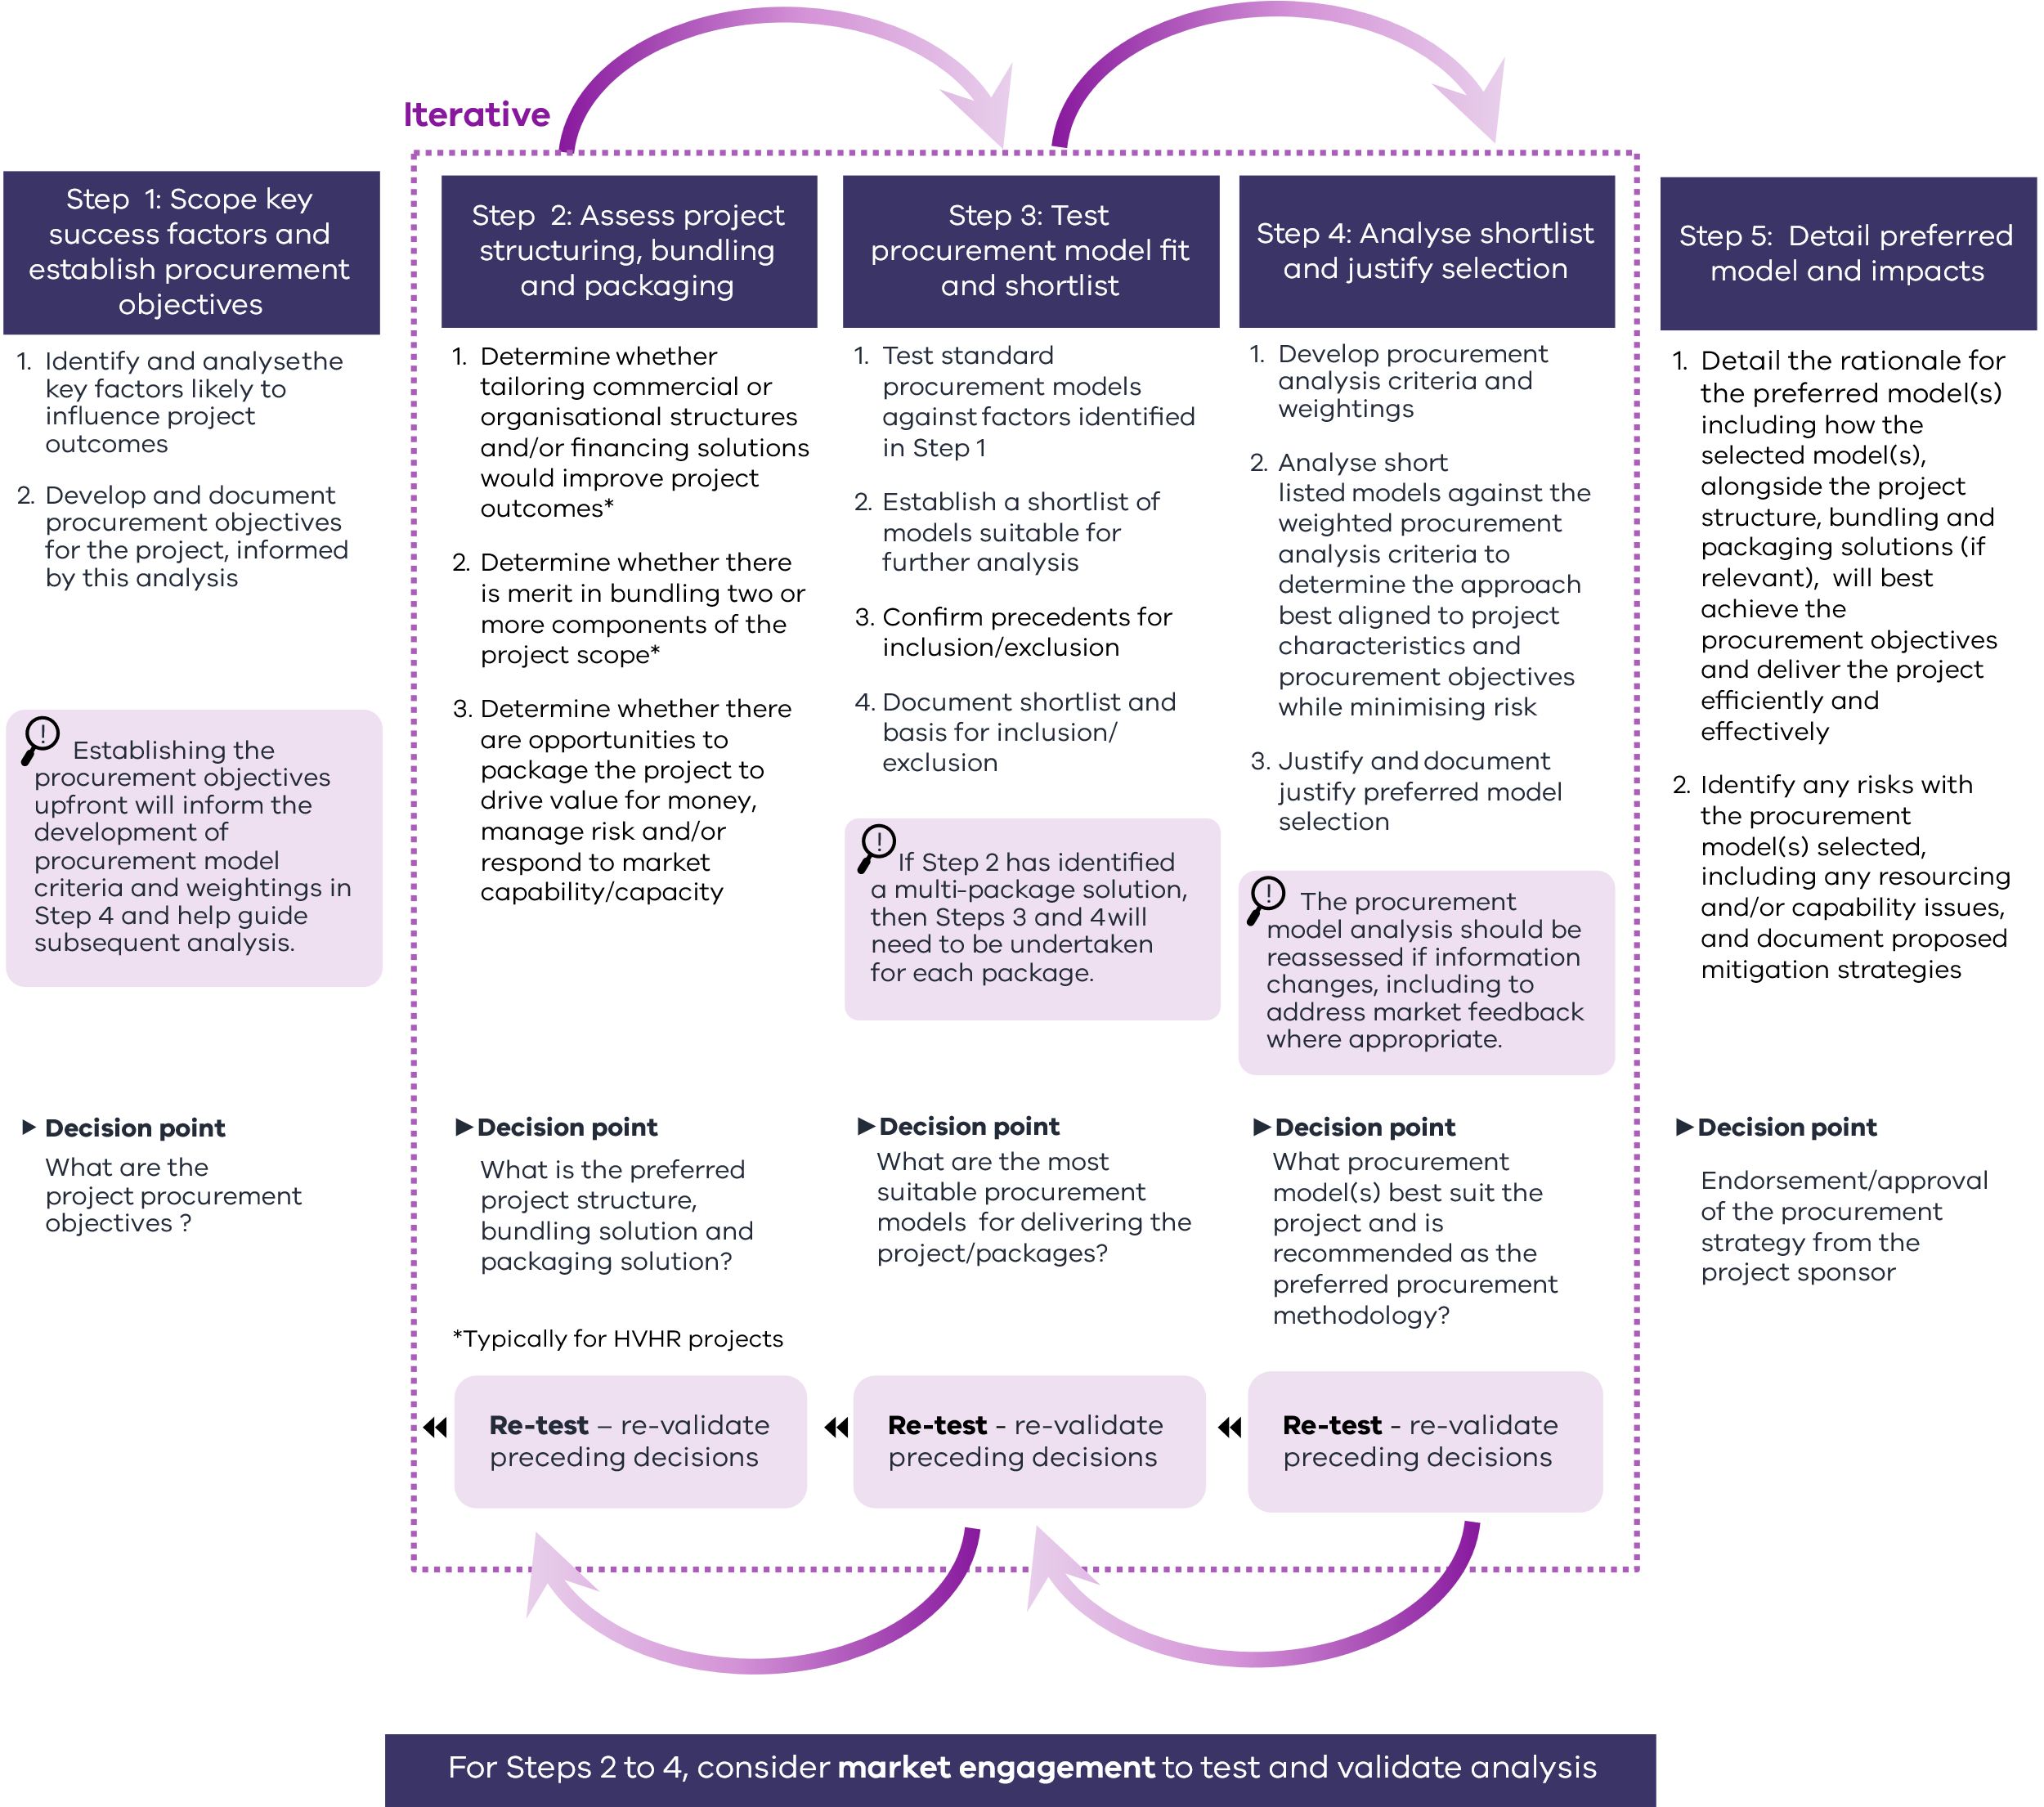

      - Step 1: Scope key project success factors and establish procurement objectives
The first step in developing a procurement strategy is to identify the key issues that may impact the successful delivery of the project outcomes and establish clear procurement objectives. This step will inform decisions on project structuring, packaging and bundling, as well as the selection of criteria and associated weightings for procurement model options analysis (Step 4). By thoroughly understanding the project’s requirements and delivery context and developing appropriate procurement objectives, practitioners can ensure that the procurement strategy is aligned with the project goals and the project is set up for success.
        - Key factors in project delivery performance
To effectively initiate procurement strategy development, it is crucial to assess the key elements of successful project delivery and evaluate the current state of development as documented in the business case and related materials. This assessment supports an outcomes-focused procurement approach that maximises public value. Figure 10 outlines the key success factors and considerations for project delivery performance which may already be addressed in the business case and related documentation. Each element is integral to the development of a robust procurement strategy.

Figure 10 – Key factors in project delivery performance
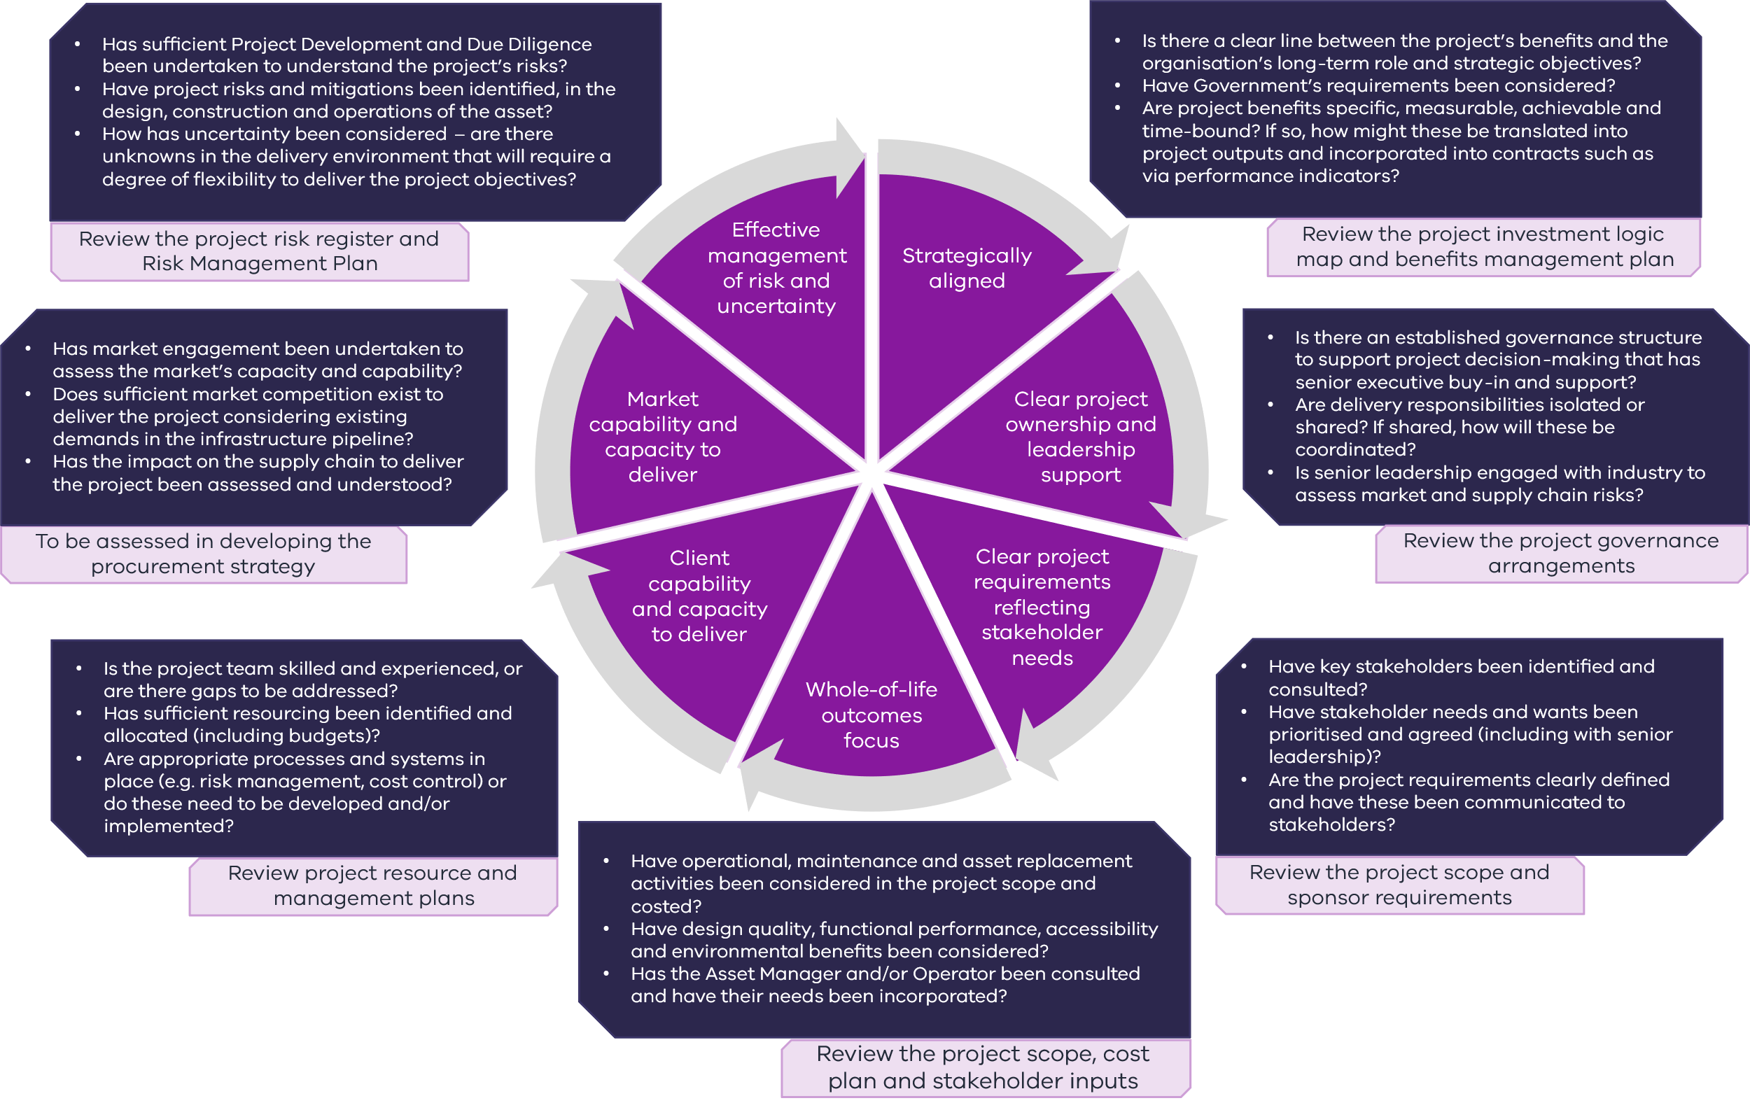

        - Identify key issues influencing project performance and success
Decision point: What aspects of a project (including objectives, characteristics, risks and controls), project delivery and the operational environment will have the greatest influence on project success?
To develop a successful procurement strategy, it is crucial to thoroughly understand the project at the outset. This involves identifying the key issues, risks and opportunities facing a project and how these can impact on the successful delivery of its objectives.
This understanding is typically achieved in a workshop setting with the project team and relevant subject matter experts. Further development of the strategy relies on this information. Therefore, it is essential to invest sufficient effort upfront in understanding and scoping the project to the greatest degree possible.
Many of these issues will already be documented in the business case. These issues should be distilled rather than reconsidered in full. However, issues not documented or considered in the business case will require substantiation in the procurement strategy.
Common factors impacting project delivery success are listed in Table 5, prompting questions to assist in identifying key issues, risks and opportunities listed in Appendix B. The extent to which these issues need to be explored will depend on the scope and scale of the project. HVHR projects will require in-depth assessment across all areas.
The procurement strategy should briefly explain the implications of these issues for procurement and how or why they are likely to inform the procurement strategy.
Table 5 – Issues influencing project delivery performance and success
Project objectives
Assess the project to outline the client’s objectives for social, economic, environmental, cultural, security, safety or operational outcomes, as well as any desired legacy benefits.
Project characteristics
Assess the project’s scope, scale, location and value, site characteristics, construction complexity, commercial opportunities and key challenges.
Operational requirements
Assess the performance level of core and non-core services, including what aspects the Government should retain to ensure core service delivery.
Delivery constraints/opportunities
Assess project delivery issues including site status, planning and approval requirements and related network impacts.
Time constraints
Assess the degree of flexibility in delivery timelines, drivers for target dates and consequences of not achieving them.
Budget constraints
Assess the need for strict budget and price certainty and maturity of the cost estimate.
Design requirements
Assess the project’s design maturity and needs, including design features, quality standards and the need to maintain control over the design and the need for innovation or change during the design and construction phases.
Project risks and opportunities
Assess all major opportunities and risks outlined in the project’s risk register, such as those relating to site issues, permits, design, materials and constructability, market conditions and capacity, public interest and stakeholder issues and any project externalities that would change the project’s risk profile if they were to materialise. Risk allocation and management has significant bearing on procurement and project delivery and is considered further in Step 4.
Client capacity and capability
Assess client capability and capacity against the needs and complexity of project delivery requirements to determine whether current project delivery skills and resources are aligned to the project’s needs, the delivery environment and the client’s long-term role in the project outcomes.
Market capacity and capability
Assess the capability and capacity of contractors and subcontractors to deliver the project including any weaknesses or risks in the market. This assessment is often critical to assessing packaging options.
        - Establish procurement objectives
Decision point: What are the procurement objectives of this investment?
With a clear understanding of the project characteristics, and its delivery and operational environment, practitioners should agree on a clear set of procurement objectives to guide development of the procurement strategy. It is important to note that procurement objectives differ from project objectives. The project objectives are established early in the business case and outline the project’s intended outcomes, for example, social and economic benefits.
If the project objectives are about what the project delivers, the procurement objectives are about how those outcomes are achieved.
These guidelines provide a set of procurement objectives that generally apply to all public infrastructure investments in Victoria. Practitioners should adapt these common objectives to reflect the unique characteristics and delivery contexts of their projects.
Procurement decisions should have a central focus on whole-of-life quality and cost outcomes and effective management of risk and uncertainty over the project lifecycle, as these combinations drive public value.
Procurement decisions often involve trade-offs. Agencies should avoid objectives that focus on project delivery rather than investment choices that optimise whole-of-life benefits.
Whole-of-life benefits should be prioritised over delivery phase efficiencies. An example is incorporating project commencement milestones.
Agencies should also avoid pursuing policy objectives that are addressed through other policy levers or covered in whole of government procurement policies (such as the Victorian Social Procurement Framework).
Developing procurement objectives is often undertaken in a workshop setting with the project team and relevant subject matter experts. DTF is available to assist project teams in developing procurement objectives, especially if objectives vary from those outlined in Table 6. Project teams can consider variations from the common objectives set out in Table 6. However, sufficient justification must be provided to explain how they deliver public value. Project teams should take care not to confuse procurement objectives (which provide overarching guidance, aiding in project structuring, bundling and packaging consideration) with procurement model selection criteria, which are used to differentiate the suitability of shortlisted procurement models at a later stage in the development of the procurement strategy.
Table 6 – Common procurement objectives and how they apply in developing the procurement strategy
 |  | Key value driver
Objective | Description | Structuring | Bundling | Packaging | Model selection
Whole-of-life cost effectiveness | Enhance whole-of-life cost outcomes by achieving cost effectiveness during construction and operations
Quality outcomes | Enhance whole-of-life benefits of the asset such as its functionality, environmental benefits and the performance of the asset for its end users/operators/asset managers
Market participation and competition | Promote market participation, capability, competition, innovation and continuous improvement to drive value-for-money given current market and supply chain dynamics
Timely delivery | Deliver project within required timeframes
Effective management of risk and uncertainty | Achieve efficient risk pricing by retaining, sharing or allocating risks and incorporating flexibility where required to manage uncertainty, to deliver the project outcomes given the project’s delivery and operational context
      - Step 2: Project structuring, bundling and packaging
Building on the foundation established in Step 1, practitioners should utilise the procurement objectives and their comprehensive understanding of the project characteristics to guide consideration of the most suitable project structure, bundling and packaging approach. The requirements of this step will vary depending on the project’s scale and complexity. For HVHR or megaprojects1F, practitioners should consider project structuring and bundling opportunities to deliver the project efficiently and add value. Project packaging analysis should be undertaken regardless of the project size. It is important to complete this step before moving on to procurement model shortlisting and analysis for each project bundle or package (Steps 3–5). The structuring, bunding and packaging approach may need to be reworked as additional market and project detail comes to light through subsequent stages of the procurement analysis.
Practitioners should consider the benefits of market engagement to inform project development and due diligence (PDDD) when it comes to structuring, bundling and packaging determinations.
        - Project structuring
Some projects (such as HVHR or megaprojects) may warrant consideration of the supporting commercial structures, financing solutions and organisational delivery structures to address project delivery issues or optimise government investment.
Decision point: Is there a need to consider commercial and organisational structuring or alternative funding streams for the project? If so, what is the optimal project structure?
Structuring requirements will generally be present where either (or both) of the following factors are in play:
    - there is a need to manage a large and complex project or program of work, and this may require adapting organisational design or client capability and capacity to deliver the works
    - there are material commercial or financial opportunities associated with a project that may open alternative delivery arrangements that can support other government priorities.
Project structuring checklist
Consider the following questions. If you respond with ‘yes’ or ‘maybe’ to any of these questions, engage with DTF early to assess potential structuring options.
- Is there a need to significantly augment organisational capability and capacity to manage complex system and broader network integration, supply chain management and project interfaces during delivery, for example, by establishing a dedicated departmental delivery function or a separate delivery agency?
- Is there a need to manage competition requirements or supply chain constraints, particularly at a portfolio or programmatic level?
- Is there a significant pipeline of similar works expected over an extended period (for example, 5–10 years) that may merit a programmatic approach?
- Are there opportunities to optimise the project’s scope or commercial character to appeal to potential project partners such as community groups, financiers or equity investors (for example, enabling creation of separable commercial revenue streams)?
- Is there a need for government involvement in, or an opportunity to deliver improved outcomes through, otherwise private sector-led projects (for example, joint venture arrangements with private partners)?
- Is there is a need to deliver the project as part of a broader commercial enterprise or opportunity (for example, public non-financial corporations delivering or owning and maintaining built assets, not including routine arrangements)?
- Are there opportunities to mitigate the Government’s funding requirements or balance sheet exposure to the project through, for example, new revenue generation, cost offsets or third-party financing?

When evaluating project structure options, it is important to consider the broader operating context and whether alternative structuring could better manage risk, enhance project outcomes or provide more opportunities to drive value-for-money.
          - Addressing complexity and governance
This assessment should consider the size and complexity of the project and the client’s current capacity and capability to deliver. Considerations can include:
    - the optimal organisational structure (including form, capacity and capability) for delivering the project
    - the roles of sponsoring agencies, existing delivery agencies and other key stakeholders
    - the need for establishing specific project entities and optimal project governance arrangements
    - the need for maintaining design control.
An integrated delivery partner can augment client capability and capacity
Consider an integrated delivery partner (IDP) for complex projects that require significant system integration, supply chain management, program-wide delivery integration, owner capabilities and development, increased front-end project development and external due diligence activities. IDP arrangements vary from consultancy engagements to highly integrated project teams where internal project management is supplemented or fully supplied by the delivery partner for the project’s duration. An IDP service offering can range from business case and procurement support through to implementation (including construction management services).
An IDP can identify effective packaging and support delivery of a broader range of procurement models and packaging options that may not be feasible relying on internal capability. This option may be particularly relevant for agencies where project delivery is not a core function. An IDP can also provide existing systems, expertise and resources to support project delivery. It can allow for phasing of design and construction as well as disaggregating supply and delivery contracts, such as long lead items and owner-supplied materials.
An IDP model could be suitable for:
- large-scale projects or programs of work with challenging interfaces, or network and program constraints
- high complexity or specialised project scope, for example, requiring tailored supply chain management strategies.
IDP fees may include:
- a fixed fee for management functions
- the reimbursement of actual costs on an open-book basis
- performance incentives in the form of gainshare/painshare regimes and for on-time completion.
          - Programs and time-based contracting
Structuring may also be driven by the need to manage a pipeline of similar projects to be delivered over an extended period (for example, 5–10 years or more). Therefore, it is important to establish how the project aligns with other related projects, initiatives, programs or proposals, having regard to:
    - the need to integrate into a broader program of work
    - the extent to which procurement decisions will impact related projects (including timing)
    - opportunities to leverage supplier expertise or competencies
    - the ability to phase design and construction and identify opportunities to overlap and fast-track schedules, avoid abortive works or leverage other programs of work.
Projects suitable for aggregating into a program approach are typically relatively similar, stand-alone work packages with known scopes of programmed works to be carried out over an extended period (5–10 years or more). When implemented effectively, a major advantage of programs is achieving sustained levels of efficiency in a pipeline of work over the medium to long term.
A common feature of a program approach is that it is ‘time bound’, meaning that contractors are engaged for an initial period, or for a works package, or both, with an opportunity for further work subject to performance and a robust approvals process. This helps drive strategic, long-term partnerships with industry, encouraging greater investment in capability and capacity (including skills, plant, technology and materials).
The benefits of program and other time-based contracting approaches include:
    - supporting contractors to proactively plan and mobilise resources, avoiding ‘stop-start’ procurement and delivery
    - securing volume discounts and reductions based on greater certainty of workload
    - leveraging existing relationships with key stakeholders, including local councils, operators and utilities providers
    - incentivising contractors to invest in continuous improvement and innovation from project to project
    - facilitating cross-program information sharing and opportunities for whole-of-sector efficiencies such as design standardisation and the adoption of new technologies, materials and processes
    - incentivising contractor performance by rewarding performance with additional works in the pipeline or setting efficiency requirements to be achieved over time
    - expanding the market or supply chain, with a particular focus on cost, risk allocation and overall affordability of infrastructure development, by providing certainty in a pipeline of work.
Effective programs can also streamline the tendering process and reduce tender costs by establishing a framework upfront with a relatively small number of participants (less than 10 grouped by experience and capability) through a competitive process. Individual project procurements can be fast-tracked as standard prequalification and expression of interest (EOI) processes are replaced with pre-agreed contractual and commercial frameworks for the procurement of future works.
Projects and programs procured in this way must still build in ‘competitive tension’ including by benchmarking and other mechanisms that seek to validate quality and performance, to ensure work allocations demonstrate VfM. This is particularly critical when work is directly allocated, rather than awarded through smaller competitions of select panel suppliers. These programs also require effective planning, management and governance to deliver efficiencies in design and construction.
The selection of a procurement model under a program or other time-based contracting approach will depend on the nature of the individual projects to be delivered as well as the outcomes and benefits that the program is aiming to deliver. The procurement strategy must demonstrate the preferred procurement model(s) are best suited on an individual project basis and collectively as part of the program.
Program alliances
A program alliance is a procurement model that combines multiple similar projects to be undertaken under an alliance contracting model. The specific number, scope, duration and budget of these projects may be unknown, and potentially the same participants will be responsible for delivering all the projects. These are often established to deliver a long-term pipeline of capital works, typically lasting 5–10 years.
Once formed, program alliances can also serve effectively as prequalified panels of potential alliancing parties. This assists agencies to efficiently select prequalified parties for an alliance, for a specific project or a package of related works.
While program alliances provide a range of benefits, there are some risks. Successfully navigating these risks involves:
- managing the allocation of work carefully, given that this can occur via allocation criteria rather than scope and price competition at contract award
- ensuring that there is a sophisticated, active and informed client that can prepare appropriate cost benchmarks to negotiate with the contractor
- making sure that barriers to entry are not too high for new entrants
- ensuring that the ‘no fault, no blame’ approach to alliance risk allocation is appropriate relative to the program’s characteristics.
          - Commercial opportunities
Structuring opportunities often involve commercial opportunities for alternative funding and financing streams. These can include the creation of secondary opportunities, such as revenue generation, third-party funding and cost offsets or partnership opportunities which may inform the optimal project structure.
If these are relevant considerations for your project, DTF should be consulted early in the development process to assist in developing such delivery structure options.
        - Bundling determination
Bundling is most likely to be relevant to larger HVHR projects. It involves consolidating management and responsibility for multiple components of the project scope under one party. This can include development services, construction and commissioning services, maintenance, operations and facilities management services.
Bundling can generate efficiencies, allocate risks optimally, increase opportunities for innovation and improve asset utilisation, which leads to better whole-of-life cost and quality outcomes.
Decision point: Is there a case for bundling two or more components of the project scope to deliver efficiencies and drive optimal public value? If so, what is the approach for the project?
Assessing the merit of bundling is important. Procurement models can be broadly categorised as bundled and unbundled. Bundling opportunities are likely to be present when:
    - the operations or maintenance contracts (or both) are relatively large compared to the design and construction contracts
    - the operation or maintenance services (or both) are not being efficiently delivered at scale elsewhere
    - there is not a strategic need for direct control over the design or operations and maintenance of the project.
In deciding whether to bundle, it is important to consider whether the benefits outweigh the additional costs, for example, costs for complex procurement and contract management.
Key factors to consider when determining if bundling is right for your project
- The extent to which services, including design, construction, operations and maintenance services, can be grouped as part of the project.
- The expected efficiencies and potential for innovation – such as a strong interface between construction and maintenance or operating activities – compared with other service delivery opportunities.
- The constraints, risks and opportunities that may affect bundling.
- The level and nature of services that could be delivered by non-government parties versus delivered solely by government entities, noting that core government services are often excluded from bundling.
- Whether the service need, or a part thereof, can be contracted out over the longer term with a high degree of certainty.
- The merits of bundling capital delivery and ongoing maintenance responsibilities.
- Whether there is likely to be sufficient market capability and interest (approximately four or five parties) to deliver the bundled project while ensuring a competitive process.

DTF can provide support to delivery agencies in assessing the merits of bundling and developing an appropriate bundling strategy. The potential incorporation of private finance into the bundling models is covered in more detail in Section 4.4 Whole-of-life.
        - Packaging determination
Packaging works or a program of works should be considered for all projects (not just HVHR projects).
Packaging refers to how a procurement activity, typically of works, can be tailored to form smaller or larger contract packages. By doing so, it is possible to select procurement models that are better suited to specific project components. It is important to develop a packaging strategy before analysing procurement models so that separate analysis can be conducted for each package.
Decision point: What is the packaging strategy for the project, considering the project characteristics, the capabilities of the client and the market, and the capacity to deliver optimal public value?
To undertake packaging analysis, it is important to first understand:
    - project data and characteristics, including size, scale, complexity, interfaces, specialisation, location, timeframes, staging and sequencing
    - market capacity issues, including the upcoming pipeline of comparable projects in planning and procurement in Victoria and other jurisdictions
    - contractor capacity and capability
    - client capabilities, capacity and ambitions (including people and systems)
    - project integration capabilities and approach
    - the role and influence of key stakeholders
    - whole of government considerations, such as aggregate risk exposure to commonly used contractors.
Utilising this project data, agencies should determine whether packaging would deliver any benefit to the project by reducing risk, seizing opportunities, responding to market capability and capacity or improving market participation and competition.
Key factors to consider when determining if packaging is right for your project
- How many phases or activities in the project.
- What elements can be undertaken independently, simultaneously or in sequence.
- What efficiencies (or risk reductions) in supply, construction, integration and interface management or scheduling can be gained from grouping together certain works.
- What efficiencies (or risk reductions) can be gained from breaking up certain works.
- Key interdependencies between stages or activities.
- Options for early or enabling works.

DTF can assist project teams to undertake this analysis.
Table 7 outlines two general packaging strategies that practitioners should consider and some of the value drivers behind these approaches.
Table 7 – Packaging strategies
Packaging strategy
Into smaller contracts | Disaggregation: Dividing a single project into multiple (smaller) discrete packages, each with a separate contract. The procurement model for each package may differ depending on the characteristics of the package. Packaging into smaller contracts can facilitate:  - increased market capacity and competition by providing the opportunity for work to be spread across a broader range of contractors  - ‘ring fencing’ issues that arise within a single package, avoiding individual package risks having a project or program-wide impact  - risk distribution and diversification (including across contractors)  - development of contractor capacity  - bringing forward and separating early works from the main work package(s), such as a preparatory or demolition package  - delaying specific works, such as holding off on public realm landscaping packaging until other packages are completed.  Disaggregation often occurs to align the package size with the contractor or client’s capacity to deliver.
Into larger contracts | Aggregation: Grouping together procurement requirements of a similar category, with the purpose of acquiring them under a single contract. Packaging smaller works into a larger contract can facilitate:  - cost and schedule efficiencies associated with scale or geography, or both  - procurement efficiencies associated with managing fewer contracts  - access to skills, expertise and approaches that can only be provided by large multinational firms  - a reduction in the number of complex interfaces across many contracts, which can lead to better management of the liabilities that result from the various interfaces in construction and commissioning.  Aggregation is often used to bring together works of the same nature or technical requirements and disciplines or in the same geographic location.
        - Market engagement
Market engagement is important for all projects (not just HVHR projects). Market engagement can improve the likelihood of project success through a process of increasingly detailed stakeholder engagement. Through market engagement, the Government gains an understanding of the market’s appetite, capability, capacity and trends, and the potential impact of its intended procurement approach. Simultaneously, industry can prepare to respond to government requirements as they are outlined.
Market engagement prior to funding approval and development of the procurement plan (see sections 5.2 and 5.5) is typically limited without specific government approval. However, early market engagement can provide benefits, particularly for high-value and/or complex projects. Appropriate activities during procurement strategy development depend on the project’s scale and complexity, confidentiality requirements and the maturity of information available. These activities include identifying project precedents, analysing similar projects and conducting market soundings to gather feedback on preliminary project structuring, bundling and packaging approaches as well as procurement model options, key risks and timelines.
Agencies considering direct market engagement during business case development should contact DTF for advice on how to manage the process and obtain necessary government approvals before engaging the market.
More information on common approaches to market engagement is available in Section 5.2.
      - Step 3: Test procurement model fit and shortlist
The goal of shortlisting is to identify those procurement models best aligned with the project characteristics and to eliminate those least likely to effectively manage risk and deliver value (quality and cost outcomes). If a multipackage strategy has been selected (in Step 2), then shortlisting and detailed procurement analysis must be done for each package.
A particular model’s strategic fit must be informed by a comprehensive analysis of the project’s key characteristics and the delivery issues identified in Steps 1 and 2. This approach is necessary to avoid potential bias in evaluating procurement model fit. If project details are not fully known, shortlisting should be based on the best available information, and practitioners should identify the information needed to make a definitive decision.
Decision point: Which procurement models are the most suitable for delivering the project in the most effective and efficient way (given the project characteristics and delivery environment) and therefore should be shortlisted for further analysis?
Chapter 4 of these guidelines provides detailed descriptions of each procurement model set. Table 8 also provides a high-level overview of indicative procurement model fit against certain project characteristics.
Shortlisting should be supported and validated where possible by assessing successful precedents and conducting market engagement.
Successful precedents may include projects with similar objectives, characteristics and risk profiles (including projects delivered in other Australian jurisdictions). Any lessons learnt in these successful precedents should be documented and included in the evaluation. Precedent delivery on its own is not enough to justify using a particular procurement model without further analysis, but it may justify its inclusion in the shortlist.
Market engagement can aid in understanding current market risk appetite, capability and capacity. The outputs from this engagement should be documented and used to update the shortlist as required (Step 3) or to inform the detailed procurement model analysis (Step 4).
Both shortlisting (Step 3) and detailed procurement options analysis (POA) (Step 4) should be undertaken collaboratively with a broad range of project team members and key stakeholders. Typically, this would be done in a workshop setting.
The outcomes of the shortlist development should be documented. The documentation will include responses and considerations to the shortlisting categories and the key reasons for including or excluding a given procurement model. A shortlist of between three and five models should be taken forward for detailed analysis (Step 4).
Table 8 – Indicative procurement model alignment to the project characteristics
Categories | Lump sum |  |  | Cost reimbursable |  |  | Whole-of-life
Project characteristics | Construct only | Design and construct (D&C) | Enhanced D&C | Managing contractor | Incentivised target cost | Alliance | Bundled | Partnerships Victoria (PV)
Scope and outputs
Design or outputs can be clearly defined before tendering | ü | ü | ü | ü | ü | ü | ü | ü
The scope or solution is likely to change significantly before project completion due to uncertainty in the environment or ongoing input and collaboration from key stakeholders | – | – | ü | ü | ü | ü | – | –
The client needs (and has the capability and capacity) to actively take part in design and/or delivery | ü | – | – | ü | ü | ü | – | –
Whole-of-life opportunities
There are significant maintenance, operations or service activities that are suited to long-term private sector delivery | – | – | – | – | – | – | ü | ü
Risks
There are significant areas of undefinable or uncertain residual risks that cannot be resolved before tendering | – | – | ü | ü | ü | ü | – | –
Risks can be effectively priced before tendering and are able to be allocated to the contractor as the party best able to manage those risks | ü | ü | ü | ü | ü | ü | ü | ü
üGood fit with this  procurement model | üPossible fit with this procurement model |  | ü Conditional fit with this procurement model |  |  | – Blank – not applicable  for this model
      - Step 4: Analyse shortlist and justify procurement model selection
The completion of Step 4 should result in a transparent account of the reasoning applied to select the preferred procurement model(s) from the options shortlisted in Step 3. The POA method is the recommended approach. This method involves establishing selection criteria and weightings to assess the suitability of shortlisted models for the project. A guide to how this method can be used in practice, including how the criteria and weightings are established, is provided in this section.
Decision point: What procurement model best suits the project and is therefore recommended as the preferred procurement methodology?
Successful application of POA is dependent on:
    - objective and rigorous analysis of the project characteristics, risks, market dynamics, delivery environment and other success factors and sound project structuring, bundling and packaging determinations as outlined in Step 1 and Step 2
    - knowledge of the characteristics, benefits and trade-offs that come with different procurement models, including agency capacity (refer to Chapter 4).
The detailed procurement analysis process must identify how well each shortlisted procurement model can optimise quality and cost outcomes
This will be evident in how the model:
- facilitates achievement or enhancement of the project outcomes, ensuring quality and cost outcomes are optimised
- best suits the characteristics of the project, considering factors like complexity, scope and stakeholders
- delivers the intended benefits while presenting value-for-money, and balancing this cost efficiency with quality to deliver optimal outcomes.
The detailed procurement analysis process must identify how successfully each shortlisted procurement model can effectively manage risk and uncertainty
This will be evident in how the model:
- strategically treats risks in line with the risk treatment strategy, project objectives and organisational goals
- allocates risks to the party best equipped to manage them, maximising the ability to mitigate and control potential issues
- aligns key project risks with suitable procurement models to optimise risk management opportunities, leveraging their inherent characteristics
- achieves the risk management objectives for both the organisation and the project, ensuring that risks are adequately identified, assessed, monitored and controlled.
        - Establish the procurement model selection criteria and weightings
The project team should work with key stakeholders to set selection criteria that align with the project’s priority outcomes and procurement objectives determined in Step 1 and Step 2. A percentage weighting should be assigned to each criterion based on its relative importance to achieving the objectives. Justification for the selected criteria and weighting should be documented. If the project team is considering procurement model selection criteria that vary from those listed in Table 9, they should consult with DTF early in the development process.
Table 9 describes standard procurement model selection criteria derived from the common procurement objectives outlined in Step 1 . There is no minimum or maximum number of criteria to consider in detail. However, a selection of five or six should provide coverage of the key outcomes relevant to the project. Ultimately, the selection of the most suitable contractual model depends on a comprehensive assessment of project objectives, complexities, risks, the delivery and operating environment, financing needs and the involvement of relevant stakeholders.
Table 9 – Standard procurement model selection criteria (SC)
Optimise quality and cost outcomes
SC1. Whole-of-life cost effectiveness and accountability
How important is it that there is a strong incentive to minimise whole-of-life cost outcomes and is there a single point of accountability to achieve this? | Considering whole-of-life cost effectiveness and accountability is important in procurement models that include an operations and maintenance component.  This should consider the project’s size, complexity, risk profile, level of service specification, its delivery and operating environment, market structure and depth.  * NOTE: All project development should consider whole-of-life cost effectiveness. This criterion is relevant where it has been determined that bundling (construction with maintenance, operations or facilities management) may be beneficial to project outcomes.
SC2. Contractor innovation
How important is it that the contractor is incentivised to deliver new approaches in design and construction to support improved outcomes? | This may include new solutions to address constructability, value engineering, improved functionality of the asset to end users/direct operators, and/or designing for maintenance, replacement and refurbishment. Often these solutions will require a single point to assume responsibility for design and construction (and operations and maintenance where relevant) to encourage innovation.  This should consider the willingness of the market to accept design risk and the relationship between the design, construction, operations and maintenance phases of the project to deliver improved outcomes.  * NOTE: Client input into project design and development and collaboration with the contractor should be considered in SC3 if client control over design is required. Consider SC9 if collaboration with the contractor is necessary to resolve unavoidable uncertainty in the project scope or design stage supply chain integration is necessary to resolve complex technical issues.
SC3. Client control
How important is it that the client control the design brief and what level of control is needed to ensure compliance or address stakeholder requirements? | Clients may require greater control over the project’s design, including through collaboration with the contractor, to ensure compliance.  This criterion assesses the need and level of control required. This may be driven by specific stakeholder requirements such as third-party approvals and/or the level of specialisation or uniqueness. It should also consider the clients ability to retain design risk and its ability to clearly define its requirements to the market.  NOTE: Adjusting design or project requirements during a procurement process is not recommended as this typically results in higher project costs and should be limited to situations where it is unavoidable.
SC4. Delivery speed
How important is the speed of project delivery to project success? | This criterion assesses the degree of urgency to complete the works and the effect this has on commencing procurement and construction.  This criterion should only be included if there is a non-negotiable operational commencement date or event (such as school building works required by the start of the school year) or if there is a significant and quantifiable benefit to earlier completion.

Effectively manage risk and uncertainty
SC5. Risk allocation
How important is it that the client transfers or retains specific risks across the project’s lifecycle? | This criterion refers to the client’s preferences for risk allocation, including whether to allocate risks to the party best able to manage them or if there are alternative risk preferences.  This should consider whether risks have been adequately defined and are well understood. It should consider the project’s risk profile across design, construction, operations and maintenance (including any risks that would exceed client tolerance levels if retained) and the client’s ability to retain, share and manage risks. This should take account of the proposed building and packaging strategies (such as early works) as risk treatment strategies.
SC6. Market appetite and competition
Will the procurement model and risk allocation attract sufficient market interest, competition and optimise market capability and capacity? | This criterion refers to the market’s preferences for risk allocation and the suitability of the model to attract sufficient market participation and competition to promote competitive pricing.  This should consider current market and supply chain dynamics, the project’s risk profile and allocation and the capacity of the contractor market and supply chain to deliver the project under the various models. It should also consider any project risks that may exceed the market’s tolerance level or would result in unacceptable tender price premiums if allocated.
SC7. Price certainty
How important is it that the client can confidently predict its financial contribution to the project at contract award? | This criterion refers to the importance of having an assurance or guarantee of a fixed or predictable price at the point of contracting.  Price certainty can reduce the risk of cost overruns or budget variations and help improve project management and stakeholder confidence by having a strong incentive for the contractor to deliver within the agreed budget. This assessment should consider the project’s scope, complexity, design maturity, risk profile and allocation, market conditions and the risk of costly variations if project requirements changed.  To increase the likelihood of achieving price certainty, sufficient PDDD needs to have occurred as well as a robust evaluation process that filters for underbidding.
SC8. Time certainty
How important is it that the client can confidently predict that the project will be completed by the agreed target date? | This criterion refers to the importance of having an assurance or guarantee of a fixed or predictable timeline at the point of contracting.  Time certainty aims to provide clarity and minimise uncertainties associated with the project schedule by having a strong incentive for the contactor to deliver within the agreed timeline. This assessment should consider the drivers of target dates and the consequences for not achieving them.
SC9. Scope certainty
How important is that the scope is defined before tendering and to what extent is the scope undefinable before going to market? | This criterion refers to the level of uncertainty in the project scope that cannot be adequately defined before going to the market. A high level of scope uncertainty can increase project risks, potentially leading to costly variations and time overruns, if not effectively managed through the procurement method.  This assessment should consider the project characteristics in the light of possibly requiring design stage integration with the supply chain to resolve complex technical issues or encourage innovation. It also considers the project’s delivery and operating environment, stakeholder requirements, the level and nature of project risks and the ability to mitigate risks before tendering. It assesses the client’s ability to define its requirements and progress design maturity before tendering. This is distinct from underdeveloped business cases or a desire to truncate pre-tender timelines.
SC10. Flexibility to change
How important is it that the client can effectively change or control the management of the procurement method to respond to uncertainty? | This criterion refers to the need for flexibility in delivery and operations to change or manage the procurement method to respond to uncertainties and unavoidable changes in the project requirements.  This should consider the stability of the delivery and operating environment, including risks that the project requirements may change during delivery or operations due to technological changes or other uncontrollable/unknown factors or opportunities. This may also include taking account of any specialised elements that require stakeholder approval, which cannot be resolved or mitigated early or the need for the collaborative management of complex interfaces. It should also consider the client’s ability manage change and control, which requires more sophisticated client capability and resourcing to implement.  * NOTE: adjusting design or project requirements during a delivery or operation is not recommended as this typically results in higher project costs and should be limited to situations where it is unavoidable.
        - Evaluating procurement models
Evaluation of the shortlisted delivery model against the selection criteria is best undertaken by the project team with relevant subject matter experts in a workshop setting. To gain a variety of independent views, individuals should score first, followed by group discussion to agree and document reasoning for consensus scores, including how the features of the shortlisted procurement models match the project characteristics for each criterion.
Each procurement model should be scored on its ability to fulfil the selection criteria. Regardless of the mode of assessment, it is important to document the reasoning behind key decisions and considerations, including scoring and criteria discussions, identified risks and issues, potential trade-offs and the logic behind the selection of the preferred model.
        - Considering risk in procurement analysis and model selection
An important part of procurement strategy development and procurement model selection is considering how procurement models impact on other project delivery strategies, create opportunities to manage risk or exacerbate risk.
Matching the procurement model and project characteristics to ensure an equitable distribution of risk is crucial for the efficient and timely delivery of projects. Allocating risk to contractors can drive efficiency and innovation, but it must be done carefully to avoid increased bid premiums, disputes and a reduction in quality. A key principle is to allocate risk to the party that can best manage it. However, this approach must consider each party’s ability to control, foresee and bear the risk, based on an understanding of the project and the market’s insights.
When selecting a procurement model, consider the following:
    - Choose the model that optimises the procurement objectives, not the one that simply minimises risk to the client, noting residual risks must be managed.
    - Consider the risk treatment, ownership and allocation under each model. Evaluate whether the private sector can reasonably take responsibility for specific risks. Risk allocation varies under different procurement models but also depends on the contract details.
    - Stress-test the procurement model by assessing its sensitivity to the consequences of identified risks materialising. This may identify if an alternative model would result in more effective risk management. For example, an enhanced design and construct (D&C) approach (Figure 14 – Enhanced design and construct structure) may be more effective than a regular D&C approach when high-consequence risks are identified but cannot be efficiently priced and allocated at contract award (for example, the risk of unforeseen soil and groundwater contamination).
    - If unusually high risks are identified, or if likely consequences exceed the client’s risk tolerance and risk mitigation options are limited or unlikely to be cost-effective, consider an alternative procurement model.
If new risks are discovered during procurement analysis, they should be incorporated into the project's overall risk management plan. This process may reveal opportunities for modifying a specific procurement model to manage risk more effectively. Consultation with DTF should be undertaken to confirm the acceptability of potential modifications and how they will interface with DTF standard contracts.
For additional information on risk management in procurement see Section 5.3 Risk management.
Alternative techniques to traditional POA for procurement analysis have emerged in recent years. These techniques support practitioners with a toolkit to identify optimal delivery arrangements for projects based on their unique characteristics and strategic priorities. Where there is a strong case (for example, in complex or unique projects, or those with limited delivery track records) practitioners should consider these techniques to inform the development of their procurement strategy or validate the output of POA approaches.
Queensland University of Technology procurement strategy tool
Researchers at the Queensland University of Technology (QUT) have developed a comprehensive tool to develop project procurement strategies that takes account of client priorities, project characteristics and the level and nature of microeconomic risk associated with a given project.
The tool involves five steps to examine the project components and identify how the project should be procured to manage specific risks and deliver VfM outcomes while meeting the clients’ strategic priorities.
The tool has been tested on Australian projects in collaboration with Infrastructure Australia and internationally in collaboration with the Organisation for Economic Co-operation and Development. It shows promise in its ability to provide a robust and structured approach to developing project procurement strategies.
The following resources provide an overview of the tool and examples of how the tool was applied to projects in other jurisdictions.
- Procurement decision tool: draft user guide. [ ver. 1.0 ed.] | QUT ePrints
- Procurement Decision Tool: A Case Study of the Toowoomba Second Range Crossing – AP-R624-20 | Austroads
      - Step 5: Detail the preferred procurement model and feed impacts through the business case
After identifying the preferred procurement model, it is essential to document all its key conditions in the procurement strategy. This decision will define the client’s resourcing requirements, risk management approach, contract type and contract management requirements.
Decision point: Have all the key conditions to successfully implement the procurement strategy (including the preferred procurement model) been identified and documented for endorsement by the project sponsor?
The procurement strategy documentation should include the following:
    - plans for managing residual procurement risks and issues during the delivery and operational phases, including necessary controls. This should support a detailed risk assessment, incorporating the preferred procurement model once it is outlined
    - identification of necessary skills, resources and potential gaps, along with strategies to manage them. Any additional resources or skills needed to implement the procurement model should be factored into the project design and costing, and documented in the business case
    - consideration of how the procurement model decision fits into the overall project structure, bundling and packaging strategies (if applicable).
The business case schedule, project resourcing strategy and costs plan, alongside the project risk register should be cross checked to ensure alignment with the preferred procurement model and procurement strategy.
As important as it is, selecting the best procurement model is just one step in delivering the project. Tendering for the project is also a critical step to ensure that project objectives are achieved. Refer to the DTF Delivery ILG webpage for more information.
        - Minimum documentation requirements
The amount of detail in the procurement strategy should be appropriate to the scale and complexity of the investment. However, it should include at a minimum:
    - a statement of procurement objectives to best achieve the project objectives and outcomes detailed in the problem and benefits definition sections of the business case
    - a review of market capacity, capability and risk appetite to deliver the project within the planned timeframes
    - a review of the department’s (and the agency’s) existing capability and capacity to procure the asset and deliver the service outcomes, including any gaps and mitigations
    - an outline of any commercial and organisational structuring and financing required to effectively deliver the project. This may include the agency and key stakeholders, third-party funding and revenue generating opportunities and market impacts (likely only required for HVHR projects)
    - identification and evaluation of how whole-of-life outcomes will be delivered, including documentation of how opportunities for bundling elements across design, construction, maintenance and operations have been explored
    - determination of the optimal project packaging strategy to respond to project and delivery risks (it is essential that this is undertaken prior to POA)
    - outputs of the procurement model shortlisting process, including the rationale for inclusion in, and exclusion from, the shortlist as well as any precedents used to validate the analysis
    - a detailed evaluation of the benefits, costs and risks associated with the shortlisted procurement models, considering the procurement objectives, project characteristics and the delivery and service environment, against an agreed set of selection criteria
    - justification for the recommended procurement model(s), documenting any outstanding risks, limitations or assumptions.
Overall, the procurement strategy must demonstrate:
    - that a clear and transparent process has been undertaken for understanding the project objectives, project characteristics and requirements, and how these will be managed to ensure successful project delivery
    - that a robust process has been undertaken to consider procurement options and develop detailed analysis to select the recommended procurement strategy. The process should include evidence of participation or endorsement by the project sponsor
    - that all suitable procurement options have been considered
    - that the proposed procurement strategy is an effective and efficient way to deliver public value, with procurement risk strategy assessment undertaken and risk treatments documented
    - that the project team has established appropriate capacity, capability and processes to support the procurement strategy and timelines (with supporting evidence)
    - an assessment of the adequacy, behaviour and capabilities of the market to respond to the preferred procurement method.
A summary of the procurement options and assessment should be included in the body of the business case, with supporting materials and evidence included in appendices.
The recommended content requirements and structure are outlined in the procurement strategy section located in Part 2of this document.
        - Approval requirements and processes
The procurement strategy document should contain evidence that the project steering committee and senior responsible owner participated in the evaluation process and endorsed the recommended procurement model, along with any conditions of that approval.
        - Tools and other supports available
DTF has developed a range of tools and templates to support effective development of a procurement strategy. These are available on the DTF Procurement ILG webpage. It is not mandatory to use these tools and templates. However, they provide a comprehensive and structured approach to developing a procurement strategy that is consistent with these guidelines.
    - Overview of procurement models
Figure 11 – Chapter 4 overview
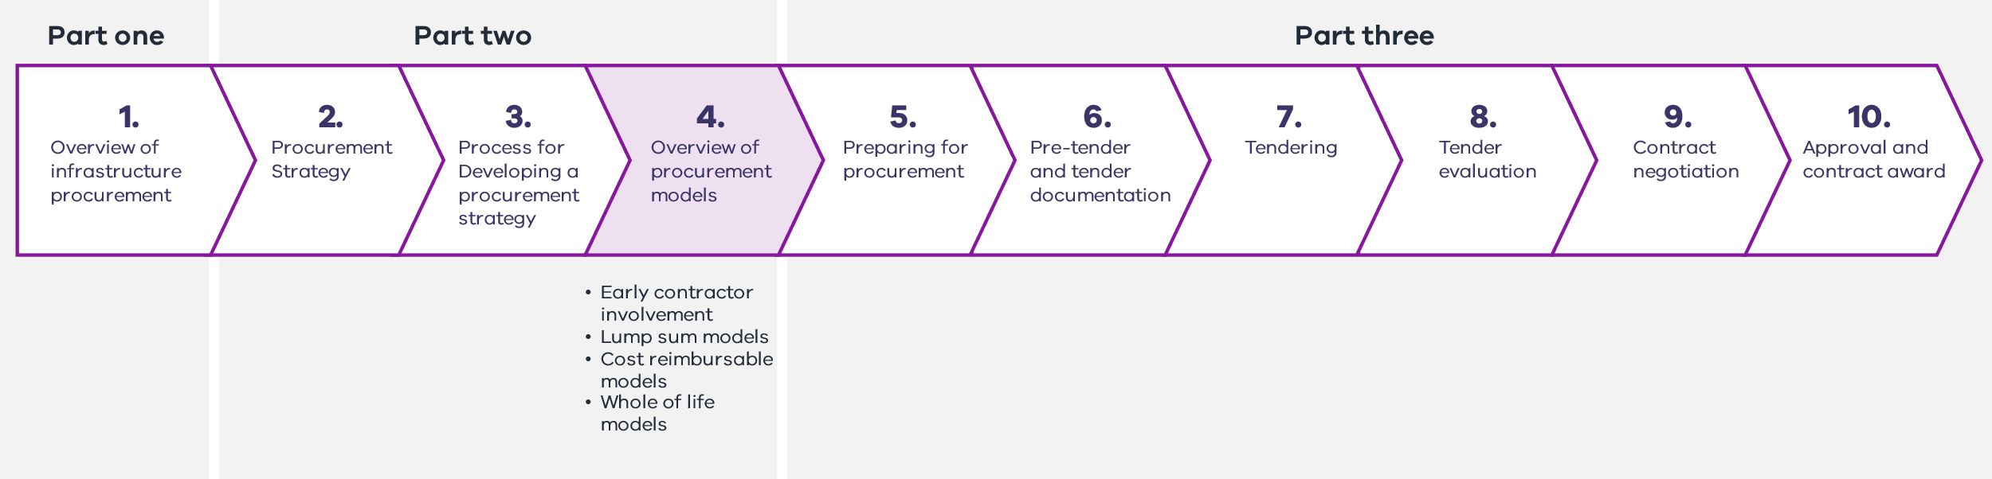
This chapter describes in detail the standard procurement models used for public construction to assist with procurement model selection. This is particularly relevant to Step 3: Test procurement model fit and shortlist, and the process for developing of a procurement strategy described in Chapter 3.
There are three categories of procurement:
    - whole-of-life
    - lump sum
    - cost reimbursable.
These guidelines highlight typical variants within each procurement model, where applicable. Alternatives to the procurement models presented in this chapter may be considered on a case-by-case basis in consultation with DTF.
      - Early contractor involvement
While early contractor involvement (ECI) is often presented as a procurement model, additional contracting beyond the earlier engagement is necessary to move into the delivery or construction phase. The progression from ECI to construction and the associated form of procurement varies from project to project. On this basis, DTF does not present ECI as a form of procurement, but rather as early project activity that can precede any form of procurement model.
ECI typically involves early appointment of a contractor in an advisory capacity. This can assist the project team to determine packaging and to consider project buildability. It can help to optimise design/preliminary design, scheduling and planning. It can also provide input regarding specialist construction issues.
ECI is useful for large, complex or high-risk projects to help the project team gain an early and better understanding of the project requirements. This can facilitate robust risk management, identify scope for innovation and investigate packaging strategies. It can also be used to identify and potentially execute early works, which may further derisk a project or save time.
ECI agreements also create challenges. These include the transfer or carry through of liability from the initial engagement to the construction contract. ECI can also create an incumbency advantage should the appointed contractor be part of the tender for the main construction contract.
      - Lump sum procurement models
Lump sum procurement models include:
    - construct only
    - design and construct
    - enhanced design and construct.
Lump sum procurement models typically feature:
    - a fixed-price contract with a schedule of unit rates for pricing variations
    - regular payments to the contractor for work completed up to the lump sum (adjusted for agreed variations)
    - an agreed date for practical completion and commencement of liquidated damages
    - clear delineation of contractual responsibilities and allocation of risks
    - a competitive tender process to select a suitable contractor based on non-price criteria, and a fixed price to deliver the full scope (or majority of scope)
    - a principal representative appointed by the agency to perform contract certification, including progress and final certificates
    - contract administration arrangements that are clear and well understood.
Lump sum contracting recognises that risks are most efficiently addressed when allocated to the party best able to manage them. Lump sum models can also incorporate targeted flexibility to address a limited number of complex risks that cannot effectively be priced or programmed prior to contract award, for example, contamination, geotechnical data or utilities risk.
Lump sum procurement models are well suited to projects where the agency, in consultation with stakeholders, can clearly articulate the project scope. In most cases, this means:
    - there will be very few scope or design changes during construction
    - the risks are well known
    - the project is relatively straightforward, without complex interfaces or a significant number of unknown risks.
        - Construct only
          - Key features
The construct only procurement model is based on sequential design and construction. Design is the responsibility of the agency, and subsequent construction is the responsibility of the contractor.
The agency prepares the design and tender documentation either in-house or by sourcing a consultant. The project is then competitively tendered, and the contract is awarded on a lump sum basis with an agreed date for practical completion.
The agency:
    - pays a fixed cost for project delivery, usually through regular progress payments to the contractor for work completed up to the lump sum (adjusted for agreed variations)
    - manages stakeholder input and interfaces as part of the design phase and takes responsibility for design risk.
The contractor:
    - takes responsibility for construction, schedule and cost risks with penalties to incentivise performance
    - takes 100 per cent of cost overrun risk.
Figure 12 – Construct only structure
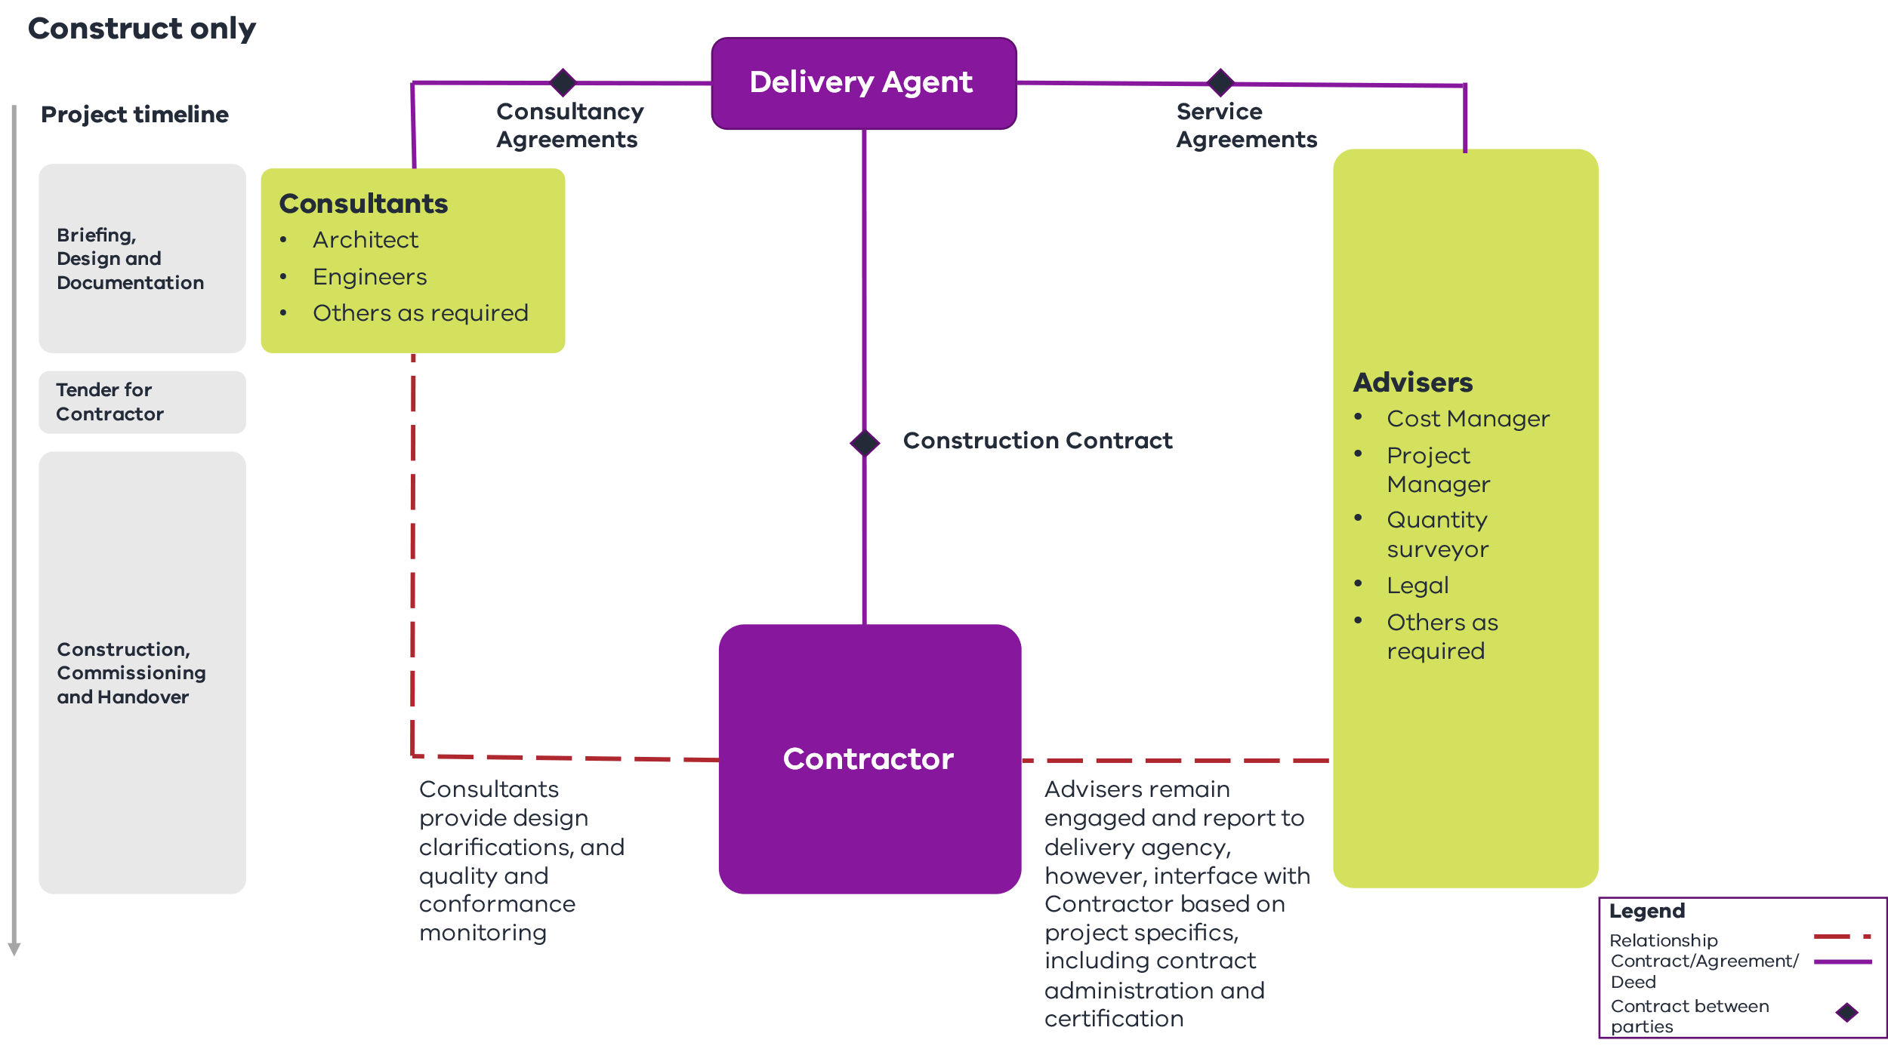
          - Model variants
There are noted model variants of the construct only procurement model.

Model variant 1: Design, novate or finalisation and construct
    - Tender occurs before documentation is fully completed (typically at 90 per cent). The successful contractor assumes responsibility for completing contract documentation, through either novation of the design team or hiring their own design consultants. This shifts some of the design risk to the contractor and potentially provides for final checks on buildability prior to construction.

Model variant 2: Schedule of rates
    - A schedule of rates is tendered based on the completed design. This is often applied where there is uncertainty in quantities. An alternative is a tendered design for an agreed lump sum, and an agreed schedule of rates for variations.
          - When to use construct only
Construct only is the standard procurement model for routine and well-defined works of small to medium size. The following characteristics favour construct only procurement.

Project value
    - Typically below $100 million, as larger projects tend to have duration and complexity that benefit from contractor input.

Scope, complexity and output certainty
    - Scope or design (or both) are relatively standard and well defined and unlikely to change during construction. There is limited scope for contractor design innovation.
    - There is a priority on a high degree of cost certainty at the time of contract award.

Risk allocation
    - Project risks (including site conditions) are well defined, understood and easily allocated.
    - The agency is willing to retain all the design risk.

Role of delivery agency
    - The agency prioritises design and has the time and skills to manage the design process, including identification and documentation of site conditions/utilities and briefing and preparing construction-ready contract documentation.
          - Benefits
The construct only procurement model offers benefits to the agency including:
    - a high degree of price certainty at the time of contract award, provided the design is substantially complete and properly reflects the project brief
    - the potential for stronger competition at tender by attracting contractors that do not have design management expertise or design resources, or are unable to take on associated design risks
    - less complexity when assessing tenders compared to many other procurement models
    - relatively straightforward and reliable contract administration principles and procedures.
          - Points to consider
A long lead time is needed prior to tender and contract award to enable design and contract documentation to be fully developed by the agency.
Completeness and accuracy of the design documentation is the responsibility of the agency. The agency must have (or engage and manage) the relevant expertise to confidently develop a design and prepare comprehensive contract documentation.
Successful delivery requires the contract and design information to be free of any errors, inconsistencies, omissions or other inadequacies that would lead to variations and extra cost to the agency.
The agency’s capability is essential, because:
    - separation of design and construction reduces opportunities for constructability optimisation
    - whole-of-life costs need adequate consideration in design decisions
    - the agency retains design risk, including design constructability, fitness for purpose, coordination and, usually, risks relating to latent (or subsurface) conditions.
          - Authorised contracts3F
DTF standard form for contracts:
    - Australian Standard (AS) 2124-1992 with VPS Special Conditions
    - VPS Medium Works Contract
    - VPS Minor Works Contract
          - Supporting resources
    - The DTF Lump Sum Procurement Category webpage
    - Practitioners Toolkit – Document library | Department of Treasury and Finance Victoria
        - Design and construct
          - Key features
In the D&C model, the design and construction phases overlap. The agency engages consultants to prepare a detailed project brief or principals performance requirements which defines the scope, quality and functionality requirements. A preliminary design at either concept or schematic level is also typically prepared for competitive tender. The contract is awarded on a fixed-price basis with an agreed date for practical completion. The contractor then completes the design, prepares construction documentation and constructs the project.
The agency:
    - pays a fixed price for project delivery, usually through regular progress payments to the contractor for work completed up to the lump sum (adjusted for agreed variations).
The contractor:
    - bids a price based on the agency’s specifications and therefore has significant ability to influence the design and buildability of the project
    - takes 50 to 100 per cent of cost overrun risk, depending on the size and risk profile of the project, subject to approved variations
    - manages stakeholder input and interfaces as part of the design phase
    - takes responsibility for design, documentation, construction, schedule and cost risks with consequences to incentivise performance.
Figure 13 – Design and construct structure
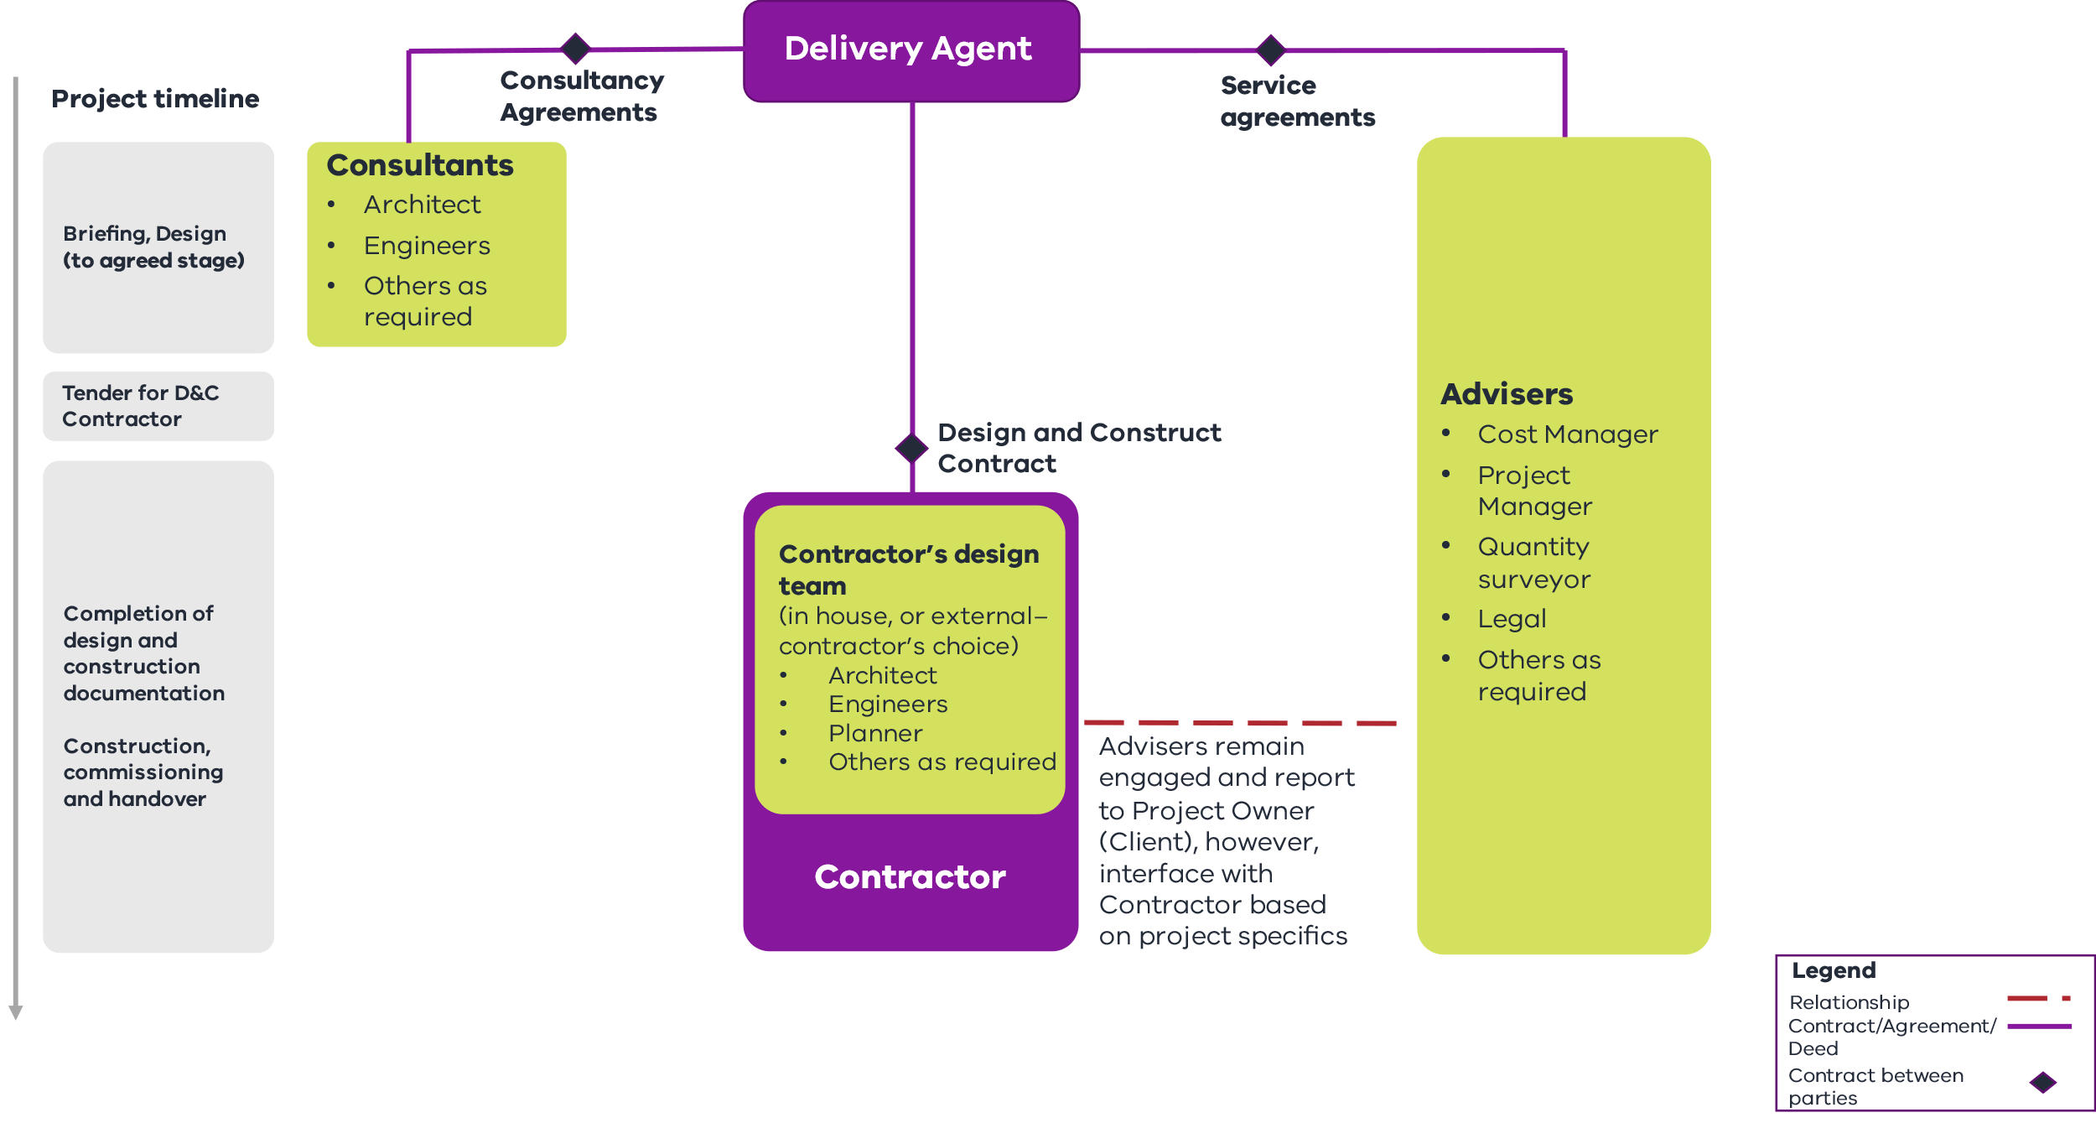
          - Model variants

Novated design and construction
The agency engages design consultants to prepare the design and construction documentation to an agreed point, typically from 70 to 90 per cent complete. The contract is awarded as a lump sum or a guaranteed maximum price (GMP). The design consultants are novated to the successful contractor, who is responsible for completing both the remaining construction documentation and the construction.
If a GMP contract is used, typically trade packages are re-tendered following completion (or further development) of the construction documentation. Any savings are shared between the agency and the contractor on a predetermined basis.
          - When to use design and construct
D&C is suitable for many medium to large projects providing a single point of accountability. The following characteristic favour D&C procurement.

Project value
    - The project can be of any value.

Scope, complexity and output certainty
    - Scope and outputs are unlikely to change during construction and can be defined by the agency prior to tendering in a detailed project brief or principal’s performance requirements defining the scope, quality and functionality requirements.
    - There is a strong relationship between design solution or constructability and design.
    - There is potential for the contractor to apply alternatives in the design or construction method.
    - There is a priority on schedule and price certainty and efficiency over the highest possible design quality.

Risk allocation
    - Risk is allocated to any project where the risks can be identified, assessed and priced in a cost-effective way (applicable to greenfield and brownfield projects).
    - The contractor is best placed to manage design risk.

Agency role
    - The agency requires the capability and expertise to capture project requirements in contractual documentation and seeks to transfer design risk.
          - Benefits
The D&C model transfers design and construction risks to the contractor as the single point of accountability. This provides:
    - potential for earlier commencement of construction after contract award while the design packages are progressively finalised
    - commercial alignment between design and constructability as the final design is owned by the contractor
    - potential value-for-money as the contractor is incentivised to include constructability advice into the design to manage costs and protect margin, which can also generate innovation and construction efficiencies
    - a fitness-for-purpose warranty from the contractor.
          - Points to consider
The success of D&C depends significantly on the accuracy and completeness of the project brief, including the quality, function and performance requirements. The agency needs to incorporate stakeholder input and other dependencies into the contract documents to minimise changes to project scope after the contract has been awarded. This capability within the agency is integral, because:
    - it is generally difficult for the agency to exert any significant level of control over the design process, since the design consultant’s duty is to the contractor
    - variations to project scope may give rise to extensions of time and cost claims from the contractor
    - careful consideration is required during tendering to ensure output specification is accurate and contractor prices are appropriate. This is to ensure the contractor does not underbid or accept an unsustainable level of risk that may result in the contractor pursing unreasonable claims
    - the contractor is typically focused on delivery, not whole-of-life cost. The agency may wish to implement contractual incentives to encourage better whole-of-life and environmentally sustainable design outcomes.
It is possible and reasonable for the agency to seek an independent design review at key project milestones to ensure that the D&C contractor has met all aspects of the project brief.
          - Authorised contracts4F
Standard form contracts:
    - AS 4300-1995 with VPS Special Conditions
          - Supporting resources
    - The DTF Lum Sum Procurement Category webpage
    - Practitioners Toolkit – Document library | Department of Treasury and Finance Victoria
        - Enhanced design and construct
          - Key features
The enhanced D&C model provides a modern approach to lump sum contracting with the addition of targeted risk-sharing elements to respond to specific high-value risks and challenges, such as contamination, that are not always appropriately managed under the traditional D&C risk allocation.
Key features can include:
    - a fixed price for the performance of the delivery activities, which allocates certain risks to the contractor that they are best placed to manage and are willing to accept
    - a bespoke contamination regime for agreed types of contamination. This includes a re-baselining mechanism with volume caps, which allows for price adjustments after contract award (including options for the re-baselining mechanism to be on a fixed-price or target outturn cost (TOC) basis depending on the project characteristics)
    - a non-binding behavioural framework to support collaboration and incentivise proactive principal engagement
    - a bespoke issue resolution process, in which the parties commit to early identification and collaborative resolution of issues. This contains a provision for developing a resolution process tailored to the project and the establishment of an issues resolution team
    - a risk-sharing regime for principal geotechnical data where the contractor is entitled to time and cost (as a modification) for unknown inaccurate principal geotechnical data and an option for a geotechnical baseline regime
    - a bespoke utilities risk-sharing regime that can be adopted as an option by the Government depending on the utilities risk. It provides the contractor time and cost relief (as a variation) for unknown utilities and in circumstances where utilities betterment is required during delivery. It can also cover time and delay costs for critical non-contestable utilities delay with a further option to treat any critical non-contestable utilities work as a provisional sum.
Figure 14 – Enhanced design and construct structure
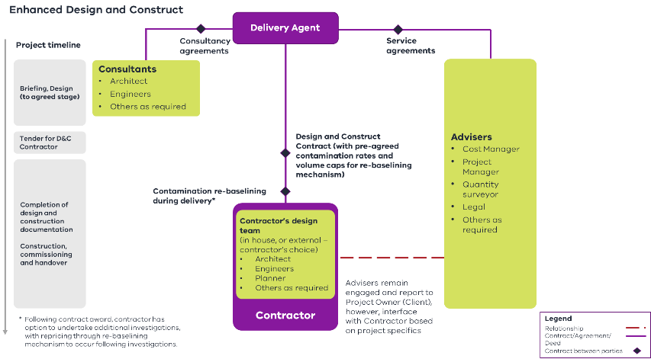
          - When to use enhanced design and construct
The enhanced D&C model combines the benefits of lump sum and cost reimbursable models, facilitating competition at contract award and providing new opportunities to take advantage of lump sum pricing by isolating cost reimbursable components to the most significant risks.
The following project characteristics favour enhanced D&C procurement.

Project value
    - Typically exceeds $100 million, to provide sufficient scale to cover the relatively high costs of governance and administration of the re-baselining regime.

Scope, complexity and output certainty
    - Scope and outputs are unlikely to change during construction and can be defined by the agency prior to tendering in a detailed project brief or principal’s performance requirements defining the scope, quality and functionality requirements.
    - More time is required after contract award to explore and cost specified key risks, including contamination and site conditions.

Risk allocation
    - Any project where risk-sharing mechanisms targeted to key risks would enable competitive lump sum tendering, such as addressing utilities, contamination or geotechnical risks.

Agency role
    - The agency requires the capability and expertise to capture project requirements in contractual documentation and the resourcing and capability to administer the re-baselining regime.
          - Benefits
The enhanced D&C model seeks to harness competitive pricing for most of the contract scope at contract award, balanced with appropriate risk allocation and performance incentives, with a more collaborative style of contracting. This involves a staged approach to scoping, design and pricing risk, while providing cost transparency.
The enhanced D&C model offers a robust alternative to cost reimbursable contracting models such as project alliances or incentivised target cost (ITC) models where a significant portion of project risks are retained by the Government.
Key anticipated benefits include:
    - a greater and earlier focus on scoping, design, costing and risk assessment
    - a staged procurement approach that provides more time to explore and cost specified key risks (such as contamination).
          - Points to consider
The enhanced D&C model is similar to the D&C model, but with the addition of requiring a sophisticated client capable of ensuring VfM outcomes, as they may have to manage a TOC process for the contamination regime.
          - Authorised contracts5F
Standard form contracts:
    - DTF Enhanced Design and Construct Deed (available on the DTF Lum Sum Procurement Category webpage)
          - Supporting resources
Lump Sum Procurement Requirements
    - DTF Enhanced Design and Construct Deed – Commercial Principles
    - DTF Enhanced Design and Construct Guidance Notes (available on the DTF Lump Sum Procurement Category webpage).
      - Cost reimbursable models
Cost reimbursable procurement models include:
    - managing contractor (MC)
    - ITC
    - alliance.
Cost reimbursable procurement models typically feature:
    - payment by reimbursable cost (in part or in full)
    - payment of fixed or percentage-based margin for contractor overheads and profit
    - commercial frameworks between the agency and contractor to share risks and opportunities in project delivery
    - incentive-based performance regimes for selected key performance criteria
    - a competitive tender process to select a suitable contractor based on non-price criteria, fixed or percentage-based contractor corporate overheads and profit and a competitive TOC development process (where appropriate)
    - elements of greater cost transparency and use of open-book arrangements.
Cost reimbursable contracting recognises that there are certain risks that cannot be effectively priced or programmed on a fixed basis and should not be fully allocated to the contractor. Remaining risks can still be effectively allocated to the party best able to manage them.
Cost reimbursable procurement models are well suited to projects where:
    - there are scope and outputs that cannot be reasonably and adequately defined in the business case or during subsequent work before tendering
    - there is a need for flexibility, for example, in scheduling or programming
    - delivery agencies have or can access the necessary expertise and resources to effectively manage and deliver these projects
    - increased input and collaboration of key stakeholders is required throughout the project.
        - Managing contractor6F
          - Key features
In the MC procurement model the agency engages an MC who is responsible for all aspects of project delivery, including managing the completion of design and construction documentation and tendering and awarding trade packages.
Prior to engaging the MC, the agency develops a project brief, preliminary design, target construction cost (TCC) and target date(s) for completion. The project is competitively tendered, and the MC is appointed based on relevant experience, key project team members, management fees, overhead and profit and, in some instances, risk pricing.
The MC is typically responsible for procuring subcontractors to facilitate project works for a guaranteed construction sum (GCS) with an agreed date for practical completion. There are two stages.
    - Development phase (Stage One) involves the MC progressing design (with the design team novated from the agency), preparing construction documentation, identifying and commencing early works and submitting an offer to the Government for construction of the works. The offer typically includes a schedule with completion dates and a GCS (the estimated cost of delivering the works).
    - Delivery phase (Stage Two) proceeds from development phase, where subject to acceptance of the GCS and program by the Government. The contractor manages delivery of the works including control, coordination, administration and direction of all activities on site through to completion and handover, including defect liability work/rectification and commissioning on behalf of the project owner.
The MC procurement model has the following key features:
    - reimbursement for actual costs on an open-book basis plus fixed fees or a percentage amount for preliminaries, overheads and profit. The MC may also receive additional incentivised payments though contract mechanisms that reward performance or achievement of specific key results areas (KRAs), for example, cost savings or innovation
    - management of design and construction risks, including program, by the MC, while their financial exposure is limited to the fee. The Government’s financial exposure is uncapped due to the cost reimbursable nature of the model. However, once the GCS is agreed, a fixed price for most scope items can be confirmed. Contractor liability caps can vary from project to project
    - provision for liquidated damages to apply if the contractor fails to meet the agreed completion date(s)
    - authority to approve subcontractor tenderers is retained by the agency. This ensures a level of consultation and provides reasonable control over the design process and construction, where appropriate.
Figure 15 – Managing contractor structure
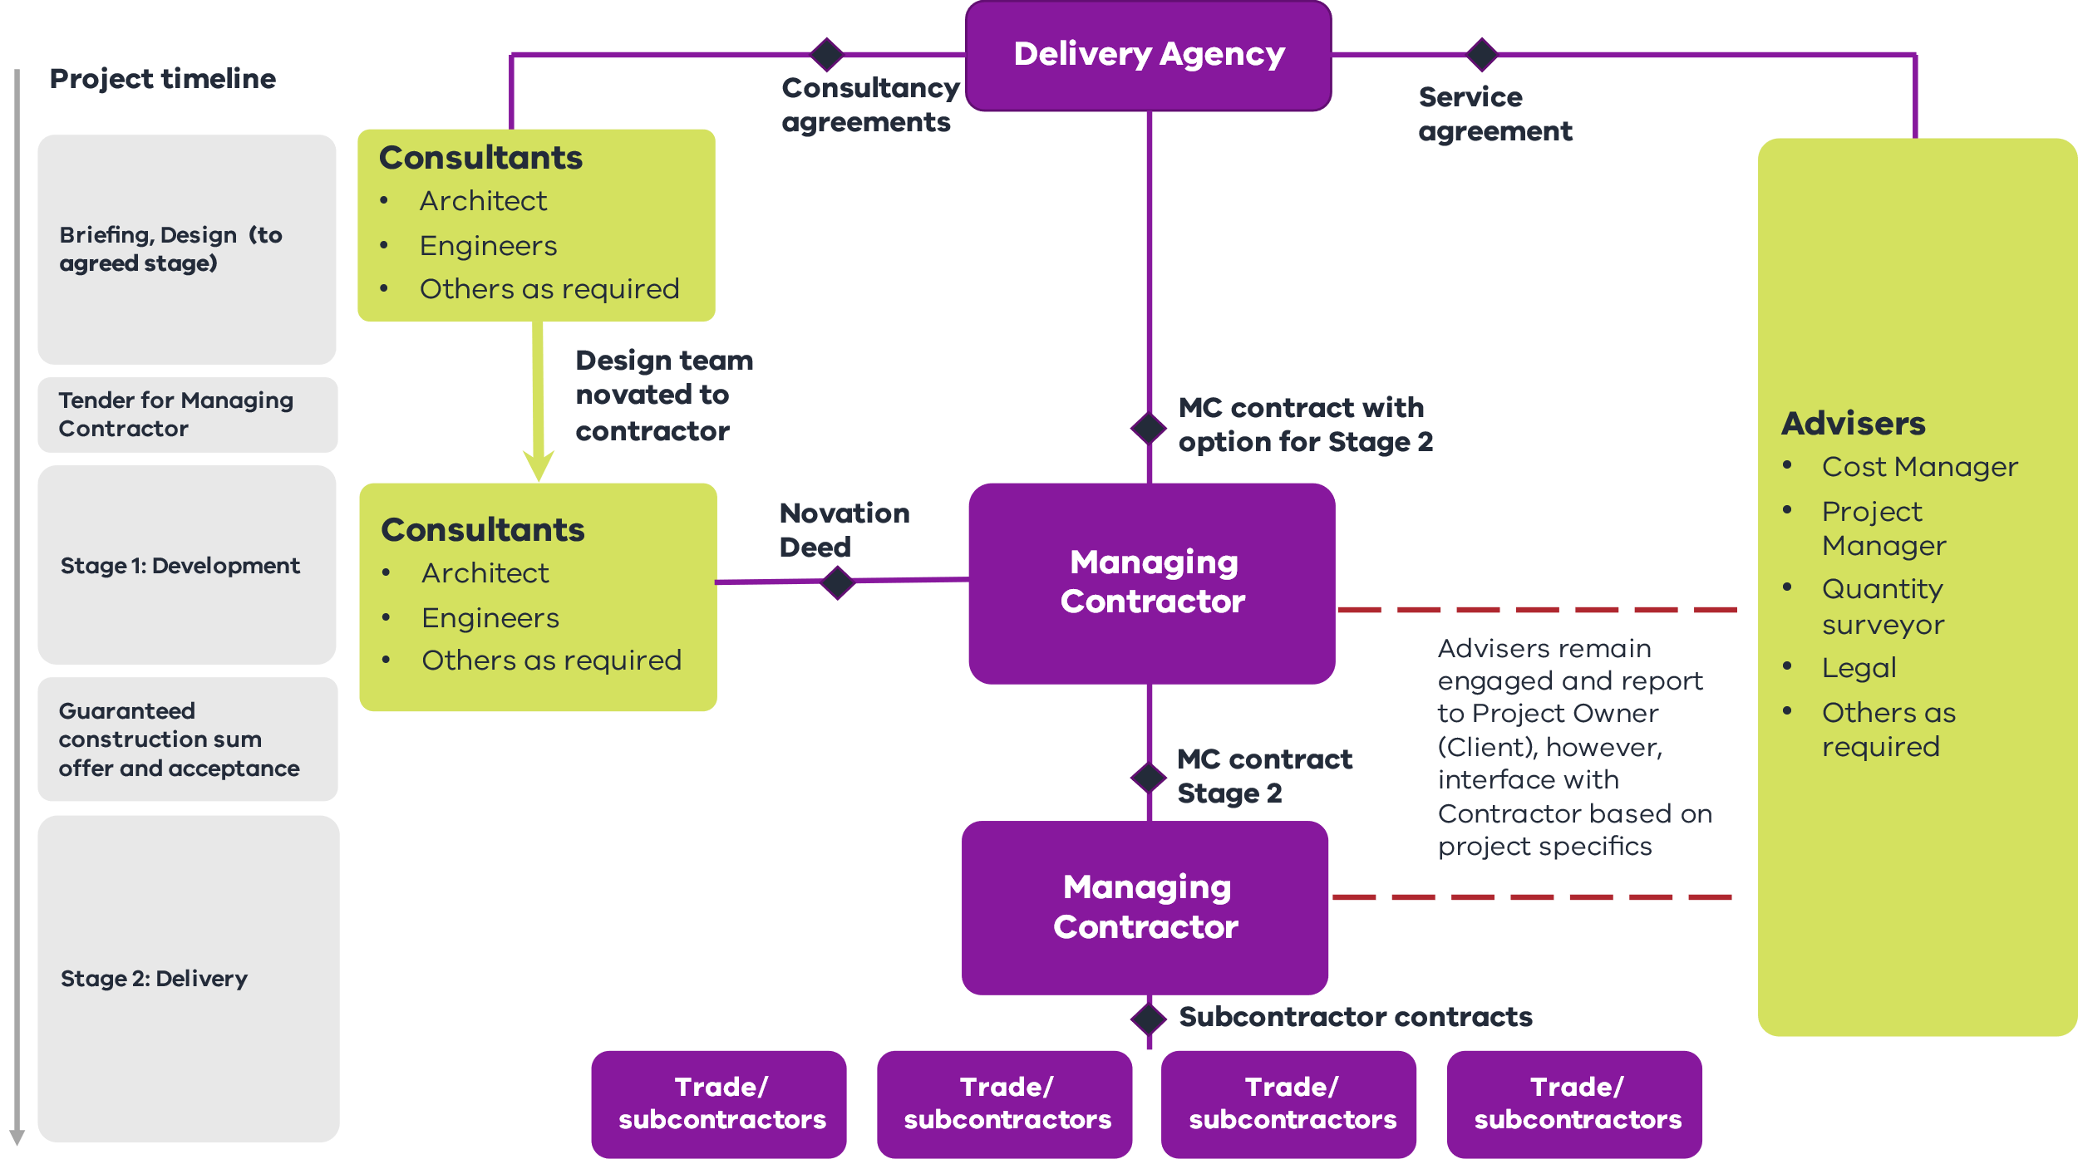
          - Model variants
The MC procurement model is increasingly used for public construction in Victoria. However, it has taken various forms across different delivery agencies. DTF’s preferred two-stage MC approach is outlined in Appendix C.
          - When to use managing contractor
The following characteristics favour MC procurement.

Project value
    - Typically exceeds $100 million to provide sufficient scale to cover the higher costs of establishment, governance and administration.

Scope, complexity and output certainty
    - The project would benefit from the expertise of contractors, and possibly key subcontractors, during the early phase of a project, for cost management, buildability input and whole-of-life considerations.
    - Scope and outputs are not fully defined.
    - The project is evolving and cannot be reasonably and adequately defined before tendering. An example is complex brownfield sites where it is difficult to define the project scope or interface with operational services. F
    - The agency requires design flexibility, to continue developing, refining or resolving the requirements (including scope), for example, to incorporate rapidly changing technology.
    - The agency requires flexibility to deliver early works, for example, utilities works, while the project scope continues to be refined.

Risk allocation
    - Site risks and operational requirements are difficult to enumerate (due to their changing nature) and ongoing coordination is required between the delivery agency and the operational environment.

Agency role
    - The agency works closely with the contractor to drive performance against budget and program and requires capability to actively interrogate costs.
    - The agency or stakeholders have specialist operational or technical knowledge integral to project delivery, for example, for specification of requirements or selection of a specialist subcontractor.
          - Benefits
    - The agency can retain a higher degree of control over the choice of subcontractors, while design, documentation and construction risks, including fitness for purpose, rest with a single party.
    - Design development can be integrated with construction planning at the earliest possible stage of the project.
    - Early works (such as utilities works) and more thorough site investigations can be undertaken during Stage One to help de-risk the project.
    - The agency has greater transparency of subcontractor prices and earlier identification of trade price risks.
    - The agency has more input into areas that have key quality requirements.
          - Points to consider
The MC procurement model requires a high level of skill, resources and sophistication from all parties to work effectively. The agency team needs to be well resourced to review the open-book pricing, including variations, and ultimately agree with the award of subcontracts.
For the MC procurement model to provide value-for-money it is important to consider the following:
    - The agency TCC estimate sets the benchmark for the MC’s GCS offer but is based on limited design documentation.
    - The level of design completed in Stage One will impact the extent of risk premium included in the GCS offer.
    - The GCS is negotiated at the end of Stage One, without competition. This incumbency status and the prospect of delays associated with re-tendering work may discourage the agency from not exercising the Stage Two option.
    - Performance of construction work by the MC eliminates competitive tendering and subcontracting. Limits to, or exclusion of, work performed directly by the MC should be considered.
    - There can be a lack of focus on lifecycle costs and considerations, similar to fixed-price forms of procurement.
    - Negotiation of the GCS based on developed design can be protracted. This can lead to the possibility of project delays or disagreement about the extent of scope that is actually delivered.
    - Obligations on the MC to undertake extensive consultation to verify the cost and program in Stage One may incentivise additional work that adds to cost and duration.
    - The agency assumes time and cost risk until the GCS is agreed.
          - Authorised contracts8F
Currently there is no DTF standard form MC contract available.
Development Victoria uses an agency-approved form of contract under MD 7.1.
The Victorian Health Building Authority uses bespoke contracts similar to Queensland’s MC two-stage D&C management contract (negotiated GCS).
          - Supporting resources
    - Cost Reimbursable Procurement Requirements
        - Incentivised target cost
          - Key features
In ITC procurement the agency develops a preliminary design and defines the scope, quality and functionality requirements. The contractor completes the project design, prepares construction documentation and constructs the project on a TOC basis with an agreed date for practical completion.
The ITC model allows for risks to be shared, while allocating some risks (such as time and quality risks) to the contractor as the party best able to manage those risks.
The contractor:
    - manages design and construction risks, including program, but their financial exposure is capped. The Government’s financial exposure is uncapped due to the cost reimbursable nature of the model
    - is commercially incentivised under a cost painshare/gainshare regime, where costs below and above the TOC are shared between the parties using a pre-agreed percentage split. The performance regime includes reward payments for achieving specific key result areas and key performance indicators (KRA/KPI).
The agency:
    - reimburses the contractor on an open-book basis including agreed overheads and profit margins.
The standard Victorian ITC model typically includes a two stage approach. The first stage comprises execution of a development phase deed, whereby a shortlisted respondent or respondents are engaged to perform early work (including design work) and develop a project proposal (including a TOC). If the project proposal is accepted by the agency, the development phase is followed by a delivery phase. Payment occurs by reimbursing contractors on an open-book basis and a percentage for corporate overhead and profit.
Figure 16 – Incentivised target cost structure
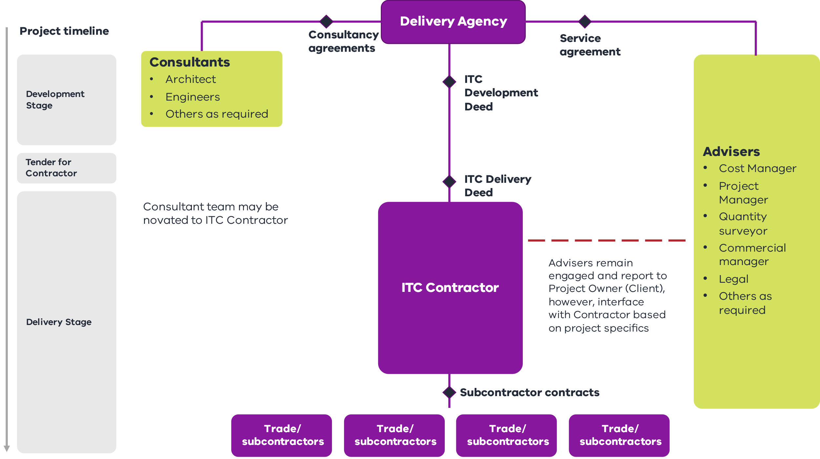
          - Model variants
The ITC model can be adapted to allow for an extended request for proposal (RFP) phase (rather than a formal development phase), which allows multiple contractors to prepare a TOC and delivery phase offer as part of competitive process within the tender period. The ITC model can also be adapted to include a lump sum component for certain scope elements of the work that can be competitively bid at contract award. However, in this case the agency will lose transparency of lump sum costings.
          - When to use incentivised target cost
The ITC model provides a balanced approach, by combining risk sharing and risk allocation to the contractor as the party best placed to manage them with a standard legal relationship. The following characteristics favour ITC procurement.

Project value
    - Typically exceeds $50 million (unless done through a programmatic approach) to provide sufficient scale to cover the higher costs of establishment, governance and administration.

Scope, complexity and output certainty
    - The nature, scope and output cannot be reasonably and adequately defined before tendering to enable efficient pricing and risk allocation to the contractor for significant project components, or there are other factors that necessitate close engagement with the contractor.9F
    - There is some uncertainty or non-standard deliverables.

Risk allocation
    - Prevailing market conditions and risk appetite would add considerable (and potentially excessive) risk premiums to a lump sum price, but the contractor is still best placed to manage time (workforce productivity) and quality risks.

Agency role
    - The agency requires extensive capacity or expertise in cost benchmarking as well as the capability to actively interrogate costs.
          - Benefits
The ITC model provides a greater and earlier focus on scoping and risk management through early investment in collaborative design and project development. It also shares risk and aligns goals between the parties, providing:
    - a staged approach that enables scope and design to be collaboratively developed and costed while ensuring competitive tension in the development phase
    - transparency on actual cost through an open-book approach
    - robust KRA/KPI (such as time, quality, stakeholder, disruption, safety and sustainability) structured as positive financial incentives to drive desired behaviours
    - a mix of reimbursement and a performance-based commercial model with a single point of accountability for design and construction as well as contractor warranties for design and fitness for purpose.
          - Points to consider
ITC procurement requires a high level of investment and preparation by delivery agencies. The agency must have or be able to build the internal systems, culture and expertise to effectively participate, manage and support the ITC process. This capability is integral in this model, because:
    - success of the risk-sharing contract elements is contingent on the agency having the necessary capability and capacity to provide robust interrogation of proponent costs, both during the procurement process and into service delivery
    - the agency is exposed to time and cost overruns under the risk and reward regime
    - there can be a lack of focus on lifecycle costs and considerations, similar to fixed-price forms of procurement.
          - Authorised contracts10F
    - ITC Development deed
    - ITC Delivery deed (available on the DTF Cost Reimbursable Procurement Category webpage)
          - Supporting resources
    - Cost Reimbursable Procurement Requirements
        - Alliance
          - Key features
An alliance is formed between the agency and non-owner participants (NOP) (the contractor, designer and other private parties) to design and construct a project.
The alliance participants work together in good faith as an integrated team to deal with key project matters on a best-for-project basis. The parties share risk, responsibilities and rewards in delivering the project.
An alliance model has the following key features.
    - The total cost of the project delivery is paid for by the Government. Typically, only the corporate overhead and profit are at risk for NOPs. The agency takes 100 per cent of cost overrun risk beyond that point.
    - The alliance team jointly develops a TOC.11F
    - The agency reimburses the NOPs on an open-book basis, including agreed corporate overheads and profit amounts.
    - NOPs are commercially incentivised under a cost painshare/gainshare regime, where costs below and above the TOC are shared between the parties using a pre-agreed percentage split, and a performance regime which includes reward payments or penalties for specific KRA/KPI.
    - Legal rights to litigate against breach of contract, mistakes and negligence are contractually limited with a ‘no blame, no disputes’ approach.
A key feature of the alliance structure is joint decision-making by an alliance leadership team incorporating participants from the agency and NOPs. However, certain important decisions are always reserved for the agency, with the Government ultimately paying for the asset.
Figure 17 – Alliance structure
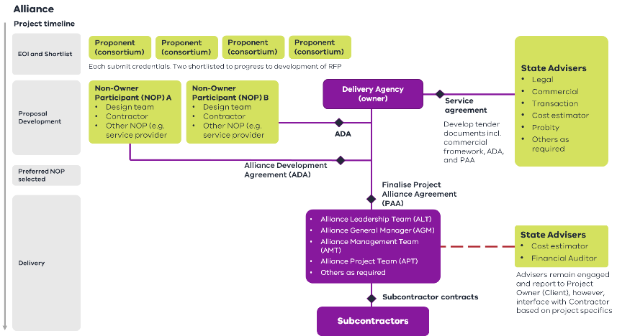
          - When to use an alliance
Alliances are most suited to larger and complex projects with high-level stakeholder influence or uncertainty. Where suited to the individual project characteristics, alliances can benefit from a programmatic approach as the opportunity for future work provides an even greater incentive for contractor performance. The following characteristics favour alliance procurement.

Project value
    - Typically exceeds $100 million, providing sufficient scale to cover the higher costs of establishment, governance and administration.12F

Scope, complexity and output certainty
    - The nature, scope and output cannot be reasonably and adequately defined before tendering to enable efficient pricing and risk allocation to the contractor for significant project components, or there are other factors necessitating close engagement with the contractor and key stakeholders.13F
    - Investigative works to quantify risks and design outcomes are not feasible during the planning phase and would be more effectively and efficiently managed in an alliance with the contractor during development and delivery.
    - There is uncertainty or non-standard deliverables.
    - Ongoing input from the agency or key stakeholders is required during design and construction.
    - Knowledge sharing and transfer between the parties is required.
    - There are complex external factors, such as stakeholders and interfaces, that will have a material impact on project cost and delivery timelines.

Risk allocation
    - Other risk isolation and mitigation measures are not effective and transferring risks is cost prohibitive. Successful management of risks is best achieved through a ‘no fault, no blame’ approach.

Agency role
    - The agency requires extensive project delivery capacity and expertise to support the collective approach to assessing and managing cost and risk including real-time decision-making during delivery.
    - The agency undertakes cost benchmarking to help drive and validate an efficient target cost.
          - Benefits
Alliances provide for a collaborative culture with incentivised targets and collective decision-making aligning goals between the parties, providing the ability to:
    - flexibly respond to changes in project scope and other delivery challenges
    - manage complex risks and stakeholder interfaces under an aligned commercial framework, including through involvement of operators
    - involve contractor(s) through the collaborative design definition and risk quantification phase to improve pricing efficiency
    - capitalise on joint knowledge, systems, innovation and risk management and to maximise client input.
          - Points to consider
Alliances require a high level of investment and preparation by delivery agencies. The agency must have (or be able to build) the internal systems, culture and expertise to effectively participate, manage and support the alliance process. This requires participation at senior or executive levels within the agency. This capability is integral, because:
    - the nature of alliances may result in heavy dependence on the contractor in the absence of agency expertise and preparation
    - the success and selection of alliances relies on participation of the agency in project delivery
    - risks are shared by the contractor up to a NOP risk cap, with limited legal recourse by either party. This increases the potential cost and risk exposure to the Government if not managed effectively
    - project success is highly reliant on the effectiveness and maturity of the relationships and leadership of all parties.
The alliance model may benefit from the additional incentives provided by programs of work. Programs incentivise contractor performance by providing a clear opportunity to the contractor for future work. However, the benefits of this approach must be balanced against maintaining value over the life of the program.
          - Authorised contracts
          - Currently there is no DTF standard form Alliance contract available Supporting resources
    - Cost Reimbursable Procurement Requirements
    - National Alliance Contracting Guidelines (September 2015)
      - Whole-of-life models
Whole-of-life (WoL) considerations should be part of every project’s development, regardless of the packaging and procurement strategy. However, certain procurement models are designed to deliver WoL outcomes and performance through long-term contractual arrangements.
There are two categories of WoL procurement models:
    - Partnerships Victoria models, where WoL activities are contracted, including with project financing, which may comprise debt and equity funding
    - bundled models, where separate components across the project’s WoL are procured under a single procurement or contract without project financing.
WoL procurement models typically feature:
    - one contractor to design, construct and maintain or operate assets (or both) over a long-term contract, typically providing a single point of accountability
    - a lump sum contract with the risks associated with design, construction, maintenance or operation (or both), including schedule and associated interfaces, transferred to the contractor
    - contractor payments or project revenue based on the asset being available for use, fulfilling specified contracting activities and achieving performance standards.
WoL procurement models are well suited to projects where:
    - it is achievable and cost-effective to bundle the design, construction and maintenance or operation of the asset under a single contract
    - bundling can create value and efficiencies through scale, higher asset utilisation, a single point of responsibility and a reduction in the number of interfaces across many contracts.
        - Partnerships Victoria models
Partnerships Victoria models are long-term contracts where the Government or users pay the private sector (typically a consortium) to deliver infrastructure and related services. These partnerships typically make the private sector parties who build public infrastructure financially responsible for its condition and performance throughout the asset’s lifetime.
Typical features of these partnerships are as follows:
    - The agency prepares an output-based specification of the asset and performance requirements rather than a prescriptive specification.
    - The consortium designs, builds, finances, maintains and in some cases operates the asset for a specific period (generally 20 to 30 years).
    - The Government usually retains ownership of the asset at the end of the contract term.
    - The consortium supplies infrastructure-related services and receives payments from the Government (or users) based on availability of the asset and the consortium’s performance in supplying asset-based services throughout the contract term.
    - The Government contributes through land, capital works, purchase of the agreed services or other supporting mechanisms.
    - Revenue streams and sources of funding repay the project finance used to build the asset.
Partnerships Victoria models can leverage project finance, revenue opportunities and government assets to unlock value and innovation. In some instances they provide a basis for broader community, commercial and precinct development.
The use of project finance is a key component of Partnerships Victoria models and can incentivise performance over the life of the project. These models feature a high level of discipline and oversight from financiers in procurement, delivery and operations.
Repayment of project financing (debt and equity) is subject to performance under the contract. Typically, the private sector parties who build public infrastructure are financially responsible for its condition and performance throughout the lifetime of the asset.
Figure 18 – Partnerships Victoria structure
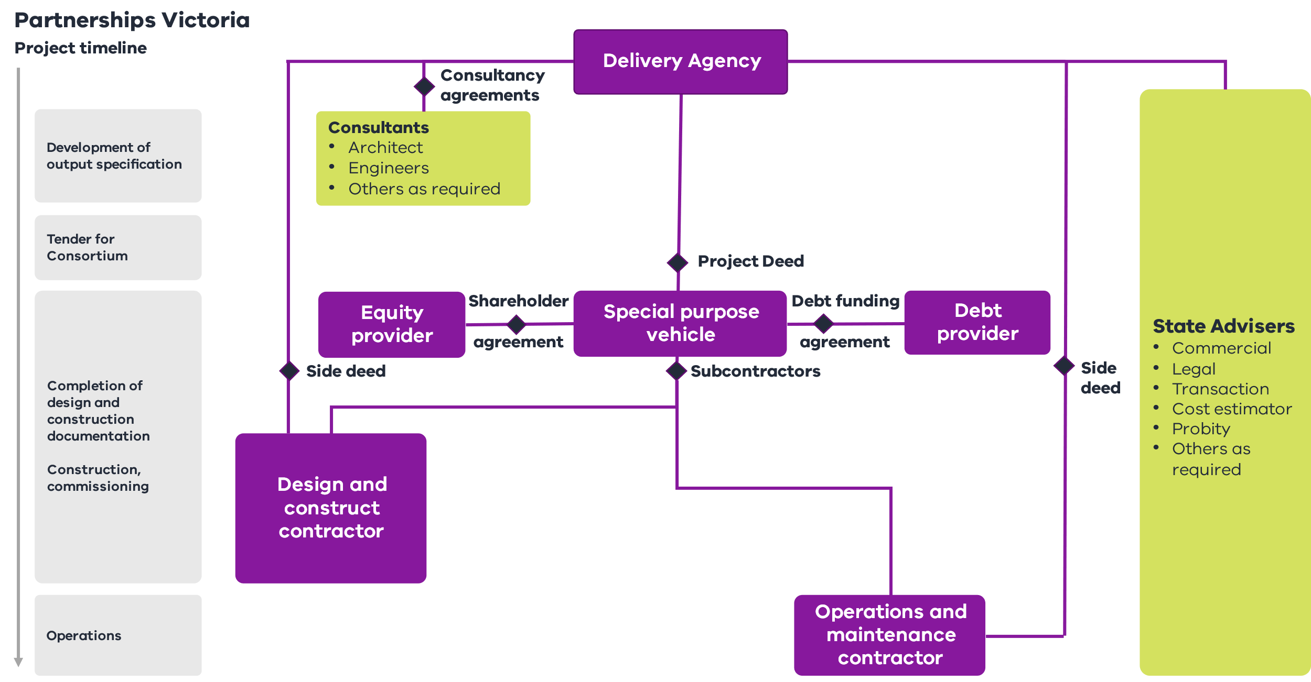
          - Model variants
Model variants commonly fall into three categories.

Model variant 1: Community partnerships
    - Typically used for hospitals, schools and justice facilities. The private sector consortium designs, finances, constructs, maintains and/or operates the facility including providing ancillary services such as cleaning, security, facilities management and catering (or some combination of those functions). Government payments during operation of the asset are based on performance. Project costs can be reduced by complementary commercial opportunities where relevant.

Model variant 2: Precinct partnerships
    - Typically used for housing or other precinct developments. The private sector consortium designs, finances, constructs, maintains and/or operates new developments, including social, affordable and private dwellings in mixed-tenure developments. The private sector consortium may receive rental revenue or generate fees from commercial development rights, which reduce project costs for the Government. This model leverages core public investment to attract complementary private investment, delivering integrated community benefits.

Model variant 3: Economic partnerships
    - Typically used for economic infrastructure, including transport and utilities. The private sector consortium designs, finances, constructs, maintains and operates the asset. It can leverage revenue opportunities and user payments to fund or partially fund the asset and delivery. Government payments vary by project and are based on performance.
          - When to use Partnerships Victoria models
Partnerships Victoria models are well suited to projects that would benefit from innovation and efficiency of private sector involvement or have significant commercial revenue or linked development opportunities. The following characteristics favour Partnerships Victoria procurement models.

Whole-of-life
    - Bundling the design, construction and operation phases is feasible and will drive innovation and efficiencies through project delivery.

Project value
    - Typically exceeds $250 million, providing sufficient scale to cover the higher costs of establishment, governance and administration.

Scope, complexity and output certainty
    - Scope and outputs can be reasonably and adequately defined in the business case or during subsequent work before tendering, enabling the development of output-based specifications.
    - There is a service component appropriate for private sector delivery.
    - There are opportunities to leverage the proposed and existing government assets and potential revenues to fund the project or related developments.

Risk allocation
    - The whole-of-life risks can be cost effectively allocated to the private consortium, with limited incorporation of risk-sharing mechanisms.

Agency role
    - The agency requires capacity and expertise to lock in a long-term output requirement in project finance, procurement management and ongoing contract management throughout the life of the contract.
    - These drivers will differ according to which Partnerships Victoria model is being implemented.
          - Benefits
Partnerships Victoria models can drive benefits during delivery and over the long term once the infrastructure is operational. These models:
    - provide ongoing design-driven operational benefits for the Government, with a focus on maximising the efficiency of whole-of-life costs and incentivising long-term service outcomes
    - can provide clarity, certainty and transparency of project scope, costs and time outcomes. These models can also provide certainty of funding and whole-of-life costs during operation
    - enable the Government to focus on core service delivery, with the asset managed by the private consortium. The private consortium manages complex interfaces and reduces ‘contract gaps’ with the Government
    - allow integration of value capture, commercial or precinct development opportunities, which can lower the Government’s costs
    - drive enhanced oversight, control and assurance mechanisms, with multiple independent parties (including the financier) monitoring to ensure what is built meets the contract requirements.
          - Points to consider
Partnerships Victoria models are suitable for projects with long-term and definable service needs, where risks can be appropriately allocated to the private consortium. They require a high level of planning and development by delivery agencies and ongoing agency contract management competency. The following points should be considered:
    - sufficient notice to the market is required, so that an adequate number of consortiums can form to ensure a competitive procurement process
    - variations to project scope may give rise to extensions of time and cost claims from the contractor
    - major modifications and augmentations can be complex to incorporate once the asset is operational, given project financing arrangements. The need for future flexibility should be considered as part of the procurement process
    - output specifications need to be accurate and contractor prices appropriate during tendering. This is to ensure the contractor does not underbid or accept an unsustainable level of risk that may result in the contractor pursing unreasonable claims
    - the agency must properly resource and train contract managers to monitor service delivery and performance to realise the full benefits of the contract
    - the financial sustainability of the companies is important given the long-term nature of the contract
    - the asset management or service component must be appropriate for private sector delivery.
          - Authorised contracts
    - Harmonised Public Private Partnerships Project (PPP) Deeds (update to 2018 Standard Form Project Deeds):
      - Social Infrastructure PPP Project Deed
      - Linear Infrastructure PPP Project Deed (available on the DTF website at https://www.dtf.vic.gov.au/stage-2-procurement/whole-life-procurement-category
          - Supporting resources
    - National PPP policy and guidelines
    - Whole of Life Partnership Victoria Procurement Requirements
        - Bundled models
Bundled models involve grouping the design, construction, operations and/or maintenance of an asset. They do not include project financing. Instead the Government is responsible for funding and financing the infrastructure. These models typically have the following features.
The agency:
    - prepares a design brief and preliminary design (including functional specification and key user requirements) for tender
    - pays progressively during construction of the asset and for maintenance and operations once the asset is operational.
The contractor:
    - constructs the asset for a fixed price and agreed schedule, then maintains the asset for an agreed period of time
    - is responsible for risks associated with the design, construction and maintenance, including schedule and associated interfaces
    - typically provides a single point of responsibility for design, construction and asset quality over the life of project.
These models typically make the private sector parties who build the public infrastructure financially responsible for its condition and performance throughout the asset’s lifetime.
          - Model variants
    - Design, Build and Maintain (DB&M)
    - Design, Build and Operate (DB&O)
    - Design, Build, Operate and Maintain (DBOM)
Figure 19 – Bundled structure
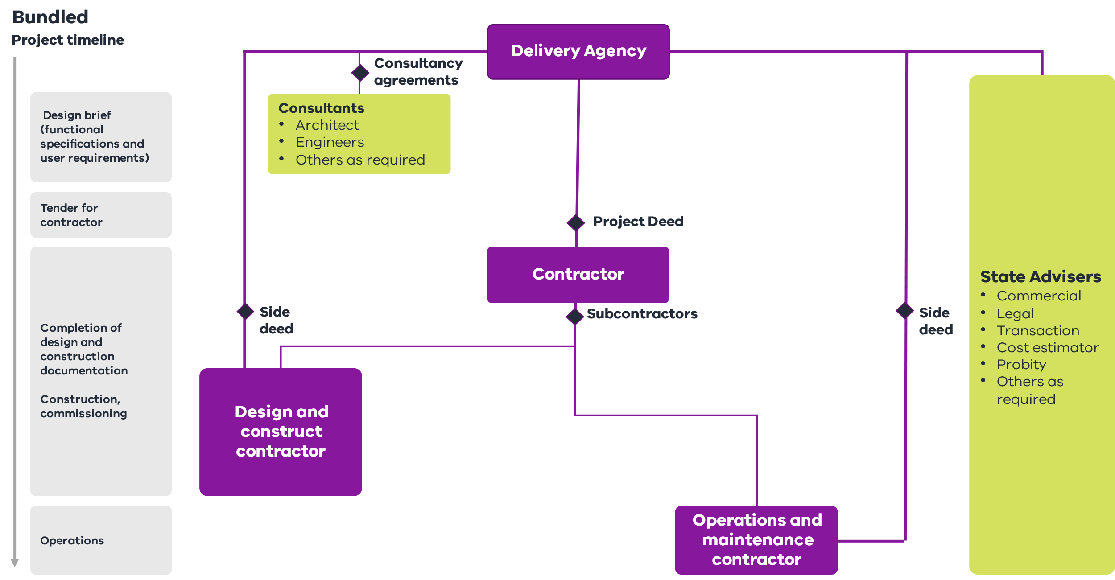
          - When to use bundled models
Bundled models are well suited to projects that would benefit from innovation and efficiency of private sector involvement. The following characteristics favour bundled procurement models.

Whole-of-life
    - When bundling the design, construction and operation phases is feasible to drive innovation and efficiencies through project delivery.

Project value
    - Typically over $250 million, providing sufficient scale to cover the higher costs of establishment, governance and administration.

Scope, complexity and output certainty
    - Scope and outputs can be reasonably and adequately defined in the business case or during subsequent work before tendering.
    - There is a service component appropriate for private sector delivery.

Risk allocation
    - Risks for the design, construction and maintenance or operation, including schedule and associated interfaces, can be defined and allocated to the contractor.

Agency role
    - The agency requires capacity and expertise to lock in a long-term service requirement, manage procurement and manage the contract throughout its life.
          - Benefits
Bundled models can drive benefits during delivery and over the long term once the infrastructure is operational. These models:
    - provide ongoing, design-driven operational benefits for the Government, with a focus on maximising the efficiency of whole-of-life costs and incentivising long-term service outcomes
    - provide greater clarity, certainty and transparency of project scope, costs and time outcomes. They also provide confidence in funding and whole-of-life costs during operation
    - enable the Government to focus on core service delivery, with the asset managed by the private consortium. The private contractor manages complex interfaces and reduces ‘contract gaps’ with the Government.
          - Points to consider
Bundled models are suitable for projects with long-term and definable service needs, and where risks can be allocated to the private consortium. The agency requires a high level of competence in planning and development, and contract management, because:
    - variations in project scope may result in extensions of time and cost claims from the contractor
    - careful consideration must be given during tendering to ensure output specification is accurate and contractor prices are appropriate. This is to ensure the contractor does not underbid or accept an unsustainable level of risk that may result in the contractor pursing unreasonable claims
    - the success of the bundled model depends on the agency’s oversight and relationship with the private sector contractor through its delivery and operational role
    - the Government retains more risk compared to other WoL models (such as Partnerships Victoria models) because bundled models typically include subcontractor liability caps and only operational/maintenance payments are at risk during operation
    - the financial sustainability of the companies are important given the long-term nature of the contract and limited recourse
    - adequate market notice is required so that an adequate number of consortium partners can form, to ensure a competitive procurement process
    - the asset management or service component must be appropriate for private sector delivery.
          - Authorised contracts
          - Currently there is no DTF standard form Bundled contract available Supporting resources
    - Whole of Life Procurement Requirements
    - Partnerships Victoria Requirements

Part 3: Implementing the procurement strategy
Part three (Chapters 5 to10) outlines the process for implementing the procurement strategy for an investment. It requires a detailed understanding of the procurement environment (discussed in Part 1) and the development of a robust procurement strategy as a component of the investment business case (discussed in Part 2). The implementation process involves the following steps:
- preparing for procurement
- pre-tender and tender documentation
- tendering
- tender evaluation
- negotiation
- approval and contract award.
Part 3 outlines a standard process for implementing a procurement strategy that is well suited to small to medium-sized infrastructure procurements using lump sum procurement models. It should be adapted and expanded when delivering larger and more complex investments, or when using cost reimbursable or WoL procurement models.
    - Preparing for procurement
Figure 20 – Chapter 5 overview
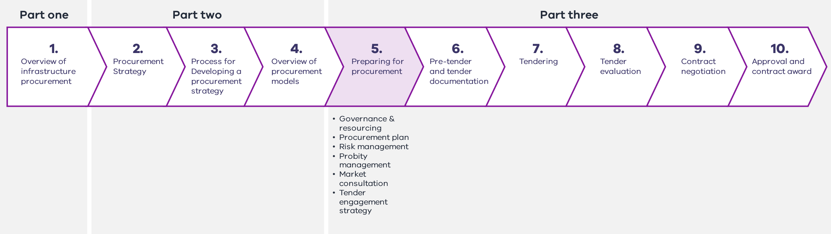

It is essential that agencies undertake planning and preparation activities prior to commencing a procurement process.
This typically includes:
    - establishing governance and resourcing arrangements for the procurement phase of the investment
    - developing a procurement plan to direct the procurement process, including a high-level schedule for the project
    - updating and identifying risks for the project, including strategies to allocate and manage risk through the procurement process
    - establishing a probity plan and framework for procurement of the project
    - undertaking market consultation as required
    - developing a tender engagement strategy.
There is no one-size-fits-all approach to tendering preparation and planning. The amount of preparation required will differ depending on the scale and complexity of the project and procurement model that is selected.
      - Establishing governance and resourcing for the procurement phase
The first step in the procurement process is establishing and resourcing a team to manage the investment through the procurement phase. The skill sets required to deliver the procurement stage may be quite different to those required in the development stages.
The required skill sets are also likely to vary depending on the size and scale of the project and the procurement model that is selected.
The Cost Reimbursable Procurement Requirements provide more detail on what resourcing and expertise the agency needs to be an active and informed client and successfully deliver cost reimbursable models.
The Whole-of-Life Procurement Requirements identify what resources are needed to deliver projects with project finance (debt and equity investment).
Getting the right governance, level of resourcing and mix of skills early in the procurement stage is essential to ensuring the team has the capability and capacity to procure a desirable solution.
        - Governance and accountability
Robust governance arrangements must be established or reconfirmed prior to commencing any procurement activities, and should clearly identify:
    - the senior responsible owner (SRO), or person with ultimate accountability for successful procurement delivery
    - a process for decision-making, including project board or steering committee terms of reference where applicable
    - working group and team member roles and responsibilities.
For smaller, less complex procurements, more streamlined governance arrangements may be appropriate. Table 10 identifies accountability requirements of generic roles and responsibilities that commonly apply in a procurement.
Table 10 – Key team governance requirements
Role | Responsibilities
Senior responsible owner (SRO) | The person in the client organisation who is ultimately accountable to the Government for the successful delivery of the project. They are responsible for all approvals relating to the procurement, including ministerial and financial delegate approvals where required.  The SRO usually sits with the client department where the agency is separate from the portfolio department  Refer to the Business Case ILG for more information on the role of the SRO.
Project board/steering committee | Project boards are not involved in the day-to-day management of the project. They consider the recommendations of the project team and provide expert advice and decisions to support the SRO and project team.
Project director/manager | The project director should be a senior officer leading the project through tendering and delivery. They have clear accountability for delivering the project requirements in accordance with the approvals given. They are a single focal point for the daily management of the client organisation’s interest in a project.
Reference group | The reference group should comprise representatives from end users and other relevant stakeholders, where appropriate, to ensure the requirements of the users and occupants of the asset inform the design brief and technical specification.
Project team | The project team comprises one or more people who, under the leadership of the project director/manager, manage the administrative and reporting requirements of the procurement.
Working groups | In larger projects the project team can be split into working groups for different aspects of the project. Working groups develop tender documentation and undertake associated commercial, legal and technical activities.
Agencies consult with DTF on governance plans for HVHR projects, as required under the HVHR framework. The Cost Reimbursable Procurement Requirements and Whole-of-Life Procurement Requirements detail requirements for potential participation by DTF in governance and evaluation bodies.
Agencies should carefully consider what decision-making is retained by the Government and what is undertaken in conjunction with the contractor in cost reimbursable models.
          - Approval points
The scope, cost and schedule for project delivery will typically be approved as part of the business case or government approval of the procurement. Agencies should consider appropriate approval pathways for project milestones and changes during the procurement process.
Tendering is a costly process for purchasers and suppliers in terms of time, resources and money. Before commencing the process, it is important to have a firm intention to proceed, with funds committed and available.
The approvals process will differ depending on the complexity and scale of the project, and the proposed procurement type.
Approvals for HVHR projects will be in accordance with the HVHR project assurance plan.
Approvals for Partnerships Victoria and cost reimbursable procurement models are available in the relevant requirements documents.
        - Resource requirements
Procurement processes require adequate resourcing to ensure procurement tasks can be delivered according to the project schedule. Agency teams will need access to the required capacity and skills for the type of procurement proposed.
It is common to engage a range of advisers to supplement in-house capacity. Depending on the size and complexity of the project, these could include commercial, financial, technical, legal, risk, transaction, probity and taxation advisers.
Resourcing requirements for Partnerships Victoria and cost reimbursable procurementprocurement models are available in the relevant requirements documents.
          - Use of prequalified registers
Ministerial Direction and Instruction 6.1 notes:
- When conducting a selective tender process or engaging a supplier from a register or supplier panel to perform works or construction services, agencies must use a register or supplier panel established and operated in accordance with the Instructions.
- Agencies may only establish, operate and use a register with the prior approval of the department Secretary, as set out in the Instructions.
Prequalified advisers can be used where appropriate to supplement agency capacity in managing procurement.
Government practitioners can use these registers to efficiently identify and engage experienced and appropriate advisers.
The Construction Supplier Register is a prequalification scheme for building and construction industry consultants and contractors. It is managed by DTF and includes categories for a range of technical advisers. Further information is available on the DTF website at: https://www.dtf.vic.gov.au/infrastructure-investment/construction-supplier-register.
The Victorian Government Purchasing Board supports a number of state purchasing contracts and registers that could be used to engage project consultants:
    - the Professional Advisory Services Panel includes consultants experienced in strategic project development, business case development, procurement, project auditing, project management and commercial advice
    - the Legal Services Panel provides a range of legal services, including for commercial projects
    - the Geospatial Data and Analytics Panel provides geospatial imagery, elevation and analytical products and services.
Further information is available on the Buying for Victoria website at: https://www.buyingfor.vic.gov.au/victorian-government-purchasing-board-vgpb
      - The procurement plan
Agencies should develop a procurement plan to guide the procurement, from tender development, through contract award, to commissioning, transition-in, and establishing operations and maintenance.
A procurement plan is developed after funding approval. It should be based on the procurement strategy and be continuously improved and amended throughout project delivery to reflect changes in the delivery environment.
        - Confirming the procurement decision
The first step in developing a procurement plan is reviewing the project business case and procurement strategy. It is essential to reassess and reconfirm the validity of the procurement decision. This stage is particularly important when the procurement team differs from the business case development team.
The procurement team may determine that a different procurement approach is required than the approach identified in the business case. The team should document the justification for taking a different approach, addressing what has changed since the procurement strategy was developed.
Appropriate government approval is required before the procurement can commence using an alternative approach.
        - Preparing the procurement plan
There is no one-size-fits-all procurement plan – content is project dependent. In general, some important inclusions are:
    - confirmation of procurement methodology
    - project overview and objectives
    - project budget, funding and approvals
    - governance and resourcing for procurement
    - tender engagement strategy
    - risk management
    - probity
    - market consultation and stakeholder engagement
    - due diligence and project documentation
    - governance plan, probity plan, stakeholder engagement plan and risk management plan for the procurement stage, if they are not contained in the overarching project plan.
Figure 21 – Key elements of the procurement plan
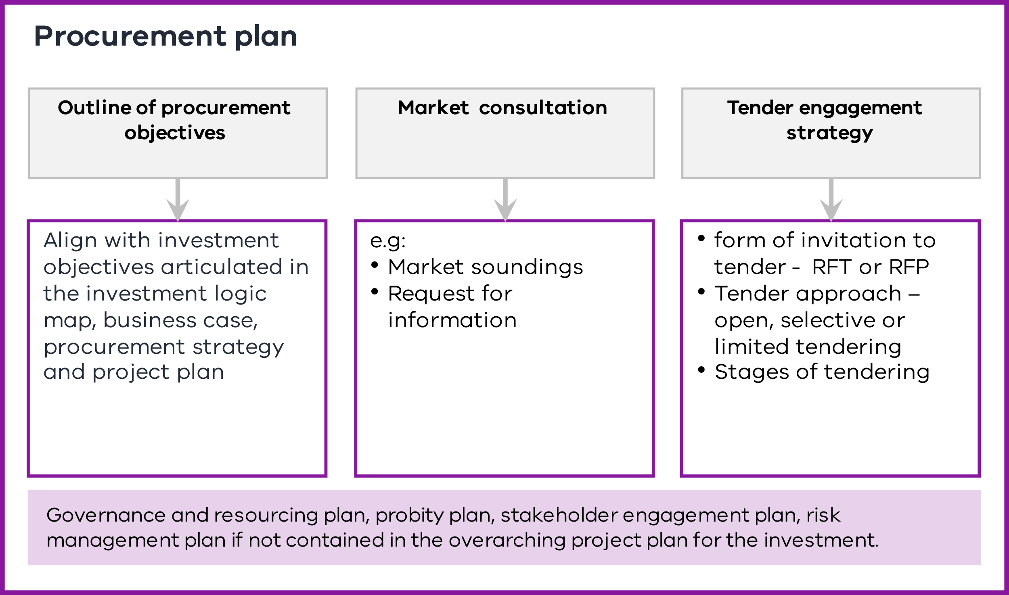

The procurement plan is a living document. It should be reviewed at each stage of the procurement process to reflect and consider new information arising during procurement implementation.
Appendix D contains more detail on potential content for the procurement plan. It is indicative only and is not exhaustive. It should not be seen as a template, but adapted according to project requirements.
      - Risk management
Risk identification and management strategies are considered when developing the procurement strategy and are relevant throughout the project lifecycle.
Agencies should establish processes to identify, analyse, mitigate and allocate risks that may impact the procurement. At a minimum this includes establishing a risk register, monitoring risks and implementing appropriate treatments to promptly address issues when they arise. The aim is to ensure the project remains on time, to budget and likely to deliver the investment benefits.
Risk assessment and management practices should be commensurate with the scale, scope and risk of the procurement.
The Victorian Government Risk Management Framework prescribes the minimum risk management requirements agencies must apply. Compliance with the risk management framework is mandated under Direction 3.7.1 of the Standing Directions 2018 under the Financial Management Act 1994. It aligns with ISO 31000 and is available at:
- https://www.dtf.vic.gov.au/planning-budgeting-and-financial-reporting-frameworks/victorian-risk-management-framework-and-insurance-management-policy
Further information on other applicable guidance can be found at:
- https://www.dtf.vic.gov.au/planning-budgeting-and-financial-reporting-frameworks/victorian-risk-management-framework-and-insurance-management-policy.
The Victorian Managed Insurance Authority provides practical guidance, tools and templates for managing risk at:
- https://www.vmia.vic.gov.au/tools-and-insights/practical-guidance-for-managing-risk.
The Risk, Time, Cost and Contingency Guideline provides supplementary guidance for identifying, quantifying and managing risk and is available at:
- https://www.dtf.vic.gov.au/investment-lifecycle-and-high-value-high-risk-guidelines/stage-1-business-case.
The PDDD Guideline provides supplementary technical guidance on how to integrate PDDD activities into project delivery. This is available at:
- https://www.dtf.vic.gov.au/investment-lifecycle-and-high-value-high-risk-guidelines/stage-1-business-case.
        - Risk allocation
Ensuring all parties have a clear and consistent understanding of their risk management responsibilities is essential to timely, efficient and economical risk management.
Risk management responsibilities should be established or confirmed at procurement commencement. Preferred risk allocation positions:
    - should be clearly communicated to the market during market consultation
    - clearly communicated in tender documents
- once negotiated and agreed, be reflected in contract documents.
The objective of risk allocation is to distribute risk appropriately across all parties – not to transfer as much risk as possible.
As a general principle, risks should be allocated to the party best able to manage them. The agency should seek to retain any risks that Government is best placed to manage and to allocate risks which another party is better placed to manage.
Allocating an inappropriate balance of risks to the contractor or other party can drive perverse outcomes, including high premiums for risk pricing by contractors which would diminish VfM outcomes.
Where it is difficult to accurately quantify and price a risk, it may be appropriate for Government to retain or share responsibility for the risk. The Government may retain responsibility for bearing the cost and other consequences of a risk occurring on a project while incentivising the contractor to effectively manage it and reduce its likelihood and impact.
Different procurement models can have very different approaches to the way risks are treated and managed. Further information on appropriate risk allocation can be found in the Cost Reimbursable Procurement Requirements for cost reimbursable models and the Whole-of-Life Procurements Requirements for these projects.
        - Techniques to de-risk projects
There are a range of risk management strategies that can be employed to de-risk an investment. These should align with the complexity and risk profile of the investment. Key strategies include (but are not limited to):
    - Project development and due diligence (PDDD): PDDD involves detailed investigations into certain project characteristics or risks to improve the agency’s understanding and level of certainty of those risks. It allows more accurate quantification and pricing of risks. It is commonly used to mitigate site and in-ground conditions, including utility risk and interface risks.
    - Early works: Early works packages can be undertaken prior to the commencement of main works that address common risks, in particular the relocation of utilities and the investigation and remediation of in-ground conditions.
    - Early contractor involvement (ECI): ECI facilitates a contractor’s technical input, in relation to risk identification, quantification and treatment, early in the project’s development phase to inform project solutions and reference designs (see Section 4.1).
        - Considering investment uncertainty
Uncertainties are external factors beyond the investor’s control that can impact the delivery of intended investment outcomes.
When planning an investment that may be impacted by uncertainty, agencies should consider the right amount of flexibility required to adapt the project to these changing circumstances.
Further information on managing uncertainty is available in the Risk, Time, Cost and Contingency Guidelines available at https://www.dtf.vic.gov.au/investment-lifecycle-and-high-value-high-risk-guidelines/stage-1-business-case.
      - Probity management
Ministerial Directions and Instructions for Public Construction Procurement 4.1 and 4.2 detail the probity requirements for public construction procurement.
Agencies must have appropriate systems in place to ensure probity for all public construction procurement including completing a probity plan for projects that exceed $10 million or are complex or otherwise high risk.
Procurement must be transparent, fair and ethical. This helps ensure there is confidence in government processes. Probity is considered at all stages of procurement and the application of probity is addressed throughout Part 3.
Proper probity management involves:
    - ensuring procurement participants act with integrity and impartiality. This includes participants being aware of their probity obligations, including applicable laws, rules and policies
    - ensuring key tender and evaluation documents and processes comply with probity requirements, including equitable treatment of tenderers, management of intellectual property and staging of negotiations with tenderers
    - establishing procedures for identifying, assessing and managing actual and perceived conflict of interests
    - Identifying probity risks and implementing effective management strategies
    - establishing tender and probity procedures that are transparent, auditable and accountable, including processes for record keeping, managing confidentiality in the tender process and keeping supplier information secure
    - establishing procedures for reporting and managing breaches of probity.
These elements are captured in a probity plan for construction procurement of more than $10 million and for complex and high-risk procurement. Probity practitioners may be used for more complex procurements. For further information on applying probity to government procurements, including requirements for appointing a probity adviser and or auditor, see: https://www.buyingfor.vic.gov.au/plan-probity
      - Market consultation
Determining the form and content of government consultation with industry is an important element of the procurement plan.
Appropriate market consultation can inform whether a proposed tender engagement strategy will result in procurement success or failure.
Consultation can identify supply side issues and provide Government with confidence that there is a competitive market capable of supplying its needs that will meet VfM outcomes.
Market consultation can vary greatly. The extent of consultation required depends on:
    - the scale and complexity of the investment
    - the level of risk or uncertainty
    - the level of experience in the procurement methodology
    - delivery constraints, such as managing a difficult physical environment or ambitious timelines.
Options for consultation may include:
    - market soundings, including structured processes seeking market comment or input, participating in industry briefings and forums or undertaking market surveys
    - a request for information, which is a process primarily used to formally collect written information from industry.
The Government may test a range of issues, including to:
    - determine whether there is sufficient market interest and maturity to drive a competitive tender response
    - seek information from the market on ability and appetite to meet project requirements, risk allocation and timelines
    - seek feedback on design and other technical elements
    - determine whether there is an appetite to consider alternative solutions/procurement options that could deliver improved outcomes and value-for-money
    - identify technological developments or innovations that could impact on delivery of the project
Procurement practitioners must consider confidentiality and probity in undertaking all consultation activities. Practitioners should also consider that market feedback will be influenced by a range of factors including commercial incentives. Procurement plans should be updated based on market consultation, where appropriate.
      - Tender engagement strategy
The tender engagement strategy is an important and mandatory element of the procurement plan. It details the method of engaging a contractor to perform the works. It should outline how the agency intends to offer the procurement opportunity to the market, including the type and form of tendering and whether to use single-stage or multistage tender approaches.
Different procurement models will have defined stages of tendering and forms of invitation to tender. Further information on these approaches can be found in the Cost Reimbursable Procurement Requirements and the Whole-of-Life Procurement Requirements.
If the procurement team decides that a sole-sourced procurement process is required (and this is inconsistent with the approach approved in the business case or with requirements for limited tendering set out in the Ministerial Directions and Instructions for Public Construction Procurement (3.2), additional approvals may be required.
        - Form of invitation to tender
Tender documentation will comprise the expression of interest (EOI), RFP or request for tender (RFT) documents depending on the type of procurement model used. Typically a design specification is used when the client has specified a defined solution and this is used in conjunction with an RFT.
A statement of requirements is used when the client has defined the services or outputs it requires but has not defined a single specific solution. It should be used in conjunction with an RFP. This approach is used for Partnerships Victoria projects.
Agencies should refer to Appendix E and see: https://www.buyingfor.vic.gov.au/source-supplier#invite-offers for further information on invitations to tender.
        - Tender approach
The Ministerial Directions and Instructions for Public Construction Procurement 3.2 sets rules and minimum thresholds for open, selective and limited tendering.
To promote competition and contestability, when engaging a supplier to perform works or construction services, agencies must use:
- an open tender
- a selective tender open to
  - all suppliers in the relevant category of a register or
  - at least three suppliers in the relevant category of a register or
- a limited tender conducted in accordance with the Instructions.
Agencies may seek tenders by using three broad types of tendering:
    - Open tendering (single or multistage) is a competitive tender open to all potential suppliers of the works or services in the local and international market.
    - Selective tendering is a competitive tender open only to suppliers on a prequalification register who are invited to participate in the tender.
    - Limited tendering is a tender conducted with limited competition.
The selection approach will be informed by the scale and complexity of the procurement, project-specific circumstances and the level of competition.
The Ministerial Directions and Instructions for Public Construction Procurement 3.2 under the Project Development and Construction Management Act 1994 (Vic) sets out the limited circumstances and value thresholds where selective and limited tendering can be adopted.
          - Stages of tendering
Either a single-stage or multistage tender process can be used for open and selected tendering. The tender approach may be informed by legislative or policy requirements (such as free trade agreements or the HVHR process). It will also be influenced by the project model and project characteristics, with more complex projects generally requiring additional tender stages.
Single-stage tendering occurs where only an invitation to tender is issued to the market. Single-stage tender approaches are commonly used for lower-risk or simple works.
Agencies should be aware that open public advertisement of a tender can lead to an unlimited number of potential tenderers whose qualifications to undertake the contract can be difficult to assess. However, requirements arising from legislation, such as free trade agreements, may necessitate a level of open tendering.
Multistage tendering occurs where pre-tender stages are used to create a shortlist of suppliers with demonstrated capacity to satisfy government requirements. Shortlisted participants will then be invited to participate in a subsequent tender process.
Multistage tendering is commonly used on large, complex or specialised projects, where tendering is likely to be costly. It usually occurs in two stages, although additional processes may also be warranted.
Agencies may consider the following processes:
    - A registration of interest typically involves an open process for potential suppliers to provide basic information about their organisation, capabilities and experience relevant to the project.
    - An EOI is used to assess suppliers’ capability to deliver procurement objectives.
EOIs limit the number of suppliers who are required to develop a more detailed response to an invitation to tender. Common elements that are generally tested in an EOI include financial capacity, strength and stability of the company partners (including parent companies), prior relevant experience and quality and capability of the nominated project team put forward by the tenderer.
Agencies should decide on the level of price and proposal development required by tenderers at each stage of the procurement. Treasurer approval of the tender engagement strategy is a requirement of the Cost Reimbursable Procurement Requirements. This includes where non-price alternatives, such as development of a single TOC by bidders, are proposed.
      - Preparing for procurement phase checklist
Before proceeding to the procurement documentation phase, agencies are required to undertake the following tasks:
Table 11 – Preparing for procurement phase checklist
Preparing for procurement phase key tasks
ü Establish governance and resourcing for the procurement phase
ü Develop a procurement plan, including a tender engagement strategy
ü Establish or update a risk management plan
ü Prepare and implement a probity plan
ü Undertake market engagement as required
    - Pre-tender and tender documentation
Figure 22 – Chapter 6 overview
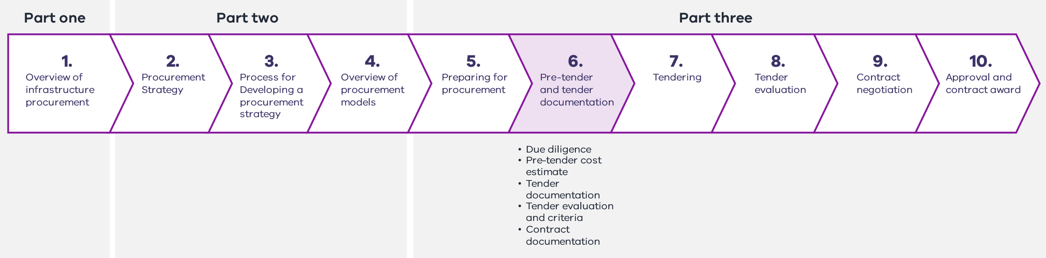
Agencies should undertake relevant due diligence, develop a cost estimate and key documentation for the tendering phase, including:
    - EOI, RFT and RFP documentation
    - tender evaluation criteria and an evaluation plan
    - contract documentation.
It is critical the tender evaluation criteria and tender evaluation plan are developed in conjunction with tender documentation. This ensures that the tender response schedules will adequately address procurement objectives.
      - Due diligence
Prior to tendering a project, an agency will undertake PDDD. This process builds a comprehensive body of knowledge and documentation about the project to verify agency understanding of project requirements and interfaces, identify risks and inform project and tender documentation. Where relevant, due diligence should include investigations to efficiently minimise project risk related to spoil management, such as certainty of spoil volumes, classification and market capacity.
DTF’s PDDD Guideline provides supplementary technical guidance on how to integrate PDDD activities into project delivery. This is available at:https://www.dtf.vic.gov.au/investment-lifecycle-and-high-value-high-risk-guidelines/stage-1-business-case.
Agencies may provide technical due diligence information (such as site investigation reports) to tenderers prior to, or as part of the tender phase. The level of reliance on the reports by tenderers will be determined on a project-specific basis.
      - Pre-tender cost estimate
Procurement teams may wish to validate the expected total project cost to provide confidence that the current market can deliver the tender within the government-endorsed funding allocation.
Where a project design specification has been prepared, the pre-tender cost estimate can be developed by a quantity surveyor, who will estimate a price for each component of works based on the current market cost.
For Partnerships Victoria projects, the procurement team must develop a public sector comparator (PSC). The PSC estimates the hypothetical risk-adjusted cost if a project were to be financed, owned and implemented by the Government. Further information on developing a PSC is outlined in the National PPP Policy and Guidelines: Volume 4: Public Sector Comparator Guidance available at: https://www.infrastructure.gov.au/infrastructure-transport-vehicles/infrastructure-investment-project-delivery/national-guidelines-infrastructure-project-delivery.
Development of a principle’s benchmark is also required for cost reimbursable models, especially in a sole source scenario. Further detail is available in the Cost Reimbursable Procurement Requirements.
      - Tender documentation
The quality of the tender documents is critical to successful tendering. They are the basis of the contract between the purchaser and the successful supplier and must accurately reflect the physical, financial, contractual and time parameters of the service required.
Ministerial Direction and Instruction 3.6 for Public Construction Procurement in Victoria sets out the requirements for completing tender documentation.
The tender documents should include information appropriate to the scale, procurement model, level of design and complexity of the procurement.
Tender documents should focus on eliciting only the information necessary to determine the best VfM solution.
Clear and explicit process rules, such as closing time, date and place for lodging tenders, evaluation criteria and confidentiality requirements, should be outlined in the documentation.
As a general rule, the more detailed and accurate the information provided to tenderers, the better the quality of the tender.
It is important that any new information arising during a procurement stage be used to reassess and inform future procurement processes and relevant tender documentation.
Typical components of tender documents are detailed in Table 12. The content will differ depending on the stage of procurement (EOI, RFT, RFP) and the type of procurement model selected.
Table 12 – Typical components of tender documents
Background | The background includes:  - a brief description of government agency managing procurement, including background, function and purpose  - an overview of the project, including objectives, scope, stakeholders and timelines  - a statement on the stage of procurement and a brief explanation of what is anticipated in each stage.
Conditions of tender and probity obligations | The conditions of tender include the rules of the tender process and relationship to the model form. They detail the overall tender process including the delivery method, probity issues, timing of submissions, communication issues and the evaluation criteria.
Specification: | Depending on the type of delivery model chosen, the specification document may be a project brief or a detailed description of the works or service. The specification sets out the performance and technical criteria.
Financial and commercial information | Financial and commercial information includes the proposed risk allocation and high-level commercial principles/structure that will apply.
Form of contract | The contract stipulates the commercial and legal terms on which the works or services will be performed.
Government policies | This information outlines the relevant government policies that apply to the procurement.
Additional information | Additional information includes:  - drawings  - environmental and geotechnical investigations  - land, planning and environmental issues  - sustainability approach  - community consultation  - project interfaces.  Agencies may also request specific information from bidders to assist in the preparation of tender documentation for the next procurement stage.
Response schedules | The response schedules outline the required tender response to supply the works or services.
        - Bid cost reimbursement
Partial bid cost reimbursement may be considered for major construction HVHR projects. Government approval will be required to confirm the policy applies to a project and to allocate appropriate funding.
If partial bid cost reimbursement applies to a procurement, the tender documentation will set out bidders’ entitlements, including covered items and any limitations on reimbursement.
Reimbursement will be linked to receiving intellectual property rights from the unsuccessful bidder’s proposal and subject to the bidder submitting a conforming bid.
The bid cost reimbursement for major construction projects policy sets out parameters for assessing and paying bid costs on projects. It is available at: https://www.dtf.vic.gov.au/infrastructure-investment/bid-cost-reimbursement-major-construction-projects.
      - Tender evaluation criteria and documentation
Ministerial Direction and Instruction for Public Construction Procurement 3.7.1 requires agencies to develop and substantially complete an evaluation plan detailing how a tender process will be evaluated before releasing tender documentation to the market. This is to ensure the information requested through the tender and the evaluation plan are aligned. The evaluation plan must be finalised before the tender closing date.
Agencies should finalise evaluation plans substantively before the release of tender documentation and finalise it prior to the tender closing date.
The evaluation plan sets out the:
    - tender evaluation criteria, including identifying any mandatory criteria
    - relative importance and associated weightings of the evaluation criteria
    - evaluation methodology and how each criteria will be evaluated
    - tender evaluation processes, including:
      - tender opening times
      - who will assess the tenders, including number of panels/working groups assessing different aspects of the submission
      - resourcing, such as technical experts required to assess certain criteria
      - which evaluation committee members will have access to what information
      - timeframes for the evaluation
      - how each evaluation criteria will be assessed and scored.
        - Evaluation criteria
Evaluation criteria should be linked to the project’s objectives to enable the agency to evaluate which tender represents the best value for money.
It is essential that tender evaluation criteria, weightings and processes are developed prior to releasing tender documentation. This is to ensure that tender documents are drafted in a way that will elicit all the information that the tender evaluation team requires to assess submissions and meet probity requirements.
Tender evaluation criteria should be disclosed in tender documents. Agencies may provide an indication of the relative importance or weighting of the evaluation criteria in the tender documentation.
Further information on specific evaluation criteria is provided in Chapter 8.
      - Contract documentation
Contract documentation formally outlines the arrangement between the project owner and the successful contractor. It helps to ensure high-quality and cost-effective outcomes for the project by:
    - specifying performance and quality standards
    - appropriately apportioning risk between the parties
    - incentivising the contractor to perform as appropriate, in line with VfM considerations.15F
Contract documentation should facilitate the parties working together in the most collaborative and constructive way possible. It should be developed during the tender development phase and disseminated as part of the tender documentation.
        - Standard forms of contract
Ministerial Directions and Instructions 7.1 and 7.2 for Public Construction Procurement in Victoria govern the use and content of contracts for construction works. They require contracts to be in a form approved by the Secretary toDTF. Collectively, these contracts are referred to as the Victorian Public Construction Contracts.
Approved Victorian Public Construction Contracts for lump sum contracts for small to medium-sized projects can be found at: https://www.dtf.vic.gov.au/practitioners-toolkit/practitioners-toolkit-document-library.
Additional contracts, including the ITC Contract Suite and Enhanced Design and Construct Deed, can be accessed at DTF’s Cost Reimbursable Procurement Category and Lump Sum Procurement Category webpages.
DTF has developed a suite of harmonised project documents for Partnerships Victoria projects (Harmonised PPP Project Deeds). These can be accessed at the Whole-of-Life Procurement Category webpage.
      - Pre-tender and tender documentation checklist
It is important that agencies have undertaken the following tasks before finalising documentation and proceeding to tendering:
Table 13 – Pre-tender and tender documentation phase checklist
Pre-tender and tender documentation phase key tasks
ü Undertake required PDDD
ü Prepare a pre-tender cost estimate
ü Seek approval of any bid cost reimbursement, if required
ü Develop all pre-tender and tender documentation
ü Develop tender evaluation criteria and plan
ü Develop contract documentation
    - Tendering
Figure 23 – Chapter 7 overview
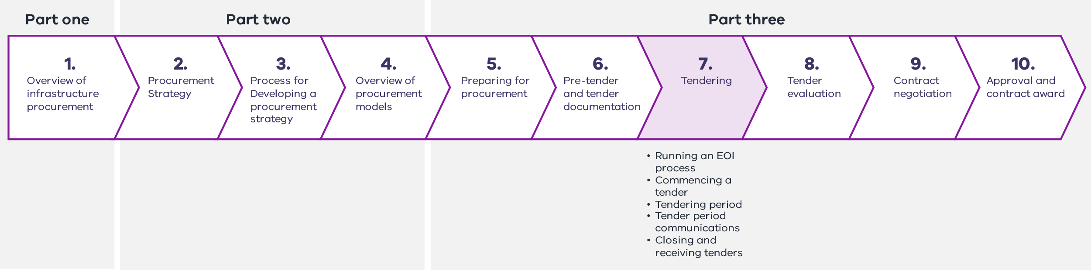
Tendering is the process where an agency communicates the procurement request to the market and respondents develop proposals to deliver the required scope of works and services. It provides suitably qualified potential respondents with an opportunity to bid for work and enables the Government to achieve the best value for the expenditure of public money through competition or rigorous assessment against benchmarking.
This chapter describes a tendering phase most applicable to lump sum and Whole of Life procurement models. In some cost reimbursable procurement models, the tender period has two parts:
    - Part 1 assesses whether potential respondents should proceed to a development phase (or the second stage of a tender period) where further design and project development work occurs.
    - Part 2 involves further design and project development work culminating in a delivery phase offer to deliver the required scope of works and services.
More information on procurement and tendering in cost reimbursable models can be found in Chapter 4 of the Cost Reimbursable Procurement Requirements.
Tendering should be undertaken in accordance with the procurement plan developed in the tender development phase and should only commence after the agency has confirmed it has the necessary authority and commitment to proceed with the project.
The Project Development and Construction Management Act 1994 (PDCM Act) provides the authorising environment for government procurement of construction works and services. Its associated Ministerial Directions and Instructions for Public Construction Procurement set procurement requirements and processes for agencies and tender participants to ensure procurements are conducted with integrity and in accordance with probity requirements and ethical standards. Complying with these mandatory requirements and processes drives consistency in procurement practices across agencies and promotes public and industry confidence in government transactions.
      - Running an expression of interest process
EOI processes must be conducted transparently and in accordance with probity requirements. Clear and explicit process rules, such as closing time, date and place for lodging EOIs, evaluation criteria and confidentiality requirements, should be documented in the EOI invitation. Expectations of probity and confidentiality should be communicated to all procurement team members and should be rigidly adhered to throughout the EOI process. All communication with suppliers during the EOI process should be treated with the same level of probity, confidentiality and transparency as the tender process. Team members should be familiar with the Ministerial Directions and Instructions for Public Construction Procurement, which set the protocols for tendering.
EOI evaluation is focused on determining whether the parties have the requisite capability to deliver the project. Evaluation should be based on the criteria specified in the EOI invitation and result in a shortlist of parties to be invited to continue the tender process. Usually, some parties will not be invited to move forward. The number of shortlisted parties will vary from project to project. However, the objectives of the process should be to:
    - shortlist only those parties that the Government genuinely believes have the capability to deliver the project. Parties should not be shortlisted to ‘make up the numbers’
    - shortlist an appropriate number of parties to maintain competitive tension and protect against the risk of a withdrawal, while maintaining parties’ investment in the process by not shortlisting too many.
Following the shortlisting process, all EOI respondents should be advised whether they will be included in the RFT process. Those on the shortlist should be advised on next steps and the expected timelines.
Any new information arising during the EOI process should be used to reassess the procurement process. In particular, it may be used to inform tender documentation.
      - Commencing the tender process
Good preparation and planning are key to an effective and efficient tender process. In the procurement development stage, agencies should have developed their tendering engagement strategy and documentation, having undertaken market consultation to identify and confirm market participants who will be invited to tender.
The first step in the tender process is notifying all tender participants that the tender has commenced and issuing the invitation to tender and tender documentation.
Ministerial Direction and Instruction for Public Construction Procurement 3.4 requires agencies to issue a tender notice to all potential tender participants.
- For an open tender, tender notices must be published, at a minimum, on the Buying for Victoria website using the applicable form so that it is accessible to all potential local and international tender participants.
- For a selective or limited tender, a tender notice must be issued to each party invited to participate in the tender process. Tender notices should be sent from the Buying for Victoria website (except for limited tenders, which do not meet minimum financial thresholds and can be issued by the agency directly).
Ministerial Direction and Instruction for Public Construction Procurement 3.4 requires the tender notice to include:
- a project summary
- a listing of the tender documentation and how it can be obtained
- key dates such as briefing times, site visits and tender closing time
- the agency’s nominated representative and contact details
- the number of copies and format required for submission (electronic or hard copy)
- details of the tender submission location and timing.
      - The tender period
The tender period is the time between the tender notice and invitation to tender being issued and the closing date for tenders. During this period, the procurement team issues the tender documentation and manages communications. Respondents prepare their offers.
Ministerial Direction and Instruction for Public Construction Procurement 3.5 requires agencies to provide tender participants with sufficient time to prepare well, considered, complete and accurate tenders.
If the tender period is too short, it may result in tenders being overpriced to cover unforeseen risks, or they may be underpriced due to being completed without due consideration. Agencies should ensure the tender period is reasonable, taking account of the following factors:
    - the complexity of the deliverables and tender requirements and the extent to which the project scope, risks and commercial terms are unique. The more complex the offering, the more numerous the elements requiring costing and assessment and the greater time required for suppliers to develop their tender. It may range from two to three weeks for simple investments to several months for complex infrastructure and assets such as rail lines, tunnels and rolling stock. Time requirements will increase if the tenderers are required to submit a design or financing strategy as part of their tender
    - the likely tender participants and market characteristics, including the likelihood and extent of
      - the need for subcontracting arrangements
      - national or international interest
      - joint bids involving multiple participants with different skills
    - the level and allocation of risk proposed or implied
    - the degree of completion of design specifications
    - the time required for respondents to investigate, prepare, check and submit their responses, including
      - assessing the project scope, documentation and due diligence, including undertaking a site inspection
      - assessing the tender and contract conditions
      - assessing their capacity to undertake the work and obtaining prices from suppliers and subcontractors
      - clarifying any inconsistencies or other queries with the agency
      - preparing a fit-for-purpose response to requirements
      - documenting the tender bid to an appropriate level of detail and accuracy.
    - any legislative or policy requirements that influence tender period duration, such as international free trade agreements.
      - Communications during the tender period
Communications with potential suppliers during the tender period must be carefully managed to ensure all tender participants are treated equitably, probity and confidentiality obligations are met, and competitive tension is maintained.
Ministerial Direction and Instruction for Public Construction Procurement 4.1 requires agencies to treat all tender participants fairly and equally, ensuring the same information is given to all tender participants and avoiding giving any one tender participant an improper advantage over another.
Ministerial Direction and Instruction for Public Construction Procurement 4.1.4 requires agencies to ensure that tender and contract management processes are auditable, transparent and accountable, by creating and maintaining appropriate records of all tender communications between the purchaser and tender participants.
        - Nominated representative
The agency should nominate an agency representative who is responsible for answering queries during the tendering period. This person should have knowledge and understanding of the project and be available for the entire tender period. The nominated representative should provide consistent responses to all tender participants and ensure that any additional information provided to one supplier is provided to all suppliers.
The nominated representative must record all tender enquiries and responses.
        - Issuing tender documentation
Agencies should maintain a written record of all requests for copies of the tender documents. Each set of tender documents released should be numbered for identification and tracking purposes. This will assist if changes are made during the tender period or if any follow-up is required.
        - Data rooms
The tender documentation, including design documentation and due diligence, may be extensive. Sometimes a physical room or electronic data room is required to allow potential tenderers to view project information.
Ministerial Direction and Instruction for Public Construction Procurement 4.1.2 requires agencies to provide all tender participants with fair and reasonable access to the data room or similar facility if applicable.
Ministerial Direction and Instruction for Public Construction Procurement 4.1.4 requires agencies to keep a record of any access to the data room.
        - Industry briefings or site visits
Industry briefings and site visits are a mechanism for providing potential suppliers with more information about a project than what is captured in the tender documents.
Industry briefings or site visits:
    - provide an opportunity for the procurement team to meet potential suppliers and gauge supplier interest
    - provide the market with an indication of the level of competition
    - reinforce the Government’s requirements and expectations
    - provide an opportunity for suppliers to clarify issues or areas of uncertainty arising from their interpretation of the tender documents
    - allow better management of tender clarifications and that all potential suppliers receive the same information
    - give suppliers the opportunity to assess the physical delivery environment, including issues identified in the due diligence, and identify any further sources of risk. This can lead to greater certainty of their costings.
To ensure equitable access to all potential suppliers, details of industry briefings or site visits should be clearly outlined in the invitation to tender and include the date, time and location. A register of attendees should be retained for probity purposes. Any information provided at the briefing that was not clearly addressed in the tender documentation should be issued as a tender addendum to all interested parties.
Ministerial Direction and Instruction for Public Construction Procurement 4.1.2 requires agencies to ensure fair and reasonable allocation of site visits if applicable.
Ministerial Direction and Instruction for Public Construction Procurement 4.1.4 requires agencies to keep a record of any site visits if applicable.
        - Tender clarifications
Tender clarifications during the tender period refer to contact between a tender participant and the agency to clarify aspects of the tender documentation that are ambiguous, inconsistent or irregular.
Tender clarifications must not give any one tender participant an advantage.
Ministerial Direction and Instruction for Public Construction Procurement 4.2.1 requires agencies to establish a clear process for receiving and responding to questions and requests for clarification.
Ministerial Direction and Instruction for Public Construction Procurement 4.1.4 requires agencies to maintain a record of all communication with tender participants.
Ministerial Direction and Instruction for Public Construction Procurement 4.1.2 requires agencies to ensure that all tender participants are promptly informed of any new information relevant to the tender process that is provided to any tender participant.
        - Addenda
Ministerial Direction and Instruction for Public Construction Procurement 3.6.3 states that agencies should avoid making changes to the tender documentation during the tender period.
If changes are unavoidable, agencies should ensure that:
- tender participants have a reasonable amount of time to consider the changes and address them within their submissions
- any changes are consistent with the Ministerial Directions and Instructions for Public Construction Procurement (probity principle 1.2 and managing probity requirements 4.1).
During the tender development phase, agencies should ensure adequate due diligence and project documentation is carried out prior to finalising tender documents to minimise the need for addenda. Where amendments are unavoidable, they must be provided as an addendum to all tenderers.
Where changes are significant or complex, or are issued during the five working days prior to the tender closing, the procurement team should consider extending the tender period to provide tender participants with sufficient time to address the change in their responses.
Receipt of addenda should be acknowledged with submitted tenders. This avoids the possibility of agencies assessing tenders that have been based on different assumptions and information.
        - Interactive tendering
Interactive tendering is encouraged for complex infrastructure procurement. Interactive tendering occurs when there is opportunity for an appropriate amount of active interface and dialogue between the tendering agency and tenderers.
The historical practice of maintaining little or no verbal communication with tenderers during the tender phase is discouraged for infrastructure delivery, because it can lead to tenderers misunderstanding the project scope and deliverables, which can result in avoidable disputes during the contract term.
Interactive tendering provides each tender participant team an opportunity to discuss their bid with the client team as they develop and refine the technical and commercial aspects of their response.
Interactive tendering can encourage innovative solutions to government need and provides a mechanism for tenderers to test their responses in a confidential environment.
The primary aim of interactive tendering is to improve the quality of the tender submissions and the project outcome by:
    - expanding and clarifying tenderers’ understanding of government requirements, including the tender requirements, project brief and client expectations
    - avoiding tenderers incurring costs from a misunderstanding or misinterpretation of the tender requirements
    - preventing a re-tendering process by ensuring that submitted tenders meet the tender requirements.
Generally, tenderers have two ways of obtaining feedback from the agency during the tender phase:
    - in a Q&A process tenderers submit questions to the procurement team in writing, and the procurement team provides written responses
    - in an interactive tender process individual tender teams participate in structured workshops involving the procurement team and other project stakeholders if necessary.
The interactive tender process is essential for complex projects. It is often used for Whole of Life procurements, particularly community partnerships where there is often a considerable interface risk between private sector infrastructure providers and government operators.
More information about best-practice interactive tendering is available in the National PPP guidelines available at: https://www.infrastructure.gov.au/infrastructure-transport-vehicles/infrastructure-investment-project-delivery/national-guidelines-infrastructure-project-delivery. Because the interactive tender process is continually being refined, this guidance should be considered in light of evolving contemporary practice.
      - Closing and receiving tenders
        - Tender close
The tender close is the date, time and place that tenders are due.
The invitation to tender must clearly state the nominated tender closing time and date, and the place and method of lodging tenders. Recommended practice for closing tenders is as follows:
    - not before 2.00pm
    - at least one day after a weekend, public holiday, building industry holiday or standard industry rostered day off
    - at least one week after a recognised industry holiday period, for example, the Christmas and New Year period.
The nominated tender closing time and date should be strictly upheld. No individual tenderer should be given an unfair advantage of receiving additional time.
        - Receiving tenders
Tenders may be received at any time prior to the nominated closing time. The process of receiving and recording tender submissions must be conducted in a manner that ensures the integrity, fairness and impartiality of the tendering process and maintains the security of tenderers’ intellectual property.
Ministerial Direction and Instruction for Public Construction Procurement 4.1 requires agencies to maintain confidentiality of participants’ confidential information, including commercially sensitive information and intellectual property.
Tenders should be opened and registered as soon as possible after the closing time with no fewer than two people present. Depending on the complexity of the procurement, it is good practice for the tender opening to be witnessed by a probity adviser or project auditor, or by a departmental representative who is not involved in the procurement.
The agency should record the names of all tenderers and their tendered price(s), including those submitted as an alternative to the purchaser’s specified requirements and those received after closing time. The list or summary of tenders is retained as a record of the tender opening process and should be signed and dated by those present.
A record of documents submitted in tender responses, including the number of electronic and hard copies, should be kept in a document register.
Once received and registered, tenders should be held in a secure document management system. Hard copies should be limited, and should be numbered and held in safe, lockable cabinet or lockable room.
        - Managing tender responses
Ministerial Direction and Instruction for Public Construction Procurement 4.1 requires agencies to maintain the confidentiality of participants’ information, including commercially sensitive information and intellectual property.

Tenders may include the following types of confidential information:
    - designated or defined elements of the tender responses
    - proprietary methodologies held by the tender participants and other commercial-in-confidence information
    - innovative alternative solutions
    - intellectual property
    - subcontracting pricing and staffing structures.
Confidentiality and security can be achieved in several ways. The approach should be scaled to match the size, complexity and risk of the procurement. Agencies should establish clear physical security measures for handling documents, such as:
    - restricting access to controlled documents to authorised personnel
    - maintaining a document register
    - using a dedicated lockable tender room for conducting evaluations
    - limiting copies of documents and ensuring strict movement controls on all offer-related documents.
Agencies should implement and document procedures for paper and electronic security including information storage and communication processes. This should include:
    - controlling how documents are delivered electronically
    - protecting data stored on networks
    - segregating information held on networked devices
    - using independent security passwords
    - transmitting documents securely, such as via password protected files and verifying procedures to ensure the correct transmission of emails and attachments.
Electronic document management systems are commonly used for the submission of tenders and for the tender evaluation process. The use of an electronic document management system allows for tender evaluation panel members to evaluate tenders in a secure and audited environment and does not require documentation to be downloaded. Access should only be approved as required, by the project manager. If the document management system allows, evaluators’ access should be restricted to only those criteria related to the returnables assigned to them. This ensures strict separation between the commercial and technical aspects of the evaluation.
An adequate and secure filing system should be maintained for all hard copy documentation and information associated with the tender evaluation phase. Tender evaluation panel members should undertake to comply with appropriate document control requirements, including returning or destroying any hardcopy documentation in their possession at the end of the tender evaluation.
Agencies may also obtain specific advice from security experts or from a probity adviser, if one has been appointed.
The need to maintain the confidentiality of participants’ information continues after the contract has been awarded. When contracts must be disclosed in full, commercially sensitive information should be redacted.
Maintaining confidentiality is not absolute and should be assessed in terms of contract disclosure requirements for freedom of information and audit purposes.
      - Tendering phase checklist
The following tasks should be completed before the tender phase is complete.
Table 14 – Tender phase checklist
Tender phase key tasks
ü Release tender notice and tender documentation to invited tender participants: https://www.buyingfor.vic.gov.au/browse-construction-supplier-registers
ü Manage tender communications in accordance with probity plan and requirements
ü Close and receive tenders
ü Manage late tenders in accordance with probity plan and requirements

    - Tender evaluation
During the tender evaluation phase, the procurement team evaluates the tenders received to identify a preferred contractor. The tenders are evaluated using the criteria set out in the tender evaluation plan, to ensure the successful tender meets the scope requirements and offers value-for-money.
Tender evaluation processes must be conducted in accordance with the tender documentation and with fairness, equality and impartiality, in order to achieve a non-contestable outcome and avoid process problems.
Figure 24 – Chapter 8 overview
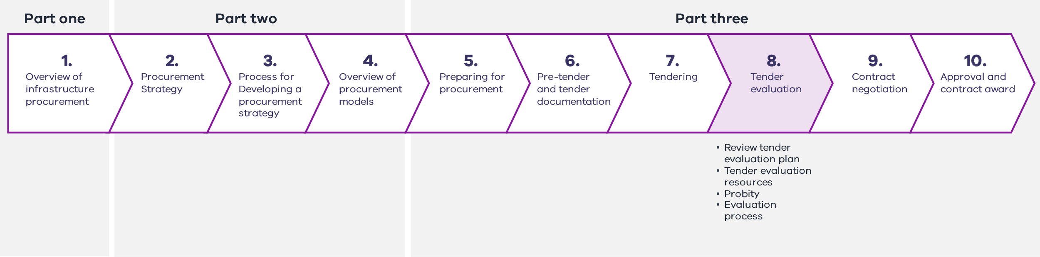
      - Review the tender evaluation plan
A tender evaluation plan should have been developed in the procurement development stage (see Section 6.4 for more information on tender evaluation plans).
The plan should be reviewed to ensure it is comprehensive and accurate, and that the criteria address the project requirements. If changes are required, they must be communicated to suppliers through updated tender documentation prior to the tender closing date.
The tender evaluation plan will include process details such as the timetable for evaluation, as well as requirements for probity, documentation and information management. These details should be communicated to all parties involved in the evaluation process, including the tender evaluation panel and any specialist advisers.
      - Tender evaluation resources
        - Tender evaluation panel
A tender evaluation panel should be established to assess the tenders. The panel should be a cross-functional group and may comprise:
    - members of the procurement team
    - other staff with appropriate skills and experience (for example, departmental staff with a strong and relevant technical background)
    - staff from departments with an interest in the project (for example, when a project has a significant impact on urban planning and amenity, it may be useful to include representatives from Department of Transport and Planning. It may also be appropriate to include a DTF representative)
    - specialist advisers to the procurement team
    - representatives from the user reference group, in particular end users (for example, operator representatives).
The tender evaluation panel will also include a small number of people who are responsible for evaluating the tenders against the mandatory evaluation criteria specified in the invitation to tender (see Section 8.4.5).
        - Subpanel arrangements
For complex evaluations the tender evaluation panel may decide to establish specialist evaluation boards or subpanels to assess specific evaluation criteria such as financial, commercial, technical or legal aspects of the tenders. These subpanels contribute information and analysis to support the overarching tender evaluation panel when they are assessing and scoring complex elements of a proposal.
The commercial manager should chair a commercial or financial subpanel, and membership will include the project manager, a relevant finance officer and other functional specialists. Pricing information should be restricted to these subpanel members, and they must not communicate it to members of other subpanels.
Technical subpanels, which may be established to assess such elements as engineering and design elements of a proposal, should not have access to pricing but may have access to other commercial information when necessary.
      - Probity in tender evaluation
Tender evaluation panel members should not engage in any conduct that could impact a fair and transparent selection process. They must avoid any practice that gives one party an improper advantage over another.
A probity plan should have been prepared during the procurement development phase (see Section 5.4 for more information on probity requirements). The probity plan will guide the management of information and conflicts of interest during the tender evaluation phase.
        - Conflicts of interest
A conflict of interest arises when a tender evaluation panel member has an affiliation or interest that prejudices, or might be seen to prejudice, their impartiality.
Conflicts can be categorised in one of three ways:
    - Actual conflicts – where there is a real conflict. For example, an evaluation panel member has a personal relationship with a tenderer who has submitted a tender or a supplier has advised on early project works and therefore has greater project knowledge than will be provided to other tenderers.
    - Potential conflicts – where future events may result in an actual conflict. For example, a supplier has bid on, and may be awarded, a contract that has competing interests to the project.
    - Perceived conflicts – where circumstances could cause a third party to think there is a conflict of interest. For example, a tenderer has a personal relationship with an employee of the agency delivering the project, however, that employee is not a tender evaluation panel member and is not involved in setting the evaluation criteria. While there is no actual conflict of interest, the personal relationship could create the risk of a perception that the employee was involved in the tender evaluation and is able to influence the decision.
Conflicts of interest do arise, and provided they are identified early and dealt with effectively, they do not represent any wrongdoing.
Failure to declare an interest, even if the individual in question believes there is no actual conflict, can compromise the tender evaluation process and may result in legal challenges. Tender evaluation panel members are required to maintain the highest standards of ethical behaviour during the evaluation period from receipt of tenders to the contract award decision.
Public officials must also comply with the Code of Conduct for Victorian Public Sector Employees.
Tender documentation should include a requirement for all tenderers to identify any conflicts of interest. Conflicts of interest for suppliers may include any of the following:
    - a supplier has been involved in an earlier stage of the project development
    - a supplier has a competing commercial or private interest in the project
    - a current supplier is involved with an interested party with a competing interest
    - a supplier’s affiliations or interests will or may compromise, or has the appearance of compromising, their ability to fulfil their duties in relation to the project
    - a supplier’s impartiality is called into question because of personal, financial or other consideration
    - any situation where a reasonable observer would consider there to be a possibility of bias.
While a tenderer may have a minor conflict of interest that can be managed throughout the process, material conflicts of interest would preclude involvement in the project.
Given this, all tenderers should be checked for any conflicts of interest as a priority. If any conflict is acknowledged, it should be assessed. Where a conflict will result in a supplier being unable to complete a contract without impacting on project process and probity requirements, it should be ruled out and the tender should not be considered in the evaluation process.
      - Evaluation process
        - Evaluation overview
The tender evaluation is usually undertaken in the following general phases:
    - assess for tender conformance, including against any mandatory criteria
    - eliminate non-compliant tenders
    - undertake and identify any necessary tender clarifications
    - assesses each submission against agreed non-price criteria to develop an individual tender assessment result from each tender evaluation panel member
    - review the results of the individual tender assessments and either agree upon or combine to develop an average and final tender assessment result
    - undertake a VfM assessment, comparing the tender evaluation scores against price
    - interview the tenderers (the highest scoring tenderer, or the top two or three tenderers)
    - undertake best and final offers (BAFOs) (if necessary)
    - check references of the two or three highest scoring tenderers.
The probity adviser or auditor should observe the tender evaluation process (if applicable) to ensure consistent and objective assessment.
        - Late, incomplete or amended tenders
Tenders that are not received in strict accordance with the tender documentation requirements fall into the following groups:
    - late tenders, which are received after the time and date set out in the tender documentation
    - tenders that are late due to a technicality, such as a delay in transit beyond a supplier’s control or technical issues with an electronic submission
    - incomplete tenders that lack information necessary for evaluation
    - amended tenders, where a supplier submits an amendment on their own initiative after the time and date set out in the tender documentation.
These tenders should only be considered if there is no reason to doubt the integrity of the supplier involved. The tender evaluation panel should exercise care to avoid probity concerns, such as accusations of bias, and must ensure there is a detailed record of the decision to accept the tender for evaluation.
        - Tender clarifications
So that tenders can be assessed on a like-for-like basis, it may be necessary to clarify aspects of a tender so that all commercial or technical issues are clear and understood.
A single point of contact should be nominated to coordinate tender clarifications and supplier responses. Tender clarifications should be submitted in writing to each tenderer, with records kept of the clarification and the response. Tender clarifications should be resolved and recorded before a final tender evaluation decision is made.
Requests for tender clarifications are likely to be different for each tenderer. Tender clarifications should not be circulated to other tenderers. To do so may result in breaches of confidentiality. To manage any risk of a probity breach through the tender clarification process, all tender clarifications should be overseen by a probity adviser or auditor (if appointed).
        - Alternative proposals
An alternative proposal is a non-conforming tender that a supplier submits alongside a conforming tender.
Alternative proposals are usually submitted when tenderers consider they add value to a procurement, for example, if they propose a solution that better meets procurement requirements than are specified in the tender documentation, or when they incorporate innovation to improve the project outcome.
Alternative proposals must be evaluated in accordance with the framework set out in the tender evaluation plan for such proposals. Ordinarily, this framework only allows consideration of alternative proposals when they accompany a conforming tender.
        - Evaluation of mandatory criteria
Tenderers are required to satisfy several mandatory criteria before they can be awarded a contract, and these criteria should be clearly identified in the tender documentation.
Ministerial Direction and Instruction for Public Construction Procurement 3.7.3 requires agencies to ensure that a tender participant satisfies the criteria before awarding a contract to perform works or construction services.
Where a tender participant has already been assessed against the mandatory criteria as part of a prequalification process (qualifying or requalifying for a register, becoming a member of a supplier panel, or an EOI process), the agency does not need to reassess the tender participant against the criteria, provided they confirm, prior to contract award, that:
      - in the case of a tender participant prequalified on a register or a member of a supplier panel, the tender participant remains on that register or supplier panel
      - in all cases, there has been no material change to the information submitted to satisfy the criteria (whether at the time of prequalification or requalification, or during the EOI process), whether positive or negative, that would affect the tender participant’s ability to satisfy the criteria.
All submissions must wholly conform to these mandatory criteria. When tenders are received, mandatory criteria should be reviewed as a priority, and any submissions that do not conform should be identified and dealt with in accordance with the processes set out in the tender evaluation plan.
Some mandatory criteria are mandated through the Ministerial Directions and Instructions for Public Construction Procurement, and some are project-specific.
Criteria mandated through the Ministerial Directions and Instructions for Public Construction Procurement are:
    - VfM
    - consideration of each supplier’s past performance in delivering works or services
    - occupational health and safety (OH&S) management (as set out in Attachment 1 to Instruction 3.7)
    - industrial relations management (as set out in Attachment 2 to Instruction 3.7).
The criteria relating to OH&S and industrial relations must be satisfied before the supplier can be awarded the contract. If the supplier has already been assessed against those criteria as part of a prequalification process, they do not need to be reassessed through the tender evaluation process.
Project-specific mandatory criteria may include:
    - criteria related to particular design elements or outcomes that must be achieved
    - general criteria related to
      - insurances
      - policy compliance, such as adherence to the Victorian Industry and Participation Policy
      - key contractual elements such as guarantees and warranties.
        - Evaluation of non-mandatory criteria
          - Individual tender evaluation
Each tender evaluation panel member should review the tender submissions in accordance with the probity rules and procurement processes outlined in the probity plan and tender evaluation plan.
Each tender evaluation panel member should individually assess tenders against the weighted evaluation criteria. Panel members should objectively assess the extent to which each submission satisfies each evaluation criterion. A simple scoring mechanism, such as a matrix, should be used to document this assessment process to provide a quantitative tender evaluation result.
The scoring system and the definition of each score should be outlined in the tender evaluation documentation.
An example of a practical scoring mechanism is to assign a score on a scale from zero to five for each evaluation criterion, whereby:
    - zero is scored for submissions that do not meet the evaluation criterion at all
    - five is scored for submissions that exceed the requirements of the evaluation criterion
    - the documentation would clarify whether ‘half marks’ were permitted.
Once each evaluation criterion has been assessed, weightings for each criterion should be applied to the raw scores to achieve a weighted score. The weighted scores should then be added to achieve a total score for each submission.
          - Average (combined) tender evaluation
Once the panel members have individually evaluated each tender, results should be compared and combined to produce a final, average assessment of the tenders. When comparing results, the tender evaluation panel should agree on a score or, where the panel cannot agree, follow the process outlined below:
    - develop a matrix that includes each panel member’s assessment of each submission
    - enter each panel member’s individual scores into the matrix
    - review the data to identify any anomalies (that is, where there is significant variation in the assessment of a particular criterion)
    - discuss anomalies to determine why they have occurred
    - consider reassessment of criteria, if appropriate.
Reviewing individual tender assessments involves discussion and debate to achieve consistency and objectivity, and to provide confidence in the overall result. It is best practice to hold tender evaluation workshops to review individual tender assessments.
Variations in the scores assigned by different panel members are very common. Some people are stricter in their scoring than others. This is acceptable. Generally, the variation is consistent across all assessments and, therefore, does not impact the overall result.
However, considerable variation in scoring can occur for other reasons. These instances should be examined to determine the cause of the variation. For example, one panel member may have missed some information provided and given the submission a low score for that criterion. This can occur when a tenderer has not adhered to the tender response schedules and the information is presented in an unexpected way. In other instances, a panel member may give a submission a high score based on previous experience with the supplier rather than on information provided in the tender. It is essential to discuss any scoring variations so that the panel has a common understanding of the submissions and the resulting scores. It is common for individual panel members to modify their scores after group discussion.
Once the moderation process has been undertaken, individual scores are combined o produce an overall score for each evaluation criterion. The weighted combined scores are then added to produce a final score and ranking for each submission. The preferred tenderer is identified by the highest ranking.
Tender evaluation is a lengthy and resource-intensive process. Adequate time should be assigned for individual assessments and workshop discussions. It is best practice to book individual and group evaluation sessions in panel members’ diaries well in advance, to allow them enough time to complete the evaluation and avoid delays in the process.
        - VfM assessment
Tender evaluation outcomes should not be determined on cost alone. Instead, the focus should be on achieving high service quality for the money expended.
VfM weighs the costs of obtaining the works and services against the benefits they provide.
Acceptance of a tender based solely on the lowest price may result in a lower quality solution. The tenderer may have underpriced the work, which may lead to underperformance, more contract variations, other contract disputes, and an adversarial relationship with the contractor. These issues may lead to project delays, additional costs to the purchaser and a greater risk of project failure.
The tender submissions should be assessed against price and financial information, and the underlying assumptions should be tested, to ensure that the preferred tender is appropriately costed, affordable, financially sustainable and represents VfM.
        - Tender interviews
Once the tender evaluation panel has agreed on the draft tender scores, the preferred tenderer and one or two of the next highest scoring tenderers may be interviewed. The purpose of tender interviews is for the tender evaluation panel to meet the high-ranking tenderers and gather additional information to inform and confirm the tender evaluation results. Tender interviews can be used to:
    - confirm aspects of a bid where an evaluation panel is uncertain
    - confirm the supplier’s knowledge of, and experience and skills in, a particular area.
Tender interviews should be conducted in accordance with the probity plan and should be attended by the probity adviser if one has been appointed.
        - Reference checks
Reference checks should be:
    - conducted for the preferred supplier and the next highest scoring tenderer
    - undertaken by one nominated representative of the tender evaluation panel.
Reference checks should be used to identify or confirm the tenderer’s:
    - involvement and experience in similar projects, particularly the experience of personnel being put forward for the works
    - level of skill and technical expertise in a particular area
    - approach to managing types of risk
    - client management and communication approach
    - professionalism
    - approach to dispute resolution.
        - Tender evaluation report
When the tender evaluation is complete, the tender evaluation team must comprehensively document the results in a final report. The tender evaluation report must document:
    - the results of the moderated individual assessments
    - the results of the final tender assessments
    - the results of the VfM assessment
    - tender clarifications conducted
    - tender interviews conducted
    - the impact of any new information arising from tender clarifications, interviews and reference checks on the final tender assessment
    - a summary of all probity steps, issues and considerations throughout the tender evaluation process
    - the panel’s recommendation for the preferred supplier
    - any additional supporting evidence or reasoning for the recommendation.
It is acceptable to nominate a preferred supplier that did not receive the highest ranking in the tender evaluation process. This commonly occurs when the VfM assessment identifies another (generally high-ranking) bid as offering an acceptable solution at a lower price. It can also occur when tender clarifications, interviews and reference checks provide new information that is unfavourable to the highest-ranked tenderer. However, it is important to comprehensively document the reasoning for recommending a preferred tenderer and provide adequate evidence to ensure a non-contestable result.
        - Best and final offers
Ideally, a preferred bidder is selected after the evaluation process. If a single bidder cannot be identified, but the project steering committee believes a VfM solution can still be achieved, a BAFO process may be used. Providing a VfM outcome can still be achieved, it may be appropriate to use BAFOs when:
    - costs submitted by all bidders are too high
    - a preferred bidder cannot be clearly determined based on the evaluation of RFP or RFT responses against the evaluation criteria
    - all RFP or RFT responses are deficient in one or more areas.
To minimise costs to the private sector and to the Government:
    - only bidders believed capable of delivering the desired results should be invited to participate in the BAFO
    - the BAFO should be completed within a short, well-defined period
    - agencies should request only one BAFO.
The bidders selected for the BAFO process should be provided with detailed questions relating to their proposals and informed of the deficient parts of their proposal.
The bidders are then given the opportunity to revise their bids and eliminate any unacceptable conditions contained in their original proposals. The amended sections are re-evaluated and re-scored according to the evaluation process defined in the invitation to tender and tender evaluation plan. The probity requirements for the tender evaluation phase, as set out in the tender evaluation plan and probity plan, continue to apply during the BAFO.
Markets are generally resistant to BAFO processes, as they increase bidding costs.
      - Tender evaluation phase checklist
Before completing the tender evaluation phase and proceeding to the contract negotiation phase, agencies must ensure that the following tasks have been completed.
Table 15 – Tender evaluation phase checklist
Tender evaluation phase key tasks
ü Confirm membership of, and brief, the tender evaluation panel
ü Identify and manage any conflicts of interest
ü Identify and manage any instances of non-compliance with mandatory criteria
ü Identify and review any alternative proposals
ü Panel members individually review and evaluate the tender submissions
ü Combine and moderate individual evaluations to identify the tender rankings
ü Undertake tender clarifications
ü Undertake tender interviews
ü Undertake reference checks
ü Prepare tender evaluation report
ü Probity auditor signs off
    - Contract negotiation
Figure 25 – Chapter 9 overview
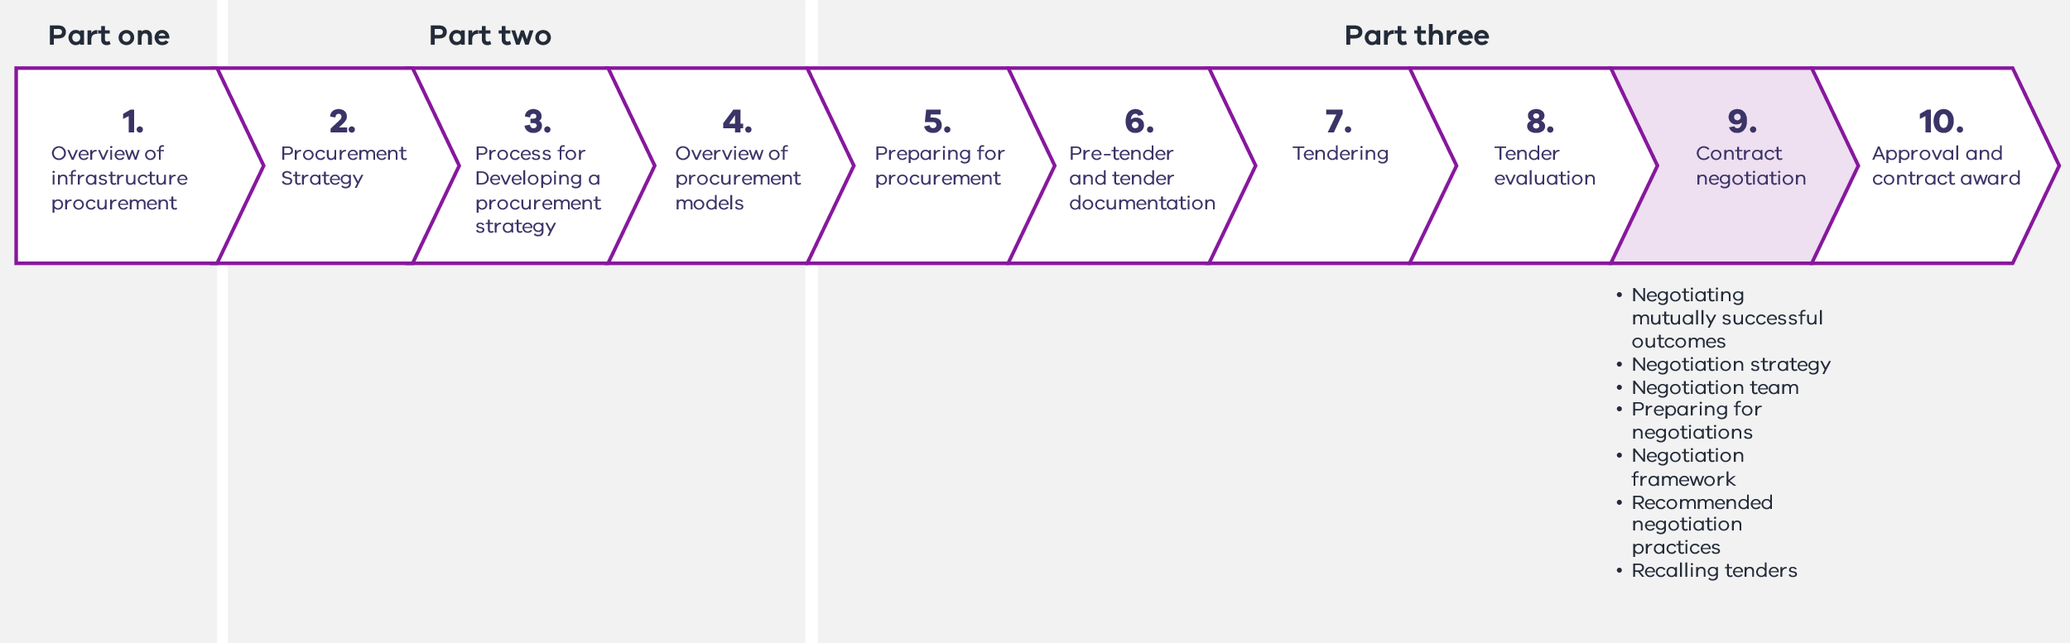
During the negotiation phase, the agency develops a negotiating strategy that identifies each party’s likely interests, sets out the Government’s preferred negotiation outcomes and establishes a negotiating team. The agency then engages with the preferred tenderer to discuss any divergent interests and agree on contract terms and conditions.
      - Negotiating mutually successful outcomes
Negotiation is a strategic discussion between the agency and a tender participant to resolve points of difference in a contract in a way that is acceptable to both parties. Agencies should exhaust negotiations with the preferred tenderer before negotiating with another tenderer unless it is expressly permitted in the tender documents. During the negotiation process, the principal must not trade off differences in tender prices to obtain a lower price or allocate an unreasonable level of risk to the contractor.
Negotiations may be used to explore opportunities to improve the overall VfM outcome of the procurement, for example, to reduce costs or delivery times, achieve a fairer allocation of risk, deliver benefits from innovation or improve the quality of scope items and outputs.
Either party can propose an offer or concession for negotiation. The agency may accept or reject proposals at its discretion (subject to any required approvals). It is in the agency’s interest to ensure contract agreements are mutually satisfactory and provide the basis for a long-term successful relationship between the Government and the contractor. The negotiation outcome should be ‘win-win’ not ‘win-lose’.
The agency should not agree to any proposals or terms that directly conflict with the procurement objectives or impede the Government’s ability to derive VfM from its investment.
Conversely, it should not seek an outcome that is unsustainable for industry. This could result in a poor relationship between the agency and contractor, poor performance and quality or more disputes during the delivery phase. The tenderer might withdraw from the tender process.
At the start of the negotiation process, each party will have its own negotiation objectives and will seek to obtain favourable terms to minimise its financial, legal and operational risks. During the negotiation process, the parties should work through any divergent interests to identify common ground and, where interests conflict, identify outcomes that are fair to both parties.
      - Developing a negotiation strategy
It is important to adequately plan and prepare for negotiations to ensure they run efficiently, anticipate potential challenges and opportunities, and develop favourable responses. This requires considering and reaching internal agreement on the agency’s negotiation objectives and extensively researching the counterparty’s likely issues and priorities.
Prior to commencing negotiations, agencies should develop and document a negotiation strategy that, at a minimum, considers:
    - the likely context and scope of negotiations, particularly any key issues, divergent interests and points of difference that will require agreement before entering into a contract
    - timeframes required to conduct negotiations, including any interim negotiation milestones or negotiation phases with set objectives
    - the Government’s objectives and priorities, including:
      - its position and objectives in relation to issues likely to arise during negotiations
      - its priority interests and corresponding negotiation objectives (these are the key outcomes for the negotiating team to achieve)
      - the best possible, most likely and worst possible outcomes of the negotiations, identifying likely drivers of success or failure
      - any unsatisfactory outcomes that should be avoided
      - alternative options and fallback positions that the Government would consider satisfactory
      - tradeable issues and concessions (issues of relatively low interest to the Government but of high interest to the counterparty that can be conceded in return for agreement on other issues)
    - the counterparty’s interests, objectives and priorities, including:
      - the importance of the relationship with the Government or the agency, including the portfolio of work awarded to the tenderer, other contracts they have been awarded or are tendering for and current relationships
      - their likely issues of primary concern and desired outcomes
      - likely alternative options, counteroffers and tradeable issues
    - an assessment of the strengths and weaknesses of the agency’s position
    - the negotiation approach, including:
      - potential negotiation tactics or techniques to help build rapport, trust and cooperation with the counterparty
      - communication style, tone and language
      - strategies for managing impasses.
      - Establishing the negotiating team
Resourcing for the negotiating team will be determined by the size, type and complexity of the project, its procurement model and the likely extent of negotiations.
It is highly recommended that the project director attends the negotiations, as the individual with authority to commit the agency to agreed outcomes.
Negotiations should be led by a person(s) with sufficient knowledge of the project and the required technical skill to guide discussions. This could be the project director or a commercial or legal adviser.
Legal advisers often attend negotiations, as they will likely update the contract documentation to reflect any agreed outcomes. The negotiation lead may also be supported by commercial and other advisers, and specialist team members, as required.
The negotiating team should be kept as small as possible, with members added on an ‘as-needs’ basis. This facilitates consistency and coordination across the negotiating team. In a large team, some team members may be less prepared than others and act or speak in a manner inconsistent with the negotiation objectives. Or, they may reveal too much information too early. Larger teams may find it harder to react to new information in a coordinated and synchronised way.
      - Preparing for negotiations
The negotiation team should prepare thoroughly for the negotiations, individually and as a team. All members should carefully read and understand the negotiation strategy and confirm they have a clear and consistent understanding of the negotiation objectives and parameters. Prior to commencing negotiations, the project director or negotiation lead should:
    - set clear expectations of how the team behaves during negotiations, including when and how members can contribute to discussions. This may include coordinating how members respond to different situations or proposals as they arise
    - clarify roles assigned to team members (if any)
    - set rules and protocols for how team members communicate and interact with each other during the negotiations. This may include preparing non-verbal cues to communicate responses or decisions during discussions
    - identify any sensitive information that should not be disclosed during the negotiations
    - identify timing and parameters for disclosing information.
      - Agreeing the negotiating framework and protocols
Prior to commencing negotiations, the negotiating team and the preferred tenderer need to set a negotiating framework and protocols to guide discussions. The negotiating framework should include the following:
    - the purpose and status of the negotiations
    - a summary of the key negotiating issues and points of divergence, to focus the discussion on agreed issues, prevent new issues from being introduced and avoid reopening settled issues. The preferred tenderer should only seek to negotiate departures from the contract that were provided with the invitation to tender, as reflected in their submitted proposal
    - an agreed timetable for the negotiation, to prevent delaying tactics and ensure the overall timetable for project implementation is upheld
    - rules of engagement and conduct
      - points of contact and communication protocols
      - meeting protocols such as the timing, location and duration of meetings, the agenda, chairperson, membership and attendance, record keeping and secretariat, expected behaviour, use of devices, time-outs and other formalities
    - an agreed dispute resolution process, including agreed processes for escalating issues, overcoming impasses and terminating negotiations when agreement cannot be reached
    - authority to commit, with both negotiating teams appointing members who have authority to make decisions on behalf of their organisations. The negotiating framework should identify any issues that will require government approval.
      - Recommended negotiation practices
There is a range of effective negotiation processes agencies may use and tailor to their requirements. Projects procured using Whole of Life procurement models may be subject to specific guidance on contract negotiation and tender selection. Agencies should consider the following tips when conducting negotiations.
    - Ensure all significant commercial issues are settled and contract negotiations are finalised before the preferred tenderer is publicly advertised and competitive tension is released. This ensures that the risks and commercial positions presented by a tender can be fully evaluated.
    - Seek a mutually acceptable procurement outcome, recognising that this helps build trust, and establish a positive and collaborative relationship with the preferred respondent.
    - Summarise and record all agreed matters at the end of each meeting. This reduces the risk of issues being revisited and provides clear instructions for drafting contracts.
    - If the project director does not have the authority to approve any aspect of the negotiations, ensure that senior leaders with the appropriate authority are accessible throughout the negotiations.
The outcome of the contract negotiation phase is either:
    - a preferred tenderer is identified, and a final agreed contract price and terms are negotiated
    - no successful tenderer is identified, and a recommendation is made to recall the tender and no contract awarded.
      - Re-calling tenders
If the agency is not able to reach a satisfactory agreement with the preferred tenderer, it may commence negotiations with another tenderer. If no acceptable tender can be identified from the tender process, a tender can be re-called. Any decision to repeat the tendering process should only be made in compelling and unavoidable circumstances. In particular, agencies should avoid re-calling tenders to obtain a better price and should negotiate with the initially preferred tenderer. If a decision is made to re-call a tender, the original tenderers should be advised of the reasons for doing so.
      - Negotiation phase checklist
Before completing the contract negotiation phase and proceeding to the approvals and contract award phase, the following tasks should be completed as required.
Table 16 – Negotiation phase checklist
Negotiation phase key tasks
ü Develop a negotiating strategy outlining the agency’s negotiating priorities, interests and objectives
ü Establish an appropriately resourced and skilled negotiating team
ü Adequately prepare for negotiations
ü Agree on the negotiating framework and protocols with the preferred tenderer
ü Negotiate the contract and commercial terms in accordance with good negotiating practices
    - Approvals and contract award
Figure 26 – Chapter 10 overview
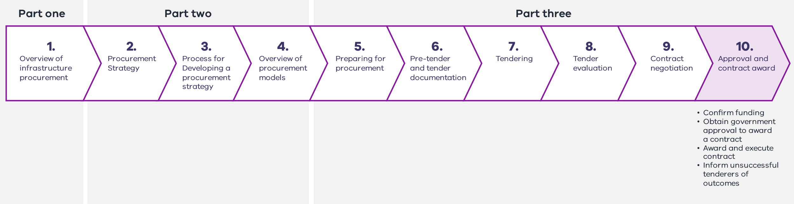
The final phase in the procurement process is obtaining formal approvals to appoint the preferred tenderer to undertake a scope of works and award the contract. This includes obtaining financial and ministerial approvals as required, notifying the successful and unsuccessful tenderers, awarding the contract and establishing contract management arrangements.

Confirming funding
Once the agency has identified a preferred tenderer and agreed on contract terms, it should confirm that the proposal is affordable and within the funding envelope allocated to the project.
If the tendered fee materially exceeds the cost estimate and is not considered affordable within allocated funding, this must be addressed. This may require consideration of value management opportunities and scope reduction options. In some circumstances, it may be appropriate to seek approval of additional funding. A project assurance process should also be undertaken to confirm that the project is ready to proceed to the delivery stage. For HVHR projects, this should include a Gate 4 Gateway Review.

Obtaining government approval to award a contract
Before awarding a contract the agency must obtain formal approval of material contract departures and expenditure commitment from a minister or officer with the appropriate delegated authority.
The approval requirements differ depending on the contract value, asset type and departmental financial management arrangements. Minor works may fall within departmental financial delegations and only require internal approvals. However, most infrastructure projects require ministerial approval. HVHR projects also need the Treasurer’s approval prior to contract award if this is a requirement of the project’s HVHR PAP.
Ministerial Direction and Instruction for Public Construction Procurement 7.1.3 requires agencies to obtain DTF Secretary approval for any material contract departures proposed by a tenderer. Agencies may use their own discretion to accept non-material contract departures requested by tenderers.
Material departures to HVHR contracts are approved through the HVHR process.
All approval submissions should be supported by the tender evaluation report and endorsement from the project director or steering committee. The tender evaluation report should be updated after the negotiation to:
    - outline the tender and evaluation processes and the negotiation outcomes
    - identify any material departures from the approved project scope and confirm that the proposal provides a VfM outcome
    - identify any agreed contract departures or changes to standard commercial terms and conditions, and confirm these have been approved by DTF or the steering committee
    - confirm that the proposal is affordable, that adequate funding is available and the department or agency recommends that the contract is entered into
    - identify any residual risks arising from the procurement process that may inform a decision to award a contract or should be monitored throughout the delivery stage.
      - Awarding and executing the contract
Once the necessary approvals have been obtained, the agency can award and execute the contract. Agencies should take reasonable steps to expedite this process and notify unsuccessful tenderers of the procurement outcome. There are four main activities for this step:
    - awarding the contract
    - executing the contract
    - establishing contract management arrangements
    - making payments on contract execution
        - Awarding the contract
The successful tenderer must be informed in writing of the agency’s intention to enter into a contract for the tendered works. The successful tenderer must confirm their acceptance of the offer in writing.
The agency should undertake any administrative requirements (for example, obtaining a bank guarantee or other contract securities).
        - Executing contract
A suitable date and location are nominated for contract execution, where the government representative signs the contracts after all other parties have signed.
The contracts should be executed by appropriately authorised personnel. Contracts for major projects are often signed by ministers or senior staff with delegated authority.
It is common practice to make a public announcement of the contract and the successful bidder when contracts have been executed. Media coverage of the contract signing may be involved. Be mindful of appropriately timing any announcements, particularly when dealing with companies listed on a securities exchange that may need to manage additional accountabilities to shareholders.
        - Contract management arrangements
The agency should ensure that appropriate arrangements are in place to administer and manage the contract and relationship with the contractor. The nominated contract manager(s) should thoroughly understand the tender process and its outcome, including the strategy embodied in the contract and the reasons for particular contractual conditions.
        - Payments on contract execution
Some contracts may include a deposit or mobilisation payment on contract execution. Ensure that appropriate paperwork is completed to allow for this.
      - Informing unsuccessful tenderers of the outcome
At the conclusion of a tender process for construction works or services, Ministerial Direction and Instruction for Public Construction Procurement 8.1 requires agencies to inform all tender participants of the outcome.
This step should be undertaken prior to any public announcement or media coverage of the contract execution.
        - Post-tender interviews
Ministerial Direction and Instruction for Public Construction Procurement 8.1 requires agencies to offer a debrief to all tender participants at the conclusion of a tender process and, if the offer is accepted, ensure a debrief is provided promptly, in accordance with the requirements set out in the Instructions.
The purpose of debriefing is to help tender participants understand the strengths and weaknesses of their submission and contribute to developing market capability.
The tender evaluation report should be the basis for debriefing. Feedback must be objective, consistent with the evaluation criteria, and focus on the bidder’s performance. Consider the following aspects in the debrief sessions.
    - Probity: The debrief sessions are confidential and must be conducted in accordance with relevant probity protocols. They should be face-to-face discussions. No written feedback should be provided. Feedback is restricted to comments that pertain specifically to the performance of the tenderer in relation to the evaluation criteria and should not refer to, or compare with, other tenders or tenderers.
    - Timing: The debrief sessions should be held in a timely manner following contract award or financial close. It is inappropriate to hold debrief meetings before the contract has been finalised.
    - Attendees: The debrief sessions should be conducted by senior members of the project team with sufficient understanding of the commercial, design and technical aspects of the tenders and the evaluation process to provide targeted, knowledgeable feedback. The sessions should be chaired by the project director, and, ideally, the same project team members should attend all debrief sessions. The tenderer is represented by a single person, unless it is a joint venture, in which case a representative from each joint venture partner may attend. When accepting the invitation for a debriefing, the tenderer must nominate their representative(s).
    - Agenda: An agenda should be prepared as far in advance as practicable, and the unsuccessful tenderer should be asked to identify issues they wish to discuss, to allow the parties to prepare. The typical format is for the agency representative(s) to describe:
      - the selection criteria and subcriteria, and the reasons they were selected
      - the weightings, and the reasons they were chosen
      - features of the tenderer’s submission that led to a favourable or unfavourable assessment against each criteria and subcriteria.
The tender participant can ask questions to clarify the agency’s perception of their submission. They must not ask about other tenderers’ submissions, or solicit comparisons with other tenderers. If they do so, the agency representatives should decline to answer.
        - Managing complaints
Ministerial Direction and Instruction for Public Construction Procurement 8.3 requires agencies to establish appropriate processes to respond to complaints raised by tender participants (and potential participants) about the conduct of public construction procurement by the agency.
      - Approvals and contract award phase checklist
Agencies need to complete the following tasks, bfore finalising the procurement stage and starting project delivery,.
Table 17 – Approvals and contract award phase checklist
Approvals and contract award phase key tasks
ü Confirm funding
ü Obtain government and financial delegate approvals
ü Award and execute the contract
ü Inform unsuccessful tenderers of the outcome
ü Offer and undertake post-tender debriefs

Appendices
- – Legislation and policy
Procurement principles key
Procurement principle
Value-for-money (VfM)
Accountability commensurate with appropriate levels of authority and responsibility
Transparency and competition
Probity
Scalability and efficiency
Building skills and capability
Continuous improvement

Key legislation/policy | Purpose | Impact on construction procurement/infrastructure delivery | Procurement stage
Legislation
Key enabling legislative frameworks and instruments: Primary legislation that provides the legal framework for infrastructure procurement and construction in Victoria
Financial Management Act 1994 (Vic) (FMA) | Drives accountability for prudent financial management in the public sector  Outlines the processes that must be used by public sector agencies in managing and expending public monies | This legislation requires the Treasurer and Assistant Treasurer to account to Parliament for the Government’s overall financial performance, including delivery of the Government’s capital program.  DTF administers the FMA and supports the Treasurer and Assistant Treasurer to acquit their responsibilities under the FMA for prudent management of government finances.  The FMA requires agencies and responsible ministers to govern and be accountable for financial management, performance and risk management in relation to the expenditure of public monies, including in relation to the procurement of infrastructure.  Clause 23D sets out principles for sound financial management that agencies must apply when undertaking procurement activities to prudently manage financial risks.  Part 7B governs the rules for obtaining land for the construction of any public works or infrastructure.  https://www.legislation.vic.gov.au/in-force/acts/financial-management-act-1994 | Whole of investment lifecycle
Standing Directions 2018 under the Financial Management Act 1994  Instructions Supporting the Standing Directions 2018 under the Financial Management Act 1994 | Provides agencies with supplementary guidance for complying with the FMA  Provides more detailed mandatory requirements, processes and financial controls to address specific areas of accountability and risk | The directions and instructions require agencies and responsible ministers to be accountable for setting and delivering appropriate priorities and strategic initiatives, and promote and regularly review the proper use and management of public resources, including infrastructure procurement.  They require portfolio departments to support their responsible ministers in the financial oversight of portfolio agencies.  They require DTF to scrutinise and provide advice to the Treasurer and Assistant Treasurer on government financial and resource management issues, including the assurance of infrastructure investments.  Section 4 of the Standing Directions 2018 and Instruction 4.2.1 outline the responsibilities of the accountable officer (chief operating officer or equivalent) in ensuring that the procurement of assets, goods and services is compliant with the FMA.  They set out requirements that agencies must address when acquiring assets, including complying with relevant legislation, standards, policies and funding arrangements, achieving VfM, understanding and engaging the market, encouraging open and fair competition, supporting probity, transparency and accountability, and managing risks appropriately.  They set out requirements for contract management and performance. They also require agencies to comply with Victorian Government Purchasing Board requirements when procuring goods and services in relation to the delivery of infrastructure.  Section 4.2.3 requires agencies to apply the Victorian Government’s Asset Management Accountability Framework, which also includes requirements for asset acquisition.  Section 4.2.4 requires agencies to apply the Ministerial Directions and Instructions for Public Construction Procurement in Victoria, issued under the Project Development and Construction Management Act 1994 (Vic).  Section 4.3 requires agencies to apply the Resource Management Framework issued by DTF, which outlines government and public sector planning, budgeting, service delivery, accountability and review expectations.  https://www.dtf.vic.gov.au/financial-management-government/standing-directions-2018-under-financial-management-act-1994  https://www.dtf.vic.gov.au/sites/default/files/document/Standing-Directions-2018-Instructions-Updated-Dec2019.pdf | Whole of investment lifecycle
Annual Appropriations Bill | Enacted each year to allow the appropriation of money out of the Consolidated Fund for the ordinary annual services of the Government for the financial year | This annual Bill facilitates a specified amount of public money being appropriated to each department, including funding for any asset proposals approved in the annual state budget.  The Bill is supported by annual publication of budget papers that detail the goods and services that are to be delivered with the appropriation.  https://www.dtf.vic.gov.au/sites/default/files/2018-01/Budget%20Operations%20Framework%20-%20February%202017.pdf | Whole of investment lifecycle
Public Administration Act 2004 (Vic) | Provides a framework for good governance in the Victorian public sector to ensure the public service serves the public interest | This legislation requires agencies undertaking procurement activities to:  - uphold the highest standards of public service conduct and integrity  - ensure the public service is effective and impartial in making procurement decisions  - ensure procurement decisions serve the public interest.  https://www.legislation.vic.gov.au/in-force/acts/public-administration-act-2004/083 | Whole of investment lifecycle
Project Development and Construction Management Act 1994 (Vic) | Facilitates project development and governs public construction in Victoria | Under this legislation the Assistant Treasurer sets standards and issues directions for public construction. It provides the legislative framework for procurement, tendering and contracting procedures and practices for public construction in Victoria.  https://www.legislation.vic.gov.au/in-force/acts/project-development-and-construction-management-act-1994/046  The MTPF Act and the Development Victoria Act 2003 (Vic) represent alternative enabling legislation for certain projects. They build on this legislation by providing a streamlined approach to seeking planning and environmental assessments and approvals | Tendering, tender evaluation, contracting and contract management
Ministerial Directions and Instructions for Public Construction Procurement in Victoria | Prescribes detailed principles and procedures that agencies must comply with when procuring public construction works and services, including requirements for tendering and contracting practices | These directions and instructions require practitioners undertaking construction procurement to:  - embed principles for public construction procurement in all procurement processes (see Section 1.2 Principles for government procurement)  - comply with International agreements where applicable  - undertake appropriate planning and preparation prior to conducting a procurement  - promote competition and contestability in procurements by setting thresholds and requirements for open, selective or limited tendering  - promote efficiency in the tender process and reduce the time and cost of tendering for both industry and Government  - ensure open and fair competition by issuing the market with tender notices before and at commencement of a tender process  - provide sufficient time for the market to respond to tenders  - use model tender documentation designed for use with a Victorian Public Construction Contract where appropriate  - ensure tender documentation clearly sets out tender terms and conditions  - disclose tender evaluation criteria  - prepare a tender evaluation plan outlining processes and resources for assessing tenders  - apply appropriate probity and public sector values throughout the procurement  - publish details of procurements and contracts  - use Victorian Public Construction Contracts where appropriate  - debrief tender participants  - assess supplier performance.  https://www.dtf.vic.gov.au/public-construction-policy-and-resources/ministerial-directions-and-instructions-public-construction-procurement | Tendering, tender evaluation, contracting and contract management
International trade agreements | Reduces or eliminates barriers to trade between Australia and other economies, including providing businesses in other economies with non-discriminatory access to government procurement activities | These require agencies to comply with rules, procedures and transparency requirements for government purchasing.  The impacts on tendering conditions may include:  - requiring tenders to be accessible to the open market, restricting use of select tendering processes  - prescribing the length of time tenders must remain open.  https://www.dfat.gov.au/trade/about-ftas/about-free-trade-agreements | Tendering
Audit Act 1994 (Vic) | Enables the Victorian Auditor-General to conduct and report on financial and performance audits in the Victorian public sector | Under this legislation, infrastructure programs, projects or procurements may be subject to performance audits by the Victorian Auditor-General’s Office.  https://www.legislation.vic.gov.au/in-force/acts/audit-act-1994 | Whole of investment lifecycle
Major Transport Projects Facilitation Act 2009 (Vic) (MTPF Act) | Facilitates the development and procurement of major transport projects | This legislation facilitates the development of major transport projects and drives efficiencies in PDDD activities.  The Premier of Victoria is responsible for declaring transport projects under the MTPF Act.  The MTPF Act’s planning assessment and approval provisions seek to streamline the assessment and approvals processes and provide a range of planning and environmental approvals for a project in a single approval decision (see Parts 3 and 8 of the MTPF Act).  The MTPF Act’s project delivery provisions provide a range of project delivery powers governing land acquisition and assembly, land management, road management, utilities and a range of other facilitating provisions.  https://www.legislation.vic.gov.au/in-force/acts/major-transport-projects-facilitation-act-2009 | Whole of investment lifecycle
Development Victoria Act 2003 (Vic) | Facilitates the development and procurement of major projects | This legislation establishes Development Victoria for the purpose of carrying out, managing or coordinating property development and social and economic capital works projects, particularly those that seek to optimise the social and economic value of surplus and underutilised Crown land.  It enables Development Victoria to provide technical and commercial advice to other agencies in respect of property development and social and economic capital works projects.
Other legislation: Secondary legislation that can impact on aspects of infrastructure and construction procurement.
Procurement practitioners should consider what legislation will impact on their investment and ensure any requirements are captured in the procurement plan, due diligence and project, tender and contract documentation.
Victorian
Aboriginal Heritage Act 2006 (Vic) | Ensures that Traditional Owners have the requisite regulatory support to protect their cultural heritage | This legislation provides for the protection of Aboriginal cultural heritage and Aboriginal intangible heritage in Victoria and empowers Traditional Owners as protectors of their cultural heritage.  It strengthens the ongoing right to maintain the distinctive spiritual, cultural, material and economic relationship of Traditional Owners with the land and waters and other resources with which they have a connection under traditional laws and customs.  It requires the development and approval of a Cultural Heritage Management Plan for all components of the project that require an Environmental Effects Statement to be prepared, or that involve a high-impact activity in an area of cultural heritage sensitivity.  https://content.legislation.vic.gov.au/sites/default/files/2023-05/06-16aa027-authorised.pdf | PDDD and site acquisition
Building Act 1993 (Vic)  Building Regulations 2018 | Regulates building construction, building standards and maintenance of specific building safety features | This legislation requires all building work in Victoria to comply with national building standards and technical requirements for the design and construction of buildings and other structures, including requirements for building permits, building inspections, occupancy permits and maintenance of buildings.  Agencies should ensure tender documents clearly outline any requirements under the Building Act that will be transferred to the contractor, for example, arranging building inspections and occupancy permits.  The Act also includes requirements when alterations to existing buildings occur including in relation to building code compliance requirements (Regulations 233).  https://www.legislation.vic.gov.au/in-force/acts/building-act-1993/136  https://www.vba.vic.gov.au/building/regulatory-framework | Tendering, tender evaluation, contracting and contract management
Building and Construction Industry Security of Payment Act 2002 (Vic) | Entitles parties undertaking construction work, or providing related goods and services, to receive fair payment, including identifying appropriate milestone payments, and prompt payment, with interest payable on late payments | This legislation requires agencies to ensure construction contracts adequately and fairly address contractor payment terms, penalties and related dispute processes. The Act establishes default payment terms where a contract is silent.  It requires that public construction contracts must not include ‘pay when paid’ or ‘pay if paid’ clauses in subcontracts, or amendment of clauses relating to payment timing in standard subcontracts.  https://www.legislation.vic.gov.au/in-force/acts/building-and-construction-industry-security-payment-act-2002/012 | Contract management
Climate Change Act 2017 (Vic) and related climate change initiatives | Introduces policy objectives and guiding principles to embed climate change in government decision-making | This legislation requires agencies to consider greenhouse gas emission reduction and climate change adaptation and resilience when designing and delivering infrastructure.  https://www.climatechange.vic.gov.au/legislation/climate-change-act-2017  https://www.climatechange.vic.gov.au | Business case, PDDD, project development and design, tendering
Crown Land (Reserves) Act 1978 (Vic) | Enables the Government to temporarily or permanently reserve Crown land for public purposes, appoint committees of management to manage reserved land for its given purpose or revoke reservations on Crown land | This legislation enables the Government to temporarily or permanently reserve Crown land for specific public purposes and for the revocation of any reservations.  It provides ministerial powers to purchase and acquire land, vest land with trustees and appoint Committees of Management to manage land.  https://www.legislation.vic.gov.au/in-force/acts/crown-land-reserves-act-1978 | PDDD, site readiness
Environment Effects Act 1978 (Vic) | Requires proposed projects or works that could have a significant effect on the environment to be assessed prior to commencement | This legislation enables the Minister for Planning to determine that an Environment Effects Statement should be prepared when a project is likely to have adverse effects on the environment.  Agencies should first consider and identify an Environmental Effects Statement (EES) in the business case. Requirements, issues and risks identified in the EES should be included in the procurement plan. Environmental due diligence should be undertaken in the tender development phase as required. Tender and contract documentation must identify and address any requirements of the EES.  https://www.legislation.vic.gov.au/in-force/acts/environment-effects-act-1978  https://www.planning.vic.gov.au/environmental-assessments/environmental-assessment-guides/environment-effects-statements-in-victoria | Business case, PDDD, tendering, contracting and contract management
Gender Equality Act 2020 (Vic) | Drives positive action towards achieving workplace gender equality in the public sector | This legislation requires agencies to conduct a gender impact assessment when undertaking infrastructure procurement. This involves assessing how the project or proposal meets the needs of people of different genders, addresses gender inequality and promotes gender equality.  https://www.genderequalitycommission.vic.gov.au/about-gender-equality-act-2020 | Business case, project approval
Heritage Act 2017 (Vic) | Provides for the protection, conservation and registration of places and objects of cultural heritage significance | This legislation requires agencies to preserve land, buildings or other improvements and artefacts of cultural heritage significance.  Agencies should undertake due diligence of heritage assets prior to tender and ensure heritage issues and risks are considered and addressed in the procurement plan. Any heritage considerations should be outlined in the tender and contract documentation where relevant.  https://www.legislation.vic.gov.au/in-force/acts/heritage-act-2017  https://www.heritage.vic.gov.au/about-us/legislation-and-regulations | PDDD, tendering, contracting, contract management
Land Act 1958 (Vic)  Victorian Government Land Use policy and guidelines | Provides a framework for the management of Crown land, including leasing and sale | This legislation sets out processes and procedures that agencies must follow when conducting the sale of Crown land, including to another public authority, or when managing or terminating leasing arrangements on Crown land sites. https://www.legislation.vic.gov.au/in-force/acts/land-act-1958  The Act is operationalised through the Victorian Government Land Use policy and guidelines, which provide a framework and guiding principles for government decision-making on land use.  https://www.land.vic.gov.au/government-land/government-land-advice/policy-and-guidelines | PDDD, site acquisition, early works
Local Jobs First Act 2003 (Vic) (LJF)  Local Jobs First Agency Guidelines | Leverages procurement activities to help develop local industries, create jobs and boost economic activity across Victoria | This legislation requires agencies to set minimum local content requirements on projects that meet value thresholds.  Agencies must apply the Major Project Skills Guarantee to support opportunities for apprentices and trainees to projects that meet value thresholds.  Agencies must notify prospective bidders about LJF requirements in tender documents, including expressions of interest, requests for proposals/tenders and other processes, using the model clauses.  Agencies must monitor compliance and reporting of LJF requirements.  https://www.legislation.vic.gov.au/in-force/acts/local-jobs-first-act-2003  https://localjobsfirst.vic.gov.au/agency-guidance | Tendering, tender evaluation, contracting, contract management
Marine and Coastal Act 2018 (Vic) | Establishes an integrated and coordinated whole of government approach to protecting and managing Victoria’s marine and coastal environment | Under this legislation agencies must obtain consent from the Minister for the Environment to use, develop or undertake works on marine and coastal land.  https://www.legislation.vic.gov.au/in-force/acts/marine-and-coastal-act-2018 | PDDD, site acquisition, early works
Occupational Health and Safety Act 2004 (Vic) | Prevents work-related death, injury and disease in workplaces | This legislation requires agencies to adequately consider health and safety requirements and issues throughout project planning, procurement and delivery.  During the procurement stage, general safety requirements, along with site or project-specific OH&S risks and issues, should be identified in tender documentation for response. Tender evaluation criteria should include safety criteria as appropriate for the investment. The tender evaluation process should consider OH&S.  https://www.legislation.vic.gov.au/in-force/acts/occupational-health-and-safety-act-2004 | Tendering, contracting, contract management
Professional Engineers Registration Act 2019 (Vic) (PER Act) | Ensures professional engineering services are provided only by suitably qualified and experienced engineers | This legislation requires agencies to ensure any engineers they engage to provide professional engineering services in the areas of structural, civil, electrical, mechanical and fire safety engineering are registered and endorsed on the Professional Engineers Register unless they work under direct supervision or only in accordance with a prescriptive standard.  To provide professional engineering services in the building industry, a professional engineer must be both registered and endorsed in the relevant area of engineering.  Registration is the process by which individuals become registered professional engineers under the PER Act.  Endorsement is a separate process and authorises a registered professional engineer to engage in the building industry.  A professional engineer who is registered but not endorsed cannot provide professional engineering services in the building industry.  https://www.legislation.vic.gov.au/as-made/acts/professional-engineers-registration-act-2019 | Tendering, contract management
Planning and Environment Act 1987 (Vic) | Establishes a framework for planning the use, development and protection of land | Under this legislation agencies must comply with local planning requirements when the investment has land use and development considerations, including:  - planning scheme amendments  - obtaining planning permits or certificates  - planning infringements and penalties.  Planning issues and risks should be first considered and identified in the business case. These should be reassessed and addressed in the procurement plan. Planning due diligence should be undertaken in the tender development phase (if not previously undertaken), and any planning considerations should be outlined in the tender documentation.  https://www.legislation.vic.gov.au/in-force/acts/planning-and-environment-act-1987 | PDDD, tendering, contracting, contract management
Sale of Land Act 1962 (Vic) | Provides a framework for the sale of freehold land | This legislation sets out processes and procedures that agencies must follow when conducting the sale or purchase of freehold land.  https://www.legislation.vic.gov.au/in-force/acts/sale-land-act-1962/166 | PDDD, site acquisition, early works
Subdivision Act 1988 (Vic) | Sets out procedures for the subdivision and consolidation of land and the creation and removal of easements or restrictions over land | This legislation sets out processes and procedures agencies must follow when an infrastructure procurement includes land use and development considerations, for example, land subdivisions and consolidations.  Land subdivisions and consolidation issues and risks should be identified in planning due diligence. They should be addressed in the procurement plan, and any subdivision considerations that may inform tender responses should be outlined in the tender documentation.  https://www.legislation.vic.gov.au/in-force/acts/subdivision-act-1988/080 | PDDD, site acquisition, early works
Traditional Owner Settlement Act 2010 (Vic) | Allows the Victorian Government to recognise Traditional Owners and certain rights in relation to access, ownership and management of Crown land and provides an out-of-court settlement of native title | This legislation enables the Victorian Government to enter into a settlement with Traditional Owners in relation to Crown land. Under the Act, a settlement package can include:  - a recognition and settlement agreement to recognise a traditional owner group and certain traditional owner rights over Crown land  - a land agreement that provides for grants of land in freehold title for cultural or economic purposes, or as Aboriginal title to be jointly managed in partnership with the Government  - a land use activity agreement that allows Traditional Owners to comment on or consent to certain activities on public land  - a funding agreement to enable Traditional Owner corporations to manage their obligations and undertake economic development activities  - a natural resource agreement to recognise Traditional Owners’ rights to take and use specific natural resources and provide input into the management of land and natural resources.  In return for entering into a settlement, Traditional Owners must agree to withdraw any native title claim, pursuant to the Native Title Act 1993 (Cth) and not to make any future native title claims.  https://www.legislation.vic.gov.au/in-force/acts/traditional-owner-settlement-act-2010/025 | PDDD, site acquisition, early works
Transfer of Land Act 1958 (Vic) | Provides a framework for alienating Crown land | This legislation sets out processes and procedures agencies must follow when the investment requires the alienation of Crown land to freehold land.  https://www.legislation.vic.gov.au/in-force/acts/transfer-land-act-1958/179  https://www.land.vic.gov.au/land-registration/for-individuals/about-types-of-land-in-victoria | PDDD
Victorian Civil and Administrative Tribunal Act 1998 (Vic) | Establishes the Victorian Civil and Administrative Tribunal as a ‘one-stop-shop’ for dealing with disputes | This legislation sets out obligations, processes and procedures agencies must follow when managing disputes relating to land use or building work that are referred to the Victorian Civil and Administrative Tribunal.  https://www.legislation.vic.gov.au/in-force/acts/victorian-civil-and-administrative-tribunal-act-1998/134 | Project design, stakeholder management
Commonwealth
Environmental Protection and Biodiversity Conservation Act 1999 (Cth) | Protects and conserves nationally and internationally important flora, fauna, ecological communities and heritage places | This legislation requires any investment that involves a development that may impact on environmental factors of local or state significance to be referred for environmental assessment and approval.  https://www.legislation.gov.au/Details/C2016C00777 | PDDD, tendering, contracting
National Building Code | Sets the minimum required level for safety, health, amenity, accessibility and sustainability in the construction of certain buildings | The code encourages productivity and lawful workplace relations on building sites. It sets out the Australian Government’s expected standards for building contractors or building industry participants involved in Commonwealth-funded construction projects.  https://ncc.abcb.gov.au | Tendering, contract management on Commonwealth-funded projects
Trade Practices Act 1974 (Cth) | Protects consumers from unfair business practices | This legislation prohibits misleading and deceptive conduct in public sector procurements by both public and private sector organisations. It prohibits price fixing, boycotting or anticompetitive behaviour.  During tenders, agencies must seek to provide complete and accurate information, and not provide any incomplete, incorrect or misleading information.  https://www.australiancompetitionlaw.info/legislation/tpa1974 | Tendering
Policy frameworks
Victorian Government policies
Asset Management Accountability Framework | Outlines a set of requirements for the lifecycle management of assets | The framework requires agencies to ensure procurements align with its service delivery requirements and asset management strategy.  It requires agencies to consider market conditions and capacity, optimal procurement model and supply chain issues when developing a procurement strategy.  It encourages agencies to consider and address whole-of-life requirements in specifications and procurement.  https://www.dtf.vic.gov.au/infrastructure-investment/asset-management-accountability-framework | Whole of investment lifecycle
Building Equality Policy | Creates training and employment opportunities for women through government procurement on building, infrastructure, civil engineering and any other capital works projects | The policy requires contractors to meet targets for female participation in trades and apprenticeships on government construction projects and to develop and comply with gender equality action plans (GEAPs).  Agencies must include contractor obligations for gender equality, including targets and GEAP requirements, in tender and contract documentation.  https://www.vic.gov.au/building-equality-policy | Tendering, contracting, contract management
DataVic Access Policy | Provides public sharing of, and access to, government data to support research and education, promote innovation and to support evidence-based decision-making in the public sector | The policy requires agencies to mandate policy compliance in contracts to ensure any datasets created under the contract are in the required format and can be made publicly accessible where appropriate.  https://www.data.vic.gov.au/datavic-access-policy | Contracting, contract management
Digital Asset Policy | Drives increased use of digital technologies and promotes increased productivity in the construction of government assets | The policy identifies how to implement and manage digital processes and technologies, such as Building Information Modelling and Digital Engineering, on government investments.  https://www.vic.gov.au/digital-asset-policy | Contracting, contract management
Fair Jobs Code | Promotes secure employment and fair labour standards, and ensure compliance with employment, workplace and industrial laws | The code requires agencies to ensure suppliers hold a Fair Jobs Code Pre-Assessment Certificate when tendering for contracts that meet value thresholds.  Agencies must ensure subcontractors delivering work hold a Pre-Assessment Certificate where works meet value thresholds.  Agencies must ensure tenderers prepare a Fair Jobs Code Plan when tendering for procurements where the contract meets value thresholds.  https://www.buyingfor.vic.gov.au/fair-jobs-code-suppliers-and-businesses | Tendering, contracting, contract management
Fair Payments Policy | Prescribes payment terms for contracts that do not exceed $3 million (GST excl.) to support small and medium businesses by increasing the timeliness and certainty of cash flow | The policy requires agencies to comply with 10-business-day payment terms for contracts entered into from 1 January 2021 where the value of the goods or services does not exceed $3 million.  Penalties apply for late payment.  A standard clause has been drafted for use by departments and agencies. Each agency should consult its legal officers to ensure that the clause is appropriately tailored on a case-by-case basis.  https://djsir.vic.gov.au/what-we-do/employment-and-small-business/contracts-for-fair-payments | Contract management
Prohibition of High-Risk External Wall Cladding Products Declaration | Reduces the risk of death or serious injury to building occupants, members of the public and occupants of neighbouring buildings and/or severe damage to property in the event of a fire | This declaration requires agencies to ensure that their contracts prohibit the installation or design of prohibited cladding products into any building work where applicable.  https://www.planning.vic.gov.au/building-policy/cladding-rectification-program | Contracting, contract management
Victorian Protective Data Security Standards | Protects public sector information across all security areas including governance, information, personnel, information and communications technology and physical security | The standards require contracted service providers with direct or indirect access to information to adhere to the standards.  https://ovic.vic.gov.au/information-security/standards | Contracting, contract management
Recycled First Policy | Seeks to optimise and accelerate the use of recycled and reused materials on Victorian transport infrastructure projects to help achieve sustainable outcomes  Encourages innovation in transport infrastructure construction to improve quality and accelerate the implementation of new Victorian recycled products  Informs Government’s understanding of future demand for recycled content in infrastructure delivery and the corresponding supply chain, market development issues and opportunities | This policy requires all tenderers on Victorian major transport projects to demonstrate within their bid how they will optimise the use of recycled and reused materials at the levels allowed under current standards and specifications.  Tenderers can also identify opportunities to trial new innovative products or opportunities to boost recycled and reused material quantities within existing standards and specifications.  Successful tenderers must report against their Recycled First commitments during delivery. This ensures recycled and reused materials are considered over virgin materials and will divert valuable materials from landfill.  The Recycled First Policy allows for continuous improvements to transport standards and specifications, and research and development. It will develop new markets and create greener, more sustainable transport infrastructure outcomes.  https://bigbuild.vic.gov.au/about/ecologiq/recycled-first-policy | Tendering, tender evaluation, contract management
Resource Management Framework | Explains the legal and policy framework that underpins resource management, budgeting and reporting processes | This framework is mandated for portfolio departments.  It describes the appropriations framework used annually to support government asset investment decision-making and resource allocation.  Section 3.5 sets out mandatory requirements for managing the departmental asset investment program, including staged release of funding on HVHR projects and accessing and managing central contingencies.  https://www.dtf.vic.gov.au/planning-budgeting-and-financial-reporting-frameworks/resource-management-framework | Business case, approvals, project governance and assurance
Social Procurement Framework | To leverage procurement activities to generate social value above and beyond the value of the goods, services or construction being procured | This framework requires agencies to include social procurement objectives in procurements that meet value thresholds and report against outcomes achieved.  Model clauses have been prepared to assist with including content related to the Social Procurement Framework in invitations to supply and contracts between the Government and preferred supplier(s).  https://www.buyingfor.vic.gov.au/social-procurement-department-and-agency-reporting-requirements-buyers | Tendering, tender evaluation, contracting, contract management
Supplier Code of Conduct | To ensure the Government contracts with suppliers who uphold high standards in relation to integrity, ethical conduct (including conflicts of interest, gifts and hospitality), human rights, OH&S and environmental management | The code of conduct requires agencies to ensure invitation to supply documentation requires suppliers to complete and return the Supplier Code of Conduct commitment letter confirming they will aspire to meet the Government’s minimum expectations for supplier conduct.  It requires agencies to:  - report and manage any breaches of the Code during contract management appropriately  - identify and appropriately manage any actual or perceived conflicts of interest when conducting procurements  - conduct themselves with the highest standards of integrity, impartiality and accountability and to undertake procurements without favouritism, bias or for personal gain  - appropriately handle any offers of gifts, benefits and hospitality.  Agencies may include aspiration to meet the code of conduct as a key performance indicator within a contract management strategy.  https://www.buyingfor.vic.gov.au/supplier-code-conduct  https://www.buyingfor.vic.gov.au/supplier-code-conduct-toolkit-and-document-library | Tendering
Tip Truck Policy | Mandates minimum rates of pay for tip truck owner drivers working on government-funded construction projects | This policy requires that agency contracts require the contractor to ensure that any tip truck driver engaged in excavation work on a project, either directly or indirectly through one or more subcontractors, is paid according to the tip truck policy.  Model clauses are available to support agencies enforce this requirement.  https://www.dtf.vic.gov.au/ministerial-directions-and-instructions-public-construction-procurement/contractual-terms-and-conditions-direction-and-instruction-72 | Contracting, contract management
Victoria’s Value Creation and Capture Framework (VCC) | To maximise the value and benefits achieved on an investment and/or to identify and leverage revenue streams that can be used to partially or wholly fund the investment | The framework requires agencies to consider VCC opportunities for any relevant asset investment proposals submitted for budget funding. Agencies should:  - use market engagement processes to test the deliverability of VCC opportunities  - ensure VCC objectives, outcomes and requirements are clearly outlined in all procurement and contract documentation. The tenderer can provide additional VCC opportunities where appropriate. It may also be appropriate to allow tenderers to propose alternative approaches that offer value to the Government, in addition to lodging a compliant tender offering  - include a separate tender criterion for evaluating any relevant VCC mechanisms. The tender evaluation process should evaluate the extent to which a proposal will achieve the VCC objectives and outcomes  - identify early if a VCC element is likely to influence contractual negotiations  - provide the Government with adequate information about the delivery of the VCC plans when seeking necessary government approvals.  www.vic.gov.au/value-creation-and-capture-framework | PDDD, project scoping, tendering, tender evaluation, contracting, contract management
Victorian Government Purchasing Board (VGPB) | Prescribes policies for procuring goods and services other than building construction | The VGPB requires agencies to comply with procurement rules when procuring any professional services required to support project delivery.  The VGPB manages several panels of prequalified practitioners that can be used to engage project advisers.  https://www.buyingfor.vic.gov.au  https://buyingfor.vic.gov.au/browse-government-contracts | Tendering, tender evaluation, contracting
Victorian Government Risk Management Framework | Describes the minimum risk management requirements agencies are required to meet to demonstrate that they are managing risk effectively | The framework describes the minimum risk management requirements agencies are required to meet to demonstrate that they are managing risk effectively.  https://www.dtf.vic.gov.au/planning-budgeting-and-financial-reporting-frameworks/victorian-risk-management-framework-and-insurance-management-policy | Business case, PDDD, project design, tendering, contracting, contract management
Whole of Victorian Government Intellectual Property Policy | Ensures that the Government manages its own and others’ intellectual property appropriately | This policy describes how the Government can appropriately manage intellectual property by:  - addressing in an agreement any rights to intellectual property that may arise as a consequence of the procurement  - securing a licence to the intellectual property, only to the extent necessary to achieve the purposes of the procurement  - only acquires ownership of the intellectual property if a licence is not adequate in the circumstances.  https://www.dtf.vic.gov.au/funds-programs-and-policies/intellectual-property-policy | Tendering, tender evaluation, contracting, contract management
Commonwealth Government policies
Australian Government Building and Construction OH&S Accreditation Scheme | Enables the Australian Government to use its influence as a major construction client and provider of capital to improve the workplace safety performance of the building and construction industry | The scheme requires agencies to only enter into head contracts with builders who are accredited under the Scheme where an investment is wholly or partially, directly or indirectly funded by the Australian Government.  https://www.fsc.gov.au/what-accreditation | Tendering, contracting
Environment Protection and Biodiversity Conservation Act 1999 (Cth) (EPBC Act) | Provides a framework for protection of the Australian environment, including its biodiversity and its natural and culturally significant places | This legislation requires agencies to obtain environmental assessments and approvals from the Commonwealth Minister for the Environment and Water if a project activity will have or is likely to have a significant impact on matters of national environmental significance protected under the EPBC Act (relating to listed threatened species, migratory species and Commonwealth marine areas).  http://classic.austlii.edu.au/au/legis/cth/consol_act/epabca1999588
National Public Private Partnership policy and guidelines | Outlines policy and guidelines for delivery of public private partnerships | These guidelines provide a consistent framework that supports public and private sectors to work together to improve service delivery through private sector provision of public infrastructure and related services.  These documents have been prepared and endorsed by Infrastructure Australia and the state, territory and Commonwealth governments as an agreed framework for the delivery of PPP projects.  https://www.infrastructure.gov.au/infrastructure-transport-vehicles/infrastructure-investment-project-delivery/national-guidelines-infrastructure-project-delivery#anc_public-private | Whole of investment lifecycle
National alliance contracting policy and guidelines | Outlines policies and guidelines for delivery of alliances | These guidelines outline a consistent national alliance contracting standard and promote best-practice approaches to alliancing.  Jurisdictions can use this resource to inform their own policy and guideline development for alliance contracting of infrastructure.  https://www.infrastructure.gov.au/infrastructure-transport-vehicles/infrastructure-investment-project-delivery/national-guidelines-infrastructure-project-delivery#anc_alliance | Business case, tendering, contracting, contract management

- – Issues influencing project delivery performance and success
Project objectives
Assess the project’s objectives, including the social, economic, environmental, cultural, security, safety or operational client objectives for the project, as well as any desired legacy benefits
- What are the project objectives?  - Are they specific, measurable, achievable, relevant and time bound?  - Have they been translated into sponsor requirements, for example, in terms of quality, innovation, performance, timeliness, risk management and stakeholder/community needs? | - Are there particular requirements or specifications that need to be met, for example, legal and regulatory requirements?  - How might these be translated into contractual requirements and performance measures?  - Is there a clear link between the project’s requirements, outputs, outcomes and benefits?
Project characteristics
Assess the project’s scope, scale, location and value, site characteristics, construction complexity, commercial opportunities and key challenges
- Can the scope of the project and its outputs be clearly defined? If so, has it been?  - What is the scale of the project (that is, the capital value, operating life and replacement costs)?  - What is the nature of the project (new build, or expansion/refurbishment/partial replacement of an existing asset)?  - Is the project being delivered in a live operating environment (greenfield or brownfield)?  - Are there any commercial or alternative funding sources associated with project delivery and/or operations? | - How complex (technical/social/environmental/ stakeholders) is the project?  - Is the construction approach straightforward and established or complex with uncertainties, untested challenges and/or numerous interfaces?  - What is the level of technology to be incorporated into the project?  - What is the influence of key stakeholders to project performance?  - Are there any unique or unusual circumstances or factors?
Operational requirements
Assess the level of core and non-core services, including what aspects the Government needs to retain to ensure core service delivery
- What service delivery outcomes will be achieved?  - What is the alignment to government policy and other stakeholder considerations? | - Is the project, or parts of it or associated services suitable for delivery by a private sector provider?  - Are recurrent service activities like operations and maintenance already being provided at scale and efficiently in the wider network?
Delivery constraints/opportunities
Assess project delivery issues including site status, planning and approval requirements and related network impacts
- What are possible future developments on or around the site?  - What is the nature of the land title?  - What are the geotechnical conditions?  - Has a contamination investigation been undertaken?  - Has an assessment of likely spoil volume to be generated by the project and the management of this spoil been completed?  - Are there environmental considerations?  - Are there cultural heritage considerations?  - Have extensive reviews of the site been done as part of the design development process?  - Are there specific planning authority and local stakeholder considerations? | - Establish how this project aligns with other related projects, initiatives, programs or proposals, including:  - the need to integrate into a broader program of work  - the extent to which the procurement decisions will impact on related projects (including timing).  - Are there advantages to alternatively sequencing design and construction (identify opportunities to overlap design and construction or fast-track schedule) or leveraging other programs of work?  - Establish how the existing environment (operations, service commissioning and related network impacts) may constrain or be constrained by the project.
Time constraints
Assess the degree of flexibility in delivery timelines, drivers for target dates and consequences for not achieving them
- Are there target dates for commencement of operations and project completion?  - What are the drivers for the target date(s)?  - How fixed or flexible are these dates? Are there any critical deadlines and interdependencies? | - What are the consequences of not achieving the target date(s)?  - What is the importance of time certainty (having an assurance or guarantee that the project is delivered by the target date(s))?
Budget constraints
Assess the need for strict budget and price certainty and maturity of the cost estimate
- How likely is the final cost to be under the forecast cost or approved budget for construction?  - Will flexibility be required to adjust elements of scope or design to align with forecast cost?  - Is there a need for strict cost control by the client in construction and/or whole-of-life costs?  - Is there a greater risk in cost overrun in construction or in managing costs during operation? | - Have risks been fully and suitably costed and has appropriate contingency been allocated?  - What is the degree of certainty about design and achievement of KPIs in design, construction and/or operations?  - How critical is budget/price certainty at contract award and why?  - If budget/price certainty is not critical at contract award, at what point during delivery is it required and why?
Design requirements
Assess the project’s design maturity and needs, including design features, quality standards and the need to maintain control over the design and the need for innovation or change, during the design and construction phases
- What is the completeness and adequacy of the project brief and functional technical or performance specifications?  - How far progressed is the design currently?  - Are there any areas of design uncertainty that cannot be resolved before tendering?  - To what degree does the design need to be resolved before tendering or construction starts?  - Is a requirement for design flexibility during construction unavoidable? What is driving this need, and can it be addressed through other strategies or mitigations? If not, what degree of design flexibility during construction is required?  - How much scope is there for alternative designs (and/or construction approaches)?  - What is the importance of certainty with respect to compliance with the design brief? | - Does the asset have any special requirements with respect to design quality, specialisation, regulatory licensing or technological innovation, that require close control and oversight of the design?  - How critical is it for the agency to retain control of design and what are the consequences for lower levels of control?  - Are the level of redundancy and allowance for future upgrade/capacity resolved and agreed?  - Is there a need for innovation in design? Are there opportunities to de-risk or improve delivery, operational and maintenance performance through design?  - What are the expected quality measures of the project in both project development (design, construction) and operations?
Project risks and opportunities
Assess all major opportunities and risks outlined in the project’s risk register, such as those relating to site issues, permits, design, materials and constructability, market conditions and capacity, public interest and stakeholder issues, and any project externalities that would change the project’s risk profile if they were to materialise
(Risk allocation and management has significant bearing on procurement and project delivery, and is considered further below.)
- What are the significant risks facing the project?  - What controls or risk mitigations have been planned in the project?  - How well placed is the client (sponsoring department and/or agency) to control these risks?  - Would a contractor be better placed to control any of these risks?  - Are there risks that can be best managed collectively with joint input from all parties?  - Is the cost of allocating responsibility for the risk efficient or would a premium likely be charged that would not represent value-for-money? | - What is the current market ability to cost effectively price and manage these risks?  - Are there any potential issues that may materially impact on the scope during the project (complex stakeholders’ relations, dependence on third-party input, significant unknown or unquantifiable risks)?  - How stable is the delivery environment? To what extent might procurement decisions change if circumstances, project characteristics or priorities changed?  - Are there any risk factors and particularly significant project risks that could not be effectively allocated, or that exceed client and/or market tolerance levels?
Client capacity and capability
Assess client capability and capacity against the needs and complexity of project delivery requirements to determine whether current project delivery skills and resources are aligned to the project’s needs, the delivery environment and the client’s long-term role in the project outcomes
- What is the capacity and capability of the client, and what entity structure (including their form, capacity and capability) would be optimal to deliver this project. This may include determining the:  - need for and/or benefit of maintaining design control  - need to integrate into a broader program of work.  - Do the department and agency (the client) have the internal skills, resources and experience necessary to support the project?  - How well do the client’s existing capabilities and experience align with project objectives, its delivery and operational needs and risks?  - Does the lead department have the capability to clearly define its requirements?  - Are the project delivery skills and resources core to the agency’s long-term role? | - How established and mature is the client with project management, governance and administration and are the resources and budget available to support it? This could include considering whether:  - governance frameworks are established and effective  - the agency has implemented business plans and policies for project delivery or if these are in development  - these plans and policies are linked to the department’s strategic objectives  - there is robust project performance monitoring and reporting in place.  - Can the client reasonably and affordably access sufficient skills to perform the various roles and tasks required for the different procurement models (including the skills and resources to manage project consultancies)?  - Are there available resources, including consultants and contractors skilled and experienced in this project type?
Market capability and capacity
Assess the capability and capacity of contractors and suppliers to deliver the project, including any weaknesses or risks in the market
(This assessment is often critical to assessing packaging options.)
- What are the current constraints in the market with respect to capital, labour and supply of goods and materials, to determine risks and opportunities? This may include considering:  - the upcoming pipeline of comparable projects in Victoria and other jurisdictions  - aggregate exposure to commonly used contractors  - supply chain constraints and any opportunities to proactively support this  - ability to disaggregate supply and delivery contracts  - commercial opportunities to create contractor capacity to support this and/or subsequent projects  - options and capacity for processing and/or disposal of contaminated spoil. | - How might the capacity of the market to manage certain risks, or capture certain opportunities, inform project structuring or packaging?  - What risks is the market willing and able to accept (time and quality)? What risks is the market not able to price and manage efficiently (for example, certain types of contamination)?  - What is the availability of suitable contractors?  - Is there evidence of a credible and competitive market to deliver what is proposed?  - What level of competition exists in the market and could this drive value-for-money?  - What is the maturity/previous experience of contractors with capability and capacity to deliver?
- – Preferred DTF two-stage managing contractor approach
DTF’s preferred two-stage managing contractor (MC) approach has the following key features.
The agency:
- prepares the project brief/principal’s project requirements, and typically a preliminary (concept or schematic level) design using consultants directly engaged by the agency
- prepares and lodges the planning application to the relevant authority
- develops a target construction cost (TCC), typically with the assistance of a quantity surveyor/cost estimator, and target date(s) for completionF
- competitively tenders with the tender documentation, including the principal’s project requirements and may include the TCC and target date(s)
- appoints the MC, based on relevant experience, key project team members, management fees, overhead and profit margins and in some instances risk pricing.
After appointment of the MC, the design team is typically novated to the MC. During Stage One the MC typically:
- manages and coordinates the design documentation, including provision of buildability advice
- prepares documentation for planning and authority approvals and the subcontractor tender
- identifies, tenders and potentially executes the early works package(s)
- prepares and submits an offer with a guaranteed construction sum (GCS)17F
If approved, the MC proceeds to Stage Two, which typically includes:
- completing any remaining early works, design, construction documentation and subcontractor tender documentation including coordination across trades
- competitively tendering the remaining works/trade packages and progressively engaging subcontractors, typically consultation with and approval of the agency
- managing the delivery of the works including control, coordination, administration and direction of all activities through to completion of the works, including commissioning on behalf of the project owner
- managing relevant defect liability work/rectification.
If the MC fails to meet the agreed completion date(s), liquidated liabilities may apply. Limits to or conditions for self-performance of construction work by the MC may also be set through the contract arrangements.
The payment regime comprises:
- reimbursement for actual costs incurred for materials and subcontracts, including consultancy agreements that are contracted to the MC, on an open-book basis
- construction, and potentially design management fee (fixed price fee ($))
- preliminaries and on-site overheads (fixed % or $)
- offsite overheads and profit (fixed %)
- risk and contingency (fixed %).
In addition, there are typically payments to incentivise management of costs, either as entitlement to a share of cost savings upon completion and/or performance payments based on the achievement of specific key result areas and key performance indicators. The share of savings arrangement is usually capped to disincentivise the MC from inflating the GCS or warranted maximum price.
While the MC is responsible for engaging subcontractors, and accordingly incurs some delivery risk, typically the subcontracting is conducted in consultation with the agency, which retains the ultimate authority to approve or reject tenderers. This level of collaboration enables the agency, in the role of principal, to maintain reasonable control over the design process (and, where appropriate, construction), particularly when the works are occurring in complex environments.
- – Common elements and considerations of the procurement plan
Agencies are required to develop a procurement plan to guide a procurement from tender development through to contract award. The purpose of the procurement plan is to identify and document the tender approach and strategy that has the highest potential of delivering the best procurement outcome on balance for the given project.
There is no one-size-fits-all procurement plan – its content will be project dependent. This appendix outlines some suggested content elements; however, it is indicative only and is not exhaustive. It should not be viewed as a template.
Table 18 – Common elements of the procurement plan
Content element | Description
Confirm preferred procurement method | Outline the preferred procurement methodology identified in the procurement strategy.  Procurement teams should confirm whether they agree with the preferred approach. If not, they should provide justification for the proposed alternative.
Summarise project and its objectives and timelines | Provide an overview of the project and its objectives, as detailed in the business case or form of project approval.  Identify key project milestones and timelines.
Confirm procurement budget, funding and approvals | Confirm the project funding.  Confirm financial and ministerial approvals for the project.  Develop a budget for the procurement stage of the project. This should include all advisers and due diligence for the duration of the procurement. This may be a subset of the project budget for project delivery. The plan should demonstrate that financial controls are in place for the procurement.
Summarise governance and resourcing arrangements | See Section 5.1 of these guidelines.  Identify the resourcing structure for the procurement stage of the project (noting this may have changed significantly from the business case stage).  Identify the advisory services required for the duration of the procurement.  Confirm project governance and approval processes, and consider documenting these in a separate governance plan.
Confirm tender engagement strategy | See Section 5.6 of these guidelines.  Confirm how the agency intends to offer the procurement opportunity to the market, including the type and form of tendering, and whether to use single-stage or multistage tender approaches.  Decide on the level of price and proposal development required by tenderers at each stage of the procurement.  Detail the engagement schedule for the procurement.
Confirm risk management processes | See Section 5.3 of these guidelines.  Identify the key risks to procurement and processes for managing these and project risks generally. This includes processes for managing project uncertainty.  Project risks could be documented in a separate risk management plan.
Establish probity plan | See Section 5.4 of these guidelines.  Identify the general probity rules for the procurement.  Identify the probity services to be engaged for the project.  Document this information in a separate probity plan for procurements over $10 million.
Identify market and stakeholder consultation and engagement processes | See Section 5.5 of these guidelines.  Determine the form and content of government consultation with industry.  Identify all stakeholders for the procurement, outline their interest and outline an engagement strategy for managing their involvement in the procurement.  Consider documenting this in a separate stakeholder engagement plan.
Identify due diligence activities and project documentation requirements | See Chapter 6 of these guidelines.  Outline the due diligence required to inform project documentation, identify who will carry out the due diligence (this may be an agency, or it may require advisory services), and estimate the length of time required to undertake the works, and potential costs.  Outline the key tender documentation to be developed, including any supporting documentation as part of tender documents.

- – Form of invitation to tender
Table 19 outlines the principal differences between two common forms of an invitation to tender – a request for tender and a request for proposal – and identifies when they should be used.
Table 19 – Types of invitations to tender
 | Request for tender | Request for proposal
Purpose | Invitation for offers to provide works and services against a defined need or detailed description of a specific solution to requirements. | Invitation for offers to provide a solution to an agency’s functional requirements and/or service outcomes.
Project documentation | A design specification that contains a detailed design and other information that explicitly describes the asset to be delivered. | A statement of requirements that descries the functional requirements to be delivered, including performance measures and standards that must be met.
When it should be used | When the purchaser knows with a large degree of certainty what solution or asset they want, including:  - when the asset is clearly defined  - when there is be a detailed design. | When the purchaser knows what services and performance requirements they require, but do not have a defined solution for meeting these requirements:  - when the requirement is well defined, but the desired solution is not known or agreed, or there is no overarching preferred solution (where there is indifference to the solution)  - when looking for innovative and best-value solutions to deliver objectives  - when it’s likely that suppliers will offer varied solutions to a defined problem.
Types of procurement models | Traditional models, such as construct only  Design and construct variants  Managing contractor  Construction management | Privately financed models  Design and construct variants  Managing contractor  Alliances  Services contracts
Payment mechanisms | Payment upon completion of defined stages.  Liquidated damages provisions and regimes where there is failure to achieve overarching deadlines.  Any contract management requirements. | Payment mechanisms reflect achieving quality standards or abating payment when not fully achieved.  Incentives are in place to achieve desired functional standards.
Contractual and performance requirements | The successful tenderer is required to deliver an asset to the purchaser’s design, and the design specification will form part of the contract documentation. Performance is assessed against the capacity of the asset to meet the design specifications and strict delivery criteria, including architectural, engineering, environmental, ergonomic, aesthetics, safety and other elements. | The contractual requirements are defined by a set of performance measures.

This guideline does not outline local government requirements for infrastructure delivery. Agencies are encouraged to identify and engage with any local councils that may impose requirements that need to be considered throughout the procurement process.
Megaprojects are valued at $2 billion or more.
The table should serve as a general guide to test procurement model fit against specific project characteristics for shortlisting purposes. This includes differentiating between the typical benefits and limitations of each of these models. Individual questions within the table are not intended to be definitive but align to the most likely scenario. For example, the level of input required from the rail operator for brownfield rail projects supports an alliance model in which the operator is a participant.
There may be department-specific standard form contracts endorsed under the Ministerial Directions and Instructions for Public Construction Procurement, which are not intended to be impacted by these guidelines.
There may be department-specific standard form contracts endorsed under the Ministerial Directions and Instructions for Public Construction Procurement, which are not intended to be impacted by these guidelines.
There may be department-specific standard form contracts endorsed under the Ministerial Directions and Instructions for Public Construction Procurement, which are not intended to be impacted by these guidelines.
The MC procurement model has taken various forms across delivery agencies in Victoria. This section outlines DTF’s preferred approach.
Distinct from underdeveloped business cases or truncated pre-tender timelines.
There may be department-specific standard form contracts endorsed under the Ministerial Directions and Instructions for Public Construction Procurement, which are not intended to be impacted by this Guideline.
Distinct from underdeveloped business cases or truncated pre-tender timelines.
There may be department-specific standard form contracts endorsed under the Ministerial Directions and Instructions for Public Construction Procurement, which are not intended to be impacted by this Guideline.
The TOC is the estimated cost of completing the contracted works and achieving the minimum outcomes required by delivery agencies for the project.
Projects with lower value may be determined to be suitable for alliance delivery, for example, where existing capability and capacity can be leveraged or where a high level of input and engagement with key stakeholders is required.
Distinct from underdeveloped business cases or truncated pre-tender timelines.
See the DTF website at: https://www.dtf.vic.gov.au/infrastructure-investment/investment-lifecycle-and-high-value-high-risk-guidelines.
Australasian Procurement and Construction Council, ‘Building and Construction Procurement Guide – Principles and Options’, May 2013.
DTF proposes to adopt the term target construction cost for the state-side estimate.
DTF proposes to adopt the terms guaranteed construction sum (GCS) and warranted construction price (WCP), rather than TOC, as TOC is typically accompanied with adjustments during the works as is typical for other reimbursable models, notably alliance projects.

