Economic Evaluation
for Business Cases
Technical guidelines
August 2013

The Secretary
Department of Treasury and Finance
1 Treasury Place
Melbourne Victoria 3002
Australia
Telephone: +61 3 9651 5111
Facsimile: +61 3 9651 5298
www.dtf.vic.gov.au

Authorised by the Victorian Government
1 Treasury Place, Melbourne, 3002

© Copyright State of Victoria 2013
This book is copyright. No part may be reproduced by any process except in accordance with the provisions of the Copyright Act 1968.
ISBN 978 1 922045 92 8
Published July 2013

If you would like to receive this publication in an accessible format please telephone 9651 0909 or email mailto:information@dtf.vic.gov.au

Contents
1. Introduction 1
2. Types and scalability of economic evaluation 3
2.1 Types of economic evaluations 3
2.1.1 Cost-benefit analysis (preferred approach) 3
2.1.2 Cost-effectiveness and least-cost analysis 3
2.1.3 Computable general equilibrium 3
2.1.4 Multi-criteria analysis 4
2.2 Scalability 4
3. Overview of an economic evaluation 5
3.1 Defining the problem, rationale for intervention and objectives 6
3.2 The base case and bias in options development and evaluation 6
3.3 Identifying costs and benefits 8
3.3.1 Welfare costs and benefits 8
3.3.2 Common pitfalls 11
4. Valuation techniques 13
4.1 Market-based valuations 13
4.2 Revealed preference method (indirect) 14
4.3 Stated preference method 14
4.4 Benefit transfer method 15
4.5 Costs of assigning monetary values to impacts 15
5. Valuation: special issues 17
5.1 Externalities 17
5.2 Carbon dioxide emissions 17
5.3 Transport 18
5.4 Forecasting 20
5.5 Wider economic benefits 20
5.6 Amenity and design quality 22
5.7 Valuing life 22
5.8 Injuries and safety 23
6. Discounting costs and benefits 24
6.1 Concept of discounting 24
6.2 Recommended approach 25
6.2.1 Sensitivity tests 26
6.2.2 Real vs. nominal prices 26
6.2.3 Evaluation period 26
7. Choosing a quantitative assessment tool 28
7.1 Net Present Value 28
7.2 Benefit-Cost Ratio 30
7.3 Internal rate of return 31
8. Assessing risk and uncertainty 33
8.1 Real options 33
8.2 Sensitivity and scenario analysis 34
8.3 Monte Carlo analysis 35
9. Assessing overall impacts 37
9.1 Distributional impacts 37
9.2 Assessing overall results and determining a preferred option 38
Appendix A: Option comparison template 39
Appendix B: Summary of the steps in an economic evaluation 41
Appendix C: Limitations of economic evaluations 43
Appendix D: Shadow prices 48
Appendix E: Case Study: Urban Renewal 52
Base case option - Status quo 54
Project option - Urban renewal 54
Market Benefits 54
Market Costs 55
Non-market impacts 56
Abbreviations 61
Glossary 62
Bibliography 63

Introduction
These Economic Evaluation guidelines are a technical supplement to the investment lifecycle and High Value/High Risk guidelines (lifecycle guidelines). Users should refer to the lifecycle guidelines as a basis for developing concepts and preparing business cases for which an economic evaluation is required. The other technical supplements in the (second) Prove stage include the following:
- consultation;
- governance;
- ICT projects business case development;
- procurement strategy;
- project budget;
- project risk;
- real options; and
- sustainability.

The Victorian Government has restructured and simplified its practices for shaping investments with the aim of providing decision makers with an increased level of certainty that any investment they are considering is likely to succeed. In other words, it is the right thing to be investing in and it will be implemented as planned.
As part of this process, these guidelines have been developed to assist agencies with conducting an economic evaluation of investment proposals. The robust use of economic evaluations will help the Victorian Government to better maximise the benefits of its investments.
The economic evaluation is therefore a vital component of the business case developed in the Prove stage and is used to support informed investment decision making. It is important to note that it should be scaled and shaped to address the level of complexity of the particular investment.
It is also crucial to understand that these guidelines (and economic evaluations in general) focus on highlighting the welfare impacts on society for the proposal being evaluated. These impacts include market and non-market costs and benefits, which in turn include what are often categorised as economic, social and environmental impacts.
The lifecycle guidelines set out a two-phase process for the consideration of impacts identified in an economic evaluation:
- the relative impact of options at ‘concept estimate’ or ‘developed concept estimate’ level of assessment; and
- an investment impact based on preliminary design estimates of costs and benefits of the recommended investment solution.
Purpose
These guidelines have been primarily developed to be used within the Victorian Government for the economic evaluation of investment decisions in relation to economic and social infrastructure. They can also be used to provide guidance to agencies undertaking an economic evaluation of recurrent expenditure programs or other policy initiatives where appropriate.
The guidelines provide a summary of the concepts and key issues to be considered when undertaking an economic evaluation of investment proposals and outline a recommended approach to tackle issues that might arise. Links to further information, in the form of well-respected nationally and internationally available guidance, are provided for users who may wish to research further into specific topics.
The guidelines are to be used by agencies, in combination with other available guidance, in order to develop appropriately robust economic evaluations of investment proposals, as part of the business case for such proposals. The Department of Treasury and Finance (DTF) will also use these guidelines to determine whether rigorous economic evaluations have been undertaken, and whether the findings of such evaluations should be accepted by the Victorian Government at face value.
It is intended that this document will continue to evolve over time to meet the needs of users. DTF would therefore welcome feedback to help improve the document and further develop relevant concepts.
If you have any questions or feedback, please contact us at:
economic.guidelines@dtf.vic.gov.au

Types and scalability of economic evaluation
Tips:
- Agencies should use cost-benefit analysis as the preferred economic evaluation method.
- Cost-effectiveness and least-cost analysis should only be used where the decision to target a specific outcome has already been agreed upon by decision-makers
- Computable general equilibrium (CGE) modelling may be used to complement a cost-benefit analysis, but not as a substitute.
- Multi-criteria analysis (MCA) should generally be limited to smaller projects and/or where the main costs and benefits cannot be valued or are impractical to value (as may be the case in some social infrastructure investments).
- The additional effort and expense incurred in assigning monetary values to costs and benefits should be scaled to reflect the likely size of those impacts and the size of the overall investment.

Types of economic evaluations
The following section outlines when to use different types of economic evaluation methods and the appropriate analysis for smaller scale investment projects. See Appendix C for a more detailed discussion on the limitations of the different types of methods.

Cost-benefit analysis (preferred approach)
As the preferred approach, cost-benefit analysis provides a robust method for evaluating the costs and benefits (including both market and non-market impacts) of a project or policy change in today's dollars to society as a whole. The estimated net benefits (total benefits minus total costs), and any significant impacts that cannot be valued, are used to help decision-makers rank and assess options, and decide whether to implement them.

Cost-effectiveness and least-cost analysis
Cost-effectiveness and least-cost analysis are partial cost-benefit approaches that compare the relative costs of different options in reference to a specific outcome that has been agreed upon (e.g. reducing the road toll by a specified number of lives). A cost-effectiveness analysis expresses the result in terms of the average cost per unit of effectiveness (e.g. the average cost per life saved). A least-cost analysis shows the total cost of each option.
While these types of economic evaluation methods are sometimes used when the main benefits cannot be easily valued, they cannot tell you if the preferred option is of net benefit to society. In addition, these evaluation methods cannot be used to find or compare alternative projects that could achieve greater net social benefits by targeting different outcomes. Therefore these methods should generally only be used where the decision to target a specific outcome has already been agreed upon by decision-makers.

Computable general equilibrium
Computable general equilibrium (CGE) modelling uses real economic data to estimate the 'economy-wide' impacts of a proposed project or a policy change. However, CGE models only include market-based goods and services, not non-market goods (e.g. the environment). Due to their complexity and limitations, such models should only be used to complement a cost-benefit analysis, and only for significantly large investment projects that are likely to have economy-wide impacts.
For the results to be seen as reliable, any CGE model used needs to be fully documented, peer reviewed, and have a record of application to relevant policy issues.

Multi-criteria analysis
A multi-criteria analysis (MCA) attempts to compare quantitative and qualitative impacts across different proposals by assigning weights and scores to various criteria that are linked to the objectives of the proposal.
When applied with care and transparency, an MCA can provide a structured and easy-to-use framework for comparing options. Within the business case, it can be an important contribution to the analysis as it can provide a means of incorporating the relative impact of different options in achieving policy outcomes.
MCA is most effective when there is a very clear basis for scoring project options against criteria and where this evaluation framework is agreed and documented before the analysis has commenced. However, MCA ultimately involves some subjective and non-testable judgments on values. In addition, it does not tell the decision-maker whether individual proposals are of net social benefit (i.e. whether anything at all should be chosen), or the optimal scale of any particular proposal.
The use of MCA should therefore generally be limited to smaller projects and/or projects where the major benefits cannot be valued or are impractical to value (as may be the case in some social infrastructure investments). For further guidance on how to undertake an MCA refer to Appendix C.

Scalability
The size of likely impacts and the size of the overall investment should be taken into account when determining how much effort to apply in estimating costs and benefits. Where a proposal is likely to impose significant costs (and therefore would be warranted only if it generated substantial benefits), it is particularly important that the proposal can rigorously demonstrate and quantify its benefits.
Less effort should be required for proposals that relate to a program which has established economic value or precedent projects which have demonstrated a net value contribution. The effort required will increase for novel, complex and high cost proposals (i.e. many High Value/High Risk proposals).
In addition, caution should be exercised when trying to compare project options of significantly different size. An appropriate cost-benefit analysis should produce no size bias between a small investment and a large investment. In contrast, the nature of alternative evaluation methods makes it very difficult to accurately compare such options.

Overview of an economic evaluation
In cost-benefit analysis (as in economic evaluations in general), the underlying core objective of government intervention is assumed to be to maximise society’s welfare. Social welfare in this context is comparable to the level of prosperity or living standards in an economy. This can be partly measured by standard economic measures such as Gross Domestic Product (GDP) and real income, but can also relate to less easily quantifiable factors that individuals value such as their own health, leisure time, benefits gained from enjoying environmental assets (and therefore the costs of pollution), and various social factors.
Figure 1 Steps in economic evaluations
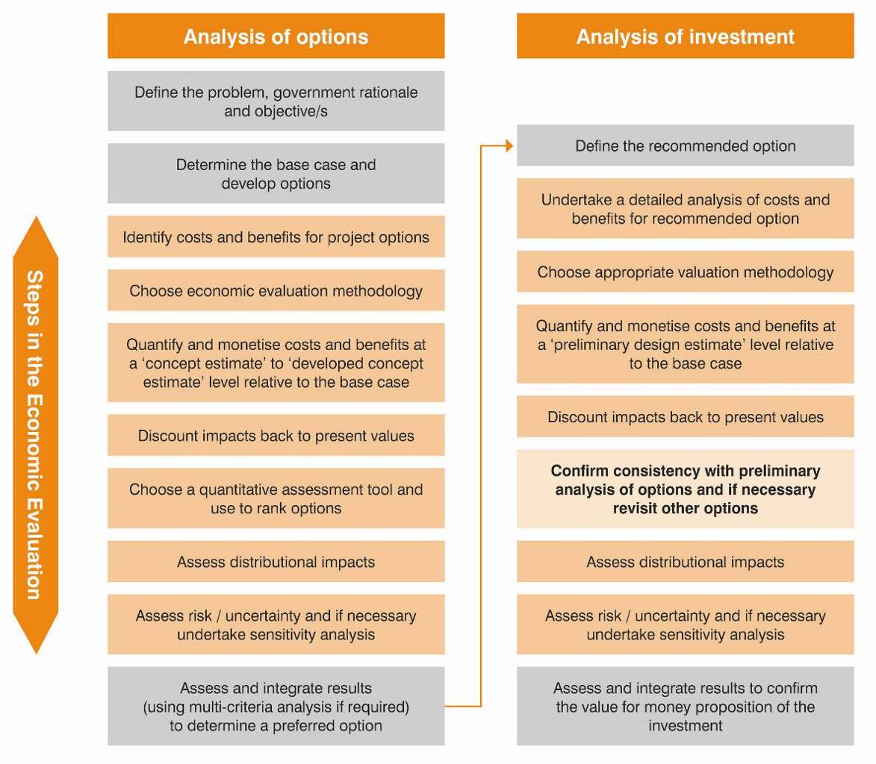

The business case addresses a range of other objectives and factors that the Government may wish to focus on in addition to the welfare maximisation derived from the economic evaluation. Figure 1 shows the steps involved in an economic evaluation for a business case.

Defining the problem, rationale for intervention and objectives
In Stage 1 (Conceptualise) of the lifecycle guidelines, the focus is on problem definition, and the preliminary determination and use of high-level benefits (and dis-benefits) to shape strategic options. As well as clearly identifying and providing evidence for the problem and the rationale for government intervention, the primary benefits or objectives have to be outlined. These benefits provide criteria to identify a preliminary strategic response to the problem. Agencies are then required to develop a short list of project options aligned with the preferred strategic response for detailed analysis in the business case.
While Stage 1 involves looking at various strategic options from a high-level perspective, Stage 2 involves agencies undertaking a more detailed evaluation of the major options backed up by research, data and evidence, before determining the recommended option.
There may be several ways to implement the recommended strategic option as a project, or it may be found that an alternative will achieve a better outcome, in which case the strategic options analysis would need to be revisited.
Agencies should note that not all benefits identified as part of an investment logic mapping process undertaken in Stage 1 will be suitable for inclusion in an economic evaluation of an investment proposal. Economic evaluations focus on welfare impacts on society rather than agency specific impacts or distributional impacts. Benefits (and costs) which would be suitable for inclusion in economic evaluations are typically specific, tangible, able to be monetised, and can be linked unambiguously to an investment or activity.
Under Stage 2, the identification and quantification of all costs and benefits to society is intended to capture the full range of welfare impacts of a given intervention. To the maximum extent possible, these effects should be quantified robustly and included in a cost-benefit analysis, however, it may also be necessary to supplement this with qualitative descriptions (or analysis) of non-measureable welfare impacts. The Benefit-Cost Ratio (BCR) that is produced as part of an economic evaluation is one indicator of how successfully an intervention meets the objective of welfare maximisation.

The base case and bias in options development and evaluation
The base case, which incorporates existing (and in some cases planned) policy settings as the current policy option, should be used as the reference point for comparing the costs and benefits of a policy (or investment) decision.
In addition to the base case and investment-based interventions, the formulation of options from those identified in the Conceptualise stage should consider:
- government interventions other than investment-based solutions; and
- at least one 'market-based solution'.
The Prove guidelines provide more detailed information on issues such as determining the base case, options development, and identifying non-investment based interventions and market-based solutions. The Prove guidelines also contain advice on ‘real options’ development to incorporate flexibility in the investment planning process in order to adapt to uncertainty (see section 8.1 of this document for further information on real options).
New project options, not previously addressed in the strategic business case, may be introduced provided they are consistent with the preferred strategic response. As previously noted, the preferred strategic response may need to be revaluated where more detailed evidence has been identified about the possible cost and benefits of different strategic options. Where project options previously presented have been eliminated, the reasoning for this should be noted.
A common and sometimes substantial problem in any economic evaluation or business case is bias. Small changes to critical underlying assumptions can make the difference between a proposal showing a significant net social benefit or a significant net social cost.
Both theory and evidence suggests that proponents are likely to significantly overstate the benefits of their preferred options and underestimate the costs.
To ensure objective, evidence-based analysis, agencies should:
- be explicit about the evidence and data used, as well as the basis for all assumptions, so that results can be replicated and tested;
- consider early involvement of DTF in the development of options, as well as to review crucial assumptions and other significant aspects of the economic evaluation;
- where possible use 'reference class forecasting' which achieves accuracy by basing forecasts on actual performance in a reference class of comparable projects;
- consult and test option development and underlying assumptions across the public sector;
- public consultation – while not always feasible, it can act as a valuable independent review to identify underdeveloped or overlooked areas and potential problems with the options considered; and
- ensuring any consulting firm engaged to help undertake the economic evaluation:
  - has a reputation for rigorous independent advice and transparency – as a general rule work should be tendered to ensure high quality and objective advice; and
  - is provided a terms of reference (and is engaged throughout their work) in such a way that facilitates such independent advice.

Identifying costs and benefits
Tips:
- Separate the allocative ('real') effects of a proposal from its distributional ('transfer') effects:
- In a cost-benefit analysis, only the allocative effects – that is, the additional costs and benefits to society – should be included when analysing the overall net impact of each option.
- Distributional effects should not be included when analysing the net impact. However, these impacts are still highly relevant for decision-makers and should be clearly presented along with the overall net impacts.
- Costs and benefits include market and non-market effects. Where possible these should be assigned a monetary value, but it may be necessary to simply provide a qualitative description of the impact.
- The analysis of costs and benefits for options should generally be at a ‘concept to developed-concept’ estimate level.
- The full range of expected costs and benefits to society (as outlined in these guidelines) should be identified for the preferred option at a ‘preliminary design estimate’ level of accuracy.
- The key assumptions made in order to conduct the analysis and the data/evidence required to value the costs and benefits should also be clearly identified.

A cost-benefit analysis should capture all welfare costs and benefits to society. The welfare impacts that should be captured are generally more specific and tangible than the benefits (and dis-benefits) referred to in the Stage 1 Conceptualise guidelines or the investment logic mapping process. Not all benefits identified as part of an investment logic mapping process will be suitable for inclusion in an economic evaluation of an investment proposal.
Undertaking an 'economic evaluation' (as is necessary under Stage 2 of the Investment Lifecycle and High Value/High Risk Guidelines) involves unbundling and refining the Stage 1 benefits, costs and dis-benefits via a cost-benefit analysis. This should take the form of identifying the main costs and benefits to society for each of the short-listed options. This identification of costs and benefits that are to be monetised should be at a concept estimate (to detailed concept estimate) level – it needs to be sufficiently detailed and comprehensive to allow a valid comparison of options. This entails assigning monetary values via the use of robust valuation methodologies. Where it is not possible or practical to monetise costs and benefits, there is a need to provide a qualitative or quantitative description of the impacts. For more complex projects the costing should be a detailed concept estimate.
Initially, this analysis is undertaken to choose between options. Once the preferred option is identified, the cost benefit analysis is revisited and further evidence, data and details on costs and benefits are developed at a preliminary design estimate level for the preferred option. This second stage confirms if the investment provides a net public benefit, which is a benchmark for project viability.

Welfare costs and benefits
The costs and benefits included in a cost-benefit analysis of each short-listed option should only be those that are additional to what would otherwise occur in the base case (see section 3.2).
Allocative and distributional impacts
One of the first tasks is to separate out the allocative (or 'real') effects of a proposal from its distributional (or 'transfer') effects.
Allocative effects impact on the overall level of welfare in society. They represent changes in how much society can produce (which, in turn, determines what is available for the community to consume). Since total resources are limited, the decision to use resources to undertake a particular initiative will mean that the resources cannot be used for other purposes. This represents an allocative cost in terms of production and consumption opportunities foregone – a concept commonly referred to as 'opportunity costs'.
On the other hand, distributional effects represent transfers in welfare between different groups in society, but do not alter the total level of welfare on society. In other words, some groups may be made better off as the result of undertaking a proposal at the expense of other groups who become correspondingly worse off.
A simplified example of different types of impacts
The Government is considering introducing a labour market programme that provides retraining for long-term unemployed workers. The principal allocative benefits would be the increase in output of persons who, in the absence of the programme, would have remained unemployed, as well as their enhanced sense of well-being. The principal allocative costs would be the costs of the training and the unpaid work output and/or leisure that the workers themselves forego in entering the programme.
In contrast, the income support that they would receive while retraining and the unemployment benefits that they subsequently would give up when employed represent transfer effects.

The impacts from this example of allocative and distributional effects for the labour market program are shown in Table 1 below:
Table 1 Example of allocative and distributional impacts
Impacts | Long-term unemployed workers  who are retrained | Rest of the community
Allocative  costs | - Any foregone unpaid work output  - Foregone leisure | - Training costs
Allocative benefits | - After-tax wages after training due to a rise in output  - Enhanced well-being and self-esteem. | - Possibly increased profits to employers  - Increase in tax take from wages due to rise in output
Distributional impacts | - Income support while training  - Loss of unemployment benefits | - Income support to trainees  - Savings in unemployment benefits

When undertaking a cost-benefit analysis, only allocative ('real') effects should be included when analysing the overall net impact of each option. Distributional ('transfer') effects should not be included as they have no net impact on society when identified correctly. However, these impacts are still highly relevant for decision-makers and should be clearly presented along with the overall net impacts.
Market impacts (including how to integrate the financial analysis)
Allocative impacts can be further categorised in a number of different ways. For simplicity these guidelines categorise these impacts as either ‘market’ or ‘non-market’ impacts.
Market impacts are those costs and benefits that are usually readily identifiable because they generally involve a clear transaction and market price. These impacts are typically very similar to the impacts identified in a financial analysis. However, market prices only reflect social values in competitive, non-distorted, markets. In addition, there are financial concepts that should not be included (or should be adjusted) in a cost-benefit analysis. For example:
- Interest payments – interest payments should not be included in a cost-benefit analysis as this would lead to double-counting. Discounting in a cost-benefit analysis implicitly reflects interest payments during the appraisal period since it reflects the opportunity cost of the option.
- Residual value (RV) is the value of an option/project at the end of the appraisal period (or its economic life). In general, in a cost-benefit analysis the RV of an asset at the end of its economic life is zero. However, where there is some ongoing impact (a benefit or cost), there may be a positive RV or a liability. The RV should be the lower of (a) the replacement cost or (b) the present value of the future stream of net benefits at the arbitrary earlier end of the project.
- Depreciation is an accounting item that represents the decline in the value of an asset. Depreciation is excluded from a cost-benefit analysis because the cost of capital expenditure is allowed for by the discounting process.
- Transfer payments should generally be excluded from a cost-benefit analysis since there is no net impact on society, with benefits transferred from one group of stakeholders to another. These impacts should, however, be reflected in any distributional impacts assessment.
- Taxation can distort real resource costs from society's perspective (for example, tariffs on imported goods lead to higher than necessary prices for these goods). However, there are also certain taxes that attempt to internalise externalities and therefore may more accurately reflect real resource costs (such as the taxation of cigarettes). Where appropriate, market prices should be adjusted to avoid circumstances where investment choice is determined by taxation that distorts real resource costs.
- Sunk costs are costs that have been committed and cannot be recovered, these should not be included in a cost-benefit analysis because they have already been incurred and should not affect new investment or policy decisions.

Table 2 Comparison of economic and financial analysis
 | Economic evaluation | Financial analysis
Purpose and context | Relative contribution of option(s) to net social welfare compared to a base case | Affordability of options from a budgetary perspective for the organisation and the government as a whole
Inclusions | All allocative resource flows including non-monetised costs and benefits | Direct financial and accounting impacts including cash flows from user charging. Capital and operating costs separately analysed.
Exclusions | GST and taxes  Depreciation  Capital charges  Interest and financing costs  Transfer payments | GST and taxes
Period of analysis | Economic life or service term | Service term or period sufficient to consider whole of life impacts
For further guidance on determining financial or budgetary impacts for a financial analysis, agencies should refer to the technical guidance Preparing Project Budgets for Business Cases, and the Stage 2: Prove Investment Lifecycle and High Value/High Risk Guidelines.
Non-market impacts
Unlike a financial analysis, where only financial costs and benefits in a cash flow statement or income statement are included, a cost-benefit analysis requires that all relevant costs and benefits are identified, whether they are readily identifiable or not. Non-market impacts should be included in a cost-benefit analysis. These costs and benefits are not readily identifiable because they generally do not involve a clear transaction or market price.
Such impacts may include:
- environmental externalities (e.g. increased pollution; reductions in native vegetation);
- social externalities (e.g. impact on heritage values; improving social cohesion); and
- economic externalities (e.g. travel time savings; reductions in death/injuries that lead to higher workforce output).
Costs and benefits can be further categorised according to those that can readily be assigned monetary values and those where this cannot be done robustly, or where the resources involved in doing so would be disproportionate given the likely impact. In the case of the latter, a qualitative/quantitative description of the impacts should generally be provided.

Common pitfalls
Due to the nature of a cost-benefit analysis, there are some common pitfalls that agencies need to be aware of when identifying costs and benefits. These common mistakes can undermine the robustness of the analysis.
Unanticipated impacts and ignoring non-market impacts
Many potential costs and benefits are unanticipated at the time of project evaluation. Non-market impacts are generally harder to anticipate and quantify and are much more likely to be overlooked. Nevertheless, listing and estimating all relevant costs and benefits early in the process, as well as all affected parties, should be attempted.
Double counting and miscounting benefits, and optimism bias
Impacts can be doubled counted accidentally. This is usually because they are inherently reflected in the pricing of other benefits (e.g. the benefits from transport time savings from a project and resultant higher house prices near the project – these benefits both represent time savings, therefore only one should be included).
Another serious error is counting costs as benefits. For example, the use of resources such as labour is often counted as an employment benefit. However, this almost always has a cost (i.e. an opportunity cost) if such resources can be used elsewhere in the economy.
For further guidance on dealing with bias (including optimism bias) see section 3.2.
Misuse of multipliers and the overestimation of flow-on effects
Input-output models are commonly used to determine the ‘multiplier’ effects or the flow-on effects to the economy should a project be implemented. However, input-output multipliers have various flaws such as double and triple counting because they assume that resources are freely available to meet any increase in demand.
Any cost-benefit analysis that includes multiplier effects should be used with care. If multiplier effects are to be included in the analysis, DTF prefers that Computable General Equilibrium (CGE) modelling be undertaken because CGE models incorporate supply constraints.
The use of economic multipliers should generally be avoided in economic evaluations.
Not adequately taking into account risk and uncertainty
See section 8 of this document for further information on how to deal with risk and uncertainty, including through the use of: ‘real options’ development; sensitivity analysis; and scenario analysis.

Further reading
- Department of Treasury and Finance 2011, Victorian Guide to Regulation – Edition 2.1, State of Victoria, Melbourne, August, pp. 74–83, and Appendices pp. 10-11.
- HM Treasury 2003, The Green Book: Appraisal and Evaluation in Central Government, TSO, London.
- Department of Finance and Administration 2006, Handbook of Cost-Benefit Analysis, Financial Management Reference Material No. 6, Commonwealth of Australia, Canberra, pp. 18–28, 94–96.

Valuation techniques
Tips:
- Valuation techniques include market-based valuations, revealed preference, stated preference, and the benefit transfer method.
- The additional effort and expense incurred in assigning monetary values to costs and benefits should reflect the likely size of those impacts.
- Impacts should only be assigned a monetary value when this is done in a robust and neutral manner in line with the appropriate use of existing widely accepted valuation techniques or default values.
- If impacts cannot be assigned monetary values then they should still be described in quantitative/qualitative terms.

Many expected project impacts can be assigned monetary values since market prices are directly observable.
For other impacts – where the market price does not reflect the true social value; or in relation to non-market impacts where market prices may not exist or be easily observed – it is obviously more difficult to assign a monetary value. Nevertheless there are often robust techniques available to do so.
Popular techniques employed in a cost-benefit analysis to estimate monetary values for non-market impacts are discussed below. They are categorised into market-based valuations, revealed preference, stated preference and benefit transfer methods.

Market-based valuations
Market-based (and revealed preference techniques) involve inferring an implicit price that is revealed by examining consumer behaviour and/or prices in a similar or related market. Table 3 describes three different market based techniques:
Table 3 Market-based techniques
Valuations | Explanations | Examples
Defensive expenditure | This is the cost incurred by individuals in order to mitigate the impact of change and to maintain the situation that existed before the change. The cost is used as a proxy for what has been avoided. | The cost of mitigating soil erosion, noise insulation.
Replacement cost | This is the cost estimated to replace the damage or substitute a service. | Cost of restoring the environment to its previous condition.
Productivity method | This is where an impact leads to a change in production levels, costs or prices. The change in outputs is observed and is used as a proxy for the impact | Loss of wetlands leading to lower agricultural output.

Revealed preference method (indirect)
The revealed preference method seeks to find out how much consumers spend on goods and services in similar or related markets by observing the choices made by consumers. One of the most commonly cited examples of revealed preferences is valuing the impact of flight path noise by comparing the prices of similar homes that are directly under the flight path with those away from the flight path. Within the revealed preference method there are three techniques:
Table 4 Revealed preference techniques
Valuations | Explanations | Examples
Proxy good /averting behaviour | The value of a close substitute acts as a proxy for the impact. | Cost of providing home care or nursing services to determine the value of home care (note if there is reason to believe the benefits significantly differ from the substitute, a different valuation method should be used).
Hedonic pricing | Hedonic pricing infers willingness to pay for a non-market effect from observed behaviour (revealed preferences). This can be done through the likes of property market analysis, wage analysis or product analysis.  For example, this technique can be applied to property prices to indirectly derive environmental impacts that usually cannot be monetised. For instance, beach values can be derived from a model that calculates the difference in prices between beachfront properties and inland properties, adjusting for all other factors. | Air quality, water quality, proximity to hazardous waste, landscape characteristics, noise, heritage buildings.
Travel cost analysis | The opportunity cost of time and travel costs incurred can act as a proxy to value non-market impacts, especially for ecosystem sites such as national parks. | Recreational goods, value of national parks.

Stated preference method
When there is no other method available to monetise a particular cost or benefit, stated preference techniques are sometimes used. Stated preferences are normally obtained by specially constructed questionnaires and interviews designed to elicit estimates of the willingness to pay (for) or the willingness to accept a particular outcome. These surveys have increasingly become part of cost-benefit analysis use worldwide and have been extensively applied to the valuation of environmental impacts
Nevertheless, there are well-known limitations with the use of stated preference techniques that should be taken into account when deciding whether to use them and how they should be implemented. Possible types of bias in stated preference surveys include: hypothetical bias (because the situation is not a real-world decision); strategic behaviour (deliberate lying or exaggeration by the responder); scope problems (where the valuation is insensitive to the scope of the good); anchoring bias (where the valuation depends of the first bid presented); and, information bias (where the framing of the question unduly influences the answer). As with all valuation techniques, stated preference methods also need to incorporate a sufficient sample size to be considered valid.
Within the stated preference method there are two main techniques:
Table 5 Stated preference techniques
Valuations | Explanations | Examples
Contingent valuation | Often seeks out the amount individuals would be willing to pay to attain a benefit or to avoid a negative impact.  Willingness to accept values are a more relevant measure of a good typically when an existing property right is lost | Maintenance of ecosystems, maintain common goods (e.g. fish stocks), heritage buildings.
Choice modelling | Requires individuals to reveal the value of the non-market impact indirectly by asking a series of binary choice questions requesting individuals to choose between goods with different characteristics and various monetary contributions. | Endangered species, forest landscape.

Benefit transfer method
The benefit transfer method adopts a value from an existing body of research as a proxy value for use in the current cost-benefit analysis. This method is often used when assessing health and environmental impacts. Explanations of why results in past research or cost-benefit analyses are suitable for the current project should be provided.
There are many existing quantitative indexes and measurements to help assign monetary values to impacts. It is important that agencies choose suitable robust measurements that are relevant and appropriate to the project by undertaking prior research.
The following factors are important when selecting benefit transfer values for the proposed project – the case studies used to generate the values should:
- be of the same or similar nature and characteristics (e.g. socioeconomic conditions, demographic characteristics, economic conditions and value judgement);
- be based on sound economic theory;
- have comprehensive and accurate data;
- have robust and relevant results;
- have consistent and comparable welfare measures (e.g. willingness to pay); and
- be appropriately adjusted if necessary (i.e. changes in income per capita, age structure, population density and levels of education).
See section 5 for further details on using default values via the 'benefit transfer method'.

Costs of assigning monetary values to impacts
The process of assigning monetary values to impacts can be resource intensive. Importantly the costs of finding information to estimate the value of non-market impacts should not outweigh the benefits of having the additional information.
The Council of Australian Government Best Practice Regulation states that:
Better information often reduces the uncertainty surrounding estimates, however, if a proposal is already known to be clearly viable or unviable, the pay-off from obtaining extra information may be negligible. Detail and complexity are not the same as rigour – which is ultimately more important.
If the cost of assigning a monetary value in a robust manner outweighs the benefits then a qualitative assessment would be more appropriate. This qualitative assessment should clearly describe the likely impact, including quantitative terms where possible.
Further reading
- HM Treasury 2011, The Green Book: Appraisal and Evaluation in Central Government, TSO, London, pp. 19-23 and 57–67.
- Department of Finance and Administration 2006, Handbook of Cost-Benefit Analysis, Financial Management Reference Material No. 6, Commonwealth of Australia, Canberra, pp. 26–33 and 120-133.
- The Treasury 2005, Cost Benefit Analysis Primer Version 1.12, New Zealand Government, Wellington, pp. 20–24.
- Department of Treasury and Finance 2011, Victorian Guide to Regulation Appendices, State of Victoria, Melbourne, pp. 16–17.
- Australian Government 2007, Best Practice Regulation Handbook, Commonwealth of Australia, Canberra, pp. 124-128.

Valuation: special issues
Tips:
- There are special issues that need to be considered when valuing particular impacts, including in relation to externalities generally, carbon dioxide emissions, wider economic benefits, and human life.
- For those sectors covered by the carbon price – the separate valuation of the cost and benefits associated with carbon dioxide emissions is redundant, as this cost is already built in to the standard analysis (e.g. via increased energy prices).
- For a detailed technical methodology on valuing costs and benefits in transport infrastructure investments, and for default externality values, agencies should refer to the Australian Transport Council’s Volume 3: Appraisal of Initiatives and Volume 4: Urban Transport of the National Guidelines for Transport System Management.
- ‘Wider economic benefits’ should be considered separately from core benefits and excluded from the headline Net Present Value or Benefit-Cost Ratio result.
- To estimate the value of a statistical life, adopt values estimated in the 2007 publication Establishing a Monetary Value for Lives Saved: Issues and Controversies by Dr Peter Abelson.

Externalities
Externalities are effects borne by third parties who do not directly use the asset or service. Some simple examples include:
- disturbance from noise;
- atmospheric and water pollution, which may include damage to buildings and health impacts; and
- climate change caused by greenhouse gas emissions.
Default values can be applied to obtain a monetary estimate of the unit cost or benefit of the externality via the ‘benefit transfer method’. It is appropriate to use default values where the particular externality costs are small in relation to total project benefits and costs. For larger projects or projects with externality effects that are expected to be significant relative to total project costs and benefits, a more thorough analysis of the proposal-specific impacts should be undertaken to determine whether these default values need to be adjusted.

Carbon dioxide emissions
In the absence of a national policy to limit emissions of carbon dioxide, it was appropriate to measure and quantify changes in carbon dioxide emissions generated by an activity or investment and include these as costs and benefits in an economic analysis. This approach reflected the generally accepted scientific opinion that anthropogenic carbon dioxide emissions are generating harmful climatic impacts, and that these impacts were not reflected in market values.
The introduction of a national carbon pricing scheme by the Commonwealth Government attempts to effectively internalise the externalities represented by carbon dioxide emissions. The full cost of most emitting activities (as determined by the Commonwealth Government) will be reflected in their market cost.
This implies that for those sectors:
- covered by the carbon pricing scheme – a separate valuation of the cost and benefits associated with carbon dioxide emissions is redundant, as this cost is already built in to the standard analysis (e.g. via increased energy prices).
- not yet covered by the carbon pricing scheme (e.g. road transport) – it remains appropriate to value costs and benefits associated with changes in carbon dioxide emissions and include these separately in an economic analysis.
The Commonwealth Government is due to introduce a carbon dioxide emissions trading scheme (ETS) from 1 July 2014. An ETS implies that Australia’s emissions are fixed at the level specified by the ETS target. Depending on the treatment of non-covered sectors in the context of an ETS, it may be the case that individual investments – in any sector - will not lead to an overall reduction in carbon dioxide emissions beyond the target set by the Commonwealth. Further advice will be provided by DTF as this scheme progresses.

Transport
Decision-making in relation to transport investments is often a complex task. It involves decisions such as choosing the right mode of transport, project and location that will best meet forecast future growth in demand, and which can work effectively with land use to promote an efficient transport network.
Because of the complexity of transport and land use investments, it is essential that the cost-benefit analysis used to guide decision-making is robust, transparent, and evidence-based.
A cost-benefit analysis of transport investments involves comparing a stream of benefits and costs under a scenario in which government makes a major new investment, as compared with a ‘base case’ that represents what would likely happen in the absence of the investment. It is important that the ‘base case’ is well thought through – it generally needs to allow for expected changes in infrastructure given the current policy settings, as well as anticipated or potential changes in land use over time.
While some relevant concepts for analysing transport projects are provided below and elsewhere in these guidelines, for a detailed technical methodology on valuing costs and benefits in transport infrastructure investments, agencies should refer to the Australian Transport Council’s Volume 3: Appraisal of Initiatives and Volume 4: Urban Transport of the National Guidelines for Transport System Management.
Transport user benefits and induced travel
An improvement in transport infrastructure changes the behaviour of travellers, allowing them to switch to the most efficient route/mode of transportation. What we attempt to capture rigorously in transport cost-benefit studies are improvements in welfare, based on the standard microeconomic ‘partial equilibrium’ approach. For example, the decline in the cost of travel generates additional travel demand (depending on the extent that transport users are responsive to a change in the cost of travelling), and increases welfare.
Induced travel is the additional demand from users generated as a result of a transport investment. Induced trips on a mode or route may include trips diverted from another mode or route as well as completely new trips. For example, an additional lane on a congested road would increase its capacity and reduce the amount of congestion, which in turn would lead to an increase in its use.
Figure 2 depicts a fall in the cost of travel resulting from a new transport investment. Commensurate with the falling cost of travel, the volume of travel demanded increases. The triangle represents the additional benefit (increase in welfare) generated by new users who would otherwise not have travelled under the base case scenario (without the investment). The benefit to existing users (the rectangle) is due to a reduction in cost (via time savings).
Figure 2 Benefits of increased quantity of travel transport
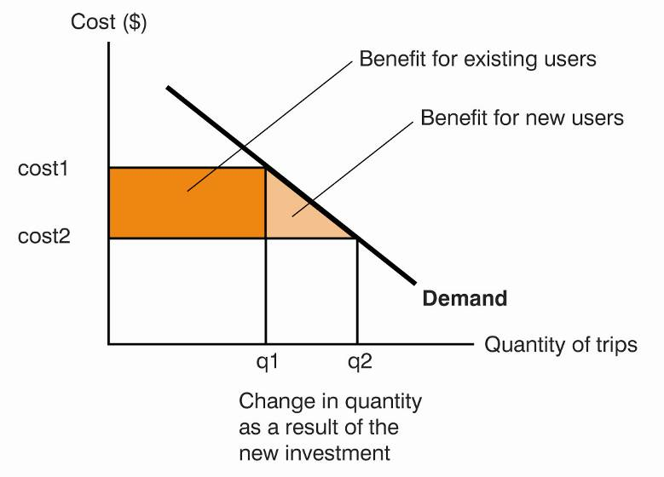

Interdependencies and synergies
Due to the interactive nature of land use and transport, it is important that the interdependencies between proposed transport and land use interventions, and their potential implications, be understood and effectively described in business cases. These interdependencies may have the character of ‘enabling conditions’, synergies or even conflicts (in terms of how they together affect the delivery of government policy objectives).
Better information relating to project interdependencies can assist in determining which combination of projects might produce the greatest benefit overall, and how policy trade-offs between different projects might usefully be managed.
Transport modelling
Strategic transport models combine a computer-based model of the transport network with inputs from a detailed survey of household travel patterns to describe the origin and destination of trips in a typical peak period. The model then allocates these trips onto the network on the basis of estimated costs of competing modes and routes of travel.
Modern transport investment appraisal necessarily relies heavily on such models despite some known limitations with their use. Transparency can a significant problem with these complex models, particularly given that most of the major benefits associated with a transport project are derived from these models.
Many transport models do not describe the impacts of transport interventions on land use patterns, so caution should be exercised in this regard. Where the model being used does not describe land use impacts, proponents are encouraged to undertake alternative forms of analysis (where this can be done accurately) to estimate the nature and scale of possible land use impacts. Where these impacts are expected to be significant, they may be used to adjust the land use assumptions in the model (as a second order scenario) and then tested as to their impacts on the project’s total benefits.
As transport models rely on current travel data as well as projections and assumptions about the future, appropriate caution should also be exercised where the models are used to test the effects of transport and/or land use interventions over longer timeframes. DTF strongly endorses sensitivity testing to examine the outputs of a given transport model, including testing results against a second transport model for large investments.

Further reading
- Australian Transport Council, 2006, National Guidelines for Transport System Management, Volume I-5.

Forecasting
Accurate forecasting is often critical in all project evaluations, not just in relation to transport. Costs and benefits generally are made up of quantities x prices. These guidelines are mostly devoted to helping agencies estimate unit values (prices). However, forecasting quantities is also crucially important.
Major problems can arise with forecasting future events accurately, which can significantly impact on the overall robustness and usefulness of the economic evaluation as a whole.
Overcoming the issue of ‘bias’, particularly ‘optimism bias’ in forecasts, is often one of the most important tasks. Care must be taken to ensure forecasts are done in a robust and neutral manner to help ensure their accuracy.
As indicated in section 3.2, to overcome bias when developing forecasts agencies should consider using ‘reference class forecasting’, which achieves accuracy by basing forecasts on actual performance in a reference class of comparable projects.

Wider economic benefits
Wider economic benefits (WEBs) refer to benefits that are missing from standard evaluation models. These benefits are most relevant to transport and other large infrastructure projects.
Commonly considered wider economic benefits include:
- the impact of transport on output due to agglomeration economies;
- the impact of transport on increasing competition;
- user benefits when transport users operate in imperfectly competitive markets;
- the benefits of increased productivity due to savings in commuting time; and
- economies of scale.
Increased output due to agglomeration economies has been the focus of most of the attempts to measure WEBs.
Agglomeration benefits recognise a productivity benefit to proximity. Firms are thought to derive productive advantages from locating in close proximity to other firms as a result of:
- access to suppliers - sharing of inputs or intermediate goods that increases the availability and reduces the price of inputs;
- access to labour - increased labour market density leads to better matching of job skills to work requirements and increases labour productivity; and
- access to information - localised knowledge spill-overs raise the level of technology.
Therefore in certain circumstance when a firm relocates to an area of agglomeration it may raise the output of other firms through one or another of these channels.
Agglomeration economic benefits are typically modelled as a function of 'effective density' – reductions in transport costs can increase the effective density of an area without any relocation of employment, leading to productivity benefits that are not included in the analysis of the core or traditional benefits.
However, the extent to which these benefits exist over and above benefits counted in the standard economic evaluation is not clear; it will depend on the nature of the project under consideration. The current literature now also talks about wider economic impacts (not benefits) because impacts can be negative, such as when transport leads to decentralisation and less agglomeration.
There are two key issues when calculating WEBs:
- what level of econometric analysis may be supported by available data; and
- how can relationships be characterised and what inferences may be drawn from them.
The work done to date to advance WEB methodologies, in particular on agglomeration, is interesting and useful work but is a developing area of economic knowledge. WEB inclusive results should therefore be presented separately from the standard Net Present Value or Benefit-Cost Ratio results.

Further reading
- Department of Transport, 2012, Job Density, Productivity and the Role of Transport, http://www.transport.vic.gov.au/research/research-and-policy-development-publications

Amenity and design quality
Design quality is an important element in Victorian Government building projects. A good design does not necessarily involve expensive materials or lavishness. Good designs generally optimise either benefits or costs (or both) while having certain qualitative outcomes in mind. The best design meets user needs, is efficient and reduces the whole-of-life costs of the project, although it may initially require higher capital investment compared with other projects.
In general, a good design adds value by:
- improving functionality, thereby improving staff productivity and reducing operational costs;
- improving service quality and outputs;
- improving and reducing negative environment externalities (costs); and
- reducing future ongoing costs and overall costs.
Although improved building or facility design can affect staff retention and other outcomes, such as patient recovery times or educational outcomes, these outcomes are often caused by multiple factors. It is generally incorrect to assume that design quality is entirely responsible for generating such benefits. If included in an economic evaluation, these benefits must be supported by robust evidence that is transparent about the strength and magnitude of any link and must incorporate relevant results from credible research.
In cases where benefits are of a qualitative nature (where it is difficult to assign a monetary value to them and instead they can only be described), the cost of enhanced design should be explicitly stated so that decision-makers are aware of the costs as well as the benefits.
Agencies should note that a comprehensive economic assessment embodies consideration of all significant benefits associated with an investment, including those linked to sustainable outcomes. Separate consideration of how a given proposal will contribute to sustainability is therefore not typically required. Notwithstanding this, for practical examples on design quality/sustainability in individual projects, agencies can refer to Major Project Victoria’s Sustainability guidance (note that this reference is provided for further information only – agencies are not required to comply with it for economic evaluations in business cases).

Valuing life
The human capital method can be used when externalities or projects have serious consequences on health impacts. This method discounts the expected earnings foregone over an individual’s lifetime back to an equivalent present value to determine the value of the impact (i.e. the output foregone).
As the results vary widely across individuals and across industries, to avoid inequity, common practice is to use an average value of ‘life year’ or ‘life’ regardless of the individual characteristics of the individuals affected.
Given how resource intensive it is to estimate the value of a statistical life, agencies should adopt values estimated in the 2007 publication Establishing a Monetary Value for Lives Saved: Issues and Controversies by Dr Peter Abelson.
Establishing a Monetary Value for lives
Abelson found that the value of statistical life (VSL) in research studies is between $3 million and $15 million. He suggested that the appropriate estimate of a statistical life based on the average healthy individual living an additional 40 years is $3.5 million, or $151,000 for each statistical life year (in 2007 dollars) at a utility discount rate of 3 per cent.

Source: Establishing a Monetary Value for Lives Saved: Issues and Controversies by Dr Peter Abelson

Since the figures are in 2007 dollars, appropriate inflation adjustment is required to estimate the cost of life and injuries. This practice is endorsed by the Victorian Competition and Efficiency Commission (VCEC) and the Commonwealth Department of Finance and Deregulation. A sensitivity analysis should also be undertaken where the VSL is a major component of the cost-benefit analysis. For example, agencies can vary the VSL to see if the preferred project is still feasible.

Injuries and safety
Injury, disease and disability can be estimated from the value of statistical life or the value of statistical life year (VSLY). The Australian Institute of Health and Welfare publishes weights for injuries, which DTF accepts as reasonable.

Further reading
- Mathers C, Vos T, Stevenson C 1999, The burden of disease and injury in Australia, AIHW cat. no. PHE 17, AIHW, Canberra, pp. 186–202.
(This publication has a list of injuries with their respective estimated weights.)
- Barker B, Begg S, Stanley LM Lopez A, Stevenson C, Vos T 2003, The Burden of Disease and Injury in Australia, AIHW cat. No. PHE 82, AIHW, Canberra, pp. 1–323.

Discounting costs and benefits
Tips:
- Discounting ensures that costs and benefits from different time periods are assessed using their present values. It reflects the opportunity cost of investing in a particular project.
- The discount rate used in project evaluations should reflect the risk profile associated with the project.
- For the purposes of assigning an appropriate real discount rate, public sector investments should be separated into one of the three categories identified that best reflects the risk level of the project.
- Ultimately, no single discount rate can precisely meet the characteristics of every public sector project. It is therefore important to sensitivity test results.
- Real prices should be used to ensure consistency with the use of a real discount rate.
- Options should be evaluated over their full lifecycle; however, for infrastructure projects with a long lifecycle, evaluation can be limited to a shorter time period, along with any estimated residual value.

Concept of discounting
Cost-benefit analysis evaluates public sector projects from a societal perspective. To do this the costs and benefits of projects are monetised and the values of costs and benefits occurring in different time periods discounted to their present values.
Discounting is based on the concept of time preference. Time preference is reflected in positive market interest rates, which show that a future dollar is worth less than a current dollar. This occurs for several reasons: impatience, the expectation that wealth will grow over time, opportunities for productive investment, and uncertainty. Discounting acknowledges the opportunity costs of investing in a particular project by asking what return it would have produced in an alternative use.
Settling on a specific default rate is a complex issue. A scan of discount rates advocated across different jurisdictions shows that there is no consensus on the appropriate discount rate for use in public sector project evaluations.
Table 6 Various jurisdictions’ default discount rates
Jurisdiction / agency | Rate (real) | Basis
Infrastructure Australia | 7 per cent | Opportunity cost of capital
Productivity Commission | 8 per cent | Opportunity cost of capital
United Kingdom | 3.5 per cent | Social time preference rate
New Zealand | 8 per cent | Opportunity cost of capital
NSW | 7 per cent | Adopting a standard set of rates

This section deals with real discount rates, i.e. rates that have the impact of inflation removed, and therefore should only be applied to real cost and benefit flows.

Recommended approach
The appropriate discount rate should be based on the opportunity cost of investing in a particular project – assessing what returns are available elsewhere. This requires an assessment of the project’s risk profile, so that comparison can be on a ‘like for like’ basis. For example, basing discount rates on average market rates of return is appropriate for government projects which have the same risk as the average private sector investment.
It is sometimes posited that a risk-free rate is appropriate for discounting public sector projects. However, while governments have powers of taxation and rule-making that can help lower risk and avoid default, government projects are very rarely free of risk. Even in situations where government is able to diversify project-specific risk by holding a balanced portfolio of assets, most government projects involve a certain amount of aggregate irreducible risk. For example, the demand for the services of infrastructure projects is linked to the state of the economy, as are the wage rates used to calculate the time savings of public sector transport projects.
For purposes of assigning an appropriate discount rate, public sector investments should therefore be separated into one of the three categories as shown in table 7.
Table 7 DTF’s recommended discount rates
Categories | Types of Investment | Basis | Rate (real)
Category 1 | Provision of goods and services in traditional core service delivery areas of government, such as public health, justice and education. The benefits of these projects can be articulated but are not easily translated to monetary terms. E.g. schools, hospitals, police stations and civic open spaces.)  Other projects in this category include projects evaluating potentially catastrophic scenarios for which considerable uncertainty surrounds estimates of costs and benefits. | Projects falling within this category should use a real risk free rate plus a very small risk premium. Based on long-term average government bond rates, an appropriate real discount rate for these projects is four per cent. | 4%
Category 2 | Provision of goods and services in traditional core service delivery areas of government (i.e. non-commercial investments), but those for which the benefits attributed to the project are more easily translated to monetary terms. E.g. public transport, roads and public housing). | These projects should be discounted using a risk free rate plus a modest risk premium depending on the project’s sensitivity to the economy. Based on long term average government bond rates, an appropriate real discount rate for these projects is seven per cent. | 7%
Category 3 | Commercial investments with similar risks as the private sector. While there should ideally be limited government involvement in this area, government should require a rate of return on commercial investments comparable to that which the private sector requires given the degree of risk associated with the area of activity. | These projects should use a market rate of return as the default discount rate, commensurate with the risk profile associated with the industry and specific characteristics of the project.  Given that there is the potential for such investments to be significantly more risky than an average market return, project proponents should liaise with DTF regarding the appropriate rate. | Consult with DTF.

Sensitivity tests
Ultimately, no single discount rate can precisely meet the characteristics of every public sector project.
It is therefore important to sensitivity test results. In cases where sensitivity testing shows the choice of discount rate to be an important factor in a project’s viability, further consideration and analysis of the appropriate rate should be undertaken. Further analysis should focus primarily on the risk characteristics of the proposal – those that are more sensitive to market returns and other factors should have a higher discount rate, while projects that are less sensitive should have a lower one.
For instance, results for Category 2 projects using a real discount rate of seven per cent should be sensitivity tested using real rates of four per cent (representing a risk free rate plus a very small risk premium) and nine per cent (representing a long term average market return).

Real vs. nominal prices
As has been mentioned, this section deals with real discount rates. Therefore real prices must be used when generating the forecasts of costs and benefits of different options. Nominal prices (such as those often embedded in historical estimates of costs and benefits) must be converted into real prices by adjusting for inflation. Agencies therefore do not need to include expected inflation in their forecasts of future costs and benefits.
Note that nominal prices (or cash-flows) are used for the financial analysis component of the business case, therefore the discount rates provided in this section need to be converted to nominal rates in order to be used in the financial analysis.

Evaluation period
The base date (generally when time is zero) should be consistent across all projects for a fair comparison. From that point in time, projects should generally be evaluated over their full lifecycle. However, it is acknowledged that evaluation may be difficult for infrastructure projects (or alternative options) with a long lifecycle. Further, as the study period becomes longer the integrity of estimates generally declines and, as a result of the application of discount rates, longer term estimates may have little impact on the outcome of the evaluation in any event.
Accordingly, agencies may wish to limit the evaluation to a shorter period, such as to 30 years, by including any estimated residual value at the end of the evaluation period (which reflects any further unmodelled values).
When the economic life of an asset (or alternative option) exceeds the evaluation period of the project, the residual value can be counted as an inflow of benefits (or costs) in the last year. The residual value should be lower of (a) the replacement cost or (b) the future stream of net benefits at the arbitrary earlier end of the project. This is then discounted back to the present value along with other costs and benefits.
In relation to projects with different economic lives, generally the alternatives can still be compared via the standard cost-benefit analysis approach. The discounting of costs and benefits automatically allows for larger or longer projects providing the excess dollar amount or longer time are discounted at the opportunity cost of capital.
However, in rare cases where a short project can be repeated with an excess return each time it is implemented, then an adjustment to the standard approach should be made. In those circumstances such projects can be assumed to repeat over time (where that accurately reflects what is actually possible) until they all share the same timeframe.

Choosing a quantitative assessment tool
Tips:
- Net Present Value is the preferred quantitative assessment tool when assessing options. The Benefit-Cost Ratio should also be reported to provide decision-makers with additional relevant information.
- The use of the ‘internal rate of return’ as the quantitative assessment tool is not recommended.

There are three main quantitative assessment tools used to help assess and rank the different options in a cost-benefit analysis: Net Present Value (NPV), Benefit-Cost Ratio (BCR) and the Internal Rate of Return (IRR).
Each measure is based on the total cost and benefit of a project to society and each discounts future costs and benefits to the present. When one measure indicates that a project or policy provides a positive net social benefit compared with the ‘base case’, so do the other two measures. However, when there are several options, the three measures may rank the options differently.

Net Present Value
The Net Present Value (NPV) measures the present value of net benefits. It is calculated as the present value of all benefits minus the present value of all capital and recurrent costs (including externalities) within the appraisal period for the project.
Present values are discounted using the appropriate discount rate as discussed in section 6 of these guidelines.
The NPV is used as a quantitative assessment tool to:
- rank options based on their magnitudes; and/or
- accept or reject options.
The formula for NPV is:
$$\begin{aligned}\text{NPV} =\sum_{t=0}^{T}{\frac{B_{t}−(K_{t}+C_{t})}{(1+d)^{t}}} \\ \text{where:} \\ \text{NPV}=\text{ net present value} \\ B_{t}=\text{ benefits} \\ K_{t}=\text{ capital cost} \\ C_{t}=\text{ operating cost} \\ \text{d }=\text{ discount rate} \\ t=\text{ year}\end{aligned}$$ | NPV | Decision
 | NPV > 0 | Pursue further  (Note decision to proceed may depend on funding availability.)
 | NPV = 0 | Indifferent.  Check qualitative benefits and costs.
 | NPV < 0 | Reject
An NPV greater than zero implies that the estimated total benefits exceed the estimated total costs given the discount rate applied.
If the selected discount rate reflects the real opportunity cost of capital and the economic evaluation has been done robustly, then a positive NPV generally will indicate that the project or policy is efficient. Where there is more than one option, the option with the highest NPV is generally the most efficient.
NPV is the most commonly used quantitative assessment tool. In general, the NPV measure provides unbiased rankings because project benefits should be discounted by the chosen discount rate rather than by an arbitrarily determined mathematical rate.
Example:
The following very simple hypothetical example shows how the NPV is calculated to compare projects.
Project Objective: To increase the understanding of cost-benefit analysis in agencies and to encourage robust applications of cost-benefit analysis in business cases.
Although there is a broad understanding of cost-benefit analysis and its application by government officers, the detailed knowledge of cost-benefit analysis and how it should be prepared could be further developed. Consequently it is difficult to decide between projects because values are not as accurate as they should be. DTF is responsible for improving the robustness of cost-benefit analyses in business cases. The following hypothetical example considers two alternatives to the 'current policy' (base case).
Box 1A Net present value calculations for Project A
Project A
This project involves setting up an online cost-benefit analysis training program. Assume for simplicity that: the discount rate is 3.5%; the benefits can be easily measured; the online training program is limited to 4 years; and the benefits gained are not ongoing.
NPV calculation ($'000, 2013 prices)
 | Year 0 ($) | Year 1 ($) | Year 2 ($) | Year 3 ($) | Year 4 ($)
Discount factor | 1.00 | 0.97 | 0.93 | 0.90 | 0.87
Benefits  Value of staff training  Value of external staff training |  | 500  100 | 500  100 | 500  100 | 500  100
Costs  Opportunity cost of not working  Investment and maintenance  FTE staff | -2000 | -100  -10  -100 | -100  -10  -100 | -100  -10  -100 | -100  -10  -100
PV | -2000 | 378 | 363 | 351 | 339
NPV | -569

Box 1B Net present value calculations for Project B
Project B
This project involves hiring consultants to run a cost-benefit analysis training program. Assume for simplicity that: the discount rate is 3.5%; the benefits can be easily measured; the training program is limited to 4 years; and the benefits gained are not ongoing.
NPV calculation ($'000, 2013 prices)
 | Year 0 ($) | Year 1 ($) | Year 2 ($) | Year 3 ($) | Year 4 ($)
Discount factor | 1.00 | 0.97 | 0.93 | 0.90 | 0.87
Benefits  Staff trained |  | 500 | 600 | 700 | 800
Costs  Opportunity cost of not working  FTE staff |  | -150  -350 | -180  -350 | -210  -350 | -240  -350
PV |  | 0 | 65 | 126 | 183
NPV | 374

Project A has a negative NPV of $569 000 which means that even without the option of Project B, it is not feasible to fund Project A. While Project A generates good benefit figures, the upfront investment cost of $2 million exceeds the benefits derived.
Project B has a positive NPV value of $374 000, and is therefore feasible. Project B is a better project to undertake than project A and is superior to the current policy so DTF should choose to pursue Project B (subject to the availability of funds).

Benefit-Cost Ratio
The Benefit-Cost Ratio (BCR) can be defined in two ways. In its most common and simplest form it is the present value of all benefits divided by the present value of all costs. A BCR that is greater than one implies a positive NPV and the project should therefore generally proceed.
However, due to technical inherent bias in the simple BCR formula, the appropriate BCR formula to use when the purpose is to estimate and maximise the return to scarce capital is the following:
$\begin{aligned}\text{ BCR}=\frac{\sum_{t=0}^{T}{\frac{B_{t}−C_{t}}{(1+d)^{t}}}}{\sum_{t=0}^{T}{\frac{K_{t}}{(1+d)^{t}}}} \\ \end{aligned}$$\begin{aligned}\text{where:} \\ B_{t}=\text{ benefits} \\ C_{t}=\text{ recurrent cost} \\ K_{t}=\text{ capital cost} \\ d=\text{ discount rate} \\ t=\text{ year}\end{aligned}$
The BCR should be reported with the NPV, but is not recommended as the only quantitative assessment tool for decision-making purposes because it is biased towards projects with early returns and small projects. Consequently, incorrect ranking may occur and can result in selecting a less efficient project, especially when they are mutually exclusive. Nevertheless, the BCR is a convenient quantitative evaluation tool when there are many investment proposals and resources are limited. The results from the BCR should be considered with the NPV results during the decision-making process.
Example:
The example below shows how choosing a different quantitative assessment tool can lead to choosing different projects.
Box 2 Net present value and benefit-cost ratio comparison
The Department of Education and Arts is considering undertaking any (or all) of the following five projects as part of its new culture and education strategy: instruments for hire, state library renovation, writers’ grants, maths centre and bookmarks give away. All five projects can be implemented, so choosing one does not preclude choosing the others. Also, the construction of the maths centre will not affect the benefits and costs of providing another project, such as the library renovation; the same can be said for any of the projects.
Projects | PV benefits  ($m) | PV annual recurrent costs ($m) | PV capital cost ($m) | NPV  ($m) | BCR
Instruments for schools | 56 | 6 | 20 | 30 | 2.50
State library renovation | 135 | 30 | 50 | 55 | 2.10
Writers' grants | 5 | 1 | 1 | 3 | 4.00
Maths centre | 80 | 10 | 30 | 40 | 2.33
Bookmarks giveaway | 1 | 0.5 | 1 | -0.5 | 0.50

Internal rate of return
The internal rate of return (IRR) is the discount rate required to achieve an NPV of zero given the expected stream of costs and benefits. The IRR is not DTF's preferred quantitative assessment tool as it generates irregular results:
- where there is no discount rate that would generate an NPV of zero;
- where there is more than one IRR; and
- which are biased towards small projects and projects with early returns that may be inconsistent with the NPV ranking of projects.
In general, the IRR is compared with a benchmark figure to determine whether a project should proceed. IRRs are also compared across projects to determine their performances.
The IRR formula is:
$\begin{aligned}\text{ NPV}=0=\sum_{t=0}^{T}{\frac{B_{t}}{(1+\text{irr})^{t}}}−\sum_{t=0}^{T}{\frac{C_{t}}{(1+\text{irr})^{t}}}−K_{0} \\ \text{where: } \\ B_{t}=\text{ initial benefits} \\ {\text{ C}}_{t}=\text{ recurrent costs} \\ K_{0}=\text{ capital }(\text{initial})\text{ outlay} \\ \text{d }=\text{ discount rate} \\ t=\text{ year} \\ \text{irr}=\text{ internal rate of return}\end{aligned}$

Assessing risk and uncertainty
Tips:
- Identifying the risk and uncertainty involved in the estimates of key costs and benefits assists decision-makers in choosing the appropriate project based on their risk preference.
- Risk and uncertainty should be addressed in the cost-benefit analysis, usually via a scenario analysis.

This section deals with how to identify and address risk and uncertainty specifically within an economic evaluation (e.g. within a cost-benefit analysis). As part of this process, agencies should first incorporate other specific guidance that has been developed around risk and uncertainty as part of the overall Investment Lifecycle and High Value/High Risk Guidelines. For instance, the ‘Preparing Project Budgets for Business Cases’ technical guide describes the process for developing risk‐based (financial) cost estimates. In addition, specific technical guidance is available around managing project risk in the ‘Prove’ and ‘Implementation’ stages.
To the extent that risk and uncertainty have already been allowed for in the estimates of costs and benefits (via agencies following the above guidance), this effort does not need to be duplicated within a cost-benefit analysis. However, there are still likely to be many costs and benefits where risk and uncertainty issues haven’t been addressed.
Risk exists when a potential event or outcome can be identified and estimated with a certain degree of confidence. Risk is expressed as the ‘expected outcome given the probability and impact of the event based on data and expert judgment’. Examples of common risks are economic, environmental, political, construction and technology risks.
Uncertainty exists when the event cannot be reasonably identified or the probability of an event occurring is unknown. Forecasts (e.g. population, economic growth, and transport demand), assumptions, judgements and conditional outcomes in investment projects often involve uncertainty.

Real options
While risk and uncertainty can be associated with particular costs and benefits (or other important variables) involved in an economic evaluation, it can also be associated with the underlying investment concept or the circumstances surrounding it. This may require an adjunct to the economic evaluation approach to incorporate options which allow the flexibility to defer some of the decision-making until that uncertainty is resolved, including through the use of real options.
Real options analysis incorporates flexibility in the investment planning process to allow investments to adapt to uncertainty. It is a useful technique for evaluating project options and planning solutions that are characterised by uncertainty. Real options enable investments to be structured to encompass flexibility at milestone stages.
Real options are non-financial options that apply to underlying real assets. The uncertain nature of the assets determines the real available options. For example, building a sequence of small desalination plants rather than one large desalination plant would give greater flexibility given the uncertainty about future rainfall.
A real options analysis is less relevant when the investment decision needs to be made upfront as an ‘all or nothing’ commitment (nevertheless investments that lack flexibility despite facing significant uncertainty should generally recognise this cost when evaluating options).
For more information on this issue, see the Prove guideline. For a more detailed discussion, see the technical supplement on real options.

Sensitivity and scenario analysis
Sensitivity analysis can be a useful tool in dealing with risk. It typically shows how sensitive the overall result (NPV) is to a change to a key variable (such as key costs and benefits that involve risk/uncertainty, and the discount rate). However, sensitivity analysis is only useful to the extent it looks at likely occurrences, rather than extreme ones – in this way it should be linked to the probability that the outcome being sensitivity tested is likely to occur.
A scenario analysis consists of multiple sensitivity tests that are performed simultaneously. It evaluates the changes to outcomes as a result of changes to multiple variables under different likely scenarios. The changes to the variables in a scenario analysis should be realistic and be based on optimistic and pessimistic scenarios that have a reasonable likelihood of occurring, rather than extreme cases.
The results generated from the sensitivity or scenario analysis should be clearly presented so the impact of risk and uncertainty on the results of the economic evaluation are known to decision-makers.
Special care is needed when testing for the impact of a change in a key variable on the change in net benefits since a variable can be correlated or interrelated with another variable. For example, the quantity of goods is interrelated to the price and cost of the good. A change in one impact would indirectly change another and the overall result. When there are significant interactions between variables, and where the expected impacts of the proposal justify additional complex analysis, a Monte Carlo simulation could provide more robust results.
Box 3 gives a simple hypothetical example of a scenario analysis.

Box 3 Scenario analysis example
A department is deciding whether to implement an IT project that allows its clients to undertake self-service activities. However, it is unsure of the likelihood that clients will adopt the online service (the success rate). The department believes that the likely success rate of the project ranges between 40 and 60 per cent.
In the pessimistic scenario, the project has a 40 per cent chance of success, which will generate up to $12 million of net benefits, but it also has a 60 per cent chance of failing, which will incur a net cost of up to $9 million. Taking into account this risk, under the pessimistic scenario, the project is expected to have a net cost -$0.6 million. However, if the department rejects the project and does nothing then the net impact is a cost of $2 million with certainty.
Under the optimistic scenario, where the project has a 60 per cent chance of success, the expected net benefit after risk has been taken into account is $3.6 million. Again, if the department rejects the project and does nothing then the net impact is a cost of $2 million with certainty.
Ultimately, once this additional information on the likely outcomes of different scenarios has been provided for each of the options, it is up to the decision-maker to decide whether or not to proceed with the project given his or her risk appetite.
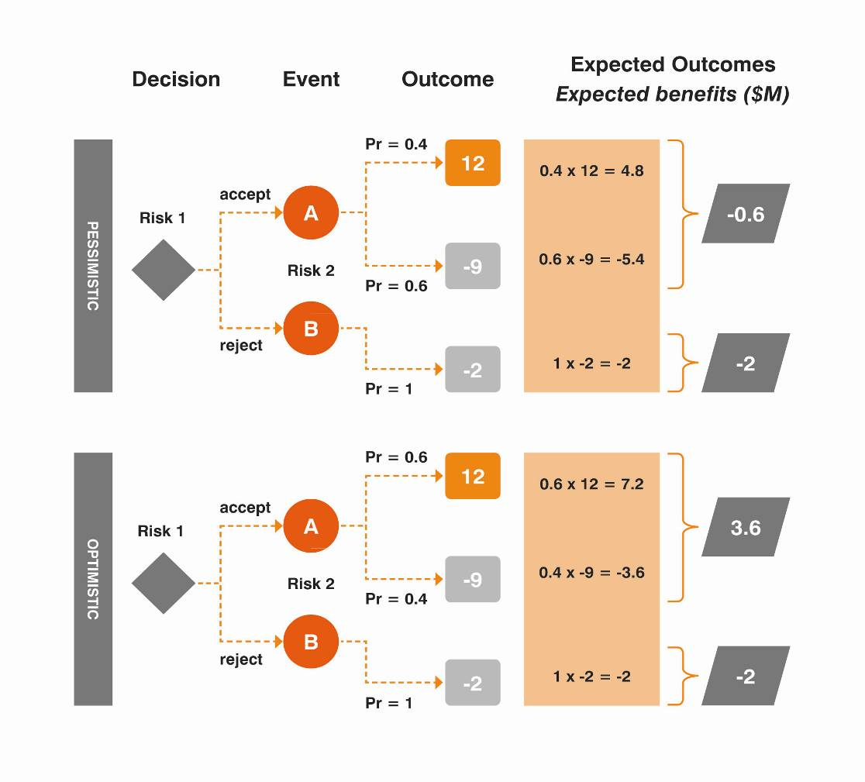

Monte Carlo analysis
A Monte Carlo analysis is a computer simulation that models and assesses risks and uncertainty by undertaking hundreds of computer-simulated trials based on the estimated frequency distributions of key input variables.
The Monte Carlo analysis then shows a complete frequency distribution of possible outcomes (i.e. the probability of particular outcomes occurring).
The simulation can be used to estimate a range of uncertain values, such as the time taken for a construction project to be completed. The Monte Carlo simulation will show the probability that a project may be delivered within different periods of time by entering a range of uncertain variables such as the number of employees or the budgeted costs, taking into account the correlations between different input variables. Like any model, the robustness of a Monte Carlo analysis is based on the assumptions and data entered into the simulation.
The use of a Monte Carlo simulation does not directly imply robust analysis unless the assumptions and data underpinning the analysis are realistic and accurate.
Where risk is a major issue, and where the expected impacts of the proposal justify additional complex analysis, a Monte Carlo analysis could be undertaken to provide a picture of the full distribution of possible outcomes. Figure 3 depicts the method of Monte Carlo simulation.
Figure 3 Monte Carlo simulation diagrams
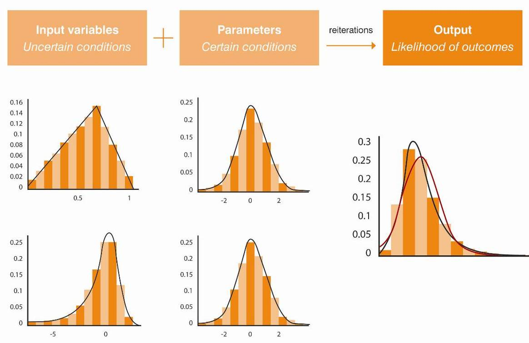

Further reading
- Department of Finance and Administration 2006, Handbook of Cost-Benefit Analysis, Financial Management Reference material No. 6, Commonwealth of Australia, Canberra, pp. 69-80 and 141–143.
- HM Treasury 2011, The Green Book: Appraisal and Evaluation in Central Government, TSO, London, pp. 28–34 and 79-90.
- RiskAMP 2011, What is Monte Carlo Simulation?, pp. 1–4.

Assessing overall impacts
Tips:
- Governments typically wish to know how proposals will affect different groups in society.
- A cost-benefit analysis should not directly include distributional (transfer) impacts in the overall result (the NPV and BCR).
- However, a description of the final distributional impacts of each proposal on various sections of society should be provided to decision-makers along with the overall results. This could include the impact on different income groups, industries and geographical areas.
- While the overall results in a cost-benefit analysis assist decision-making, they do not necessarily mean the option that generates the highest NPV or BCR will be preferred.
- The overall results, including the preferred option and other important information, should be presented in accordance with the template provided in these guidelines.

Distributional impacts
Distributional impacts refer to how costs and benefits are allocated across different groups in society. Projects may have uneven effects on different individuals according to income level, age, gender, ethnicity, location, health, skill, or other factors. Projects can also have impacts on different industries.
While the distribution of impacts generally won’t alter the overall net benefit implied by a particular project, they are generally important factors in decision-making, and agencies should aim to provide good information about these to government.
For example, a project with a high NPV/BCR may have large welfare gains that are thinly spread across high income earners, while losses are concentrated on low-income groups. Investments that have such a significant impact on income equality may not be desirable despite the cost-benefit analysis showing positive results (unless an adequate compensation program can be employed).
As indicated in section 3.3, a cost-benefit analysis should not directly include distributional (transfer) impacts in the overall results (e.g. the NPV and BCR) because it can distort the result if not done correctly and it obscures the distributional impacts.
It is also important that a cost-benefit analysis excludes subjective assumptions that attempt to provide a weighting to distributional impacts. Decisions about the significance of distributional impacts are more appropriately assessed by elected decision-makers rather than by agencies.
A cost-benefit analysis should instead identify and describe how the impacts of the project or policy are distributed between various groups. A description of the distributional impacts on the affected stakeholders, including the scale of the impact and how it spreads across different groups, should be included separately.
Finally, care needs to be taken to understand the final incidence of costs and benefits on different groups in society. Often initial distributional impacts flow on to other groups leading to a different end result.

Assessing overall results and determining a preferred option
The integrated analysis for the business case includes important information such as:
- the headline cost-benefit analysis results;
- a description of non-monetised impacts;
- a description of the distributional impacts;
- the financial analysis; and
- the analysis of risk and uncertainty.
While the headline results of a cost-benefit analysis assists decision-making, it does not necessarily mean that every option that generates the highest NPV (or BCR) will be considered the preferred option and will be funded. Other important information needs to be taken into account by decision-makers before determining the preferred option.
Agencies should clearly present cost-benefit analysis results and additional important information in business cases. Information needs to be presented in a manner that can be understood by decision-makers and relevant stakeholders without technical expertise.
The business case should include a summary of the options and their estimated NPV and BCR outcomes (including a preferred option) in line with the ‘Options comparison template’ provided in Appendix A of these guidelines. An alternative template is also provided for agencies who decide it is necessary to use multi-criteria analysis to integrate some (or all) of the results.
Agencies will need to revisit the cost-benefit analysis and the integrated assessment once the preferred option has been identified. The detailed analysis of the preferred option should be determined on the basis of a more refined costing of that option and its benefits; consistency with the initial analysis should also be confirmed.
Agencies need to include the following information in the economic evaluation in the business case (or an appendix to the business case):
- a summary of the problem;
- a discussion of each short-listed option, how the options were developed and how they address the problem outlined;
- a description of the base case including any assumptions about the future;
- a summary of relevant costs and benefits and detailed explanations of how they were valued and derived from the base case (e.g. market price, shadow pricing, valuation techniques, benefit transfer method etc.);
- the underlying assumptions in the analysis and their justifications;
- a description of the impacts that were not monetised, with explanations of why they were not monetised and the implications for the analysis;
- an assessment of the final distributional impacts;
- a discussion of the key risk and uncertainty in each option (including a scenario analysis and potentially a real options analysis) and if alternative assumptions would change the result of the preferred option;
- data sources and any other relevant sources; and
- a brief summary of the overall results.

Appendix A: Option comparison template
The model template below sets out the information that should be summarised in the option analysis section of the business case.
 | Project option 1:  Do Nothing | Project option 2: | Project option 3: | Project option 4: | Project option 5:
Analysis period (years)

Capital costs ($m)

Output costs ($m)

Cost-Benefit Analysis (of monetised costs and benefits)
Present value of benefits ($m)

Present value of costs ($m)

Net Present Value ($m)

Benefit-Cost Ratio

Other important considerations (see the examples provided)
Scenario analysis (in NPV)
Pessimistic scenario ($m)
Optimistic scenario ($m)

Non-monetisable costs/benefits
(e.g. small, med., large)

Distributional impacts
(e.g. small, med., large)

…
Preferred option
Provide a summary to justify the preferred option.

Below is an alternative summary table incorporating multi-criteria analysis:
 | Project option 1:  Do Nothing | Project option 2: | Project option 3: | Project option 4: | Project option 5:
Analysis period (years)

Capital costs ($m)

Output costs ($m)

Cost-Benefit Analysis (of monetised costs and benefits)
Present value of benefits ($m)

Present value of costs ($m)

Net Present Value ($m)

Benefit-Cost Ratio

Multi-Criteria Analysis (ranking of non-monetisable costs and benefits, etc.)
Criteria 1

Criteria 2

Criteria 3

…
Preferred option
Provide a summary to justify the preferred option.

Appendix B: Summary of the steps in an economic evaluation
Step | Task | Activities
1 | Define the problem, government rationale and objective/s | 1.1 Explain the purpose of the economic evaluation by describing the problem(s).  1.2 Assess whether the market can solve the problem and, if not, explain the rationale for government intervention.  1.3 Outline the primary objective/s of government intervention, which need to address the underlying problem(s).  Note: The underlying core objective of government interventions is generally to maximise society’s welfare.
2 | Determine the base case and develop options | 2.1 Determine the base case.  2.2 Develop strategic options with clear explanations of how they would achieve the benefits (objective/s) and address the problems.  2.3 Consider non-investment (policy) options and market-based solutions.  2.5 Take measures to avoid ‘bias’ in the analysis.
3 | Identify costs and benefits for the different options | 3.1 Identify all costs and benefits to society, including market impacts and non-market impacts.  3.2 Ensure that the impacts identified are not transfers.  3.3 Exclude financial impacts that would lead to double counting.  3.4 Take steps to avoid common pitfalls in identifying costs and benefits.
4 | Choose an evaluation methodology | 4.1 Determine data and resources required to value the identified costs and benefits.  4.2 Choose the appropriate economic evaluation methodology.  Note: The preferred methodology is cost-benefit analysis but other methods of analysis may be appropriate in some circumstances.
5 | Quantify and monetise costs and benefits | 5.1 Quantify and monetise the costs and benefits.  5.2 Use the valuation techniques, appropriate default values, and other guidance recommended in these guidelines.
6 | Discount impacts back to present values | 6.1 Use the appropriate real discount rate as advised in these guidelines to discount all costs and benefits back to their present values (and do sensitivity testing using alternative discount rates).  6.2 Ensure only real prices are used to ensure consistency with the use of a real discount.  6.3 Determine the appropriate evaluation period.
7 | Choose a quantitative assessment tool | 7.1 Determine the appropriate quantitative assessment tool to help assess the options. These guidelines recommend using Net Present Value and the Benefit-Cost Ratio.  7.2 Use the quantitative assessment tool/s to help rank the options.
8 | Assess risk and uncertainty | 8.1 Identify risk and uncertainty with the options analysed. Undertake a scenario analysis (or, if there is significant uncertainty, a Monte Carlo analysis).  8.2 Consider whether the use of Real Options may lead to more beneficial outcomes by providing flexibility in the face of uncertainty.  8.3 Analyse and discuss how the above analyses may affect the feasibility and ranking of the options.
9 | Assess distributional impacts | 9.1 Identify the impacts on different groups in society that are likely to be affected by the different options.  9.2 These distributional impacts can be identified by income group, industry sector, location, etc.
10 | Assess results and determine a preferred option | 10.1 Analyse overall results including the NPV and BCR, distributional impacts, scenario analysis, impacts that cannot be assigned a monetary value, and any other important concerns.  10.2 Recommend the final preferred option.  10.3 Present findings and a recommendation in the full business case in accordance with the template provided in these guidelines.

Appendix C: Limitations of economic evaluations
This Appendix builds on section 2 of these guidelines by describing the limitations of the different types of economic evaluation methods in more detail.
Cost-benefit analysis, cost-effective analysis and least-cost analysis, and computable generated equilibrium (CGE) modelling are all common economic analyses. Cost-benefit analysis is the most comprehensive form of economic analysis, while the other forms of analysis are only useful for certain more limited evaluations. Another, non-economic, form of analysis is multi-criteria analysis. This is sometimes used, but is not based on economic principles.
Cost-benefit analysis (preferred approach)
Figure C1 Basic cost-benefit analysis diagram

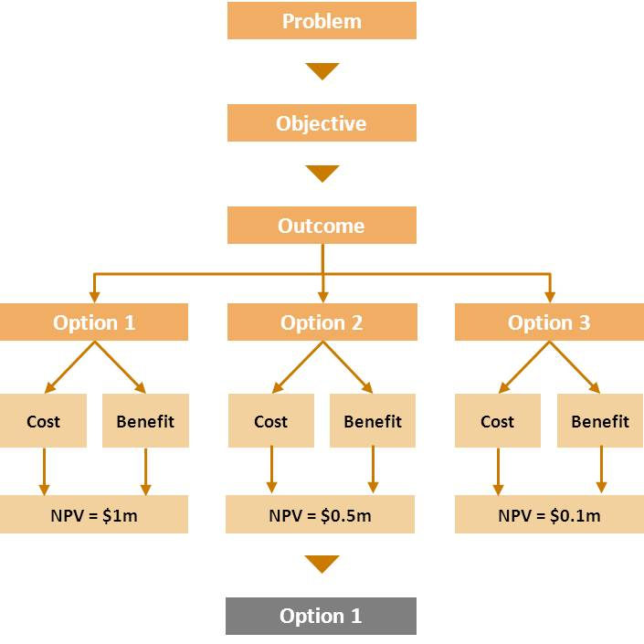
Limitations
While cost-benefit analysis can be very robust, it can also be flawed if not carried out appropriately.
For example, it is susceptible to the problem of bias – typically optimism bias – where small changes or omissions to underlying critical assumptions and values can lead to a proposal showing a significant net social benefit when it otherwise would not. However, arguably there is less scope for undetectable bias in a cost-benefit analysis due to its strong theoretical and evidence-based foundations.
In some situations it can be very difficult and/or costly to value (monetise) non-market impacts accurately. As discussed throughout these guidelines, there are well-developed techniques and existing extensive research into values that can often be used to attempt to overcome this problem.
Another limitation is the lack of accounting for distributional impacts in a cost-benefit analysis. However, as discussed in section 9, there are well-established methods available to highlight these impacts to decision-makers.
Despite these potential flaws, if applied in an objective and robust manner, a cost-benefit analysis is a very rigorous method for assessing proposals and can help remove subjectivity. Cost-benefit analysis is also recognised worldwide as the standard economic assessment tool for analysing investment and policy proposals.
Cost-effectiveness and least-cost analysis
Figure C2 Basic cost-effectiveness diagram
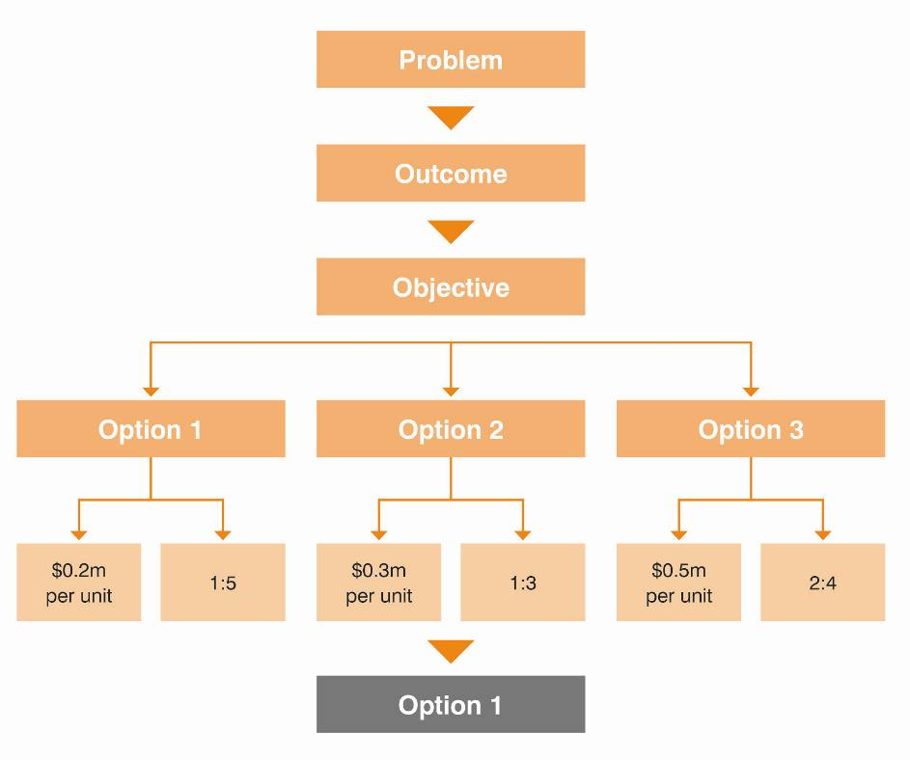

Limitations
While cost-effectiveness and least-cost analyses can be used to compare different projects that provide the same type of benefits to determine the most cost-effective option, they do not provide answers on whether the projects generate net social benefits. They also cannot be used to find or compare alternative projects that could achieve greater net social benefits by targeting different outcomes. Therefore, these methods should generally only be used where the decision to target a specific outcome has already been agreed upon by decision-makers.
Computable general equilibrium
Figure C3 Economy depicted by a CGE model
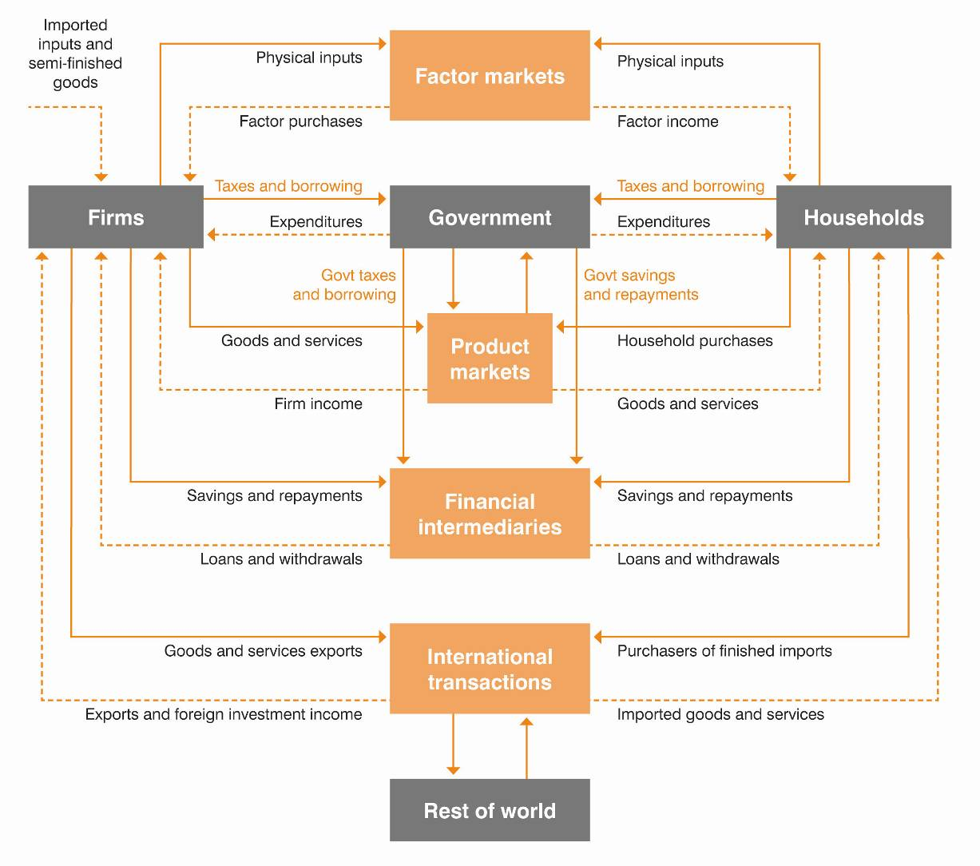
Limitations
Unlike cost-benefit analysis, CGE modelling generally does not take into account non-market impacts, such as externalities. However, a CGE model is more likely to account for second-round interstate and macroeconomic impacts than is a cost-benefit analysis model. For these reasons CGE modelling should only be used to complement a cost-benefit analysis.
The theory of CGE modelling is sound in contrast with other alternative models, such as input-output impact analysis, which tends to overstate benefits. Nevertheless, it is easy to misuse CGE models by applying incorrect assumptions since the outputs are only as good as the inputs feeding into the model. It is therefore very difficult for outside observers and decision-makers to understand, or indeed test, whether the results of the modelling are correct.
For example, it is easy to misuse CGE models by assuming a large impact on employment or double counting by using gross employment figures under a tight labour market. It is important when CGE modelling is undertaken that the results account for net changes of impact in the economy rather than gross changes.
Dynamic CGE models can give a sense of changes over time, but comparative static models, which are easier (and cheaper) to use, only give snapshots of what happens in the ‘long run’ as the economy moves from one notional equilibrium to another.
Multi-criteria analysis
Limitations
When applied with care and transparency, a multi-criteria analysis (MCA) can provide a structured and easy-to-use framework for comparing options. However a MCA is ultimately based on subjective judgements of value and it can therefore arguably be more easily biased towards the assessor’s preconceived opinions through the selective use of available data. It also cannot tell the decision-maker whether individual proposals are of net social benefit (i.e. whether anything at all should be chosen), or the optimal scale of any particular proposal.
The use of MCA should therefore generally be limited to smaller projects and/or projects where the major benefits cannot be valued or are impractical to value (as may be the case in some social infrastructure investments).
If a MCA is undertaken, the development of the criteria (and the weights attached to each criterion) is crucial. Such criteria would generally be:
- linked directly to the objectives of the proposal;
- complete and relevant – all important criteria are included and redundant criteria are excluded;
- appropriate in size and scope – criteria are appropriate to the relative size, impacts and risk of the identified options;
- practical and address the objectives – criteria can be easily assessed and are able to estimate or measure the outcomes/objectives; and
- mutually independent of preference – so that each criterion can be independently assessed without knowing the result of other criteria. This helps prevents double counting and overestimating benefits.
A MCA should include empirical data, valuations and calculations in relation to costs and benefits whenever possible in order to rely less on subjective rankings and weightings. For a good basic guide on how to undertake a MCA, refer to the VCEC’s Guidance Note on Multi-Criteria Analysis.
Figure C4 Basic multi-criteria analysis diagram
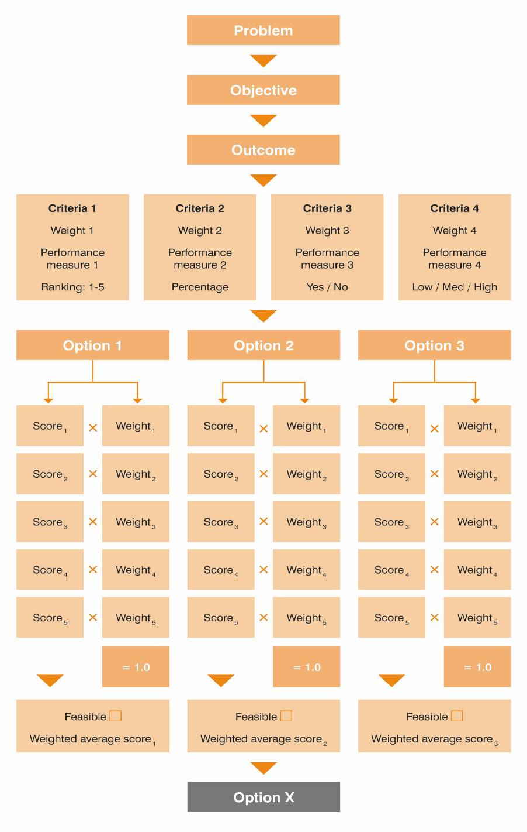
Appendix D: Shadow prices
Tips:
- Market prices do not always accurately reflect what the price would be in an unconstrained competitive market. The concept of ‘shadow prices’ can be used to take this into account.
- Incorporating 'shadow prices' can involve significant complexity and requires technical understanding. Their use should therefore be limited to cases where their impact is likely to be significant and where the effort determining them is likely to be worthwhile – such as for very large projects.
- Government assets (including land) should be costed at market value, even if owned or given away.
- Wage costs should reflect market rates. A shadow price for labour should generally not be used.
- Taxation generally creates an 'excess burden', which is a cost to society from taxation distorting economic behaviour. Where a proposal is to be funded by state taxation (e.g. through consolidated revenue), agencies could multiply all net financial costs by 1.08 as a very conservative estimate for Victoria’s excess tax burden.

Government interventions such as tariffs, taxes, subsidies, price controls and quantity controls can distort market prices. Other factors such as monopolies, cross-subsidisation, imperfections in the labour market, and ignoring scarcity values can also distort market prices and outcomes. In a cost-benefit analysis, the concept of ‘shadow prices’ can be used to take this into account.
When market prices are distorted and no longer reflect the real 'social opportunity cost' of the particular goods and services, the results obtained from market-based and reveal preference valuation techniques should be considered with caution.
Where there is significant market distortion, it is optimal to incorporate the use of shadow prices into an economic evaluation to remove the impact of these factors. This can be simple to do in some cases, such as ensuring that all government assets (including land) are costed at market value, even if the intention is that they be transferred at nil consideration. However, in many cases the use of shadow prices can involve significant complexity and require technical understanding.
The use of shadow prices should therefore be limited to cases where their impact is likely to be significant and where the effort in determining them is likely to be worthwhile – such as for very large projects. Where shadow prices are used, the associated underlying assumptions should be clearly explained and sensitivity analysis done to highlight their impact.
The following sections highlight two important shadow price issues where DTF believes further guidance may be warranted.
Utilisation of labour
In the past it has often been argued that the opportunity cost (shadow price) of labour is less than the market wage when unemployment is high because the labour hired in a particular project would otherwise be underutilised or idle. For instance, in 1978 Sassone and Schaffer stated that:
“labor that would otherwise be unemployed should be valued at a zero social cost when employed in the project - in spite of the fact that labor has a dollar cost”
However, in a tight labour market (as currently exists in Australia), there is unlikely to be a net increase in employment in the economy as a result of any particular project. Labour employment can be regarded as a benefit only when additional jobs are created from involuntary unemployment, which is rare in most projects. On that basis, market wage rates should be used to value labour costs rather than a shadow price.
The excess burden of taxation (tax distortion cost)
Unlike the private sector where projects are financed with private contributions, government projects are usually financed using taxpayers’ money. In such circumstances, it may be useful to determine the costs of taxation in order to consider it alongside other impacts as part of the economic evaluation of the project (or recurrent spending proposal). This allows government to consider the full range of costs associated with an investment prior to making a decision.
Taxation generally generates a ‘deadweight loss’, which is also known as the ‘excess burden of taxation’. This is a cost to society that comes about through taxation distorting economic behaviour (including decision-making and resource allocation), leading to less than optimal outcomes for the economy. A simple example of this is the reduced incentive to work in the presence of high marginal income tax rates. In addition, there are administration and compliance costs associated with generating taxation revenue.
To take this into account, any government intervention that uses taxation revenue not only needs to produce benefits of at least the amount spent, but the benefits also need to cover the associated ‘tax distortion’ (‘excess burden’) costs. Few cost-benefit analyses explicitly allow for the excess burden of taxation, although North American practice seems to favour its inclusion. In Australia, cost-benefit analysis evaluations and guidelines have generally not addressed this cost.
One reason for this is that it can be argued that the general level of taxation has already been pre-determined. This implies that projects or recurrent spending proposals financed from general government funding do not themselves raise taxation (or have a marginal effect).
On the other hand, it can be argued that the level of taxation is constantly reviewed by governments in light of overall spending requirements. Whether or not individual projects (or recurrent spending) go ahead directly impacts on the overall level of taxation a government is required to raise (influencing decisions to raise or lower or maintain tax rates). Incorporating the cost of the excess burden of taxation for proposals funded from general revenue would allow this to be readily taken into account by decision-makers – whereas this impact would otherwise generally be ignored.
Another reason that the ‘excess burden of taxation’ is not usually taken into account is that it is difficult to estimate. Campbell (1997) estimated that the marginal tax burden for Australia was around 25 per cent of general taxation revenue. However, there have been many other differing estimates for the excess burden of individual taxes and the overall tax base in Australia. This has made it difficult to identify an appropriate figure to use.
The recent Commonwealth Government-commissioned Henry Tax Review offered an opportunity to address this issue. As part of the technical work for the review, estimates of the excess burden of taxation for various Commonwealth and state taxes were produced (see Table D1 below).
Table D1 Henry Tax Review modelling on the excess burden of Australian taxes
Excess burden rating | Tax | Marginal excess burden rate
Low | Tobacco excise | -8
Low | Import duties | -3
Low | Petroleum resource rent tax | 0
Low | Municipal rates | 2
Low | GST | 8
Low | Land taxes | 8
Low | Alcohol excise and wine equalisation tax (WET) | 9
Medium | Fuel taxes | 15
Medium | Stamp duties other than on real property | 18
Medium | Luxury car tax | 20
Medium | Labour income tax | 24
High | Conveyancing stamp duties | 34
High | Motor vehicle registration | 37
High | Motor vehicle stamp duties | 38
High | Corporate income tax | 40
High | Payroll tax | 41
Very high | Insurance taxes | 67
Very high | Royalties and crude oil excise | 70
Very high | Gambling taxes | 92

The figures represent the most recent attempt to address this issue in Australia in a significant manner. Nevertheless, the results should be treated with caution as they were produced with significant caveats. However, they show that some taxes are much more economically efficient (i.e. they have a much lower excess burden) than others.
DTF discourages agencies developing proposals for new taxes or (non-user pays) levies to fund proposals. If agencies do propose to raise a specific tax or levy to fund their proposal, it is recommended that an estimate of the excess burden of this taxation be presented alongside the economic analysis to inform government about these impacts. Agencies should either refer to the specific tax source in the table above (and its associated marginal excess burden rate) or consult directly with DTF if it is unclear what the appropriate figure should be. The appropriate marginal excess burden rate should then generally be multiplied against the net financial (capital and operating) funding required by the proposal (before these financial costs have been discounted).
For all other proposals funded by Victorian Government tax revenue (including those from consolidated revenue), the marginal excess burden rate for land tax could be used to determine the excess burden of that taxation. Land tax is the most efficient tax within the Victorian Government’s control and has an estimated marginal excess burden of eight cents for every additional dollar of tax revenue raised.
This figure represents a very conservative but reasonable proxy for the excess burden of taxation (tax distortion cost) in Victoria based on the assumption that the Government could finance its projects from the most efficient tax source. Therefore agencies could multiply all net financial costs that require Victorian Government funding by a value of 1.08 based on land tax, Victoria's most efficient tax source. This would not apply to the extent a project is funded directly:
- from Commonwealth grants; or
- from cost-recovery methods (including those that are privately operated) that are based on efficient user-charges.

Further reading
- The Treasury 2005, Cost Benefit Analysis Primer Version 1.12, New Zealand Government, Wellington, p. 18.
- Department of Finance and Administration 2006, Handbook of Cost-Benefit Analysis, Financial Management Reference material No. 6, Commonwealth of Australia, Canberra, pp. 34-47.
- HM Treasury 2011, The Green Book: Appraisal and Evaluation in Central Government, TSO, London.
- NSW Treasury 2007, NSW Government Guidelines for Economic Appraisal,
Office of Financial Management Policy & Guidelines Paper, pp. 47-49.
Appendix E: Case Study: Urban Renewal
The following simple case study is hypothetical and designed to demonstrate how a cost-benefit analysis should be undertaken. The case study examines and explains some of the relevant considerations in setting out cost-benefit analyses and measuring benefits. The case study does not attempt to replicate a detailed economic evaluation – issues are dealt with in a simple manner for illustrative purposes only. Agencies should not take examples and policy response in the case study as having been endorsed by DTF. Agencies should consult with DTF in the first instance if uncertain about the appropriate approach to their particular economic evaluation.
E.1 Context and problem
This section sets up the problem that the investment will seek to address, which helps to identify a base case against which incremental benefits can be measured.
There are several public housing buildings in the city of Pittsmith that were built in the 1950s to accommodate factory workers. Over time, the demographic of Pittsmith's housing residents has changed from employed factory workers to disadvantaged low-skilled residents with very low incomes.
The Pittsmith Department of Housing, Employment and Development (HED) has identified that the high-density, concentrated public housing buildings, coupled with the low-skilled characteristics of residents, has discouraged businesses from opening and operating in Pittsmith. As a result, employment opportunities for public housing tenants have been further reduced, while the absence of services in the area is a disincentive for potential incoming residents. There are approximately 2500 residents, including 2000 public housing tenants in Pittsmith.
Pittsmith has a high rate of unemployment relative to its neighbouring cities Shelton and Rosedale. It also has a higher rate of youth unemployment and crime relative to the other cities. Rosedale is located across the river from Pittsmith and Shelton, and historically has had high employment with a full range of services available to its residents.
Former Pittsmith residents have relocated to Shelton and Rosedale for jobs, leaving Pittsmith to become increasingly concentrated with the remaining poorly skilled public housing tenants facing limited job prospects.
Shelton was in a similar economic situation as Pittsmith few years ago. It underwent a series of urban development and renewal programs that included demolishing and reconstructing its run-down public housing stock. The local government of Shelton also redesigned and landscaped abandoned parks to provide a friendlier and more sustainable environment for its residents. Consequently, there is less concentration of public housing tenants in a given area and the amenity improvements have attracted new residents from neighbouring cities, especially former Pittsmith residents.
E.2 Objectives
Costs and benefits identified in the options below are incremental impacts relative to this base case. The Investment Logic Mapping (ILM) process is a valuable tool for rigorously thinking about the objectives of the investment and to start to think about what the benefits might be. It is important to note that there will be overlap in the benefits identified in the ILM process and they will not necessarily translate neatly into valid benefits for the purposes of undertaking a cost-benefit analysis from a societal perspective.
Figure E1 Investment logic map for urban renewal example
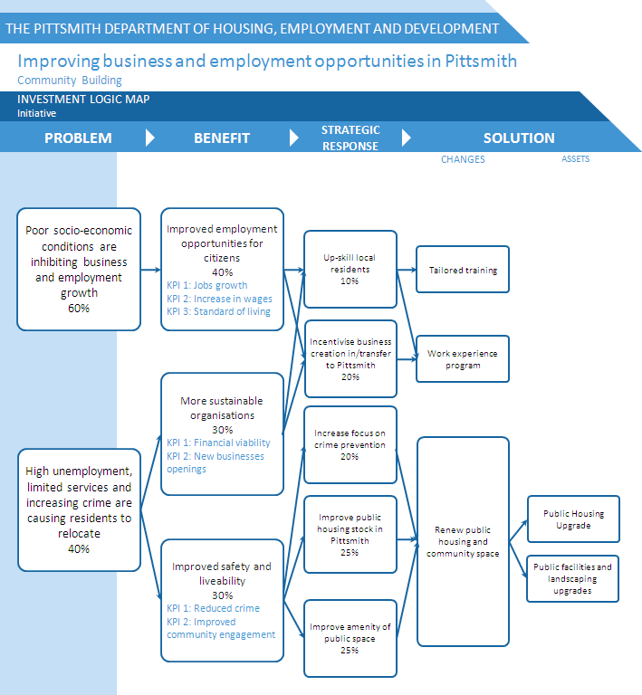

E.3 Base case and options
It is important to define the base case and options clearly so that incremental costs and benefits can easily be assessed and valued in reference to the base case. In this hypothetical case study, only one option is explored and compared with the base case.
Base case option - Status quo
The base case ('current policy') option is for a ‘business as usual’ scenario in which costs of $3.2 million a year are incurred for the entire time horizon. It costs HED $2.3 million per year to maintain and repair public housing buildings in Pittsmith as buildings continue to deteriorate. Policing costs $900 000 every year for 15 police officers to patrol Pittsmith. These costs are expected to be ongoing. There are also other impacts, such as damages to public property through antisocial behaviour.
Costs and benefits identified in the option below are incremental impacts relative to this base case.
Project option - Urban renewal
This option includes renovating public housing buildings to promote a new image of Pittsmith and attract businesses and new residents. Tailored training will be provided to tenants to boost skills, coupled with on-the-job work experience to help them find employment. The surrounding area will also be renewed and landscaped to provide better amenities. It is expected that a change in environment will reduce crime through community involvement, and jobs will be created through synergies between the more amenable urban form and the delivery of locally-based training programs.
E.4 Identifying impacts
Ideally, all impacts should be identified before they are quantified or monetised. A description to justify why the impact is in the cost-benefit analysis could also be included.
Market Benefits
Some possible monetised benefits for this urban renewal case study are shown in the following table.
Table E7 Urban renewal benefits
Urban renewal benefits | Description | Suggested methodology
Reduction in crime expenditure | A reduction in crime (e.g. vandalism) can lead to a reduction in public expenditure on crime prevention and/or crime enforcement. | - Market price;  - Defensive approach; and/or  - Benefit-transfer from other urban renewal case studies
Reduction in maintenance costs and/or insurance cost | Upgrading assets can reduce the costs of maintenance though this is not always the case. Sometimes, reducing the risk of damages can also lower the cost of insurance on the asset. | - Market price (take care to avoid double counting with property capital gains.)
Sustainability | There can be sustainability benefits generated from having efficient building designs such as savings in energy costs | - Market price
Increased labour incomes from new jobs | Labour incomes can increase due to the creation of new jobs in the economy for individuals who would have otherwise been involuntary unemployed.  Note that projects benefiting those who are unemployed in the short-term and/or labour hire from the project do not generally count as benefits. Since these individuals can find work elsewhere in the economy, the projects are effectively transferring labour from other parts of the economy and thus, does not constitute as an incremental benefit | - Market wage rates; and/or  - Benefit – transfer using case studies to provide evidence

Market Costs
Some possible monetised costs for this urban renewal case study are shown in the following table.
Table E8 Urban renewal costs
Urban renewal costs | Description | Suggested methodology
Construction and maintenance | Construction and maintenance costs include administrative planning costs and costs associated with the construction and maintenance phases of the project | - Market price
Acquisition | Acquisition costs are costs that are associated with the project such as land and/or building acquisitions | - Market price
Program | Program costs are any relevant costs associated with operating services and programs, including staff hire  Note that staff hire from the project counts as a cost instead of a jobs creation benefit | - Market price; and/or  - Market wage

Non-market impacts
Some possible non-market impacts, which can be quantified or monetised on a case-by-case basis for this urban renewal case study are shown in the following table.
Table E9 Urban renewal on-monetised impacts
Urban renewal benefits | Description | Suggested methodology
Health and wellbeing improvements | Health and wellbeing impacts can arise as a result of an improvement in the environment such as a reduction in air, water and/or noise pollution | - Case-by-case basis;  - Stated preference; and/or  - Qualitative
Amenity | Amenity impacts can be benefits from facility or neighbourhood improvements. These impacts often reflect through the changes in property prices in the surrounding area or neighbourhood. However extreme care should be taken in attempting to monetise and include these impacts as this may inadvertently involve double counting certain impacts. | - Case-by-case basis; and/or  - Qualitative.

E.5 Valuing impacts
The table below shows rough calculations of the main benefits of the option. Some benefits can be indirectly reflected in the valuation of other benefits and therefore should not be quantified to avoid double counting. Valuing impacts, especially non-monetary impacts, is difficult and should be undertaken with care.
Table E10 Valuing impacts in the urban renewal case study
Costs | Description | Valuation
Capital/Renovation | Quoted costs for construction | $16 million
Landscaping | Quoted costs for landscaping | $2 million and an ongoing $200 000 each year
Training program | The cost of the training program is an immediate one-year expenditure and is calculated as follow:  cost of training per person x number of people participating in the training  $7 000 x 450 trainees | $3.15 million per year for one year

Benefit | Description | Valuation
Increased labour incomes from new jobs (occur from second year onwards)¹ | This income benefit arises from new jobs created from involuntary unemployment that exists in the community where labour would otherwise be idle.  The case study assumes that 380 new jobs will be created (from the second year onwards) based on the case study of a similar urban renewal experience in Shelton.  The benefit is calculated as follow:  Market wage per year x number of new jobs created each year  $30 000 x 380 jobs | $11.4 million a year in the last two years
Maintenance expenditure savings | This is an estimate of the maintenance cost savings generated from the urban renewal project. It is a saving of existing expenditure compared to the base case and should be included as a benefit. The saving is expected to begin in the first year of the project when the renovation is completed and ends at the end of the third year due to deterioration. | $2 million a year
Utility or energy savings | This benefit is from a permanent reduction in energy and utility costs as a result of the renovation upgrade. It is a saving of utility expenditure relative to the base case and should be included as a benefit. | $200 000 a year (ongoing after the program)
Savings in crime prevention expenditures (in the second and third year) | It is expected that the number of police on patrol will halve due to better amenity in the neighbourhood according to similar experience in Shelton. This is a saving of crime prevention expenditure relative to the base case and should be included as a benefit.  The saving is calculated as follow:  Police wage per year x the number of police  $60 000 x 7.5 police officers | $450 000 a year in the last two years of the program
Note: Agencies need to take caution when identifying new jobs as a benefit. Since this case study targets job creation, the benefit here is new jobs created in the community where workers would otherwise be unemployed, not jobs or labour hired from the project (e.g. capital / renovation or training programs) that would otherwise be employed in another project. Job creation estimates need to be well-supported by evidence and the underpinning assumptions made clear – however they should generally only be used with extreme caution (see Appendix D of these guidelines for a more detailed explanation).

E.6 Discount the costs and benefits to their present value
Determine the appropriate real discount rate and ensure that real prices are used when discounting the impacts back to their present values.
The impacts are discounted back to present value over the period of three years.
Table E11 Estimated present values of urban renewal impacts
Project Option  Impacts | Year 0  ($m) | Year 1  ($m) | Year 2  ($m) | Year 3  ($m) | Total  ($m)
Discount Rate (7 per cent) | 1.000 | 0.935 | 0.873 | 0.816
Costs
Capital/Renovation | (15.00) |  |  |  | (15.00)
Training programs | (3.15) |  |  |  | (3.15)
Landscaping | (2.00) | (0.19) | (0.17) | (0.16) | (2.52)
Total costs (PV) | (20.15) | (0.19) | (0.17) | (0.16) | (20.67)
Benefits
Utility/energy savings (*perpetuity) | 0.20 | 0.19 | 0.17 | 0.16 | 2.86*
Maintenance expenditure savings |  | 1.87 | 1.75 | 1.63 | 5.25
Real jobs created |  |  | 9.96 | 9.31 | 19.26
Police expenditure savings |  |  | 0.39 | 0.37 | 0.76
Total benefits (PV) | 0.20 | 2.06 | 12.27 | 11.47 | 28.13

E.7 Quantitative evaluation tool/s
Determine the appropriate quantitative assessment tool to help assess the options.
The NPV is the preferred quantitative evaluation tool to compare investment projects but both the NPV and BCR are listed below.
Table E12 Comparing urban renewal options
Option | PV cost | PV benefits | NPV | BCR
Project Option | -20.67m | $28.13m | $7.45m | 1.36
Note: The base case is zero, so impacts should be relative to the base case.

E.8 Assess distributional impact
Identify the impacts on different groups in society that are likely to be affected by the different options.
It is expected that the project will benefit low-income residents as a result of the job benefits generated. The amenity improvement and other public good benefits will make Pittsmith an attractive area to live and invest in, and will result in an increase in property prices for medium-income residents. Additionally, small businesses in Pittsmith will gain benefits by having access to a more productive workforce. It is expected that no Pittsmith residents will experience adverse impact as a result of the project.
E.9 Sensitivity analysis
Identify risk and uncertainty in the options analysed and undertake a sensitivity analysis.
The key variable to sensitivity test is the number of new jobs created, given that the estimate is based on another jurisdiction's experience and is highly uncertain due to differing economic conditions.
As the table below shows, under a pessimistic scenario in which only 100 new jobs are created, the NPV is negative. Nevertheless, there are several benefits that cannot be quantified or monetised and they should be fully explored in considering whether to proceed with the project.
Table E13 Sensitivity assessment of the urban renewal project
Jobs created | Calculation | Valuation | NPV
Pessimistic scenario (100 jobs) | 100 x $30,000 | $3m a year | -$6.74m
Cost-benefit analysis (380 jobs) | 380 x $30,000 | $11.4m a year | $7.45m
Optimistic scenario (500 jobs) | 500 x $30,000 | $15m a year | $13.54m

E.10 Recommendations
A summary explanation of why the option is recommended overall by the agency.
Box E1 Urban renewal project recommendations
Urban Renewal | The urban renewal option meets the objective of the business case and has a positive NPV. Although sensitivity testing shows that the project may not generate net benefits under a pessimistic scenario, the non-monetary benefits that the project provides are shown in the business case and provide grounds for continuing to make the investment.

Figure E2 Urban renewal case study template
Option Comparison ($ m )
Business Case: Urban Renewal in Pittsmith
Year: 2012/13 - 2015/16
Option | Description and Key assumptions
Current Policy  [Base Case] | 1. It currently costs $2.30 million per year to maintain and repair public housing in Pittsmith  2. Policing costs $900 000 every year for 15 policemen to patrol Pittsmith.  3. Damages to public property from anti-social behaviour cannot be estimated.
Urban Renewal | 1. Renovate public housing buildings and renew surrounding areas to attract new businesses and residence outside of Pittsmith.  2. The proposal will create a range of benefits outlined in the business case.
 |  | Urban Renewal
Net Present Value |  | 7.45
Benefit/Cost Ratio |  | 1.36
Quantitative Impact
Market Benefits (Present Value) |  | 8.87
Non-Market Benefits (Present Value) |  | 19.26
Total Benefits (Present Value) |  | 28.13
Market Costs (Present Value) |  | (20.67)
Non-Market Costs (Present Value) |  | 0.00
Total Costs (Present Value) |  | (20.67)
Sensitivity Analysis (NPV)
Real Jobs Created  Pessimistic Scenario - 100 jobs  Optimistic Scenario- 500 jobs |  | (6.74)  13.54
Distributional Impact
It is expected that the project will benefit low-income residents as a result of the job benefits generated. The amenity improvement and other public good benefits will make Pittsmith an attractive area to live and invest in, and will result to an increase in property prices for medium-income residents. Additionally, small businesses in Pittsmith will gain benefits by having access to a more productive workforce. It is expected that nobody in Pittsmith will experience adverse impact as a result of the project.
Qualitative Benefits
Wellbeing improvement
Improving the health & wellbeing of residents creates a better environment to live, work and undertake leisure.
Choices
An increase in small business activities means a greater choice of goods and services available to residents.
Amenity improvement
An improvement in amenity leads to wider benefits such as social inclusion.
Preferred Option: Urban Renewal
The urban renewal option is the preferred option because it meets the objective of the business case and has the highest NPV. Although sensitivity shows that the option may not generate net benefits under a pessimistic scenario, the non-monetary benefits that the project provides are shown in the business case.

Abbreviations
BCR | Benefit-Cost Ratio
CGE | Computable General Equilibrium
DTF | Department of Treasury and Finance
ETS | Emission Trading Scheme
GDP | Gross Domestic Product
IRR | Internal Rate of Return
MCA | Multi Criteria Analysis
NPV | Net Present Value
PV | Present Value
RV | Residual Value
VCEC | Victorian Competition and Efficiency Commission
WEB | Wider Economic Benefit

Glossary
Business case: The purpose of a business case is to demonstrate that there is a compelling case to invest, and that the investment can be delivered. Business case templates are available on the DTF investment lifecycle guidance website.
Discounting: Discounting is a technique that allows projects to be compared without bias by converting costs and benefits occurring in different time periods back to their present values.
Externality: A cost or benefit from a transaction/activity that is received or borne by people not directly involved in the transaction/activity. For example, a factory may pollute a river, which would have detrimental effects on other users of the river (a negative externality). Alternatively, the discovery of a new technology may be utilised by businesses that develop other products (a positive externality).
Market impacts: Market impacts are those costs and benefits that are usually readily identifiable because they generally involve a clear transaction and a clearly identifiable market price.
Market-based solution : Market-based solutions involve using market mechanisms such as pricing, property rights and competition in order to solve common problems.
Market failure: Where markets, left to their own devices, would produce suboptimal outcomes. Examples include information asymmetries, externalities and natural monopolies.
Net benefit: A proposal shows a net benefit where the aggregate community-wide benefits exceed the costs. Where some stakeholders lose from a proposal, others have to gain by more for this condition to hold. One example would be the introduction of seat belts where the costs imposed on manufacturers/consumers have been exceeded by benefits derived from lives saved and injuries avoided. Where a range of options are available, the one in which the benefits exceed the costs by the greatest margin would be the one with the greatest net benefit.
Nominal: An item in current prices, not adjusted for the effects of inflation.
Non-market impacts: Non-market impacts are those costs and benefits that are not readily identifiable because they generally do not involve a clear transaction or market price. Such impacts include what are often referred to as environmental, social and economic externalities.
Opportunity cost: Whatever must be given up to obtain some item (e.g. the opportunity cost of a simple investment is the potential return that could have been received via making an alternative investment).
Real: An item valued at constant prices (i.e. corrected for the effects of inflation).
Spill-over impact: See externalities.
Social Welfare: Social welfare is a measure of overall wellbeing in society that takes into account both market and non-market impacts. This can be partly measured by standard economic measures such as GDP and real income, but can also relate to less easily quantifiable factors that individual’s value such as their own health, leisure time, benefits gained from enjoying environmental assets and various social factors. In this context, welfare is synonymous with the more commonly used economic term “utility”, the level of satisfaction individuals receive from their circumstances.
(Adapted from: Australian Government 2007, Best Practice Regulation Handbook, Commonwealth of Australia, Canberra, http://www.finance.gov.au/obpr/docs/handbook.pdf)
Bibliography
Abelson, P. 2007, Establishing a Monetary Value for Lives Saved: Issues and Controversies, Working Papers in Cost benefit Analysis WP 2008-2, http://www.finance.gov.au/obpr/docs/Working-paper-2-Peter-Abelson.pdf
Asian Development Bank 1997, Guidelines for the Economic Analysis of Projects, http://www.adb.org/sites/default/files/pub/1993/eco-analysis-projects.pdf
Australian Transport Council 2006, National Guidelines for Transport System Management, Volume I-5, http://www.atcouncil.gov.au/documents/
Australian Government 2007, Best Practice Regulation Handbook, Commonwealth of Australia, Canberra, http://www.finance.gov.au/obpr/docs/handbook.pdf
Australian Government 2010, Best Practice Regulation Handbook, Commonwealth of Australia, Canberra, http://www.finance.gov.au/obpr/proposal/handbook/docs/Best-Practice-Regulation-Handbook.pdf
Aviram, H. and Graham, D. 2005, Incorporating Agglomeration Economies in Transport Cost-Benefit Analysis: The Case of Proposed Light-Rail Transit in the Tel-Aviv Metropolitan Area, http://www-sre.wu-wien.ac.at/ersa/ersaconfs/ersa05/papers/133.pdf
Barker, B.; Begg, S.; Stanley, L.M.; Lopez, A.; Stevenson C.; & Vos, T. 2007, The Burden of Disease and Injury in Australia 2003, AIHW cat. No. PHE 82, Australian Institute of Health and Welfare, Canberra, http://www.aihw.gov.au/WorkArea/DownloadAsset.aspx?id=6442459747
Bureau of Transport Economics 1999, Facts and Furphies in Benefit-Cost Analysis: Transport, Report 100, Commonwealth of Australia, Canberra, http://www.bitre.gov.au/publications/1999/files/report_100.pdf
Ballard C. & Fullerton D. 1992, Distortionary Taxes and the Provision of Public Goods, Journal of Economic Perspective 6.3, pp. 117-131
Burns, M.; Kupke, V.; Marano, W.; & Rossini, P. 2001, Measuring the changing effects of aircraft noise: a case study of Adelaide Airport, Seventh Annual Pacific-Rim Real Estate Society Conference, Adelaide, 21-24 January 2001, http://www.prres.net/Papers/Burns_Measuring_the_changing_effects_of_aircraft_noise.pdf
Campbell, H. 1997, Deadweight loss and the cost of public funds in Australia, Agenda, http://epress.anu.edu.au/wp-content/uploads/2011/06/4-2-NT-3.pdf
Carr, L. & Mendelsohn, R. 2003, Valuing Coral Reefs: A Travel Cost Analysis of the Great Barrier Reef, Royal Swedish Academy of Sciences, p.353-357, http://environment.yale.edu/files/biblio/YaleFES-00000272.pdf
Central Expenditure Evaluation Unit 2012, Guide to Economic Appraisal: Carrying Out a Cost Benefit Analysis, The VFM Code, pp.1-40
Coughlin, C.C., and Mandelbaum, T.B., 1991, A Consumer’s Guide to Regional Economic Multipliers, Review, Federal Reserve Bank of St. Louis, Jan, pp.19-32, http://research.stlouisfed.org/publications/review/91/01/Consumer_Jan_Feb1991.pdf
Council of Australian Governments 2007, Best Practice Regulation: A Guide for Ministerial Councils and National Standard Setting Bodies, http://www.finance.gov.au/obpr/docs/COAG_best_practice_guide_2007.pdf
Cowell, F. A. and K. Gardiner 1999, Welfare Weights. Economics Research Paper 20, STICERD, London School of Economics and Political Science
Creedy, J. 2008, A Note on Discounting and the Social Time Preference Rate, Australian Journal of Labour Economics, 11, 3, pp.249-255
Department of Communities and Local Government (United Kingdom) 2009, Multi- criteria analysis: a manual, London, http://www.communities.gov.uk/publications/corporate/multicriteriaanalysismanual
Department of Finance and Administration 2006, Introduction to Cost Benefit Analysis and Alternative Evaluation Methodologies, Financial Management Reference Material No.5, Commonwealth of Australia, Canberra, http://www.finance.gov.au/publications/finance-circulars/2006/docs/Intro_to_CB_analysis.pdf
Department of Finance and Administration 2006, Handbook of Cost-Benefit Analysis, Financial Management Reference material No. 6, Commonwealth of Australia, Canberra, http://www.finance.gov.au/publications/finance-circulars/2006/docs/Handbook_of_CB_analysis.pdf
Department of Finance and Deregulation 2008, Best Practice Regulation Guidance Note: Value of statistical life, Commonwealth of Australia, Canberra, www.finance.gov.au/obpr/docs/ValuingStatisticalLife.rtf
Department of Infrastructure and Planning (Queensland Government), Cost Benefit Analysis, Project Assurance Framework Supplementary Guidance Material, http://www.treasury.qld.gov.au/office/knowledge/docs/project-assurance-framework-guidelines/paf-cost-benefit-analysis.pdf
Department of Transport 2010, Guidelines for Cost Benefit Analysis, State of Victoria, Melbourne, http://www.transport.vic.gov.au/about-us/corporate-governance/guidelines-for-cost-benefit-analysis
Department of Treasury and Finance, Investment Lifecycle and High Value/High Risk Guidelines, http://www.lifecycleguidance.dtf.vic.gov.au/section.php?section_ID=1
Department of Treasury and Finance 2010, Developing a Discount Rate for a business case, Investment Lifecycle Guidance Note, State of Victoria, http://www.lifecycleguidance.dtf.vic.gov.au/admin/library/attachments/Guidance%20Note%20-%20developing%20and%20using%20a%20discount%20rate%20for%20business%20cases.PDF
Department of Treasury and Finance 2011, Victorian Guide to Regulation Appendices, State of Victoria, Melbourne, http://www.vcec.vic.gov.au/CA256EAF001C7B21/WebObj/VGRAppendices-July2011/$File/VGR%20Appendices%20-%20July%202011.pdf
Department of Treasury and Finance 2011, Victorian Guide to Regulation – Edition 2.1, State of Victoria, Melbourne, August 2011, http://www.vcec.vic.gov.au/CA256EAF001C7B21/WebObj/VGR-incl/$File/VGR%20-%20incl.%20SLA%20guidelines%20from%201%20July%202011.pdf
Department of Treasury and Finance 2010, Investment Logic Map Guideline, State of Victoria, Melbourne, http://www.dtf.vic.gov.au/CA25713E0002EF43/pages/investment-management-the-theory-behind-the-investment-management-standard-investment-logic-map
Department of Treasury and Finance 2010, The Informed Discussion Guideline, State of Victoria, Melbourne, http://www.dtf.vic.gov.au/CA25713E0002EF43/pages/investment-management-the-theory-behind-the-investment-management-standard-the-informed-discussion
Dobes, L. 2007, A Century of Australian Cost-Benefit Analysis: Lessons from the Past and the Present, Office of Best Practice Regulation Conference, Canberra, http://www.finance.gov.au/obpr/docs/Working-paper-1-Leo-Dobes.pdf
Economic Evaluation Branch 1994, Guide to Benefit-Cost Analysis in Transport Canada, http://www.tc.gc.ca/media/documents/corporate-services/bca.pdf
Environmental Protection Agency (United States) 2000, Guideline for Preparing Economic Analyses, http://yosemite.epa.gov/ee/epa/eerm.nsf/vwAN/EE-0568-50.pdf/$file/EE-0568-50.pdf
European Commission 2002, Guide to Cost Benefit Analysis of Investment Projects, Structural Funds, Cohesion Fund and Instrument for Pre-Accession, http://ec.europa.eu/regional_policy/sources/docgener/guides/cost/guide02_en.pdf
European Commission 2008, Guide to Cost-Benefit Analysis of Investment Projects, Structural Funds, Cohesion Fund and Instrument for Pre-Accession, http://ec.europa.eu/regional_policy/sources/docgener/guides/cost/guide2008_en.pdf
Forsyth, P., 2011, Evaluating Investments – CBA or CGE? Lecture Notes, DPI Seminar 7 September 2011, Melbourne, Victoria, Australia
Flyvbjerg, B. 2006, From Nobel Prize To Project Management: Getting Risks Right, Project Management Journal August 2006, http://flyvbjerg.plan.aau.dk/Publications2006/Nobel-PMJ2006.pdf
Fuguitt, D., & Wilcox, S.J., 1999, Cost-Benefit Analysis for Public Sector Decision Makers, Westport, Conn. and London: Greenwood, Quorum Books
Henry, K.; Harmer, J.; Piggott, J.; Ridout, H.; & Smith, G. 2011, Australia’s Future Tax System, Report to the Treasurer, Commonwealth of Australia, Canberra, http://taxreview.treasury.gov.au/content/downloads/final_report_part_1/00_AFTS_final_report_consolidated.pdf and
http://taxreview.treasury.gov.au/content/downloads/final_report_part_2/AFTS_Final_Report_Part_2_Vol_2_Consolidated.pdf
HM Treasury 2007, Treasury Taskforce Technical Note 7: How to achieve design quality in PFI projects, London, http://www.hm-treasury.gov.uk/d/PPP_TTF_Technote7.pdf
HM Treasury 2011, The Green Book: Appraisal and Evaluation in Central Government, TSO, London, http://www.hm-treasury.gov.uk/d/green_book_complete.pdf
Infrastructure Australia 2008, Volume 5: Discount Rate Methodology Guidance, National Public Private Partnership Guidelines, Commonwealth of Australia, Canberra, http://www.infrastructureaustralia.gov.au/public_private/files/National_PPP_Guidelines_Vol_5Discount_Rate_Methodology_Guidance_Jan_09.pdf
Infrastructure Australia 2010, Reform and Investment Framework Templates for Use by Proponents: Template for Stage 7
Infrastructure Australia 2012, Better Infrastructure Decision-Making: Guidelines for making submissions, Australian Government, Canberra, http://www.infrastructureaustralia.gov.au/reform_investment/files/Better_Infrastructure_Decision_Making_Guidelines_v5.pdf
KPMG Econtech for Commonwealth Treasury, CGE Analysis of the current Australian tax system – Final Report, 2010, http://taxreview.treasury.gov.au/content/html/commissioned_work/downloads/KPMG_Econtech_Efficiency%20of%20Taxes_Final_Report.pdf
Lebel, P., Montclair State University’s CGE chart, http://msuweb.montclair.edu/~lebelp/CircularFlowDiagram.jpg
Mathers C.; Vos T.; & Stevenson C. 1999, The burden of disease and injury in Australia, AIHW cat. no. PHE 17, AIHW, Canberra, http://www.aihw.gov.au/WorkArea/DownloadAsset.aspx?id=6442459196
New Zealand Treasury 2005, Cost Benefit Analysis Primer Version 1.12, http://www.treasury.govt.nz/publications/guidance/planning/costbenefitanalysis/primer
NSW Treasury 2007, NSW Government Guidelines for Economic Appraisal, Office of Financial Management Policy & Guidelines Paper, http://www.treasury.nsw.gov.au/__data/assets/pdf_file/0016/7414/tpp07-5.pdf
Office of Management and Budget, To the Heads of Executive Agencies and Establishments Subject: Regulatory Analysis, Circular A-4, United States Government, 17 September 2003, http://www.whitehouse.gov/omb/circulars_a004_a-4
Partnerships Victoria 2003, Use of Discount Rates in the Partnerships Victoria Process, Partnerships Victoria Technical Note, http://www.partnerships.vic.gov.au/CA25708500035EB6/WebObj/UseofDiscountRatesinthePartnershipsVictoriaProcess/$File/Use%20of%20Discount%20Rates%20in%20the%20Partnerships%20Victoria%20Process.pdf
Partnerships Victoria 2005, Current Rates, State of Victoria, Melbourne, http://www.partnerships.vic.gov.au/CA25708500035EB6/WebObj/CurrentratesasatJanuary2005/$File/Current%20rates%20as%20at%20January%202005.pdf
Pearce, D.; Atkinson, D. & Mourato, S. 2006, Cost-Benefit Analysis and the Environment: Recent Developments, OECD, Paris, http://titania.sourceoecd.org/vl=5580034/cl=17/nw=1/rpsv/~6674/v2006n4/s1/p1l
Perkins, F. 1994, Practical Cost Benefit Analysis, Macmillan Education Australia, South Melbourne
Rabin, J. & Stevens, G. 2002, Handbook of Fiscal Policy, CRC Press
RiskAMP 2011, What is Monte Carlo Simulation?, http://www.riskamp.com/files/RiskAMP%20-%20Monte%20Carlo%20Simulation.pdf
Roskill Commission 1971, Report of the Commission on the Third London Airport, (Chairman The Hon. Mr Justice Roskill) HMSO, London
Sassone, P. & Schaffer, W.A., 1978, Cost-Benefit Analysis: A Handbook. New York Academic Press
Stubbs, J. and Storer, J. (1996), Social Cost Benefit Analysis of NSW Department of Housing’s Neighbourhood Improvement Program Case Study Area: Airds, http://www.parliament.nsw.gov.au/Prod/parlment/committee.nsf/0/28217fa2555c6d75ca2570bb001cf66d/$FILE/Sub%2011%20web%20appendix%20part%201.pdf
Transportation Benefit-Cost Analysis Website http://bca.transportationeconomics.org/
Treasury Board of Canada Secretariat 2007, Canadian Cost Benefit Analysis Guide: Regulatory Proposals
Transportation Research Board 2002, Estimating the Benefits and Costs of Public Transit Projects: A Guidebook for Practitioners, I-1 – V-17, http://onlinepubs.trb.org/onlinepubs/tcrp/tcrp78/guidebook/tcrp78.pdf
United States Government, Improving Regulation and Regulatory Review, Executive Order No. 13,563, Federal Register, vol.10, No. 14, 18 January 2011, pp. 3821-3823, http://www.gpo.gov/fdsys/pkg/FR-2011-01-21/pdf/2011-1385.pdf
Victorian Competition & Efficiency Commission (VCEC), Multi-criteria Analysis (MCA), Guidance Note, State of Victoria, Melbourne, http://www.vcec.vic.gov.au/CA256EAF001C7B21/WebObj/Guidancenote-multi-criteriaanalysis-PDF/$File/Guidance%20note%20-%20multi-criteria%20analysis%20-%20PDF.pdf
Wing IS 2004, Computable General Equilibrium Models and Their Use in Economy-Wide Policy Analysis: Everything You Ever Wanted to Know (But Were Afraid to Ask), http://users.ictp.it/~eee/workshops/smr1541/Peterson3.pdf

The Victorian Guide to Regulation remains the primary guidance for all regulatory proposals, see http://www.vcec.vic.gov.au/CA256EAF001C7B21/pages/regulation-review-guidance-material.
For these guidelines this means to maximise the social welfare of Victoria/Victorians as a whole. Certain policy interventions that are specifically designed to address equity or distributional issues may not meet this underlying core objective. However, even in such circumstances the overall impact on society should be taken into account when comparing options.
For further information on understanding the rationale for government interventions see the Prove guideline.
For further information on ‘reference class forecasting’, see Flyvbjerg, B. 2006, From Nobel Prize To Project Management: Getting Risks Right, Project Management Journal, http://flyvbjerg.plan.aau.dk/Publications2006/Nobel-PMJ2006.pdf
Some of these impacts would not be included in a financial analysis that is based only on cash-flows in any case.
See Appendix D.
Nevertheless, care must be taken as market prices only reflect social values in competitive, non-distorted, markets – see Appendix D.
D. Pearce, G. Atkinson, & S. Mourato, Cost-Benefit Analysis and the Environment: Recent Developments, OECD, Paris, 2006, http://titania.sourceoecd.org/vl=5580034/cl=17/nw=1/rpsv/~6674/v2006n4/s1/p1l , pp.119-125.
See section 4 for further details on the benefit-transfer method.
See the Prove guideline for more information on developing the ‘base case’.
Abelson P 2007, Establishing a Monetary Value for Lives Saved: Issues and Controversies, Working Papers in Cost benefit Analysis, p. 21, http://www.finance.gov.au/obpr/docs/Working-paper-2-Peter-Abelson.pdf.
Harrison, M. 2010, Valuing the Future: the social discount rate in cost-benefit analysis, Visiting Researcher Paper, Productivity Commission, Canberra.
This example is based on another example from Fuguitt & Wilcox, 1999, Cost-Benefit Analysis for Public Sector Decision Makers, pp. 86–87.
Agencies should refer to section 2 and Appendix C in these guidelines before using multi-criteria analysis.
For further information on cost-effectiveness analysis see pp. 107–114 of the Commonwealth Department of Finance and Administration’s Handbook of Cost-Benefit Analysis at http://www.finance.gov.au/publications/finance-circulars/2006/docs/Handbook_of_CB_analysis.pdf
This diagram is replicated from a diagram provided on the website of Professor Phillip LeBel from Montclair State University: http://msuweb.montclair.edu/~lebelp/CircularFlowDiagram.jpg.
For further detail on CGE modelling, please refer to: Wing IS 2004, Computable General Equilibrium Models and Their Use in Economy-Wide Policy Analysis: Everything You Ever Wanted to Know (But Were Afraid to Ask), http://users.ictp.it/~eee/workshops/smr1541/Peterson3.pdf
Victorian Competition & Efficiency Commission (VCEC), Multi-criteria Analysis (MCA), Guidance Note, State of Victoria, Melbourne, http://www.vcec.vic.gov.au/CA256EAF001C7B21/WebObj/Guidancenote-multi-criteriaanalysis-PDF/$File/Guidance%20note%20-%20multi-criteria%20analysis%20-%20PDF.pdf
Sassone P, Schaffer WA 1978, Cost-Benefit Analysis: A Handbook, Academic Press, New York, pp. 69–70.
Dobes L 2007, A Century of Australian Cost-Benefit Analysis: Lessons from the Past and the Present, Office of Best Practice Regulation Conference, Canberra, 21 November, p. 16. http://www.finance.gov.au/obpr/docs/Working-paper-1-Leo-Dobes.pdf.
Campbell, H. 1997, Deadweight loss and the cost of public funds in Australia, Agenda http://epress.anu.edu.au/wp-content/uploads/2011/06/4-2-NT-3.pdf
KPMG Econtech for Commonwealth Treasury 2010, CGE Analysis of the current Australian tax system – Final Report, 26 March , pp. 44–46, see: http://taxreview.treasury.gov.au/content/html/commissioned_work/downloads/ KPMG_Econtech_Efficiency%20of%20Taxes_Final_Report.pdf

