Occupational Health and Safety Management System – Template for supplier of
Works – with third party certification

Supplier details
Supplier name
Organisation structure  As applicable | Company  Partnership  Sole trader  ACN number _______________________  ABN number ________________________
Postal address
Phone
Mobile
Fax
Email

Nominated Occupational Health and Safety contact
- Your organisation’s nominated Occupational Health and Safety contact person.
- This should be the person who completes or authorises the Supplier’s responses and who has the expertise and authority to answer questions about the Supplier’s Occupational Health and Safety system, documents and evidence submitted.
Name
Position
Phone
Mobile
Fax
Email

Instructions

Mandatory evaluation criteria for occupational health and safety management
The Ministerial Directions for Public Construction Procurement in Victoria at Evaluation criteria (Direction 3.7) establish mandatory evaluation criteria for occupational health and safety management.
Applicants applying for pre-qualification must submit an occupational health and safety management system, including evidence of its application, that responds to these evaluation criteria.
Tenderers submitting offers for construction works projects can use this template as the basis of their response to the mandatory evaluation criteria for occupational health and safety management.

About this template
Use template where the applicant for pre-qualification / tenderer:
- is a supplier of Works,
- holds third party certification for its occupational health and safety management system.
Use a different template if you are a supplier of Works that holds third party certification for its occupational health and safety management system, or a supplier of Construction Services. The different templates are available at Mandatory evaluation criteria for OHS management (Attachment 1 to Instruction 3.7).

Third party certification for occupational health and safety management systems
Occupational health and safety management systems may be certified as satisfying the requirements of the occupational health and safety evaluation criteria numbers 1 - 10.
Approved assurance systems are:
- ‘SafetyMap’
- AS 4801 2001: OHS Management Systems
- Civil Contractors Federation Management Code
- Australian Government Building and Construction WHS Accreditation Scheme
- ISO 45001 2018 Occupational health and safety management systems.
Where an applicant / tenderer holds certification with one of the approved assurance systems, the applicant / tenderer:
- does not need to individually address criteria 1 - 10,
- must submit a copy of its certification, and respond to criteria 11-12.

Using this template
This template sets out:
- the criteria that you must respond to,
- provides space for you to record your response,
- a guide to acceptable evidence for each criterion,
- an explanation of the criterion.
A suitably qualified and authorised person from your organisation needs to prepare the occupational health and safety management system using this template.
You need to prepare and submit your:
- response to each criterion,
- acceptable evidence that demonstrates that you use the occupational health and safety management system. Acceptable evidence includes providing examples such as templates, instructions or frameworks or evidence such as toolbox meetings, copy of induction records and the like.
If you are preparing a paper copy, the acceptable evidence needs to be collated with the criterion that it refers to.
If you are preparing an electronic copy, clearly label each item of acceptable evidence with the relevant criterion number and name of the acceptable evidence. Examples:
Applicant name OHS management system
Applicant name Criteria 1-10 – certificate of certification of OHSMS
Applicant name Criterion 12 – WorkSafe insurance premium statement

Submit the OHS management system
Submit this template and acceptable evidence with your application for pre-qualification or tender.

Assistance to prepare occupational health and safety management system
Assistance is available for suppliers of Construction Works applying for pre-qualification.
The Victorian WorkCover Authority provides information and assistance to employers seeking to improve their OHS capability and performance, through the ‘OHS Essentials Program’.
Eligible small (less than 20 employees or $1 million in remuneration) and medium (less than 200 employees or $20 million in remuneration) sized businesses with a Victorian WorkCover Authority insurance policy can take part in the program for free.
Further information is available by visiting the Victorian WorkCover Authority website or by telephoning the Victorian WorkCover Authority on 1800 136 089.
Industry specific guidance and assistance is available from industry associations, including:
- Master Builders Association of Victoria, 332 Albert Street, East Melbourne or telephone 9411 4521
- Housing Industry Association, 70 Jolimont Street, Jolimont or telephone 1300 650 620
- Industry associations, such as Engineers Australia, Royal Australian Institute of Architects
Note: In providing this information about assistance available to prepare a management system, the Department of Treasury and Finance and the Construction Supplier Register are not making any representation or giving any warranty as to the skill or expertise of any person, or their appropriateness to assist you in your circumstances. This information is provided solely to help you in making your own enquiries.

Criteria 1-10: Third party certification
The supplier of Works’ holds third party certification for its occupational health and safety management system.
Response or cross reference

Guide to acceptable evidence
A copy of the certificate of certification.

Explanation of the criteria
Occupational health and safety management systems may be certified as satisfying the requirements of the occupational health and safety evaluation criteria numbers 1 - 10.
Approved assurance systems are:
- ‘SafetyMap’
- AS 4801 2001: OHS Management Systems
- Civil Contractors Federation Management Code
- Australian Government Building and Construction WHS Accreditation Scheme
- ISO 45001 2018 Occupational health and safety management systems.
Where an applicant / tenderer holds certification with one of the approved assurance systems, the applicant / tenderer does not need to individually address criteria 1 – 10. Instead the applicant / tenderer must submit a copy of its certification.
Applicants / tenderers must respond to criteria 11-12 individually. It is not possible to receive certification for these criteria.

Criteria Nos. 11 and 12 - Introduction

Introduction to criteria 11 and 12
Criteria Nos. 11 and 12 relate to the supplier of Works’ OHS Performance as indicated by:
- the level of OHS related enforcement activity;
- the supplier of Works’ response to such activity; and
- the supplier of Works’ insurance premium rate, compared with the industry.
The way a supplier of Works responds to enforcement activity and notices, including the supplier of Works’ implementation of remedial action, can be an indicator of effective and continually improving OHS systems and processes.
Workers compensation premium rates are related to industry average performance. A premium rate of more than 150% of the industry rate may reflect an unacceptably high level of claims.

Criterion 11: Enforcement activity
The supplier of Works’ response to enforcement activity, where there has been enforcement activity within the past 24 months or issues raised by any WorkSafe Victoria, Environment Protection Authority, Energy Safe Victoria or other relevant inspectorate and/or HSR including:
- prohibition notices;
- improvement notices;
- written directions;
- provisional improvement notices issued by a HSR;
- activities relating to an incident notified to WorkSafe Victoria under Part 5 of the Occupational Health and Safety Act 2004; and
- any prosecution commenced by WorkSafe Victoria or completed, within the period.
or
Where there has been no enforcement activity, a signed statement to that effect.

Response or cross reference

Guide to acceptable evidence
Where there has been enforcement activity, copies of relevant documents relating to the enforcement activity or issues raised including:
- WorkSafe Victoria or WorkSafe Victoria Entry Reports and notices;
- notices from other relevant bodies;
- HSR provisional improvement notices;
- summonses and particulars of charges or other documents detailing alleged offences;
- documents relating to outcome of prosecution; and
- provide documents showing the action taken by the supplier of Works to correct deficiencies identified in the notices or proceedings.
or
Where there has been no relevant inspectorate or regulatory activity, notices, or prosecutions of the kind outlined in Criterion 11, a signed statement provided on company letter and signed by an authorised person that states that there has been no relevant inspectorate or regulatory activity, notices, or prosecutions of the kind outlined in Criterion 11.

Explanation of the criterion
The level, nature and seriousness of enforcement activity and the response of the supplier of Works to it may be a significant indicator of the supplier of Works’ OHS capability and performance.
Enforcement activity may reflect non-compliance and poor safety performance by a supplier of Works. A timely and effective response by the supplier of Works to enforcement activity may demonstrate the quality of their safety systems and processes.
Demonstrated compliance with a notice, or effective response or remediation following enforcement activity may render that enforcement activity no longer relevant and may even show improvements in the supplier of Works’ systems and processes.
WorkSafe Victoria and other agencies relevant to OHS (e.g. Energy Safe Victoria) and HSRs may seek to enforce OHS related legislation and regulations through:
- directions;
- improvement notices;
- prohibition notices;
- prosecutions; and
- enforceable undertakings.
HSRs are entitled to issue provisional improvement notices which have the same effect as an improvement notice issued by an inspector (unless a review is sought by the supplier of Works).
For this criterion the supplier of Works will need to provide information (if any) in relation to enforcement activity and the supplier of Works’ response. Documents which the supplier of Works should provide include:
- associated Entry Reports, to provide a clear picture of the alleged non-compliance or risk; and
- evidence that the supplier of Works has responded appropriately to the breach or the risk which was the subject of the enforcement activity.
Certification by the supplier of Works of an absence of regulator activity of the kind indicated will be satisfactory evidence of compliance with this criterion.

Criterion 12: Workers Compensation Insurance
Comparison of the supplier of Works’ insurance premium rate with that of the industry as a reflection of the supplier of Works’ claims history.
The supplier of Works’ current insurance premium rate not exceeding 150% of industry rate for the past 3 years.
Note: Not required for self-employed person not having employees or deemed employees.

Response or cross reference

Guide to acceptable evidence
Documentary evidence from Insurer / WorkSafe Victoria of currency of insurance, premium rate and industry classification (e.g. premium notice, incorporating insurance premium rate, compared with the industry). An example is provided at Annex 1.
Where the premium rate exceeds 150% of the industry rate the supplier of Works will need to provide a satisfactory explanation for the high premium rate.
Note: The premium notice generally has a cover letter and three to four extra pages. Submit the full notice statement, including the covering letter. Refer to the example provided at Annex 1.
Note: The premium notice is not a copy of certificate of insurance currency.

Explanation of the criterion
Workers compensation premium rates for a supplier of Works reflect the claims performance of the supplier of Works and are related to industry average performance.
High levels of workers compensation claims may indicate poor safety performance.
The supplier of Works will need to provide details of the supplier of Works’ workers compensation insurance premium level compared to the industry rate.
Note: A premium rate of more than 150% of the industry rate will usually reflect an unacceptably high level of claims. Where the supplier of Works has a premium rate of more than 150% of the industry rate the supplier of Works will need to provide a satisfactory explanation for the high premium rate.

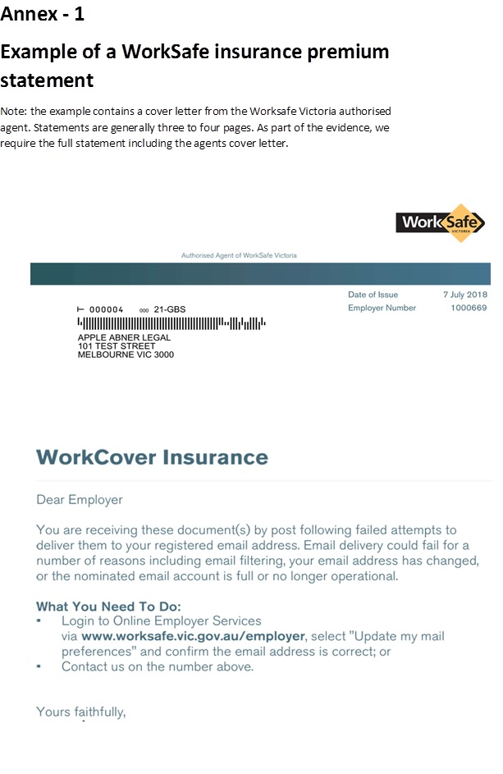
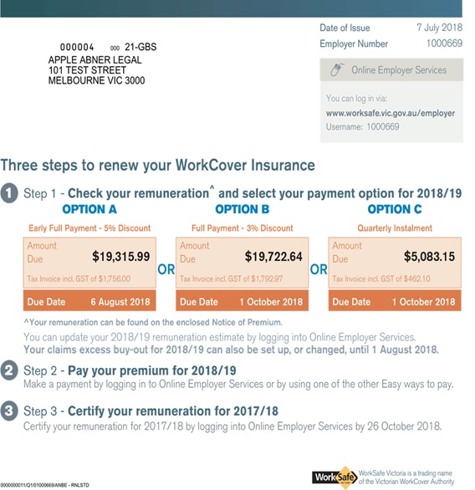

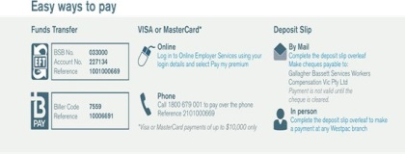

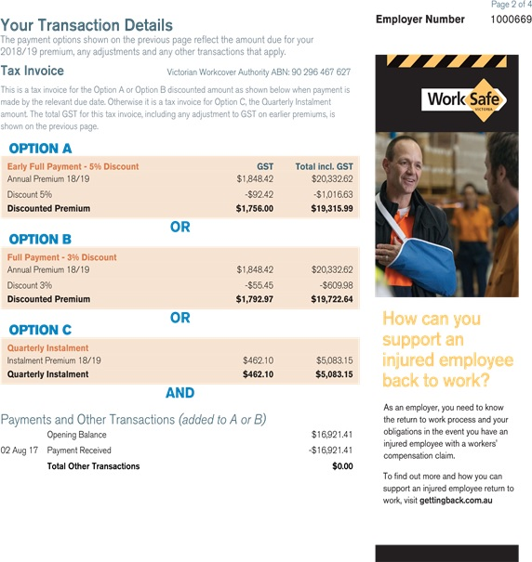

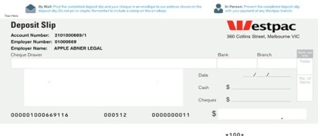

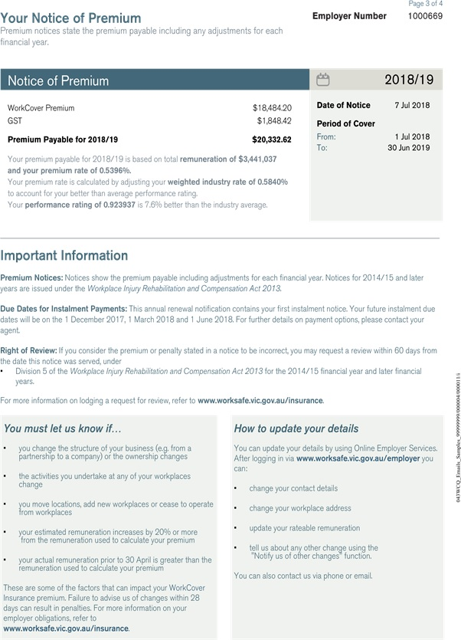

The copyright in this Template Occupational Health and Safety Management System – Supplier of Works with third party certification is owned by the State of Victoria (Department of Treasury and Finance).

© State of Victoria 2019

You are free to re-use this Template Occupational Health and Safety Management System – Supplier of Works with third party certification under a Creative Commons Attribution 4.0 licence, provided you credit the State of Victoria (Department of Treasury and Finance) as author, indicate if changes were made and comply with the other licence terms. The licence does not apply to any branding, including Government logos.

Copyright queries may be directed to IPpolicy@dtf.vic.gov.au

