# Gender Responsive Budgeting in Victoria: Roles and Responsibilities

*Updated 17 October 2024*

This document provides an overview of the roles and responsibilities of Government and the Victorian Public Service (VPS) in Gender Responsive Budgeting (GRB) in Victoria.

### In the *2021-22 Budget* Victoria introduced GRB to promote gender equality

GRB is a tool to ensure that public financial management supports the promotion of gender equality through the way budgets are constructed, funds are collected and spent, and outcomes achieved.

When adopting GRB, budgetary processes and policies are adapted so that expenditures and revenues reflect gender differences and inequalities in finances, decision-making power, service needs and responsibilities for caring. GRB is a mechanism that addresses the misconception that policies and services are gender neutral by design and is used to identify tangible actions to support more gender equitable outcomes.

By designing polices, programs and services that respond to the different needs of people of different genders, the Government will achieve better value for money because services will be better targeted to the users’ needs and support greater economic participation by women.

### Victoria’s GRB approach embeds gender considerations across the policy development cycle and requires action across the whole of government

Victoria’s approach to GRB has been adapted based on international best practice and building on the nation-leading *Gender Equality Act 2020* (GE Act). Implementing and embedding effective GRB will require robust strategic frameworks, well designed operational tools and a strong enabling environment (Figure 1).

Figure 1: Current GRB practice in Victoria based on OECD best practice framework

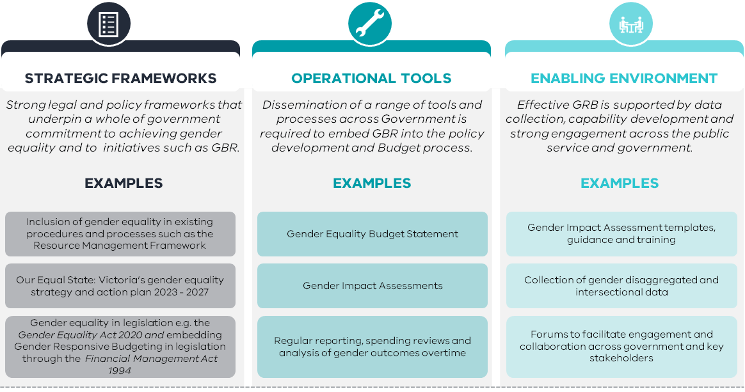

Government undertakes many steps to bring a policy proposal forward to become funded in the Budget. Adoption of GRB requires gender considerations to happen throughout this process and will change how policy is developed, services are designed and how Government makes resource allocation decisions.

### The Treasurer leads the work to embed GRB into the budget process but all members of Government have a role

In March 2022, the Public Accounts and Estimates (PAEC) tabled their report on their Inquiry into GRB and recommended that Government “…clearly define the roles and responsibilities of all the stakeholders involved in Gender Responsive Budgeting and the processes that must be followed”. [1]

This reflects that GRB is a significant shift in how policy is developed in Victoria and that clarity of roles and responsibilities across the whole of government will be critical to effective GRB. In this context, Table 1 and 2 provide a detailed overview of the key roles and responsibilities Government will play in GRB, under the Victorian approach (Figure 1).

Table 1: Government roles and responsibilities relating to GRB

| Actor | Responsibilities |
| --- | --- |
| Premier | The Premier provides key support for the GRB enabling environment by setting and articulating the Government’s priorities and key policies and communicating the Government’s agenda at a high level – including the commitment to GRB and how GRB considerations influence Government decisions and policies.  Through the annual budget process the Premier, as the leader of the Government, is responsible for ensuring that the Government fulfills its obligations to the people of Victoria by supporting ministers in effectively delivering announced policies including, but not limited to, GRB. |
| Treasurer | The Treasurer is the responsible minister for GRB, including decisions on implementation approach, incorporation into budget processes and decision making, representation in budget papers and other key details.  The Treasurer approves the Gender Equality Budget Statement and makes all decisions on how to present GRB related matters in the budget papers.  As the leader of the annual budget process, the Treasurer provides key support to the enabling environment, and has lead responsibility for ensuring that Government ministers are provided with the information needed to deliver GRB effectively.  The Treasurer is the responsible Minister for sections of the *Financial Management Act* *1994* (FMA), which is the key legislation setting out the financial management requirements into which GRB is incorporated. |
| Minister for Women | The Minister for Women is responsible for women’s policy and gender equality policy which, in relation to GRB, includes:   * being the responsible minister for the GE Act, which requires Gender Impact Assessments – a key tool in enabling GRB * preparing the government-wide gender equality strategy, a key element of the GRB strategic framework for approval by Government and determines gender equality targets and indicators under that strategy * responsibility for key intersecting work such as the Government’s response to the Inquiry into Economic Equity for Victorian Women * responsibility for implementation of some recommendations from the PAEC Inquiry * endorsing the foreword of the Gender Equality Budget Statement (but does not contribute to or approve other content for this document).   The Minister also supports the enabling environment by endorsing, either individually or jointly with the Treasurer, policies and programs regarding Whole of Victorian Government gender targets and data, gender policy gaps, gender priorities for budget considerations, etc. |
| Assistant Treasurer | The Assistant Treasurer is the responsible Minister for some sections of the *Financial Management Act 1994*, which is the key legislation setting out the financial management requirements into which GRB is incorporated.  Pursuant to Section 8 of this Act the Assistant Treasurer issues the Standing Directions and is responsible for the output performance management framework and ensuring that GRB principles are incorporated into these instruments.  The Assistant Treasurer is responsible for promoting the inclusion of gender disaggregation within the objective indicators and performance measures within departmental performance statements and promoting the inclusion of objectives that increase gender equality. |
| Portfolio ministers | Portfolio ministers are responsible for commitment to the Whole of Government gender equality strategy, and contribute to the enabling environment, by:   * endorsing departmental budget submissions and ensuring departments consider gender equality, and other intersecting areas of potential inequality, in policy design and funding proposals * enabling their departments and entities to comply with legislative requirements of the GE Act * ensuring that their own portfolio policies incorporate considerations of how they contribute to the Government’s gender equality goals. |

Table 2: Victorian Public Sector (VPS) roles and responsibilities relating to GRB

|  |  |  |
| --- | --- | --- |
| Actor | Responsibilities | |
| Department of Premier and Cabinet (DPC) | As the First Minister’s Department, DPC:   * advises the Premier on budget policies and processes including high-level communication of issues, priorities and processes in relation to GRB * advises the Premier on resource allocation decisions and all financial and performance management related decisions * with DTF, supports Departments and their portfolio agencies on the budget process requirements, including GRB. | |
| Department of Treasury and Finance (DTF) | As the lead agency for the budget process DTF:   * advises the Treasurer on budget policies and processes including high-level communication of issues, priorities and processes in relation to GRB * advises the Treasurer and the Assistant Treasurer on resource allocation decisions and all financial and performance management related decisions * supports the Treasurer in drafting the budget papers, including the Gender Equality Budget Statement * supports Departments and their portfolio agencies on the budget process requirements, including GRB. | |
| Other Departments | Departments’ key responsibilities related to GRB are:   * supporting their Ministers and relevant portfolio agency staff in relation to key GRB principles, requirements and expectations, as advised by DTF and DPC * incorporating GRB considerations into Departmental briefings and advice to Ministers * follow DTF stipulated GRB requirements for the budget process. | |
| Commission for Gender Equality in the Public Sector (CGEPS) | CGEPS is responsible for administration of the GE Act, including the requirements for gender impact assessments which are a key building block of the implementation of GRB.  CGEPS is responsible for public sector-wide reporting processes and for the provision of the operational tools that support GRB (toolkits and best practice guidelines) for Gender Impact Assessments across the public sector (for all defined entities). |
| Office for Women in DFFH | The Office for Women (OFW) provide gender policy expertise across government and support gender equality work that intersects with GRB, by:   * providing gender equality policy advice to the Minister for Women * drafting the Whole of Victorian Government gender equality strategy and tracking progress toward gender equality * supporting the incorporation GRB and gender equality considerations in analysis and briefings to the Minister for Women and Cabinet/ERC on women’s policy and gender equality. |

All departments are required to comply with the requirements of the GE Act and to understand Gender Impact Assessments that specifically enable GRB.

1. paec_59-13_inquiry_into_gender_responsive_budgeting.pdf (parliament.vic.gov.au)