CSR Implementation Training for CSR buyer

Supplier performance report submission process

Overview

This is a brief overview of the process for buyers submitting performance reports on suppliers. As a buyer, you should be able to access the link to submit the supplier performance report web form from the DTF website.

Pre-Requisites

• You must have access to the supplier performance report web form from the DTF website.
• You need a compatible web browser such as Chrome or Edge.

Instruction | Screenshot
Access the Supplier performance report web form from the DTF website | 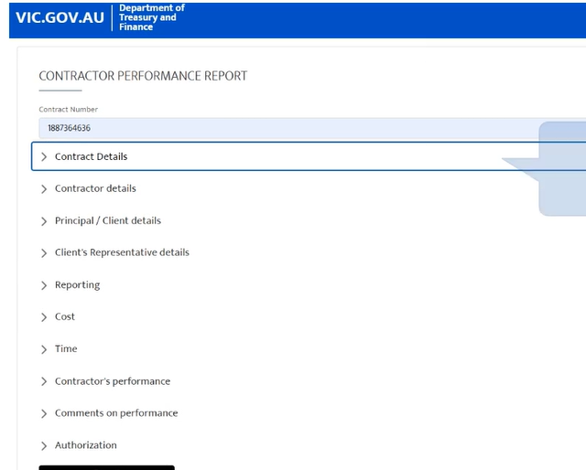
When the performance report link is clicked from the DTF website or the buyer portal, it opens the web form as shown. Here, you can enter all relevant details about the supplier's contract project and provide a performance rating | 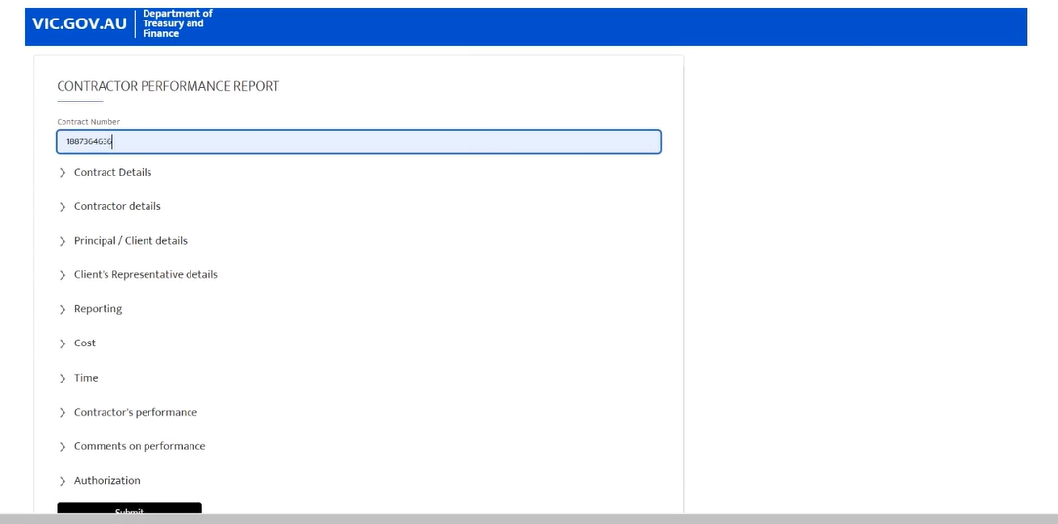
Fill in the information under all the sections and click on “Submit” | 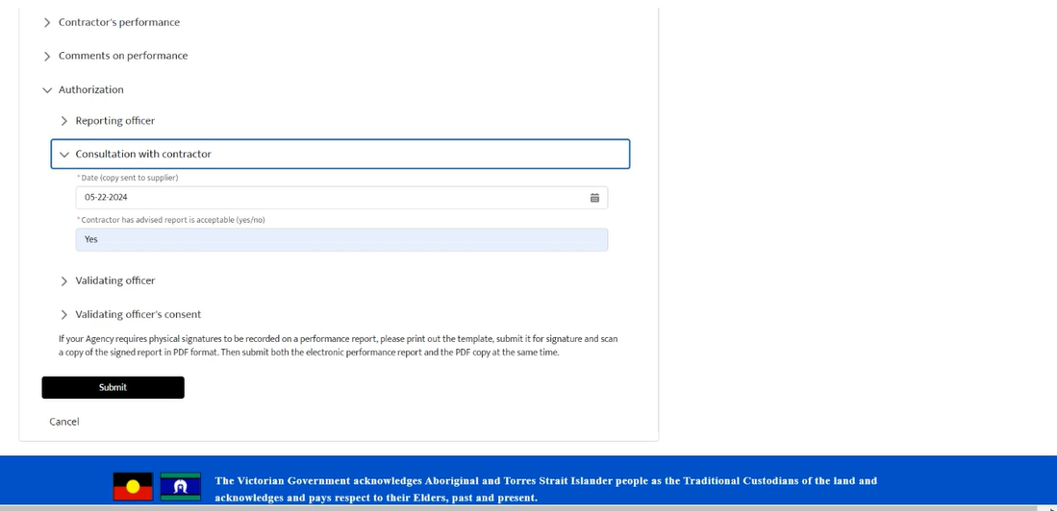
You should successfully be able to submit the performance report and the CSR team will be notified on this. | 