CSR Implementation Training for CSR Buyers

Buyers Access Request Submission

Overview

This is a brief overview of the Buyer Access Request Submission process. As a buyer, you should be able to submit a request to the CSR team for accessing the buyer portal. You should be able to fill in all the basic buyer information and submit the access request to the CSR team.

Pre-Requisites

• You must have access to the buyer access request web form from the DTF website.
• You need a compatible web browser such as Edge.

Instruction | Screenshot
When you click on the buyer access request form from the DTF website, you will be redirected to a web form to fill in the necessary information. | 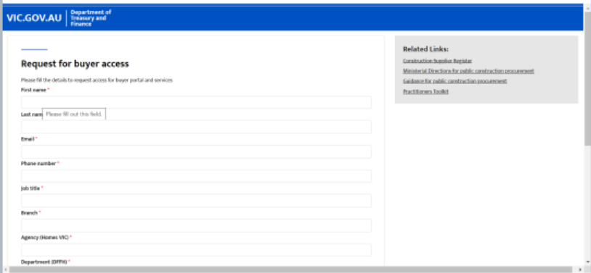
The last question in the form will ask if the buyer has previously had access to CSR system.  This is in relation to the email address entered in the field earlier. If the email address was used previously to access the CSR system, then the buyer would have to select “Yes.  If this is the buyer’s first time requesting access, the they would select “No”. | 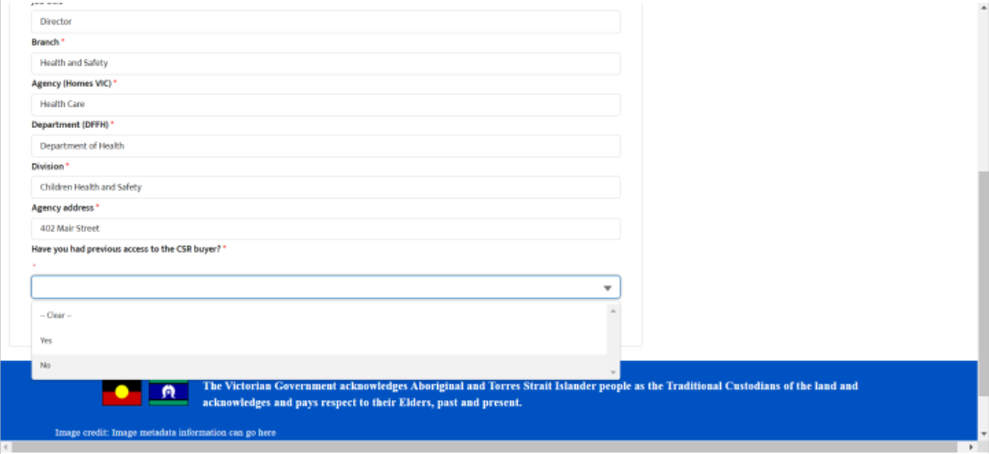
Once the form is complete, the buyer will click “Submit”. | 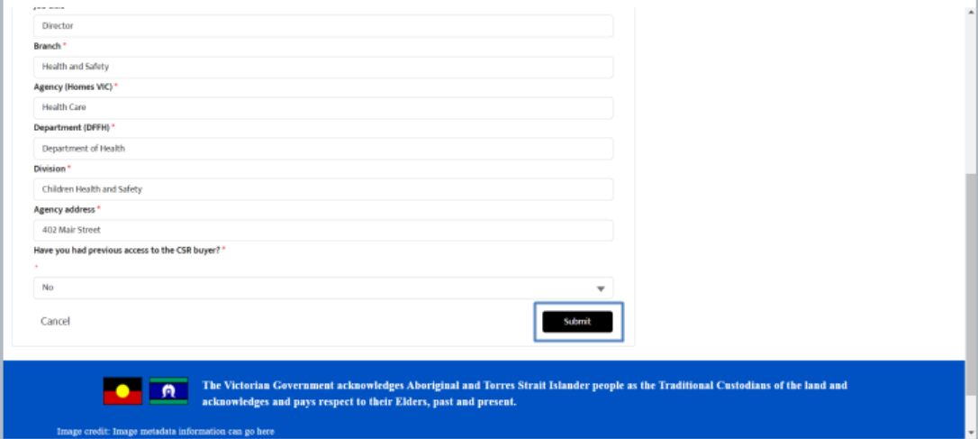
A notification will appear that the buyer access form has been submitted and the buyer can expect a response within 5 business days. | 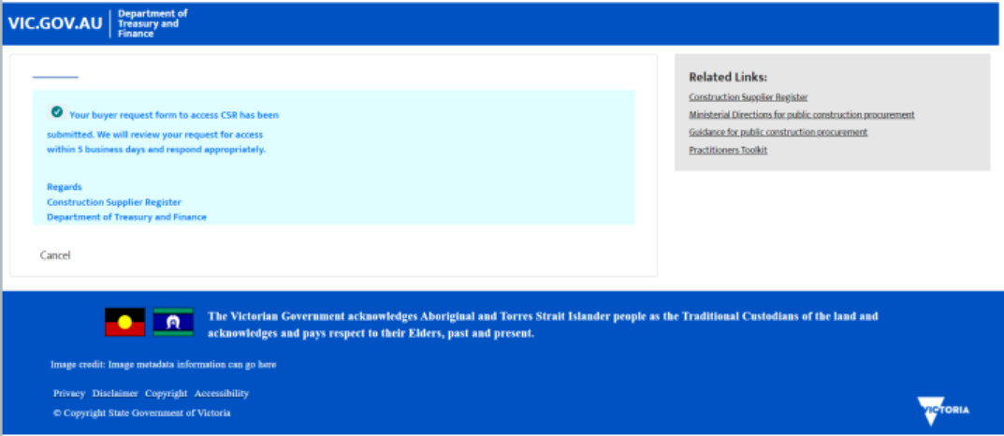
The buyer will also receive an email notification with the same message. | 