CSR Implementation Training for CSR buyer

Buyers Self Registration process

Overview

This is a brief overview of the Buyer Self Registration process after their access request has been approved. The buyer must submit a request for the buyer portal. Once their request has been approved, they will receive an email notification with a link to self-register for the buyer portal.

Pre-Requisites

• You must have submitted the buyer access request form and it should have been approved.
• You must have received the email with the self-registration link.
• You need a compatible web browser such as Edge.

Instruction | Screenshot
Once the buyer request has approved, you will receive an email to self register to buyer portal | 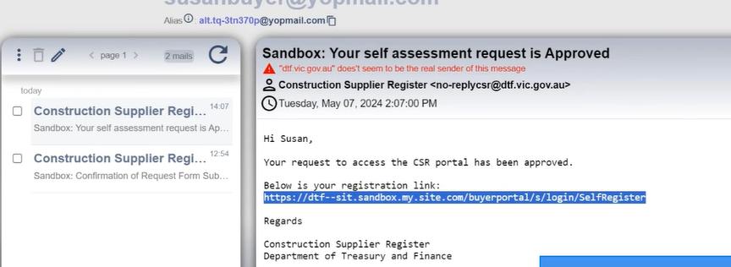
The link will direct the buyer to enter their email and setup the new password. | 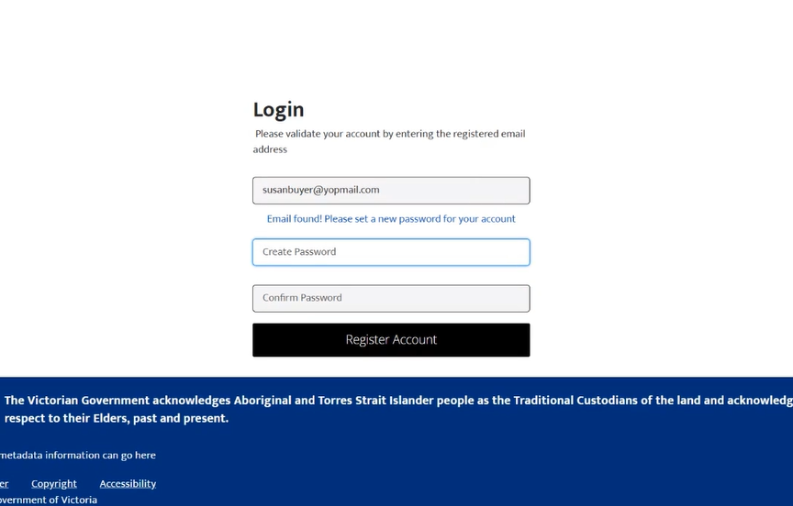
Once they setup the password, They will be able to login to the buyer portal | 