CSR Implementation Training for CSR buyer

Buyers Service requests submission process

Overview

This is a brief overview of the Buyer Service Request Submission process. As a buyer with portal access, you should be able to submit service requests for any particular service, provide feedback, or request to unsubscribe

Pre-Requisites

• You must be a buyer with access to the buyer portal.
• You need a compatible web browser such as Chrome or Edge.

Instruction | Screenshot
Login to the buyer portal | 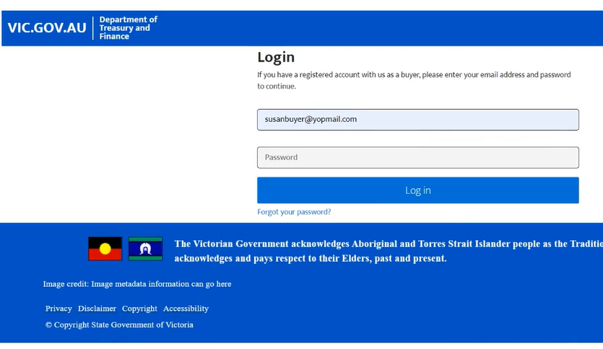
Click on the “Request a service/ Submit a feedback” button to submit a request | 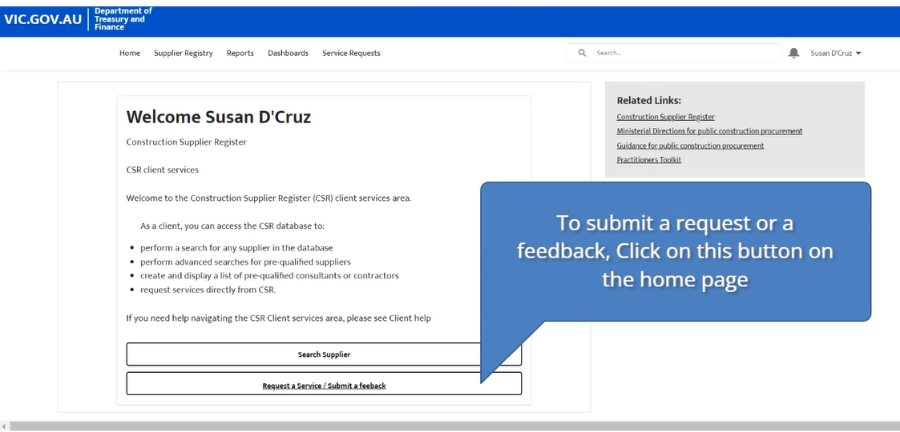
Choose a service from this dropdown list | 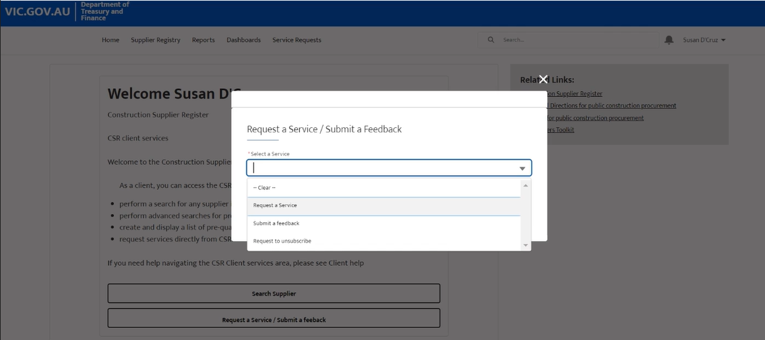
Based on the chosen service, fill in all the relevant information and click on submit. | 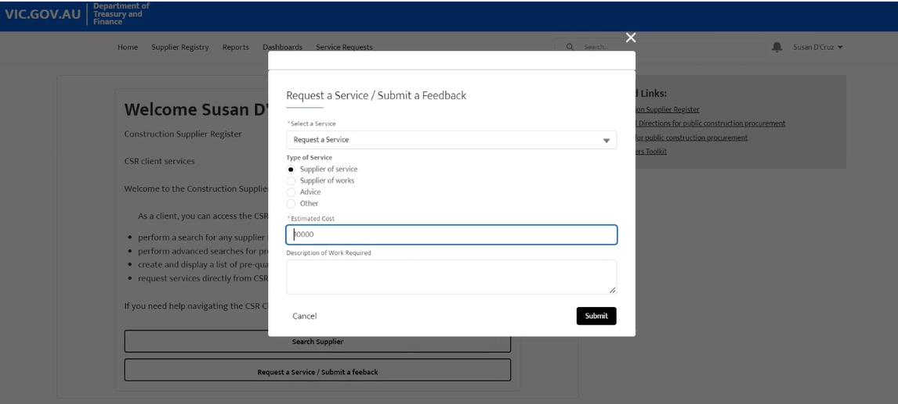
You will receive a confirmation message once the request is submitted | 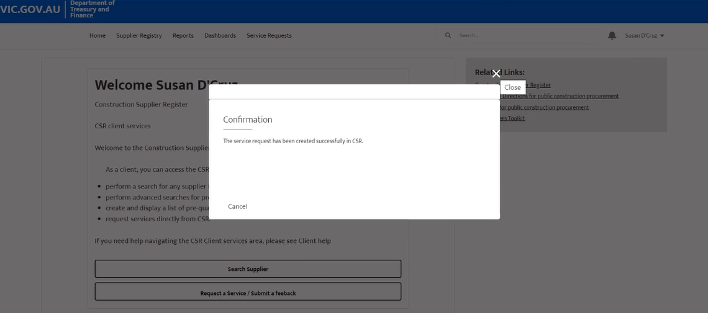
You can also view all your submitted service requests from the “Service request” tab | 