CSR Implementation Training for CSR Staff

Buyer – Searching for suppliers by creating a report

Overview

This is a brief overview of a buyer searching for suppliers by creating a report.

Pre-Requisites

- You must have an activated CSR user account with a username and password provided by the admin
- A compatible web browser such as Edge

Instruction | Screenshot
First, log in to access the CSR system. | 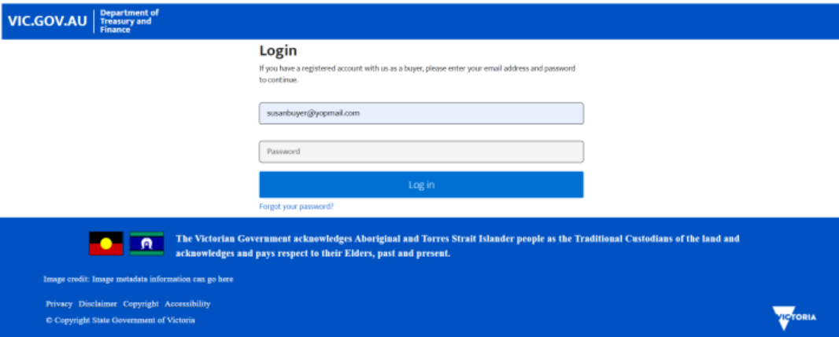
Once in the CSR system, scroll down and select “Search Supplier”. | 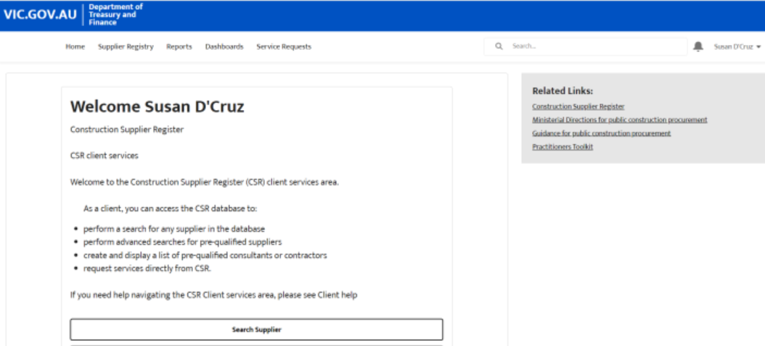
Then, select “New Report”. | 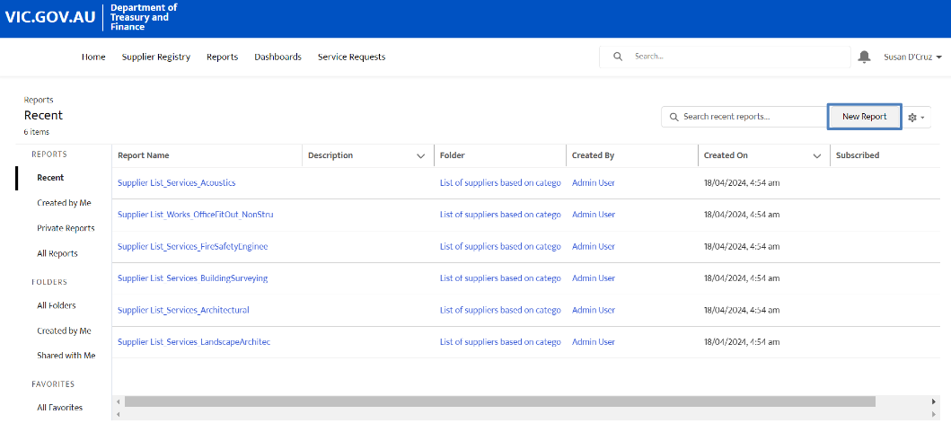
This will show a list of reports available.  Scroll down the list until a report type called “Account with Supplier Categories “ appears. | 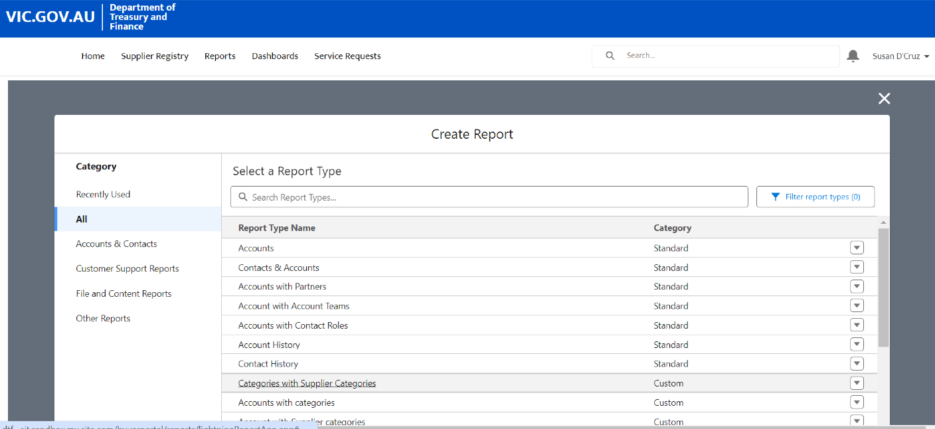
Click on “Account with Supplier Categories”. | 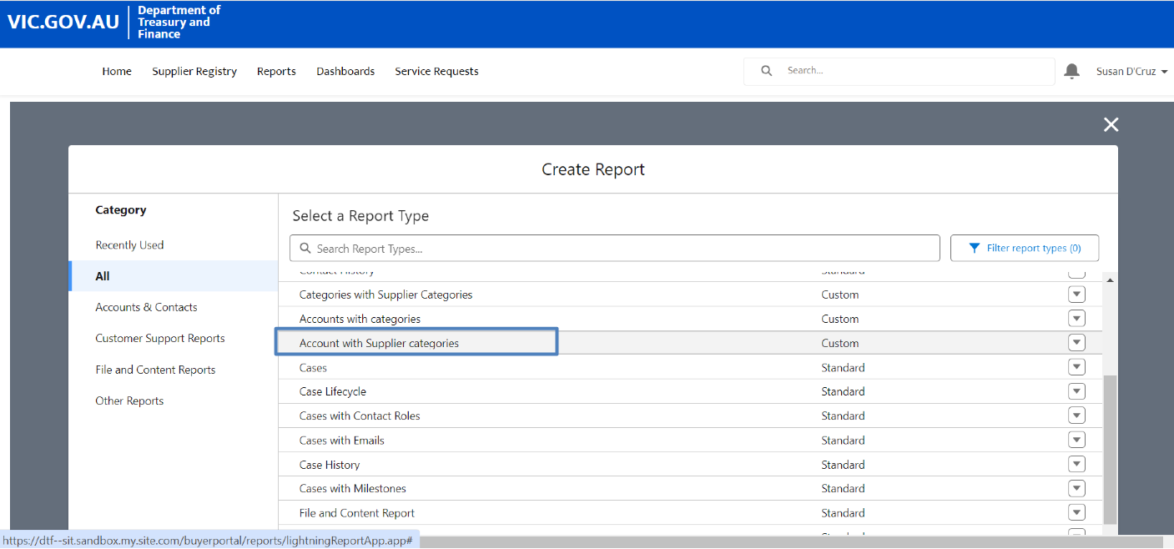
Then, select ”Start Report”. | 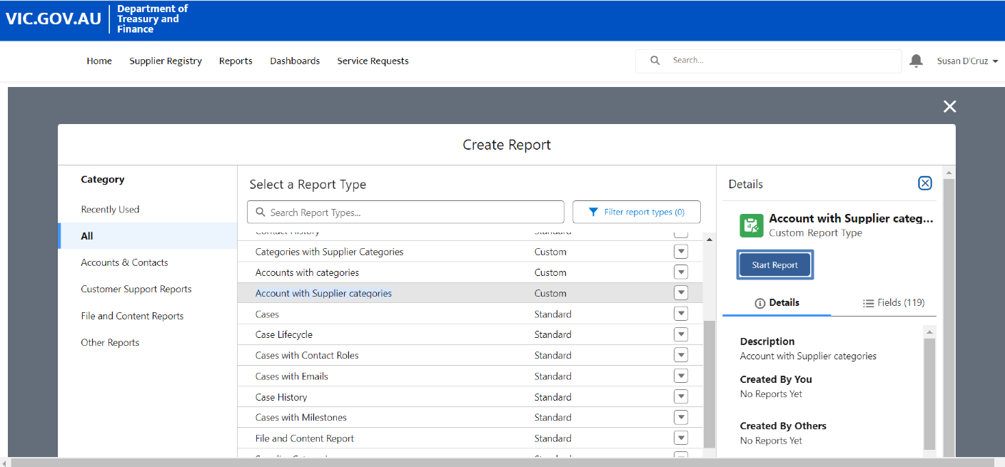
This opens the report page.  Select the “Filters” icon. | 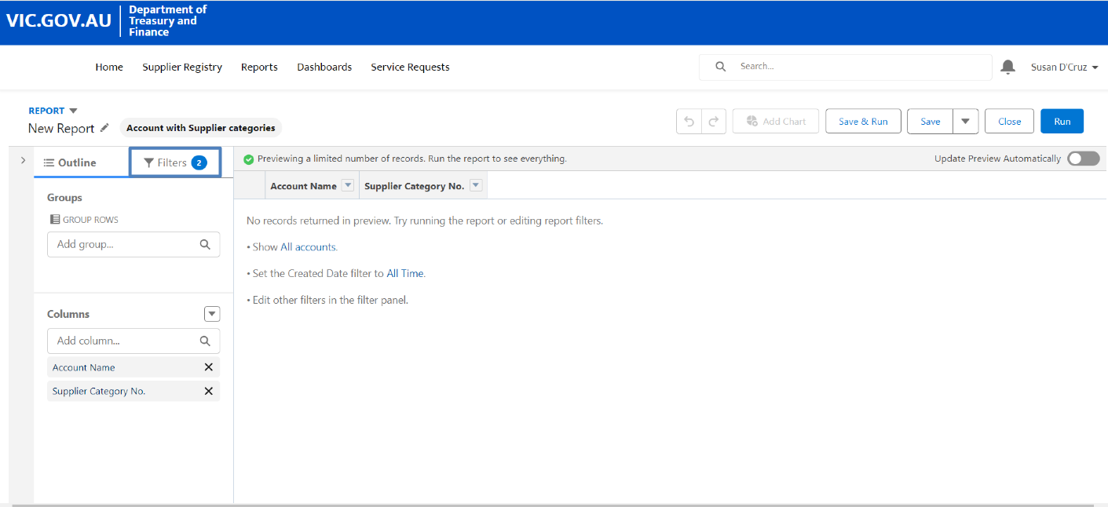
Click on the “Show Me” field. | 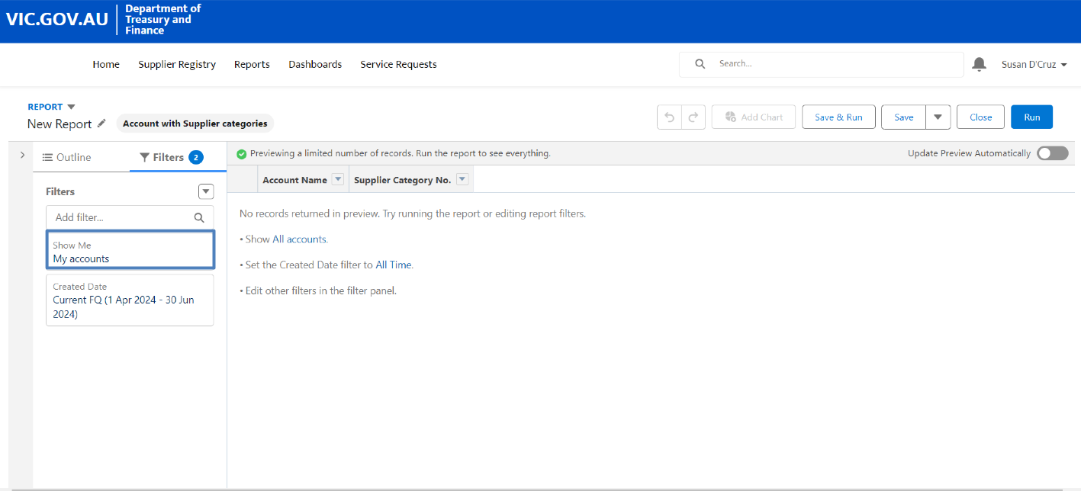
Click on the “My accounts” drop down menu. | 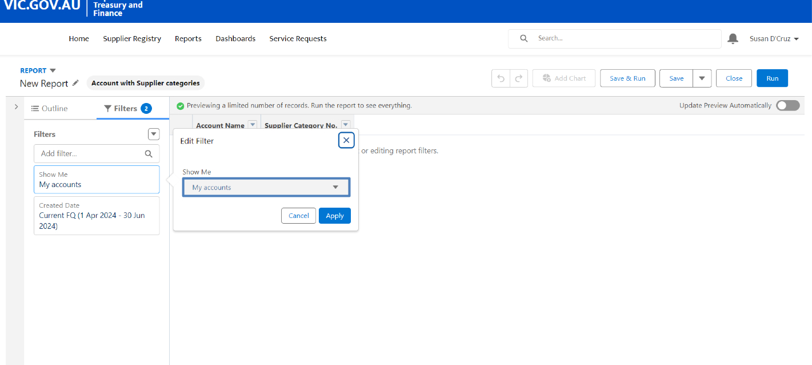
Select “All accounts”. | 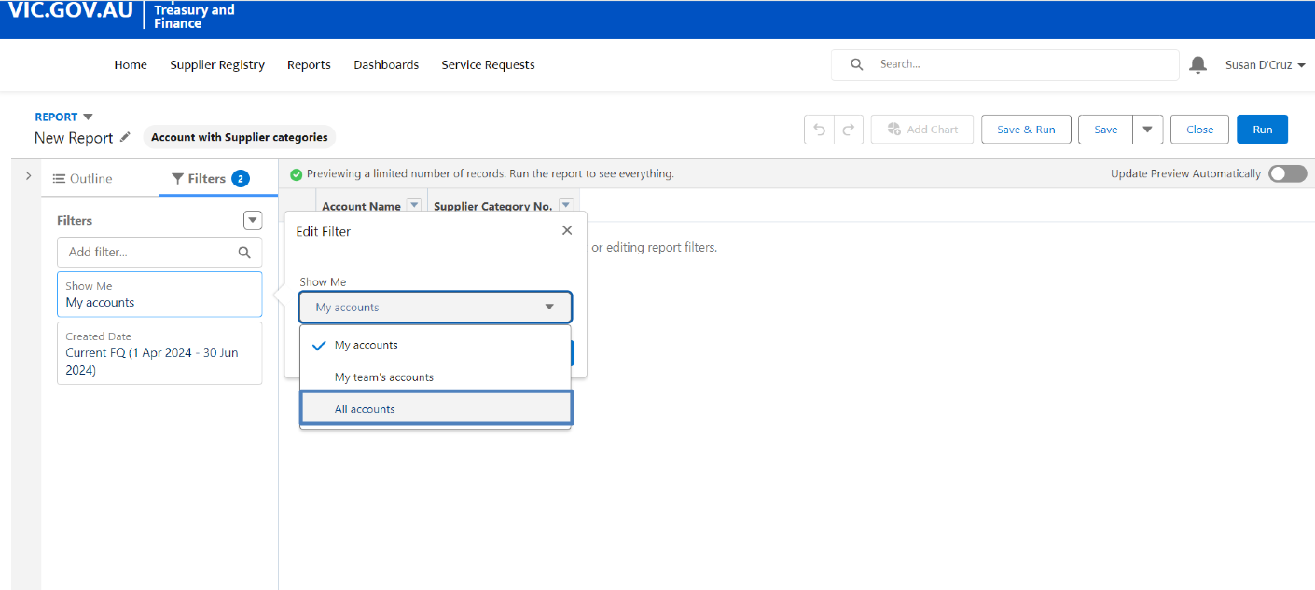
Then, select “Apply”. | 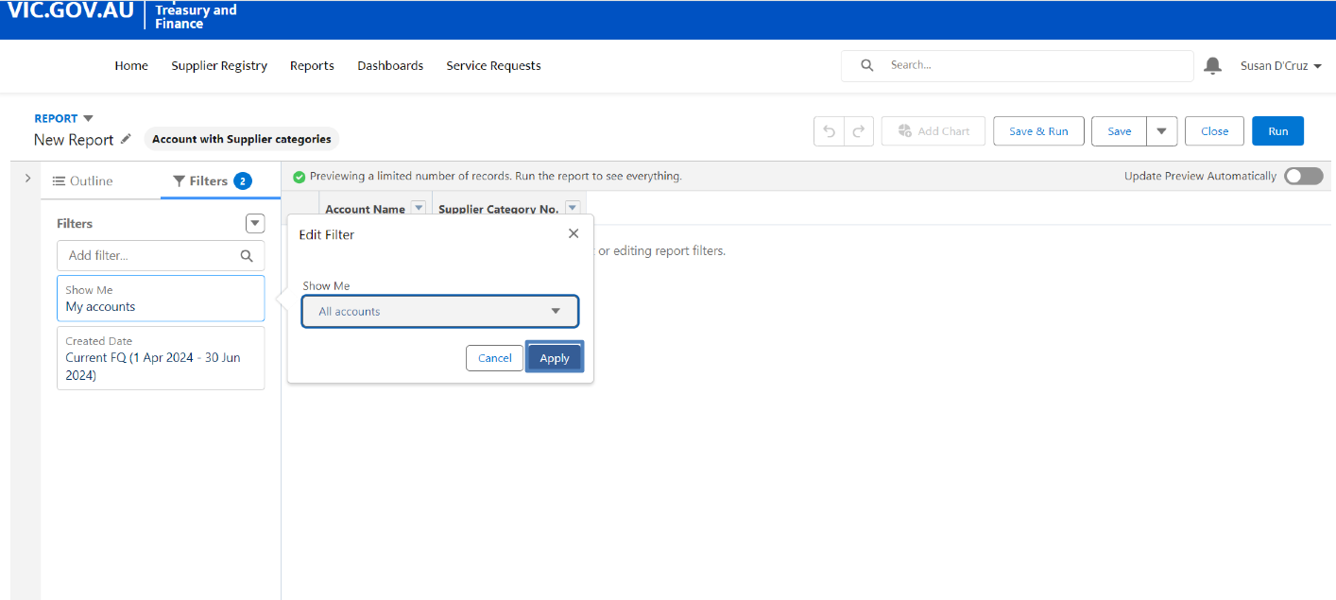
Click on the “Created Date” field to adjust the date range if required. | 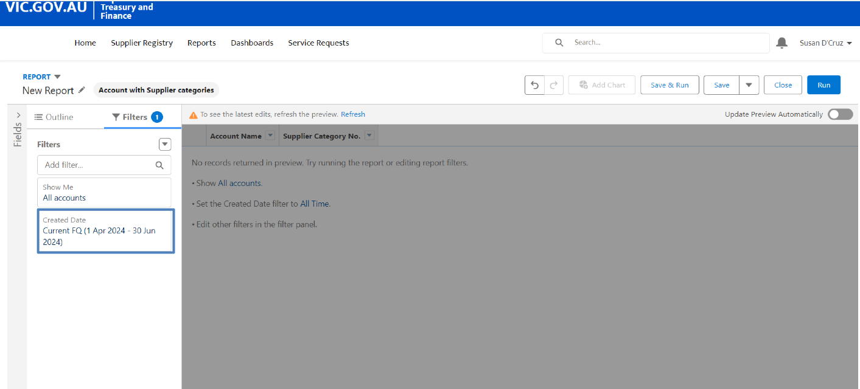
Click on the “Range” drop down menu to customise the date range of the report. | 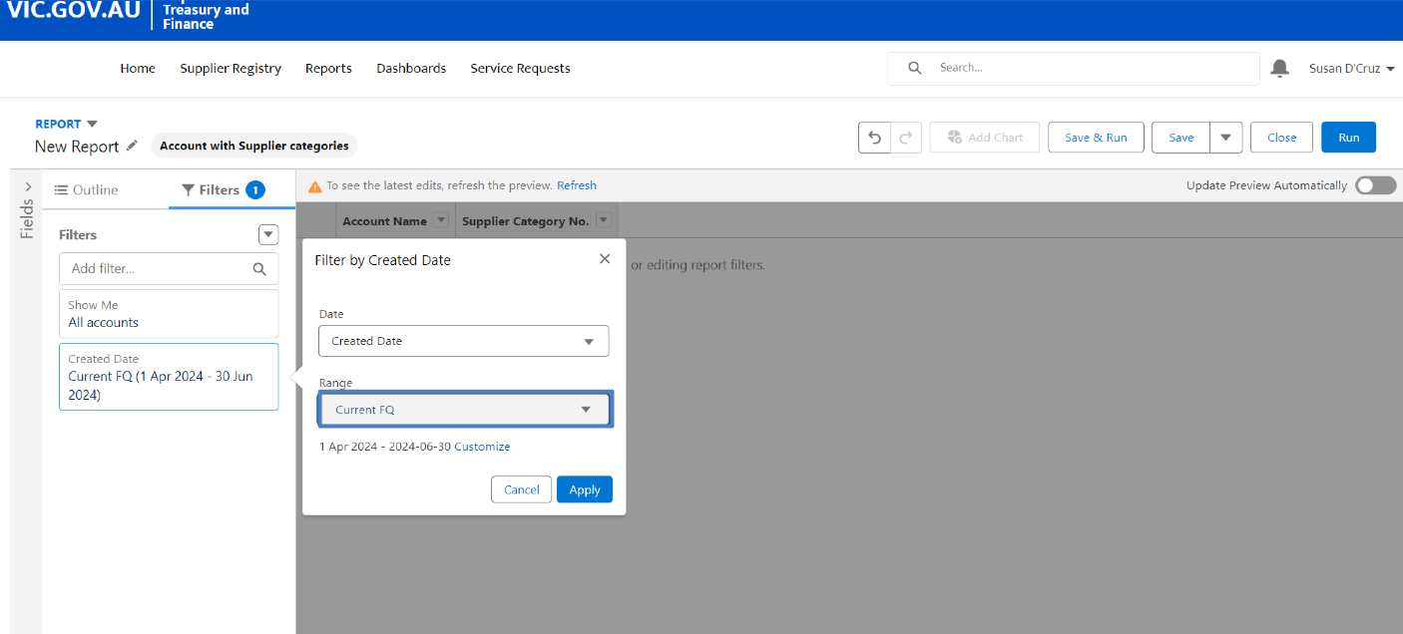
For this example, the report will include all entries ever entered.  Select “All Time” from the drop down menu. | 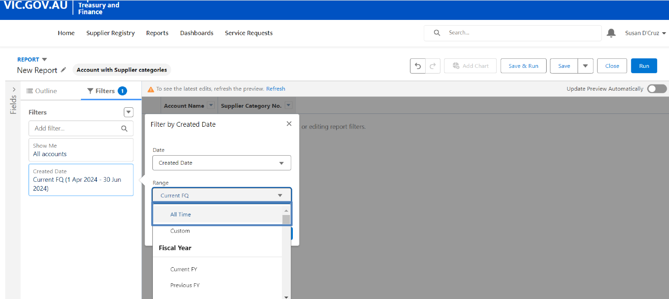
Click on ”Apply”. | 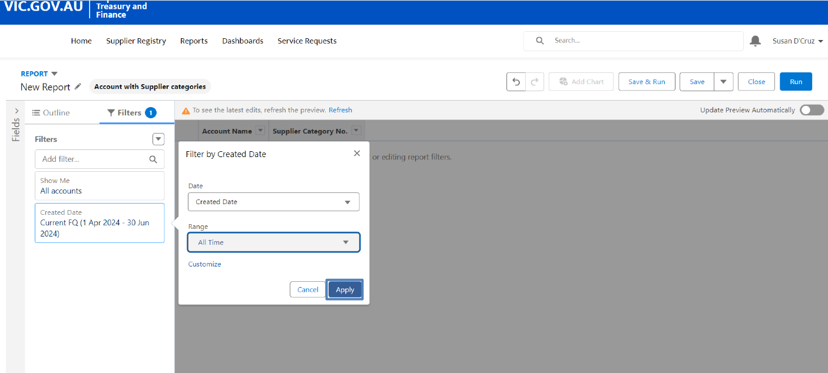
Select “Refresh” to apply the latest edits to the report view. | 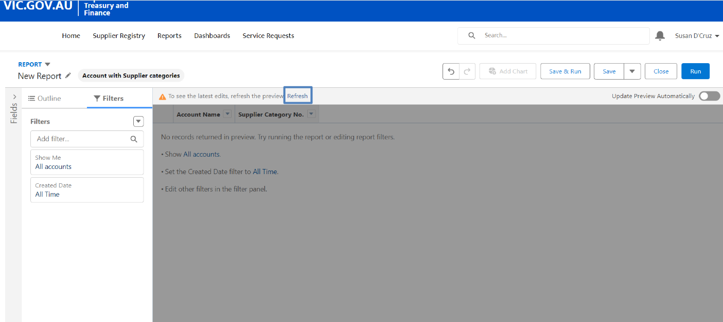
The report with all the accounts is now available. | 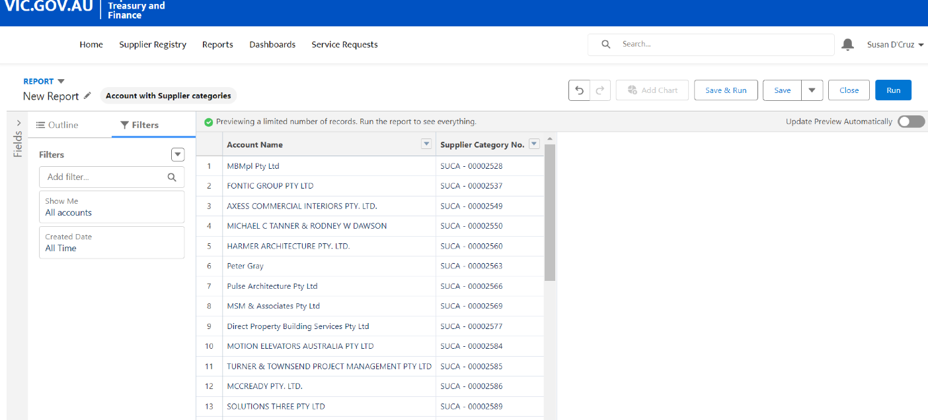
The report can be customised further.  To do so, select the “Outline” icon on the top left.  Then select “Add column…”. | 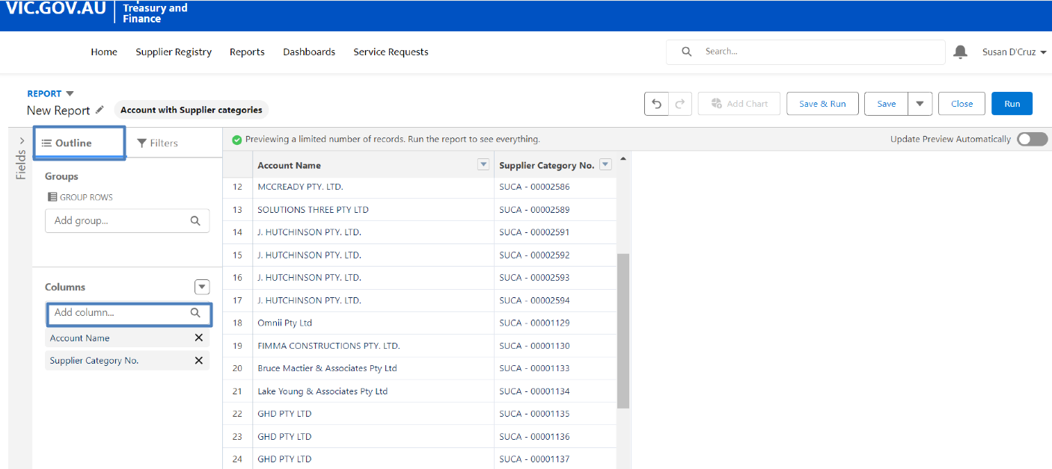
From here, fields can be added to show the data in the report.  For this example, the field for account name will be added, so type “name” and then select the most appropriate option from the drop down menu. | 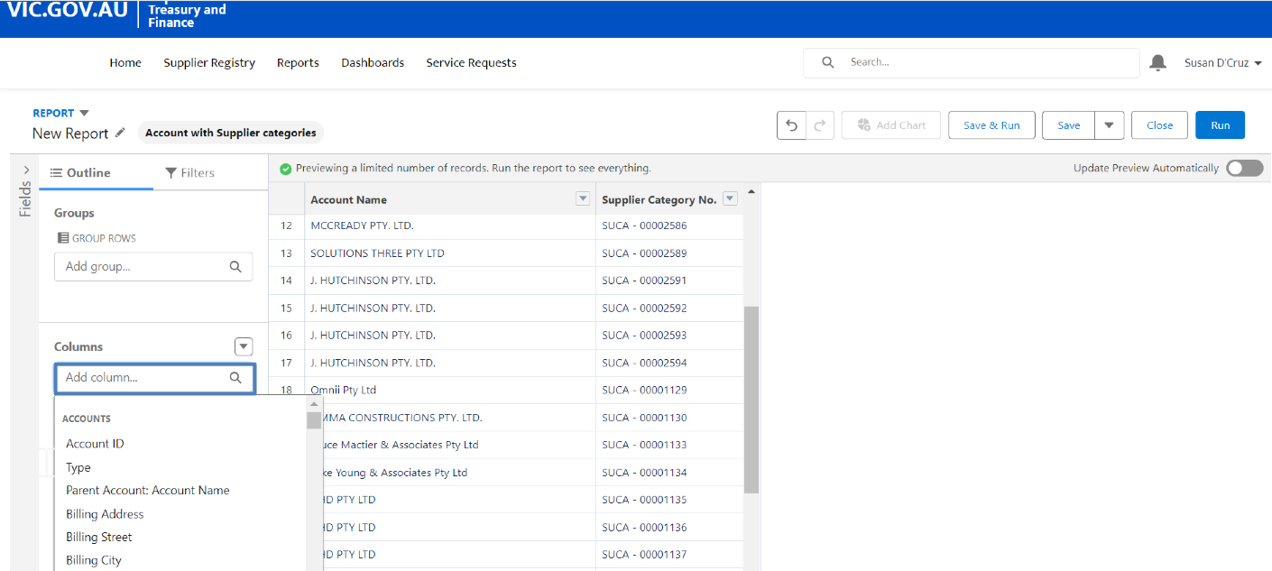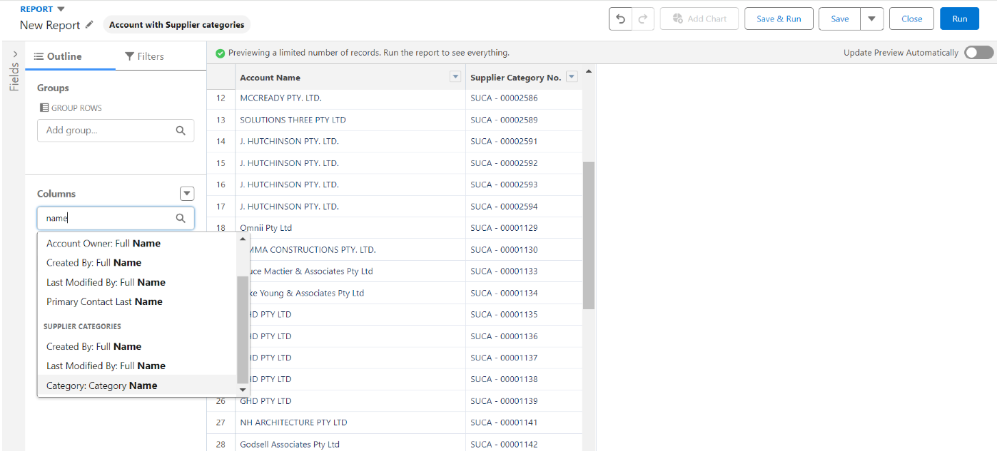
Select “Refresh” to apply the latest edits to the report view. | 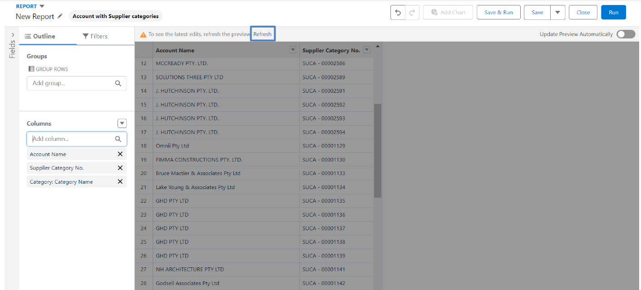
If a field is not necessary, select the “X” in the column section to delete the field from the report. | 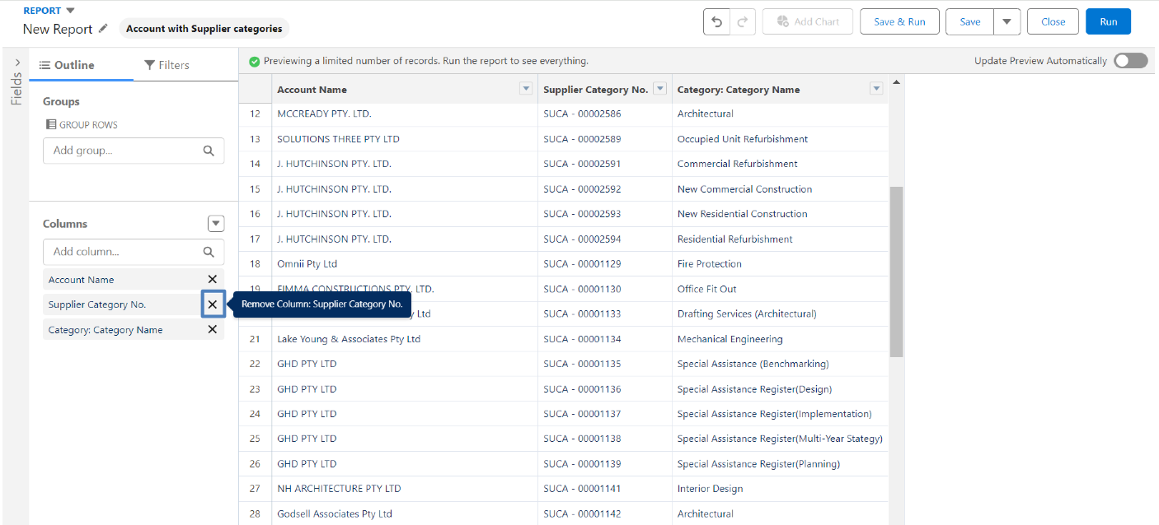
Fields can be added according to what data is required in the report. Multiple fields can be added and/or deleted. | 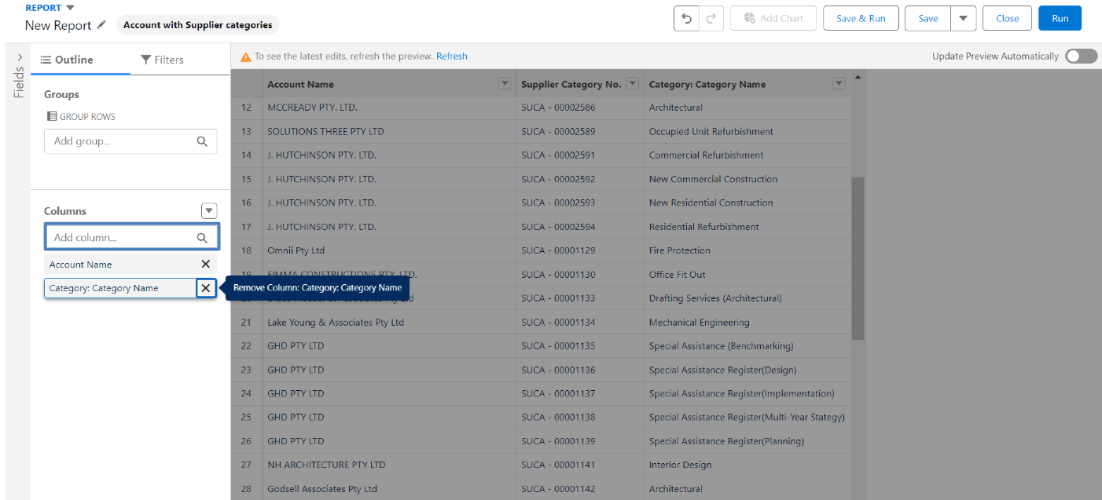
Select “Refresh” to apply the latest edits to the report view. | 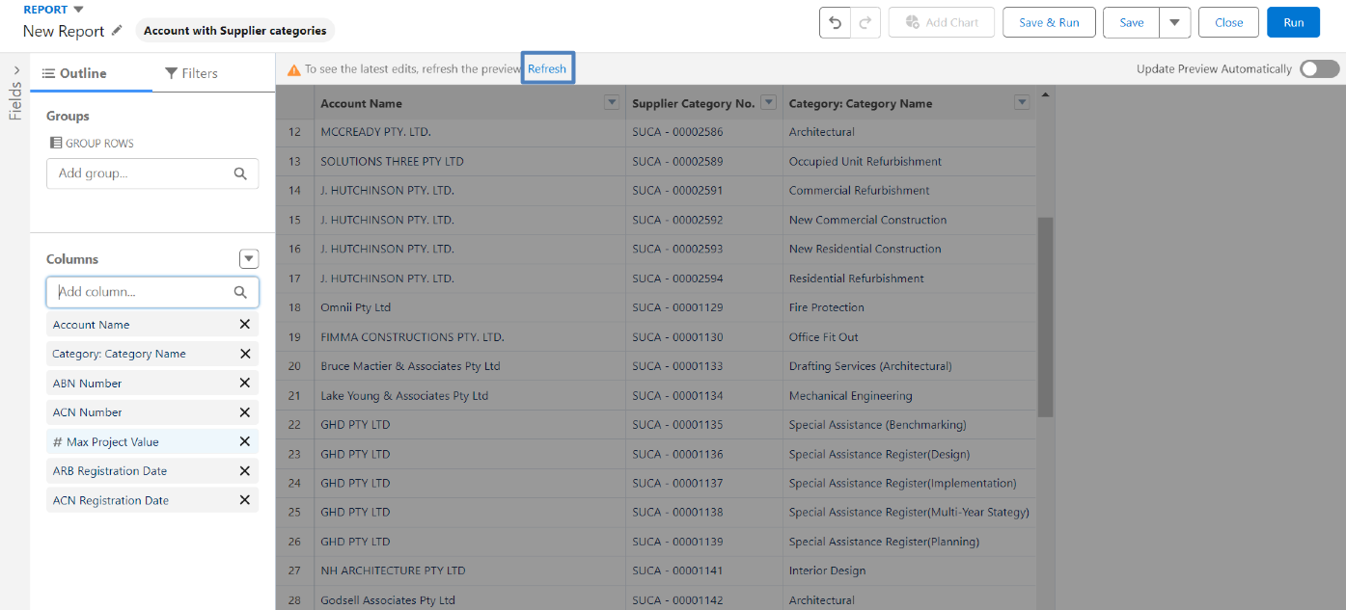
The data with the select columns will now display in the report view. | 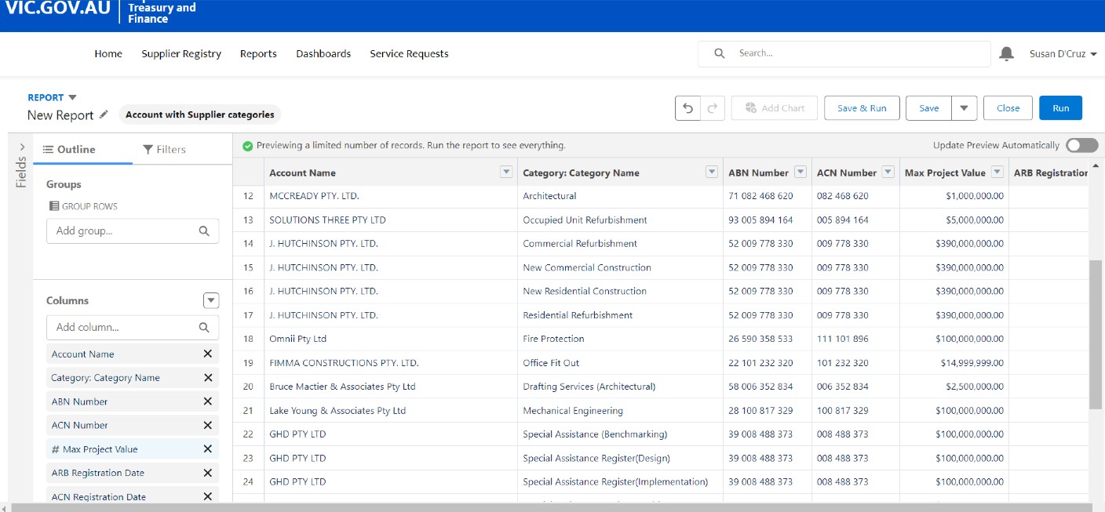
From the report view, data can be further customised.  For this example, the report will be filtered to show accounts from the one category. | 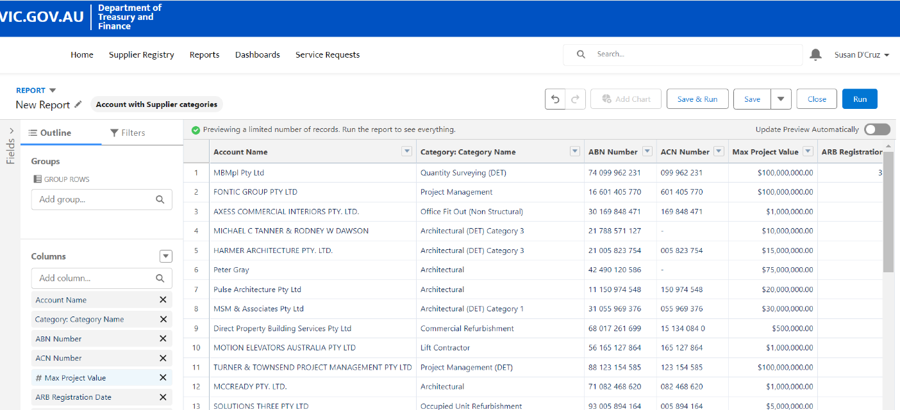
To do so, select “Filters”. | 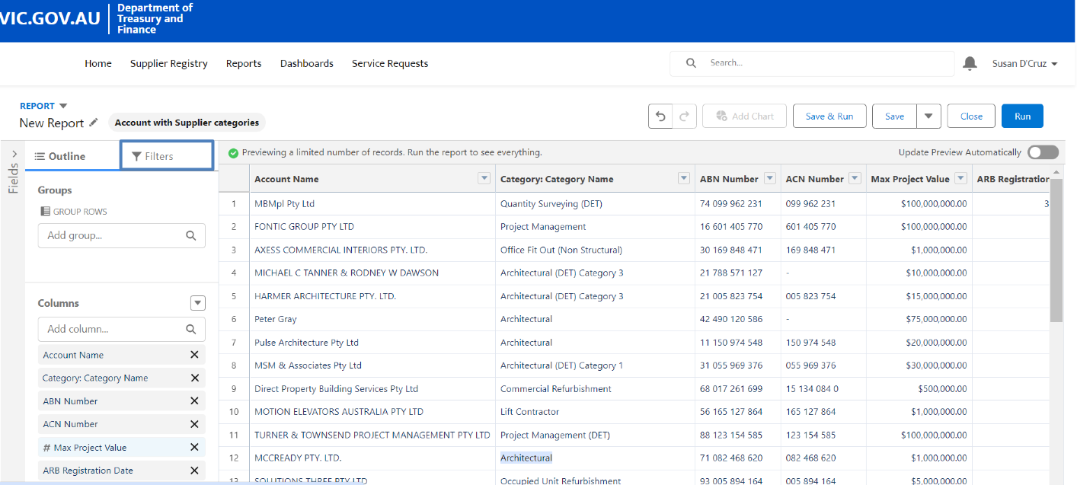
Click on the “Add filter…” field. | 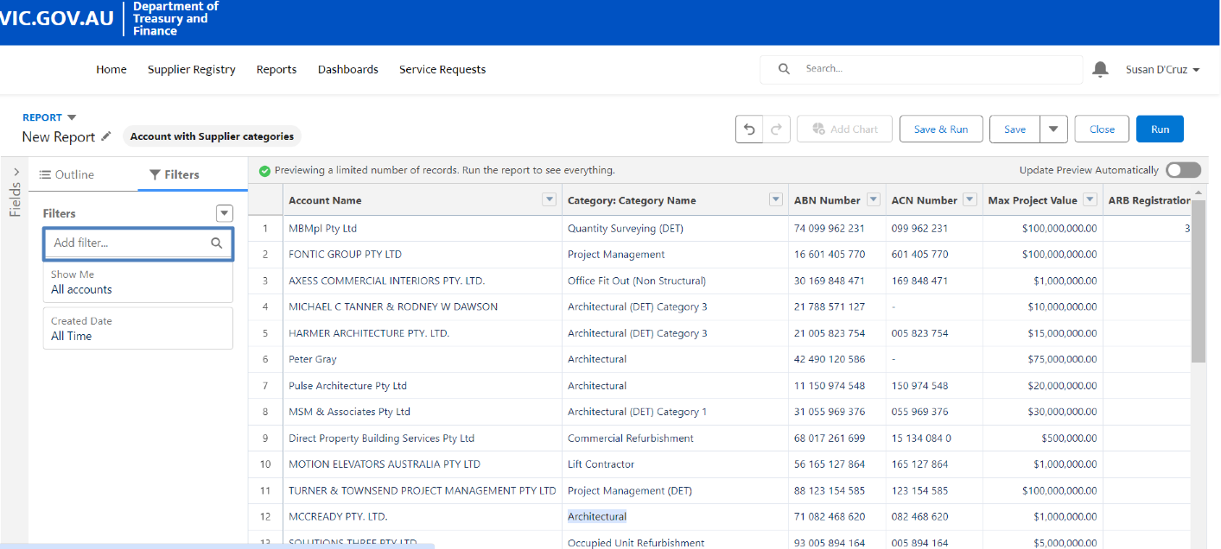
Type in the filter to be applied to select it from the drop down menu. In this case, the filter to be applied is “category name”. | 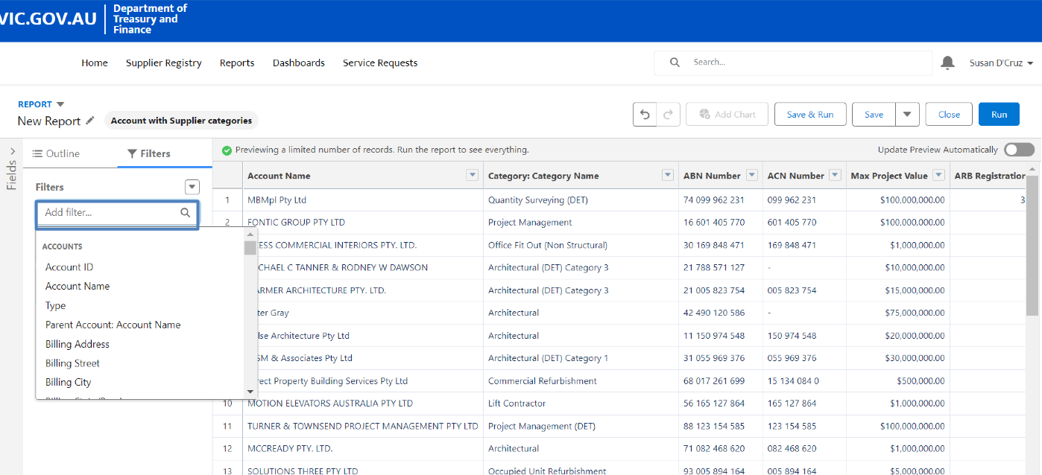
Select the option from the drop down menu. | 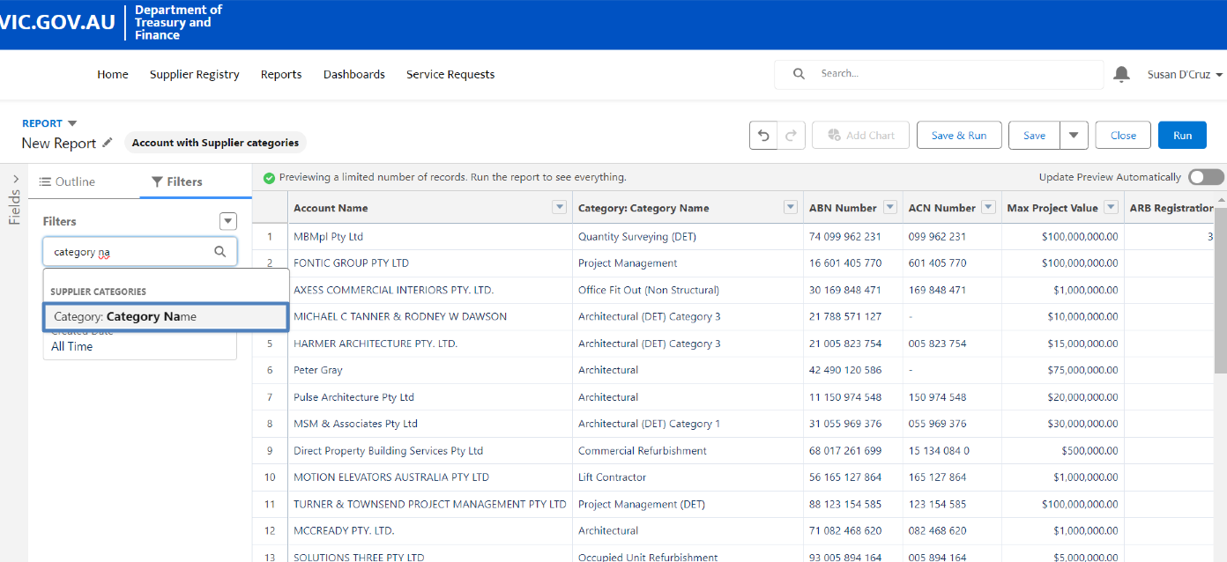
The drop-down menu allows results to have specific search qualities. e.g., if “equals” is selected, the search results in the Category will contain the exact same term entered in the field. | 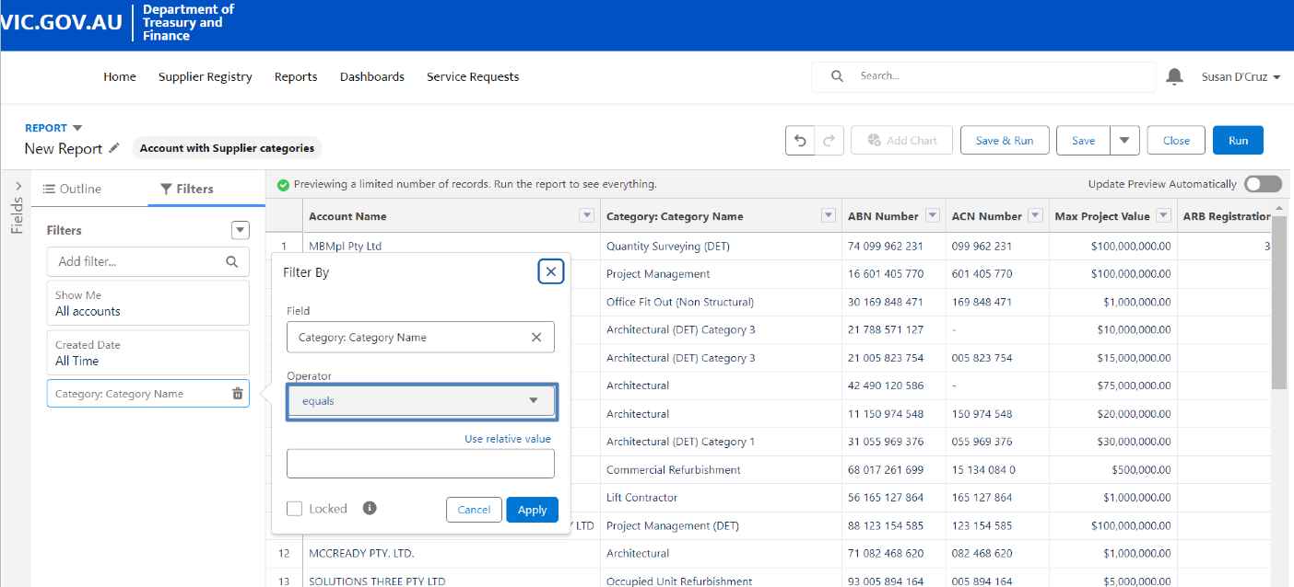
For this example, the search results need to include the term that is searched. For this, the option from the drop down menu is “contains”. | 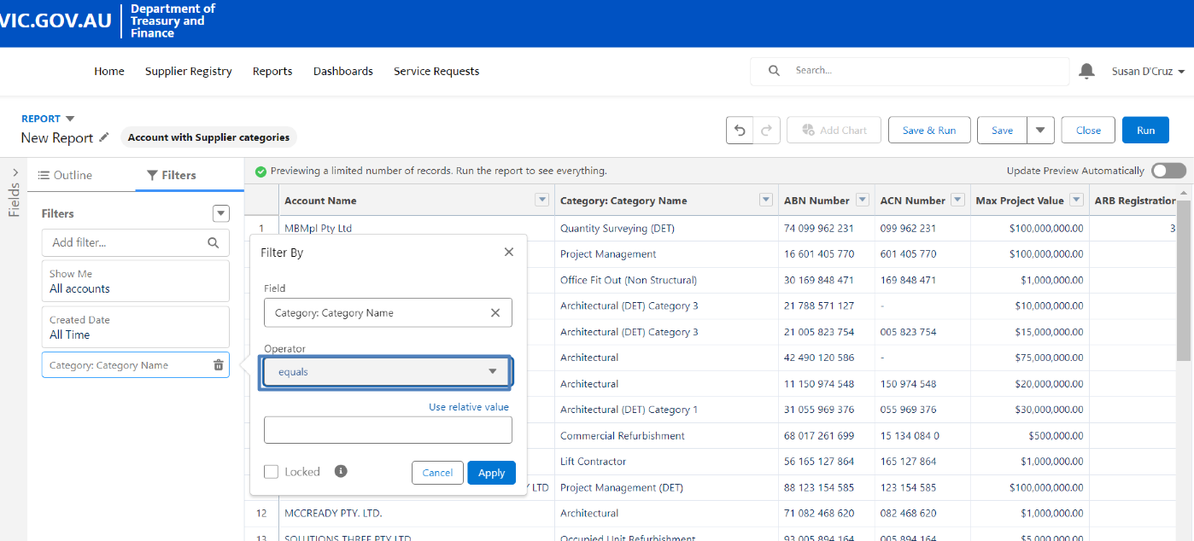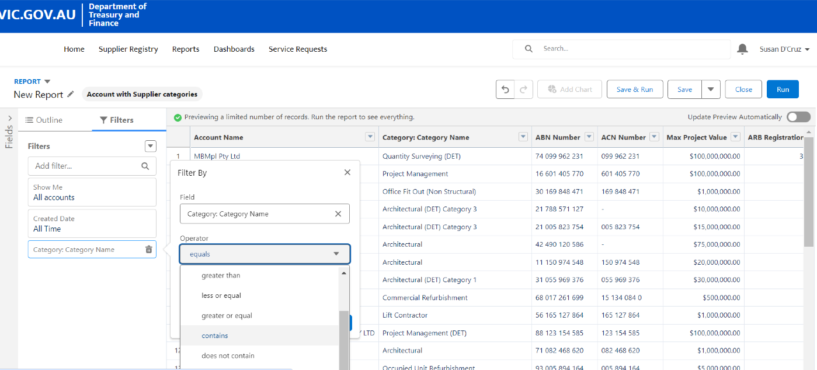
Select the field below and type in the term to be searched. | 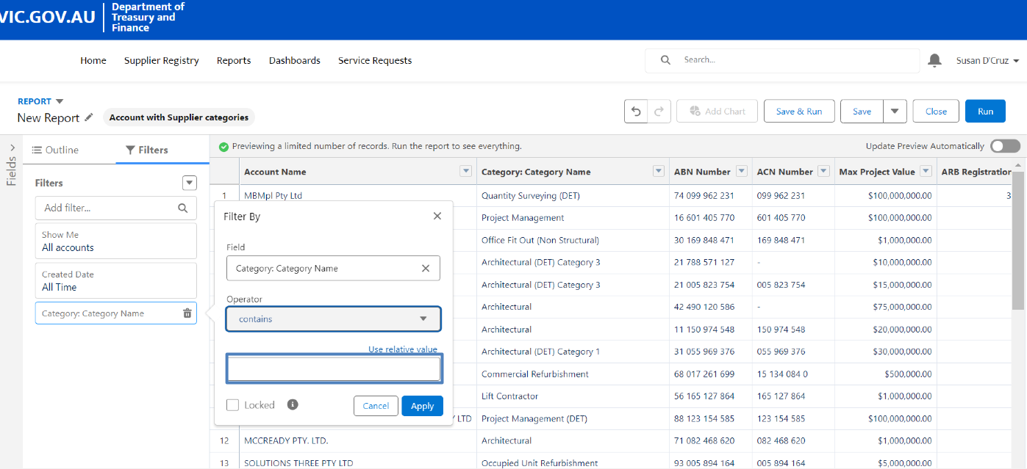
Click “Apply” to search | 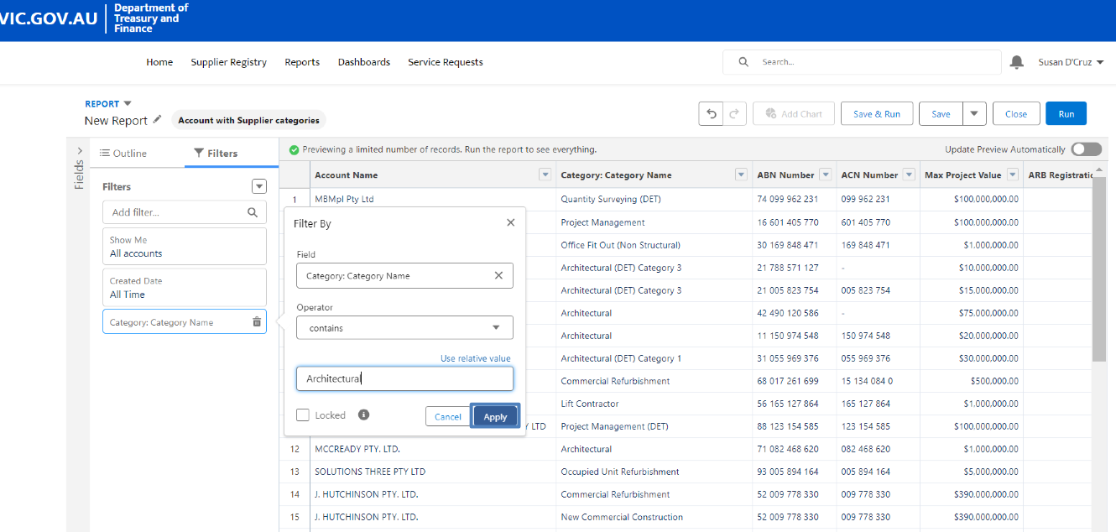
Click ”Refresh” to update the report. | 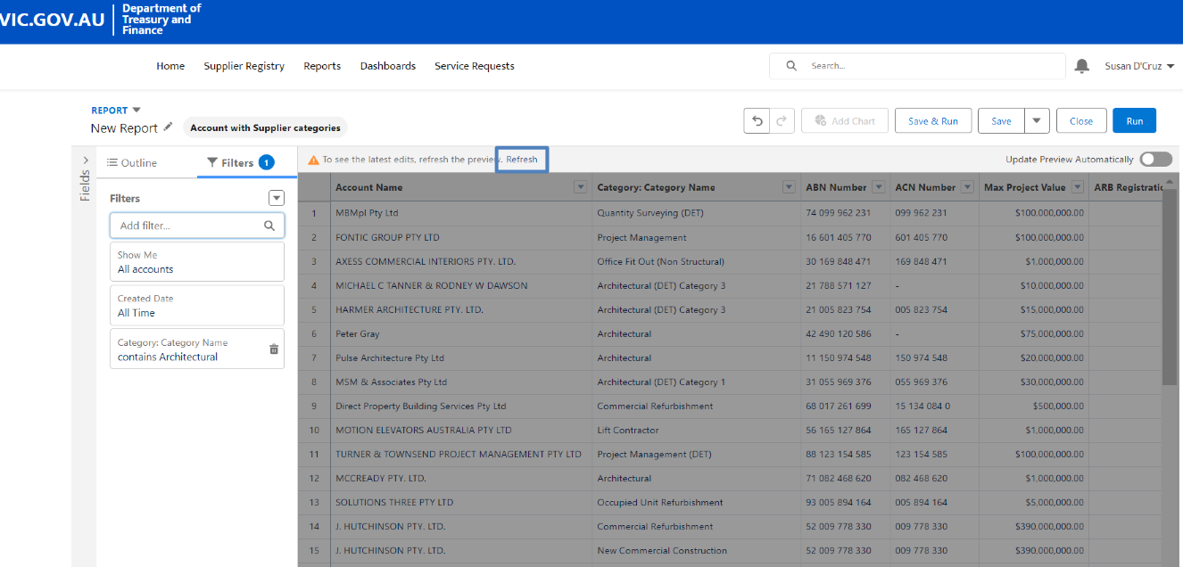
Click “Run” to run the report. | 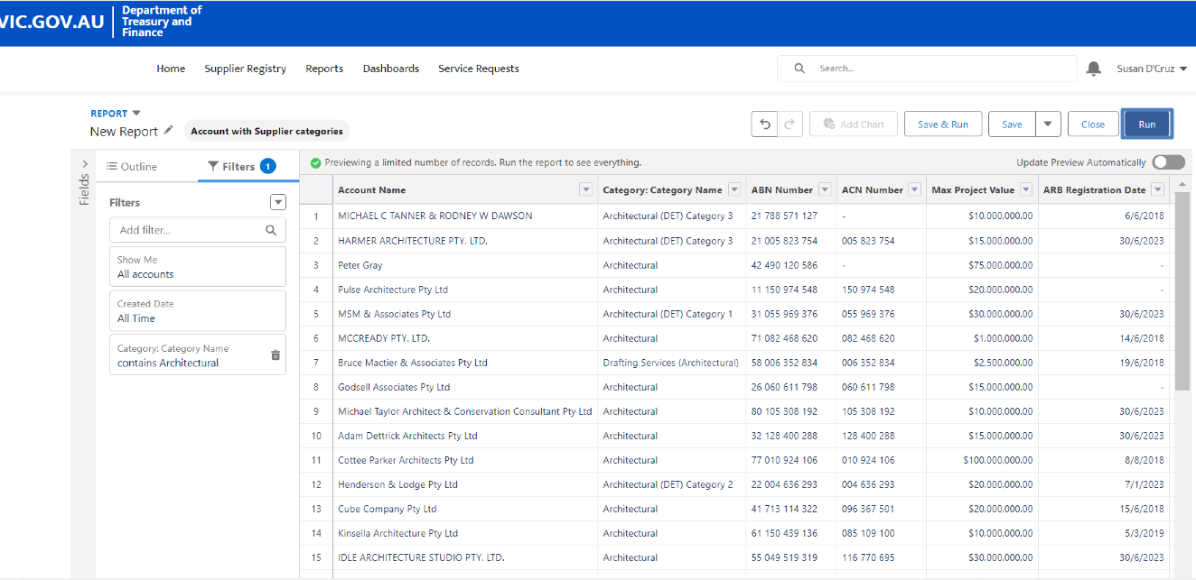
The final report will now be displayed with the specific terms entered. | 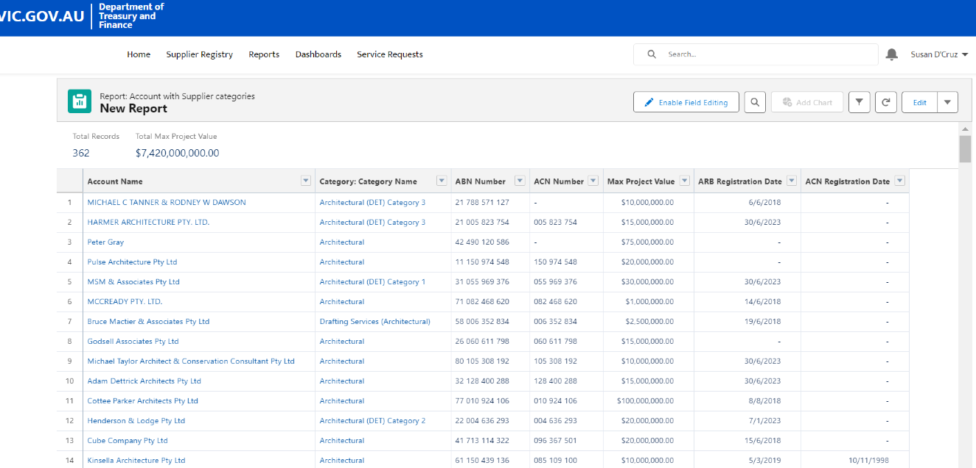
Click on the downward arrow. | 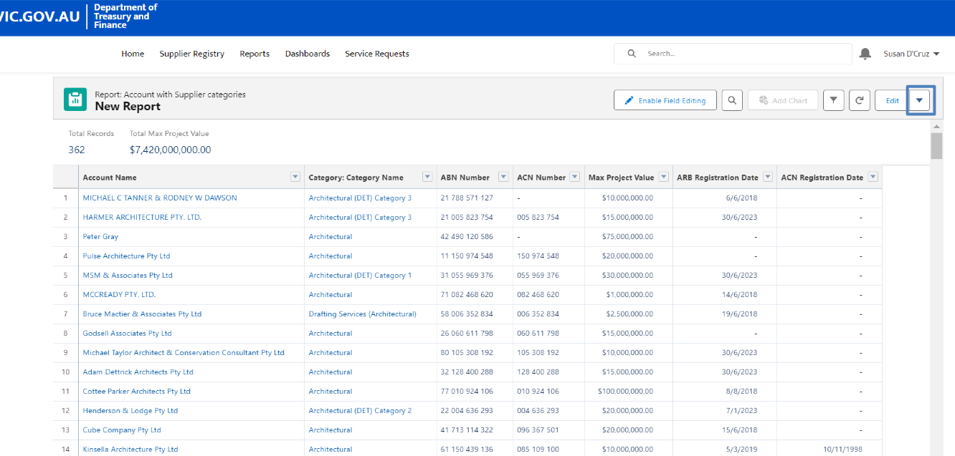
Select “Save”. | 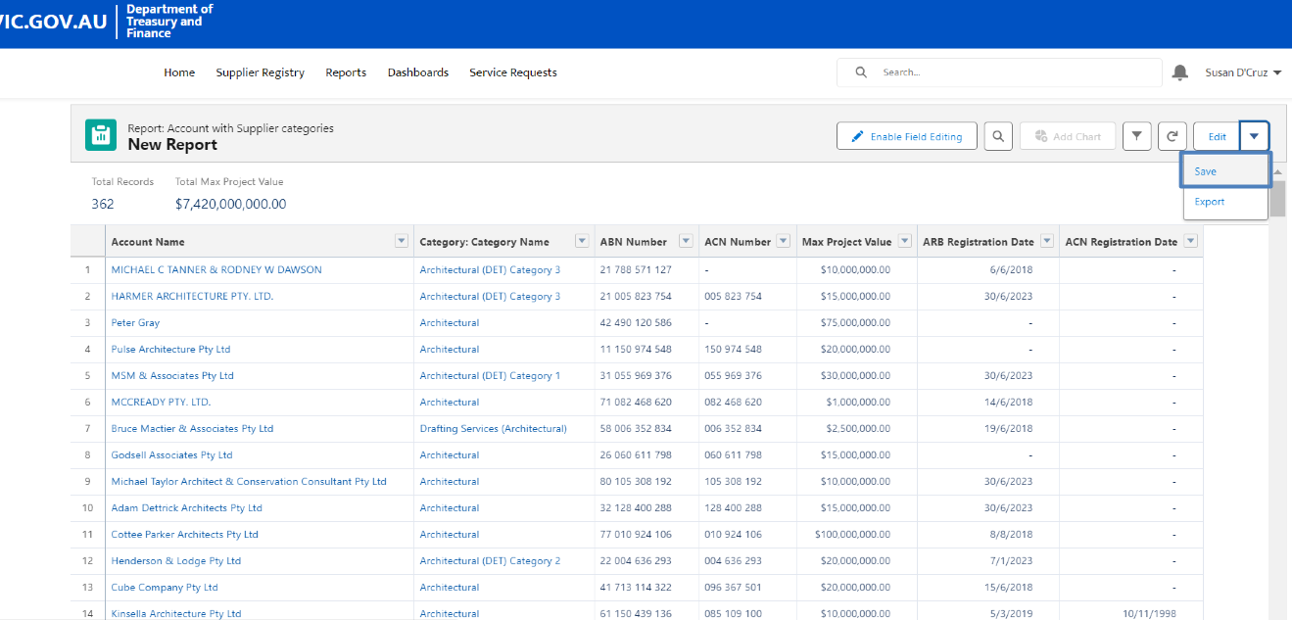
Click on the text field under “Report Name” to name the new report. | 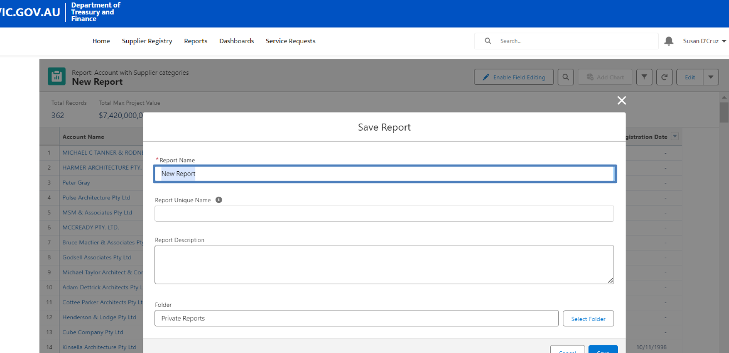
Click on the text field under “Report Unique Name” and unique name for the report. | 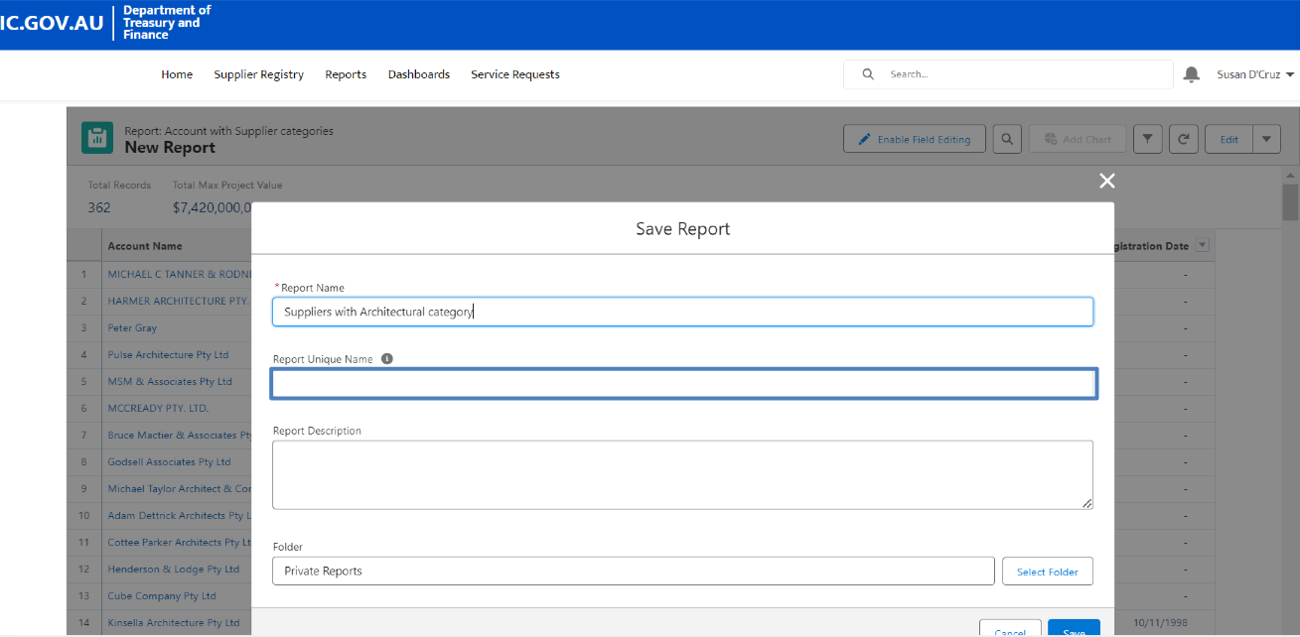
Click on “Save”. | 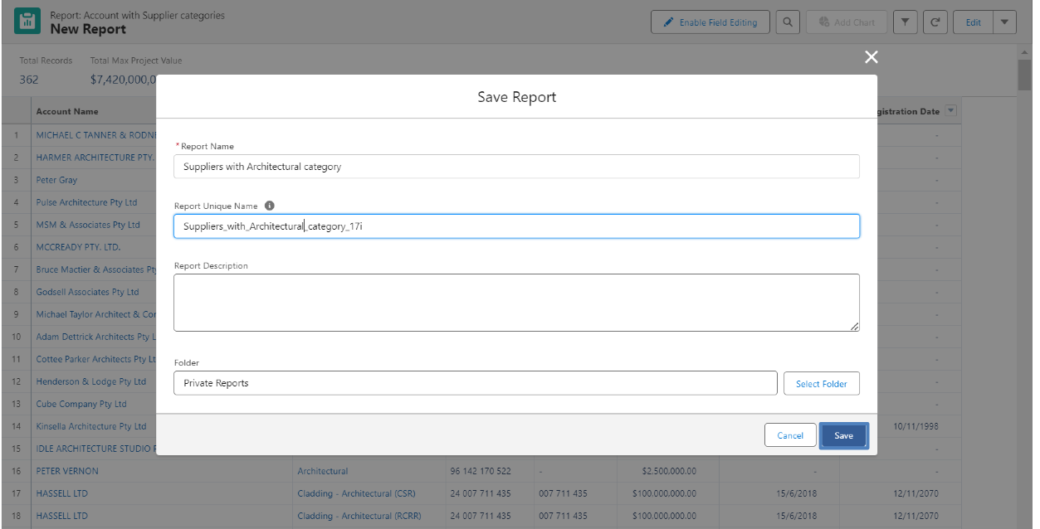
To export the document, click on the downward arrow | 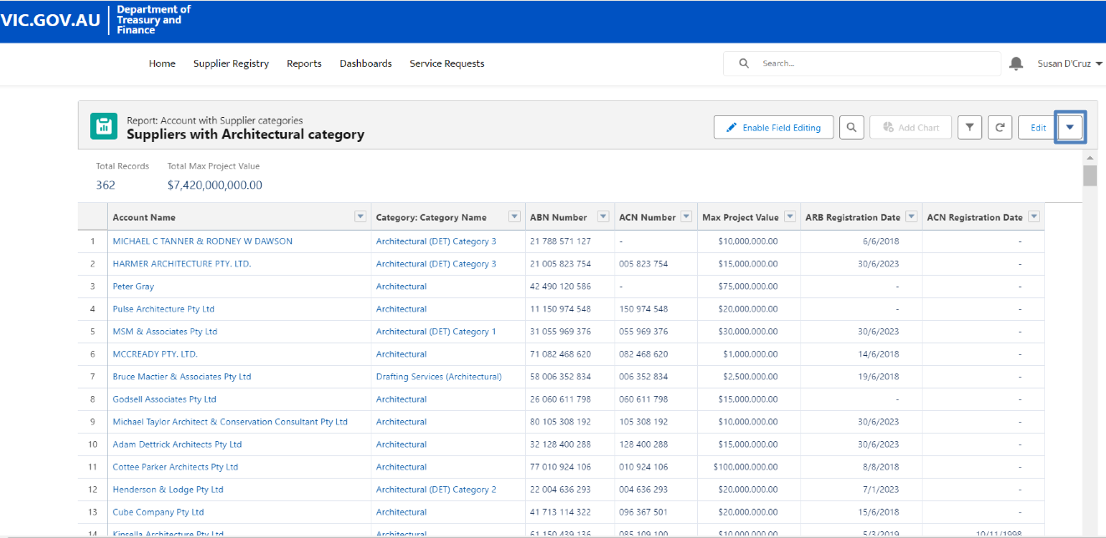
Select “Export”. | 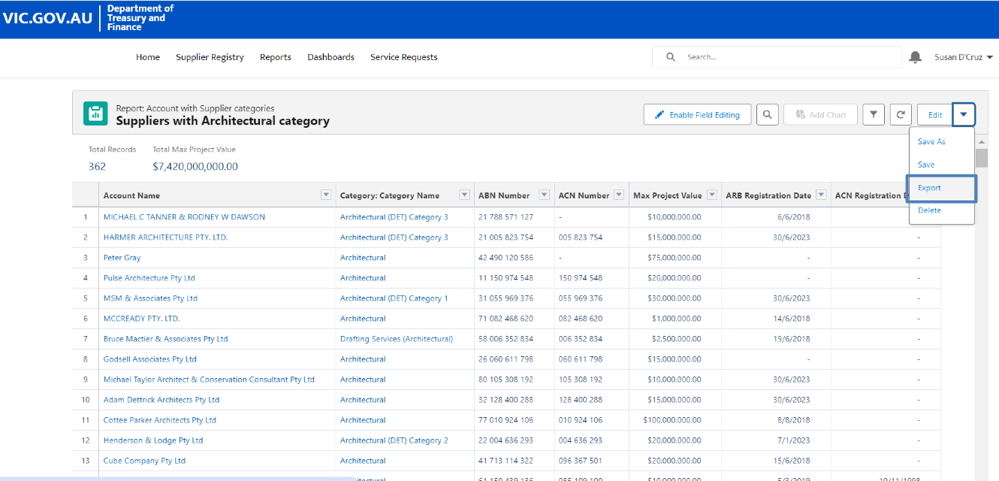
Click on the drop down menu to select the format of the exported report. | 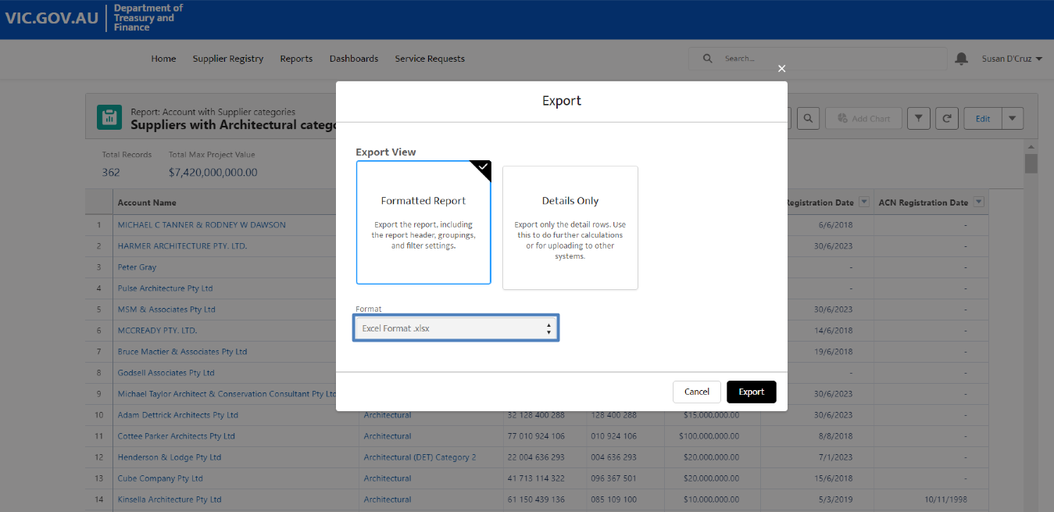
Select “Export”. | 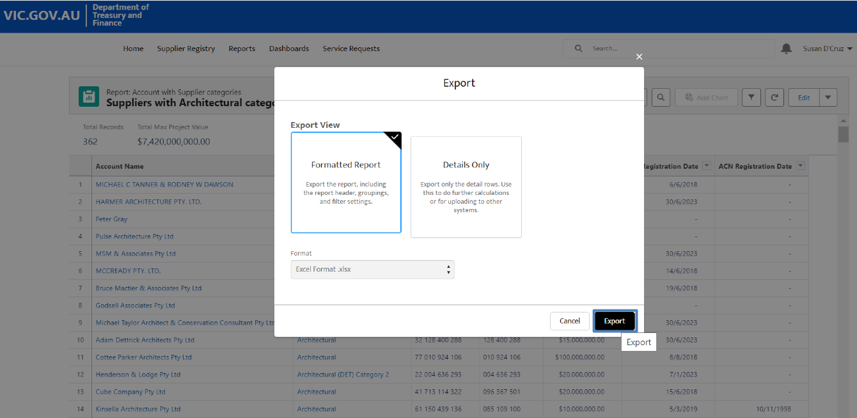
The exported report is now downloaded. Double click on the file to open and view the report. | 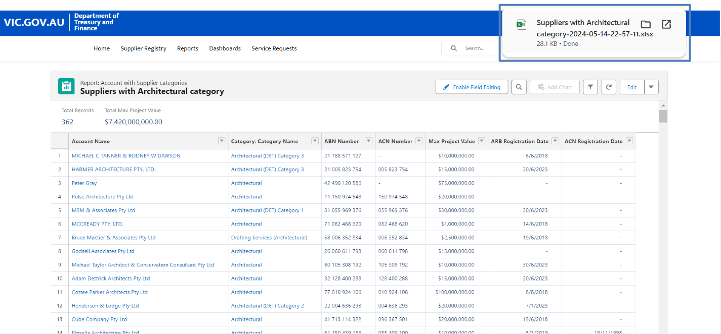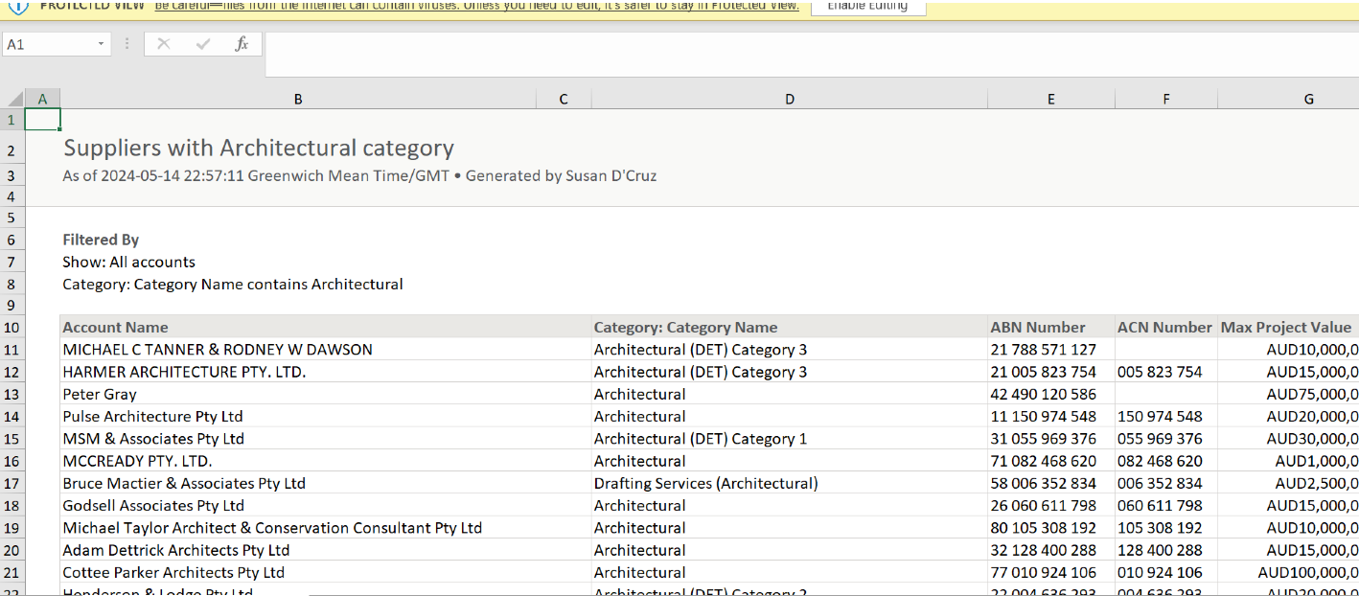
The report will also be available for future reference in the CSR portal. | 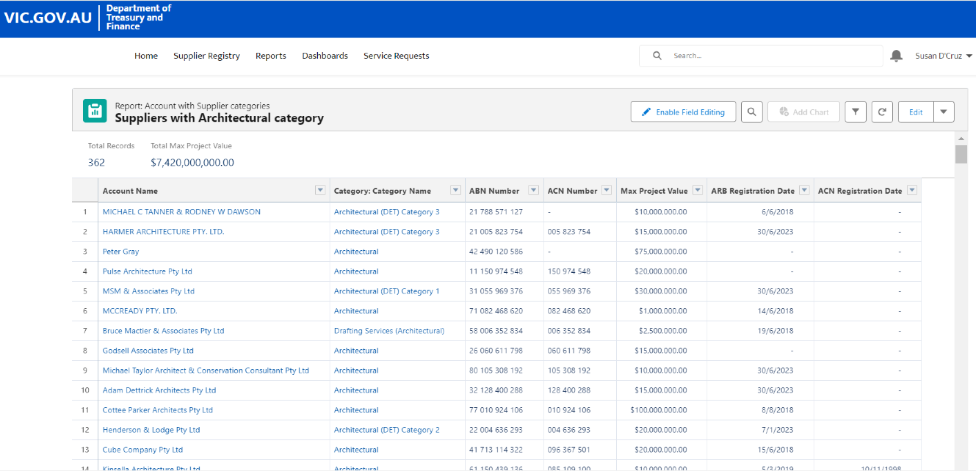
To see the report, select “Reports” in the top menu in the CSR portal. | 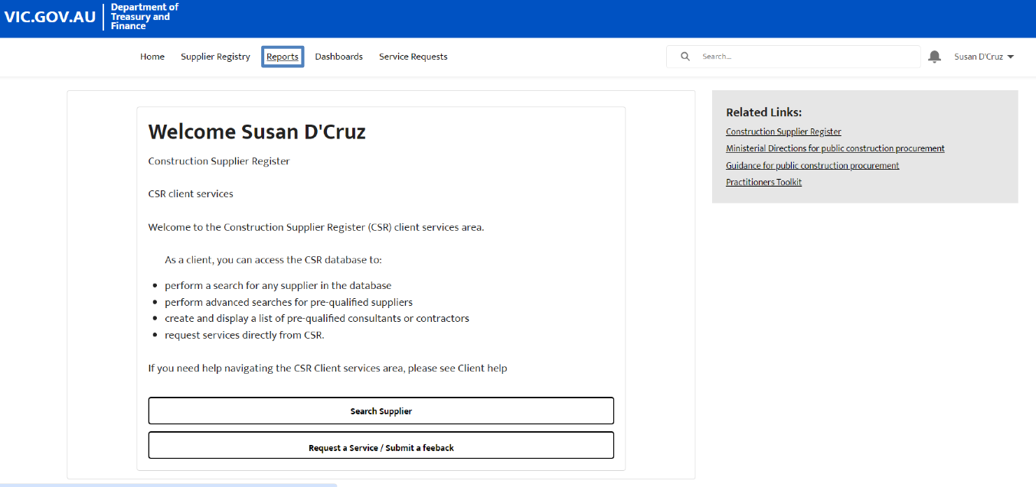
Select “Created by Me”. | 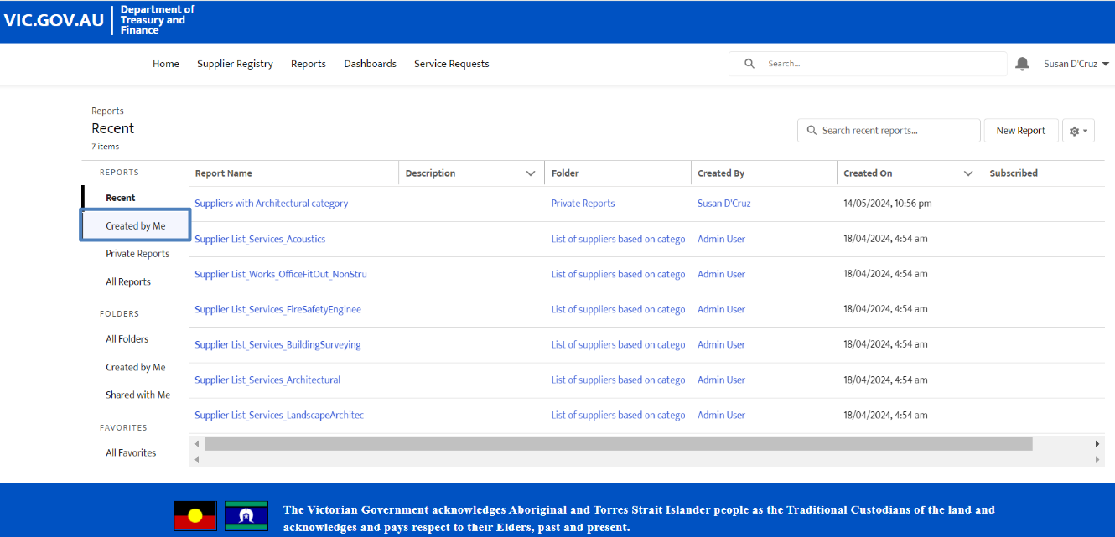
The report created with the customised fields will appear here. | 