CSR Implementation Training for CSR Staff

Buyer – Different Ways to Search for Suppliers

Overview

This is a brief overview of different ways a buyer can search for suppliers.

Pre-Requisites

- You must have an activated CSR user account with a username and password provided by the admin
- A compatible web browser such as Edge

Instruction | Screenshot
First, log in to access the CSR system. | 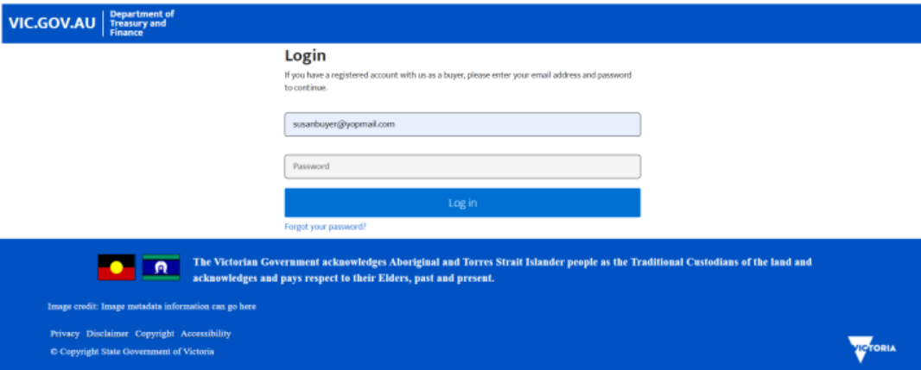
There are multiple ways for a buyer to search for a supplier.  The first method is the most direct way.  Click on the search field at the top and type the name of the supplier. | 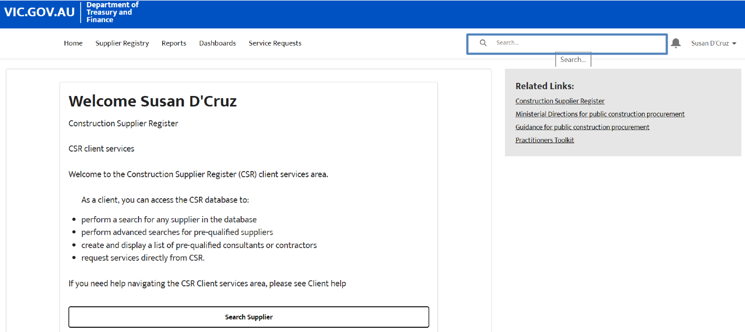
Click on the name of the account that appears in the list. | 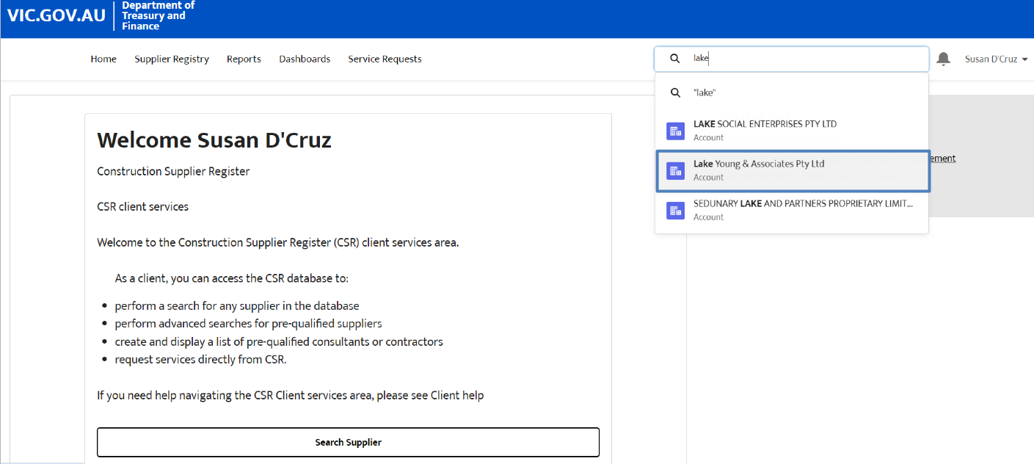
The details for the chosen supplier will be displayed. | 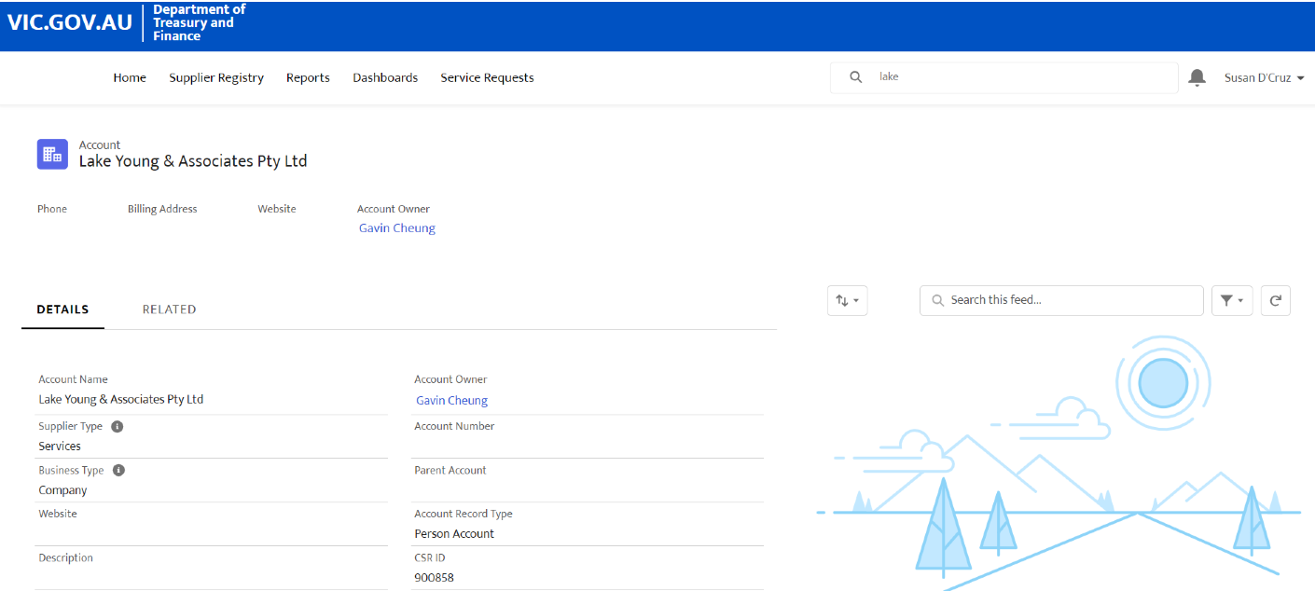
Another method is to conduct the search with other specific details, such as an ABN.

Click on the search field and type in the ABN of the supplier.
Click on the result that appears in the list. | 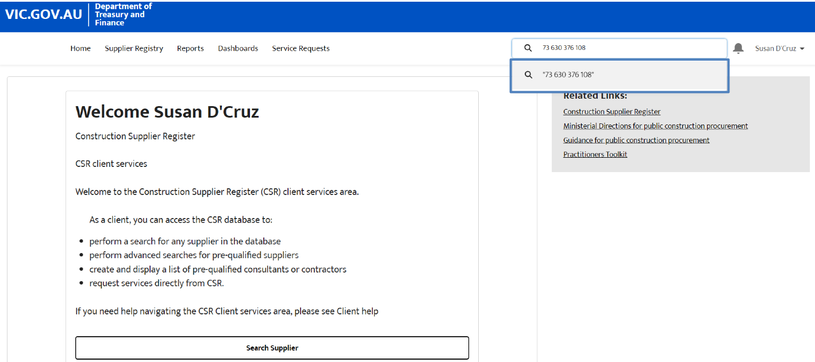
The supplier that is listed with the searched ABN will be displayed.  Click on the name of the supplier. | 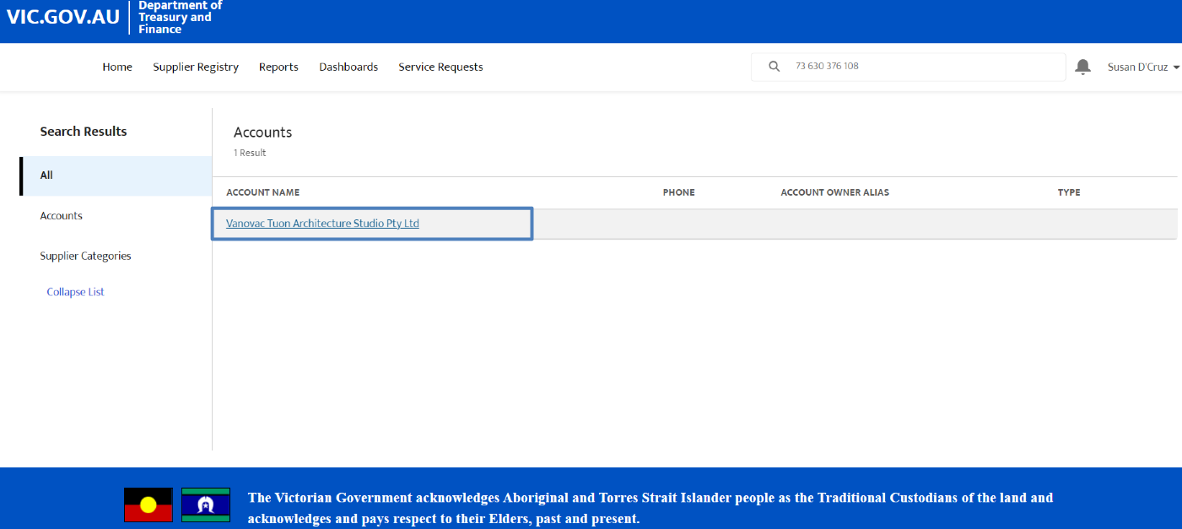
The details for the chosen supplier will be displayed, including the searched ABN. | 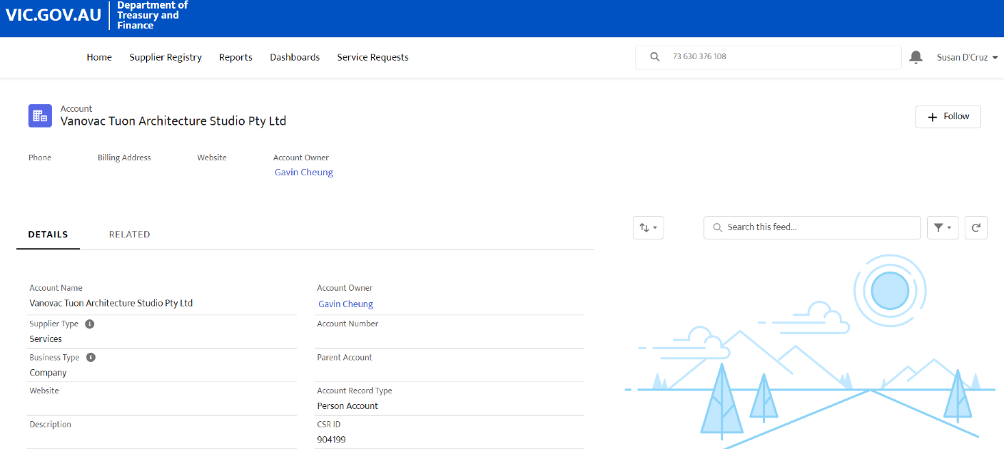
In addition to searching via ABN, searches can also be conducted with ACNs.

Click on the search field and type in the ACN of the supplier.
Click on the result that appears in the list. | 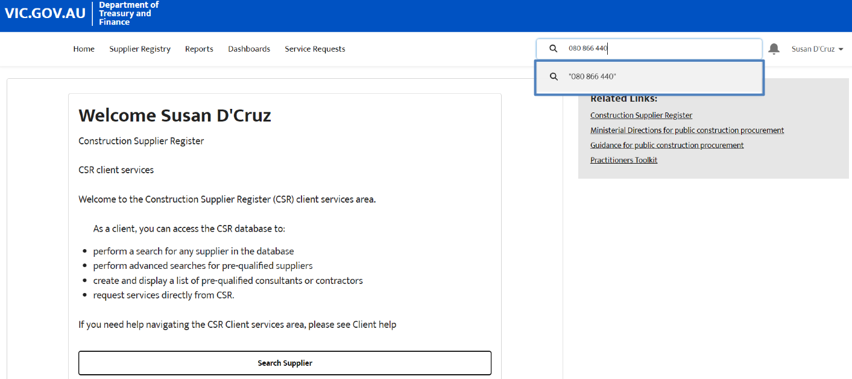
The supplier that is listed with the searched ACN will be displayed.  Click on the name of the supplier. | 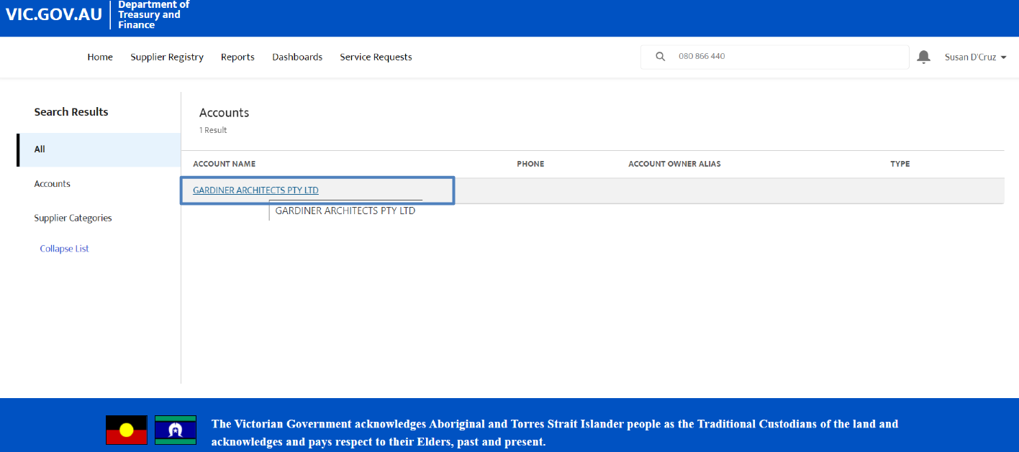
The details for the chosen supplier will be displayed, including the searched ABN. | 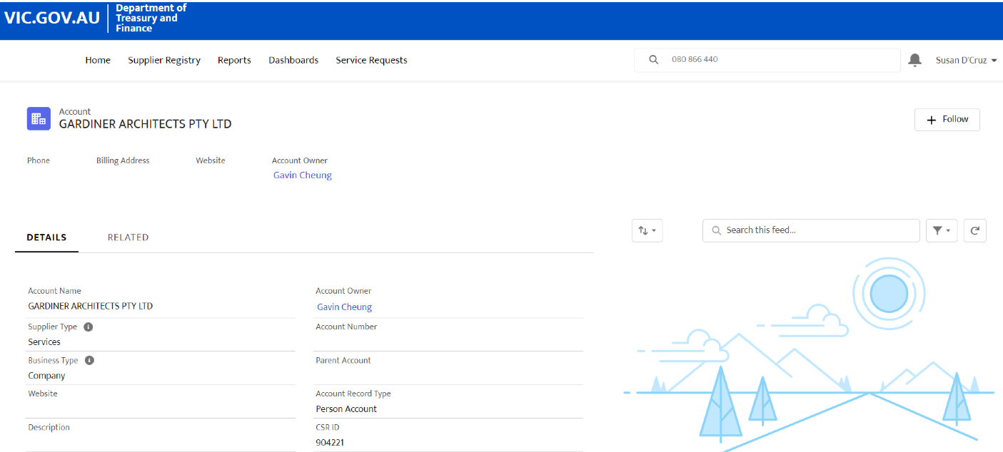
Searches can be conducted with only part of the details.  In this example, only the first three digits will be used to conduct the search. | 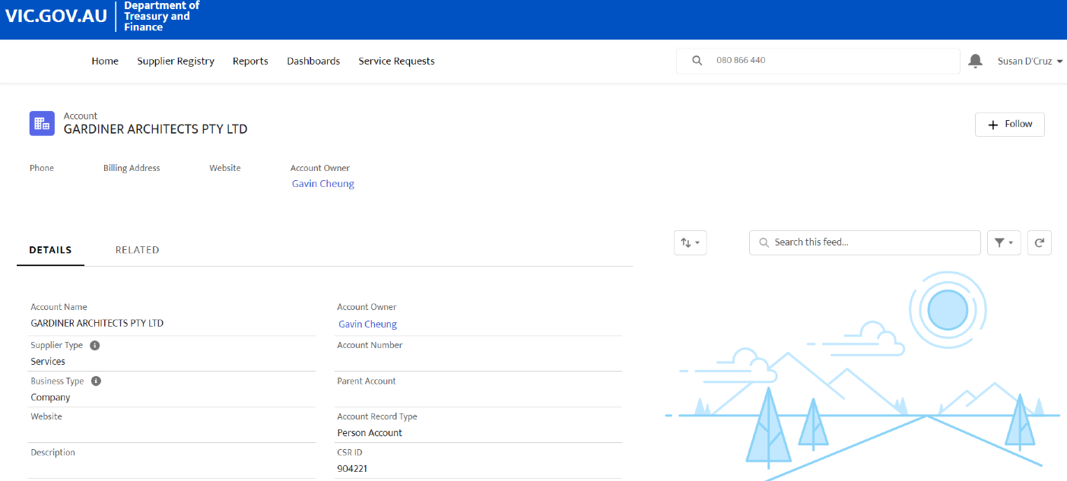
Click on the result that appears in the list. | 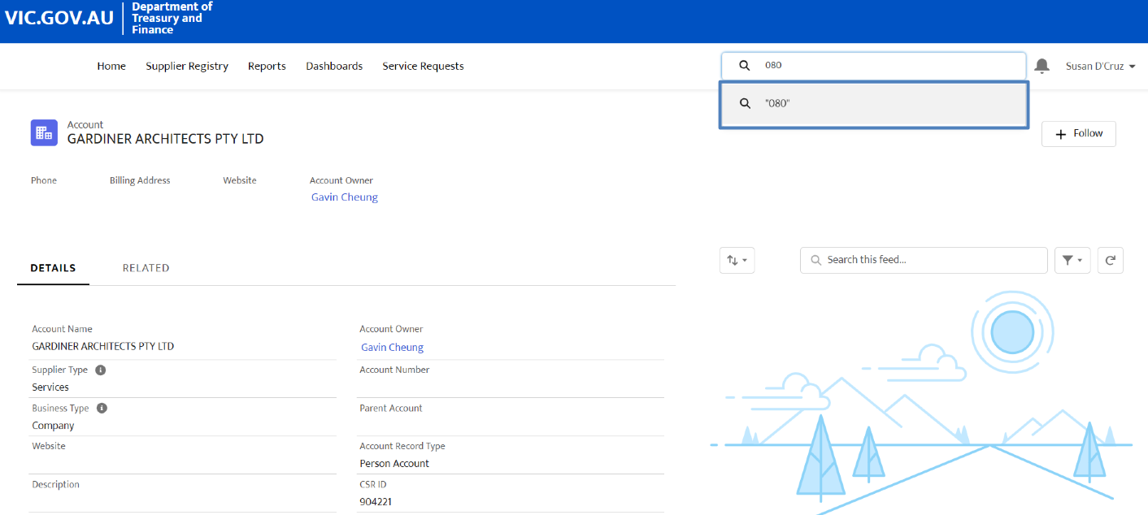
Now all the suppliers with ACNs containing the three digits will appear.  Select the correct supplier. | 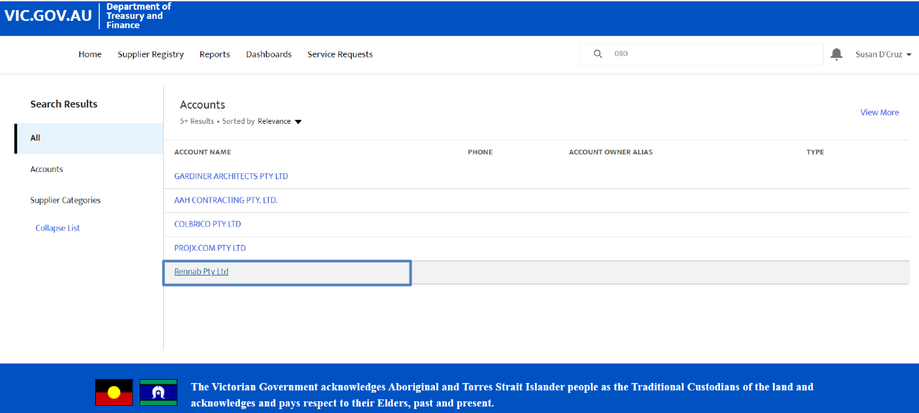
The details for the chosen supplier will be displayed, including the searched ABN. | 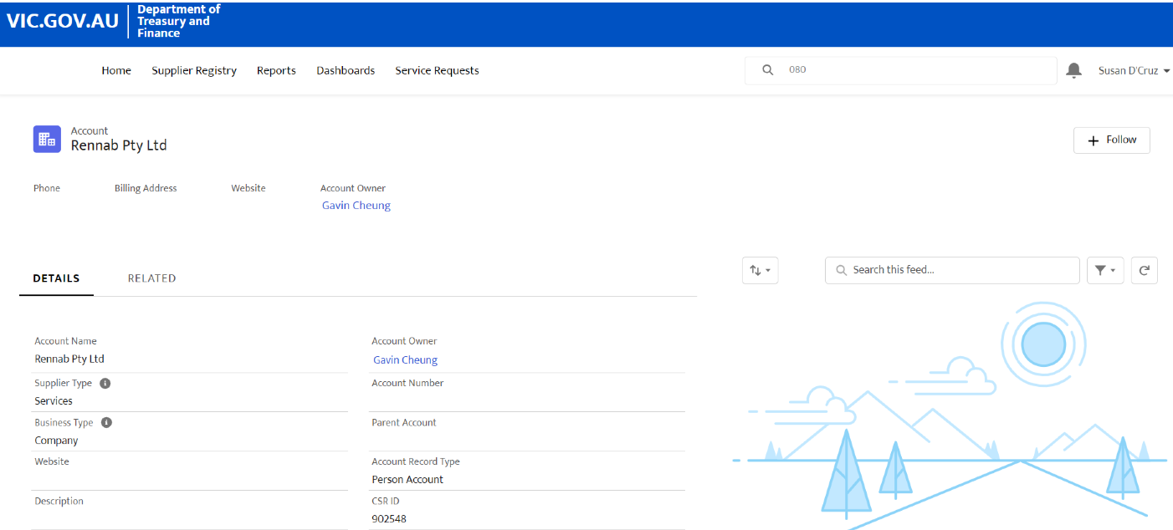
The second method is via the Supplier Registry.  Click on “Supplier Registry” on the top of the home page. | 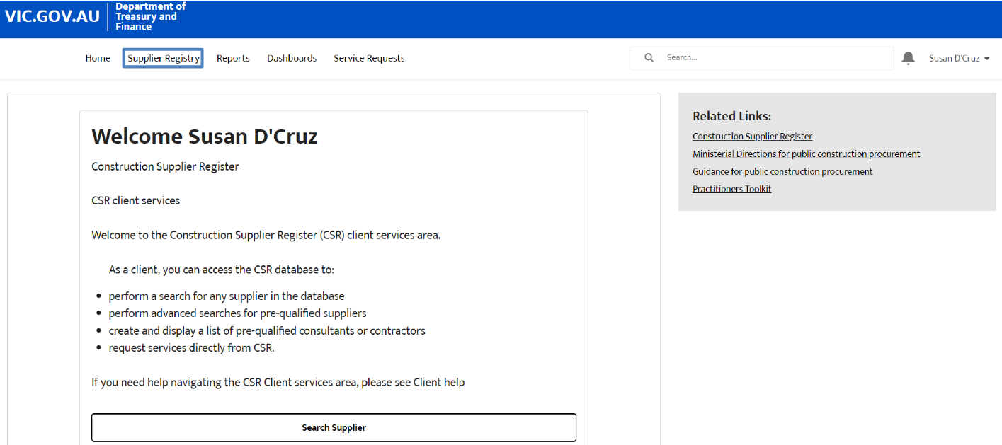
This will display a list of suppliers registered in the CSR system. | 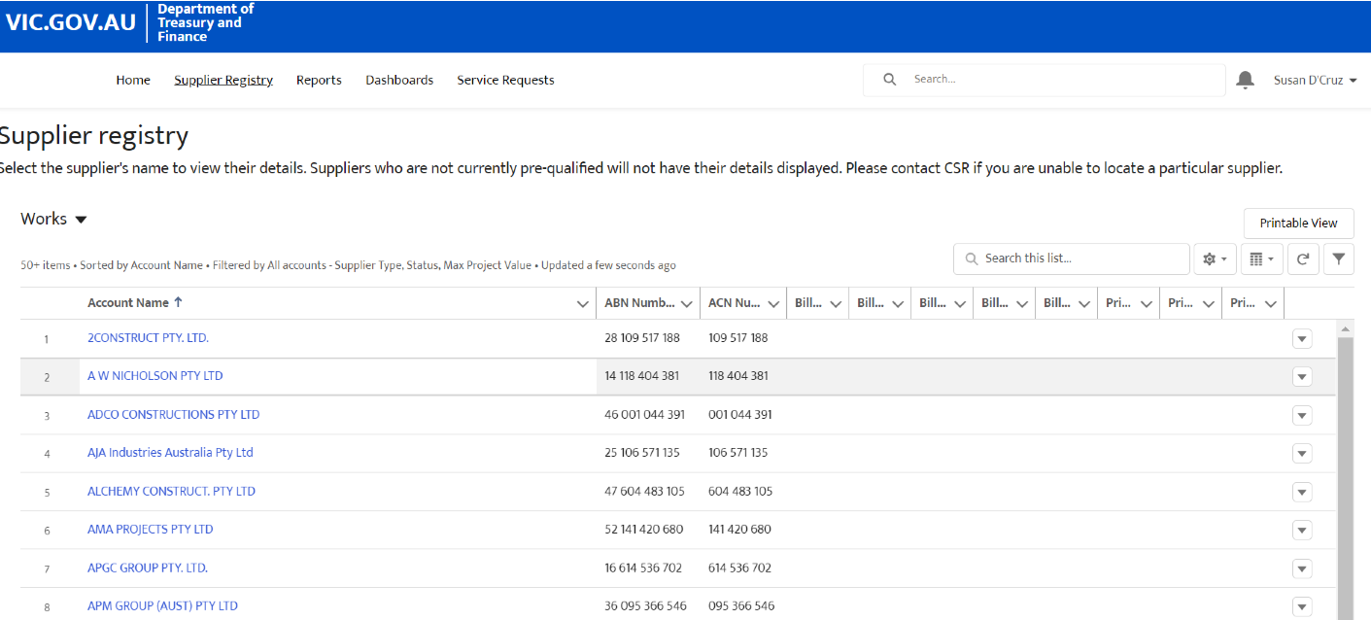
To filter the list, select the drop down menu. | 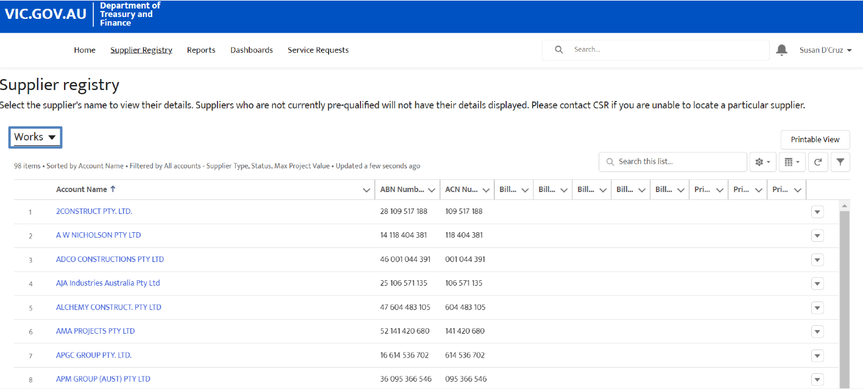
Select the type of list of suppliers to view. | 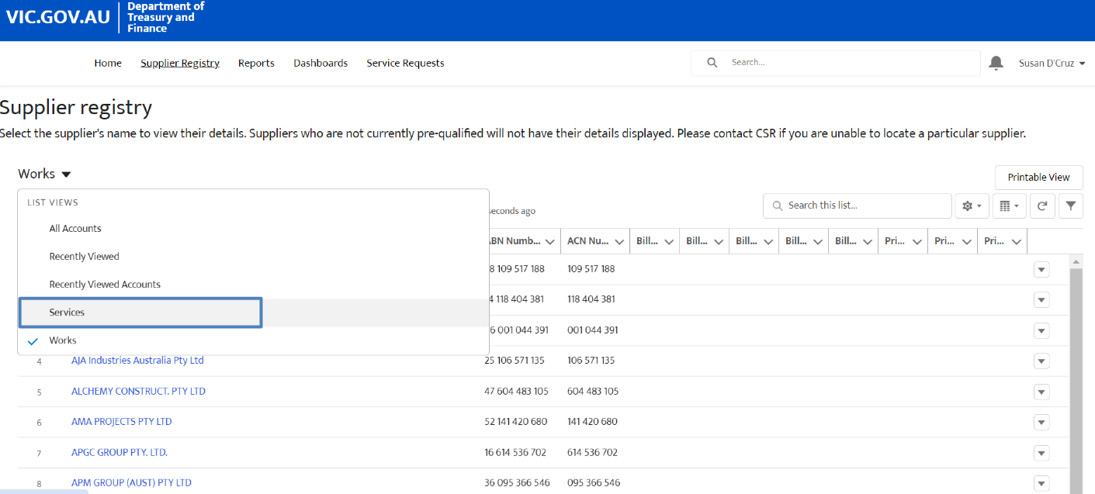
The list will now display suppliers who perform services instead of works.  The required supplier can be selected from this list. | 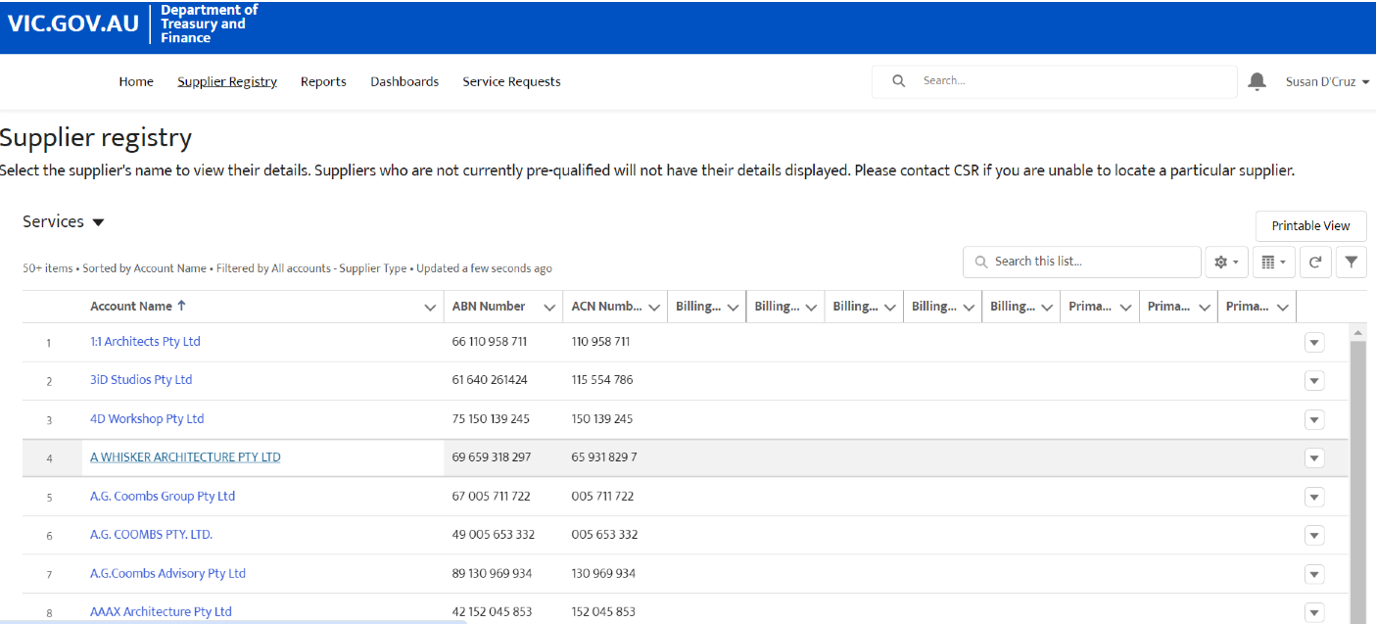
Another method to look for suppliers through the supplier registry is to search directly in the list through the search field.  Select “Supplier Registry” from the top menu. | 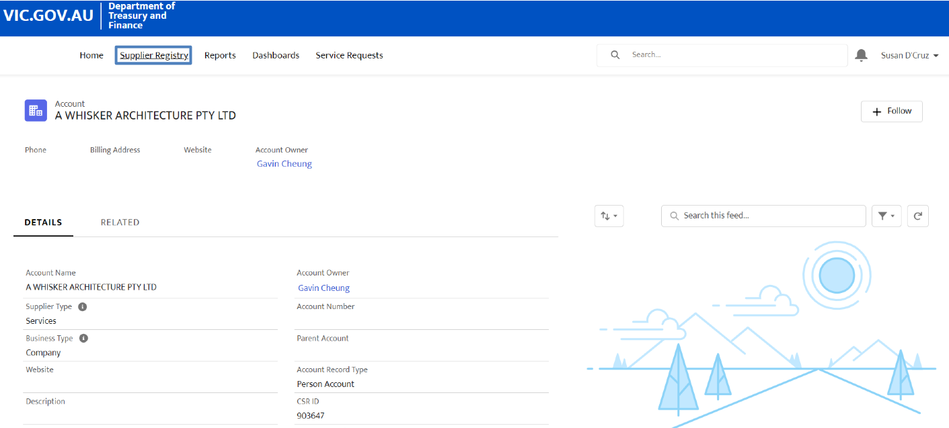
Click on the search field and type the name of the required supplier. | 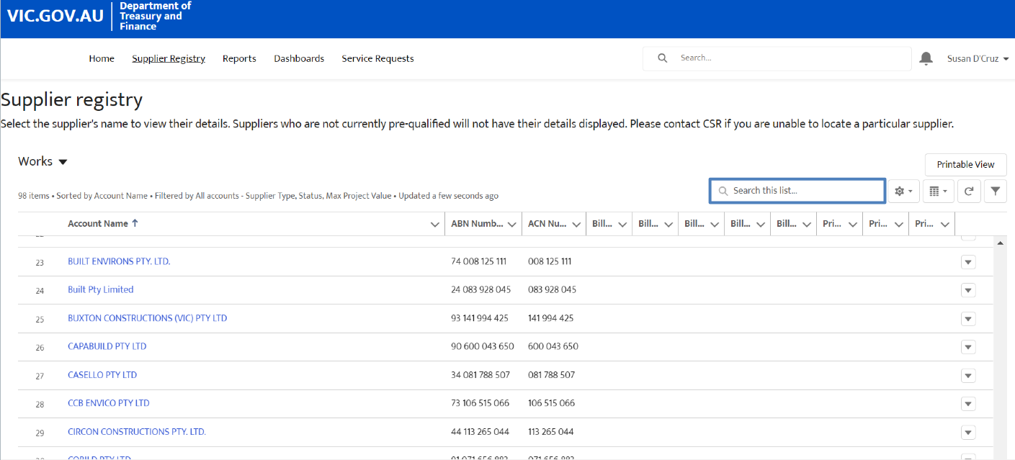
Select the supplier that appears in the list. | 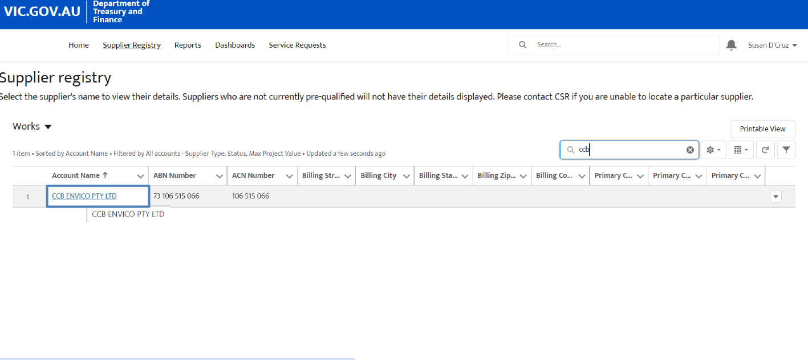
The third method is by selecting a list of most recently viewed accounts.  Select “Supplier Registry” from the top menu. | 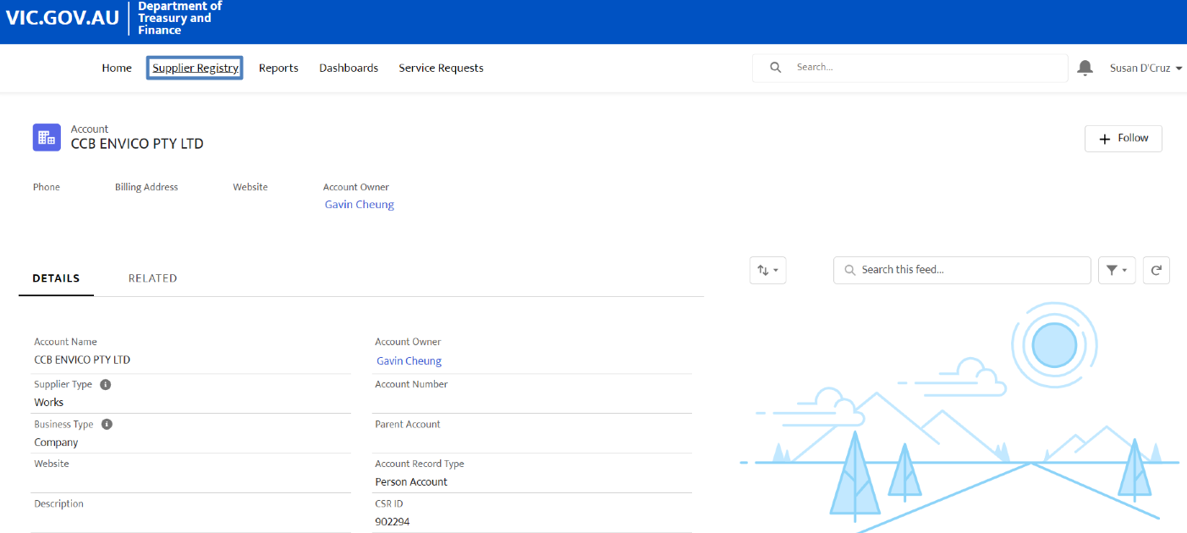
Select the drop down menu. | 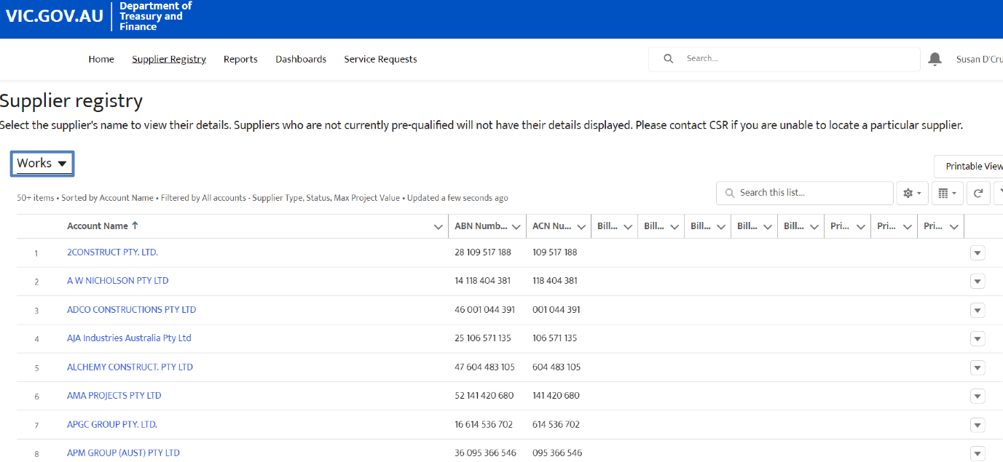
Select “Recently Viewed Accounts”. | 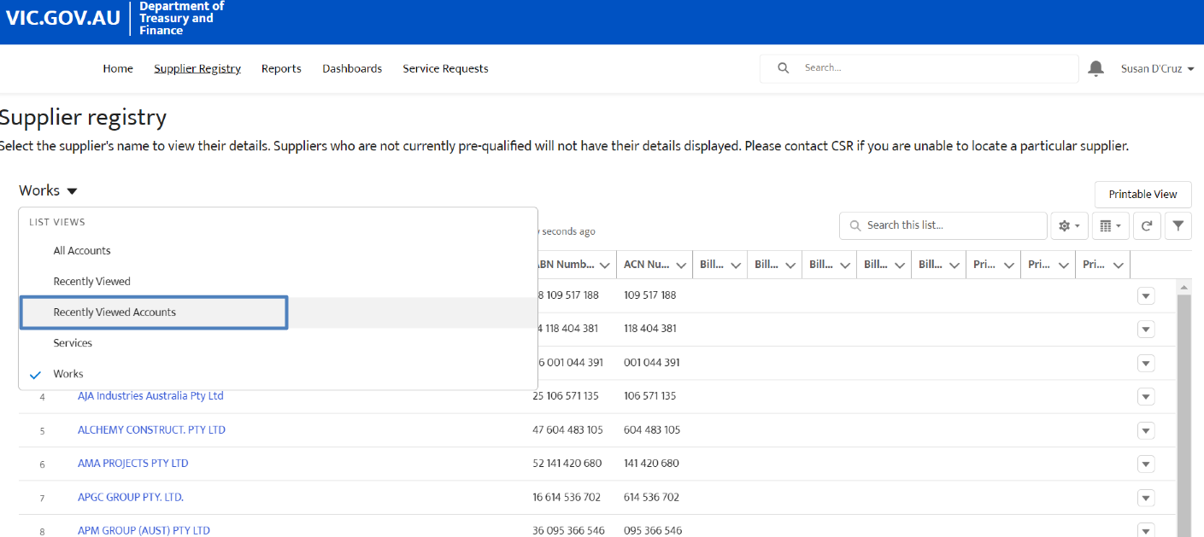
The list will now display suppliers who perform services instead of works.  The required supplier can be selected from this list. | 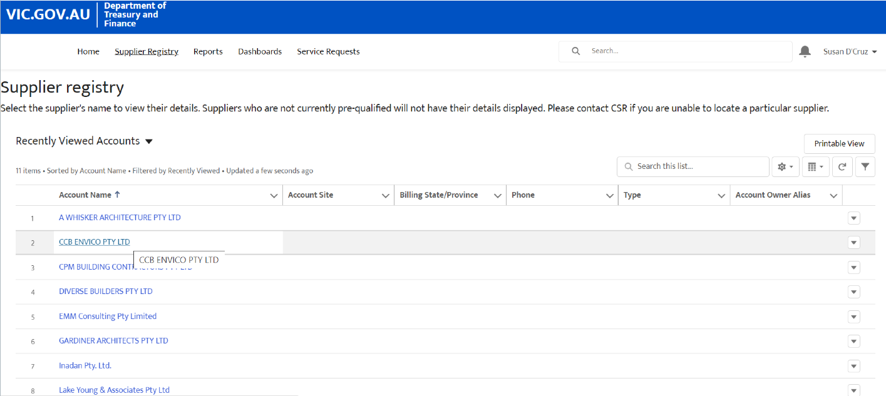
If the required supplier still cannot be located, then the search can include all suppliers in the registry.  Select the drop down menu. | 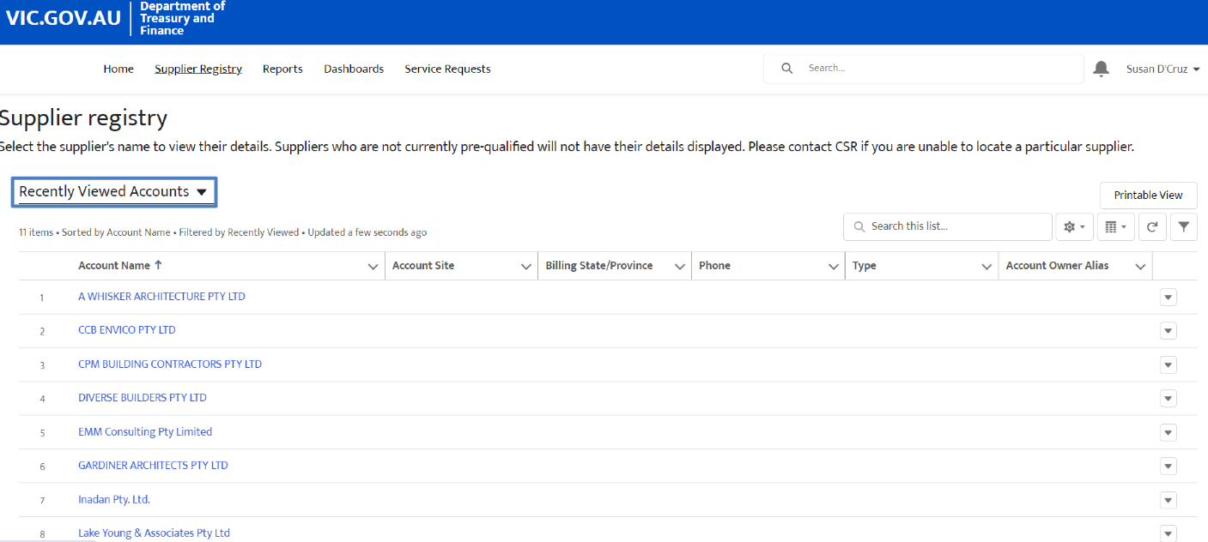
Select “All Accounts”. | 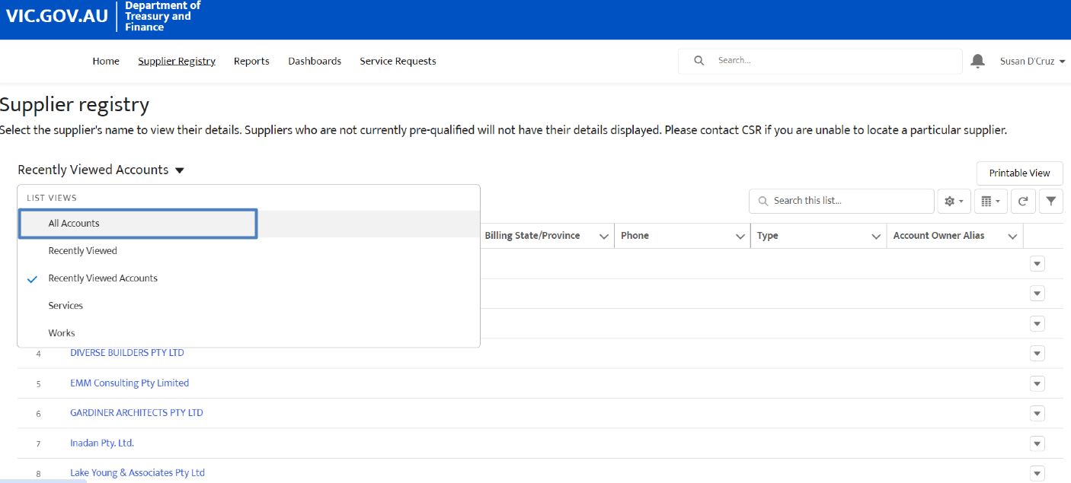
The list will now display all the suppliers in the registry, including both suppliers that provide works and suppliers that provide services. | 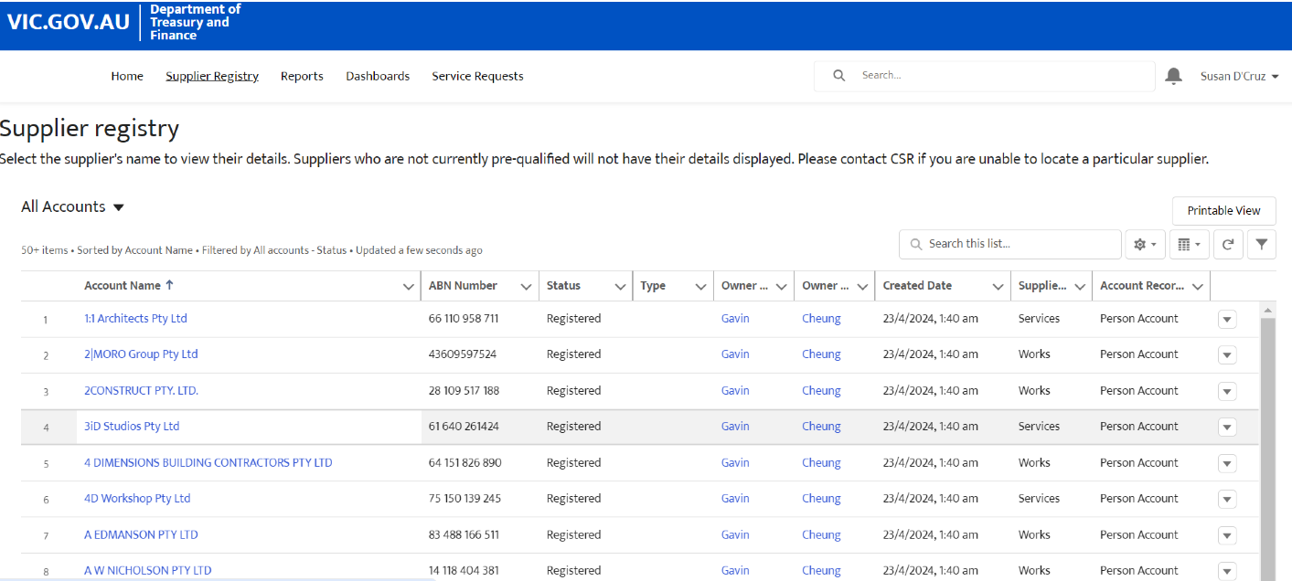
If the desired list of suppliers is displayed and is required to be shared outside of the CSR portal, the list can be exported into a shareable format.  For this example, the list of suppliers who provide services will need to be shared.  Select the drop down menu. | 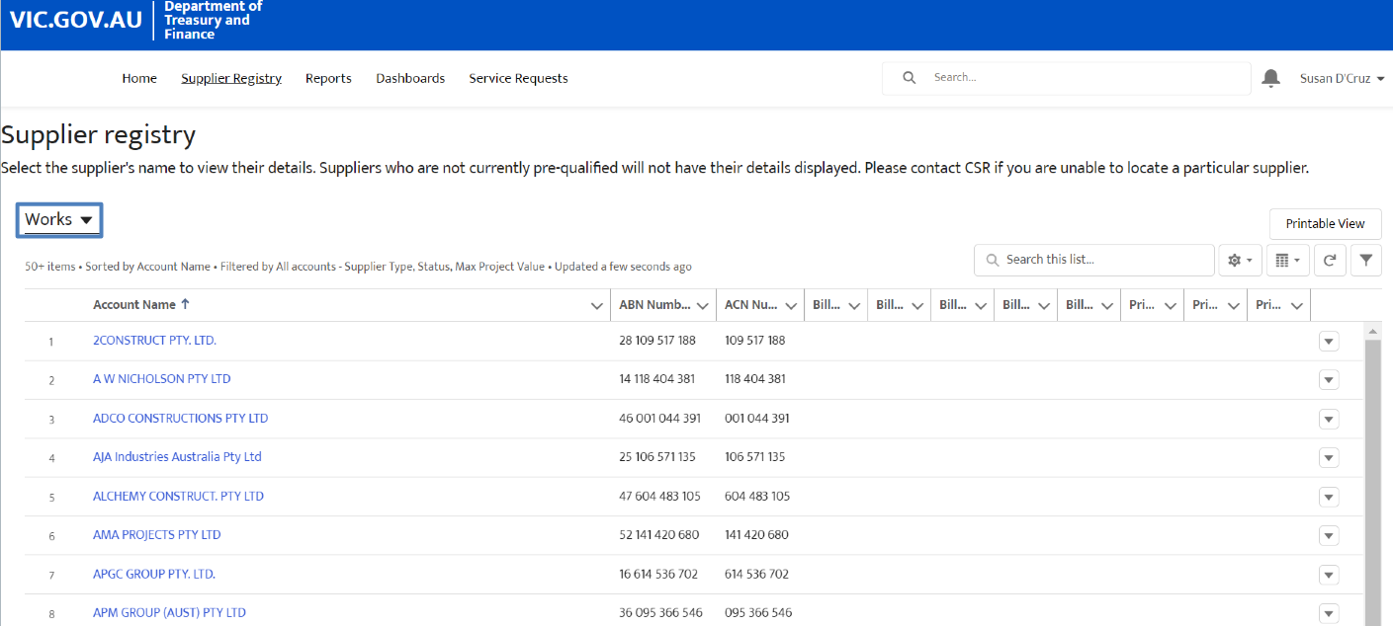
Select “Services”. | 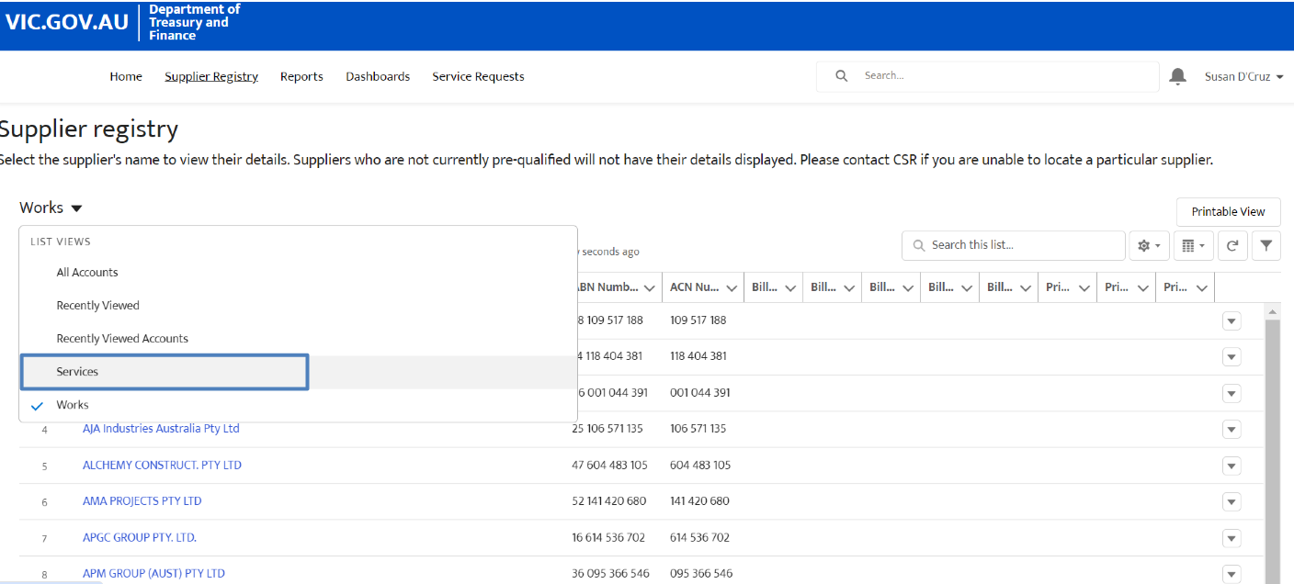
Select “Printable View”. | 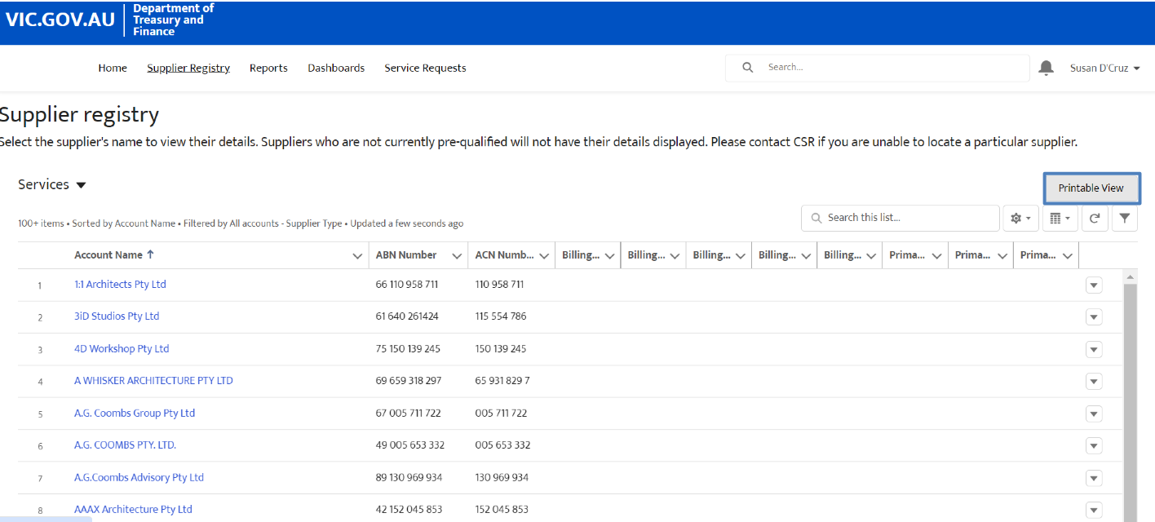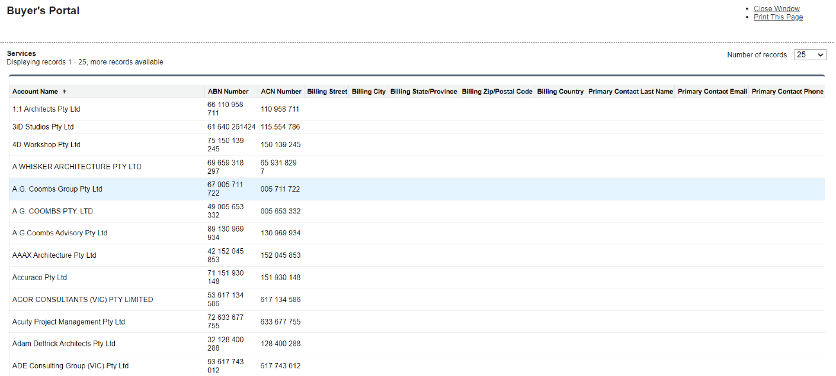
Select “Print This Page”. | 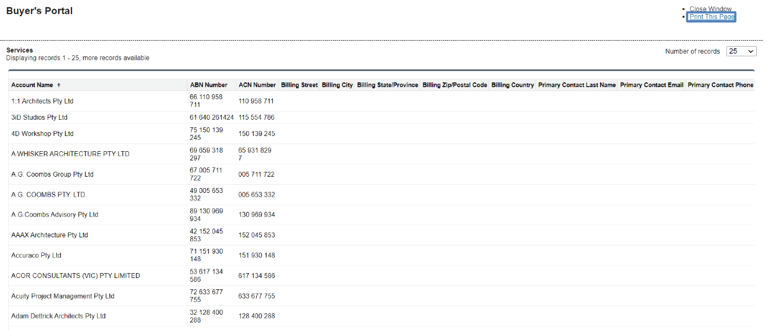
The list can now be saved either as a PDF to be shared and viewed outside of the CSR portal, or it can be printed as a physical copy. | 