Gateway Review Process
Gate 5 – Readiness for service workbook

The Secretary
Department of Treasury and Finance
1 Treasury Place
Melbourne Victoria 3002
Australia
Telephone: +61 3 9651 5111
dtf.vic.gov.au

Authorised by the Victorian Government
1 Treasury Place, Melbourne, 3002

© State of Victoria 2019
Copyright queries may be directed to IPpolicy@dtf.vic.gov.au

ISBN 978-1-925551-35-8
Published October 2019

If you would like to receive this publication in an accessible format please email information@dtf.vic.gov.au

This document is also available in Word and PDF format at dtf.vic.gov.au

Contents
The Gateway Review Process 1
About this workbook 1
Readiness for service 1
Gateway Review 5: Readiness for service 4
Project documents 5
1. Business case and stakeholders 6
2. Project Development and Due Diligence 7
3. Risk management 8
4. Review of current phase 9
5. Readiness for next phase: Benefits realisation 11
Appendix A: Best practice sources 13

The Gateway Review Process
The Gateway Review Process examines programs and projects at key decision points. It aims to provide timely advice to the Senior Responsible Owner (SRO) as the person or people responsible for overseeing the delivery of the project and transitioning it into operation. A review provides the SRO with an independent view on the current progress of the program or project and assurance that it can proceed successfully to the next stage.
Given the aim is to help the SRO at key decision points, each review is short and focused on the work that is complete at the time. For the best result, a review is carried out shortly before a decision is made to allow sufficient time for any recommendations to be implemented.

About this workbook
This workbook supports Gateway Review 5: Readiness for service. This review investigates how ready the organisation is to make the transition from the specification and/or solution to implementation. It assesses the capabilities of delivery partners and service providers and confirms ownership of the project is clearly identified after handover to operational services.
This workbook provides appraisal questions and sources of further information, including best practices for review teams. It offers questions to explore and evidence to look for. Because each policy, program or project is unique, and circumstances change, the workbook should be used as a guide to the range of appropriate questions and evidence, and not as a full checklist of mandatory items.

Readiness for service
Gateway Review 4: Tender decision covered activity up to the signing of contracts or agreements to place work with an existing supplier or partner. This review looks at whether the solution is robust before implementation; how prepared the organisation is to implement the business changes before and after delivery; the contract management arrangements; and whether there is a basis for evaluating ongoing performance. It is important that Partnership Victoria projects are well prepared for the contract management phase. This requires a governance structure for the operational phase of the project together with adequate budgets, appropriately skilled staff, and appropriate accommodation for the service management team.
For property and/or construction projects, this review takes place after the project has been approved as ‘ready for use’. Commissioning will have begun but will not be completed until after occupation, as systems are rebalanced to take account of the effect of occupancy. For IT-enabled projects, this review takes place after all testing, including business integration and business assurance testing, is completed and before rollout or release into production.
The review should also establish the level of Project Development and Due Diligence (PDDD) analysis that has been undertaken and evaluate its appropriateness. Where relevant, measures to address gaps in the extent of due diligence conducted could be detailed in the Recommendation Action Plan. More information about PDDD is available on the DTF website.

Figure 1: Overview of the Gateway Review Process
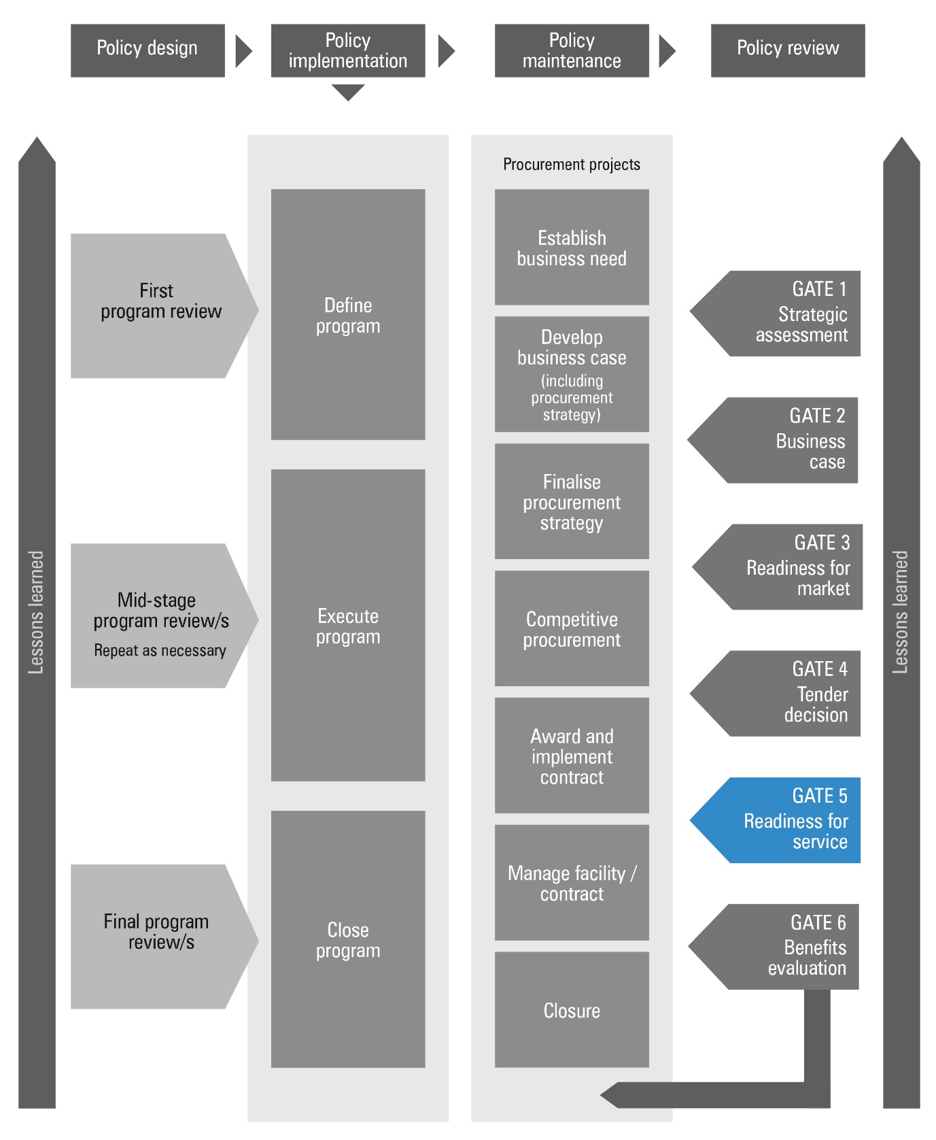

Figure 2: Applying the Gateway Review Process to different project delivery methods
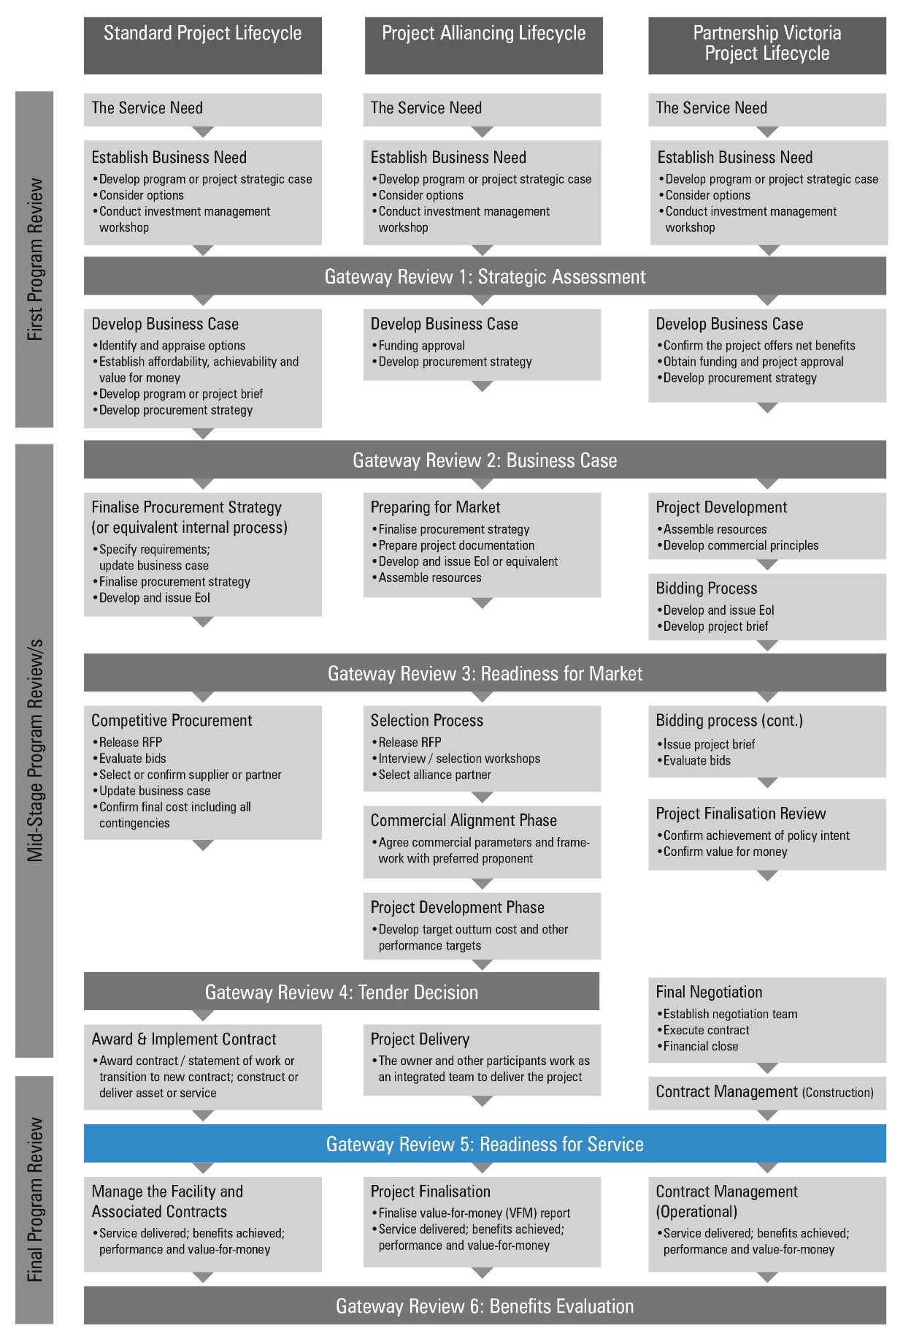

Gateway Review 5: Readiness for service
The purpose of the review is to:
- check the current phase of the contract is complete with supporting documentation;
- ensure contractual arrangements are up-to-date;
- check that the Business Case is still valid and unaffected by internal and external events or that a change control register has been maintained which logs all changes made to the project outlining authorisations, the impact to the budget, timescale and outcomes.
- check the original projected business benefit is likely to be achieved;
- ensure processes and procedures are in place for the long-term success of the project;
- confirm necessary testing is done, e.g. commissioning of buildings, business integration and user acceptance testing, to the client’s satisfaction and the client is ready to approve implementation;
- check there are feasible and tested business contingency, continuity and/or reversion arrangements;
- ensure ongoing risks and issues are being managed effectively, and do not threaten implementation;
- establish the level of PDDD analysis that has been undertaken and evaluate its appropriateness;
- evaluate the risk of proceeding with the implementation while issues remain unresolved;
- confirm the business has the necessary resources and is ready to implement the services and the business change;
- confirm client and supplier implementation plans remain achievable;
- confirm the management and organisational controls are in place to manage the project through implementation and operation;
- confirm contract management arrangements are in place for operational phase of the contract;
- confirm arrangements for handover of the project from the delivery team to the operational business owner;
- confirm all parties have agreed plans for training, communication, rollout, production release and support;
- confirm all parties have agreed risk management plans;
- confirm both client and supplier have plans for managing the working relationship, with reporting arrangements at appropriate levels;
- confirm information assurance accreditation and/or certification;
- confirm that a project closure report is being prepared.
- confirm defects or incomplete works are identified and recorded; and
- check lessons for future projects are identified and recorded.

Project documents
The investigation areas and examples of evidence should be available before the Gateway review starts. This information is likely to be found in the documents suggested below, but may be located in other program or project documents, or elsewhere in the organisation’s documentation system.
- An updated requirements definition with any changes agreed during the period up to Gateway Review 5;
- The business case, an updated change control register and plans for benefits realisation which reflect the effect of any changes to requirements, and plans for service delivery;
- A project closure report, which outlines the project’s performance, lessons learnt, and readiness to handover to operations.
- Close-out, if the project ends at implementation and status reports and reconciliations for:
  - cost versus budget;
  - actual versus planned schedule;
  - risk management;
  - communication and external relations;
  - environmental performance;
  - adherence to statutory requirements;
  - an assessment of contractual issues during the project to date;
  - lessons learnt during the project;
  - governance arrangements for the management of the operational contract;
  - a plan for performance measurement;
  - the updated contract;
  - test plan and test reports;
  - progress reports on development and construction;
  - updated risk register and issues log, including residual risks;
  - outline of project plans to completion and detailed plans for the next stage;
  - the plan for management of change including expected changes to requirements over time;
  - details of any facilities not meeting the required specification and any missing or deficient items, with agreed plans for addressing any outstanding issues;
  - risk management strategies;
  - benefit management plan; and
  - for IT-enabled projects, updated contingency and reversion plans.
- Project Development and Due Diligence (PDDD) analysis;
- A financial impact report which includes a snapshot of the financial performance of projects, including spend to date, cost to complete, and contingency and risk draw-down;
- For IT-enabled projects, information assurance documentation or accreditation, and operational and maintenance instructions and warranties; and
- For construction projects, updated health and safety file, operational and maintenance instructions such as maintenance and operation manuals, and warranties.

    - Business case and stakeholders
Areas to probe | Evidence expected
1.1 Is the project still required? | - approval of any changes to requirement defined at Gateway Review 4, which remain within the scope of the original Victorian Government Purchasing Board’s advertisement;  - communications with stakeholders;  - project board endorsement of:  - updated business case and benefits plans;  - a review of the solution against the requirement;  - reconciliation of government and organisation objectives with those defined at Gateway Review 4: Tender Decision; and  - plans for modular and/or incremental implementation.
1.2 Does the project meet the business need? | - confirmation the operational service and/or facility or partnering contract has stakeholder approval.
1.3 Is the business case still valid? | - updated project plan, business case with change control register to justify implementation decisions and show the project is:  - meeting business need;  - likely to deliver value-for-money;  - affordable; and  - achievable, with implementation broken down into modules and/or increments.
1.4 Are any changes between award of contract and completion of transition and/or testing affecting business change plans? | - change management documentation;  - impact analysis;  - products, design or operational changes;  - justified and approved changes;  - updated change control register for the business case and benefit plan for the business change; and  - updated processes, procedures and activities.
1.5 Is the organisation ready for business change? | - agreed plans for business preparation, transition and operational phases, IT and/or new facilities;  - communications plan;  - informed and trained staff; and  - a clearly defined service management function and/or organisation.
1.6 Can the organisation implement the new services and maintain existing services? | - a resource plan showing:  - capacity and capability; and  - resources are available to meet commitments.
1.7 Are the appropriate skills and experience available? | - commitment to provide the resources required;  - job descriptions for key project staff; and  - skills appraisal and plans for addressing any shortfalls.

    - Project Development and Due Diligence
Areas to probe | Potential evidence
2.1 Has the project been delivered to the scope, time, quality and schedule? Have any of the project objectives already been met? Have any of the project benefits been delivered? | - Project delivery report and comparison with benefit management plan and business case.
2.2 Have all processes related to land acquisition been completed? | - land acquisition requirements assessment.  - completed register of required land acquisition.
2.3 Are all delivery risks and issues closed out? | - updated project risk register and exceptions noted in project delivery report.
2.4 Are all stakeholders satisfied with the outcome of the project | - project stakeholder register and exceptions in project delivery report.
2.5 Have all new procedures for process testing, commissioning, acceptance or transition been completed? | - testing and commissioning plan.
2.6 Have all new procedures for process testing, acceptance and transition been completed? | - asset handover plan.
2.7 Have you received confirmation that all drawings are submitted to the appropriate drawing management system? | - drawing management system and acquittals log.  - as built drawings and drawing register.
2.8 Have all operational and maintenance procedures and training been developed? | - asset management plan.  - asset management system.  - O&M manuals.  - training management plans.
2.9 Have lessons learnt been captured? | - lessons learnt register.

    - Risk management
Areas to probe | Evidence expected
3.1 Have the risks and issues identified at contract award phase been resolved? | - risks resolved with no outstanding issues.
3.2 Are risks and issues associated with the implementation phase being properly identified and managed? | - risks resolved with no outstanding issues;  - commissioning and service delivery the only remaining risks; and  - risks, including findings from PDDD analysis, fully quantified with appropriate risk management plans in place.
3.3 With unresolved issues, what are the risks of implementing rather than delaying? | - project risk management strategy in place, developed according to best practice;  - assessment of all remaining issues and risks, with responsibility for management of residual risks clearly defined;  - evaluation report on the risk and impact of cancelling, delaying or proceeding with implementation that considers:  - the project outcome and wider program of change;  - benefits realisation;  - consequences for supplier, client, business, stakeholders, users, etc.; and  - other factors such as financial outcome, political issues and delivery.  - options and management plans for all scenarios and a recommendation based on sensitivity analysis; and  - project board has ratified the recommendation to delay or proceed with implementation.

    - Review of current phase
Areas to probe | Evidence expected
4.1 Does the service or facility meet the acceptance criteria? | - justification and authorisation of any changes to original specification; and  - analysis of ‘as built’ products to show how the solution complies with acceptance criteria.
4.2 Is the project under control? Is it running according to plan and budget? | - reconciliations of cost with budget and actual schedule with planned schedule;  - updated risk register and issue log, excluding commissioning issues and mitigation for PDDD findings and analysis;  - status reports for communication and external relations activities;  - environmental performance reports;  - compliance with statutory requirements e.g. health and safety, data protection;  - contractual issues resolved and recorded; and  - for IT-enabled projects, compliance with security standards such as information assurance.
4.3 Have all stakeholder issues been addressed? | - progress reports completed and circulated according to the communication plan for stakeholder information.
4.4 Have all new process testing and commissioning and/or acceptance or transition procedures been completed? | - commissioning and/or test plans, results and analysis of products against acceptance criteria;  - commissioning and/or test results conform to the predefined criteria;  - ratified test reports and logs;  - commissioning and/or testing team with relevant skills and experience;  - confirmed ‘end-to-end’ testing, including new or changed business processes;  - testing takes into account future modules or deliverables; and  - missing or incomplete items and agreed corrective action documented.
4.5 Have all parties accepted the commissioning and/or test results and any action required? | - supplier and client plans and procedures.
4.6 Where there are significant environmental impacts, are all regulatory requirements being met? | - required efficiency certification.
4.7 Are there workable and tested business contingency, continuity and/or reversion plans for rollout, implementation and operation? | - fully documented and timetabled decision paths for key aspects e.g. decisions on rollout with decision makers clearly identified and informed;  - where appropriate, plans should cover IT components;  - endorsement by project board and supplier;  - listed roles and responsibilities, resources allocated and staff trained;  - commissioning and/or testing reflects expected scenario(s);  - transition plans for new work practices;  - plans for handover to facilities management, where applicable;  - training plans and relevant supporting material; and  - plans for a user support helpdesk.
4.8 Have the supplier and all internal and external parties agreed to these plans? These could include:  - management of change;  - migration and data transfer;  - client and supplier implementation; and  - rollout. | - all required plans in the contract;  - all parties, or their representatives, are aware of and have agreed to their responsibilities;  - partnering agreements in place or planned; and  - shared understanding of the change control process.
4.9 Have changes to the contract been forecast, accurately recorded and approved? | - contractual basis for ‘manage and operate contract’ reviewed and agreed; and  - contract documentation showing authority for all changes since award, including rationale for the change.
4.10 Is the organisation ready to manage the contract? | - the current involvement of the future operational contract management team;  - the handover arrangements regarding knowledge and learning between provision of assets (where required) and contract management teams;  - identification of project team members available to the contract management team over the first year of operation; and  - any issues related to defects in the finished product how these will be dealt with.

    - Readiness for next phase: Benefits realisation
Areas to probe | Evidence expected
5.1 Are all project elements ready for service? | - updated schedules;  - health and safety file;  - handover certificates;  - product and/or works warranty schedules;  - test and commissioning data;  - transition plans are in place;  - plans for the ‘operate contract’ and/or service phase are available;  - contingency plan in place; and  - technical documentation is available, including:  - delivered drawings;  - operation and maintenance manuals;  - instructions; and  - information assurance documentation.
5.2 Is ownership after handover clearly understood? | - SRO has identified the business owner for the operational service;  - SRO has identified and agreed the critical success factors with the business owner; and  - handover responsibilities and arrangements have been documented and agreed by both parties.
5.3 Is the client ready to adopt new work practices? | - new business processes have been planned, tested and are ready to go live;  - information and support are available such as customer information at call centres; and  - members of the public as end-users are aware of the new service and where to get more information.
5.4 Is the long-term contract management process in place? | - detailed plans, roles, responsibilities, governance structure including any escalation process, and organisation are in place for client and supplier, with reporting arrangements at appropriate levels;  - operational business owner identified if not the SRO;  - suitably qualified staff appointed by client and supplier, with continuity skills appraisal and shortfall plans addressed;  - management staff trained in contract management and familiar with contract aims and purpose; and  - plans for managing service delivery, changes to the contract and relationship with supplier.
5.5 Is there a process to manage and measure performance? | - performance management plans in place;  - performance enhancement process agreed with service provider and documented in the contract before award; and  - performance measures agreed with service provider and/or partners and documented in contract.
5.6 Is there a process to manage and measure benefits? | - benefit management plan in place and linked to program outcomes;  - benefits measures agreed with service provider and/or partners;  - contract management includes a sufficiently robust framework to assess performance; and  - for collaborative projects, all parties understand and agree with their responsibilities and arrangements for benefits realisation.
5.7 Have ongoing operation and maintenance been considered in detail? | - issues and ongoing costs relating to maintenance of buildings and/or IT infrastructure and applications, are monitored against expectations and addressed.
5.8 Is there a process for post implementation reviews? | - plan for post-implementation reviews endorsed by supplier and internal and external parties.
5.9 Has an appropriate level of PDDD analysis been undertaken for the next phase? | - PDDD analysis and findings.

Appendix A: Best practice sources
Source | Information
Investment management guidelines  See Investment management  www.dtf.vic.gov.au/infrastructure-investment/investment-management-standard | - investment management standards  - investment logic maps  - investment concept briefs  - benefit management plans
Investment lifecycle guidance  See lifecycle guidance  www.dtf.vic.gov.au/infrastructure-investment/investment-lifecycle-and-high-value-high-risk-guidelines  See PDDD guidance  https://www.dtf.vic.gov.au/investment-lifecycle-and-high-value-high-risk-guidelines/stage-1-business-case | - business case development guidelines, including strategic assessment guidance  - procurement strategy guidelines  - project tendering guidelines  - risk management guidelines  - Project Development and Due Diligence guidelines
Procurement advice, policy and guidelines
Victorian Government Purchasing Board
hwww.procurement.vic.gov.au | - longer term contract management  - contract variations
www.infrastructure.gov.au/infrastructure/ngpd | - National guidelines for Infrastructure Projects
www.dtf.vic.gov.au/infrastructure-investment/public-private-partnerships | - Social Procurement Framework
www.dtf.vic.gov.au/public-construction-policy-and-resources/ministerial-directions-and-instructions-public-construction-procurement | - Ministerial Directions and instructions for Public Construction Procurement
www.dtf.vic.gov.au/infrastructure-investment/market-led-proposals | - Market-led proposals guideline
PPP projects  For the National PPP policy and guidelines, see  www.infrastructureaustralia.gov.au  Specific Partnerships Victoria requirements apply, see  www.partnerships.vic.gov.au | - contract management policy and guidance material
Project alliancing  See Project alliancing at www.dtf.vic.gov.au | - Project Alliancing Practitioners Guide
Information and Communications Technology (ICT) projects  www.enterprisesolutions.vic.gov.au  www.dtf.vic.gov.au/infrastructure-investment/high-value-high-risk-framework | - Guidance on High Value High Risk projects including ICT projects  - ICT-related strategy, standards, policies, project dashboard, and  - technical resources for Whole of Victorian Government (WoVG).
Asset Management Accountability Framework  Department of Treasury and Finance  www.dtf.vic.gov.au/infrastructure-investment/asset-management-accountability-framework | - further information about government asset management expectations including acquiring new assets  - other general information
Gateway Review Process  www.dtf.vic.gov.au/infrastructure-investment/gateway-review-process | - Gateway Guidance material  - Becoming a Gateway reviewer

