Gateway Review Process
Program Review

The Secretary
Department of Treasury and Finance
1 Treasury Place
Melbourne Victoria 3002
Australia
Telephone: +61 3 9651 5111
dtf.vic.gov.au

Authorised by the Victorian Government
1 Treasury Place, Melbourne, 3002

© State of Victoria 2019
Copyright queries may be directed to IPpolicy@dtf.vic.gov.au

ISBN 978-1-925551-46-4
Published October 2019

If you would like to receive this publication in an accessible format please email information@dtf.vic.gov.au

This document is also available in Word and PDF format at dtf.vic.gov.au

Contents
The Gateway Review Process 1
About this workbook 1
The wider context of program delivery 1
Types of programs 2
Programs as small projects with a common focus 3
Programs as a framework for independent projects 3
Program reviews of projects with lengthy implementation 4
Gateway Program Review 7
1. Policy context and strategic fit 9
2. Business case and stakeholders 12
3. Management of intended outcomes 16
4. Risk management 18
5. Review of current outcomes 19
6. Readiness for next phase 21
Appendix A: Best practice sources 24

The Gateway Review Process
The Gateway Review Process examines programs and projects at key decision points. It aims to provide timely advice to the Senior Responsible Owner (SRO) as the person responsible for a program or project. A review provides the SRO with an independent view on the current progress of the program or project and assurance that it can proceed successfully to the next stage.
Given the aim is to help the SRO at key decision points, each review is short and focused on the work that is complete at the time. For the best result, a review is carried out shortly before a decision is made to allow sufficient time for any recommendations to be implemented.

About this workbook
This workbook supports Gateway Program Reviews. This review investigates the direction and planned outcomes of a policy initiative, organisational change or program. The review and the progress of its constituent projects can be repeated throughout the life of the program from start-up to closure. An early program review is particularly valuable as it helps to confirm the way forward is achievable before plans have been finalised.
This workbook describes the key products, appraisal questions and sources of further information including best practice. It provides review teams with key questions to explore and suggests evidence to support those questions. Because each policy, program or project is unique and circumstances change, the workbook should be used as a guide to the range of appropriate questions and evidence, not a complete checklist of mandatory items.

The wider context of program delivery
Programs are delivered in the wider context of carrying forward policy and strategic objectives and improving organisational performance.
Once a way forward for delivery is identified, major policies and organisational change are often implemented as a program. When policies or change programs are announced, the means of implementing them is clear while other aspects need considerable policy development. A program structure provides a means of managing progress at different rates while ensuring coherence and keeping the focus on the overall outcomes. The program’s potential to succeed is checked prior to being announced and/or established, using a Gateway Program Review. The review can be repeated whenever key decision points are reached or whenever the program’s usefulness or viability comes into doubt.
The program may contain a number of linked sub-programs, projects and other pieces of work. These are delivered in a co-ordinated sequence that will achieve the program outcomes with the optimum balance of cost, benefit and risk. The individual projects within the program are reviewed at key decision points from start-up to the point where they have contributed the benefits set out in the project’s business case, i.e. Gateway reviews one to six. Feedback from the final project review informs the ongoing program reviews.
The program will be managed as part of a corporate portfolio of organisational programs, which may be competing for resources and may have changing priorities. Program managers should be aware of any interdependencies between their program and other programs in the organisation’s portfolio and those in other organisations.

Types of programs
A program in the Gateway context can refer to:
- a series of interrelated projects with a common aim; or
- a broad framework or policy concept that may result in a series of largely independent, smaller projects.
It may be developed as a single initiative through to the business case stage or beyond, but delivered as separate projects over a period of years. This may mean the program will not fit neatly into the standard Gateway reviews from one to six.
A program can undergo one gateway review, or it can undergo a number of Gateway reviews, such as an early review; one or more reviews at key decision points during the course of the program and a final review at the conclusion of the program.
A program review can also apply to a project where there is a lengthy period between decision points or decision points are repeated due to a staged implementation. There is benefit in conducting a review to ensure the program has retained its strategic relevance and that specific project elements remain on track even though it is not at a point covered by any of the individual Gateway reviews, from one to six.
In these cases, reviews need to be more flexible to account for the needs of the individual program or project while still providing good advice to the SRO. It is more appropriate to conduct a program review as distinguished from the Gateway reviews from one to six to avoid confusion, as they do not closely follow any single Gateway review format but draw elements from each, given the stage of the program.
Programs do not always have a simple decision point and contracts and funding may be locked in for a period of several years. As major program elements start and finish, or as the program itself changes, there is benefit in ensuring:
- the elements are consistent with the overall program;
- there is sufficient understanding and resourcing of each element; and
- lessons from each part are being applied to the remaining stages.
Program reviews will typically ask the questions common to all Gateway reviews, such as the consistency of the program with the original need and solutions identified, appropriate management of risks, and robust governance arrangements. There will also be appropriate questions for the individual program, often drawn from the Gateway review most in keeping with the current program status or the status of multiple elements.
Because each program review will be tailored to the individual program it is vital a shared understanding of the scope of the review is reached through discussions with the Gateway Unit and during the planning session.

Programs as small projects with a common focus
Where a program consists of smaller, integrated projects, such as an IT-change program with a number of elements, program reviews will focus on the adequacy of the program structure and the extent to which each element is achieving the overall program goals in a coherent manner.
In general, an early program review would examine similar elements to the Gate 1-2: Concept feasibility and Business case review as the sub-projects should have a common need and an integrated solution. Program reviews can be conducted as a number of the major elements are approaching key decision points, similar to Gateway Reviews from three to five: Readiness for market, Tender decision and Readiness for service. These can be repeated for as long as the program is implemented.
Where major elements of the program are at different stages, the review should include relevant questions from individual Gateway Reviews, for instance, a change program may have core elements approaching readiness for operational service, while other sub-projects dependent on them are being tendered to the market. In this case, the program review should incorporate elements of the Gateway Reviews from three to five.

Programs as a framework for independent projects
Programs may exist as a framework for largely independent, small projects, such as a program of school or road construction. In these cases, individual projects are usually not high-risk enough to undertake individual Gateway Review although the program as a whole may represent a substantial risk.
The focus in these reviews is on the consistency and robustness of common processes, such as project identification, tendering and implementation. Because these projects will often be similar in nature, the program as a whole should also share common lessons learned, and risk analysis and management.
Reviews will generally not be scheduled around key decision points unless a decision is taken that changes the aims and nature of the program, but could be on a periodic, on-going basis to ensure these program mechanisms are sound.

Program reviews of projects with lengthy implementation
Program reviews may be conducted for projects that have a staged or lengthy implementation period. Typically, these projects will go through the standard Gateway Reviews one to six, but where there is a long gap between reviews or repeating decision points, there may be benefit in conducting a review to ensure the project has maintained its focus.
This is most common between Gateway Reviews four and five with the reviews to focus on how well the project is continuing to meet the identified need, how the project controls and mechanisms are functioning and how the project team is managing any emerging issues.

Examples of programs
Examples of change programs or business needs where a program structure is appropriate and program reviews may be required:
- establishing and delivering new facilities typically led by the specification of the outputs required, a clear view of the requirements and a well-defined scope;
- changing the way the organisation works led by a vision of the outcomes and benefits, typically some uncertainty about the change, but clear delivery approaches that can be used to achieve the vision;
- policy change focused on changes and improvements in society, driven by the desired outcome but likely to be ambiguous and complex to define. The scope may need to be revisited as uncertainty is resolved; and
- if a project is very large and/or complex, it is broken down into a series of related projects or stages and managed as a program.
Figure 1: Overview of the Gateway Review Process
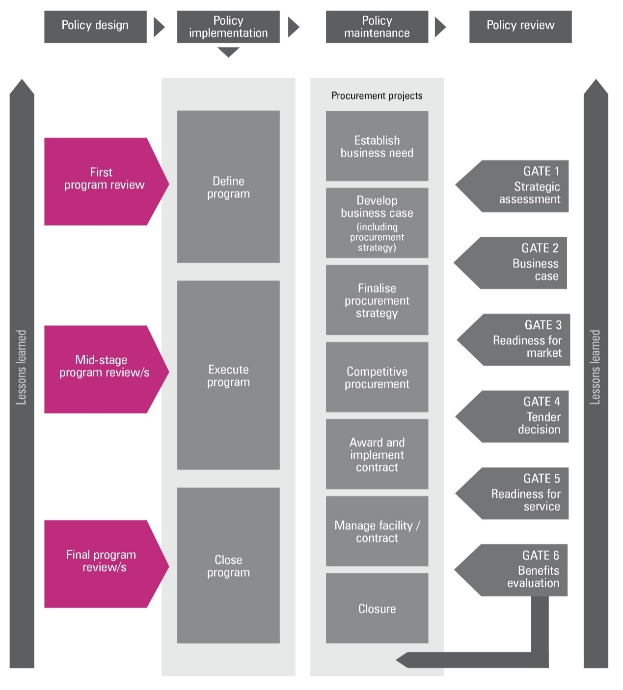
Figure 2: Applying the Gateway Review Process to different project delivery methods
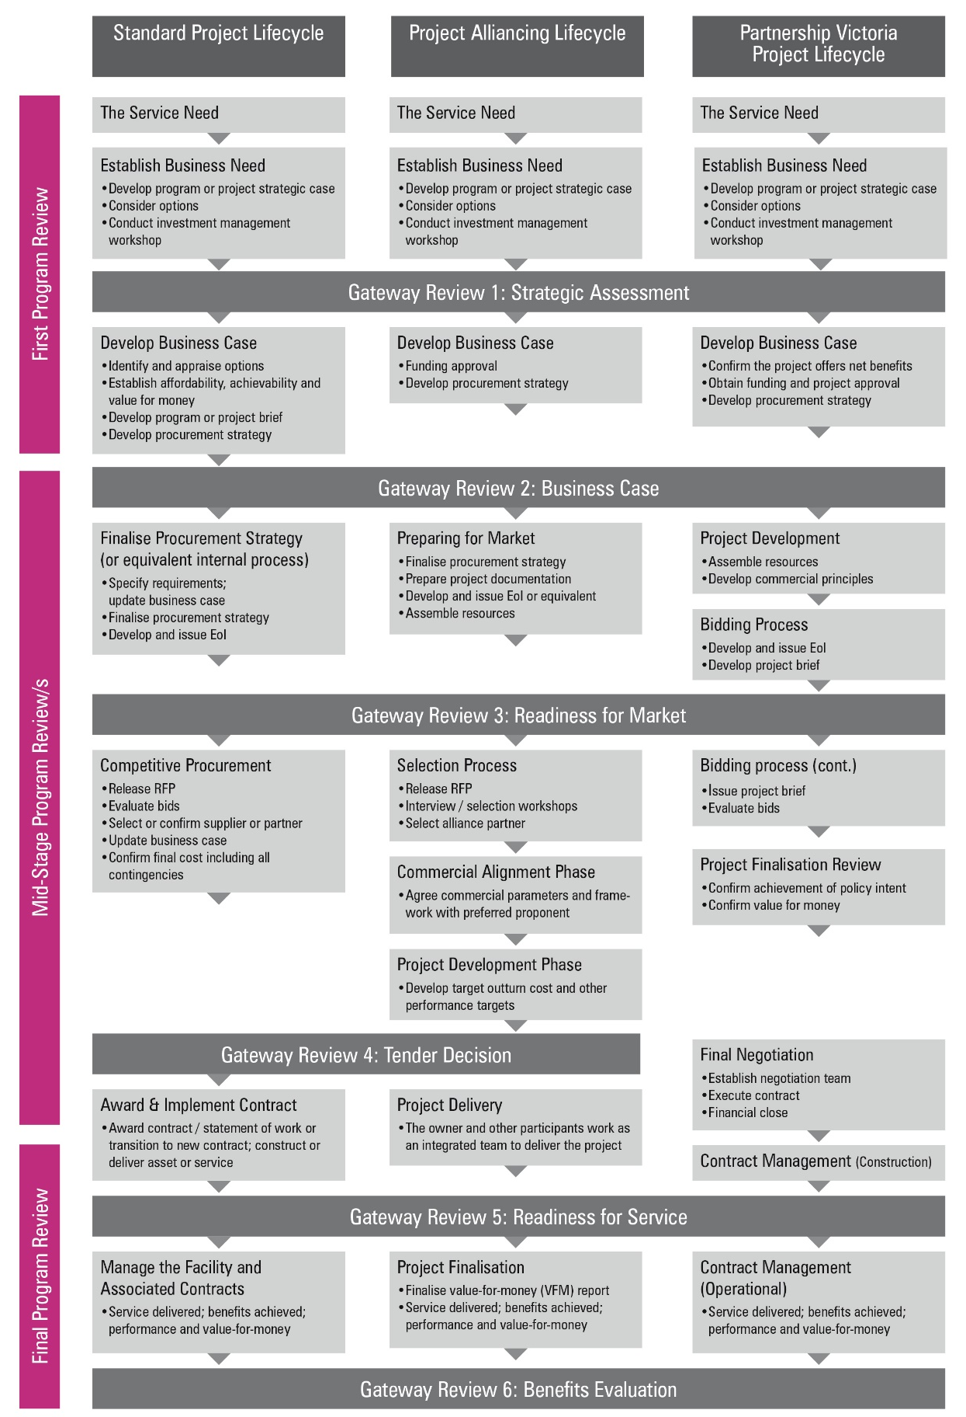

Gateway Program Review
The purpose of the program review is to:
- review the outcomes and objectives for the policy or program and their fit, confirm they contribute to the overall strategy of the organisation and its senior management and interface effectively with broader high level government policy objectives and initiatives;
- ensure the policy or program is supported by users and key stakeholders;
- confirm the program’s potential to succeed has been considered in the context of the organisation’s delivery plans and change programs and any interdependencies with other programs or projects in the organisation’s portfolio and those of other organisations;
- review the arrangements for leading, managing and monitoring the program as a whole and the links to individual parts, e.g. to any existing projects in the program’s portfolio;
- review the arrangements for identifying and managing the main program risks and the individual project risks, including external risks such as changing business priorities;
- check provision for financial and other resources has been made for the program and plans for the work to be done through to the next stage are realistic, properly resourced with sufficient people of appropriate experience and authority. This includes individual projects within a program;
- after the initial program review, check progress against plans and the expected achievement of outcomes, e.g. Investment Concept Brief and Investment Logic Map, Business Case and Benefits Management Plans;
- check the market is appropriately engaged with the feasibility of achieving the required outcome; and
- check the program takes account of integration with other internal and external programs.

Program documents
The areas of investigation and examples of evidence should be available before the Gateway Program Review starts. The information is likely to be found in the documents suggested below, but may be located in other program documents or elsewhere in the organisation’s documentation system:
- corporate and business plans, departmental objectives and government policy documents. This should set out the organisation’s strategy and policy objectives in relation to a set of public services or explain the objectives of the organisation’s change agenda;
- investment concept brief and investment logic map;
- any relevant service level agreements and associated targets and delivery plans;
- a program brief or program business case. This document will be loosely formed at the outset and developed over the life of the program. It should provide progressively more detailed information about:
  - objectives: a description of the purposes, outcomes sought, key deliverables and timescales plus the main success criteria against which the program will be measured;
  - background: outline of the key drivers for the program, showing how it will contribute to policy outcomes or the organisational business strategy;
  - a model of the intended outcome(s) as a vision of the future and how the vision will be delivered through the organisation(s) involved, delivery agents, new services, etc.;
  - scope: the boundaries of the program;
  - the required benefits from the program: these will be elaborated in a benefit profile for each defined benefit, covering a description of the benefit, when it will be realised and the measures and performance indicators that will be used to assess achievement levels and their costs;
  - the main assumptions and constraints on which the program will be founded and dependencies with other programs or strategies;
  - stakeholders: a list of the key stakeholders and their role in the program, with a strategy and plan for communicating and engaging with them;
  - finance: the financial provision made for the program and its components;
  - organisation: the way in which the program is to be organised, led and linked to other related programs;
  - risks: the main risks so far identified, a strategy for managing them and need for any contingency arrangements;
  - issues: a strategy for capturing and resolving issues;
  - outcomes: a benefit management plan with a strategy for measuring results and achieving outcomes; and
  - components: a list of the projects in the program’s portfolio and interdependencies that have to be delivered successfully if the program is to achieve its objectives and their current status.
- a plan covering the work to be done over the short to medium-term:
  - identifying the streams of work and sub-programs and the main deliverables and milestones for each one and the contribution each is to make to the program outcomes; and
  - resource estimates, e.g. funding for delivery bodies, people, systems.
    - Policy context and strategic fit
Areas to probe should be adjusted to reflect the timing of the program review.
How to use this section for:
Early program review | If this is very early in the program lifecycle, information may be uncertain because options are being explored for the way forward.  Strategic fit: there must be a demonstrable link to the organisational business strategy, i.e. why is this program needed?  Governance: the governance framework will be in outline, but there should already be a clear owner for the program.  Delivery: capability to deliver will be considered at a high level, ideally supported by estimates based on evidence from similar initiatives.  Lessons learned: there should be mechanisms in place to learn lessons regardless of the stage in the program lifecycle.  Risks: high-level risks should have been identified even at a very early stage.  At program initiation, all areas in this section will need thorough investigation as they provide the foundation for successful delivery.
Mid-stage program review | The focus on each area in this section is whether assumptions or circumstances have changed, e.g. a change in policy direction, continued availability of skilled resources.
Late program review | The critical area at the final stage is to confirm the link to business strategy is still robust and supported by senior management, e.g. ministers or the management board.

Areas to probe | Evidence expected
1.1 Is the policy or program innovative in planning to succeed? | - new approaches have been explored and existing systems challenged; and  - the project is structured to allow responsiveness and flexibility in achieving outcomes.
1.2 Does the program’s sponsoring group agree with the business strategy and is the strategy robust? | - a clear direction set out in the corporate and business plans, government policy documents or departmental objectives.
1.3 Does the program reflect the current business policy and environment and is it aligned with the business strategy? | - documents showing the sponsoring group e.g. Ministers or the board, have agreed to the scope of the program and its alignment with policy objectives, organisational strategy and/or change priorities; and  - where there are significant changes in policy priorities, in stakeholders’ views, or the key objectives, details of a re-appraisal of the program.
1.4 Is the governance framework fit for purpose and is there commitment to key roles and responsibilities for this policy or program within current corporate priorities? | - a commitment from the sponsoring group, e.g. management, key partners and Ministers, a willingness to take ownership, and a clear understanding of their roles in achieving successful outcomes; and  - key roles identified and assigned, e.g. responsible Minister, SRO, program director, program manager, business change manager and sub-program and/or project managers with named individuals with responsibility for the transition to new ways of working.
1.5 Does the project, program or policy require new governance arrangements e.g. cross-portfolio? | - for cross-portfolio policy or programs, evidence all parties involved know how they are engaged in the policy or program and are committed to its delivery; and  - clear governance arrangements to ensure sustainable alignment with the business objectives of all organisations involved.
1.6 Are the required skills and capabilities for this program available, taking account of the organisation’s current commitments and capacity to deliver? | - the organisation has brought together or plans to bring together the skills and capabilities it needs to plan and achieve the desired outcomes and has access to external sources of expertise;  - the team is realistic about the complexity of the changes and how they can be managed and can demonstrate learning from previous and/or other programs;  - key roles within the program are identified with named individuals;  - key individuals have an appropriate track record of successful delivery;  - the program has access to expertise which can benefit those fulfilling the requisite roles; and  - an appropriate allocation of key program or project roles between internal staff and consultants or contractors.
1.7 Is the organisation able to learn from experience with this and other policy or programs? | - the organisation has processes in place to incorporate lessons learned from this policy or program and its components into wider best practice; and  - the organisation learns from the experiences of others.
1.8 Is there a framework for managing issues and risk to this policy or program? | - defined roles, responsibilities and processes for managing issues and risk across the program, with clearly defined routes for bringing issues and risks to the attention of senior management.
    - Business case and stakeholders
Areas to probe should be adjusted to reflect the timing of the program review. How to use this section for:
Early program review | There must be a clear understanding of the outcomes needed from the program from the early stages, even though the overall scope and way forward may not be clear.  The measures of success will be in the outline.  Key stakeholders should already have been identified, especially for cross-cutting programs.  The components of the program, sub-programs and projects and their resource requirements will not be certain at this stage.  There should be early indicators of the additional factors affecting success, which will vary significantly depending on the program.  Program controls will not have been established in detail.  At program initiation, all areas in this section will require thorough investigation.
Mid-stage program review | Assumptions will need to be revisited, in particular:  - whether stakeholders remain supportive;  - whether the program is still affordable;  - management of issues relating to additional factors that could affect success; and  - the effectiveness of program controls.
Late program review | The main areas to investigate are continued clarity of understanding about the required program outcomes and stakeholder support as the program closes.

Areas to probe | Evidence expected
2.1 Is there a clear understanding of the outcomes to be delivered by the policy or program, are they sound, is there a robust investment concept brief and investment logic map? | - a description of the program’s business or policy drivers and objectives and how they contribute to the overall objectives of senior management for a particular service or the organisation’s change agenda;  - an outline of the required outputs or outcomes and their relationship to each other;  - a definition of the benefit profiles for the program for each of the benefits expected;  - evidence that the way forward is likely to achieve the intended outcome;  - for policy implementation, a rationale and objectives statement, appraisal of options and evaluation plan for the option being pursued, and  - a description of the link to government performance and delivery targets and/or senior management commitments.
2.2 Does the policy or program demonstrate a clear link with wider government objectives? | - an analysis to show the program’s relationship to relevant government policies;  - account has been taken of relevant impact assessment and appraisal issues such as regulatory impact, sustainable development and environmental appraisal; and  - a demonstrated link between strategic objectives and outcomes and the program deliverables.
2.3 Is there an understanding of the scope of the policy or program? Does it overlap or interface with other internal or external policies or programs? | - a description of the program scope to date; and  - details of any overlap or link with existing internal or external programs or policies.
2.4 What will constitute success? | - a definition of key critical success factors and how the required quality of performance will be measured;  - a description of main outcomes and an analysis of the leading and lagging indicators;  - the relationship between program outcomes and government targets, or major policy initiatives;  - projected performance over the life of the program with key performance targets and measures agreed with stakeholders; and  - the program can be evaluated in a practical and affordable way.
2.5 Who are the stakeholders, and do they support the program? How are they being engaged? | - a list of key stakeholders and statements of their needs and support for the program;  - a plan for communicating with and involving stakeholders and securing common understanding and agreement;  - for cross-portfolio policies or programs, clear lines of accountability to resolve any conflict with stakeholder requirements; and  - a recognition of the need to involve external delivery partners and industry and the supply side.
2.6 What are the component projects and sub-programs, and why is it structured in this way? | - a description of program strands and/or sub-programs and main projects with an explanation of how each will contribute to the required outcomes; key deliverables and the identification of key interdependencies; and  - implementation will be broken up into manageable steps and phased delivery where appropriate and avoid ‘big bang’ approaches.
2.7 Is the proposed program affordable? | - an estimate of the program cost based on previous experience and/or a comparison with other similar programs, broken down by program strands and/or sub-programs and main projects;  - the available funds identified and methods of securing additional necessary funding determined;  - a provision in the current spending review allocation including an allowance for risk; and  - market soundings and an assessment of likely cost profiles.
2.8 What are the additional factors that could affect success? | - the main risks identified at the outset with nominated risk owners, options for mitigating these risks considered, and the need for contingency and business continuity plans recognised;  - a description of dependencies and/or other factors and/or programs already under way that could affect the outcomes of the program;  - engagement with delivery chains and/or the market to determine capability to meet the need and to identify suitable options for delivery;  - where suppliers and/or partners are already in place, evidence of their ability to deliver has been considered; and  - the legal framework for the program and its projects exists, is comprehensive and sound.
2.9 Have program controls been determined, especially where constituent projects will join other organisations? | - a definition of overall program controls such as progress tracking, risk management, issue identification and resolution, and impact assessment;  - interdependencies between other programs and projects defined, with high-level plans for managing them;  - for collaborative programs, accountabilities and governance arrangements for different organisations defined and agreed; and  - processes to manage and record key program information and decision making.
2.10 Has a delivery strategy been developed? | - an analysis of delivery options; and  - the parties in the delivery chain are identified and an approach for working together established.

    - Management of intended outcomes
Areas to probe should be adjusted to reflect the timing of the program review.
How to use this section for:
Early program review | If the first review is very early, the key aspects to investigate in depth are:  - the main outcomes identified; and  - the relationships between the outcomes.  Plans for achieving the outcomes are likely to be unclear at an early stage. There should be evidence of high-level plans for the way forward or a set of options for consideration, with a preferred option identified. There should also be a reasonably clear indication of how success will be measured, e.g. a trajectory for take-up of a service.  At program initiation, all areas must be investigated in depth to confirm expectations for delivery are realistic and performance can be measured with reasonable accuracy.
Mid-stage program reviews | The main focus of the mid-stage review is to check plans for delivery of outcomes remain achievable.
Late program review | The topics in this section may not need to be covered at program closure.

Areas to probe | Evidence expected
3.1 Have the main outcomes been identified? | - a current list of the main outcomes and desired benefits; and  - links to strategic outcomes and the deliverables from specific projects.
3.2 Are the planned outcomes still achievable, or have any changes in scope, relationship or value been properly agreed and has the business case been reviewed? Is the policy program time critical? | - the outcomes and their relationship to each other identified;  - credible plans for the achievement of the outcomes; and  - an ongoing commitment from stakeholders to the outcomes and their achievement.
3.3 Are key stakeholders confident that outcomes will be achieved when expected? Is it on track to deliver? | - a confirmation that planned outcomes have been achieved to date;  - mechanisms for collecting performance data are in place and a plan for evaluating the impact of the program is in operation;  - a program board, i.e. a steering committee, program coordination group or equivalent, is confident that planned milestones will result in good quality deliverables and the desired outcomes; and  - commitment from key stakeholders that program deliverables will achieve the desired outcomes.
3.4 Is there a plan for achieving the required outcomes? | - a benefits management strategy and a plan to ensure outcomes are delivered in terms of performance measures and/or key performance indicators;  - plans to identify appropriate baseline measures to assess future performance;  - plans to carry out performance measurement against the defined measures and indicators;  - where planned outcomes have not been achieved, the problems have been identified and plans are in place to resolve them; and  - clarity on how the objectives from the sub-programs and/or projects link to the outcomes of the program.

    - Risk management
Areas to probe should be adjusted to reflect the timing of the program review.
How to use this section for:
Early program review | If the first review is very early, the major risks must be identified at a high level with an indication of how they will be managed and initial consideration of the requirements for contingency plans.  At program initiation all aspects of risk management must be probed in depth.
Mid-stage program reviews | The focus is on checking that risk management is effective.
Late program review | The status of the risk register at program closure will be the principal area to investigate and will consider which risks have now been removed and which will be transferred to the risk register for a new initiative or corporate risk log.

Areas to probe | Evidence expected
4.1 Have the major risks been identified? | - current list of major strategic, political and/or reputation and legislative risks to the overall program analysed by likelihood and impact;  - identified early warning indicators;  - the risks of success, e.g. take-up or greater than expected usage, have been considered and contingencies identified; and  - a regular review of risks, mitigation options and contingency plans.
4.2 How will risks be managed? | - an identification of a governance framework and procedures for risk management in the program and allocation of responsibilities;  - details of the risk allocation with high level plans for managing them;  - action to manage the risks identified and action taken; and  - details of the escalation procedures.
4.3 Have assurance measures for the program been put in place? | - critical friends to the program (e.g. internal audit, procurement specialists and/or peer reviewers co-opted onto the program board) are appointed that challenge assumptions, decisions and risks;  - Gateway reviews, health checks and/or policy reviews are incorporated into the plans;  - review recommendations are turned into action plans;  - advice from critical friends is acted upon;  - an audit arranging for complementary assurance about control and processes from audit functions through the delivery chain;  - the program is subject to the organisation’s assurance framework for its portfolio of programs and projects; and  - market and/or supply considerations are understood and acted upon.
4.4 Is there a contingency plan and business continuity plans? | - decisions about contingency and business continuity arrangements made with appropriate plans;  - the program’s effects on public services are analysed and decisions taken about those for which contingency arrangements will be needed; and  - milestones relating to contingency measures are in the plans and the milestones are being achieved as expected.
4.5 Have lessons from similar programs been considered? | - details of applicable issues identified from previous similar programs are considered in the current program.

    - Review of current outcomes
Areas to probe should be adjusted to reflect the timing of the program review.
How to use this section for:
Early program review | This section would not normally apply but some of the topics may need to be considered.
Mid-stage program review | All areas need to be investigated in depth to confirm the program remains on track and issues are being managed effectively.
Late program review | Confirm the expected outcomes have been achieved and no outstanding issues remain.

Areas to probe | Evidence expected
5.1 Does the program need to comply with broader government or departmental timing requirements? | - timelines for processes are identified and lead times are factored into the program schedule.
5.2 Is the program on track in relation to planning and/or delivery? | - the program report and plan are updated;  - milestones are achieved as planned;  - the plan for benefits measurement and achievement is on track;  - the risk register is current;  - there are highlight reports for constituent work streams;  - the resources and funding used to date;  - issues being resolved;  - confidence from delivery partners that future milestones and plans are realistic; and  - interdependencies with other programs are being managed.
5.3 Have problems occurred and if so, how have they been resolved? | - issues documented with details of action taken;  - governance framework with escalation routes to senior management;  - the program plan is updated to reflect changing issues and risks; and  - recommendations from previous Gateway Reviews are actioned.
5.4 Have options for potential ways forward been identified? | - documentation of various solutions including policy, asset and non-asset options;  - a comparison of retention maintenance and replacement indicative costs; and  - an options analysis or feasibility studies that may or may not be available at this stage.

    - Readiness for next phase
Areas to probe should be adjusted to reflect the timing of the program review. How to use this section for:
Early program review | This review would examine planned steps to program initiation, all areas would apply to strategic thinking and scope.
Mid-stage program reviews | All areas should be probed in-depth with the focus on ensuring everything is in place to start delivering the required outcomes.
Late program review | This section would not normally apply at program closure but some of the topics may need to be considered.

Areas to probe | Evidence expected
6.1 Is there a continuing need for the program? | - the desired outcomes of the program remain aligned to the organisational strategy;  - continuing commitment from stakeholders;  - the program is organised to deliver the outcomes when needed; and  - the program brief or program business case has been updated and remains valid.
6.2 What assumptions have been made about the program? | - a list of major assumptions made in preparing the program brief, updated to reflect any changes that could affect success and current assessments of the validity of all assumptions.
6.3 How will change be managed? | - plans for managing the transition to new ways of working and/or structures and/or policies, with any key barriers identified and the approach to overcoming them agreed.
6.4 Affordability: Are the funds to reach the next phase available? | - the budget provision for the program; and  - adequate approaches for estimation, monitoring and controlling the expenditure on the program.
6.5 Are the required internal or external individuals and organisations suitably skilled, available and committed to carrying out the work? | - information showing who needs to be involved, when and what they must deliver;  - identification of the key specialist and management skills required for the next phase of the program;  - key roles in place with skills matched to the nature of the work; and  - the resources will be available in the next phase.
6.6 Achievability: Are the plans for the next phase realistic? | - a plan showing:  - streams of work such as sub-programs and projects;  - deliverables and/or milestones and the route map to achieve them;  - timescales;  - organisation;  - costs and resources;  - stakeholder involvement;  - risk management;  - benefits management; and  - the plan has been tested and found to be robust.
6.7 Are appropriate management controls in place? | - accountabilities allocated to SROs;  - program management controls and reporting mechanisms are defined and operational; and  - plans for ongoing management of the delivery chain are in place.
6.8 Where procurement is a part of the program, how is capability and capacity for acquisition to be managed? | - a procurement strategy is in place and evidence of its application to policy or program and its projects; and  - a market management plan in place demonstrating a good understanding of supply side capability and capacity.
- Is the business case established and being maintained? | - confirm a business case has been prepared and is current.
6.10 Is a benefit management plan active and are benefits being reported? | - confirm the benefit management strategy is complete with a method of reporting planned benefits.

Appendix A: Best practice sources
Source | Information
Investment management standard  See Investment management  https://www.dtf.vic.gov.au/infrastructure-investment/investment-management-standard | - investment management standards  - investment logic maps  - investment concept briefs  - benefit management plans
Investment lifecycle guidance  See lifecycle guidance  https://www.dtf.vic.gov.au/infrastructure-investment/investment-lifecycle-and-high-value-high-risk-guidelines | - business case development guidelines, including strategic assessment guidance  - procurement strategy guidelines  - project tendering guidelines  - risk management guidelines
Procurement advice, policy and guidelines  Victorian Government Purchasing Board  http://www.procurement.vic.gov.au/Home | - longer term contract management  - contract variations
https://www.infrastructure.gov.au/infrastructure/ngpd/index.aspx | - National guidelines for Infrastructure Projects
https://www.dtf.vic.gov.au/infrastructure-investment/public-private-partnerships | - Social Procurement Framework
https://www.dtf.vic.gov.au/public-construction-policy-and-resources/ministerial-directions-and-instructions-public-construction-procurement | - Ministerial Directions and instructions for Public Construction Procurement
https://www.dtf.vic.gov.au/infrastructure-investment/market-led-proposals | - Market-led proposals guideline
https://www.dtf.vic.gov.au/public-construction-policy-and-resources/ministerial-directions-and-instructions-public-construction-procurement | - Local Jobs First resources
PPP projects  For the National PPP policy and guidelines, see  - www.infrastructureaustralia.gov.au  Specific Partnerships Victoria requirements apply, see  - https://www.dtf.vic.gov.au/infrastructure-investment/public-private-partnerships | - contract management policy and guidance material
Project alliancing  See Project alliancing  - www.dtf.vic.gov.au | - Project Alliancing Practitioners Guide
Capital development guidelines  Department of Human Services  https://providers.dhhs.vic.gov.au/capital-development-guidelines-series-7 | - contract administration  - commissioning of facilities  - managing contract occupational health and safety
Asset lifecycle  Department of Education and Early Childhood Development  www.education.vic.gov.au | - operations and maintenance
Information and Communications Technology (ICT) projects  https://www.enterprisesolutions.vic.gov.au/  https://www.dtf.vic.gov.au/infrastructure-investment/high-value-high-risk-framework | - Guidance on High Value High Risk projects including ICT projects  - ICT-related strategy, standards, policies, project dashboard, and  - technical resources for whole of Victorian Government
Victorian Government asset management series  Department of Treasury and Finance  http://home.vicnet.net.au/~assetman | - further information about commissioning assets  - other general information
Gateway Review Process  See https://www.dtf.vic.gov.au/infrastructure-investment/gateway-review-process | - Gateway Guidance material  - Becoming a Gateway reviewer

