Guidance on the application of FRD 101 Application of Tiers of Australian Accounting Standards

Significant entity decision tree
The diagram below summaries the key criteria in determining whether an entity is defined as a ‘significant entity’ for tiered financial reporting purposes under FRD 101.
Decision Tree

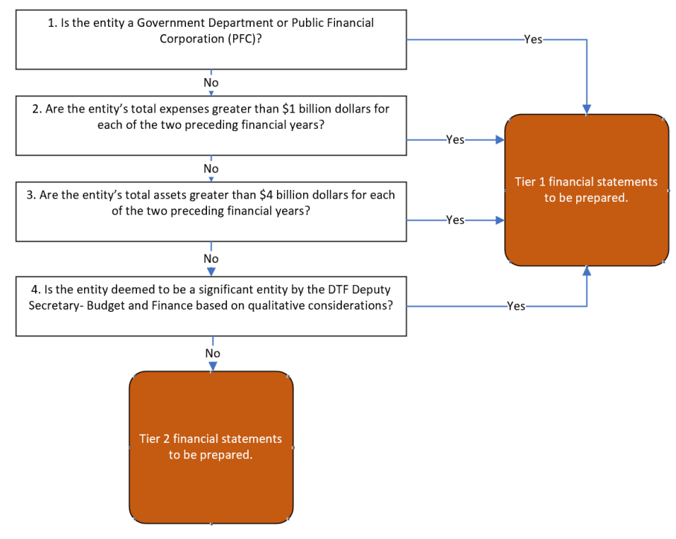

2. Significant entity list
List of significant entities as of May 2024
The table below sets out the public sector entities that are classified as a ‘significant entity’ under FRD 101 Application of Tiers of Australian Accounting Standards.
Entities are required to monitor their tiered reporting classification. This includes consulting with the DTF Principal Accounting Officer if an entity’s total expense or total asset thresholds change (or are expected to change) for two consecutive financial years impacting the entity’s significant entity status.
Entity Name | Government department or Public Financial Corporation? | Total expenses greater than $1 billion for the two preceding financial years? | Total assets greater than $4 billion for the two preceding financial years? | Deemed to be a significant entity based on qualitative consideration?
Government Departments
Department of Education | √ | √ | √
Department of Energy, Environment and Climate Action | √ | √ | √
Department of Families, Fairness and Housing | √ | √ | √
Department of Health | √ | √ | √
Department of Jobs, Skill, Industry and Regions | √ | √
Department of Justice and Community Safety | √ | √ | √
Department of Premier and Cabinet | √
Department of Transport and Planning | √ | √ | √
Department of Treasury and Finance | √ | √ | √
Department of Government Services | √
Public Financial Corporations
Transport Accident Commission | √ | √ | √
Treasury Corporation of Victoria | √ |  | √
Victorian Managed Insurance Authority | √
Victorian WorkCover Authority | √ | √ | √
Breakthrough Victoria Pty Ltd | √
State Trustees Limited | √
Victorian Fund Management Corporation | √
Health Portfolio Agencies
Eastern Health |  | √
Melbourne Health |  | √
Monash Health |  | √
Northern Health |  | √
Alfred Health |  | √
Ambulance Victoria |  | √
Austin Health |  | √
Barwon Health |  | √
The Royal Children’s Hospital |  | √
Western Health |  | √
Water Corporation
Goulburn-Murray Rural Water Corporation |  |  | √
Greater Western Water Corporation |  |  |  | √
Melbourne Water Corporation |  | √ | √
South East Water Corporation |  |  | √
Yarra Valley Water Corporation |  |  | √
Justice and Community Safety Agencies
Office of the Chief Commissioner of Police (Victoria Police) |  | √ | √
Victorian Gambling and Casino Control Commission |  | √
Victorian Legal Services Board |  |  | √
Fire Rescue Victoria |  | √
Transport and Planning Portfolio Agencies
Victorian Rail Track |  | √ | √
Suburban Rail Loop Authority |  |  |  | √
Northeast Link State Tolling Corporation |  |  |  | √
V-Line |  | √
Melbourne Port Lessor Pty Ltd |  |  | √
Creative Industries & Tourism Agencies
National Gallery of Victoria |  |  | √
Australian Grand Prix Corporation |  |  |  | √
Environmental Portfolio Agencies
Parks Victoria |  |  | √
State Electricity Commission |  |  |  | √

