This paper was prepared by Anglicare Victoria at the request of the Victorian Department of Treasury and Finance.
Anglicare Victoria (AV) would like to thank Sacred Heart Mission (SHM) and Melbourne City Mission (MCM) for their generosity in sharing their experience and contributing to the development of this paper.
AV also continues to be grateful for the support of the COMPASS investors who made this project possible, and to the fantastic team of staff across the two provider agencies that worked so diligently and passionately to deliver the program, in particular Amanda Stacey, Program Manager and Catherine James, General Manager.
Most of all, AV acknowledges that this program’s success is a reflection of the hard work and dedication of the young participants and their commitment to achieve.

Impact investment: The COMPASS experience

Introduction

In 2015, Anglicare Victoria, its partner agency VincentCare began development of the COMPASS program which was later to become one of the first two programs funded under the Partnerships Addressing Disadvantage initiative.
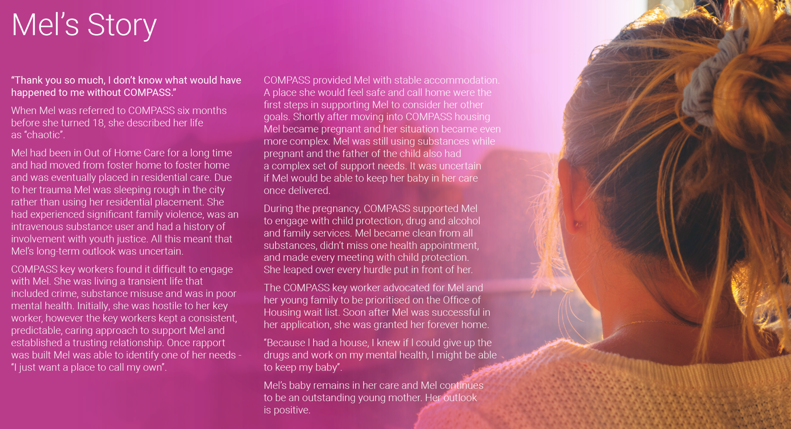
COMPASS was designed to deliver a cohesive package of personal support and accommodation in order to improve outcomes for younger people transitioning from Out of Home Care (OOHC). It was delivered by Compass Leaving Care Ltd – a registered charity jointly owned by Anglicare Victoria and VincentCare – and supported 195 participants between 2018 and 2023.
The first young people entered COMPASS in late 2018. Five years on, we have placed 182 young people through the COMPASS Leaving Care Program, and delivered a range of outcomes which are detailed in the annual Investor Reports available through the COMPASS website. The strength of the COMPASS model was recognised recently by the Victorian Government, which committed $32 million in the Victorian 2023-24 State Budget.
None of this would have been possible without the contribution of our COMPASS investor group, who made a commitment to risk their capital in order to test this innovative model in the Victorian context.
The final investor group comprised 55 separate entities, including philanthropic Trusts and self-managed super funds, including both independent investors and those who were supported by an investment advisor acting as an intermediary and those acting independently.
This paper documents Anglicare Victoria’s experiences as we ventured into the world of private investment seeking to identify investors who were willing to back these young people to succeed, and the various steps we took to secure the $14.3 million that we needed to begin.
Each project will be different, and the model we followed is simply one of many approaches to raising capital.
However, we hope that documenting our experiences might be of use to other organisations who which to work with impact investors to deliver better outcomes.

About COMPASS

The COMPASS program was designed in response to a clear, unmet need to provide better support for care leavers in Victoria.
Studies in Australia and overseas confirmed our own local experience: young care leavers experience significantly poorer outcomes than their peers across a number of areas.
Young people living in OOHC have experienced significant trauma and disruption in their lives, and often have little or no access to support from family, friendship circles and local communities. They are:
- more likely to be homeless;
- less likely to complete school beyond Year 10 or participate in further education;
- likely to be unemployed;
- more likely to experience poor health outcomes, including mental health;
- more likely to suffer harm associated with alcohol and other drug use; and
- more likely to be involved with the justice system.
As well as the personal cost to these young people, these outcomes represent a significant cost to the community. Preventative strategies are therefore crucial.
In 2018 in Victoria, formal State care currently ended at 18 years old – or earlier. Young people growing up in Out of Home Care (OOHC), began preparing to leave as early as 15 years old.
COMPASS was designed to improve outcomes by supporting young people to transition successfully from care and establish themselves in secure accommodation with the life skills and confidence to pursue their aspirations as young adults.
It combined access to secure housing with dedicated, personalised case management and access to additional specialist supports. Different levels and types of support and housing were provided, according to the young person’s needs.
The service model spanned housing and community services, and benefits would flow to a wide range of government portfolio areas. The opportunity to develop the project with an impact investment funding allowed the flexibility to innovate outside existing program boundaries, and to engage with government across program and Departmental boundaries.
Anglicare Victoria and VincentCare joined forces to create a special purpose entity – Compass Leaving Care Ltd to deliver the program.
Intake into the COMPASS program was staggered over approximately 3 years, with each person participating for 2 years (total program length of approximately 5 years, with performance monitored for an additional 2 years after conclusion).

The Investment opportunity
COMPASS was designed to generate variable financial returns for investors which are variable based on measured performance against the following 3 outcome measures:
- Housing (60% weighting): assessed by monitoring requests for emergency accommodation, measured 2 and 4 years after each participant commences the program;
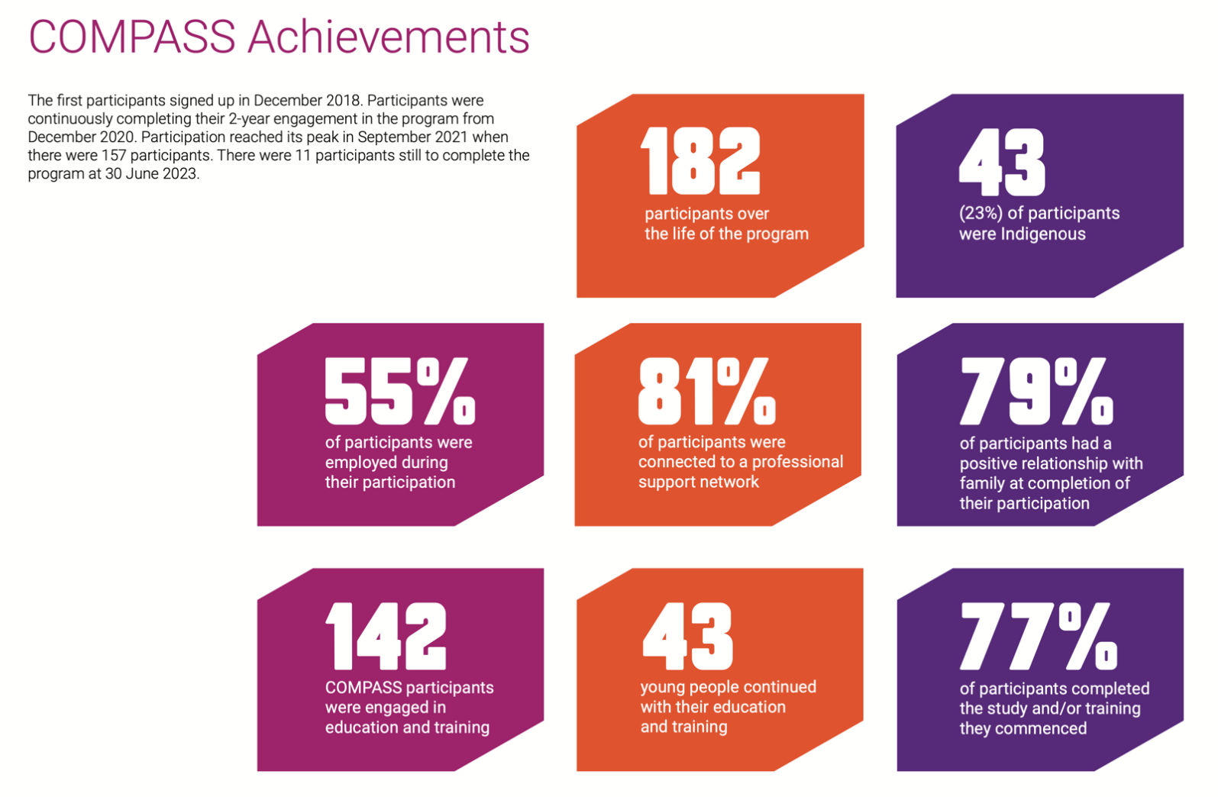
- Health (20% weighting): assessed by hospital emergency department presentations, measured 2 and 4 years after each participant commences the program; and
Source: Compass Annual Report 2023 (1)
Although the terms and conditions of the investment were confidential until the release of the Information Memorandum, the financial model was designed with the preferences of investors in mind, knowing that their support would be critical to success.
For example, our advice was that the investment would be more attractive to investors if it were able to generate a cash yield throughout its 7.5 year term. Accordingly, the financial model was developed to deliver returns throughout the life of the program, with fixed coupon payments delivered in the early stages of the SIB when results were not yet available.
The investment also included a property element, with net proceeds from selling the property portfolio after program closure also returned to investors.

- Justice (20% weighting): assessed by the number of recorded convictions, measured 4 years after each participant commences the program.
Performance was to be assessed by comparing the outcomes for COMPASS participants with a statistically matched, stratified control group of care leavers across the state. Outcomes for participants were assessed during their participation, as well as 2 year post- their participation, in order to assess sustained improvement.
Work began to raise $14.3 million in investment needed to establish and operate the program as soon as the Implementation Agreement between COMPASS and the Victorian Government was signed in February 2018.

KPMG consultants provided extensive support in the design and modelling of the financial model. We also drew on our own previous experience with donors and wealth managers.
Some investors have subsequently indicated that they would have welcomed an opportunity to be involved in the design of the program and its structure.
Though timelines precluded this option for COMPASS, other providers have successfully engaged investors early in the development stage.

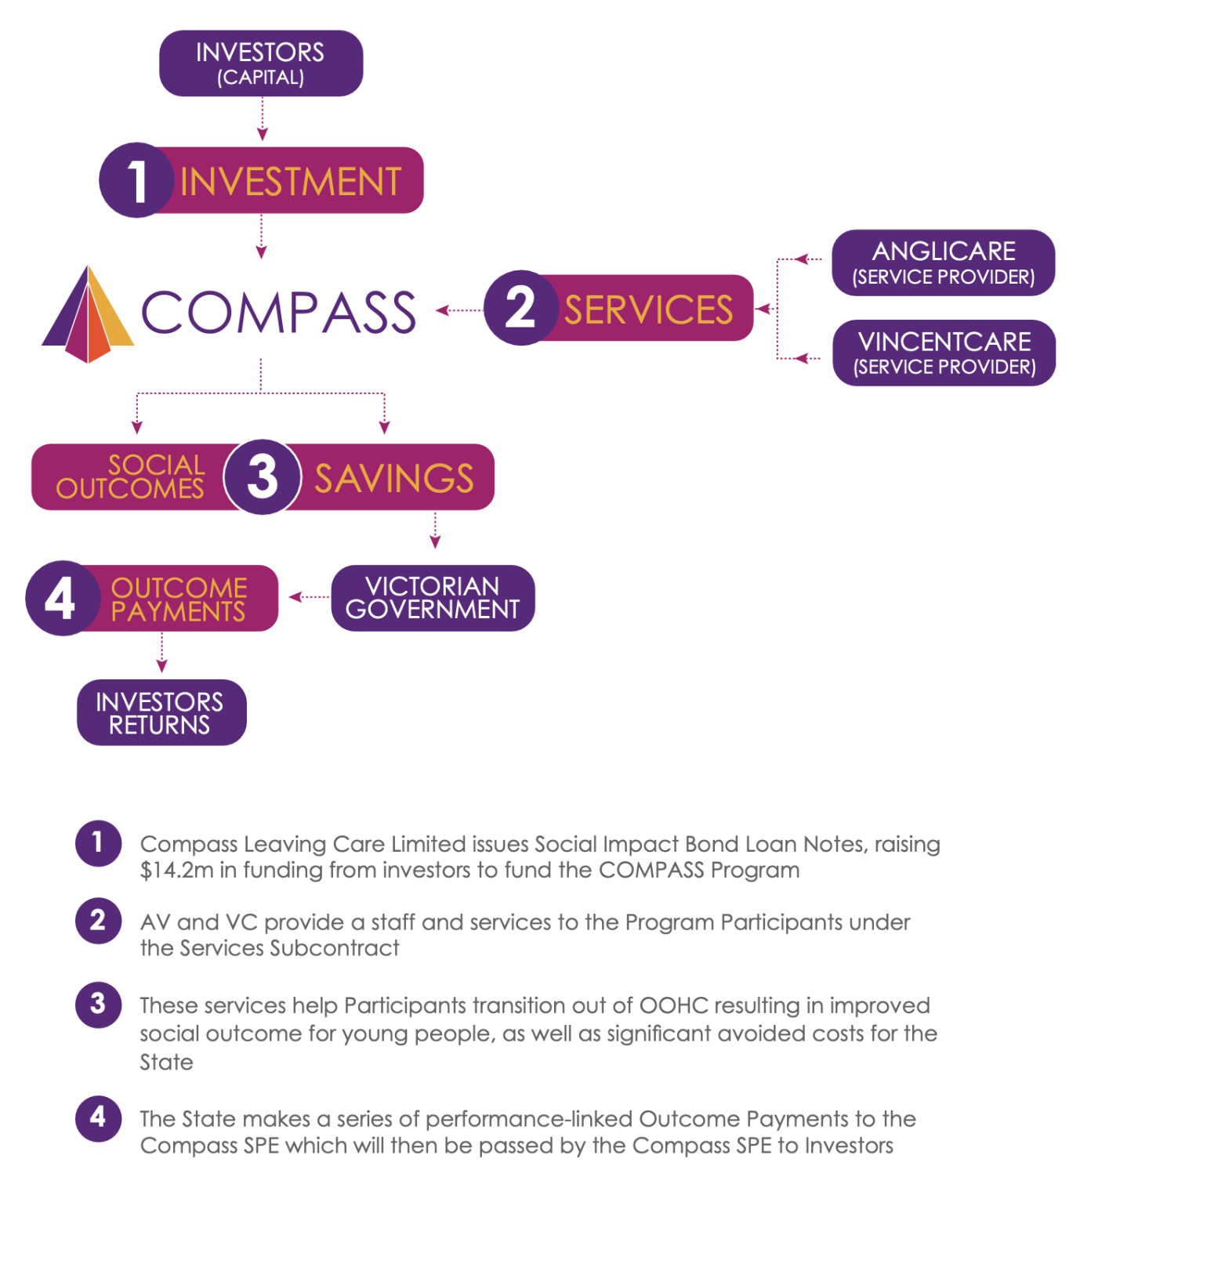

Source: COMPASS Information Memorandum (2)
For example, we understand that Melbourne City Mission (MCM) and Sacred Heart Mission (SHM) – with the support of impact investment advisors - worked closely with a small investor group of philanthropic funds to design the financial model for their Living Learning Program and Journey to Social Inclusion PADs which were variants on the traditional social impact bond structure (see pages 11 & 13).
Regardless of the approach, the objective is to arrive at a financial model that will attract impact investors and appropriately distribute financial risks and rewards, as discussed below.

Preparing the offer
Key Points
- Clearly articulate the need: Impact investors want to understand the positive difference their investment can make.
- Outline the evidence: Prospective investors may not be familiar with your target group, your methods or the language used in your field.
- Be transparent about the offer: Investors need to understand the nature of the offer and the distribution of risk.

An Information Memorandum (May 2018) was prepared to provide investors with the information they would need to assess the investment opportunity.
This contained information about the need for the program, the outcomes it sought to achieve, the rationale for the design, detail about how it would be delivered, and how the investment and financial model was structured.
It also provided information about key roles and responsibilities of the partner organisations and our experience and expertise.
Clearly defining and articulating the offer helps ensure that you are attracting the interest of the right investor group and allowing them to make an informed decision about their participation.

Transparency

Model
Our investors primary concern was whether the program would work – that is, would it deliver outcomes for the identified client group?
Providing information about the model and the evidence base and the underlying program logic was key.
In doing so, it is important to remember that the investment community you are working with may have limited prior knowledge of the client groups’ needs, the standards, methods and practice of service delivery.
Presenting the program logic and the underlying evidence base is therefore important so that investors can understand how the outcomes will be delivered, and explaining how the program will deliver change.

Performance & expectation
Establishing expectations about program outcomes that were both ambitious but realistic and grounded in evidence was important. This ensured that all parties were making informed decisions about the risks and the likelihood of success.

In the case of COMPASS, this was supported by detailed modelling by KPMG actuaries. This analysis utilised international evidence of comparable programs as well as linked local data to create a predictive model of what outcomes successful implementation could achieve.
This analysis was then applied to provide projections of the range of outcomes that we could reasonably expect to achieve – and informed government’s calculations of the impact savings that could be derived from avoided costs related to health, housing, justice and other service deliver costs.
The investor group was also keen to know that there was capacity to adjust the approach if opportunities to improve the result were identified.
This was also important information to ensure that AV, VincentCare and their respective Boards were able to make informed decisions about investment of their own organisations’ resources.
Including information about how the program would be evaluated and adjusted over time – above and beyond assessing the payable performance measures – was therefore welcome.

Financial modelling and transaction structure
The Information Memorandum (2) also outlined the nature of the investor’s contribution and the structure of the financial arrangement.
In the case of COMPASS, investors made a single investment which contributed to both operating expenses and the purchase of housing and received a blended return across the life of the project as well as the proceeds of any net capital increase in property value.
This is only one of a variety of ways that investor funds can support PADs. For example, SHM’s J2SI PAD involved one primary lender as well as philanthropic organisations who acted as guarantors. In the case of MCM’s Living Learning Program investors contributed both a philanthropic purpose specific grant and a second ‘at risk’ investment component which attracted performance-linked returns.
Clarity about the nature of the investor’s role will help them determine their interest and also inform their approach to due diligence and decision-making.
The Information Memorandum also showed how the performance of the program would translate into financial returns.
The returns payable across three different indicators at five different rates (compared to the defined control group): minimum, improved, good, very good, excellent and exceptional, and details about when each measurement point would occur.

Governance
The governance, organisational and management arrangements for COMPASS were also established and documented in advance and included in the initial Information Memorandum.
Investors were also advised of the governance arrangements for the bond, so they could be assured of appropriate oversight
In the case of COMPASS, the decision was made for Anglicare Victoria and VincentCare to establish a jointly owned special-purpose vehicle in order to deliver COMPASS. This provided assurance to the investor group that their funds would be quarantined for this purpose only and that that there would be audited accounts published according to the required annual schedule.
The creation of a special purpose entity offered investors protection against any potential or perceived conflict between the interests of COMPASS, AV and VincentCare as the contracted service delivery agencies. It also ensured continuity: in the unlikely event that AV or VincentCare could no longer participate, there was capacity for COMPASS to engage other service providers to deliver the program.

Risk
Key areas of risk were documented in the Information Memorandum, as required under disclosure rules.
This was important to ensure that investors were making an informed choice and understood the variables at play, including those over which the parties to the Agreement had limited control. For example, it was important to remind investors that although COMPASS included a capital component used to purchase accommodation, the real estate market would determine the price at which those properties were disposed of at the conclusion of the bond.
The Information Memorandum was also careful to document what areas of risk or information it did not address – for example, prospective investors were urged to seek their own independent tax advice.

Timing
Including information about program timing and commencement is important for investors to be able to complete their own financial projections.
This includes being transparent about any contingencies that may prevent the program from commencing (e.g. investment targets not being met) as intended, and how that will be managed.
This requires thorough planning for program implementation including staffing, budgeting, and accurately assessing the flow of program referral and intake, as with any funded program.
However, it also needs to factor in the time required for potential investors to conduct and complete their own due diligence and governance requirements.
For example, if a philanthropic Trust’s governance body requires advice from its finance committee before making investment, the process of reaching a determination may take some months to complete. Similarly, there may be constraints governing an entity’s investing cycle – e.g. two investment rounds per year.
This created some challenges for COMPASS fundraising, as the quick implementation schedule we established precluded some potential investors from participating. The nine months spent fundraising was too short a turn-around time for some interested parties.
In the case of COMPASS, there was limited opportunity to engage with the investment community about the investment in advance, as details about the structure and returns remained confidential until after the Implementation Agreement was signed.
Some investors have indicated that they would have appreciated greater involvement in the developmental stages of the project and its financial structure, rather than being presented with a pre-determined investment product. This approach may have the benefit of reducing the uncertainty associated with fund-raising after the agreement has been struck.

Balancing risk and reward
While our investor group were deeply committed
to achieving lasting outcomes for program participants, they were keen to ensure that the level of risk they carried was fair and proportionate.
In dealing fairly with our investor group, it was therefore important to discuss the potential risk as well as the potential reward and discuss any measures in place to manage those risks e.g. the arrangements in place to protect them from the impact of a change of government policy or commitment.
In determining the potential returns, and the fair distribution of risk between investors, government and providers, AV drew on specialist expert advice from KPMG and others.
The involvement of a well respected independent firm in developing the bond was a source of assurance to the investor group, especially those smaller investors who had less capability to carry out a thorough due diligence investigation.
Although the market has grown since the inception of COMPASS in 2018, impact investing in human services remains a small part of a competitive market. Structuring and describing the projects clearly and transparently is likely to continue to be vital in building investor confidence.

Finding our investors
COMPASS used a number of different approaches to identify potential investors. They were not a homogenous group. They included individuals, super funds, philanthropic Trusts and not-for-profit organisations, and so different methods were used to engage. In addition, investment advice services were important advisors and decision-makers for our investor group.

Finding potential investors
When the COMPASS Information Memorandum was first launched, it was one of the first two impact investment offered in partnership with the Victorian government (alongside SHM). There were examples in other States and although not all of these had been successful, the experience for investors had generally been positive as far as we knew.
However, the impact investment market – particularly for human services – is small and competitive. Impact investors may be reviewing products available from across Australia.
Identifying potential investors and securing investment can therefore be a challenge.
The strategies we used to promote COMPASS to potential investors included
- A launch event including speakers and an outline of the bond
- Direct mail Anglicare Victoria donors to advise them of the bond and offering to provide further information
- Established a website containing contact details and enabling download of basic information
- Briefed investment advisors with a demonstrate interest in our work and/or impact investing
- Directly contacted (cold calling) institutional investors with a public commitment to impact investing or a publicly promoted impact investing fund
- Directly contacted philanthropic Trusts with a mission or objective aligned with the COMPASS objectives.
Key Points
- Be prepared to respond promptly to very detailed questions and queries.
- Investment decisions take time – allow for potential investors’ meeting schedule.
- Investors are diverse and will have diverse interests and concerns.
- Investment advisors are key players in investors’ decision making.

Small investors
Our experience was that small investors such as smaller-scale philanthropic and family Trusts were more engaged and willing to take a risk in the interest of outcomes for clients – though other organisations have had more success in this respect.
Some of these investors had a long-standing personal interest in and commitment to the welfare of young people in care, and this group included individuals and Trusts with whom Anglicare Victoria had an established relationship.
For this group decision-making often involves a relatively small number of people, which means they can be nimbler and more responsive than a larger organisation (e.g. one with an investment committee with a fixed meeting schedule).
However, their financial commitment may be smaller than what a large organisation can provide, meaning more investors for the project to manage.

Large organisations
The involvement of large organisations such as well-established philanthropic Trusts or corporate impact investment funds has several potential advantages.
These may include
- The capacity to make large investments, thereby reducing the resources needed to identify and maintain investors
- The capacity to conduct comprehensive due diligence
- The ability to provide program promotion and attract other investors through their own involvement.
- A greater capacity to absorb financial risk
Most philanthropic organisations have governance meetings set according to a pre-determined schedule, and this will dictate the speed of decision making. Further it is likely that the investment committee will seek to consider a proposal at more than one meeting.
For example, in a Trust where the investment committee meets quarterly, they may ask for a briefing on the project in March, endorse undertaking a full due diligence in June, and consider an investment recommendation in September. AV was told by at least one potential investor that their organisation could not decide to commit funds to an innovative model such as this within our 9-10 month target timeframe.
A philanthropic Trust may seek to add value to your project by suggesting variations to the program, cohort or financial structure. This will generally only be possible early in the development process, and the knowledge and experience they offer can be very valuable in determining the approach.
It should be noted however, that any such modifications may impact on other investors and stakeholders and will have to be considered in light of any other pre-existing agreements.

The role of investment advisors
Investment advisors perform an important gate-keeping function in relation to the available pool of impact investing funds. A significant proportion of COMPASS’s 55 investors learned about the investment opportunity via investment advisors with whom they had a prior relationship.
One advisory firm that specialises in impact investing conducted thorough due diligence investigation into the COMPASS approach over a matter of months. Although responding to information requests took resources, this process resulted in an opportunity to present to a meeting to brief their advisor group. A number of their clients subsequently chose to invest. Our engagement with this company was rigorous,
time-consuming and very worthwhile.
Investment advisors have a keen awareness of investor sentiment, preferences and motivations. They may be able to provide some to provide general guidance in the formative stages of a proposal about what investors are and aren’t looking for.
However, their specific input will be limited by their professional obligation to remain independent in the advice they provide to their clients.

Key issues

Resourcing and availability
Organisations’ due diligence processes are detailed and time-constrained, and many queries will be unique, requiring a tailored response to ensure that the specific query is addressed. For example, one organisation submitted a list of nearly fifty detailed questions seeking further written information across all aspects of the proposal (operations, evidence, governance, financial modelling etc).
Providing a prompt and accurate response is important to decision-making and also demonstrates professionalism and command of the content to the potential investor.
Good record keeping will help ensure no queries are missed, as well as helping with workload and consistency of response.

Investing versus grant-making
The financial structure of the COMPASS offering was an investment with variable return (rather than a grant).
As a result, investment decisions were made by organisations’ Investment Committees rather than the grant-making bodies that AV would generally have more dealings with.
These two groups may have different skill sets and expertise and decision-making criteria. For example, an investment committee in a philanthropic Trust might be less informed about the circumstances and challenges of living in OOHC than their grant making colleagues, and more informed about financial modelling. This will influence the type and level of detail required in relation to both those areas.
Although they presented a very different financial model, this distinction also impacted SHM’s efforts (3) to secure guarantors and was identified as a barrier.
In the case of Melbourne City Mission’s (MCM) Living Learning program, investors’ interest included both a grant component and a performance-based investment component, each of which had to be treated and managed differently, as the requirements in terms of accountancy and tax treatment are different. MCM were supported by specialist impact investing financial advisors as well as the investor bodies themselves in developing the investment model.
MCM’s living learning program
The Living Learning Program was designed to deliver services that address barriers to personal and educational achievement.
The program targeted school leavers aged 15-21 who are experiencing mental health complexities and who are persistently not engaged in employment, education, or training.
Living Learning is an integrative program delivered by Melbourne City Mission (MCM) and their independent school Hester Hornbrook Academy (HHA), providing three years of wraparound support for young people in three cohorts of 48 participants, 144 students in total.
MCM developed the funding model in collaboration with a small group of major philanthropic investors. Acting as project partners, and leveraging their significant profile, the initial investors also helped MCM to secure the remainder of the funding required
Specialist impact investing advisors also assisted in developing the financial structure for the project.
The resulting financial model involved each investor playing a dual role of both philanthropic grant provider and impact investor.
Therefore, both the investment and grant-making functions of the participating organisations had an interest in the project.

Supporting innovation
As noted earlier, one of the important advantages of involving investors is that they can provide a unique “value-add” to create new opportunities and program elements that the other parties to the transaction cannot.
For example, the COMPASS investors provided a capital component to the program that provided capacity to increase housing supply for our cohort of clients. That would other would not have been possible.
MCM’s project included philanthropic grants contributing to the project, which reduced the ‘at risk’ component of funding that was needed.
In the case of J2SI, philanthropic organisations acted as guarantors for the main lender, thereby sharing some of the project risk and reducing the cost of capital, taking the investment cost from unsecured debt to secured debt. SHM also provided a first loss guarantee, reducing the risk for guarantors.
Sample transaction documents for the J2SI low cost debt and guarantor structure are available of the Department of Treasury and Finance website (6).

Source: Evaluation of the Living Learning PAD (5)

Securing and administering investment

The promotion and application process may be the first time that an investor has had any contact with your organisation.
Ensuring that there are robust systems in place for management and administration of the process will help establish confidence.
Examples include
- Establishing a dataset of contact details of interested parties
- Creating and registering the COMPASS special entity
- Securing a banker to collect and hold investments and to disburse performance payments
- Creating an application form for those wishing to invest, including key information legally required to assess eligibility
Organisations that offer specialist impact investing services can be engaged to assist with these administrative aspects.

Contractual arrangements
Depending on the financial structure of the bond, there will need to be some kind of contractual instrument in place to secure the roles and responsibilities of the respective parties, including how funds will be provided and repaid.
In the case of COMPASS, standard contracts were developed with the expert assistance of Corrs Chambers Westgarth.
Investors may wish to review the contract prior to reaching a decision, so this work will need to occur ahead of time. It is likely that government endorsement will also be required to ensure that the contracts appropriately reflect the terms and conditions of the Implementation Agreement.
There is also administrative work to ensure that the contracts are valid and properly executed e.g. collecting the documentary evidence that establishes that the person signing the contract is

Key Points
- Allocate resources for administration and ongoing investor engagement and include this cost in project budgets.

- Allow sufficient time for all parties to complete their due diligence and execute their decisions through their governance channels.
- Consider the engagement of legal and financial advice to ensure that arrangements are fair and sustainable.

authorised to do so on behalf of the entity concerned.

Banking
Banking services will be required for the execution of the financial arrangement with investors.
The nature of these services will depend on the structure of the PAD.
In the case of COMPASS, there were multiple investors and a number of specified payment points, so it was important that a process for authorising and implementing payments was in place.
This included establishing a ‘holding’ account which could be used for investors to place an initial deposit to secure their investment. This provided an additional level of assurance to investors, as funds were transferred into the control of COMPASS only when the full investment had been secured and implementation commenced.

Data access and monitoring
Ongoing data access and monitoring will be key to assessing the performance of the program and it is important to have clear undertakings in place about the timely provision and use of data. In the case of COMPASS, this involved analysis and cross-referencing of data across a number of datasets, administered by different government agencies.
Given the long term nature of these projects, it is important to have the data requirements and methods of calculation carefully documented to ensure that data remains available throughout the monitoring period.
The role of impact investment specialists
There are now a number of companies who specialise in helping CSOs to develop, package and present impact investment to the market, and can assist with legal and financial administration.
They have experience of impact measurement and may also act as advisors during negotiations with government.
Engaging these companies can have the benefit of allowing the CSO and its partners to focus on the program and delivering the outcomes. As with any other business agreement, being clear on roles, responsibilities and expectations is key.
The engagement of advisors does not remove the normal obligations of management and Board to exercise their due diligence.
This includes making a judgement about how the costs of the engagement will be met and making appropriate allowance for it in the project budget.

Independent review
Investors have a direct interest in ensuring that their investment’s performance is fairly assessed and that they receive any payments to which they are entitled under their agreement.
Establishing a form of independent review which can be influenced by neither government nor provider is one way to offer this assurance.
In the case of COMPASS this took the form on engaging a firm (with no other involvement with the parties) to act as “Independent Certifier”.
The approach agreed with this body will also need to comply with privacy legislation and include any necessary protections against release of personal information or protected government data.
Sacred heart mission’s J2Si
Sacred Heart Mission’s (SHM’s) Journey to Social Inclusion (J2SI) was Program designed to support people to break the cycle of chronic homelessness. J2SI is a three-year program for people providing:
1. Assertive case management and service coordination
2. Rapid access to housing and support to maintain tenancy
3. Trauma-informed care in recognition of the events that have shaped people’s lives
4. Progressive skills development for social and economic inclusion
5. The capacity for self-management and independent living
J2SI program had been delivered on two previous occasions. The 2018 iteration, supporting 180 people over 5 years, was delivered as one of the Victorian Government’s first initiatives (alongside COMPASS) in what is now known as the Partnerships Against Disadvantage (PAD) initiative.
The program used an innovative finance model with Victorian Government funding and low-cost debt from the Catholic Development Fund (CDF). In addition, philanthropic guarantees were provided by NAB Foundation, William Buckland Foundation, Orcadia Foundation and Robert & Irene Gilbert, lowering the cost of capital.
This was the first time a philanthropic guarantee had been included in a pay-for-performance social impact investment in Australia.

(Source: Centre for Social Impact, nab (3) & (4)

Source: Centre for Social Impact, nab (4) & (3)

Investors as project partners

Engagement
There is no doubt that the COMPASS investor group were primarily concerned with the intent and purpose of the program to deliver positive outcomes for young people.
The value they sought was a sense of contribution to developing an effective approach to address a pressing concern and were willing to take a financial risk to do so.
All communication about the program and its participants was warmly welcomed by this group, especially where personal narratives of participants experience were included.
Accurate, timely and detailed information about the investment and its performance is also very important and will be needed by investors to ensure that they can manage their own financial obligations (including compliance with taxation laws).
As our investor group was large, we engaged through a number of means
- Annual reports detailing progress, available data in relation to outcomes, and (de-identified) personal narratives of program participants.
- Annual investor meetings that provided an opportunity for investors and other interested parties to hear first-hand from the COMPASS team and raise any queries. In most cases, some COMPASS participants also volunteered to attend and speak with the group (with support of the team), which was warmly welcomed.

- Personal correspondence detailing any significant news or change in regard to the program.
- Regular correspondence detailing performance and financial outcomes for each investor at designated payment points.
- News relevant to policy development in relation to the target cohort group (see below).

In addition, the COMPASS General Manager remained available to personally respond to queries from investors and their representatives throughout the life of the program.
Key Points
- Keep investors informed – they are invested in the outcome as well as the financial return.

- Provide different approaches and opportunities to cater to the differing needs of your investor group.

Confidentiality
Philanthropic Trusts and similar institutional investors will often have a high degree of transparency about the investments they make and may be valuable partners in promoting the program to other potential investors.
Conversely, the COMPASS experience is that many of our smaller investors preferred to keep their financial affairs private and did not wish their investment to be publicised.
Some investors preferred that all engagement with the program was managed via their financial advisors, rather than personal contact. Others were frequently in touch with the team with queries or interested in an update.
In acknowledging the vital contribution of investors, it is important to understand each investor’s position and ensure that public information and promotion materials does not contain any information about investors that they would prefer did not enter the public domain.

Demonstrating impact

Program
Any information about the COMPASS program and its performance was warmly welcomed by our investor group. This included but was not limited to the mandatory information that accompanied the financial transactions.
Types of program information that investors were interested in - above and beyond the payment-linked performance metrics – included implementation updates (rate of referrals, number of participants etc.), information about the COMPASS team and the way they work and outcomes and evaluations
For example, although participation in education and employment was not a measurable outcome,
it was a key result area that COMPASS and its investors monitored closely and reported on.

Policy
Developing innovative solutions to entrenched social problems is one of the commonly cited objectives of impact investing projects such as the Partnerships Addressing Disadvantage.

In considering the COMPASS investment, the intent was to test and trial an approach to improving outcomes for care leavers while at the same time avoiding costs to government.

Being involved in lasting reform was a key motivator for our investor group, and many asked about the mechanism for translating this project into ongoing policy change during their due diligence process. News about the policy impact is therefore also important to investors.

Investors (which included many interstate) warmly welcomed the announcement of $33 million to support a Housing-first approach for young care leavers in Victoria, modelled on the COMPASS
approach (7).

Personal
Overwhelmingly, personal stories from participants have been the type of information that COMPASS investors have valued most.

Each project investor has chosen to take a financial risk in the hope of delivering real and sustainable change, and to offer support to young people at risk.

The opportunity to hear from young people stepping into their adulthood safe, confident and empowered was the most positive result they could hope for.

Works Cited
1. Compass Leaving Care Ltd. Annual Report 2023. Melbourne : Anglicare Victoria, 2023.
2. Anglicare Victoria. COMPASS Information Memorandum. Melbourne : Anglicare Victoria, 2018.
3. Moran, M, Ward-Christie, L and Muir, K. Journey to Social Inclusison: A case study on the J2SI Impact Investment Transaction. 2019.
4. Centre for Social Impact. Journey to Social Incluision: A case study summary of the J2SI Impact Investment Transaction. National Australia Bank. [Online] 2019. [Cited: 1 May 2024.] https://www.nab.com.au/content/dam/nabrwd/documents/pds/social-impact/nab-journey-to-social-inclusion-case-study-2019-summary.pdf.
5. Urbis. Evaluation of the Living Learning Partnership Addressing Disadvantage - Interim Report. Dtf.vic.gov.au. [Online] May 2023. [Cited: 3 May 2024.] https://www.dtf.vic.gov.au/sites/default/files/document/Evaluation%20of%20the%20Living%20Learning%20Partnership%20Addressing%20Disadvantage%20-%20Interim%20Report.pdf.
6. Department of Treasury and Finance. Tools and Resources. Department of Treasury and Finance Victoria. [Online] dtf.vic gov.au.
7. Department of Treasury and Finance. Doing What Matters: Service Delivery, Buidget paper No. 3. Department of Treasury and Finance Victoria. [Online] dtf.vic gov.au.

https://compassleavingcare.org.au
As a result of the national Home Stretch campaign, care leavers now have the option to remain in the care up to the age of 21.

