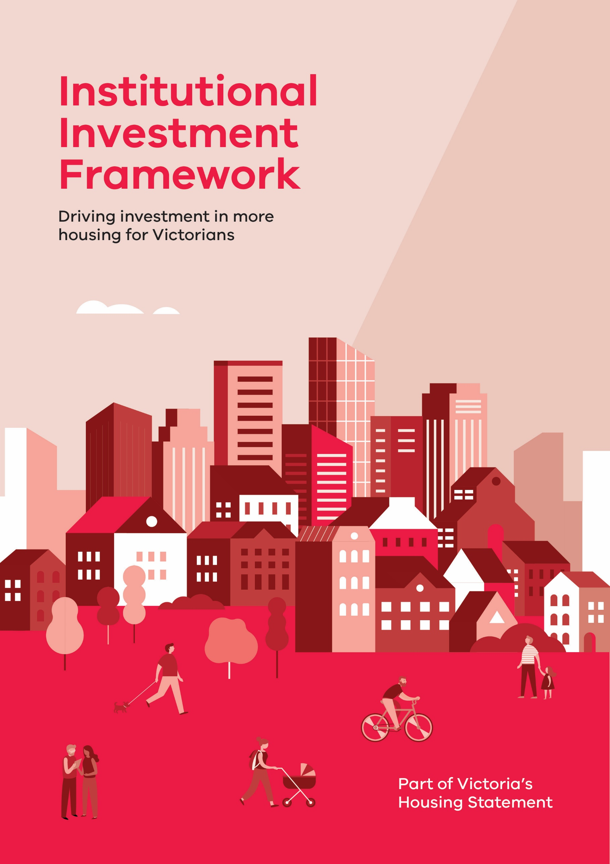

ACKNOWLEDGEMENT   
OF COUNTRY

The Victorian Department of Treasury and Finance acknowledges that Aboriginal and Torres Strait Islander peoples are the First Peoples and Traditional Custodians of Australia, and the oldest continuing culture in human history. We proudly acknowledge Victoria’s Aboriginal communities and recognise the value and ongoing contribution of Aboriginal people and communities to Victorian life. We pay our respect to Elders past and present and emerging.

As we work to ensure Victorian Aboriginal communities continue to thrive, the Government acknowledges the invaluable contributions of generations that have come before us, who have fought tirelessly for the rights of their people and communities towards self-determination. We reflect on the continuing impact of government policies and practices and recognise our responsibility to work together with and for Aboriginal and Torres Strait Islander peoples towards improved cultural, social and economic outcomes.

Aboriginal artwork ‘lim-ba nindee thana warn-ga-ilee’ (Preserve our Dreaming Lore) – Gunnai Language


*‘lim-ba nindee thana warn-ga-ilee’   
(Preserve our Dreaming Lore) – Gunnai Language*

*Bitja (Dixon Patten Jnr) Yorta Yorta, Gunnai,   
Gunditjmara and Dhudhuroa of Bayila Creative*

Authorised by the Victorian Government  
1 Treasury Place, Melbourne 3002

© State of Victoria (Department of Treasury and Finance) 2024



[](http://creativecommons.org/licenses/by/3.0/au/)

You are free to reuse this work under a [Creative Commons Attribution 4.0 licence](http://creativecommons.org/licenses/by/4.0/) International Licence provided you credit the State of Victoria (Department of Treasury and Finance) as author, indicate if changes were made and comply with the other licence terms.

The licence does not apply to any third party material, images or branding, including the Victorian Coat of Arms and government logos.

**Disclaimer**

This publication may be of assistance to you, but the State of Victoria and its employees do not guarantee that the publication is without flaw of any kind or is wholly appropriate for your particular purposes and therefore disclaims all liability for any error, loss or other consequence that may arise from you relying on any information in this publication.



Foreword

All Victorians deserve a home, a place of pride, comfort and security, whether they are renting or owning. We need to build more homes that cater to a wide range of housing needs to make housing more affordable. That is why the Victorian Government has launched the [*Housing Statement*](https://www.vic.gov.au/housing-statement)to tackle the root cause of housing affordability: housing supply.

To boost supply, the Victorian Government announced the **Institutional Investment Framework** as part of our *Housing Statement,* to support the Statement’s ambitious target to build 800,000 homes in Victoria over the next decade.

The Framework brings together supports and partnership opportunities designed to make it easier to build more housing for Victorians. It simplifies approval processes for institutional investors, developers, and key industry players.

Our goal is to foster the conditions needed to stimulate investment into more social, affordable, key worker and market housing at scale, and to help industry build more high‑quality homes faster in places where Victorians want to live.

We invite institutional investors, developers, local government, land holders and the community housing sector to work with the Government on innovative and sustainable housing solutions for the future. These efforts align with the National Housing Accord which recognises institutional investment as a key element for unlocking housing supply.

Together, we will open up more opportunities for Victorians to have a   
safe and secure place that they call home.

Tim Pallas  
Treasurer of Victoria

Opening the door to Victoria’s housing market

## Purpose

This Institutional Investment Framework (Framework) brings together a range of government initiatives and investment opportunities in one place, to make it easier for investors, developers, governments, private land holders, community housing associations and not-for-profit organisations to contribute to housing outcomes in Victoria.

This Framework outlines the Victorian Government’s plans to support investment in housing, build investment confidence and support projects with a coordinated whole-of-government approach.

## Objectives

The Institutional Investment Framework is built on four objectives:

* To increase the supply and delivery of mixed tenure housing projects across Victoria
* To encourage state and local government land and land held by private, charitable and religious institutions to be developed into a pipeline of large-scale housing projects, including for Build-to-Rent projects
* To strengthen government coordination to provide investors with a positive and efficient experience in partnering with government
* To ensure transparency, competitiveness and build confidence in housing as a viable and sustainable investment asset in Victoria.

Diagram displaying opportunities and supports for investment. 

The diagram has the appearance of a house with puzzle pieces. 

The left side relates to Government, with pieces indicating access to land; financial incentives; streamlined planning; and better coordination.

The right side relates to investors with pieces indicating private equity; private debt; development; and private land.

# What success looks like

* **Safe, secure, and well-located homes** Institutional investment in housing can support the supply of more homes that are near amenities and essential services such as schools, hospitals and transport infrastructure, and a variety of housing and tenure types to suit different community needs.
* **Affordability** More investment in housing supply creates a pipeline of housing projects that leads to more social, affordable, key worker, market and innovative housing, offering affordable housing options for Victorians.
* **High-quality building and design** Homes are built to standard with optimal energy efficiency and environmental impacts.
* **Sound investments** The Framework seeks to reduce barriers to support the financial viability of investments in housing supply for institutional investors. The Framework seeks to support returns that are commensurate to risk, and are more stable and predictable across the life of the tenancy.
* **Partnerships** Projects seek to utilise expertise and contributions from investors, developers, landholders, the Government, and community housing providers.
* **Improved investment experience** Lower transaction costs to make housing investment a fair and stable investment. Investors are able to deliver projects with certainty and confidence.

# Framework pillars

To meet the objectives, the Framework consists of **four** **key pillars.**

Four key pillars include:
1. Access to land - access to government, private and charitable land, and potential inclusion in a land bank
2. Streamlined planning - planning reforms to improve certainty and accelerate projects
3. Financial incentives - access to government low-interest loans, State guarantees, social and affordable housing grant payments and tax concessions
4. Better coordination - a Housing Investment Front Door to support engagement with government, problem-solve and facilitate housing outcomes such as Build-to-Rent.

## 

## Pillar 1 – Access to land

Unlocking valuable land resources suitable for development is a key enabler for investment. The *Housing Statement* includes actions to make the development of surplus government land easier by opening development-ready land to institutional and private investors. These opportunities can be utilised together with other developable land provided by local governments, private and charitable and religious bodies to create a pipeline of investment opportunities at scale to institutional investors.

#### Unlock 45 well-located surplus government land sites

The Government has identified a pipeline of 45 government sites that can be unlocked for medium to high density housing projects. The first tranche of these sites is currently being prepared to be brought to market for expressions of interest. Different models of access will be offered across the 45 sites, whether through ground lease, joint venture partnerships or sale of land.

#### Redevelop ageing high-rise public housing towers

Opportunities will be available for over 40 hectares of land in inner and middle-ring metropolitan Melbourne, across suburbs such as Carlton, Fitzroy, Kensington, North Melbourne, South Yarra and Williamstown. Homes Victoria will seek proposals for an initial tranche of sites available for redevelopment, starting with Carlton, Flemington and North Melbourne. Further site opportunities and tranches of sites are expected to open progressively for redevelopment by 2051.

## 

## Pillar 2 – Streamlined planning

Planning processes will be streamlined through a suite of reforms, paving a dedicated pathway for projects that include social and affordable housing, expanding government supports for planning facilitation and improving dispute resolution.

#### Faster decisions for medium to high density residential developments

The [Development Facilitation Program](https://www.planning.vic.gov.au/guides-and-resources/strategies-and-initiatives/development-facilitation-program) criteria have been expanded to fast-track large-scale housing projects, shortening approval timeframes down to four months. The four months includes time taken from formal lodgement to decision. This will facilitate more mixed tenure housing, meet future public housing needs, facilitate innovative partnerships and encourage high-quality urban developments. The changes also allow for building heights and setbacks to be varied, and rezoning for eligible proposals with a development component.

The Minister for Planning will be the responsible authority for decisions. Third-party objectors to projects will not have a Victorian Civil and Administrative Tribunal (VCAT) review right for projects of over $50 million in scale in metropolitan Melbourne or $15 million in regional Victoria where at least 10 per cent affordable housing will be provided (Third-party review rights are switched off but applicant review rights remain). The Minister for Planning may also allow other residential projects to be assessed under the provision. When determining this, the Minister will consider alignment to the Development Facilitation Program’s rationale, ownership and operation by a community housing provider or environmental performance and urban design aspects.

Institutional investors will be able to engage in this program with a dedicated case manager. An application to the Development Facilitation Program will need to be accompanied by a quantity surveyor report verifying the development cost. Local Governments are engaged at pre-application stage not only during the formal notice period, to understand and manage stakeholder views early on. Further details on definition of development cost, other eligibility requirements, and process information can be found on the Department of Transport and Planning’s website.

#### More homes near public transport and activity centres

We will introduce clear planning controls to deliver an additional 60,000 homes around an initial 10 activity centres across Melbourne: Broadmeadows, Camberwell Junction, Chadstone, Epping, Frankston, Moorabbin, Niddrie (Keilor Road), North Essendon, Preston (High Street) and Ringwood. Activity centre plans will guide investment into the things a growing community needs like improved streets, parks, and community infrastructure.

#### Converting commercial office spaces into residential housing

The Property Council of Australia and the City of Melbourne have identified close to 80 commercial office buildings that are currently under-used because of changing work patterns and demand for flexible floor space increasing. We will work with the Property Council and the City of Melbourne to consider opportunities to facilitate the conversion of these offices into around 10,000 to 12,000 apartments and mixed-use properties.

#### Implementing Red Tape Commissioner reforms to improve dispute resolution

The Red Tape Commissioner identified that planning decisions and dispute resolution processes need to be improved. To improve these processes, we will update and modernise the *Planning and Environment Act 1987* to improve process efficiencies, including giving VCAT the power to dismiss matters without a prospect of success, reducing hearing times by imposing time limits on submissions, reducing associated costs and improving land compensation approaches. This will enhance planning processes for projects that are not exempt from VCAT review.

## 

## Pillar 3 – Financial incentives

The Victorian Government is offering enhanced financial incentives – including guarantees and low interest loans – to open opportunities for more social and affordable housing. The Government will also work closely with the Commonwealth Government on complementary social and affordable housing growth initiatives, such as the Housing Australia Future Fund.

#### Affordable Housing Investment Partnerships

Up to $2.1 billion is available in low interest loans and government guarantees for social and affordable housing through the [Affordable Housing Investment Partnerships program](http://www.dtf.vic.gov.au/ahip). Low interest loans that provide all-in interest rates without line or establishment fees and provide around a 100-150 basis point discount from commercial interest rates have already supported the development of 3,100 new social housing dwellings through $510 million in approved loans.

#### Government grants for projects

Different grants exist to support an ongoing pipeline of social, affordable and market housing projects, available through competitive tender rounds. Current grants include:

* **Social Housing Growth Fund** – the $1 billion [Social Housing Growth Fund](ttps://www.homes.vic.gov.au/social-housing-growth-fund) provides grants to community housing providers and their partners to deliver social and affordable housing projects. Investors can partner with participating agencies by providing equity or finance towards projects.
* **Ground Lease Model payments** - long-term ground leasing service contracts can support build-to-rent housing projects, through the payment of service fees to project groups for creating and managing social, affordable key worker and market housing outcomes on specific sites. Homes Victoria’s application of the Ground Lease Model requires the project company to finance, build, manage and maintain the dwellings under a performance-based contract for 40 years or longer.
* **Housing Australia Future Fund grants** – the Commonwealth Government, through the National Housing Finance and Investment Corporation (to be renamed Housing Australia) will be able to provide grants and loans to social and affordable housing projects once operational.

#### Land tax concession for eligible build-to-rent developments

From January 2021 until 31 December 2031, [eligible Build-to-Rent developments](https://www.sro.vic.gov.au/land-tax-discount-build-rent-developments) of at least 50 self-contained dwellings are eligible to receive a 50 per cent land tax concession for up to 30 years, and a full exemption from Absentee Owner Surcharge over the same period.

## Pillar 4 – Better coordination

Investors and developers need a clear entry point to engage with government on mixed tenure housing. A one-stop shop will offer a ‘front door’ located within Invest Victoria for investors to engage with Government on housing investment, making it easier to access government programs and approvals alongside valuable supports for your housing projects.

#### A one-stop shop for institutional housing investors

The proposed front door will act as a single entry pointfor institutional investors engaging with government. It will simplify engagement with government by:

* providing clear and consistent advice on supports available across government for all enquiries and proposals
* supporting transactions for large scale projects which require coordination across multiple government agencies
* receiving unsolicited market proposals and referring them to relevant agencies
* connecting project partners with relevant departments and agencies, and facilitating partnerships between investors with land holders, developers, financiers, local governments, community housing associations and not-for-profit organisations
* supporting market sounding or consultation processes
* identifying opportunities to support housing projects at scale.

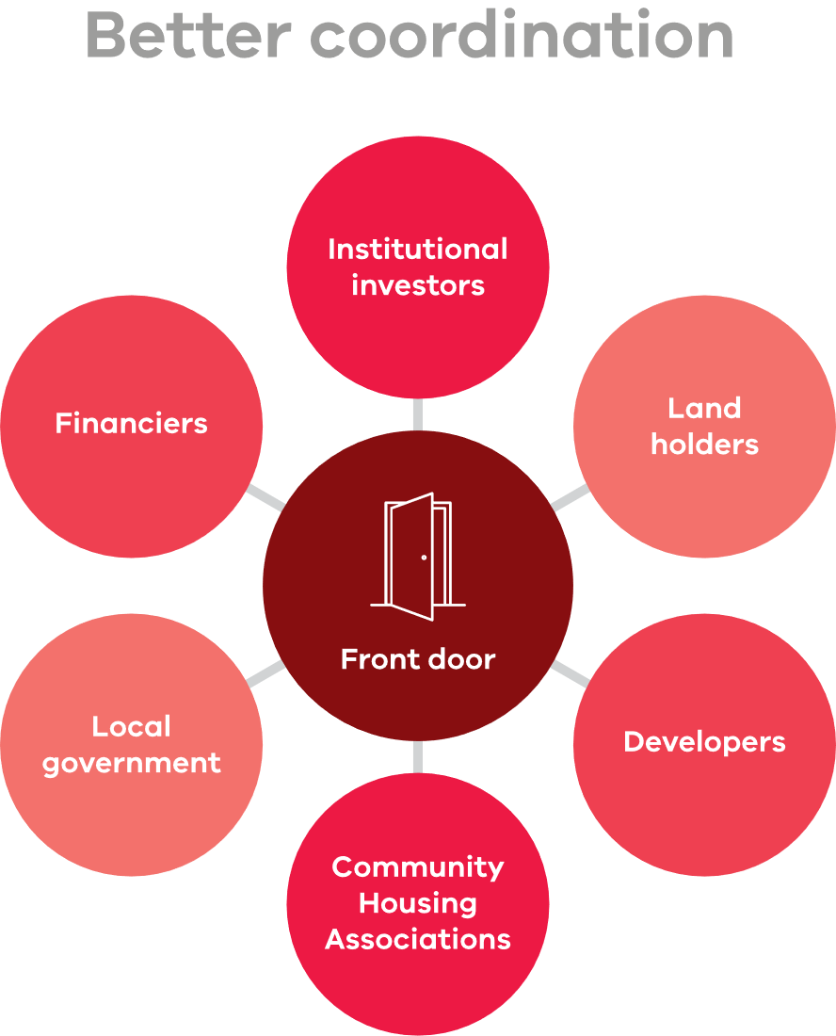

## What’s next?

The Department of Treasury and Finance and Invest Victoria are now actively engaging with institutional investors to realise the objectives of the Institutional Investment Framework.

The Framework presents exciting investment opportunities and a pathway for investors to participate in these opportunities and produce more housing supply in Victoria.

Please contact [institutionalhousinginvestor@invest.vic.gov.au](mailto:Institutionalhousinginvestor@invest.vic.gov.au) for further information.